**Compiler Design Lab**

**Practical-5**

**Name: Yash Patni**

**Roll: 71**

**Batch: A4**

**Aim: Write a program to generate three address code for the given language construct using SDTS.**

**Code:**

from prettytable import PrettyTable

def generate_three_address_code(code_lines):

    final_code = []

    temp_counter = 1

    do_index = None

    instruction_pointer = 100

    for line in code_lines:

        line = line.strip()

        if 'do' in line:

            do_index = instruction_pointer

            instruction_pointer += 1

            continue

        elif 'while' in line:

            conditions = line[line.find('(') + 1:line.rfind(')')].split('||')

            for condition in conditions:

                final_code.append(f'if {condition.strip()} goto {do_index}')

                final_code.append('goto')

                instruction_pointer += 1

            final_code.append("End")

            instruction_pointer += 1

        else:

            statements = line.split(';')

            for statement in statements:

                if '=' in statement:

                    lhs, rhs = statement.split('=')

                    lhs = lhs.strip()

                    rhs = rhs.strip()

                    if '*' in rhs or '/' in rhs:

                        temp_var = f't{temp_counter}'

                        final_code.append(f'{temp_var} = {rhs}')

                        final_code.append(f'{lhs} = {temp_var}')

                        temp_counter += 1

                    elif '+' in rhs or '-' in rhs:

                        temp_var1 = f't{temp_counter}'

                        temp_counter += 1

                        temp_var2 = f't{temp_counter}'

                        final_code.append(f'{temp_var1} = {rhs}')

                        final_code.append(f'{temp_var2} = {temp_var1}')

                        final_code.append(f'{lhs} = {temp_var2}')

                        temp_counter += 1

                    elif rhs.isdigit():

                        final_code.append(f'{lhs} = {rhs}')

                    else:

                        temp_var = f't{temp_counter}'

                        final_code.append(f'{temp_var} = {rhs}')

                        final_code.append(f'{lhs} = {temp_var}')

                        temp_counter += 1

                    instruction_pointer += 1

                elif statement.strip():

                    final_code.append(statement.strip())

                    instruction_pointer += 1

    return final_code

def read_code_from_file(file_name):

    with open(file_name) as f:

        code_lines = f.readlines()

    return [line.strip() for line in code_lines if line.strip()]

def display_three_address_code(three_address_code):

    print('\nThe Three Address Code Generated is:')

    table = PrettyTable()

    table.align = "l"

    table.field_names = ['Index','Code']

    for i, code_line in enumerate(three_address_code):

        table.add_row([100 + i, code_line])

    print(table)

code_lines = read_code_from_file('/content/code.txt')

print('Statements:')

print(''.join(code_lines))

three_address_code = generate_three_address_code(code_lines)

display_three_address_code(three_address_code)

**Output:**

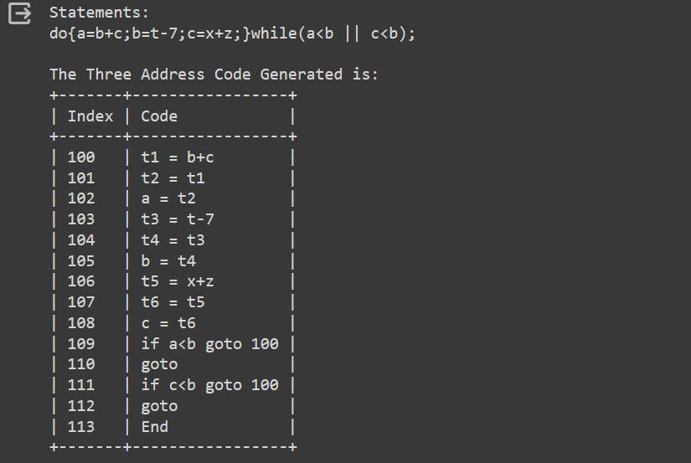

**Conclusion:** In this practical we successfully generated 3 address code for do-while loop using sdts.