**Compiler Design Lab**

**Practical-6**

**Name: Yash Patni**

**Roll: 71**

**Batch: A4**

**Topic: Code Optimization**

**Aim: Write a code to implement Local optimization techniques until no further optimization is possible for the given three address code.**

**Code:**

def optimize_TAC(tac):

    optimized_tac = tac

    def copy_propagation(tac):

        var_map = {}

        optimized_tac = []

        for line in tac:

            tokens = line.split()

            if len(tokens) == 3 and tokens[1] == "=":

                if not tokens[2].isdigit():

                    var_map[tokens[0]] = tokens[2]

                optimized_tac.append(line)

            else:

                new_line = " ".join([var_map.get(token, token) for token in tokens])

                optimized_tac.append(new_line)

        return optimized_tac

    def constant_propagation(tac):

        constants = {}

        optimized_tac = []

        for line in tac:

            tokens = line.split()

            if len(tokens) == 3 and tokens[1] == "=" and tokens[2].isdigit():

                constants[tokens[0]] = tokens[2]

                optimized_tac.append(line)

            else:

                new_line = " ".join([constants.get(token, token) for token in tokens])

                optimized_tac.append(new_line)

        return optimized_tac

    def constant_folding(tac):

        optimized_tac = []

        for line in tac:

            tokens = line.split()

            if len(tokens) == 5:

                op1, operator, op2 = tokens[2], tokens[3], tokens[4]

                if op1.isdigit() and op2.isdigit():

                    result = eval(f"{op1} {operator} {op2}")

                    new_line = f"{tokens[0]} = {result}"

                else:

                    new_line = line

                optimized_tac.append(new_line)

            else:

                optimized_tac.append(line)

        return optimized_tac

    def common_subexpression_elimination(tac):

        subexpr_map = {}

        optimized_tac = []

        for line in tac:

            tokens = line.split()

            if len(tokens) == 5:

                subexpr = " ".join(tokens[2:])

                if subexpr in subexpr_map:

                    new_line = f"{tokens[0]} = {subexpr_map[subexpr]}"

                else:

                    subexpr_map[subexpr] = tokens[0]

                    new_line = line

                optimized_tac.append(new_line)

            else:

                optimized_tac.append(line)

        return optimized_tac

    def dead_code_elimination(tac):

        used_variables = set()

        assigned_variables = set()

        optimized_tac = []

        for line in tac:

            tokens = line.split()

            assigned_variables.add(tokens[0])

            if len(tokens) == 5:

                used_variables.add(tokens[0])

                used_variables.add(tokens[2])

                used_variables.add(tokens[4])

        for line in tac:

            variable = line.split()[0]

            if variable in used_variables or variable not in assigned_variables:

                optimized_tac.append(line)

        return optimized_tac

    prev_tac = []

    print("Original TAC:")

    print("\n".join(tac))

    print("\nOptimizing with copy propagation:")

    optimized_tac = copy_propagation(optimized_tac)

    print("\n".join(optimized_tac))

    print("\nOptimizing with constant propagation:")

    optimized_tac = constant_propagation(optimized_tac)

    print("\n".join(optimized_tac))

    print("\nOptimizing with constant folding:")

    optimized_tac = constant_folding(optimized_tac)

    print("\n".join(optimized_tac))

    print("\nOptimizing with common_subexpression_elimination:")

    optimized_tac = common_subexpression_elimination(optimized_tac)

    print("\n".join(optimized_tac))

    print("\nEliminating dead code:")

    optimized_tac = dead_code_elimination(optimized_tac)

    print("\n".join(optimized_tac))

    while prev_tac != optimized_tac:

        prev_tac = optimized_tac

        optimized_tac = copy_propagation(optimized_tac)

        optimized_tac = constant_propagation(optimized_tac)

        optimized_tac = constant_folding(optimized_tac)

        optimized_tac = common_subexpression_elimination(optimized_tac)

        optimized_tac = dead_code_elimination(optimized_tac)

    return optimized_tac

tac = [

    "a = 2",

    "b = x * x",

    "c = x",

    "d = a + 5",

    "e = b + c",

    "f = c * c",

    "g = d + e",

    "h = e * f"

]

optimized_tac = optimize_TAC(tac)

print("\nAfter dead code elimination")

print("Optimized TAC:")

print("\n".join(optimized_tac))

**Output:**

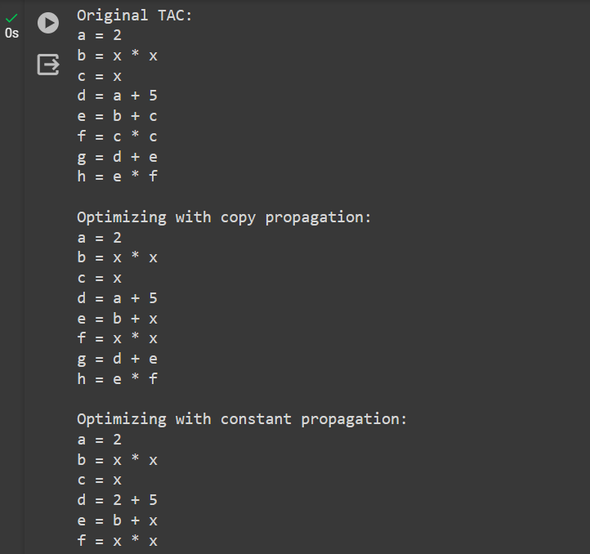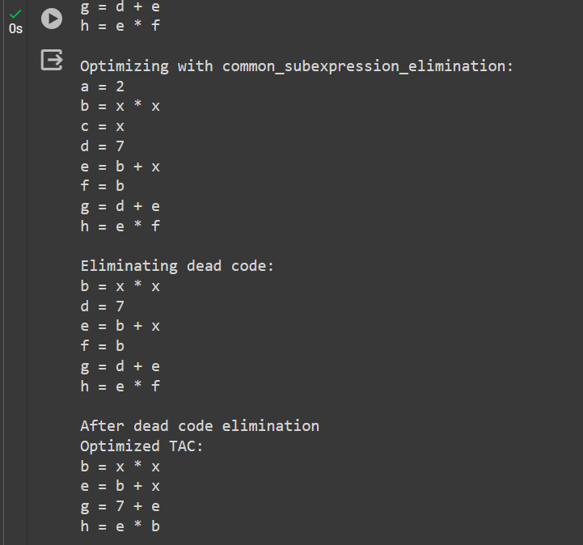

**Conclusion:** In this practical we successfully implemented local optimization techniques and optimized the given 3 address code.