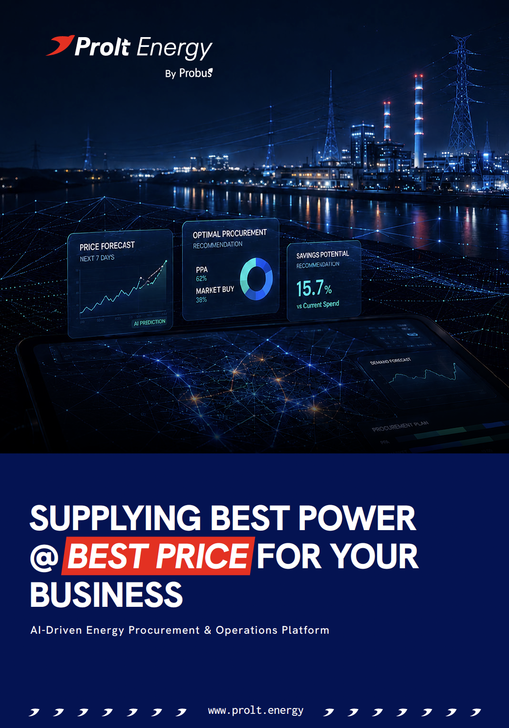



Proposal for Prolt Energy – AI Driven Platform for Energy Procurement & Operations

Submitted by Prolt Energy

For: Chaurishi Ayurveda LLP, Noida

Sanctioned Load | Connectivity | DISCOM Name | Feeder Type

1. EXECUTIVE SUMMARY

A clear, quantified opportunity to reduce energy cost
A savings proposal built from Chaurishi Ayurveda LLP’s actual utility bills and consumption data.

AVERAGE MONTHLY SAVINGS  ₹2,11,034  Estimated from the actual energy bills shared with Probus. | AVERAGE ANNUAL SAVINGS  ₹25,32,409  A direct opportunity to improve operating margins. | FIXED-COST PAYBACK  Less than 150 days  Following payback, savings flow directly to the business.

The proposal: move from a largely single-source electricity model to a managed procurement model that combines DISCOM supply, Open Access, exchange-based procurement, green power, solar, and battery storage wherever commercially viable.
THE  DECISION | Proceed with the Open Access implementation journey and let Probus manage the full operating cycle - from application and metering to daily energy buying, settlement, and reporting powered by our AI driven platform – Prolt Energy  Open Access timeline: 60-90 days

Objective
Supply the best available energy to your business at the lowest possible landed cost, while maintaining reliability and regulatory compliance.
Prolt Energy is an AI-driven energy procurement and operations platform for commercial and industrial consumers. It helps C&I Consumer source cost-effective power through a combination of DISCOM supply, Open Access, exchange-based procurement, green power, solar, and battery storage, wherever commercially viable.

Objective: Supply the best available energy to your business at the lowest possible landed
2. KEY CHALLENGES
The issue is not only the tariff. It is the absence of continuous, time-block-level procurement decisions.

HIGH POWER COST  Commercial and industrial DISCOM tariffs and peak-period charges can materially increase the monthly electricity bill. | LIMITED VISIBILITY  Monthly bills do not reveal the true time-of-day and 15-minute block-wise cost of electricity.
COMPLEX EXECUTION  Open Access requires scheduling, approvals, settlements, compliance, and coordination across several counterparties. | MANUAL DECISIONS  Without market intelligence and forecasting, procurement opportunities are missed and the full energy portfolio remains unoptimized.

TODAY  Single-source dependency  Monthly review  Fragmented coordination | → | WITH PROLT  Multi-source strategy  Time-block intelligence  Managed energy operations with full transparency

3. PROLT ENERGY SOLUTION
Prolt acts as your business’ intelligent energy procurement partner.
We analyse your business’ bills, load profile, tariff category, contract demand, sanctioned load, demand charges, power factor, and applicable open access rules. Based on this, Prolt designs a practical energy procurement strategy using the most suitable mix of:
- DISCOM supply
- Open Access power
- Exchange-based procurement
- PPA/ Green power procurement
- On-site solar, wherever applicable
- Battery storage, wherever commercially viable
The goal is to reduce landed cost without compromising reliability.

4. PROPOSED SCOPE OF WORK –

A structured path from diagnosis to ongoing operations
Each phase produces a clear decision output and prepares the business for execution.

PHASE 1  Bill & Load Analysis | • Monthly consumption and billing trends  • Maximum demand and contract demand  • Time-of-day consumption  • Fixed and demand charges  • Power factor penalty / incentive  • Tariff category  • Load factor  • Baseline cost of energy
PHASE 2  Open Access & Alternate Supply Feasibility | • Open Access eligibility  • Green power feasibility  • PPA feasibility evaluation  • Landed cost comparison against existing DISCOM tariff (incl. all charges and losses)
PHASE 3  Energy Optimisation Plan | • Prolt will install its HT Meter with AMR facility at your premises  • Recommended energy mix  • Expected monthly savings  • Risk-adjusted landed cost  • Procurement and operating model  • Implementation roadmap
PHASE 4  Managed Energy Operations | • Load forecasting  • Market price tracking  • Procurement planning  • Scheduling coordination  • Trader / DISCOM / SLDC coordination support  • Settlement and reconciliation support  • Monthly savings reports  • Energy dashboard and MIS

5. MANAGED ENERGY OPERATIONS

More than analysis: Prolt manages the operating cycle
The platform combines intelligence with execution, visibility, and accountability.

FORECAST  Load & price | PLAN  Source mix | SCHEDULE  Coordinate | SETTLE  Reconcile | REPORT  Track savings

Expected business benefits
• Lower monthly electricity cost, with up to 30% monthly energy bill reductions.
• Real-time visibility into energy consumption and cost.
• A clear comparison between DISCOM and alternate supply options.
• Reduced complexity in Open Access and market-based procurement, with full transparency.
• Data-driven energy decisions supported by forecasting and market intelligence.
• Monthly savings tracking and transparent reporting.
• A future-ready power procurement model.

Traditional approach | Prolt Energy approach
Monthly bill review | Time-block-level energy intelligence
Single-source dependency | Multi-source energy strategy
Manual decisions | AI-driven procurement planning
Limited tariff analysis | Full landed-cost comparison
Fragmented coordination | Managed energy operations

6. ANALYSIS INPUTS & DELIVERABLES
Everything required to move from feasibility to execution
A clear input checklist, matched to a defined set of decision-ready deliverables.

INFORMATION REQUIRED  1. Last 12 months electricity bills  2. Sanctioned load and contract demand details  3. Connected load details  4. Existing tariff category  5. 15-minute or 30-minute load data, if available  6. Details of existing solar installation, if any  7. DG set / backup power details  8. Operating pattern or production schedule  9. Planned capacity expansion, if any | DELIVERABLES  1. Electricity bill analysis report  2. Baseline energy cost report  3. Open Access feasibility report  4. Landed cost comparison  5. Expected savings estimate  6. Energy procurement strategy  7. Implementation roadmap  8. Commercial proposal for managed energy services

Engagement model: Diagnostic Study first, followed by Managed Energy Service covering procurement planning, market monitoring, scheduling, reconciliation, savings tracking, and reporting.

7. SAVINGS FOR YOUR BUSINESS –
The savings opportunity is consistent across the billing history
Actual data shows a recurring reduction opportunity, with the strongest saving in May 2026.

AVERAGE MONTHLY SAVINGS  ₹2,11,034  Based on the historical energy bills and consumption data provided. | AVERAGE ANNUAL SAVINGS  ₹25,32,409  The annual cost of delaying the switch to a managed procurement model.

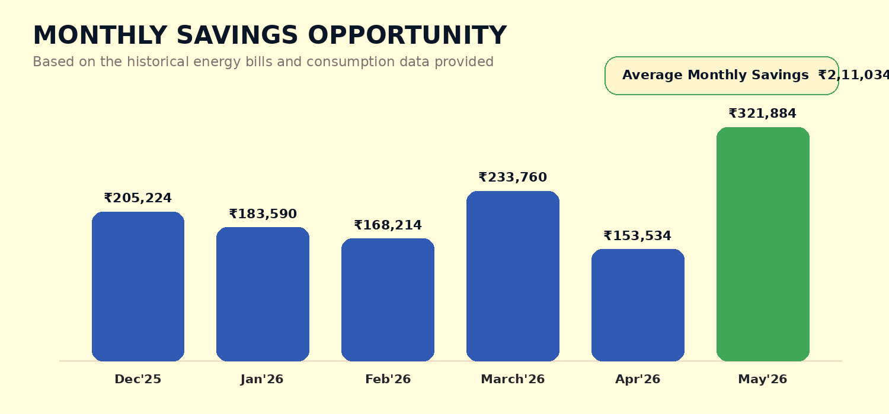
You are losing around Twenty Five lakhs annually by not switching to Prolt immediately.

8. DETAILED SAVINGS ANALYSIS
Six months of customer-specific savings evidence
The figures below are reproduced from the savings analysis prepared for Chaurishi Ayurveda LLP.

Metric | Dec'25 | Jan'26 | Feb'26 | March'26 | Apr'26 | May'26
Total Cleared Units@  Consumer bus | 1,03,255 | 94,063 | 85,298 | 88,932 | 75,678 | 1,00,690
Total Consumption As per E-bill | 1,05,107 | 1,01,142 | 86,184 | 1,02,300 | 89,976 | 1,01,370
Total Power Cost through Open Access | 6,10,282 | 5,51,964 | 5,02,401 | 4,77,565 | 4,29,705 | 4,55,197
Discom Cost | 8,15,506 | 7,35,555 | 6,70,614 | 7,11,324 | 5,83,239 | 7,77,080

Month | Cleared vs Actual consumption % | Power Purchase Cost (Discom Only) | Power Purchase Cost (With Prolt) | Total Saving | Saving/Unit
Dec'25 | 98% | ₹7.90 | ₹5.91 | ₹2,05,224 | ₹1.99
Jan'26 | 93% | ₹7.82 | ₹5.87 | ₹1,83,590 | ₹1.95
Feb'26 | 99% | ₹7.86 | ₹5.89 | ₹1,68,214 | ₹1.97
March'26 | 87% | ₹8.00 | ₹5.37 | ₹2,33,760 | ₹2.63
Apr'26 | 84% | ₹7.71 | ₹5.68 | ₹1,53,534 | ₹2.03
May'26 | 99% | ₹7.72 | ₹4.52 | ₹3,21,884 | ₹3.20

AVERAGE MONTHLY SAVINGS  ₹2,11,034 | AVERAGE ANNUAL SAVINGS  ₹25,32,409

9. SOME INSIGHTS FROM PROLT PLATFORM

We have prepared a detailed bill summary of your business as below, for example, a savings study of the months of January and May 2026 has been presented below –

January 2026 Insights
POTENTIAL REDUCTION  Around 17%  of energy costs | POTENTIAL SAVING  Around INR 2,00,000/-  for January 2026

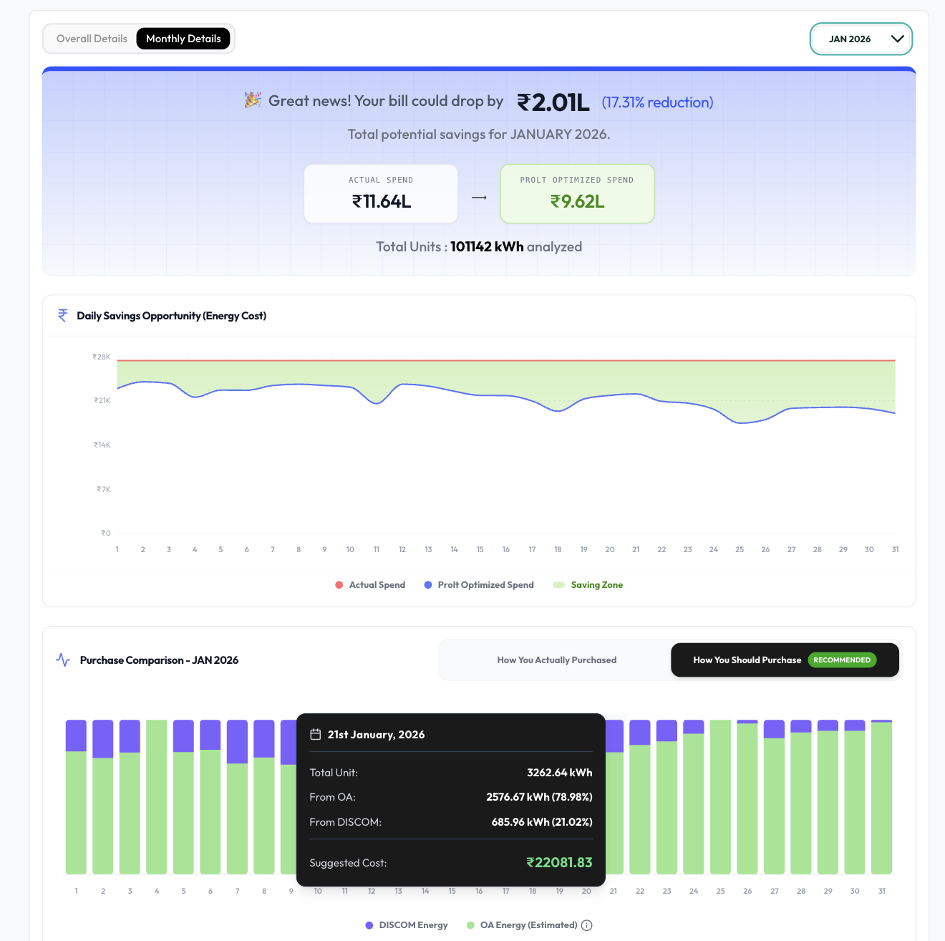

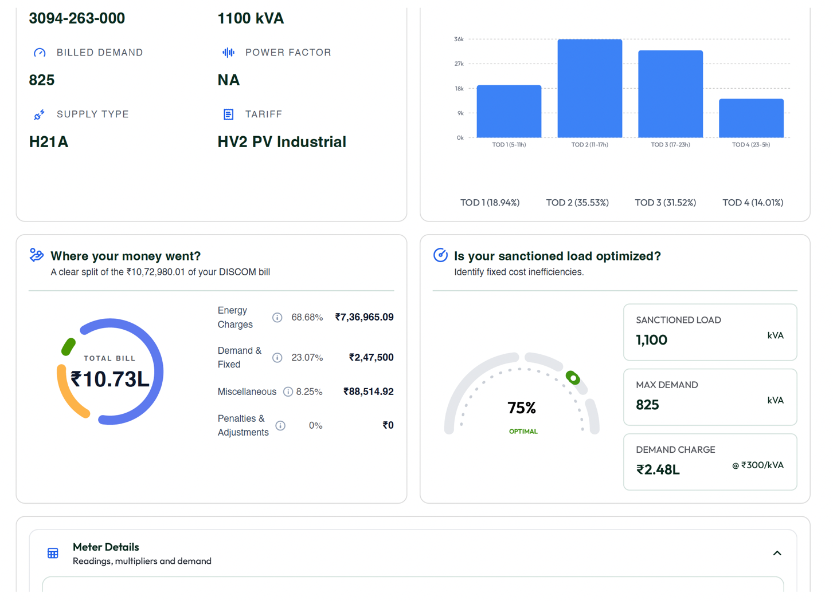
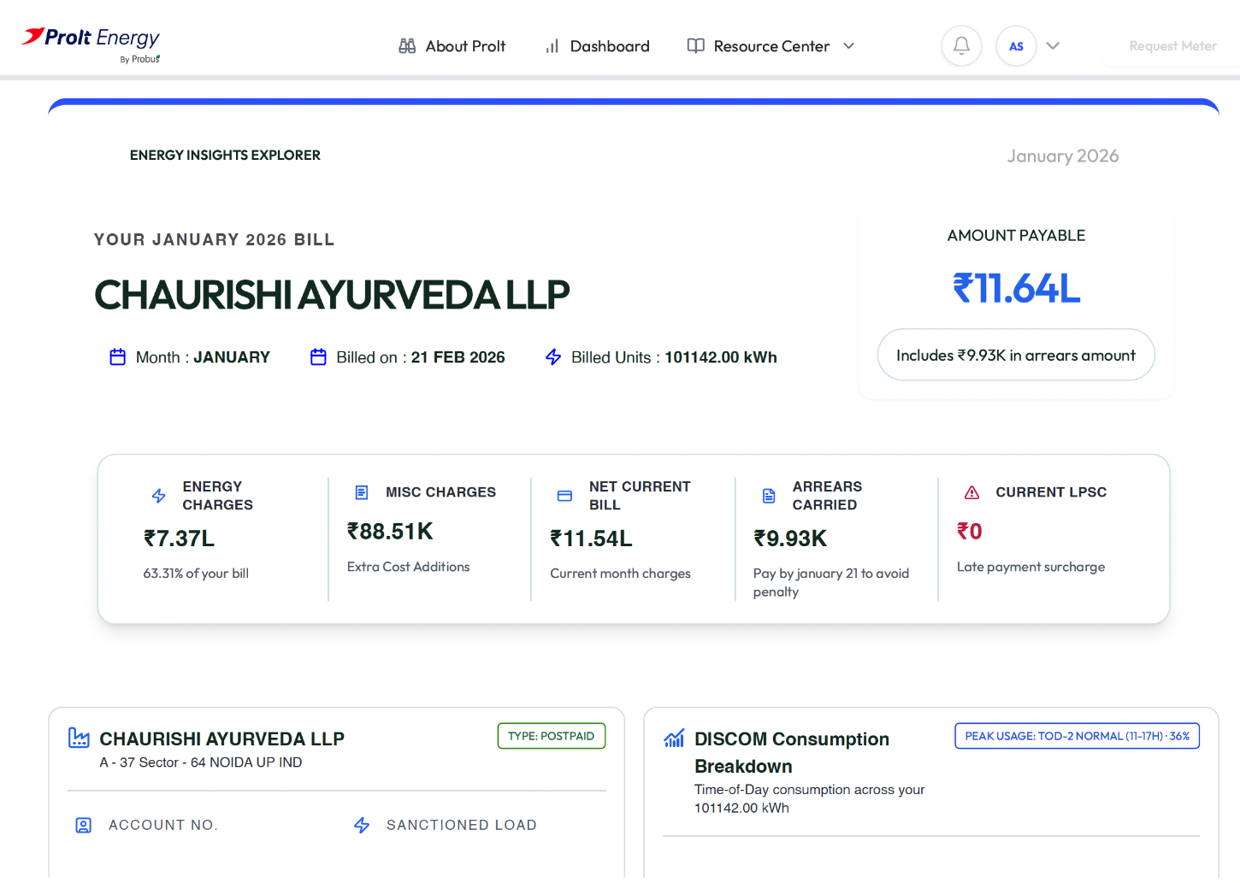
January 2026 Bill Insights -

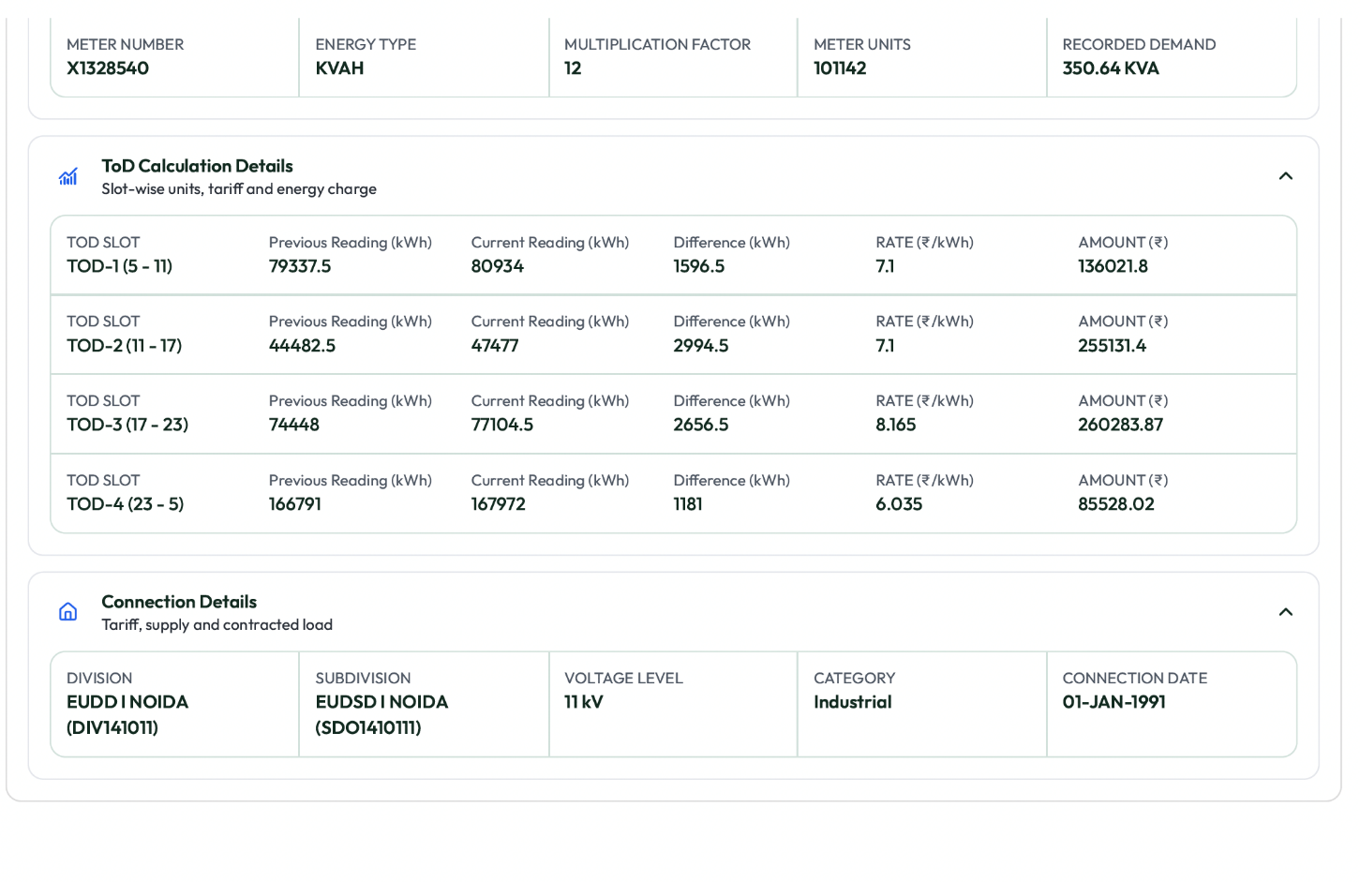

Insight:
INSIGHT
In January, your business operated at 31.5% of its total capacity during the peak Time-of-Day window from 5:00 PM to 11:00 PM, when utility power costs were at their highest - ₹8.165 per kWh.

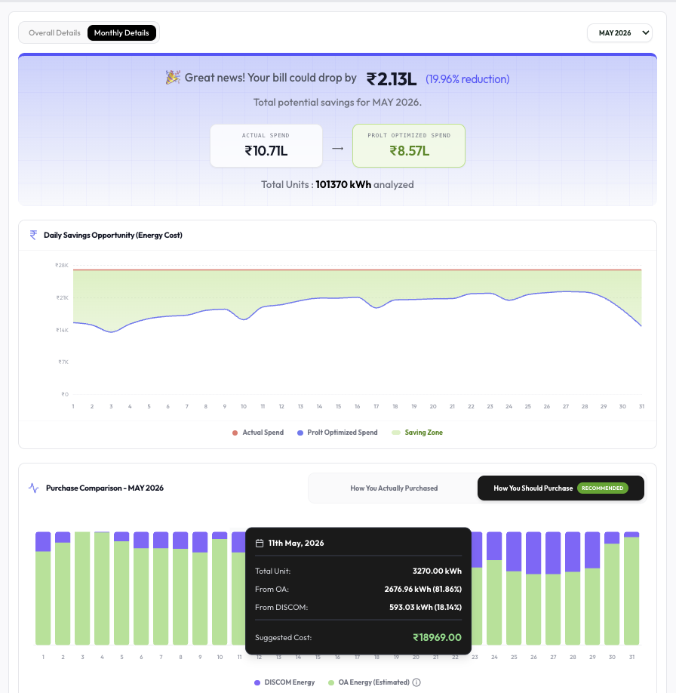
May 2026 Insights
POTENTIAL REDUCTION  Around 20%  of energy costs | POTENTIAL SAVING  Around INR 2,13,000/-  for May 2026
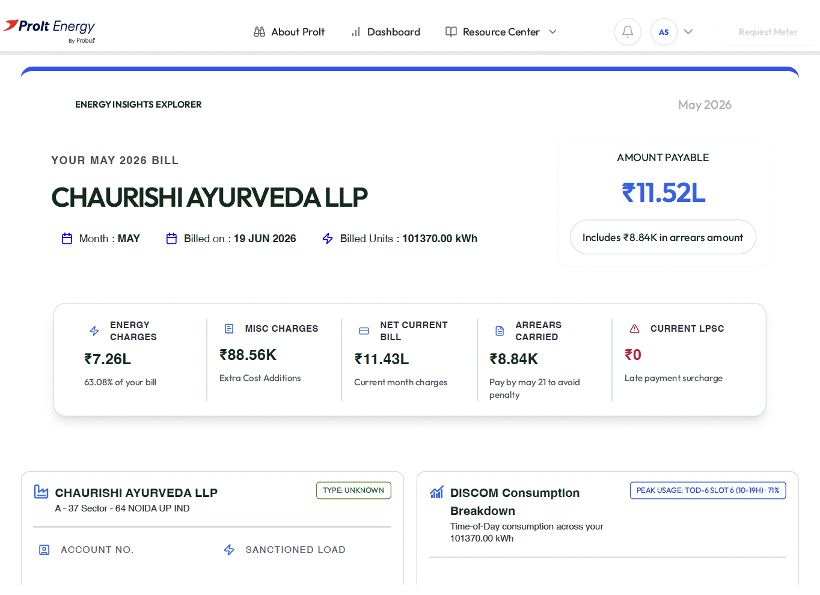
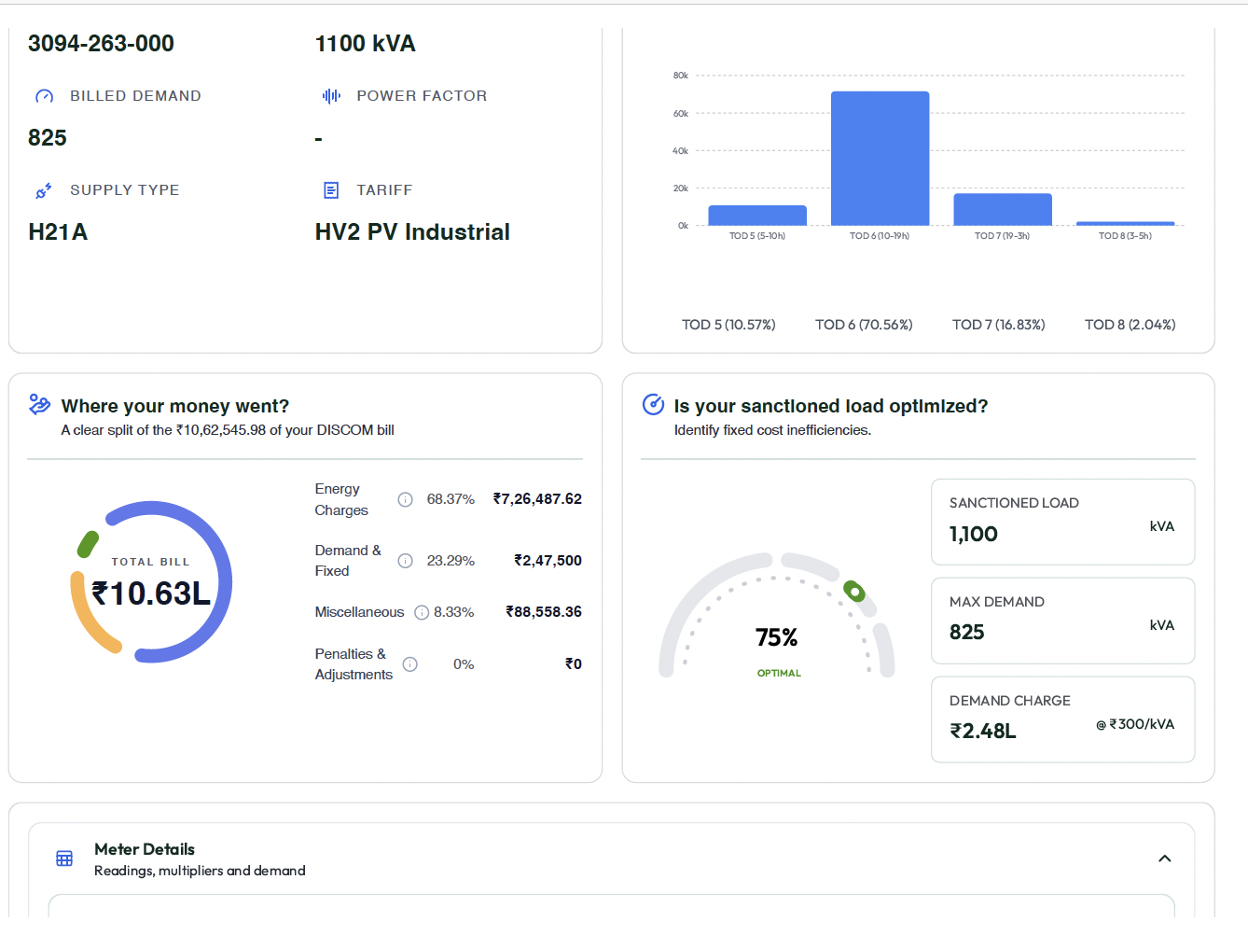
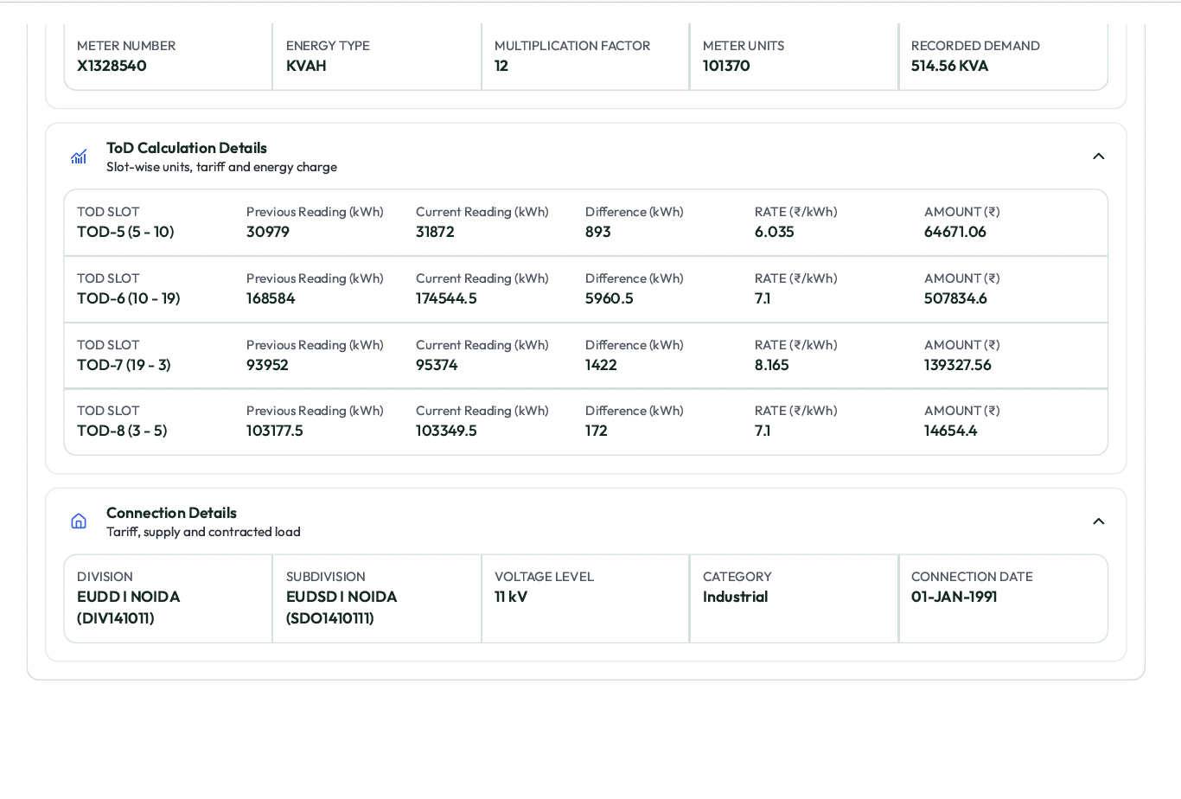

Insight:
INSIGHT
In May, your business still has an opportunity to operate at the cheapest Time-of-Day window from 5:00 AM to 10:00 AM, when utility power costs were at their lowest - ₹6.035 per kWh.

Add on Features-

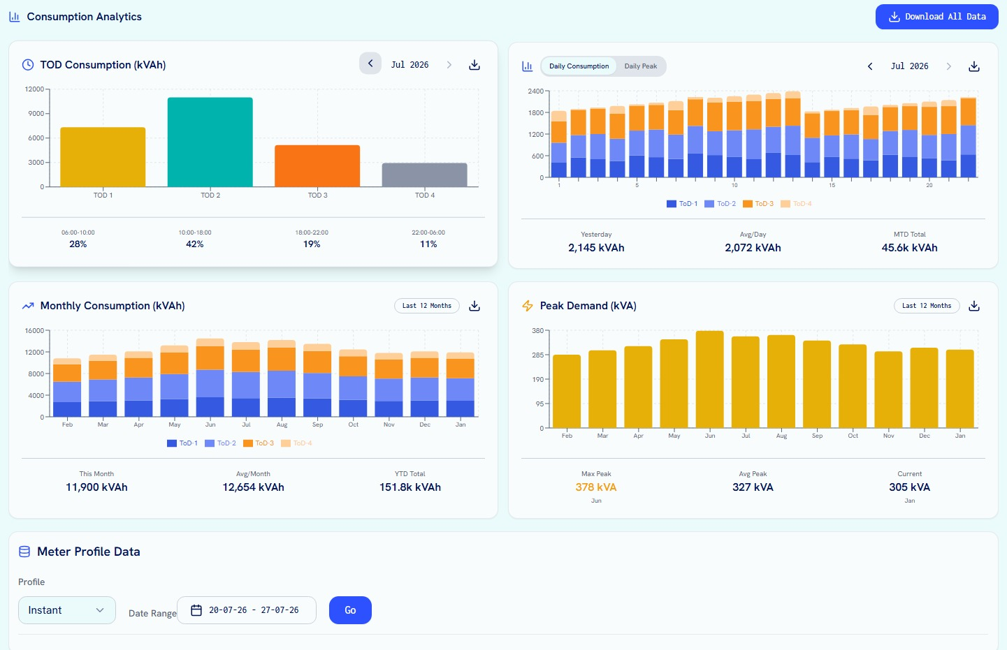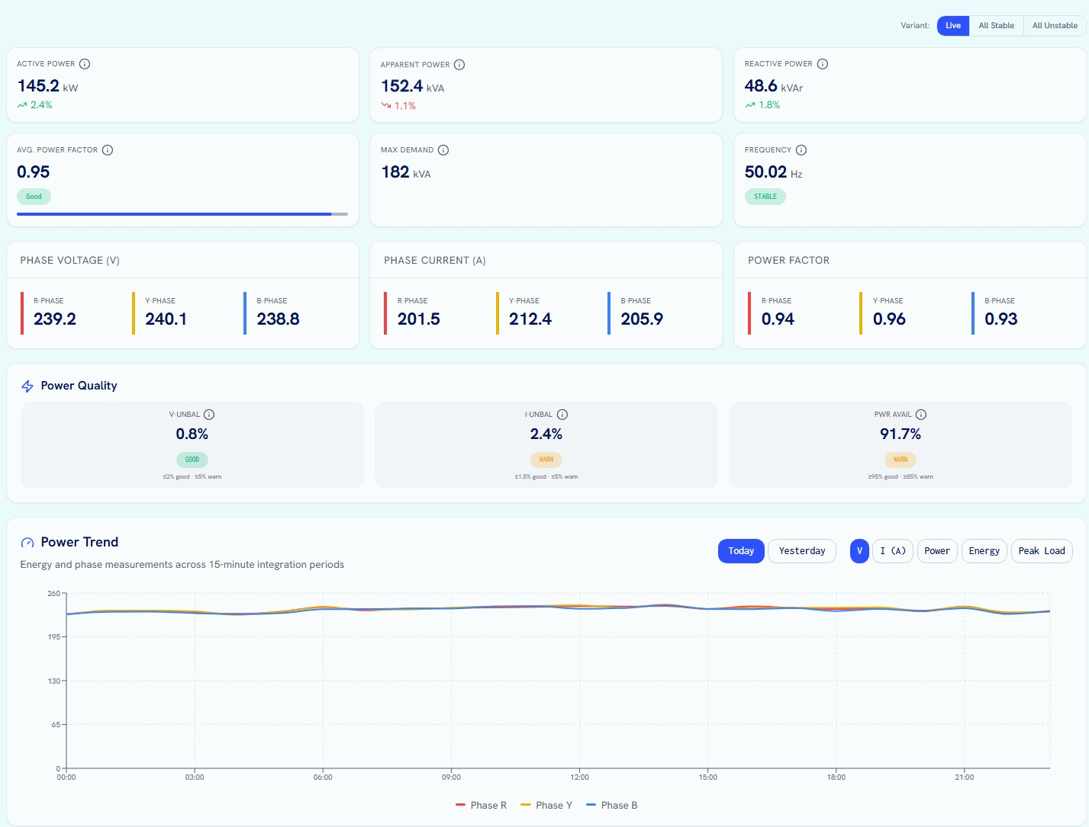

Visit https://prolt.energy/ , upload your energy bills, and instantly discover how much your business can save.

Get Prolted — and start saving on energy from Day 1
10. EXECUTION TIMELINE
A managed implementation journey, led end to end by Prolt

Chaurishi Ayurveda provides the go-ahead. Prolt coordinates the application, metering, permissions, and operating transition.

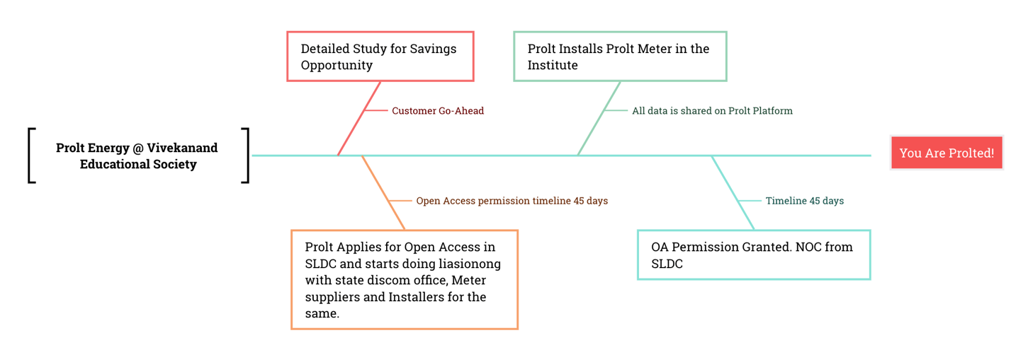
PROLT @ Chaurishi Ayurveda
1. Prolt provides a detailed savings assessment by analysing the bills and consumption pattern.
2. Chaurishi Ayurveda gives the go-ahead to begin the Prolt journey.
3. Prolt submits all paperwork for the Open Access application in SLDC. Open Access timeline: 60-90 days.
4. Prolt installs the Prolt Meter at the facility to begin the AI energy buying journey.
5. Prolt coordinates with the meter supplier, contractor, and DISCOM for ABT Meter installation at the premises.
6. The ABT Meter is installed.
7. Once OA permission is granted, the smart energy buying and savings journey begins on Prolt.
8. Prolt provides the Prolt Platform under a Power as a Service model, sourcing the best available power at the lowest possible prices.

11. WHY PROLT ENERGY
A single accountable partner for technology, markets, and execution
Prolt combines energy intelligence with the operating capability required to convert analysis into realised savings.

STEP 1  Diagnostic Study  Assessment of current power cost, load profile, tariff structure, and alternate procurement opportunity. | STEP 2  Managed Energy Service  Procurement planning, market monitoring, scheduling, reconciliation, savings tracking, and reporting.

Built by Probus Smart Things
Prolt Energy is built by Probus Smart Things, a technology company with deep experience in energy monitoring, grid digitisation, communication systems, and data analytics.
Prolt combines energy market intelligence, AI-based forecasting, regulatory understanding, and operational execution to deliver a complete energy procurement solution for industrial consumers.
BUY BETTER POWER. AT BETTER PRICES. WITH BETTER VISIBILITY.

12. SUMMARY & NEXT STEP
Recommendation: begin the implementation journey now
The historical data supports a clear business case for moving to Prolt Energy.

PROCUREMENT POTENTIAL  Approximately 95%  of the energy requirement during lower-cost daytime hours or cheaper available options, optimised against the facility’s 24-hour consumption profile. | AVERAGE MONTHLY SAVINGS  ₹2,11,034  Based on the actual energy bills shared with Probus. | FIXED-COST PAYBACK  Less than 150 days  After payback, energy savings improve operating margins.

Lower energy costs. Faster payback. Savings from Day 1.
NEXT STEP  Approve the Open Access implementation and metering process so Probus can begin the transition to smart energy buying.  Visit prolt.energy, upload your energy bills, and instantly discover how much your business can save. | GET  PROLTED

Submitted by Prolt Energy
A Probus Smart Things Initiative
Saikat Bose | saikat@probus.io

END OF PROPOSAL

