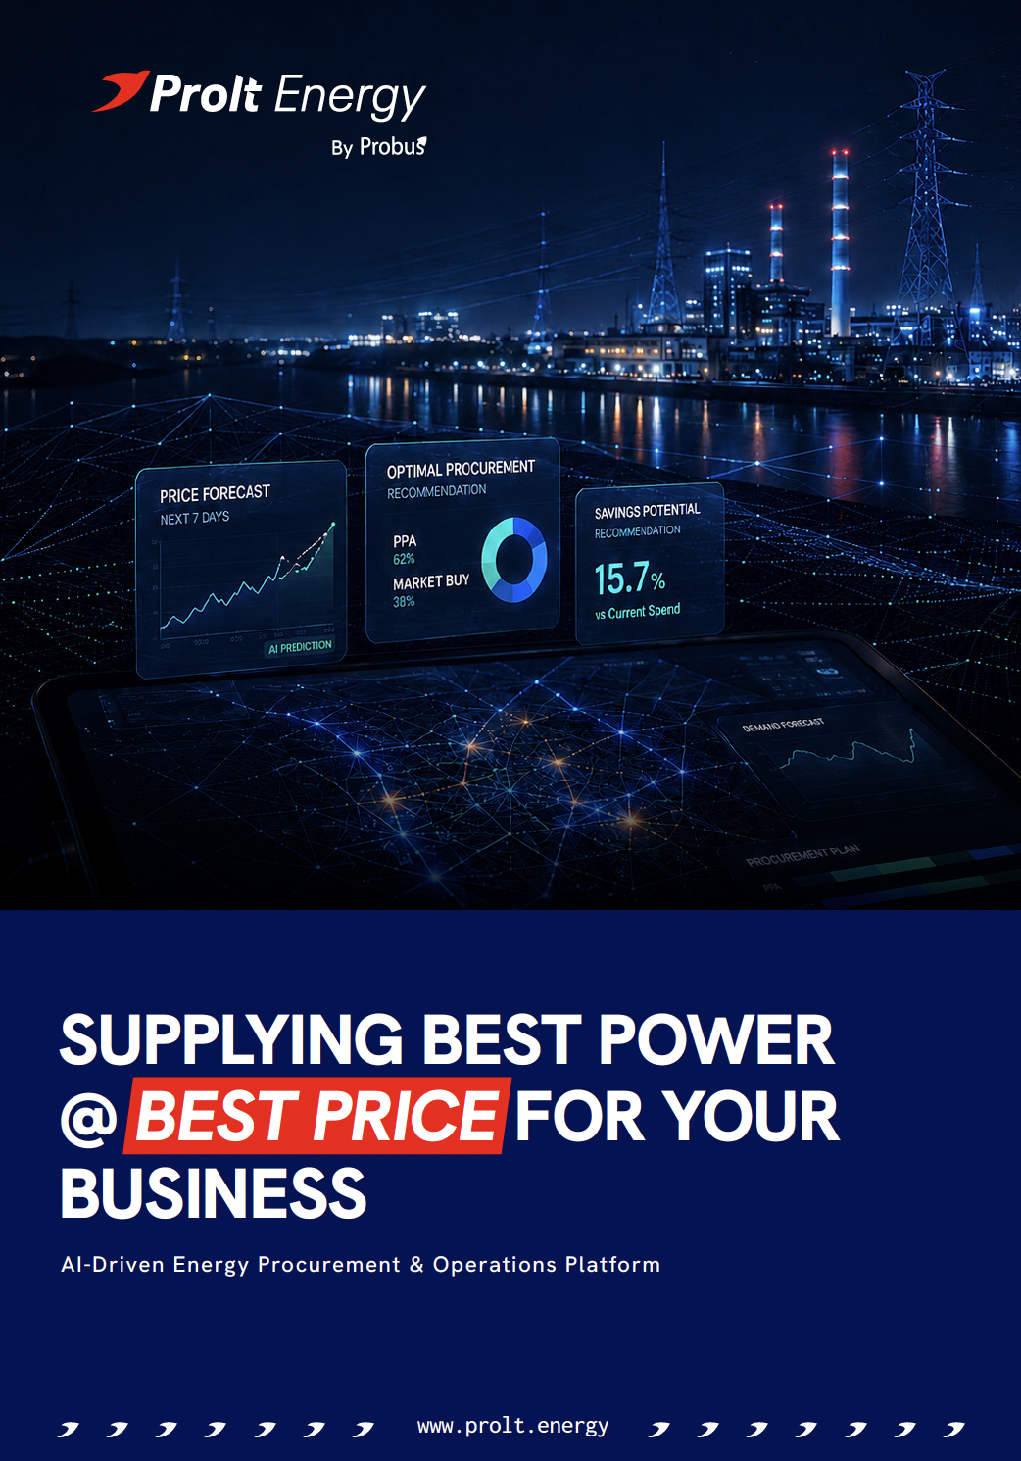
COMMERCIAL PROPOSAL FOR XXXXXXXXXXXXX
To start your journey of getting cheaper electricity through sources other than your existing DISCOM (Open Access), the customer has to apply for the same in UPSLDC (Prolt Energy will be doing the application on your behalf).
Sanctioned Load | Connectivity | DISCOM Name | Feeder Type
1000 KVA | 11 KV | PUVVNL | Dedicated
The Scope of Work will be as follows:
- Supply, Installation, Testing, and Commissioning of ABT Meter
- Liaisoning with the concerned Utility and UPSLDC for ABT Meter commissioning, Open Access (OA) membership, statutory approvals, and coordination until the required permissions are obtained.
- Daily Power Bidding and Transaction Management on the Indian Energy Exchange (IEX) and other applicable platforms, as required.
- Monthly Energy Bill Settlement and Reconciliation, including coordination and liaisoning with the concerned authorities for timely clearances and closure of related matters.
- Supply and Installation of Probus Smart Meter and Smart LED TV, including necessary configuration and commissioning.

Complete Project Management & Liaisoning for Open Access Registration
ACTIVITIES | PERIODS (Weekly)
ACTIVITIES | 1 | 2 | 3 | 4 | 5 | 6 | 7 | 8 | 9 | 10 | 11 | 12
Signing of PPA
Supply, Installation & Commissioning of PROLT Meter & Screen
Receipt of Purchase / Work Order & Advance Amount for Open Access Registration
Preparation of Documents for Open Access & Submission of Application to UPPTCL
Approval of Application from UPPTCL
Release of PO for Procurement of 3 Nos. of ABT Meter along with CT-PT
Inspection of Materials (ABT Meter) by UPPTCL
Delivery of Materials (ABT Meter along with CT-PT)
Installation of Materials (ABT Meter along with CT-PT) & Sealing by T&C and Test
Apply for ST-11 in UPSLDC
Approval of ST-11 by Various level of DISCOMs & UPPTCL (lastly)
Apply for Registration in NOAR
NOAR approval and power flow arrangement
Apply for NOC in NOAR / UPSLDC
Approval for NOC by NOAR / UPSLDC
IEX Registration
Trading in Exchange Platform Starts

Note:
The timelines are indicative, as obtaining approvals are subject to the processing time of the respective statutory authorities and utilities and may vary on a case-to-case basis. However, Probus shall make all reasonable efforts to complete every stage of the process at the earliest possible time and keep you informed of the progress throughout the engagement.
Schedule of charges are as below:
S. No. | Item Description | UoM | Occurrence | Price
1 | ABT Metering Setup |  |  | ₹ 15,00,000
1.1 | Supply:  - ABT Meters Secure Make (0.2s Class Accuracy)- 3 Nos.  - Indoor Meter Cubical with CT/PT (0.2s Class Accuracy)- 1 Nos.  - Outdoor CT/PT Unit (0.2s Class Accuracy)- 1 Nos. | Lot | One Time | ₹ 4,50,000
1.2 | Service: Installation, Commissioning, Testing & Sealing of Meters & Consultancy Charges thereof:  - ABT Meters- 3 Nos.  - Indoor CT/PT Unit- 1 Nos.  - Outdoor CT/PT Unit- 1 Nos. | Lot | One Time | ₹ 5,50,000
1.3 | Utility Liaisoning & Consultancy:  Open Access application at respective DISCOM & SLDC including liaisoning covering  - Permission for procurement of ABT meter and CT-PT.  - Nomination of inspection authority.  - Liaison for inspection by inspecting authority including boarding, lodging, foods, cab and any other expense required for inspection.  - Submission of inspection report.  - Sealing nomination and sealing arrangement Installation and commissioning of ABT meter and CT-PT.  - ST-11 approval.  - NOAR approval and power flow arrangement.  - All liaisoning works up-to power flow. | Lot | One Time | ₹ 5,00,000
2 | SLDC Security Deposit (Refundable) |  |  | ₹ 1,50,000
2.1 | UPSLDC Bank Guarantee / FDR for new memberships:  (Payable to UPSLDC by the customer directly @ Rs 1,50,000 / MW) | Lot | One Time | ₹ 1,50,000
3 | Fixed Recurring Charges |  |  | ₹ 1,27,000
3.1 | IEX Annual Membership Fees | Lot | Annual | ₹ 1,00,000
3.2 | UPSLDC Monthly NOC Charges | Lot | Monthly | ₹ 7,000
3.3 | ST -11 & Bill Settlement | Lot | Monthly | ₹ 20,000
4 | Probus Fees
4.1 | Probus Trading Margin | Per kWh | Monthly | 2p/kWh
4.2 | Probus Platform Fees for Prolt Energy Platform | Per kWh | Monthly | 2p/kWh
4.3 | Probus Value Share for Prolt Energy Platform | Percent | Monthly | 15%
4.4 | Prolt Energy Smart Metering Infra:  - HT Meter + AMR (4G Fallback to 2G AMR)- 1 Nos.  - Installation of Metering Infra  - Smart LED TV | Lot | One Time | ₹ 1,70,000

Terms & Conditions:
1 | Payment Terms & Milestones
1.1 | Supply of ABT Metering Setup | 40% Advance against PO/PI  60% At the time of dispatch
1.2 | Services for ABT Metering Setup | 100% Advance against SO/PI  (Before start of Installation work under 1.2)
1.3 | Liaisoning & Consultancy | 100% Advance against SO/PI  (Before start of work under 1.3)
1.4 | UPSLDC Bank Guarantee | 100% Advance – Direct to UPSLDC
1.5 | Fixed Recurring Charges (S. No. 2.1 to 2.3) | 100% within 7 days of submission of Monthly Invoice.
1.6 | Probus Fees (S. No. 3.1 to 3.3) | 100% within 7 days submission of Monthly Invoice
1.7 | Prolt Energy Smart Metering Infra (S. No. 3.4) | 100% Advance against PO/PI
2 | Taxes & Duties | All Taxes and Duties to be as per actuals and as per the guidelines of the applicable Act. (Currently GST @ 18.00%)
3 | Freight | As per actuals (only on S. No.1.1)
4 | Packaging & Forwarding | Included (only on S. No.1.1)
5 | Insurance | Included (only on S. No.1.1)
6 | Delivery | 4-5 Weeks after receipt of PO and pro-rate payment (only on S. No.1.1)
7 | Validity | 30 Days
8 | Warranty | As per warranty terms of the respective OEMs
9 | Contract Agreement | Post acceptance of the Proposal a 3-year Contract Agreement shall be signed for detailed terms and conditions.



