**YASH SHRIKANT SAHANE** 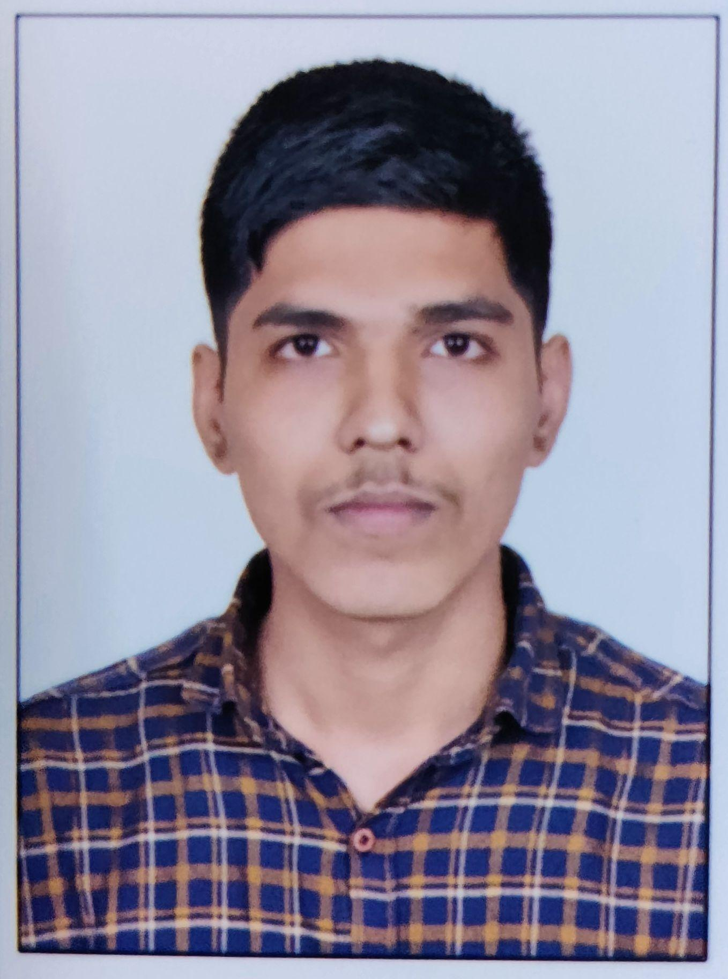

**Email id: yashsahane23@gmail.com**

**Contact: (M) +7039465105, 9819021672**

**Career Objective:**

I would like a career that gives me rich exposure through diverse assignments and working with people of high caliber. I would constantly look out for challenges, which would help me to achieve my personal and professional goal.

**Academic Qualification:**

| **Class** | **Board / University** | **Year of Passing** | **Percentage** |
| --- | --- | --- | --- |
| B. Tech | Nutan College of Engineering And Research (NCER) | Pursuing | Pursuing |
| Diploma | Government Polytechnic Mumbai | 2021 | 87.71% |
| X | S.S.S. Multipurpose Technical Highschool (SSC Board) | 2018 | 85.60% |

**Internship:**

1. **Web Development:**

* ○ Company: Udemy
* ○ Duration: 1 Month
* ○ Period: 1 Feb to 28 Feb, 2018

1. **Web Development :**

* Company: College Ranker
* Duration : 1 Month
* Period : 15 Mar to 15 Apr, 2022

**Projects:**

* Personal Portfolio Website
* Forum Site
* Login System
* Note Taking Site

**Computer Skills:**

**General:**

* High knowledge of Computer hardware & software.
* Good in programming languages such as C, C++, Java, Python.
* Knowledge of front-end Mern development languages such as HTML, CSS, JavaScript.
* Some knowledge of back-end languages such as MongoDB, PHP.
* Knowledge of designing softwares such as Figma.

**Skill Set:**

● Team player

● Goal oriented

● High level of integrity

**Special Interests:**

● Internet surfing

● Gaming

**Personal Details:**

**Correspondence :** d/o Sri.Shrikant Sahane

C/o Nalanda Nagar, Ramabai Colony, Ghatkopar (E),

Mumbai 400075

**Date of Birth :** October 27 2002

**Marital Status :** Single

**Languages Known :** Hindi, Marathi, English

**Declaration:**

I hereby solemnly affirm that all the details provided above are true to the best of my knowledge.

Date: 22nd oct 2021 Yash Shrikant sahane Place: Mumbai