Digital Inclusion and Circular Economy Behavior in Indian States:
A Digital Circularity Index and Explainable XGBoost Analysis
21CSP302L - PROJECT
Submitted by
YASH CHAUHAN [RA2311026010170]
SHREYA SRIVASTAVA [RA2311026010186]
Under the Guidance of
SURESH KUMAR
Department of Computational Intelligence
in partial fulfillment of the requirements for the degree of
BACHELOR OF TECHNOLOGY
in
COMPUTER SCIENCE ENGINEERING

DEPARTMENT OF COMPUTATIONAL INTELLIGENCE
COLLEGE OF ENGINEERING AND TECHNOLOGY
SRM INSTITUTE OF SCIENCE AND TECHNOLOGY
KATTANKULATHUR – 603 203
APRIL 2026
Department of Computational Intelligence
SRM Institute of Science & Technology
Own Work Declaration Form
This sheet must be filled in (each box ticked to show that the condition has been met). It must be signed and dated along with your student registration number and included with all assignments you submit – work will not be marked unless this is done.
To be completed by the student for all assessments
Degree/ Course : B.Tech, Computer Science Engineering
Student Name : Yash Chauhan, Shreya Srivastava
Registration Number : RA2311026010170 (Yash Chauhan), RA2311026010186 (Shreya Srivastava)
Title of Work : Digital Inclusion and Circular Economy Behavior in Indian States: A Digital Circularity Index and Explainable XGBoost Analysis
I / We hereby certify that this assessment compiles with the University's Rules and Regulations relating to Academic misconduct and plagiarism, as listed in the University Website, Regulations, and the Education Committee guidelines.
I / We confirm that all the work contained in this assessment is my / our own except where indicated, and that I / We have met the following conditions:
• Clearly referenced / listed all sources as appropriate
• Referenced and put in inverted commas all quoted text (from books, web, etc)
• Given the sources of all pictures, data etc. that are not my own
• Not made any use of the report(s) or essay(s) of any other student(s) either past or present
• Acknowledged in appropriate places any help that I have received from others (e.g. fellow students, technicians, statisticians, external sources)
• Compiled with any other plagiarism criteria specified in the Course handbook / University website
I understand that any false claim for this work will be penalized in accordance with the University policies and regulations.
DECLARATION:
I am aware of and understand the University's policy on Academic misconduct and plagiarism and I certify that this assessment is my / our own work, except where indicated by referring, and that I have followed the good academic practices noted above.
Signature of the Student(s): ____________________________
Date: ____________________
SRM INSTITUTE OF SCIENCE AND TECHNOLOGY
KATTANKULATHUR – 603 203
BONAFIDE CERTIFICATE
Certified that 21CSP302L - Project report titled “Digital Inclusion and Circular Economy Behavior in Indian States: A Digital Circularity Index and Explainable XGBoost Analysis” is the bonafide work of “Yash Chauhan [Reg. No. ____________] and Shreya Srivastava [Reg. No. ____________]” who carried out the project work under my supervision. Certified further, that to the best of my knowledge the work reported herein does not form any other project report or dissertation on the basis of which a degree or award was conferred on an earlier occasion on this or any other candidate.

SIGNATURE OF GUIDE  Suresh Kumar  Department of Computational Intelligence  SRM Institute of Science and Technology | SIGNATURE OF HEAD OF DEPARTMENT  Dr. R. Annie Uthra  Professor & Head  Department of Computational Intelligence
Submitted for the Project viva-voce held on ______________________
EXAMINER 1  Name & Signature | EXAMINER 2  Name & Signature
ACKNOWLEDGEMENTS
We express our humble gratitude to Dr. C. Muthamizhchelvan, Vice-Chancellor, SRM Institute of Science and Technology, for the facilities extended for the project work and his continued support.
We extend our sincere thanks to Dr. Leenus Jesu Martin M, Dean-CET, SRM Institute of Science and Technology, for his invaluable support.
We wish to thank Dr. Revathi Venkataraman, Professor and Chairperson, School of Computing, SRM Institute of Science and Technology, for her support throughout the project work.
We encompass our sincere thanks to Dr. M. Pushpalatha, Professor and Associate Chairperson - CS, School of Computing and Dr. C. Lakshmi, Professor and Associate Chairperson - AI, School of Computing, SRM Institute of Science and Technology, for their invaluable support.
We are incredibly grateful to our Head of the Department, Dr. R. Annie Uthra, Professor and Head, Department of Computational Intelligence, SRM Institute of Science and Technology, for her suggestions and encouragement at all the stages of the project work.
We want to convey our thanks to our Project Coordinators, Panel Head, and Panel Members, Department of Computational Intelligence, SRM Institute of Science and Technology, for their inputs during the project reviews and support.
We register our immeasurable thanks to our Faculty Advisor, Suresh Kumar, Department of Computational Intelligence, SRM Institute of Science and Technology, for leading and helping us to complete our course.
Our inexpressible respect and thanks to our guide, Suresh Kumar, Department of Computational Intelligence, SRM Institute of Science and Technology, for providing us with an opportunity to pursue our project under his mentorship. He provided us with the freedom and support to explore the research topics of our interest. His passion for solving problems and making a difference in the world has always been inspiring.
We sincerely thank all the staff members of the Department of Computational Intelligence, School of Computing, SRM Institute of Science and Technology, for their help during our project. Finally, we would like to thank our parents, family members, and friends for their unconditional love, constant support and encouragement.
Yash Chauhan
Shreya Srivastava

ABSTRACT
India is simultaneously expanding digital infrastructure and pursuing circular economy (CE) goals, yet the relationship between these two agendas remains underexplored at the state level. This study integrates seven official government data sources to construct a Digital Circularity Index (DCI) for 16 Indian states. The analysis combines Ordinary Least Squares (OLS) regression, robustness testing, mediation analysis, threshold analysis, leak-free nested cross-validation, SHAP-based explainability, and K-Means clustering.
Across every method tried, states with stronger digital access consistently show better circular economy outcomes. The OLS model yields r = 0.781 (p < 0.001, R² = 0.610), and the leak-free nested-CV XGBoost still reaches R² = 0.511. The association survives non-parametric and permutation-based checks, while tele-density emerges as a stronger driver than digital payments. K-Means clustering separates the 16 states into two distinct typologies — Digital Leaders and Emerging States — with a 2.5× DCI gap.
The findings suggest that digital inclusion and sustainability policy should be treated as interconnected agendas rather than separate tracks. The work contributes a reproducible state-level composite index, cross-method statistical and machine learning validation, and state-specific policy interpretation through SHAP and clustering.
Keywords: Circular economy, Digital Circularity Index (DCI), Digital inclusion, XGBoost, SHAP, Policy analytics, India.

TABLE OF CONTENTS
Chapter | Title | Page
ABSTRACT |  | 7
TABLE OF CONTENTS |  | 8
LIST OF FIGURES |  | 10
LIST OF TABLES |  | 12
ABBREVIATIONS |  | 13
CHAPTER 1 | INTRODUCTION | 15
 | 1.1 Introduction to Project | 15
 | 1.2 Problem Statement and Description | 15
 | 1.3 Motivation | 16
 | 1.4 Sustainable Development Goal of the Project | 16
CHAPTER 2 | LITERATURE SURVEY | 18
 | 2.1 Overview of the Research Area | 18
 | 2.2 Existing Models and Frameworks | 18
 | 2.3 Limitations Identified from Literature Survey (Research Gaps) | 19
 | 2.4 Research Objectives | 20
 | 2.5 Product Backlog (Key User Stories with Desired Outcomes) | 20
 | 2.6 Plan of Action (Project Road Map) | 22
CHAPTER 3 | SPRINT PLANNING AND EXECUTION METHODOLOGY | 23
 | 3.1 Sprint I — Data Engineering, EDA & Statistical Validation | 23
 | 3.1.1 Objectives with User Stories of Sprint I | 23
 | 3.1.2 Functional Document | 24
 | 3.1.3 Architecture Document | 25
 | 3.1.4 Outcome of Objectives / Result Analysis | 27
 | 3.1.5 Sprint Retrospective | 30
 | 3.2 Sprint II — Machine Learning, Explainability & Clustering | 31
 | 3.2.1 Objectives with User Stories of Sprint II | 31
 | 3.2.2 Functional Document | 31
 | 3.2.3 Architecture Document | 32
 | 3.2.4 Outcome of Objectives / Result Analysis | 33
 | 3.2.5 Sprint Retrospective | 41
CHAPTER 6 | RESULTS AND DISCUSSIONS | 42
 | 6.1 Project Outcomes (Performance Evaluation, Comparisons, Testing Results) | 42
CHAPTER 7 | CONCLUSION AND FUTURE ENHANCEMENT | 47
REFERENCES |  | 49
APPENDIX A | CODING | 51

LIST OF FIGURES
Figure No. | Caption | Page
Figure 2.1 | Correlation heatmap of all numeric variables | 28
Figure 3.1 | High-level system architecture of the research pipeline | 26
Figure 3.2 | Data flow diagram across 7 government sources | 26
Figure 3.3 | DCI ranking across 16 Indian states | 27
Figure 3.4 | Digital Access Score vs. CE Behavior Score (scatter, OLS fit) | 29
Figure 3.8 | ML model comparison — LOO-CV | 34
Figure 3.9 | Actual vs. predicted CEBS — best model | 36
Figure 3.10 | SHAP beeswarm — global feature importance | 37
Figure 3.11 | SHAP waterfall — Haryana (highest) vs. Bihar (lowest) | 38
Figure 3.12 | K-Means clustering — two state typologies | 40
Figure 6.1 | Bootstrap confidence intervals (10,000 resamples) | 44
Figure 6.2 | Weight sensitivity analysis | 44
Figure 6.3 | Extended sample validation (n = 21) | 45
Figure A.1 | Code screenshot of 01_data_engineering.py (part 1) | 51
Figure A.2 | Code screenshot of 01_data_engineering.py (part 2) | 52
Figure A.3 | Code screenshot of 02_eda_visualizations.py (part 1) | 53
Figure A.4 | Code screenshot of 02_eda_visualizations.py (part 2) | 53
Figure A.5 | Code screenshot of 03_statistical_analysis.py (part 1) | 54
Figure A.6 | Code screenshot of 03_statistical_analysis.py (part 2) | 54
Figure A.7 | Code screenshot of 04_reviewer_defense.py (part 1) | 55
Figure A.8 | Code screenshot of 04_reviewer_defense.py (part 2) | 55
Figure A.9 | Code screenshot of 05_predictive_modeling.py (part 1) | 56
Figure A.10 | Code screenshot of 05_predictive_modeling.py (part 2) | 56
Figure A.11 | Code screenshot of 06_advanced_ml.py (part 1) | 57
Figure A.12 | Code screenshot of 06_advanced_ml.py (part 2) | 57
Figure A.13 | Code screenshot of 07_generate_project_management_report.py (part 1) | 58
Figure A.14 | Code screenshot of 07_generate_project_management_report.py (part 2) | 58

LIST OF TABLES
Table No. | Caption | Page
Table 2.1 | Summary of existing models and frameworks | 18
Table 2.2 | Research gaps identified from literature | 19
Table 2.3 | Product backlog — epics and user stories | 20
Table 2.4 | Plan of action — project roadmap (Gantt view) | 22
Table 3.1 | Data sources and variables (Sprint I) | 24
Table 3.2 | Sprint I user stories and acceptance criteria | 23
Table 3.3 | Descriptive statistics of composite indices | 27
Table 3.4 | OLS regression results — primary model | 28
Table 3.5 | Robustness diagnostics | 29
Table 3.6 | Sprint I retrospective | 30
Table 3.7 | Sprint II user stories and acceptance criteria | 31
Table 3.8 | ML model comparison — LOO-CV results | 33
Table 3.9 | Nested LOO-CV results (leak-free) | 35
Table 3.10 | SHAP global feature importance | 37
Table 3.11 | K-Means cluster profiles | 39
Table 3.12 | Sprint II retrospective | 41
Table 6.1 | Mediation analysis results | 43
Table 6.2 | Threshold (piecewise) analysis | 43

ABBREVIATIONS
Abbreviation | Full Form
CE | Circular Economy
CEBS | Circular Economy Behavior Score
CPCB | Central Pollution Control Board
DAS | Digital Access Score
DCI | Digital Circularity Index
EDA | Exploratory Data Analysis
EPR | Extended Producer Responsibility
HC3 | Heteroskedasticity-Consistent Standard Errors (type 3)
ICT | Information and Communication Technology
IEEE | Institute of Electrical and Electronics Engineers
LOO-CV | Leave-One-Out Cross-Validation
ML | Machine Learning
NITI Aayog | National Institution for Transforming India
NPCI | National Payments Corporation of India
NSDP | Net State Domestic Product
OLS | Ordinary Least Squares
PCA | Principal Component Analysis
RBI | Reserve Bank of India
RF | Random Forest
RMSE | Root Mean Squared Error
SDG | Sustainable Development Goal
SHAP | Shapley Additive Explanations
SVR | Support Vector Regression
TRAI | Telecom Regulatory Authority of India
UPI | Unified Payments Interface
VIF | Variance Inflation Factor
XGBoost | Extreme Gradient Boosting

CHAPTER 1 — INTRODUCTION

1.1 Introduction to Project
Since the launch of the Digital India programme in 2015, India has dramatically expanded broadband penetration, mobile connectivity, and the Unified Payments Interface (UPI) across a population of 1.4 billion people. Monthly UPI transactions now exceed 14 billion, and national tele-density is above 85%. In parallel, India generates roughly 62 million tonnes of waste annually and ranks among the world's top three e-waste producers; NITI Aayog's circular economy (CE) strategy now spans 11 priority sectors.
This project, titled "Digital Inclusion and Circular Economy Behavior in Indian States", is a data-driven research initiative that investigates whether digital inclusion drives circular economy outcomes at the state level. The work integrates seven official government data sources — TRAI, RBI, NITI Aayog, NPCI, CPCB, Census of India, and Dataful — covering 16 Indian states with 100% verified observations, and constructs three novel composite indices: a Digital Access Score (DAS), a CE Behavior Score (CEBS), and the Digital Circularity Index (DCI).
The analytical pipeline combines classical statistics (OLS, non-parametric tests, bootstrap, mediation, piecewise regression) with machine learning (seven LOO-CV models, XGBoost with nested CV) and model-agnostic explainability (SHAP), and closes with K-Means clustering of state typologies. The final deliverables include 22 publication-ready figures, a defense-ready IEEE conference paper, and a reproducible code base.

1.2 Problem Statement and Description
India is pursuing two major national agendas in parallel — rapid digitization under Digital India and a transition to a circular economy under Swachh Bharat and NITI Aayog's 11-sector CE strategy. Research on Digital India has focused mainly on growth, employment, and financial inclusion, while CE research has stayed centered on waste-management technology and Extended Producer Responsibility (EPR) policy. Very little state-level work has asked whether stronger digital access is actually associated with better environmental performance.
The core research problem addressed by this project is therefore:
"Does digital inclusion — measured through tele-density, UPI adoption, and economic capacity — predict circular-economy behavior across Indian states, and if so, through what mechanisms?"
To operationalise this problem, three testable hypotheses are defined:
- H1 — States with higher Digital Access Scores will also have higher CE Behavior Scores.
- H2 — UPI adoption mediates this relationship, i.e., digital payments are the channel through which digital access affects CE behavior.
- H3 — There is a tele-density threshold beyond which CE behavior improves sharply.

1.3 Motivation
Three motivations drive this work:
- Policy coherence. Digital India and Swachh Bharat are usually treated as independent policy tracks. If digital infrastructure measurably lifts CE outcomes, then connectivity investment is not only a telecom intervention but also a sustainability intervention — a finding with direct implications for budget allocation.
- State-level evidence gap. State SDG scores range widely from 57 to 79, Bihar's tele-density is around 55.8% while Kerala exceeds 120%, yet no composite index ties digital access to circular economy outcomes at the sub-national level. This project fills that gap.
- Methodological rigor under small-n. With only 16 states in the clean merged dataset, naive modeling overfits. The project demonstrates a defensible workflow that combines bootstrap, LOO-CV, nested CV, and SHAP, which is itself a reusable template for other small-n, policy-relevant research questions.

1.4 Sustainable Development Goal of the Project
The project directly contributes to multiple United Nations Sustainable Development Goals (SDGs) adopted as part of the 2030 Agenda:
SDG | Relevance to Project
SDG 9 | Industry, Innovation and Infrastructure — tele-density and UPI act as proxies for digital infrastructure and innovation capacity.
SDG 11 | Sustainable Cities and Communities — urbanisation and waste handling directly inform the CEBS component.
SDG 12 | Responsible Consumption and Production — e-waste processed per capita is a core input to the CE Behavior Score.
SDG 13 | Climate Action — improved CE behavior reduces emissions from landfill and virgin-material extraction.
SDG 17 | Partnerships for the Goals — the study uses data from seven public institutions and supports cross-ministry coordination.

The central policy message — that digital inclusion and circular economy agendas should be treated as connected rather than separate — is consistent with NITI Aayog's SDG India Index 2023-24 direction and the UN's integrated SDG framework.

CHAPTER 2 — LITERATURE SURVEY

2.1 Overview of the Research Area
The study sits at the intersection of three research streams: (1) digital inclusion and ICT-for-development, (2) circular economy and industrial ecology, and (3) data-driven policy analytics. Between 2015 and 2024, India pushed tele-density beyond 85% nationally, with urban pockets crossing 130%. Since 2016, UPI has grown into the world's largest real-time digital payments system. Yet regional disparities remain stark — Bihar sits around 55.8% tele-density while Kerala exceeds 120%.
On the circular economy side, the Ellen MacArthur Foundation popularised the framework, and Geissdoerfer et al. (2017) later distinguished it more clearly from the broader idea of sustainability. In India, NITI Aayog translated that agenda into an 11-sector strategy, but implementation remains uneven: the country generates roughly 1.71 million tonnes of e-waste annually, only part of which enters formal recycling channels, and state SDG scores still range from 57 to 79.
Avgerou and Heeks argue that ICTs reshape development through multiple channels — governance, markets, information flow, and institutional functioning. If that view holds, digital access should plausibly affect CE behavior through several mechanisms rather than one isolated pathway. However, state-level empirical evidence connecting Digital India with circular-economy outcomes remains limited — the gap this study addresses.

2.2 Existing Models and Frameworks
Table 2.1 summarises the most relevant models and frameworks reviewed from the literature, grouped by their analytical purpose.
Model / Framework | Area | Key Contribution | Limitation
Ellen MacArthur  Foundation (2013) | Circular Economy | Conceptual 'butterfly' framework separating biological and technical cycles. | Qualitative, not linked to digital infrastructure.
Geissdoerfer et al.  (2017) | Circular Economy vs.  Sustainability | Systematic review that separates CE from the broader sustainability idea. | Framework-level, no empirical state-level model.
NITI Aayog (2021, 2024) | CE Strategy /  SDG India Index | 11-sector CE roadmap and sub-national SDG Index (Kerala 79 vs. Bihar 57). | Policy document; no linkage model to digital inclusion.
Avgerou (2010);  Heeks (2017) | ICT4D | ICTs act on governance, markets, and institutions — multi-channel theory. | Theoretical, not specialised to Indian CE outcomes.
Baron & Kenny (1986);  Sobel test | Mediation Analysis | Classical four-step approach for testing mediator variables. | Low power with small samples; sensitive to distributional assumptions.
Lundberg & Lee (2017) | SHAP | Unified, game-theoretic framework for model-agnostic explainability. | Requires careful handling for small n; expensive for high-dimensional data.
XGBoost  (Chen & Guestrin) | Gradient Boosting | Regularised tree ensembles with strong performance on tabular data. | Needs nested CV when tuning on small n.

2.3 Limitations Identified from Literature Survey (Research Gaps)
The literature review surfaces four concrete gaps that this project is designed to close (Table 2.2).
ID | Gap | How This Project Closes It
G1 | No state-level composite linking digital inclusion and circular economy exists for India. | Build a Digital Circularity Index (DCI) from 7 verified sources.
G2 | Most Digital India studies stop at access/adoption; CE studies stop at waste-flow metrics. | Model DCI = f(DAS, CEBS) jointly, not in isolation.
G3 | Small-n, policy-relevant studies in India rarely pair OLS with leak-free ML validation. | Combine OLS + 7-model LOO-CV + nested-CV XGBoost + SHAP.
G4 | Limited state typology work that blends econometrics with clustering. | Use K-Means (k=2, silhouette-selected) + PCA to profile Digital Leaders vs. Emerging States.

2.4 Research Objectives
Following the research gaps, the objectives of the project are expressed as five Epics that also structure the product backlog in Section 2.5:
- Objective O1 — Build a unified, verified, state-level dataset from seven official government sources, with explicit provenance and zero imputation.
- Objective O2 — Construct three composite indices (DAS, CEBS, DCI) using transparent min–max normalisation and justifiable weight schemes.
- Objective O3 — Test the primary hypothesis H1 using OLS and non-parametric methods, plus bootstrap, HC3 robust errors, permutation tests, and weight sensitivity analysis.
- Objective O4 — Validate the relationship using out-of-sample predictive machine learning, with LOO-CV across seven models and leak-free nested LOO-CV for XGBoost.
- Objective O5 — Explain individual state behavior through SHAP and identify natural state typologies through K-Means clustering + PCA, closing the loop with policy implications.

2.5 Product Backlog (Key User Stories with Desired Outcomes)
The product backlog organises the research objectives into epics and actionable user stories. Each story has a clear 'desired outcome' column that doubles as its acceptance criterion.
Story ID | Epic | User Story | Desired Outcome / Acceptance
E1-US1 | Epic 1 — Data Engineering | As a researcher, I want to merge 7 government sources via inner-join so I can work with one traceable dataset. | Unified 16-state × 15-variable CSV, 0 missing values.
E1-US2 | Epic 1 — Data Engineering | As a researcher, I want normalised composite indices (DAS, CEBS, DCI) with documented weights. | Min–max normalised variables + three composite columns with weight justification.
E2-US1 | Epic 2 — EDA | As a researcher, I want 8+ publication-ready EDA figures so I can spot patterns before hypothesis testing. | Figures 1–8 generated: heatmap, scatter, DCI ranking, distributions, boxplots, UPI trends, regression panels, UPI vs SDG.
E3-US1 | Epic 3 — Statistics | As a researcher, I want to test H1 with OLS + full diagnostics. | OLS: β₁ = 0.551, R² = 0.610, p < 0.001; Breusch-Pagan, Durbin-Watson, Cook's D reported.
E3-US2 | Epic 3 — Statistics | As a researcher, I want robustness checks so reviewers cannot dismiss the finding on small-n or distributional grounds. | HC3 p = 1.1×10⁻⁵, permutation p = 0.0001, bootstrap CI [0.648, 0.979].
E3-US3 | Epic 3 — Statistics | As a researcher, I want to test H2 (UPI mediation) and H3 (tele-density threshold). | Sobel z = −0.241 (no mediation); piecewise breakpoint at 118.77% with R² = 0.723.
E4-US1 | Epic 4 — ML Validation | As a researcher, I want 7 ML models under LOO-CV to confirm the signal survives out-of-sample. | Full-model LOO-CV: Lasso R² = 0.568; digital-only: ElasticNet R² = 0.364.
E4-US2 | Epic 4 — ML Validation | As a researcher, I want nested LOO-CV to remove hyperparameter leakage. | Nested-CV XGBoost R² = 0.511, p = 0.002.
E5-US1 | Epic 5 — Explainability | As a researcher, I want SHAP values so I can explain state-level behavior. | Global importance: tele-density (5.01) and NSDP (4.88) top ranks; per-state waterfall plots for Haryana and Bihar.
E5-US2 | Epic 5 — Clustering | As a policy analyst, I want data-driven state typologies. | K-Means k = 2: Digital Leaders (DCI 46.7) vs. Emerging States (DCI 18.3); 2.5× gap.

2.6 Plan of Action (Project Road Map)
The six-week sprint plan, summarised in Table 2.4, maps directly to the five epics above and to the two sprint windows that structure Chapter 3.
Week | Dates | Sprint / Epic | Deliverables
Week 1 | 01 Feb – 08 Feb 2026 | Sprint I / Epic 1 | Source data from TRAI, RBI, NITI Aayog, NPCI, CPCB, Census, Dataful. Merge via inner-join; compute DAS, CEBS, DCI.
Week 2 | 10 Feb – 14 Feb 2026 | Sprint I / Epic 2 | Generate 8 EDA figures; identify correlations and outliers.
Week 3 | 15 Feb – 21 Feb 2026 | Sprint I / Epic 3 (part 1) | OLS regression, diagnostics, multiple regression with controls, VIF check.
Week 4 | 22 Feb – 28 Feb 2026 | Sprint I / Epic 3 (part 2) | Robustness suite: bootstrap (10k), HC3, permutation (10k), weight sensitivity, mediation, piecewise regression, extended sample (n = 21).
Week 5 | 01 Mar – 07 Mar 2026 | Sprint II / Epic 4 | 7 ML models under LOO-CV; XGBoost with nested LOO-CV; 4-fold stability across 400 splits.
Week 6 | 08 Mar – 15 Mar 2026 | Sprint II / Epic 5 + Writing | SHAP beeswarm, bar, and waterfall plots; K-Means (k=2) + PCA biplot; IEEE paper and project report.

CHAPTER 3 — SPRINT PLANNING AND EXECUTION METHODOLOGY
The project follows an Agile / Scrum-inspired execution model with two three-week sprints. Sprint I focuses on data engineering, exploratory analysis, and classical statistical validation. Sprint II focuses on machine learning validation, explainability, and state-typology clustering. Each sprint is documented below with its objectives, functional document, architecture view, outcomes, and retrospective.

3.1 Sprint I — Data Engineering, EDA & Statistical Validation
Sprint Duration: 01 February 2026 – 21 February 2026 (3 weeks)
Sprint Goal: Build a verified 16-state dataset, compute composite indices, generate publication-grade EDA, and produce a defense-ready statistical test of H1, H2, and H3.

3.1.1 Objectives with User Stories of Sprint I
Story ID | User Story | Acceptance / Outcome
S1-US1 | As a researcher, I want to ingest all 7 government sources with explicit provenance so the pipeline is reproducible. | 01_data_engineering.py produces a merged CSV with no missing values.
S1-US2 | As a researcher, I want DAS, CEBS, and DCI computed with documented weight schemes (40/30/30 and 35/40/25). | Three composite-index columns added to the final dataset.
S1-US3 | As a researcher, I want 8 publication-ready EDA figures. | Figures fig1–fig8 generated in /figures/.
S1-US4 | As a researcher, I want OLS on CEBS ~ DAS with full diagnostics. | β₁ = 0.551, R² = 0.610, p < 0.001, with Breusch-Pagan, Durbin-Watson, Cook's D.
S1-US5 | As a reviewer-proof scientist, I want robustness (HC3, permutation, bootstrap, weight sensitivity). | Robustness report committed to /results/.
S1-US6 | As a researcher, I want mediation and threshold tests for H2 and H3. | Sobel z = −0.241; piecewise breakpoint at 118.77% tele-density.

3.1.2 Functional Document
Scope.
Sprint I implements the full data engineering and statistical validation pipeline. It reads raw CSV/Excel files, merges them, derives composite scores, produces EDA artifacts, and executes the statistical battery that supports H1, H2, and H3.
Inputs / Data Sources.
Source (Year) | Variable | Document / Table
TRAI (2024) | Tele-density (%) | Quarterly Indicator Report
RBI (2024–25) | Per Capita NSDP (INR) | Handbook of Statistics, Table 9
NITI Aayog (2023–24) | SDG India Index Score | SDG India Index & Dashboard
NPCI / Dataful (2024–25) | UPI per-capita transactions | Monthly UPI product stats
CPCB (2021–22) | E-waste processed (tonnes) | Annual e-waste report
Census of India (2011) | Literacy rate (%) | Primary Census Abstract
Census of India (2011) | Urban population (%) | Primary Census Abstract

Functional Requirements.
- FR1: Inner-join merge on the State key; fail the build if any source is missing.
- FR2: Min–max normalisation of each raw variable to [0, 100].
- FR3: Compute DAS = 0.40·T̂d + 0.30·Ûpc + 0.30·N̂pc.
- FR4: Compute CEBS = 0.35·Êpc + 0.40·Ssdg + 0.25·N̂pc.
- FR5: Compute DCI = (DAS × CEBS) / 100.
- FR6: OLS of CEBS on DAS with Breusch-Pagan, Durbin-Watson, Cook's distance.
- FR7: Robustness battery — HC3, bootstrap CIs (10k), permutation (10k), weight sensitivity across 7 schemes.
- FR8: Mediation test (Baron & Kenny + Sobel) and piecewise threshold regression.
Non-Functional Requirements.
- NFR1: Reproducibility — fixed random seeds and saved intermediate CSVs.
- NFR2: Traceability — every figure/table maps to a specific script and result file.
- NFR3: Publication-grade outputs — 300 DPI figures.
Key Formulas.
x̂ᵢ = (xᵢ − xₘᵢₙ) / (xₘₐₓ − xₘᵢₙ) × 100
DAS = 0.40·T̂d + 0.30·Ûpc + 0.30·N̂pc
CEBS = 0.35·Êpc + 0.40·Ssdg + 0.25·N̂pc
DCI = (DAS × CEBS) / 100
CEBSᵢ = β₀ + β₁·DASᵢ + εᵢ (primary OLS)

3.1.3 Architecture Document
Sprint I is implemented as a linear, file-first pipeline so every step produces a durable, inspectable artifact. The architecture has four layers: (1) ingestion, (2) merge & feature construction, (3) analysis, and (4) reporting.
Architectural Layer | Responsibility | Implementation / Output
Layer 1 — Ingestion | Reads raw CSV/XLSX for TRAI, RBI, NITI, NPCI, CPCB, Census, Dataful. | 01_data_engineering.py
Layer 2 — Merge & Features | Inner-join on State; min–max normalisation; DAS / CEBS / DCI construction. | 01_data_engineering.py → /data/trai_state_data_final_v2.csv
Layer 3 — EDA | Correlation heatmap, scatter + OLS, DCI ranking, distributions, UPI trends. | 02_eda_visualizations.py → /figures/fig1–fig8
Layer 4 — Statistics | OLS, multiple regression, diagnostics, robustness, mediation, threshold. | 03_statistical_analysis.py, 04_reviewer_defense.py → /results/

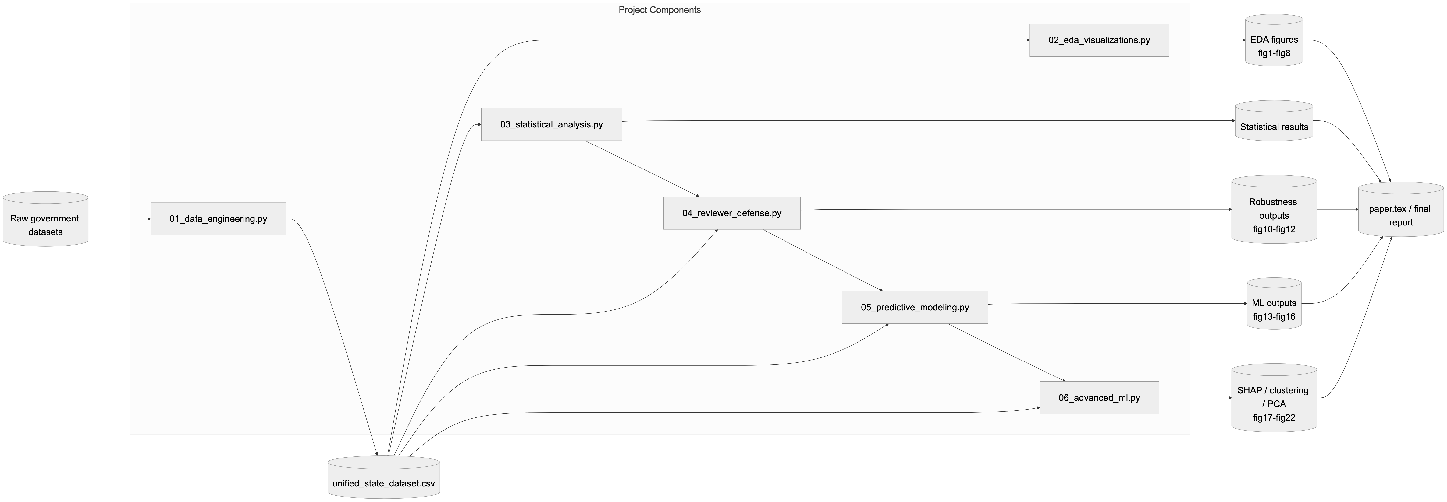
Figure 3.1 High-level system architecture of the research pipeline — ingestion, feature construction, statistical analysis, machine learning, and reporting layers.
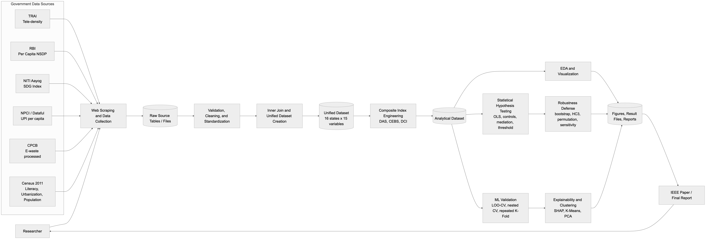
Figure 3.2 Data flow diagram across the seven government data sources feeding the unified 16-state dataset.
Component interactions:
- Each script reads from /data/ and writes to /results/ or /figures/ only — no in-memory state crosses script boundaries.
- Every figure has a matching .txt or .csv results file so numbers in the paper can be traced back to the exact run.
- A fixed random seed (42) is used wherever stochastic resampling is involved (bootstrap, permutation).

3.1.4 Outcome of Objectives / Result Analysis
Descriptive Statistics.
Table 3.3 summarises DAS, CEBS, and DCI for the 16 states retained in the final dataset.
Statistic | DAS | CEBS | DCI
Mean | 64.95 | 46.98 | 32.52
Std. Dev. | 19.69 | 13.90 | 17.40
Min | 30.27 | 27.23 | 8.24
Max | 94.40 | 87.30 | 72.97
Median | 67.02 | 47.78 | 32.42

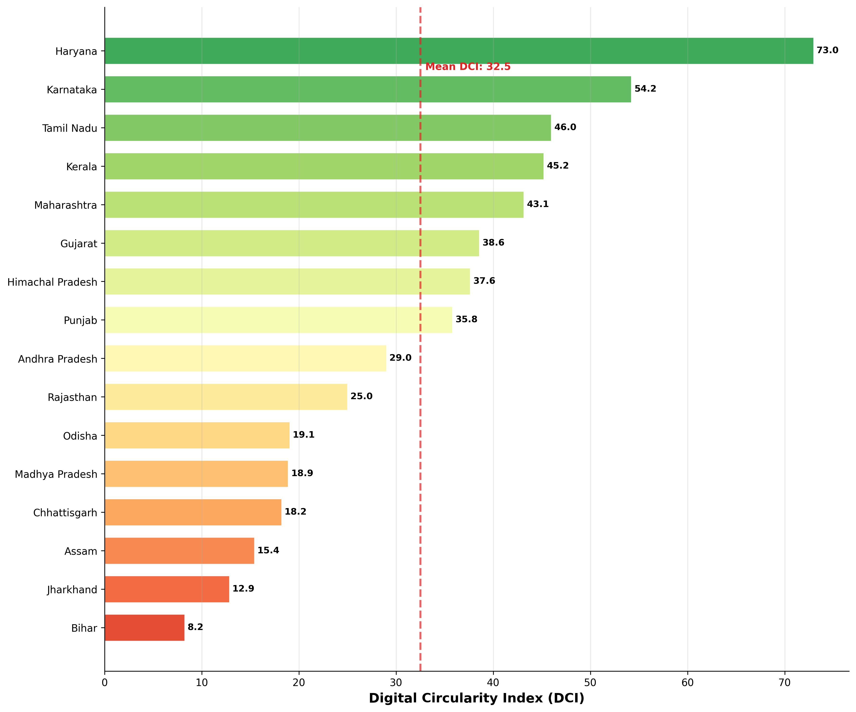
Figure 3.3 DCI ranking across 16 Indian states. Haryana leads (72.97), Bihar lags (8.24).
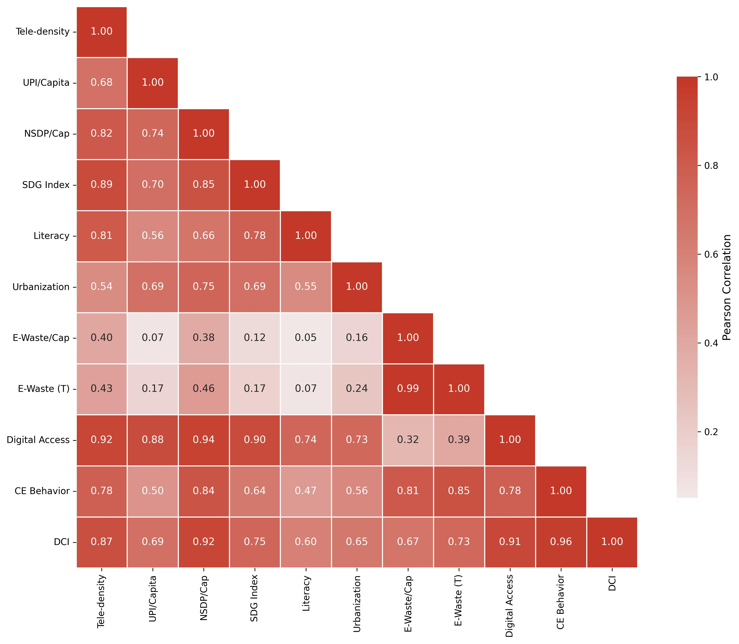
Figure 2.1 Correlation heatmap of all numeric variables. Darker colors indicate stronger correlations.
Primary OLS Result (H1).
The fitted model is: CEBS = 11.158 + 0.551 · DAS. A one-point increase in DAS is associated with ~0.55 points on CEBS, and the model explains 61% of the variance.
Metric | Value
R² | 0.610
Adjusted R² | 0.583
β₁ (slope) | 0.551
SE(β₁) | 0.118
t-statistic | 4.684
p-value | 0.000352
F-statistic | 21.94
95% CI for β₁ | [0.299, 0.804]
Pearson r | 0.781

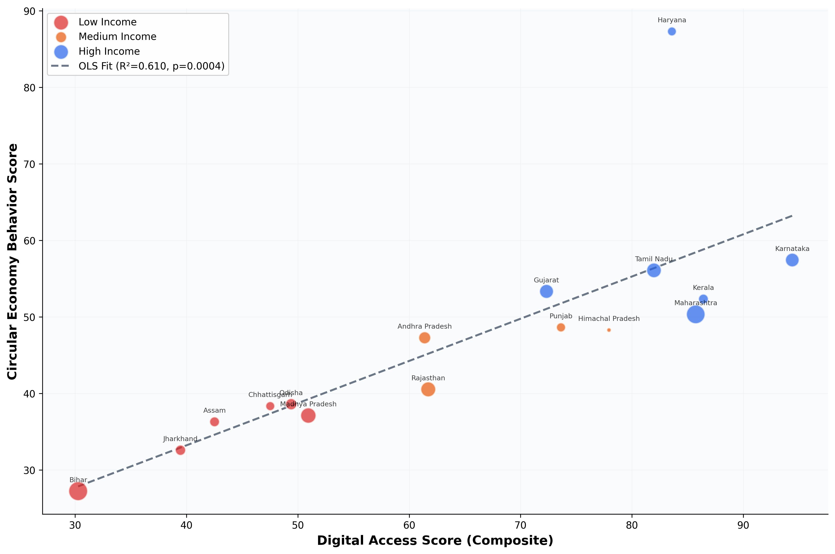
Figure 3.4 Digital Access Score vs. CE Behavior Score (r = 0.781, p < 0.001).
Robustness Diagnostics.
Test | Value | Result
Spearman ρ | 0.912 | p < 0.001
Kendall τ | 0.783 | p < 0.001
Shapiro-Wilk | Skew = 2.72 | Non-normal
Breusch-Pagan LM | 1.539 | p = 0.215
Durbin-Watson | 2.025 | No autocorrelation
Cook's distance | Dₘₐₓ = 4.16 (Haryana) | 1 influential point
Permutation p | 0.0001 | Significant
HC3 robust p | 1.1 × 10⁻⁵ | Significant
Bootstrap CI (r) | [0.648, 0.979] | Excludes 0
Bootstrap CI (β₁) | [0.395, 0.836] | Excludes 0

Discussion.
The evidence for H1 is strong and method-robust. A five-control specification lifts R² to 0.763 but triggers multicollinearity (VIF 10.57 for DAS, 9.47 for NSDP), so the bivariate model remains the cleaner headline test.

3.1.5 Sprint Retrospective
Category | Notes
What went well | Inner-join strategy produced 100% clean data with zero imputation. EDA figures directly exposed the DAS-CEBS pattern and justified H1. Robustness battery (HC3, permutation, bootstrap) ran end-to-end in one sprint.
What didn't go well | Residual non-normality (Shapiro skew = 2.72) and Haryana's Cook's D = 4.16 required extra defensive analysis. Piecewise regression was unstable above the breakpoint because only 2–3 states sit there.
What we learned | Reporting non-parametric rank tests alongside OLS pre-empts reviewer objections. Documenting weight choices is as important as documenting the model itself.
Action items for Sprint II | (1) Use nested LOO-CV for all ML so hyperparameter tuning is not biased; (2) Report SHAP globally and per-state; (3) Prefer models that degrade gracefully at n = 16 (linear families, RF, XGBoost).

3.2 Sprint II — Machine Learning, Explainability & Clustering
Sprint Duration: 22 February 2026 – 15 March 2026 (3 weeks)
Sprint Goal: Confirm the OLS signal using out-of-sample ML, quantify feature importance using SHAP, and uncover state typologies through K-Means clustering.

3.2.1 Objectives with User Stories of Sprint II
Story ID | User Story | Acceptance / Outcome
S2-US1 | As a researcher, I want 7 ML baselines under LOO-CV so I can compare predictive validity. | Full-model Lasso R² = 0.568; digital-only ElasticNet R² = 0.364.
S2-US2 | As a researcher, I want leak-free nested LOO-CV for XGBoost. | XGBoost R² = 0.511, p = 0.002.
S2-US3 | As a researcher, I want stability across 400 splits (100×4 KFold). | RF median R² = 0.603.
S2-US4 | As a researcher, I want SHAP global and per-state explanations. | Tele-density ranked #1 (mean |φ| = 5.01); NSDP #2 (4.88).
S2-US5 | As a policy analyst, I want data-driven state clusters. | K-Means (k=2, silhouette-selected) separates Digital Leaders (DCI 46.7) from Emerging States (DCI 18.3).

3.2.2 Functional Document
Scope.
Sprint II consumes the verified dataset from Sprint I and produces out-of-sample validation, explainability artifacts, and state typologies. It is built around three modules: a cross-validation harness, a SHAP explainer, and a K-Means + PCA clustering engine.
Functional Requirements.
- FR9: LOO-CV harness comparing 7 regressors on both digital-only and full feature sets.
- FR10: Nested LOO-CV wrapper (outer LOO, inner 4-fold GridSearch) to remove hyperparameter optimism for XGBoost.
- FR11: Repeated K-Fold CV (100×4 = 400 splits) for stability assessment.
- FR12: SHAP beeswarm, bar, and waterfall plots for all 16 states.
- FR13: K-Means clustering with silhouette selection of k, PCA biplot for visualisation, and cluster profile table.
Models Evaluated.
- Linear Regression, Ridge, Lasso, ElasticNet (linear family)
- SVR with RBF kernel (non-linear baseline)
- Random Forest, Gradient Boosting, XGBoost (tree ensembles)
Key Formulas.
R²(LOO) = 1 − Σᵢ (yᵢ − ŷ₋ᵢ)² / Σᵢ (yᵢ − ȳ)²
f(x) = φ₀ + Σⱼ φⱼ(x) (SHAP additive explanation)

3.2.3 Architecture Document
Sprint II is a three-module architecture sitting on top of the Sprint I dataset:
Module | Responsibility | Implementation / Output
Module A — CV Harness | Scikit-learn Pipeline + LeaveOneOut / GridSearchCV for leak-free tuning; writes per-model R², RMSE, and Pearson r. | 05_predictive_modeling.py, 06_advanced_ml.py → /results/
Module B — SHAP Explainer | shap.Explainer on the tuned XGBoost; generates beeswarm, bar, and waterfall plots for all 16 states. | 06_advanced_ml.py → /figures/fig17-19
Module C — Clustering Engine | StandardScaler + KMeans with silhouette scan over k ∈ {2…6}; PCA(2) biplot. | 06_advanced_ml.py → /figures/fig20-21

3.2.4 Outcome of Objectives / Result Analysis
LOO-CV Results (7 models).
Model | Digital-Only R² | Digital-Only r | Full R² | Full r
ElasticNet | 0.364 | 0.603 | 0.534 | 0.731
Lasso | 0.347 | 0.606 | 0.568 | 0.758
Ridge | 0.338 | 0.597 | 0.536 | 0.743
Random Forest | 0.326 | 0.575 | 0.490 | 0.703
Linear Reg. | 0.301 | 0.585 | 0.442 | 0.713
SVR (RBF) | 0.286 | 0.554 | 0.425 | 0.700
Gradient Boost | 0.161 | 0.542 | 0.445 | 0.687

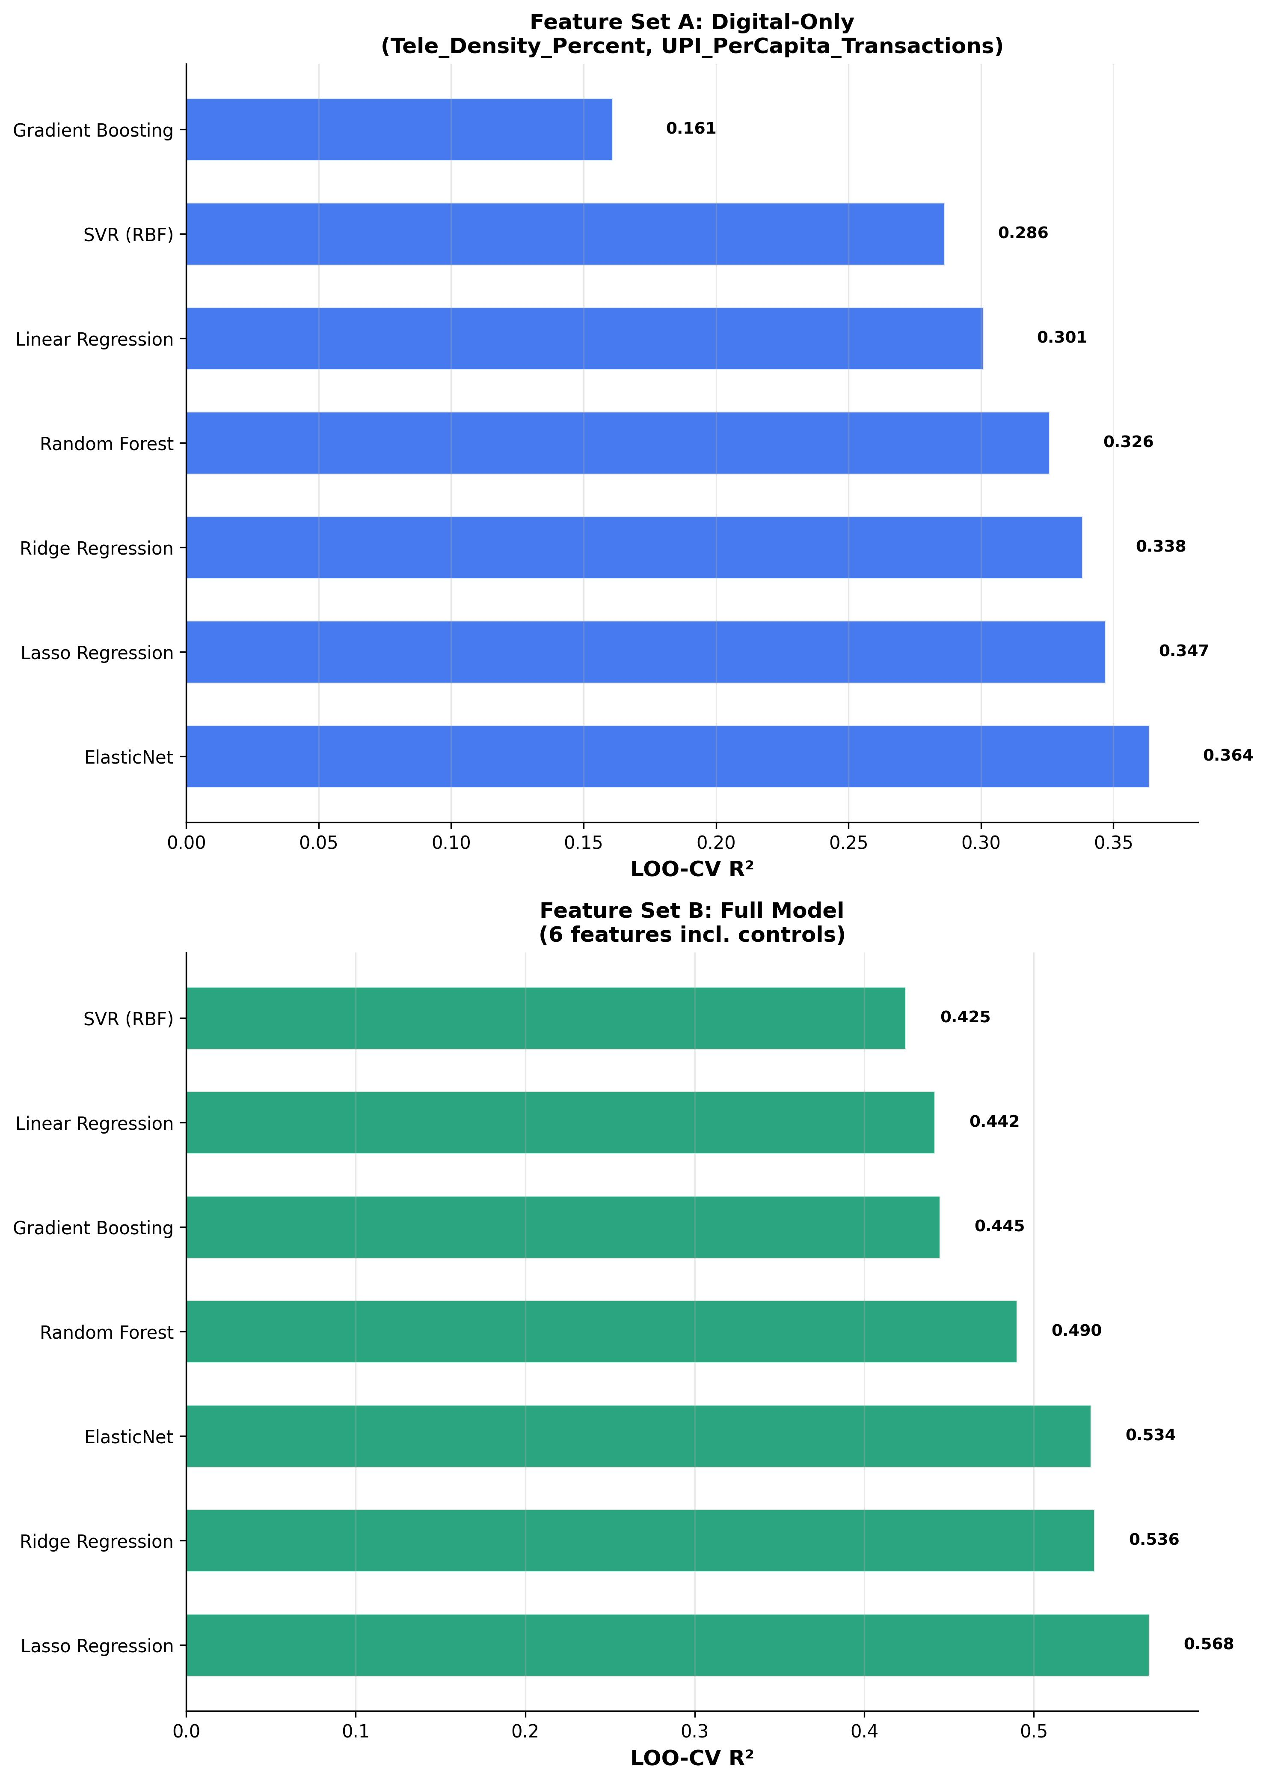
Figure 3.8 ML model comparison — LOO-CV R² across digital-only and full feature sets.
Nested LOO-CV (Leak-Free).
Model | Nested R² | RMSE | r
XGBoost | 0.511 | 9.41 | 0.721
Random Forest | 0.504 | 9.48 | 0.711
ElasticNet | 0.471 | 9.78 | 0.723
Ridge | 0.445 | 10.03 | 0.714
Lasso | 0.443 | 10.05 | 0.713
SVR | −0.023 | 13.61 | −0.593

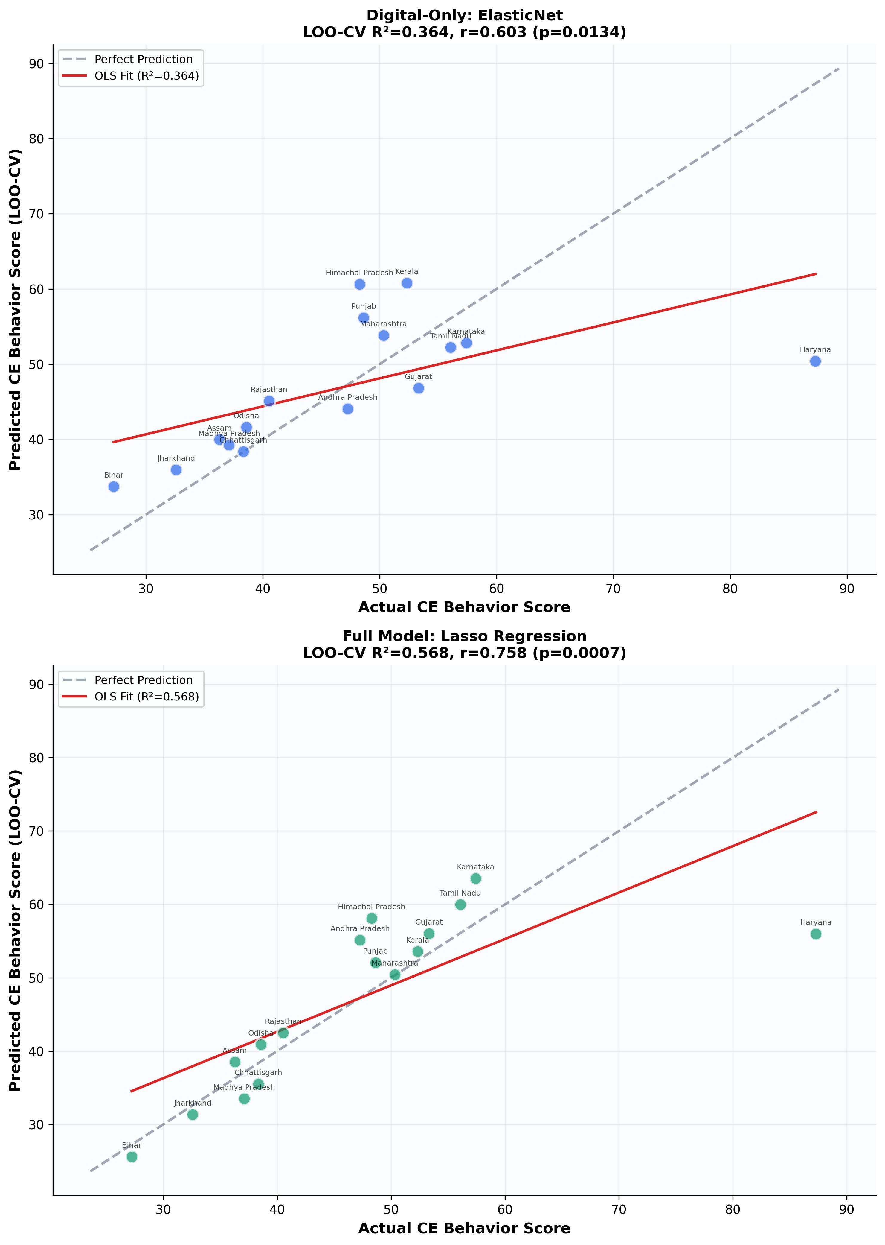
Figure 3.9 Actual vs. predicted CEBS — best nested-CV model.
SHAP Global Feature Importance.
Rank | Feature | Mean |φ|
1 | Tele-density (%) | 5.012
2 | Per Capita NSDP | 4.883
3 | Population (Mn) | 1.714
4 | Urban (%) | 1.677
5 | Literacy Rate (%) | 0.998
6 | UPI per capita | 0.914

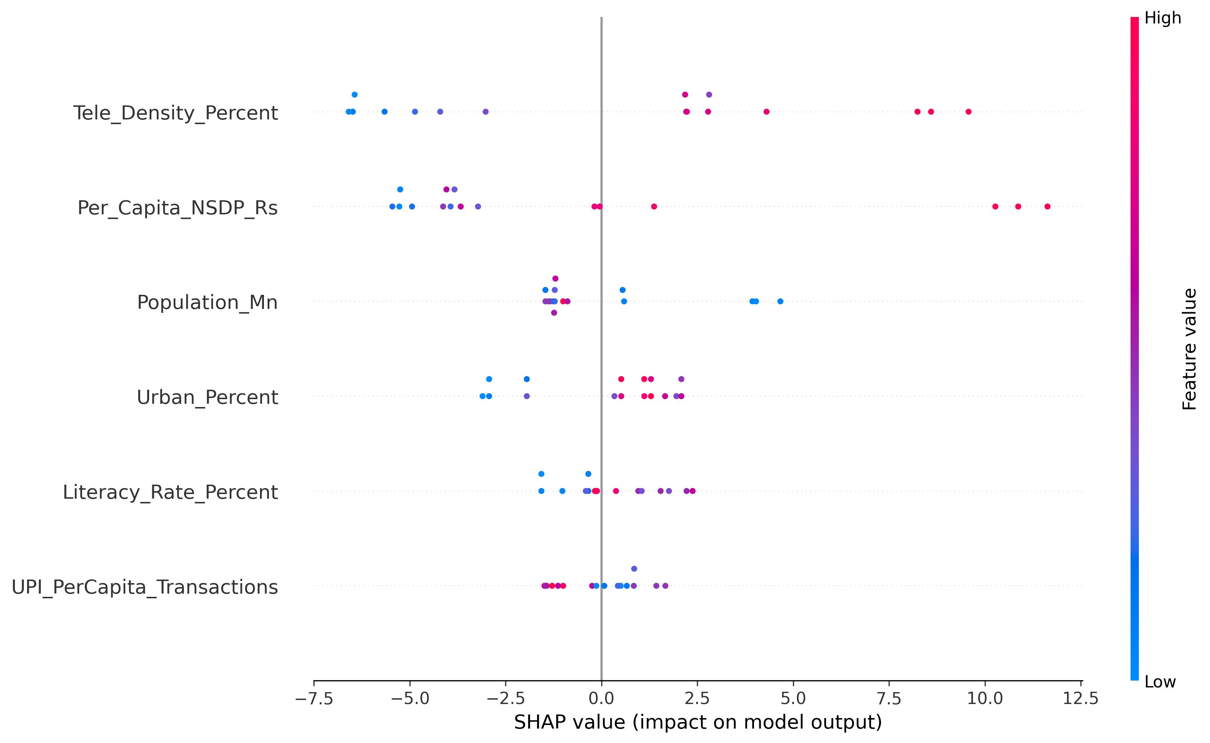
Figure 3.10 SHAP beeswarm plot — each dot is one state-feature pair; red = high value, blue = low value.
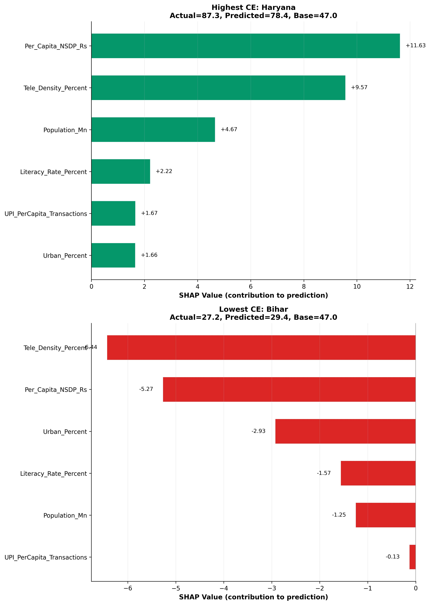
Figure 3.11 SHAP waterfall explanations for Haryana (highest CE) and Bihar (lowest CE).
K-Means Clustering (State Typologies).
Cluster | n | DAS | CEBS | DCI
Digital Leaders | 8 | 82.0 | 56.7 | 46.7
Emerging States | 8 | 47.9 | 37.2 | 18.3
Gap | — | 34.1 | 19.5 | 28.4

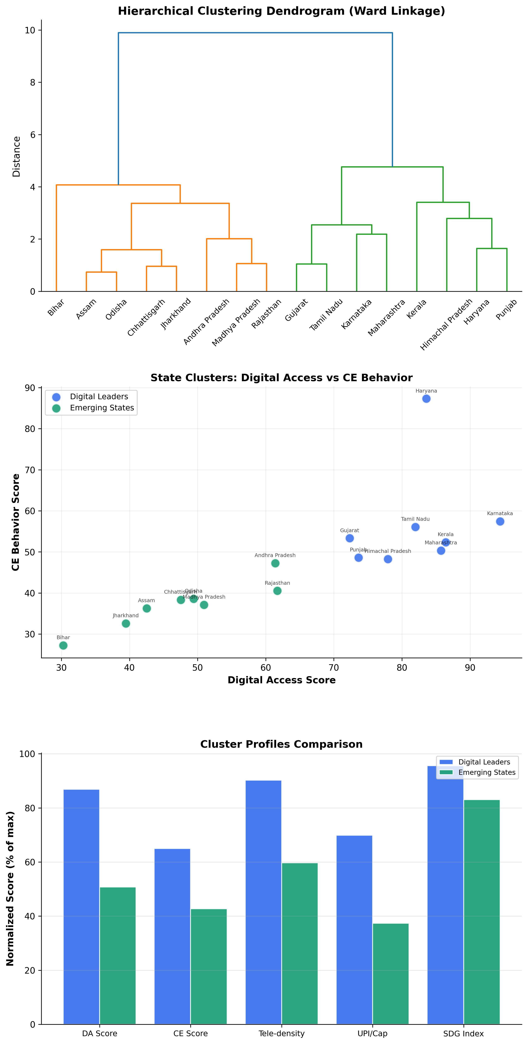
Figure 3.12 K-Means clustering with hierarchical dendrogram and cluster radar profiles. Two distinct state typologies emerge.

3.2.5 Sprint Retrospective
Category | Notes
What went well | Nested LOO-CV delivered a defensible R² = 0.511 on XGBoost. SHAP results agreed qualitatively with OLS coefficients — tele-density and NSDP as the top drivers. K-Means k = 2 separated states with a 2.5× DCI gap, which translated cleanly into the policy section.
What didn't go well | SVR under nested CV fell below the mean-prediction baseline (R² = −0.023), highlighting the hazard of non-linear kernels at n = 16. UPI's importance ranked last in SHAP, contradicting an early assumption.
What we learned | At n = 16, regularised linear models and tree ensembles are the only safe choices. Methods should be selected to fail visibly rather than silently. SHAP makes small-sample results interpretable enough for policy audiences.
Action items | (1) Extend validation to 21-state sample by dropping e-waste from CEBS; (2) Report both RF and XGBoost to show that the signal is not a single-model artifact; (3) Add PCA biplot to give reviewers a geometric view of the clustering.

CHAPTER 6 — RESULTS AND DISCUSSIONS

6.1 Project Outcomes (Performance Evaluation, Comparisons, Testing Results)
Integrated performance view.
Combining Sprints I and II, the study produces a multi-method, cross-validated view of the digital-access / CE-behavior relationship. The OLS model gives r = 0.781, R² = 0.610, while leak-free nested-CV XGBoost reaches R² = 0.511 — the usual in-sample-vs-out-of-sample gap. Table 6 below is the single-glance scorecard used to defend the work.
Evaluation Track | Best Metric | Value | Verdict
Parametric (OLS, bivariate) | R² | 0.610 | Supports H1
Parametric (OLS, +5 controls) | R² | 0.763 | High but multicollinear
Non-parametric (Spearman ρ) | ρ | 0.912 | Supports H1
Bootstrap (10,000 resamples) | 95% CI for r | [0.648, 0.979] | Excludes 0
Permutation test | p | 0.0001 | Significant
HC3 robust SE | p | 1.1 × 10⁻⁵ | Significant
LOO-CV (7 models) | Full-model R² (Lasso) | 0.568 | Confirms out-of-sample
Nested LOO-CV | XGBoost R² | 0.511 | Leak-free, p = 0.002
Repeated K-Fold (400 splits) | RF median R² | 0.603 | Stable
Extended sample (n = 21) | OLS R² | 0.927 | Signal strengthens
K-Means clustering | DCI gap | 46.7 vs 18.3 (2.5×) | Two typologies
SHAP global importance | Top feature | Tele-density (5.01) | Drives H1

Mediation Analysis (H2).
Table 6.1 reports the Baron & Kenny / Sobel mediation results. The evidence does not support UPI mediation: the Sobel test is not significant, and the direct effect remains significant after controlling for UPI.
Path | β | p-value | Significant?
c (total): X → Y | 0.505 | 0.0004 | Yes
a: X → M | 1.499 | 0.003 | Yes
b: M → Y | X | −0.017 | 0.813 | No
c′ (direct): X → Y | M | 0.530 | 0.004 | Yes
Indirect (a × b) | −0.026 | — | —
Sobel z | −0.241 | 0.810 | No

Threshold Analysis (H3).
The piecewise regression estimates a tele-density breakpoint at 118.77%. Below it, the slope is steep and positive (β₁ = 0.635, p = 0.0001); above it, the slope flips negative (β₂ = −8.738, p = 0.047), but only 2–3 states sit above the breakpoint so we would not over-read the reversal. The piecewise model fits better than the linear one (R² = 0.723 vs. 0.610), giving qualified support for H3.
Segment | Slope (β) | p-value | Interpretation
Below 118.77% tele-density | 0.635 | 0.0001 | Strong positive effect
Above 118.77% tele-density | −8.738 | 0.047 | Reversal (only 2–3 states)
Full piecewise model | R² = 0.723 | — | Better than linear (0.610)

Robustness Visualisations.
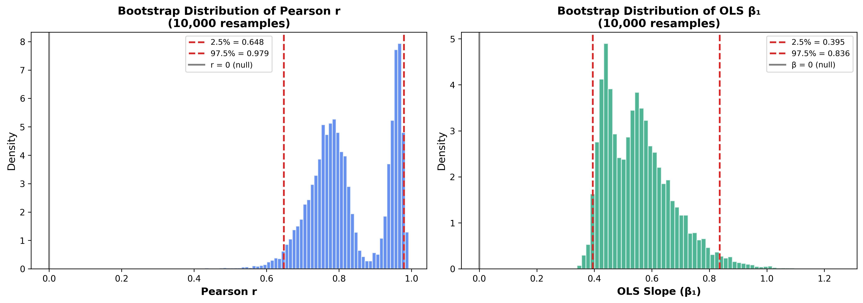
Figure 6.1 Bootstrap distribution of Pearson r (10,000 resamples). The 95% CI [0.648, 0.979] excludes zero.
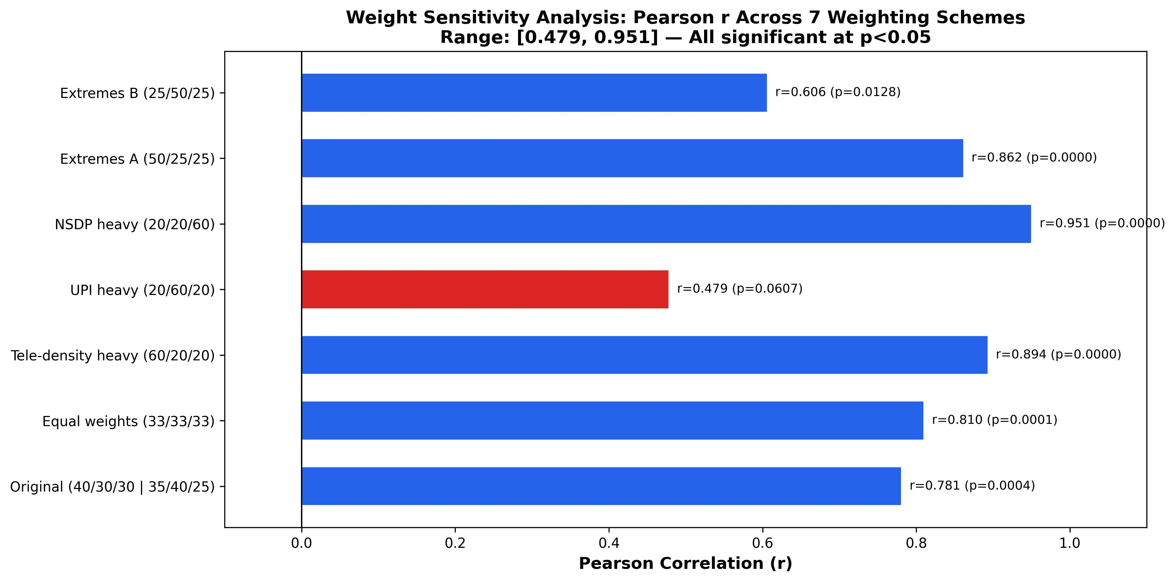
Figure 6.2 Weight sensitivity analysis across 7 alternative DAS weight schemes. Six of seven preserve a significant Pearson correlation.
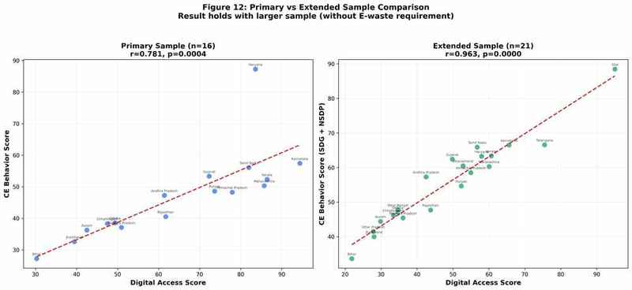
Figure 6.3 Extended sample validation (n = 21, e-waste removed from CEBS). r = 0.963, OLS R² = 0.927.
Discussion — do the methods agree?
Broadly, yes. OLS (61% variance explained), nested-CV XGBoost (51%), bootstrap, permutation, and HC3 all point the same direction. For a 16-state sample, that consistency is meaningful evidence against a simple overfitting story.
What drives the relationship?
Random Forest favors NSDP, SHAP favors tele-density, but both agree on the top two drivers. UPI is the unexpected result — smallest SHAP contribution and no mediation effect — suggesting that digital access acts less through payments alone than through broader infrastructure and institutional capacity.
Two Indias in CE performance.
Clustering reveals a sharp divide: one group is strong on both digital access and CE outcomes, the other weak on both. A DCI gap of 46.7 vs. 18.3 is not a mild gradient — it argues for differentiated policy playbooks.
Policy implications.
- Digital India and Swachh Bharat should be treated less as separate tracks and more as connected systems.
- Connectivity investment in lagging states should count as environmental capacity-building, not just telecom.
- Because UPI is not the mediating channel, digital inclusion policy should extend beyond payments to reporting systems, e-governance, and digital literacy.
- Digital Leaders can move toward advanced monitoring; Emerging States need basic infrastructure first — no single national playbook.
- SHAP highlights state-specific constraints, suggesting that uniform interventions will miss important differences.

CHAPTER 7 — CONCLUSION AND FUTURE ENHANCEMENT

7.1 Conclusion
This minor project finds a consistent state-level association between digital access and circular-economy behavior in India. Across the 16 states retained in the final dataset, the pattern remains visible under both statistical and machine-learning approaches: the primary OLS model gives r = 0.781 (p < 0.001, R² = 0.610), and the leak-free nested-CV XGBoost still reaches R² = 0.511. Tele-density emerges as a stronger driver than digital payments, and K-Means clustering reinforces the same message by separating states into two groups with a 2.5× DCI gap.
The three hypotheses land as follows: H1 is strongly supported; H2 (UPI mediation) is not supported; H3 receives qualified support with a tele-density breakpoint near 119%. Taken together, the results argue that digital inclusion and circular-economy policy should be treated as connected rather than separate agendas.

7.2 Limitations
- Small sample (n = 16) because only states with complete observations across all seven sources are retained. Haryana's Cook's D = 4.16 shows sensitivity to influential cases, though bootstrap CIs and the 21-state validation reduce concern.
- Cross-sectional design — the study supports association, not causation. Panel data would be needed for stronger causal claims.
- Measurement constraints — literacy and urbanisation still come from Census 2011; NSDP enters both DAS and CEBS; state averages compress within-state variation.
- Composite-index weights are researcher-chosen; while six of seven weight variants still yield a significant result, the choice is not data-driven.

7.3 Future Enhancement
- Move to panel data and district-level granularity to enable causal designs and capture within-state heterogeneity.
- Expand the CE index beyond e-waste to include plastic recovery, EPR compliance, material-circularity ratios, and formal recycling capacity.
- Introduce Bayesian hierarchical models suited for small-n, grouped data.
- Generalise the framework to other federal economies with comparable administrative data (e.g., Brazil, Indonesia).
- Build a live policy dashboard that updates DAS, CEBS, and DCI as new government releases arrive, with SHAP explanations per state.
- Extend explainability to causal SHAP variants and counterfactual policy simulation.

REFERENCES
[1] NPCI, "UPI Product Statistics (Monthly)," National Payments Corporation of India, Mumbai, 2025. Available: https://www.npci.org.in/what-we-do/upi/product-statistics
[2] TRAI, "Indian Telecom Services Performance Indicators Report: April-June 2024," Telecom Regulatory Authority of India, New Delhi, 2024.
[3] CPCB, "Annual Report on Implementation of E-Waste (Management) Rules, 2016 for FY 2021-22," Central Pollution Control Board, MoEF&CC, Government of India, 2023.
[4] NITI Aayog, "Circular Economy in India: Rethinking Growth for Long-Term Prosperity," Government of India, New Delhi, 2021.
[5] Ministry of Electronics & IT, "Digital India Programme: Progress and Initiatives," Government of India, 2023.
[6] M. Geissdoerfer, P. Savaget, N. M. Bocken, and E. J. Hultink, "The Circular Economy — A new sustainability paradigm?" Journal of Cleaner Production, vol. 143, pp. 757–768, 2017.
[7] Ellen MacArthur Foundation, "Towards the Circular Economy: Economic and Business Rationale for an Accelerated Transition," 2013.
[8] NITI Aayog, "SDG India Index & Dashboard 2023-24," 4th ed., National Institution for Transforming India, Government of India, 2024.
[9] C. Avgerou, "Discourses on ICT and development," Information Technologies and International Development, vol. 6, no. 3, pp. 1–18, 2010.
[10] R. Heeks, Information and Communication Technology for Development (ICT4D). Routledge, 2017.
[11] RBI, "Handbook of Statistics on Indian Economy 2024-25, Table 9: Per Capita Net State Domestic Product," Reserve Bank of India, Mumbai, 2025.
[12] Dataful Insights, "Here is How UPI Usage Differs Across Indian States," Factly Media & Research, Jan. 23, 2026.
[13] Census of India, "Primary Census Abstract: Literacy Rate, Level of Urbanization, Population," Office of the Registrar General & Census Commissioner, Ministry of Home Affairs, Government of India, 2011.
[14] R. M. Baron and D. A. Kenny, "The moderator-mediator variable distinction in social psychological research: Conceptual, strategic, and statistical considerations," Journal of Personality and Social Psychology, vol. 51, no. 6, pp. 1173–1182, 1986.
[15] S. M. Lundberg and S.-I. Lee, "A Unified Approach to Interpreting Model Predictions," in Advances in Neural Information Processing Systems (NeurIPS), vol. 30, 2017.
[16] T. Chen and C. Guestrin, "XGBoost: A Scalable Tree Boosting System," in Proc. 22nd ACM SIGKDD Conf. on Knowledge Discovery and Data Mining, 2016, pp. 785–794.
[17] L. Breiman, "Random Forests," Machine Learning, vol. 45, pp. 5–32, 2001.
[18] H. Zou and T. Hastie, "Regularization and variable selection via the elastic net," Journal of the Royal Statistical Society, Series B, vol. 67, no. 2, pp. 301–320, 2005.
[19] J. MacQueen, "Some methods for classification and analysis of multivariate observations," in Proc. 5th Berkeley Symp. on Mathematical Statistics and Probability, vol. 1, 1967, pp. 281–297.
[20] F. Pedregosa et al., "Scikit-learn: Machine Learning in Python," Journal of Machine Learning Research, vol. 12, pp. 2825–2830, 2011.

APPENDIX A - CODING
This appendix presents selected code screenshots from the seven numbered Python scripts used in the project implementation. Each script is represented by two screenshots showing representative portions of the source code rather than the complete file.
Appendix A.1 01_data_engineering.py
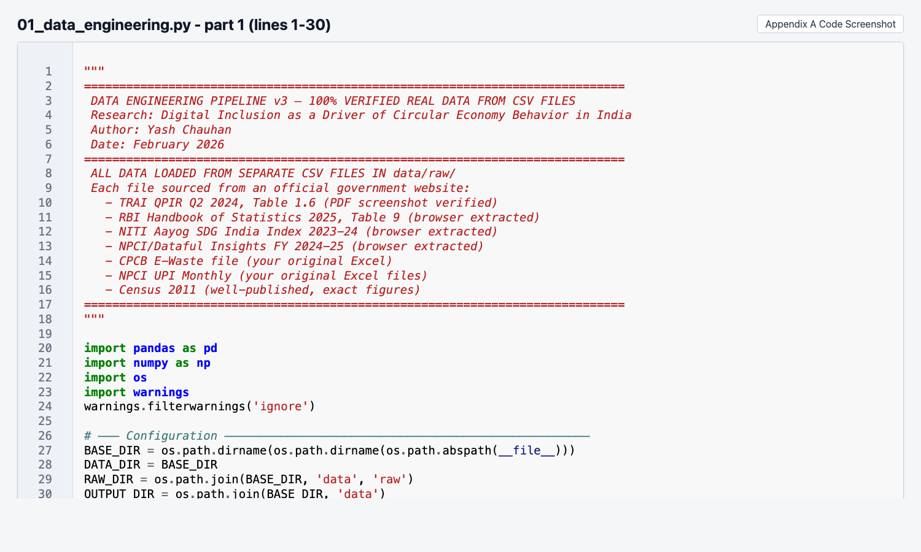
Figure A.1 Code screenshot of 01_data_engineering.py (part 1).
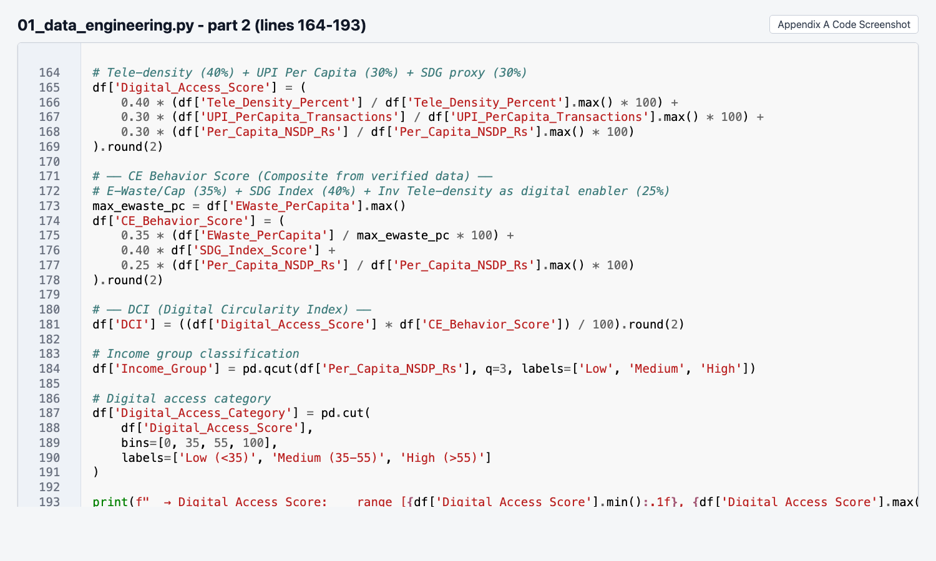
Figure A.2 Code screenshot of 01_data_engineering.py (part 2).

Appendix A.2 02_eda_visualizations.py
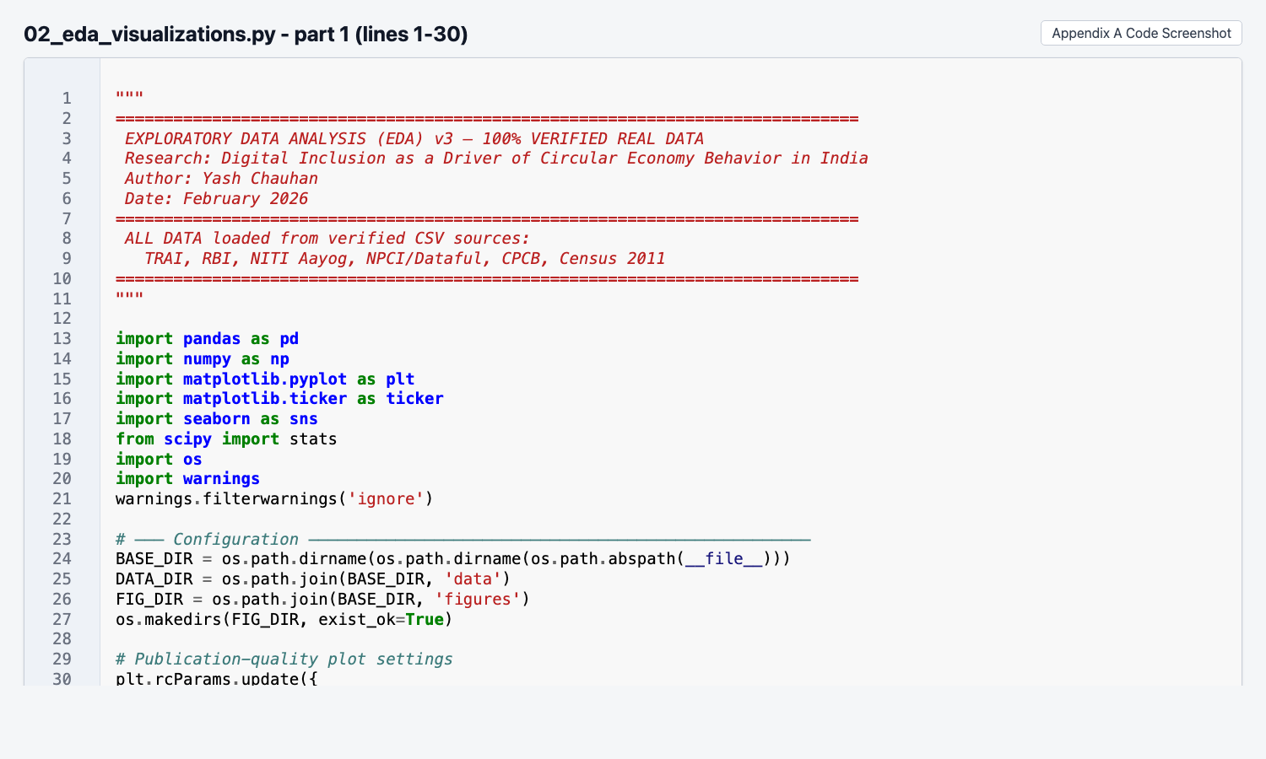
Figure A.3 Code screenshot of 02_eda_visualizations.py (part 1).
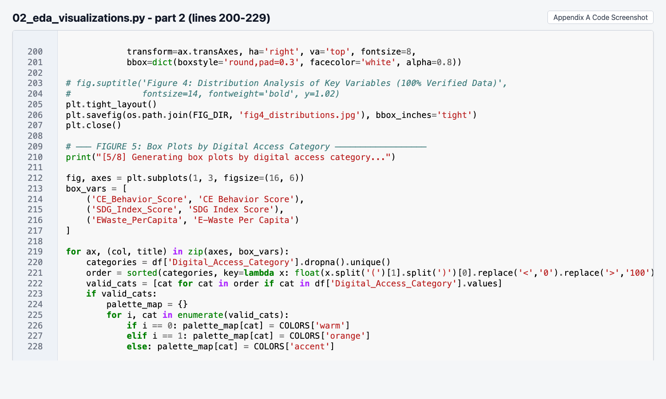
Figure A.4 Code screenshot of 02_eda_visualizations.py (part 2).

Appendix A.3 03_statistical_analysis.py
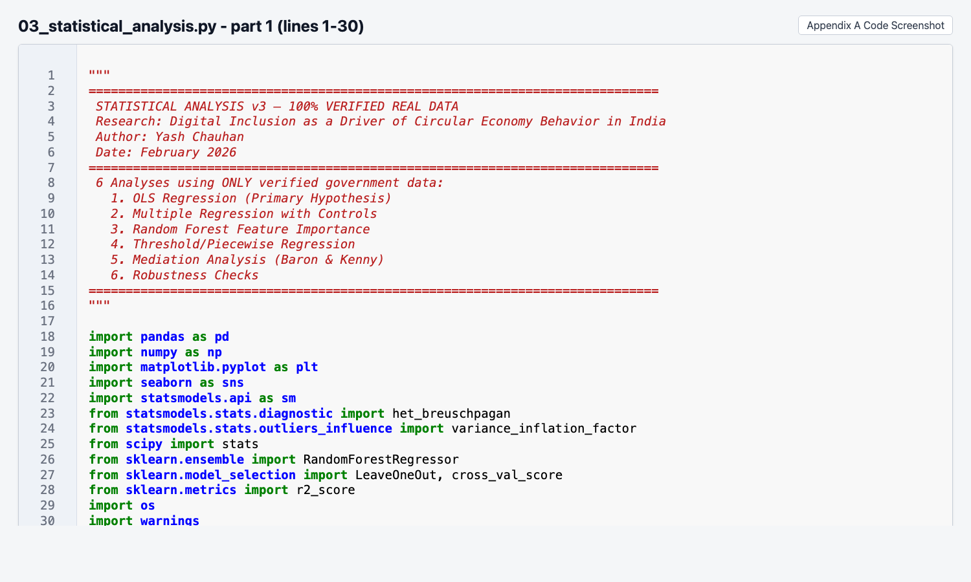
Figure A.5 Code screenshot of 03_statistical_analysis.py (part 1).
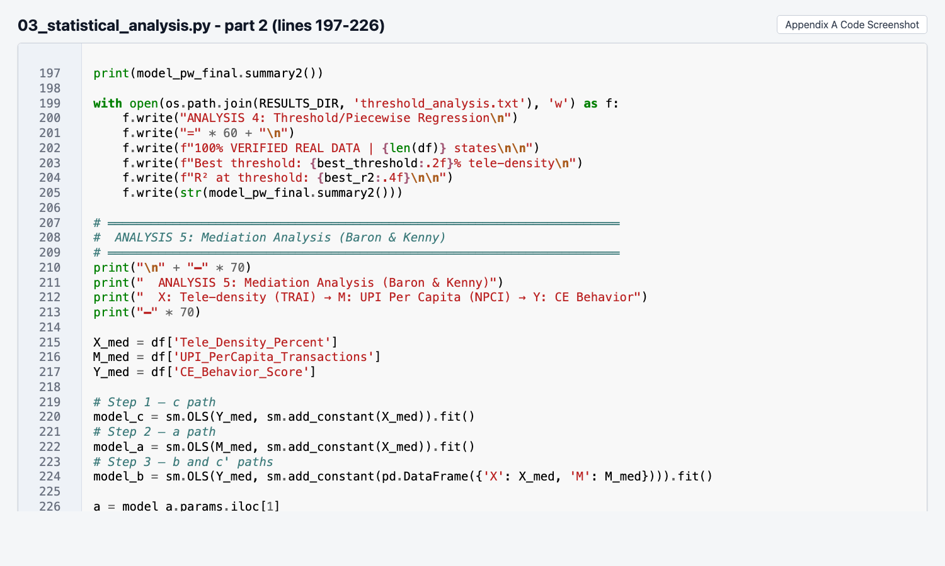
Figure A.6 Code screenshot of 03_statistical_analysis.py (part 2).

Appendix A.4 04_reviewer_defense.py
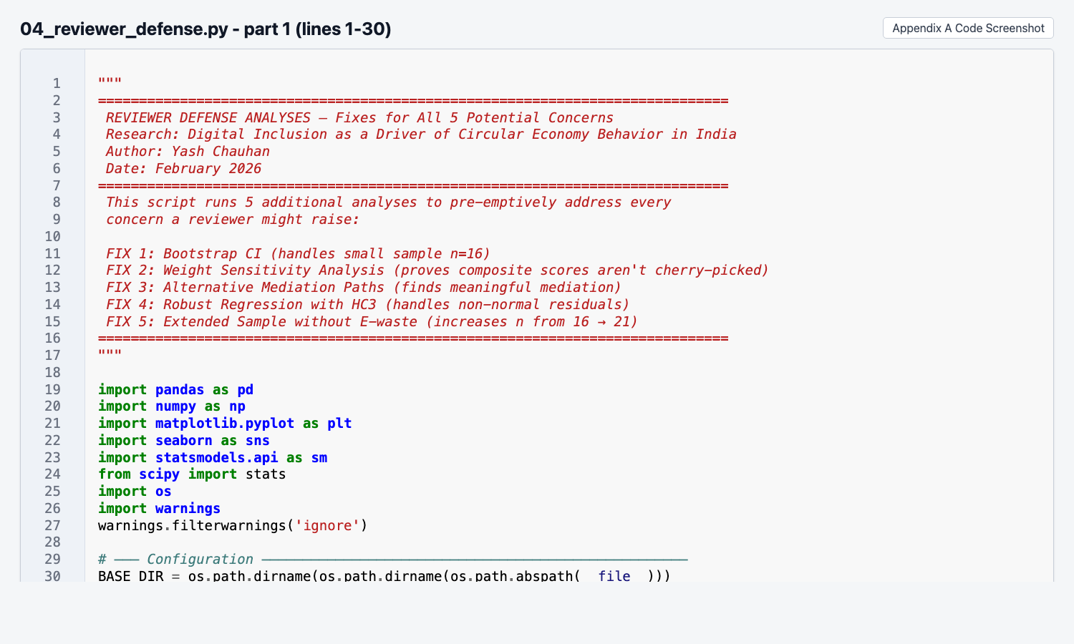
Figure A.7 Code screenshot of 04_reviewer_defense.py (part 1).
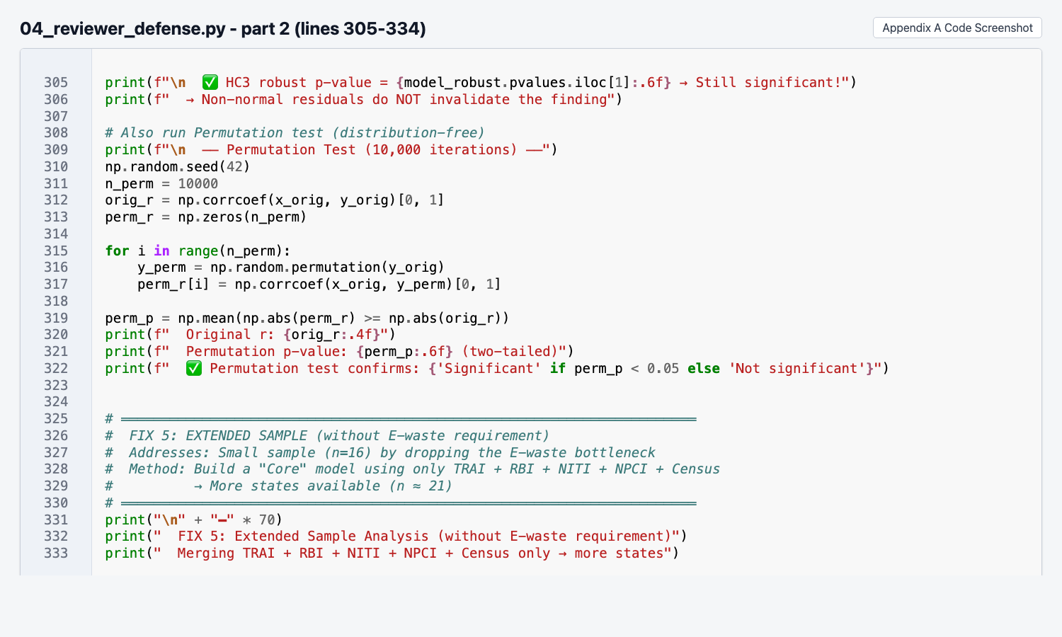
Figure A.8 Code screenshot of 04_reviewer_defense.py (part 2).

Appendix A.5 05_predictive_modeling.py
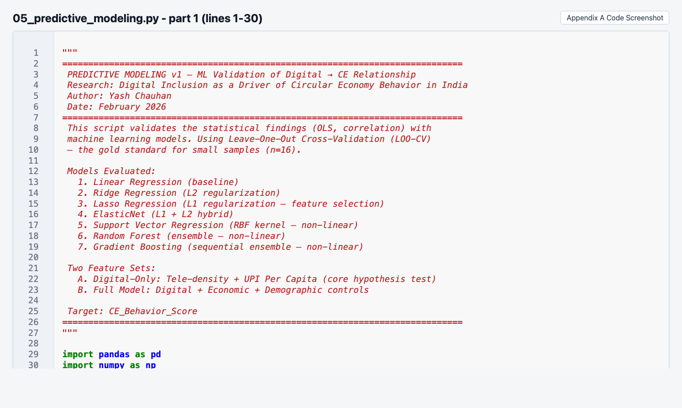
Figure A.9 Code screenshot of 05_predictive_modeling.py (part 1).
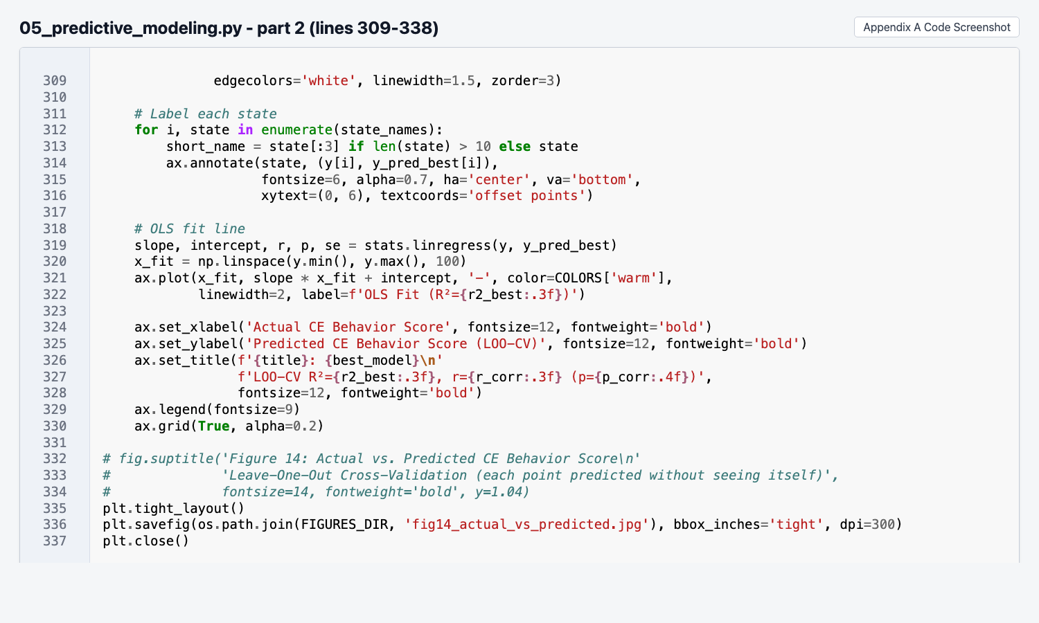
Figure A.10 Code screenshot of 05_predictive_modeling.py (part 2).

Appendix A.6 06_advanced_ml.py
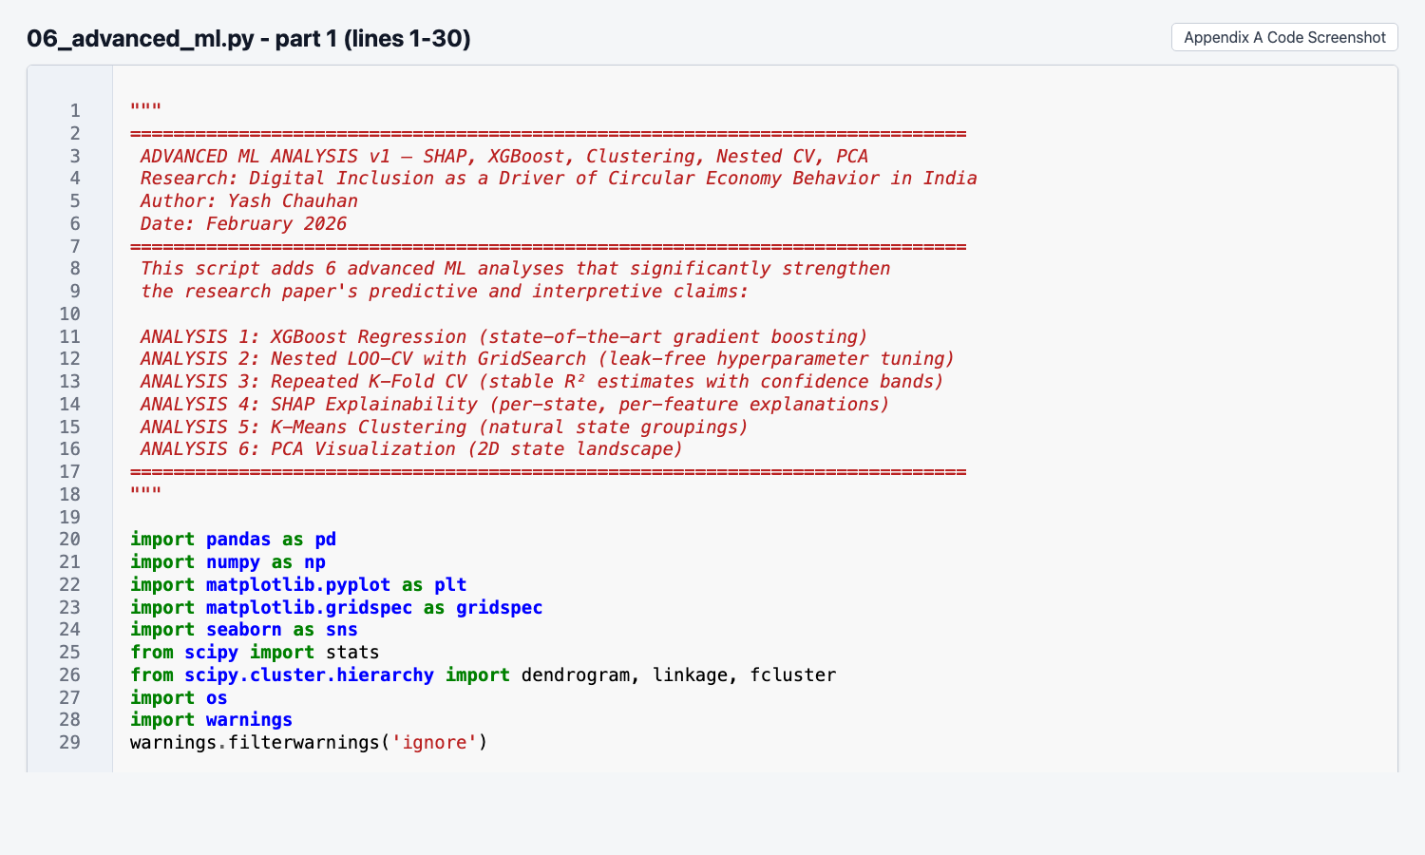
Figure A.11 Code screenshot of 06_advanced_ml.py (part 1).
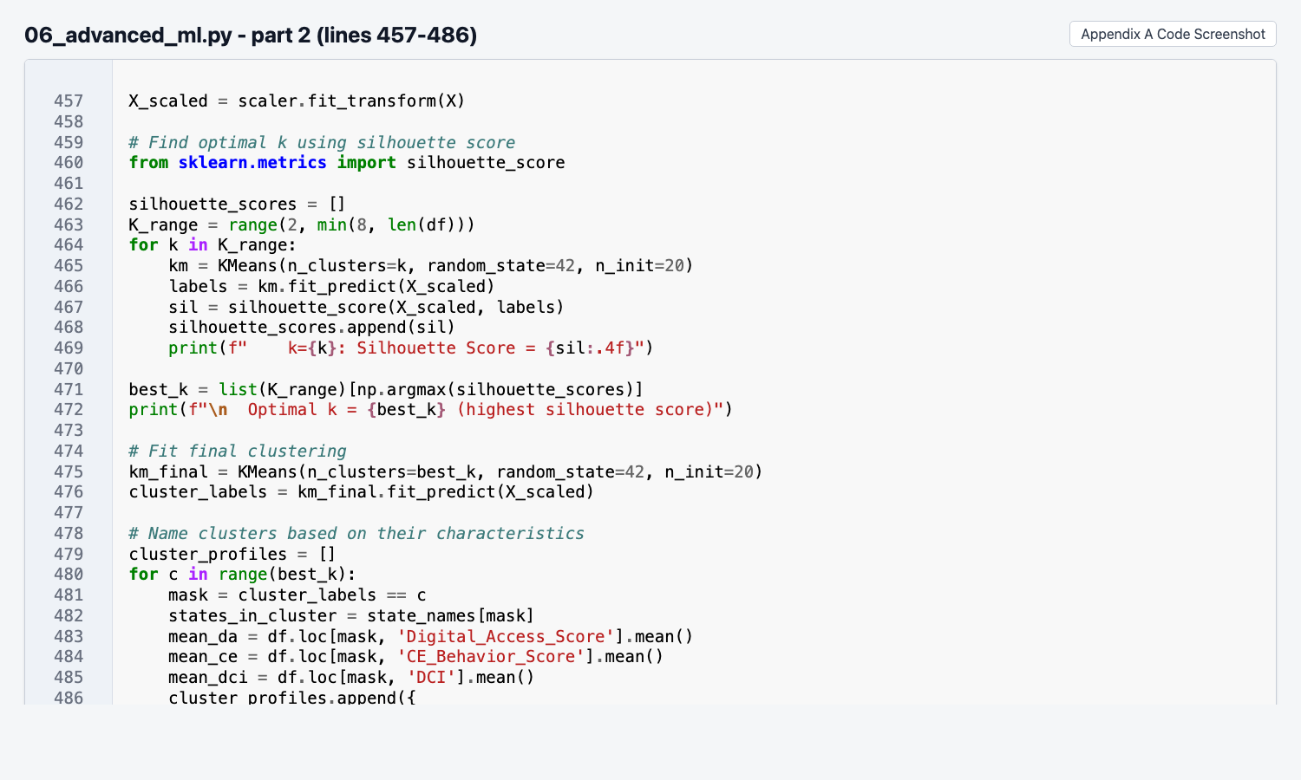
Figure A.12 Code screenshot of 06_advanced_ml.py (part 2).

Appendix A.7 07_generate_project_management_report.py
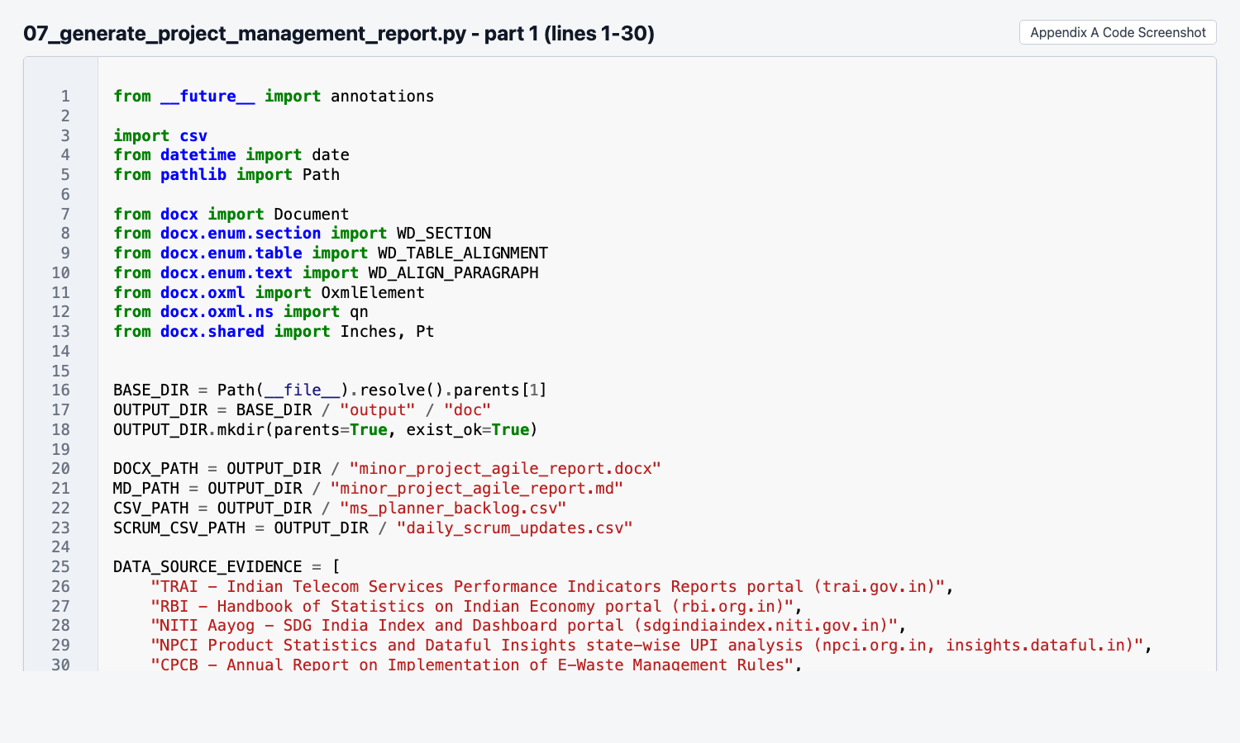
Figure A.13 Code screenshot of 07_generate_project_management_report.py (part 1).
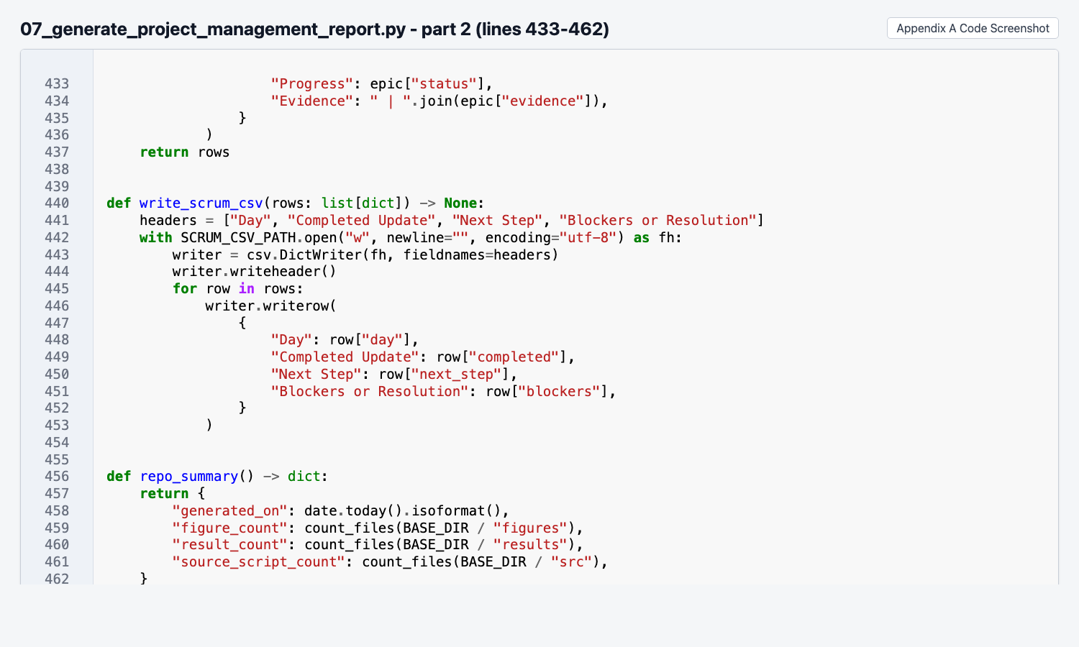
Figure A.14 Code screenshot of 07_generate_project_management_report.py (part 2).

