Digital Inclusion and Circular Economy Behavior in
Indian States: A Digital Circularity Index and
Explainable XGBoost Analysis
Suresh Kumar Chelliah, Shreya Srivastava, Yash Chauhan
Dept. of Computational Intelligence
SRM Institute of Science and Technology
Kattankulathur, Tamil Nadu 603203, India
sureshkc@srmist.edu.in, ss1371@srmist.edu.in, yc0810@srmist.edu.in
Abstract
India is expanding its digital infrastructure while also trying to build a more circular economy, but the relationship between these two policy agendas has not been tested at the state level. This study uses seven official public data sources to build a composite measure of digital access and circular economy performance for 16 Indian states. Regression analysis, leak-free predictive validation, feature attribution, and clustering all point to the same result: states with stronger digital access tend to perform better on circular economy outcomes. The relationship remains robust across multiple checks, telecommunications connectivity appears more influential than digital payments, and the gap between digitally advanced and lagging states is substantial. These findings suggest that digital inclusion and sustainability policy should be treated as linked rather than separate agendas.
Circular economy, digital circularity index (DCI), digital inclusion, extreme gradient boosting (XGBoost), Shapley additive explanations (SHAP)

Introduction
Since 2015, India has been running what amounts to a massive experiment in digital transformation. The Digital India programme rolled out broadband targets, mobile connectivity, and the Unified Payments Interface (UPI) across a country of 1.4 billion people. By most yardsticks, it has worked: monthly UPI transactions crossed the 14-billion mark in recent months , and tele-density now exceeds 85% at the national level . At the same time, India faces an environmental problem it cannot afford to ignore. The country generates roughly 62 million tonnes of waste each year and ranks among the world’s top three e-waste producers . To tackle this, NITI Aayog laid out a circular economy (CE) strategy covering 11 priority sectors , and the UN SDG commitments hang over every state government.
Here is the question that nobody seems to ask: do these two agendas talk to each other? The scholarly literature on Digital India is almost entirely about economics—GDP growth, job creation, financial inclusion . CE research, for its part, stays within the bounds of waste management technology and EPR policy . There is surprisingly little work connecting the digital story to the environmental one, especially at the state level, where policy actually gets implemented. If a state with better telecom infrastructure also recycles more e-waste or scores higher on the SDG index, that would be worth knowing—not as a curiosity, but because it would give policymakers a reason to treat connectivity and sustainability as a single investment rather than two competing budget items.

What This Paper Does
This paper tries to fill that gap. We built a composite Digital Circularity Index (DCI) using data from seven government sources across 16 states and then threw a battery of methods at it: OLS regression, non-parametric tests, bootstrap resampling, seven ML models under Leave-One-Out CV, an XGBoost model with nested CV to prevent any data leakage, SHAP for feature-level explanations, and K-Means clustering to identify state groupings. Every data point traces back to an official publication—TRAI, RBI, NITI Aayog, NPCI, CPCB, or Census records—with no interpolation or estimation involved.
Four things came out of this that we think are new. First, the DCI itself: to our knowledge, no prior index jointly captures digital access and CE behavior at the sub-national level in India. Second, the multi-method setup: using both parametric and non-parametric statistics alongside ML gives a more honest picture than choosing one approach and hoping it generalises. Third, the data discipline: with only 16 states surviving the inner join across all seven sources, there was a strong temptation to fill in missing values—we chose not to. Fourth, the policy specificity: SHAP waterfall plots and K-Means clusters offer state-by-state recommendations rather than one-size-fits-all conclusions.

Research Questions and Hypotheses
The central question is straightforward: does digital inclusion predict circular economy performance across Indian states? We formalised this into three testable hypotheses:
- H1: States with higher Digital Access Scores will also have higher CE Behavior Scores.
- H2: UPI adoption mediates this relationship—i.e., digital payments are the channel through which digital access affects CE behavior.
- H3: There is a tele-density threshold beyond which CE behavior improves sharply.
The rest of the paper follows a standard structure. Section II reviews the literature and spells out the research gap. Section III describes our data, index construction, and analytical methods. Section IV reports the results. Section V discusses what the numbers mean for policy and flags the limitations. Section VI wraps up.

Literature Survey

Digital Inclusion in India
The numbers tell the broad story quickly. Between 2015 and 2024, India pushed tele-density from about 75% to above 85% nationwide, with some urban pockets blowing past 130% . UPI went from a pilot in 2016 to the largest real-time payment system anywhere on the planet . Impressive—until you pull apart the averages. Bihar sits at a tele-density of 55.80%. Kerala is above 120%. That gap is not a footnote; it is the whole story for anyone trying to understand whether “digital India” actually means the same thing in Patna as it does in Kochi.
What struck us in reviewing this body of work is where the attention goes. Papers on digital inclusion almost always land on economic outcomes: GDP growth tied to broadband rollout , or financial inclusion measured by UPI adoption. That makes sense—those are the metrics the programme was designed around. But it also creates a blind spot. Whether any of this connectivity has done anything for waste management, recycling, or broader sustainability goals is a question that very few researchers have bothered to ask.

Circular Economy in India
The circular economy idea entered the academic mainstream through the Ellen MacArthur Foundation’s 2013 report , and Geissdoerfer et al. did the useful work of separating it from the older, vaguer notion of “sustainability.” In India specifically, NITI Aayog published a strategy document covering 11 sectors . On paper, the ambition is there. In practice, the country produces about 1.71 million tonnes of e-waste per year, and the share that actually goes through formal recycling channels is small . SDG Index scores tell a similar story of patchwork progress: they range from 57 to 79 depending on the state . Some states are making real headway. Others are not.

Where Digital and CE Research Miss Each Other
Avgerou made a point that stuck with us: ICTs do not just affect one thing. They create network effects that cut across governance, markets, and social norms all at once. Heeks pushed this further, arguing that digital infrastructure changes habits, speeds up information flow, and improves how institutions work—and these effects build on each other rather than cancelling out. If that framework holds, then digital access should influence CE behavior through several channels simultaneously, not just through one tidy mechanism. We come back to this in Section V when interpreting the mediation results.
The odd thing is that, despite how much has been written about Digital India on one hand and the circular economy on the other, almost nobody has put the two together—at least not with data, and certainly not at the state level where Indian policy is actually made. That is the gap we are working in.

Methodology

Research Design
The research design is cross-sectional, covering 16 Indian states for which complete, verified data was available across all seven government sources. An inner-join strategy retains only states with verified data across every source, prioritizing data integrity over sample size.

Data Sources
Table 1 summarizes the seven official data sources used.
Data Sources and Variables
Source | Variable | Year
TRAI | Tele-density (%) | 2024
RBI | Per Capita NSDP (INR) | 2023–24
NITI Aayog | SDG Index Score | 2023–24
NPCI/Dataful | UPI Per Capita Txns | 2024–25
CPCB | E-Waste Processed (T) | 2021–22
Census | Literacy Rate (%) | 2011
Census | Urban Population (%) | 2011
After joining, the dataset contains 16 states $×$ 15 variables (9 raw + 6 derived). The states are: Andhra Pradesh, Assam, Bihar, Chhattisgarh, Gujarat, Haryana, Himachal Pradesh, Jharkhand, Karnataka, Kerala, Madhya Pradesh, Maharashtra, Odisha, Punjab, Rajasthan, and Tamil Nadu.

Composite Index Construction

Min-Max Normalization
Each raw variable $x_{i}$ is normalized to a $[0,100]$ scale:
$${\hat{x}}_{i}=\frac{x_{i}−x_{min}}{x_{max}−x_{min}}×100$$

Digital Access Score (DAS)
DAS captures how digitally mature a state is:
$$DAS=0.40⋅{\hat{T}}_{d}+0.30⋅{\hat{U}}_{pc}+0.30⋅{\hat{N}}_{pc}$$
where ${\hat{T}}_{d}$ is normalized tele-density, ${\hat{U}}_{pc}$ is normalized UPI per capita transactions, and ${\hat{N}}_{pc}$ is normalized per capita NSDP. Tele-density receives the highest weight (40%) as the foundational measure of digital infrastructure.

CE Behavior Score (CEBS)
CEBS captures progress toward circular economy goals:
$$CEBS=0.35⋅{\hat{E}}_{pc}+0.40⋅S_{sdg}+0.25⋅{\hat{N}}_{pc}$$
where ${\hat{E}}_{pc}$ is normalized e-waste per capita, $S_{sdg}$ is the SDG Index Score, and ${\hat{N}}_{pc}$ is normalized per capita NSDP.

Digital Circularity Index (DCI)
DCI uses a multiplicative form to capture the interaction:
$$DCI=\frac{DAS×CEBS}{100}$$
The multiplicative form means a state cannot score high on DCI with only one strong dimension—both digital access and CE behavior must be high.

Statistical Analysis Methods
H1 is tested through OLS regression:
$$CEBS_{i}=β_{0}+β_{1}⋅DAS_{i}+ε_{i}$$
with Breusch-Pagan (heteroskedasticity), Durbin-Watson (autocorrelation), and Cook’s distance (influential points) diagnostics. For H2, the Baron & Kenny mediation framework is applied with the Sobel test for indirect effects. H3 is examined via piecewise regression with grid-search threshold estimation.

Machine Learning Methods

Leave-One-Out Cross-Validation (LOO-CV)
With $n=16$, traditional train/test splits lose excessive data. LOO-CV trains on $n−1$ samples and predicts the held-out sample:
$$R_{LOO}^{2}=1−\frac{\sum_{i=1}^{n}{(}y_{i}−{\hat{y}}_{−i})^{2}}{\sum_{i=1}^{n}{(}y_{i}−\overset{‾}{y})^{2}}$$
Seven ML models are evaluated: Linear Regression, Ridge, Lasso, ElasticNet, SVR, Random Forest, and Gradient Boosting.

Nested LOO-CV with GridSearch
To prevent hyperparameter leakage, nested cross-validation is used: the outer LOO loop evaluates performance while the inner 4-fold CV handles hyperparameter tuning. Models evaluated include XGBoost, Random Forest, Ridge, Lasso, ElasticNet, and SVR.

SHAP Explainability
Feature attribution relies on SHAP . The SHAP value $ϕ_{j}$ for feature $j$ satisfies:
$$f(x)=ϕ_{0}+\sum_{j=1}^{p}{ϕ_{j}}(x)$$
where $ϕ_{0}$ is the base prediction and $ϕ_{j}(x)$ is the contribution of feature $j$ to the prediction for instance $x$.

K-Means Clustering
Unsupervised K-Means clustering identifies natural state groupings, with optimal $k$ determined by maximizing the silhouette score.

Results

Descriptive Statistics
We start with the basics. Table 2 lays out the summary statistics for DAS, CEBS, and DCI across the 16 states. The range is striking. Bihar scores lowest on every index—DAS of 30.27, CEBS of 27.23, DCI of just 8.24. At the other end, Haryana tops the DCI at 72.97, largely because of its outsized e-waste processing numbers. Karnataka leads in Digital Access at 94.40.
Descriptive Statistics of Composite Indices ($n=16$)
Statistic | DAS | CEBS | DCI
Mean | 64.95 | 46.98 | 32.52
Std. Dev. | 19.69 | 13.90 | 17.40
Min | 30.27 | 27.23 | 8.24
Max | 94.40 | 87.30 | 72.97
Median | 67.02 | 47.78 | 32.42
Fig. 1 makes the spread easier to see—Haryana and Bihar are almost on different scales. The correlation heatmap in Fig. 2 adds more detail: SDG Index, Per Capita NSDP, and Tele-density show the tightest links with CE Behavior Score, which is consistent with what we expected going in.
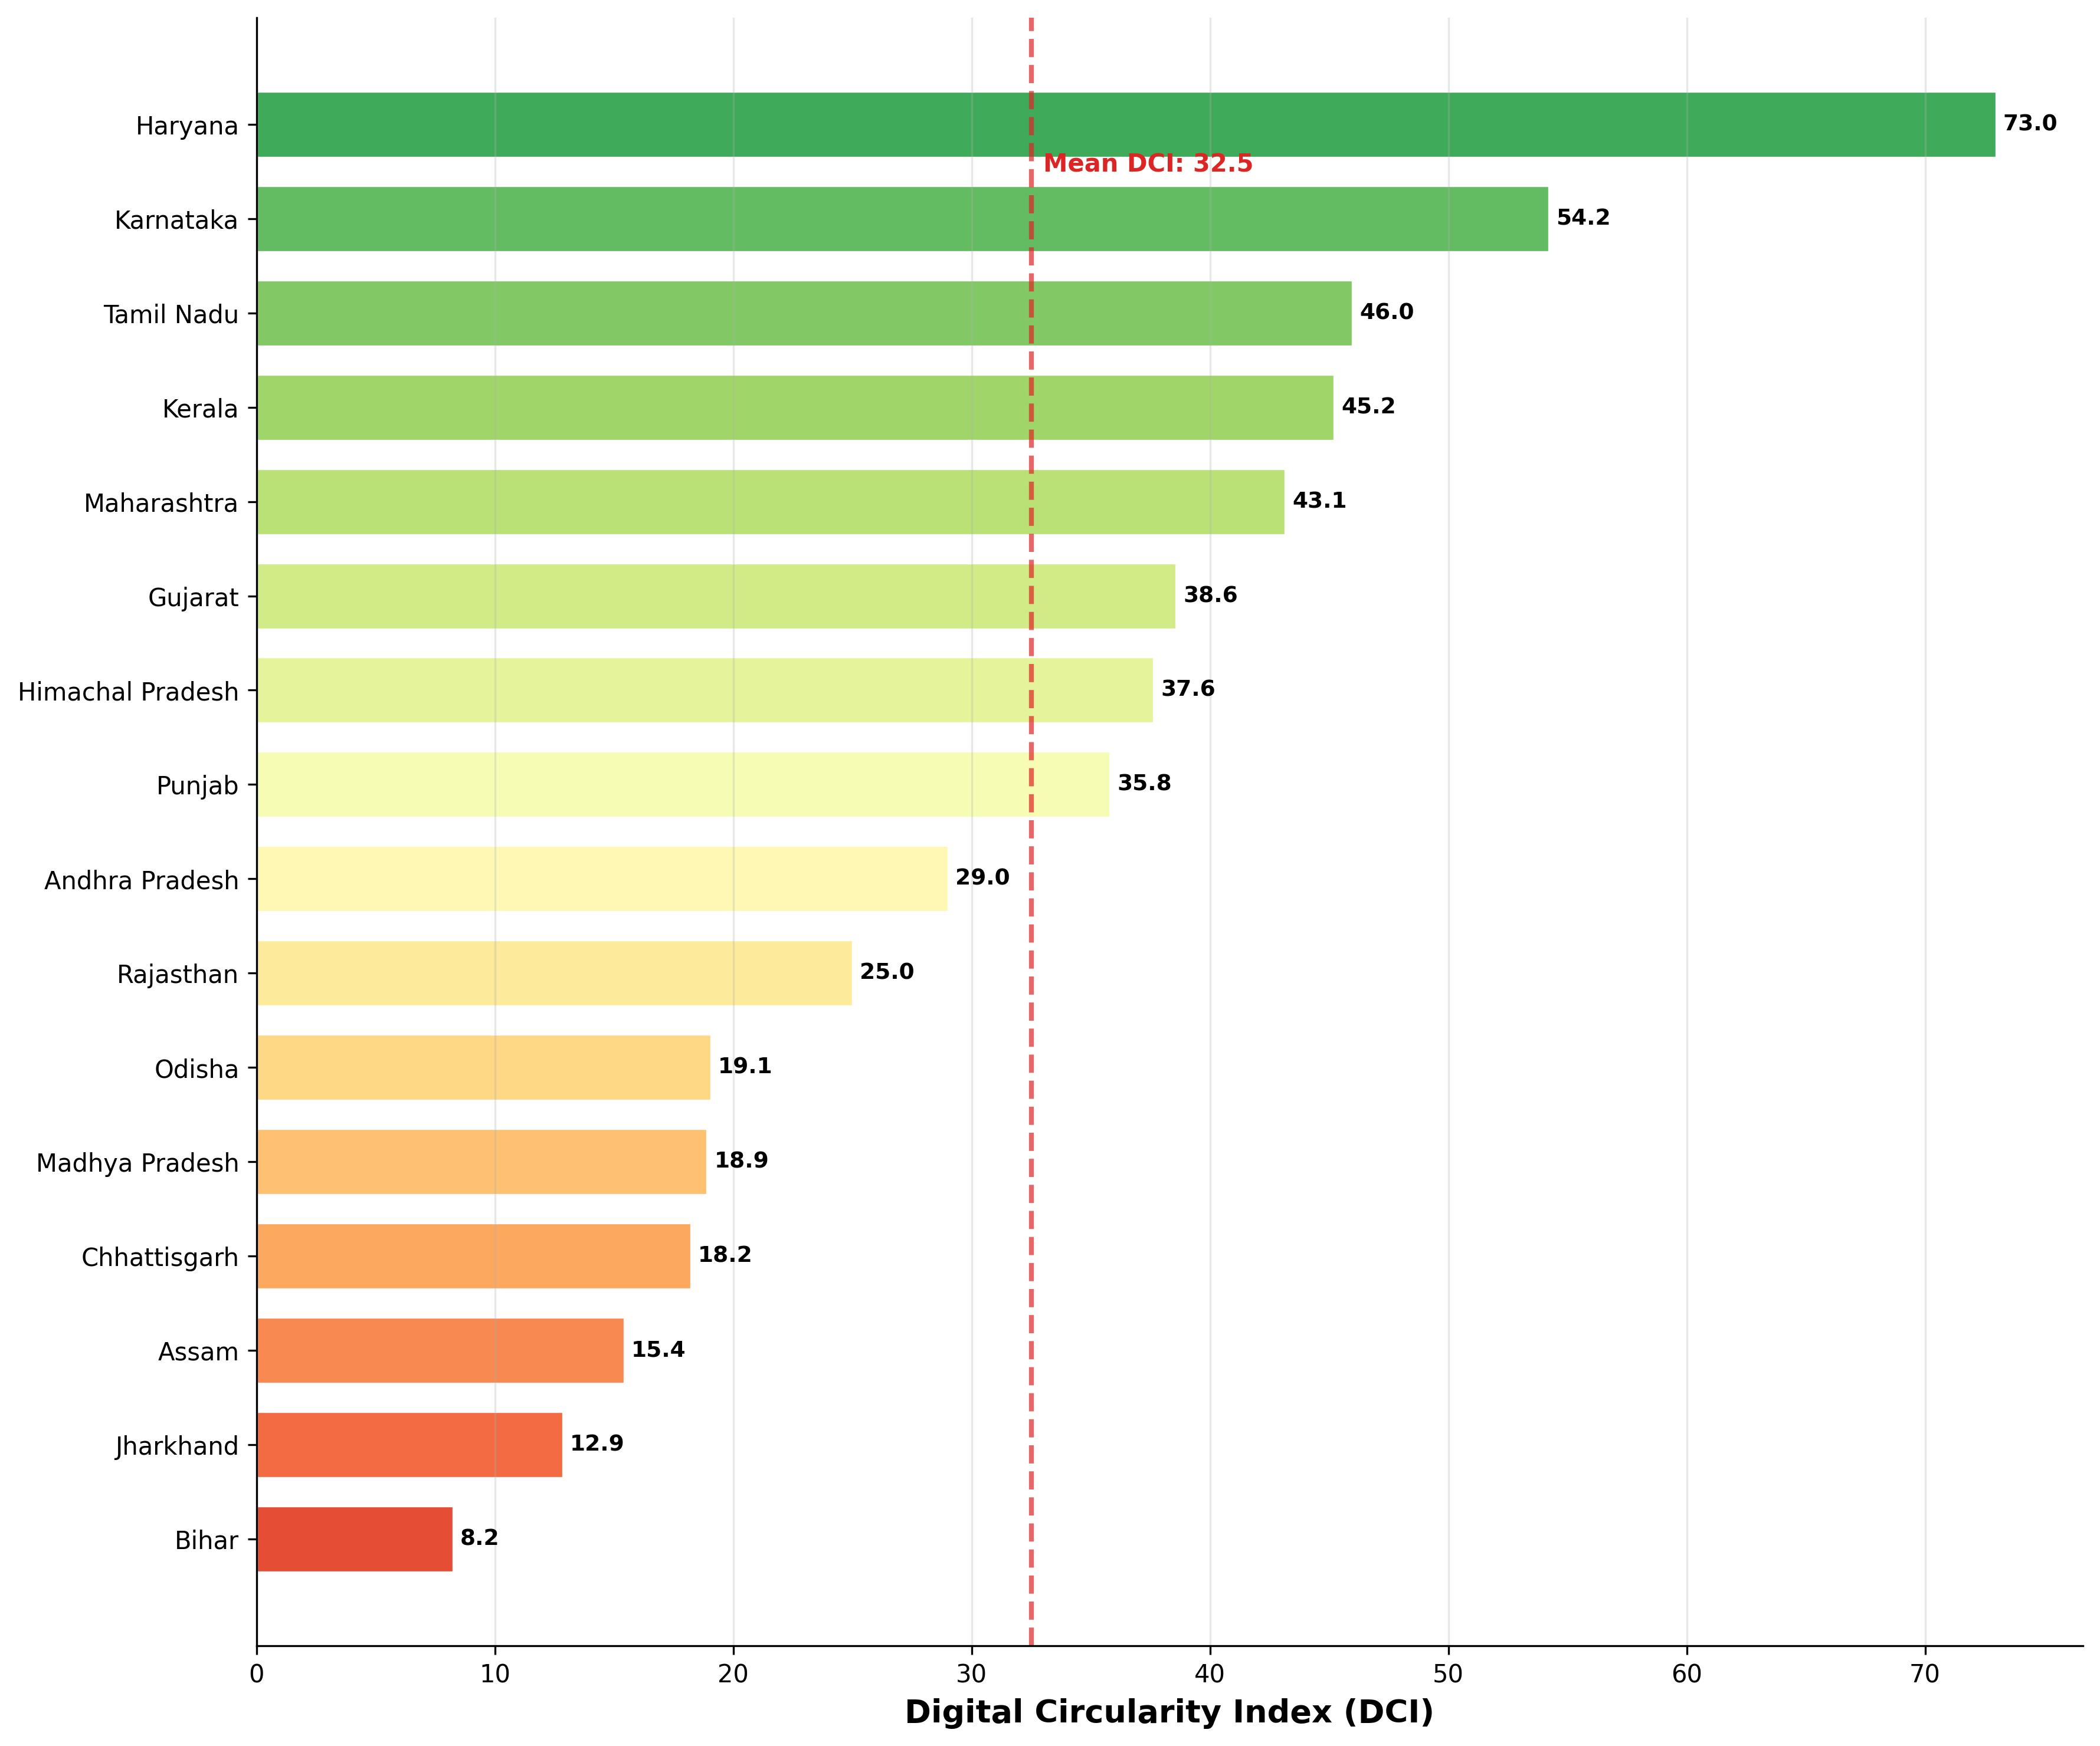
Digital Circularity Index (DCI) ranking across 16 Indian states. Haryana leads (72.97), Bihar lags (8.24).
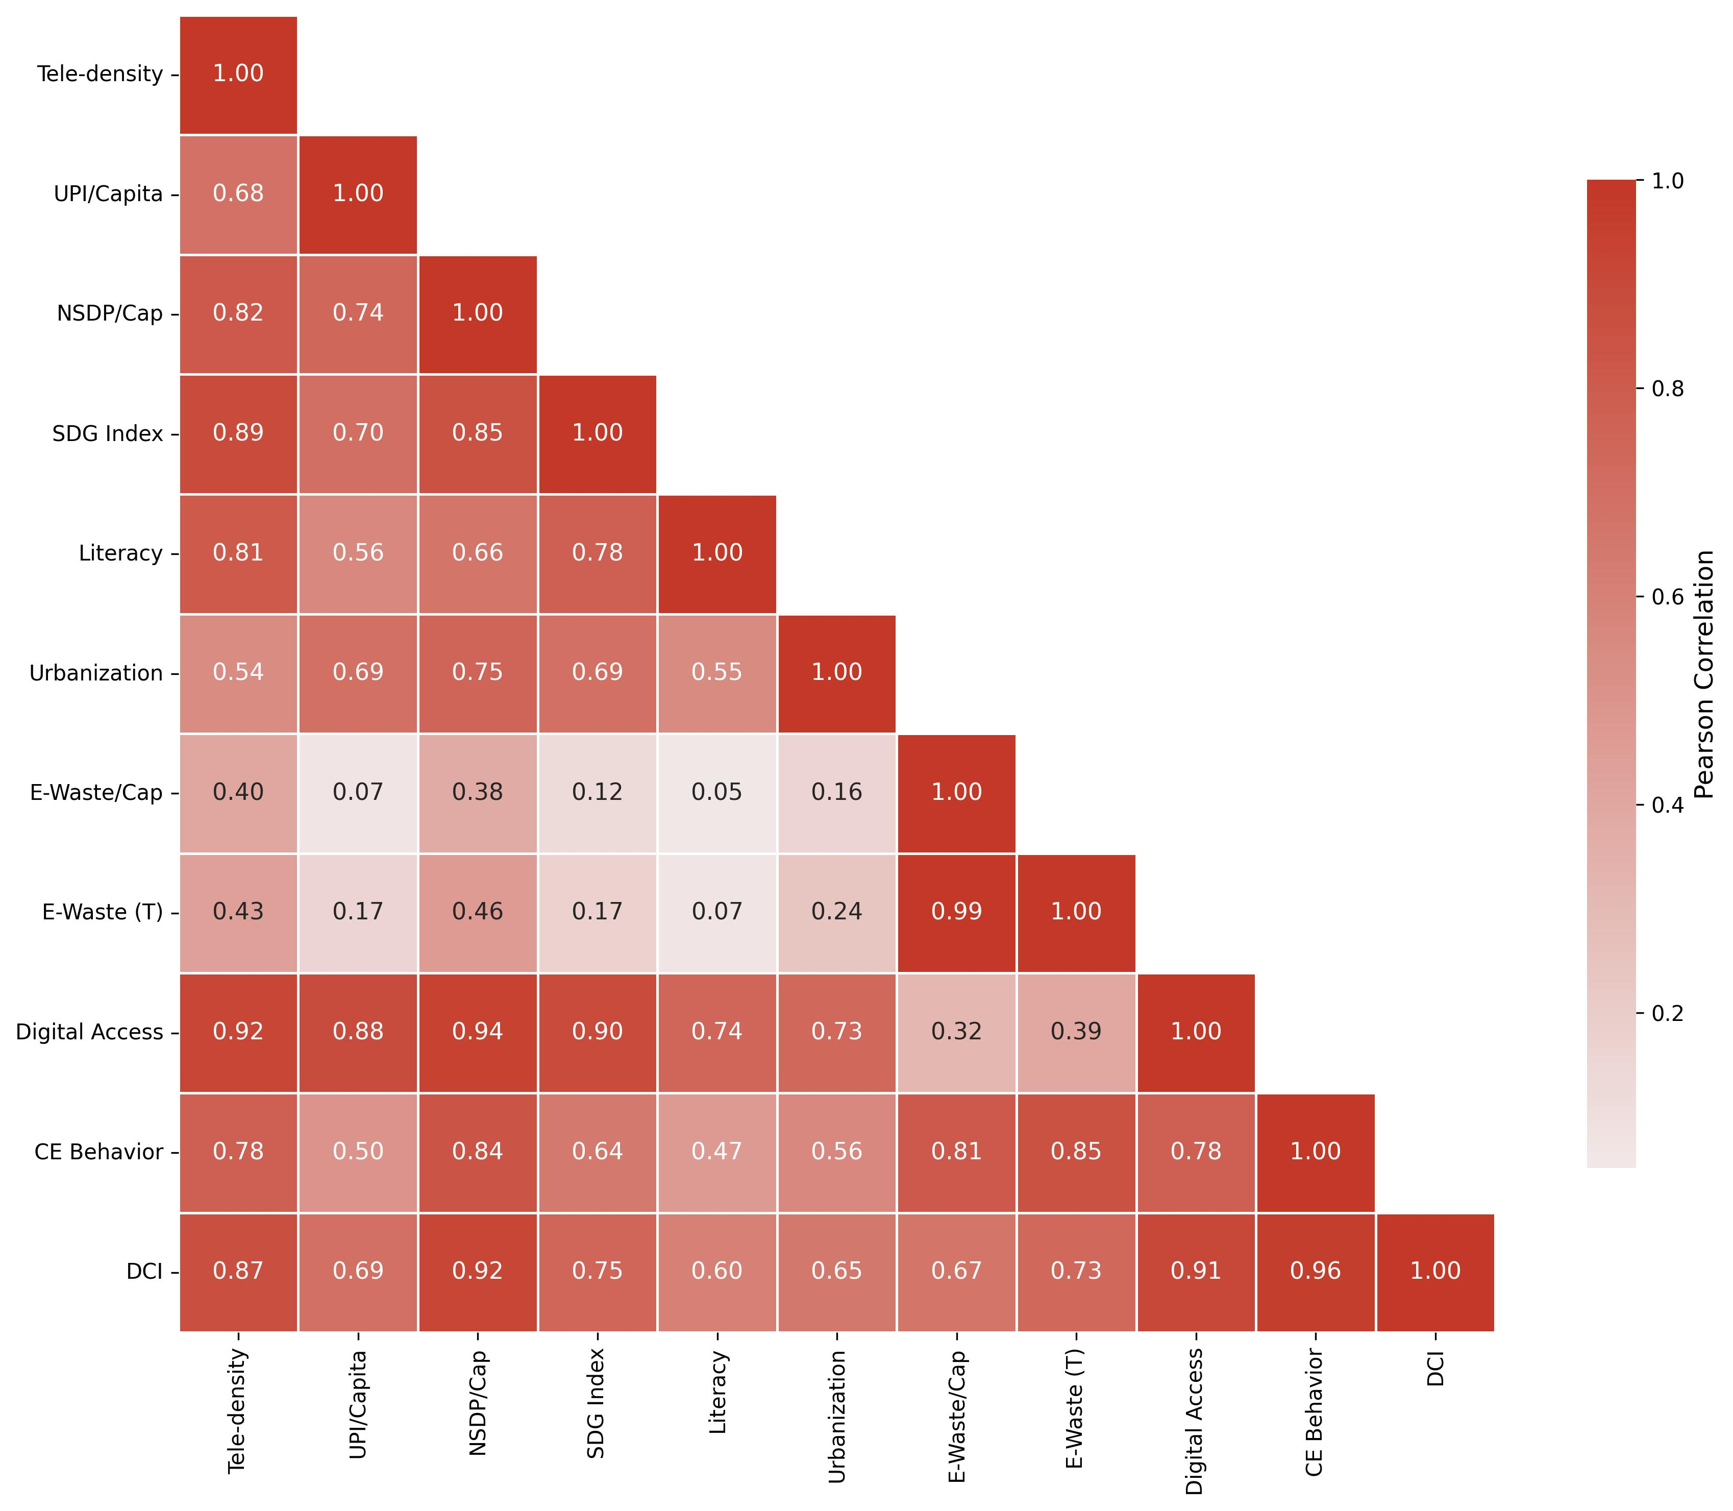
Correlation heatmap of all numeric variables. Darker colors indicate stronger correlations.

Primary Regression Analysis (H1)
We regressed CE Behavior Score on Digital Access Score using OLS. The result:
$$CEBS=11.158+0.551⋅DAS$$
In plain terms, every one-point increase in DAS corresponds to about half a point in CEBS. The model captures 61% of the variance. The full output is in Table 3; H1 holds at $p<0.001$.
OLS Regression Results — Primary Model
Metric | Value
$R^{2}$ | 0.610
Adjusted $R^{2}$ | 0.583
$β_{1}$ (slope) | 0.551
SE($β_{1}$) | 0.118
$t$-statistic | 4.684
$p$-value | 0.000352
$F$-statistic | 21.94
95% CI for $β_{1}$ | [0.299, 0.804]
Pearson $r$ | 0.781
We also tried a multiple regression with five controls. It lifted $R^{2}$ to 0.763 (Adjusted $R^{2}=0.644$, $F(5,10)=6.44$, $p=0.006$), but two VIF scores—DAS at 10.57, NSDP at 9.47—blew past the multicollinearity threshold of 10. That is not surprising: NSDP appears in both composite scores by design. The bivariate model above gives a cleaner test of H1. The scatter plot is in Fig. 3.
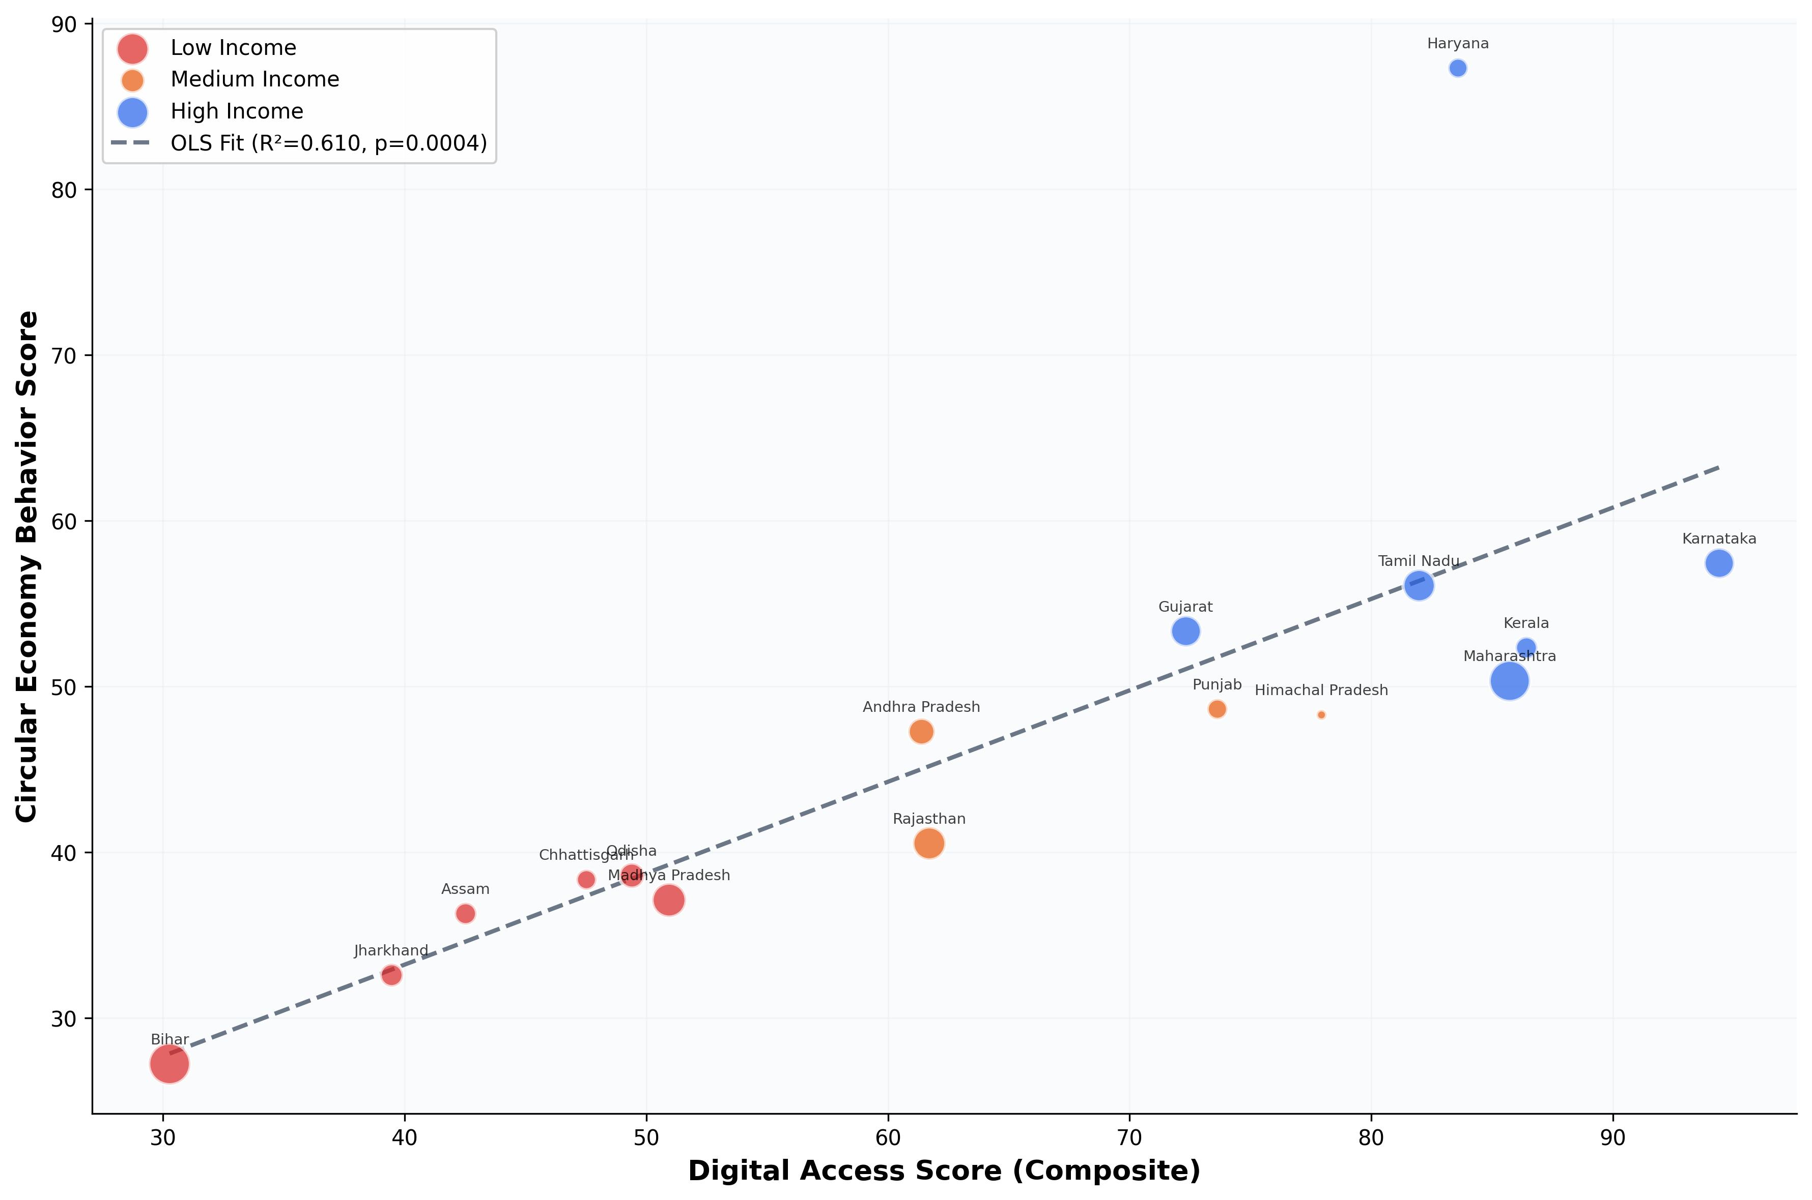
Digital Access Score vs. CE Behavior Score ($r=0.781$, $p<0.001$). Each point represents one state.

Robustness Checks
The residuals from the OLS model are not normal—skewness of 2.72, kurtosis of 10.3—and Haryana is the main reason (Cook’s $D=4.16$). We ran several checks to see whether the relationship survives despite this. It does. Table 4 has the full set of diagnostics.
First, we switched to HC3 heteroskedasticity-consistent standard errors. The $p$-value actually got smaller ($p=0.000011$). A permutation test with 10,000 iterations gave $p=0.0001$. And when we dropped parametric assumptions entirely, both Spearman ($ρ=0.912$) and Kendall ($τ=0.783$) came back significant at $p<0.001$. We also re-ran the regression after removing Haryana altogether. The relationship held.
The other worry is that our weight choices—40/30/30 for DAS, 35/40/25 for CEBS—might be driving the result. We tested seven alternative schemes ranging from equal weights to configurations that heavily overweight a single variable. Six out of seven gave significant Pearson correlations at $p<0.05$. The one borderline case was the UPI-heavy scheme ($r=0.479$, $p=0.061$), but even there the Spearman rank correlation was 0.882 ($p<0.001$). So the finding is not a product of how we chose to weight the indices.
Robustness Diagnostics
Test | Value | Result
Spearman $ρ$ | 0.912 | $p<0.001$
Kendall $τ$ | 0.783 | $p<0.001$
Shapiro-Wilk | Skew = 2.72 | Non-normal
Breusch-Pagan LM | 1.539 | $p=0.215$
Durbin-Watson | 2.025 | No autocorr.
Cook’s distance | $D_{max}=4.16$ (HR) | 1 infl. pt.
Permutation $p$ | 0.0001 | Significant
HC3 robust $p$ | 0.000011 | Significant
Bootstrap CI ($r$) | [0.648, 0.979] | Excludes 0
Bootstrap CI ($β_{1}$) | [0.395, 0.836] | Excludes 0

Mediation Analysis (H2)
Does UPI adoption act as the mechanism linking digital access to CE behavior? That was the premise behind H2. We tested it with the Baron & Kenny framework (Table 5).
Mediation Results
Path | $β$ | $p$-value | Sig.?
$c$ (total): $X→Y$ | 0.505 | 0.0004 | Yes
$a$: $X→M$ | 1.499 | 0.003 | Yes
$b$: $M→Y∣X$ | $−$0.017 | 0.813 | No
$c^{′}$ (direct): $X→Y∣M$ | 0.530 | 0.004 | Yes
Indirect ($a×b$) | $−$0.026 | — | —
Sobel $z$ | $−$0.241 | 0.810 | No
Short answer: no. The Sobel test returned $z=−0.241$ ($p=0.810$). The direct path stayed significant even after controlling for UPI ($c^{′}=0.530$, $p=0.004$), meaning UPI adds nothing as a mediator. We checked two other possible channels. Tele-density $→$ NSDP $→$ CEBS gave a Sobel $z$ of 0.566 ($p=0.571$). Tele-density $→$ SDG $→$ CEBS gave $z=−0.690$ ($p=0.490$). All three were dead ends. Whatever is going on between digital access and CE behavior, it does not travel through a single identifiable pathway.

Threshold Analysis (H3)
We fit a piecewise regression to test whether there is a tele-density breakpoint. The grid search placed it at 118.77%:
- Below that threshold, the slope is steep and positive: $β_{1}=0.635$ ($p=0.0001$).
- Above it, the slope flips negative: $β_{2}=−8.738$ ($p=0.047$)—but only two or three states sit in this range, so we would not read too much into the reversal.
- The piecewise model fits better than the linear one: $R^{2}=0.723$ vs. 0.610.
H3 gets support with that caveat. Around 119% tele-density, the returns to additional connectivity—at least in terms of CE outcomes—start to flatten or reverse. More data points above the threshold would be needed before drawing strong conclusions.

Machine Learning Validation (LOO-CV)
To check whether the OLS result was just overfitting to 16 data points, we ran seven ML models under LOO-CV. Each model trained on 15 states and predicted the 16th; we cycled through all 16 states. Table 6 has the numbers.
ML Model Comparison — LOO-CV Results
Model | Digital-Only |  | Full Model
2-3 (lr)4-5 | $R^{2}$ | $r$ | $R^{2}$ | $r$
ElasticNet | 0.364 | 0.603 | 0.534 | 0.731
Lasso | 0.347 | 0.606 | 0.568 | 0.758
Ridge | 0.338 | 0.597 | 0.536 | 0.743
RF | 0.326 | 0.575 | 0.490 | 0.703
Lin. Reg. | 0.301 | 0.585 | 0.442 | 0.713
SVR (RBF) | 0.286 | 0.554 | 0.425 | 0.700
GB | 0.161 | 0.542 | 0.445 | 0.687
Two things stand out. First, even when fed only the three digital-access features, ElasticNet predicted 36% of CE behavior variance ($p=0.013$). That is a genuine out-of-sample signal, not a restatement of the training fit. Second, the best full-model LOO-CV $R^{2}$ (Lasso, 0.568) lands close to the OLS $R^{2}$ of 0.610. The regression was not overfitting.

Nested LOO-CV (Leak-Free Evaluation)
There is a subtlety in standard LOO-CV: hyperparameters are still tuned on the full training set, which can create a small upward bias. We dealt with this by wrapping everything in a nested design. The outer loop holds out one state for testing. An inner 4-fold CV selects hyperparameters using only the remaining 15 states. Table 7 shows what happened.
Nested LOO-CV Results (Leak-Free)
Model | Nested $R^{2}$ | RMSE | $r$
XGBoost | 0.511 | 9.41 | 0.721
Random Forest | 0.504 | 9.48 | 0.711
ElasticNet | 0.471 | 9.78 | 0.723
Ridge | 0.445 | 10.03 | 0.714
Lasso | 0.443 | 10.05 | 0.713
SVR | $−$0.023 | 13.61 | $−$0.593
XGBoost came out ahead at $R^{2}=0.511$ ($p=0.002$). No test data leaked into training, and no information from the test observation influenced hyperparameter choices. That makes 0.511 a genuinely conservative number. SVR, by contrast, fell apart completely under these conditions—its negative $R^{2}$ means it was worse than simply guessing the mean.
We also ran a Repeated K-Fold CV (100 repeats $×$ 4 folds, 400 total splits) to see how stable these predictions were. Random Forest showed the tightest distribution (Mean $R^{2}=0.442$, Median $R^{2}=0.603$). The confidence intervals were wide—hard to avoid with 16 observations—but the median $R^{2}$ stayed positive for every model we tested.

SHAP Explainability Analysis
Once we had a trained XGBoost model, the next step was to ask what it had learned. We computed SHAP values for all six features across all 16 states. Table 8 ranks features by how much they move the prediction on average.
SHAP Global Feature Importance
Rank | Feature | Mean $|ϕ|$
1 | Tele-density (%) | 5.012
2 | Per Capita NSDP | 4.883
3 | Population (Mn) | 1.714
4 | Urban (%) | 1.677
5 | Literacy Rate (%) | 0.998
6 | UPI Per Capita | 0.914
Tele-density ranked first (mean $|ϕ|=5.01$). Per capita NSDP was close behind at 4.88. UPI—the programme that gets the most public attention—came in last at 0.91. That was not what we expected. The beeswarm plot in Fig. 4 shows the full distribution of SHAP values per feature, and Fig. 5 breaks down individual predictions for Haryana and Bihar. The contrast is sharp: Haryana gets large positive pushes from NSDP (+11.63) and tele-density (+9.57), while Bihar gets dragged down by both.
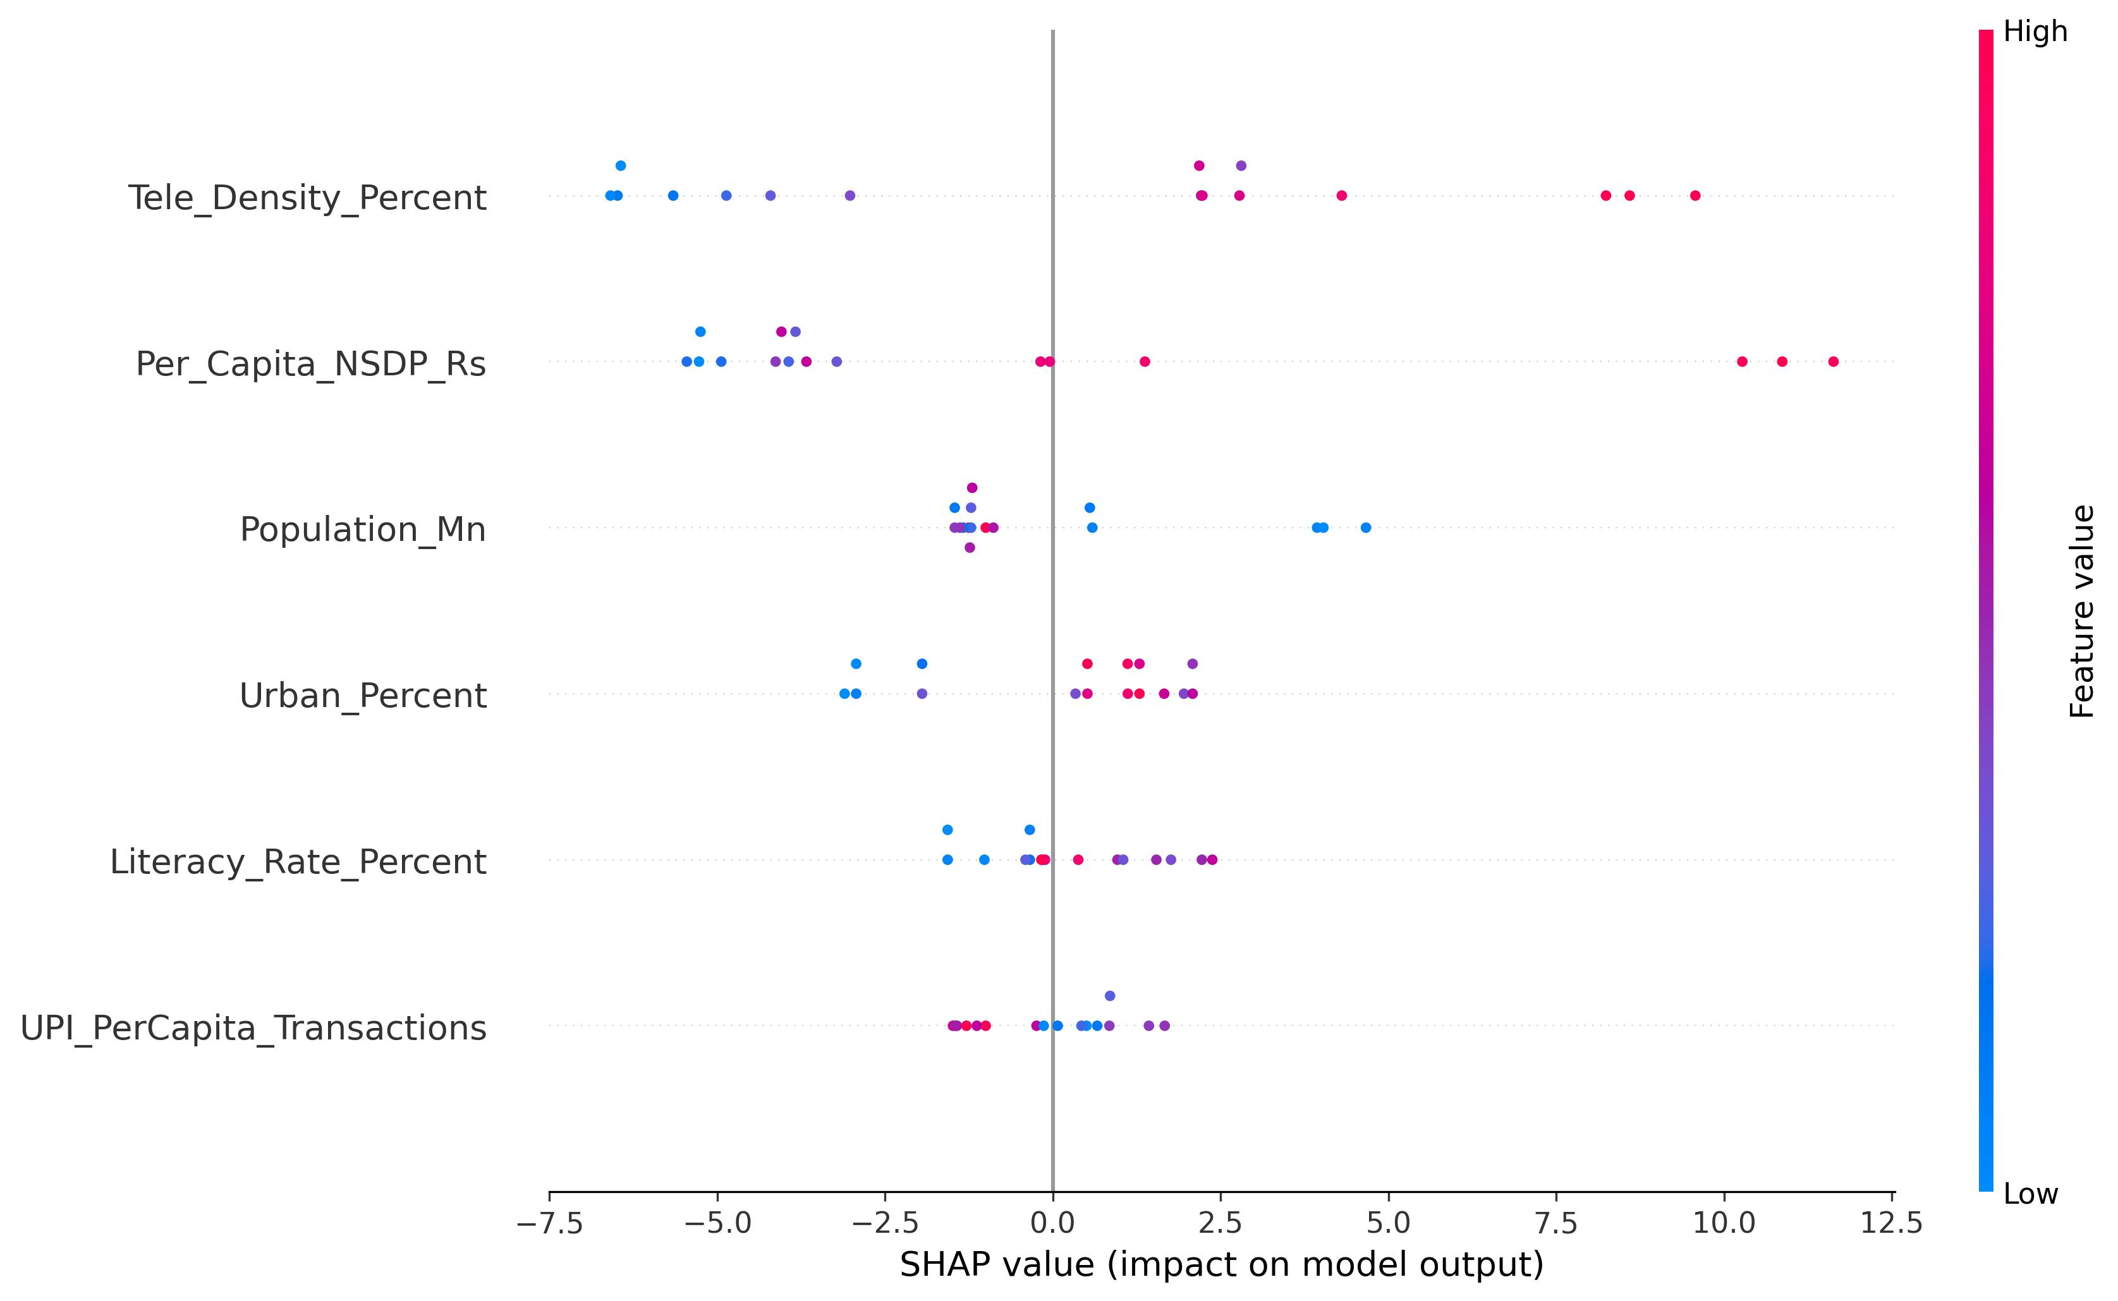
SHAP beeswarm plot. Each dot represents one state for one feature. Color indicates feature value (red = high, blue = low). Tele-density and NSDP have the widest spread.
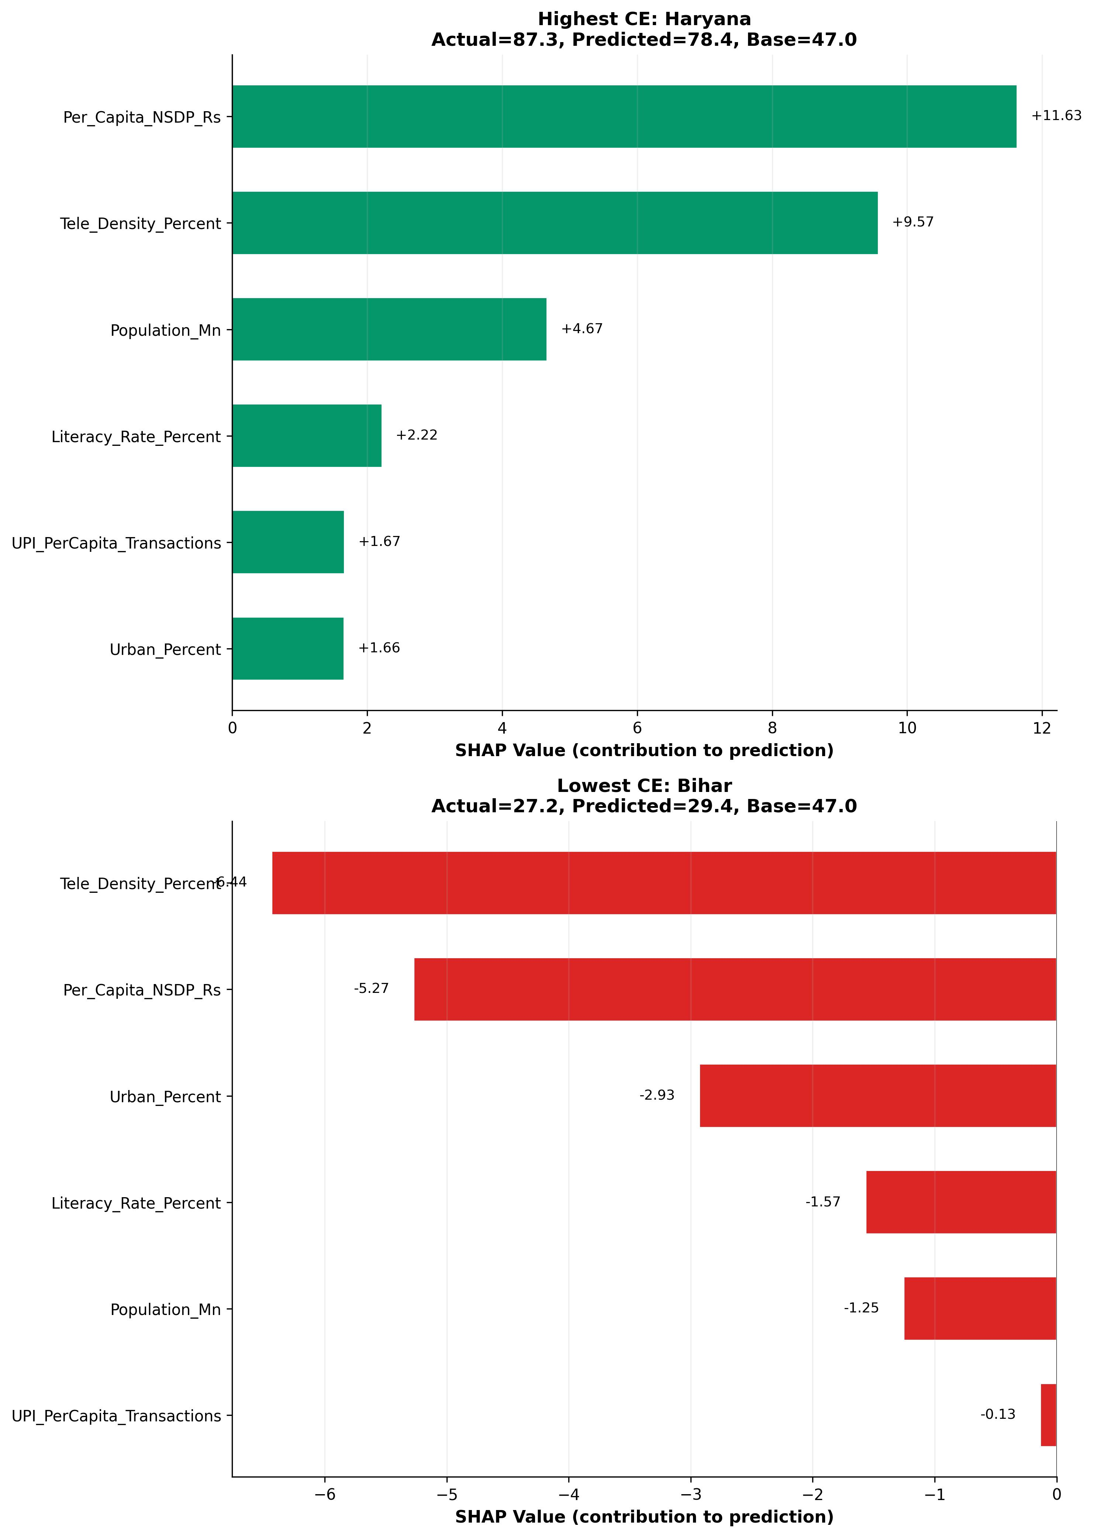
SHAP waterfall explanations. Left: Haryana (highest CE)—high NSDP (+11.63) and tele-density (+9.57) push score up. Right: Bihar (lowest CE)—low tele-density ($−$6.44) and NSDP ($−$5.27) push score down.

K-Means Clustering (State Typologies)
We ran K-Means clustering with the silhouette score determining the number of clusters. It picked $k=2$ (Table 9). One group—which we label Digital Leaders—contains Gujarat, Haryana, Himachal Pradesh, Karnataka, Kerala, Maharashtra, Punjab, and Tamil Nadu. The other eight states—Andhra Pradesh, Assam, Bihar, Chhattisgarh, Jharkhand, Madhya Pradesh, Odisha, and Rajasthan—form the Emerging States cluster.
K-Means Cluster Profiles
Cluster | $n$ | DAS | CEBS | DCI
Digital Leaders | 8 | 82.0 | 56.7 | 46.7
Emerging States | 8 | 47.9 | 37.2 | 18.3
Gap | — | 34.1 | 19.5 | 28.4
The DCI gap between clusters is about 2.5$×$ (46.7 vs. 18.3). That is a large divide. It sits on top of the digital divide that others have already documented, but adds a CE performance dimension that, to our knowledge, has not been measured this way before. PCA reinforced the same split: the first principal component (62.3% of variance) lined up with digital-economic development and separated the two clusters cleanly in the biplot. Fig. 6 has the clustering visualisation.

Extended Sample Validation
One fair criticism of the analysis is the small sample. So we ran a check: we dropped e-waste—the variable that knocks the most states out of the dataset—from CEBS and recalculated. That added Goa, Telangana, Uttar Pradesh, Uttarakhand, and West Bengal, bringing $n$ to 21. The correlation went up, not down: Pearson $r=0.963$ ($p<0.000001$), Spearman $ρ=0.951$, OLS $R^{2}=0.927$. Whatever we found with 16 states, 21 states made it stronger.
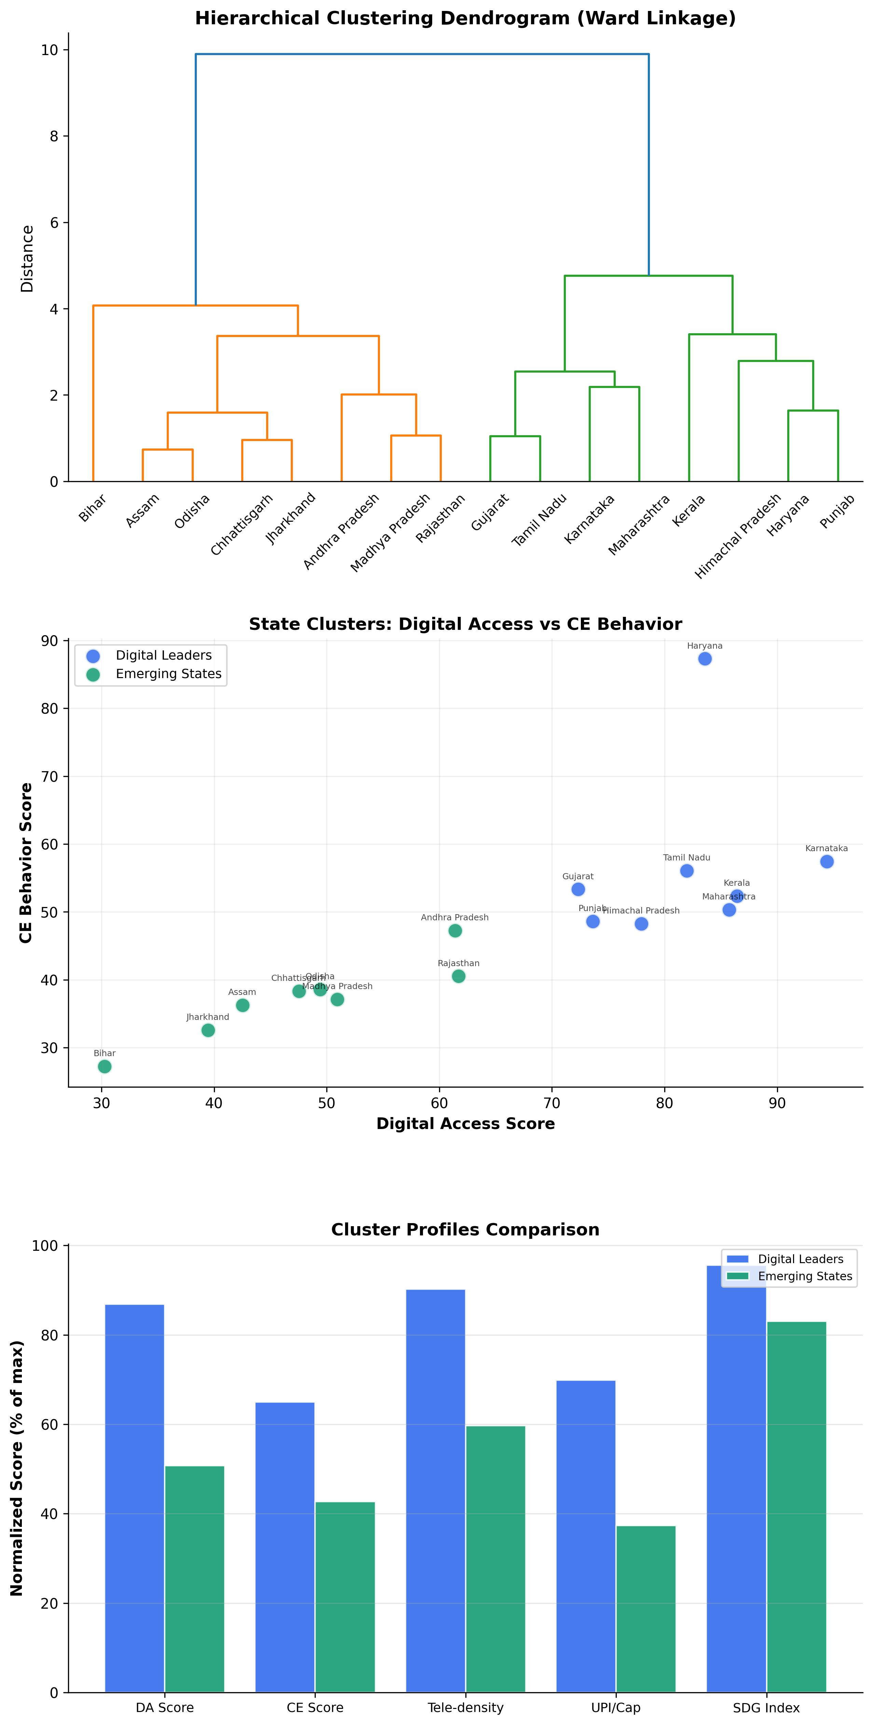
K-Means clustering results with hierarchical dendrogram and cluster radar profiles. Two distinct state typologies emerge.

Discussion

Do the Methods Agree?
They do. OLS gives $R^{2}=0.610$. XGBoost under the strictest protocol we could design—nested LOO-CV with inner hyperparameter tuning—gives $R^{2}=0.511$. The drop is about what you would expect when you move from an in-sample fit to a leak-free out-of-sample evaluation. What matters is that both numbers are positive, both are significant, and neither depends on a particular distributional assumption. Spearman and Kendall, which assume nothing about normality, agree. So does the permutation test. The DAS–CEBS link is not a statistical fluke.
The fact that XGBoost holds up at 0.511 is worth pausing on. This is a sample of 16 states. Small samples make machine learning hard—there is not much data to learn from, and any individual state can pull the model around. That the model still explains half the variance under these conditions tells us the signal is real, not an artefact of overfitting.

What Drives the Relationship?
SHAP and Random Forest give slightly different answers about which feature matters most, and the discrepancy is actually informative. RF ranks Per Capita NSDP first (48.8% of importance), while SHAP puts tele-density on top (mean $|ϕ|=5.01$). The reason is that they measure different things. RF captures how much variance a feature accounts for; SHAP measures how much each feature shifts an individual prediction away from the baseline. Both agree on the same top two features—tele-density and NSDP—which is reassuring. They just weight them differently.
The bigger surprise is UPI. It ranked last in the SHAP ordering, despite being the most talked-about component of Digital India. This lines up with the mediation analysis: the Sobel test for UPI as a mediator was nowhere near significant ($z=−0.241$, $p=0.810$). The implication is that digital access matters for CE behavior, but not because of digital payments specifically. It appears to work through broader infrastructure effects—the kind of diffuse, multi-channel mechanisms that Avgerou and Heeks described in the ICT4D literature.

The Two Indias in CE Performance
K-Means gave us two clusters with a DCI gap of about 2.5$×$. On one side: Gujarat, Karnataka, Kerala, Maharashtra, and four others, averaging a DCI of 46.7. On the other: Bihar, Jharkhand, Chhattisgarh, and five more, averaging 18.3. This is not just the well-known digital divide restated in new terms—it adds a sustainability dimension. States that lag in digital access do not just fall a little behind on CE outcomes. They fall far behind. The relationship between the two types of disadvantage appears to be multiplicative, which is exactly what the DCI formula was designed to capture.

What This Means for Policy
We see five practical takeaways, though we want to be honest about how far cross-sectional data can take policy recommendations.
First, the Digital India and Swachh Bharat programmes are currently administered in separate silos. Our data suggest they should talk to each other. Digital platforms already exist for waste tracking, and UPI could be used for recycling incentives or deposit-return schemes—but nobody seems to be connecting these systems at the state level.
Second, connectivity investment in the lagging states—Bihar at 55.80% tele-density, Jharkhand at 62.62%, Chhattisgarh at 69.50%—is not just a telecom issue. If the DAS–CEBS relationship is real, closing the connectivity gap would also move the needle on sustainability. The 119% threshold from the piecewise regression gives a rough target: below that level, every percentage point of tele-density gains buys measurable CE improvement.
Third, because UPI alone is not the mediator, policy should not fixate on digital payments. E-governance, environmental monitoring apps, and digital literacy all look like they matter, though we cannot pin down the individual contribution of each.
- The two clusters call for different strategies. Digital Leaders can push advanced interventions—AI-driven waste sorting, IoT-based monitoring—because the infrastructure is already there. Emerging States need the basics first: cell towers, broadband, and functioning waste collection.
- SHAP makes state-specific recommendations possible. Bihar’s biggest bottleneck is tele-density. For Chhattisgarh, it is economic capacity (NSDP). A uniform national policy would miss these differences.

Limitations and Future Work
We should be upfront about what this study cannot do. Sixteen states is a small sample. We chose that number deliberately—it is what survives the inner join across all seven data sources without filling in any gaps—but it limits statistical power and makes every outlier (Haryana, with its Cook’s $D$ of 4.16) influential. The bootstrap CIs and the extended 21-state validation help, but they do not fully resolve the issue.
Cross-sectional data cannot tell us whether digital access causes better CE outcomes or whether both are driven by some third factor, like state-level governance quality. We find a strong association. Calling it causal would require panel data—ideally 3 to 5 years of observations—and methods like Granger causality or difference-in-differences.
There are also data limitations we could not work around. Census figures for literacy and urbanisation date to 2011; the 2021 Census was cancelled because of COVID-19. NSDP features in both DAS and CEBS, which could mechanically inflate the correlation between them, though the fact that tele-density alone predicts CEBS at $p=0.0001$ suggests the overlap is not the whole story. And state-level averages hide a lot. A place like Karnataka has both Bengaluru and rural Malnad—the state average papers over enormous within-state variation.
The most useful next step would be district-level data, which would push $n$ above 100 and make Structural Equation Modeling viable. Adding plastic waste recovery rates, municipal solid waste diversion, and EPR compliance to the CE index would also help. And applying the DCI framework to countries with comparable data systems—Bangladesh, Indonesia, Nigeria—would test whether the relationship holds beyond India.

Conclusion
Across 16 Indian states, digital access and circular economy behavior move together—and the relationship holds up under every method we tried. OLS gives $r=0.781$ ($p<0.001$). XGBoost, evaluated with no data leakage whatsoever, gives $R^{2}=0.511$. Different assumptions, same answer.
The finding that surprised us most was UPI’s irrelevance as a mediator. SHAP gave the top spot to tele-density, not digital payments. None of the three mediation pathways we tested carried the effect on its own (Sobel $p>0.49$ in every case). The link between digital access and CE behavior does not run through one clean mechanism.
K-Means split the states into two groups separated by a 2.5$×$ DCI gap. The piecewise regression flagged 119% tele-density as the point of diminishing returns. Together, these results make a case—not an airtight one, but a reasonable one—for treating digital inclusion and circular economy investment as parts of the same agenda. The states with the most to gain are the ones where both connectivity and sustainability lag furthest behind.

Acknowledgment
The authors thank the Telecom Regulatory Authority of India, Reserve Bank of India, NITI Aayog, National Payments Corporation of India, and Central Pollution Control Board for making their data publicly available.

References
- NPCI, “UPI Product Statistics (Monthly),” National Payments Corporation of India, Mumbai, 2025. [Online]. Available: https://www.npci.org.in/what-we-do/upi/product-statistics
- TRAI, “Indian Telecom Services Performance Indicators Report: April–June 2024,” Telecom Regulatory Authority of India, New Delhi, 2024. [Online]. Available: https://trai.gov.in
- CPCB, “Annual Report on Implementation of E-Waste (Management) Rules, 2016 for FY 2021–22,” Central Pollution Control Board, Ministry of Environment, Forest and Climate Change, Government of India, 2023. [Online]. Available: https://cpcb.nic.in
- NITI Aayog, “Circular Economy in India: Rethinking Growth for Long-Term Prosperity,” Government of India, New Delhi, 2021.
- Ministry of Electronics & IT, “Digital India Programme: Progress and Initiatives,” Government of India, 2023. [Online]. Available: https://digitalindia.gov.in
- M. Geissdoerfer, P. Savaget, N. M. Bocken, and E. J. Hultink, “The Circular Economy – A new sustainability paradigm?” J. Cleaner Prod., vol. 143, pp. 757–768, 2017.
- Ellen MacArthur Foundation, “Towards the Circular Economy: Economic and Business Rationale for an Accelerated Transition,” 2013. [Online]. Available: https://ellenmacarthurfoundation.org
- World Economic Forum, “Harnessing the Fourth Industrial Revolution for the Circular Economy,” Geneva, Switzerland, 2019.
- NITI Aayog, “SDG India Index & Dashboard 2023–24,” 4th ed., National Institution for Transforming India, Government of India, New Delhi, 2024. [Online]. Available: https://sdgindiaindex.niti.gov.in
- C. Avgerou, “Discourses on ICT and development,” Inf. Technol. Int. Dev., vol. 6, no. 3, pp. 1–18, 2010.
- R. Heeks, Information and Communication Technology for Development (ICT4D). Routledge, 2017.
- RBI, “Handbook of Statistics on Indian Economy 2024–25, Table 9: Per Capita Net State Domestic Product,” Reserve Bank of India, Mumbai, 2025. [Online]. Available: https://www.rbi.org.in
- Dataful Insights, “Here is How UPI Usage Differs Across Indian States,” Factly Media & Research, 2025. [Online]. Available: https://insights.dataful.in
- Census of India, “Primary Census Abstract: Literacy Rate, Level of Urbanization, Population,” Office of the Registrar General & Census Commissioner, Ministry of Home Affairs, Government of India, 2011. [Online]. Available: https://censusindia.gov.in
- R. M. Baron and D. A. Kenny, “The moderator-mediator variable distinction in social psychological research: Conceptual, strategic, and statistical considerations,” J. Pers. Soc. Psychol., vol. 51, no. 6, pp. 1173–1182, 1986.
- S. M. Lundberg and S.-I. Lee, “A Unified Approach to Interpreting Model Predictions,” in Advances in Neural Information Processing Systems (NeurIPS), vol. 30, 2017.

