**Table of Contents**

1. PROBLEM STATEMENT 3

2. AIM 3

3. OBJECTIVES 3

4. REVIEW OF LITERATURE 3

5. FEASIBILITY STUDY AND REPORT 4

5.1 TECHNICAL FEASIBILITY 4

5.2 OPERATIONAL FEASIBILITY 4

5.3 RESOURCE AND TIME FEASIBILITY 4

5.4 ECONOMIC FEASIBILITY 4

6. REQUIREMENT COLLECTION AND CATEGORIZTION 4

6.1 STAKE HOLDERS 4

6.2 QUESTIONNAIRES 4

6.3 CATEGORIZATION OF REQUIREMENTS 5

6.3.1 FUNCTIONAL REQUIREMENTS 5

6.3.2 NON-FUNCTIONAL REQUIREMENTS 5

7. SOFTWARE REQUIREMENTS SPECIFICATION 6

7.1 Introduction 6

7.1.1 Purpose 6

7.1.2 DOCUMENT CONVENTIONS 6

7.1.3 INTENDED AUDIENCE AND READING SUGGESTIONS 6

7.1.4 PRODUCT SCOPE 6

7.2 OVERALL DESCRIPTION 6

7.2.1 Project Perspective 6

7.2.2 Product Functionality 6

7.2.3 User classes and characteristics 7

7.2.4 Operating Environment 7

7.2.5 DESIGN AND IMPLEMENTATION CONSTRAINTS 7

7.2.6 USER DOCUMENTATION 7

7.2.7 ASSUMPTIONS AND DEPENDENCIES 8

7.3 EXTERNAL INTERFACE REQUIREMENTS 8

7.3.1 USER INTERFACE 8

7.3.2 HARDWARE INTERFACES 8

7.3.3 SOFTWARE INTERFACES 8

7.3.4 COMMUNICATION INTERFACES 8

7.4 SYSTEM FEATURES 8

7.5 OTHER NON-FUNCTIONAL REQUIREMENTS 9

7.5.1 PERFOMANCE REQUIREMENTS 9

7.5.2 SAFETY REQUIREMENTS 9

7.5.3 SECURITY REQUIREMENTS 9

7.5.4 SOFTWARE QUALITY ATTRIBUTES 9

7.5.5 BUISNESS RULES 9

8. TOOLS AND TECHNOLOGIES USED 9

8.1 IDE USED 9

8.1.1 Visual Studio Code 9

8.1.2 Jupyter Notebook 10

8.2 FRAMEWORKS USED: 10

8.2.1 React JS 10

8.2.2 OpenCV 10

8.2.3 Python Flask 10

8.2.4 Tensorflow 11

8.3 LANGUAGES USED 11

8.3.1 HTML 11

8.3.2 CSS 11

8.3.3 JavaScript 11

8.3.4 Python 11

9. SYSTEM IMPLEMENTATION 12

9.1 REGISTRATION AND VALIDATION 12

9.2 DATA PRE-PROCESSING 13

10. REFERENCES 14

## PROBLEM STATEMENT

Preschool age is critical for kid’s development. A good reading ability and understanding of any child depends on the training he/she receives. This requires the parents to invest more time and money on materials and tools. With the rapid growth in technology today, learning and teaching materials has shifted from the black board to more sophisticated gadgets that support teaching and learning at any level of learning, starting from the preschool to the higher learning. With time, a kid’s way of learning also has changed and demand more interactive and a playful environment to learn.

## AIM

To design and develop a web based application that will achieve an activity based learning and focuses on using real-world objects to facilitate pre-school learning of the English alphabets, spellings, counting of numbers, recognition and drawing of real world objects.

## OBJECTIVES

* To train our model to identify and classify scribbled alphabets, digits, and drawings.
* To create two sections: Learning and Playing
* To design a system with friendly navigation, backgrounds, sounds and colours to attain the attention of kids while learning.
* To show the child’s progress after a certain period of time.

## REVIEW OF LITERATURE

The authors "Anchit Shrivastava, Isha Jaggi, Shefali Gupta, Deepali Gupta" analysed the most suitable and best method for digit recognition by considering 60,000 images for training set with a pixel size of 28×28. The images/training sets were matched with the original image. It was found out after complete analysis and review that the classifier ensemble system has the least error rate of just 0.32%. They also reviewed different methods of handwritten digit recognition.

The authors “Tsung-Han Tsai, Po-Ting Chi, Kuo-Hsing Cheng” built a sketch classifier technique with deep learning models. They had used the depth-wise convolution layer to lighten the deep neural network. The result showed the improvement in approximately 1/5 of computation. They had used Google Quick Draw dataset to train and evaluate the network, which can have 98% accuracy in 10 categories and 85% accuracy in 100 categories. The system can achieve real-time implementation of sketch classification.

The authors Olisah Kingsley S and Mohamed Ismail Z conducted a review on three possible solutions that can improve learning and teaching in pre-schools. The report also developed the most appropriate solution that will answer the research questions. Their research shall also discuss the importance and impact of information and communications technology on teaching and learning in pre-schools. It also discussed the advantages and disadvantages of web-based e-learning system over traditional kids learning.

The authors "Rahul Chauhan, Kamal Kumar Ghanshala, R.C Joshi" built CNN models to evaluate its performance on image recognition and detection datasets. The algorithm is implemented on MNIST and CIFAR-10 dataset and its performance is evaluated. The accuracy of models on MNIST is 99.6 %, CIFAR-10 is using real-time data augmentation and dropout on CPU unit.

The authors "Kristine Guo, James WoMa, Eric Xu" from Stanford University, built a multi-class classifier to assign hand-drawn doodles from Google’s online game Quick, Draw! into 345 unique categories. To do so, we implement and compare multiple variations of k-nearest neighbours and a convolutional neural network, which achieve 35% accuracy and 60% accuracy, respectively. They also evaluated the models’ performance and learned features.

## FEASIBILITY STUDY AND REPORT

### TECHNICAL FEASIBILITY

* The project is technically feasible as it can be built using the existing available technologies.
* Since the proposed application would be used by large audience it must be robust and scalable.
* To develop the Smart learning System one should have the knowledge of Machine learning.
* From the user perspective it just requires a web browser and an efficient internet connection.
* Users need just browsers to access the system. This makes the project technically feasible.

### OPERATIONAL FEASIBILITY

* The project is operationally feasible as the user having basic knowledge about computer and Internet can easily use the system.
* The system will provide an attractive and easily understandable i.e. user-friendly Graphical User Interface. The actors on this are mainly administrator and kids.
* System uses machine learning algorithm for prediction which is more efficient and gives more accurate results. Therefore the project is operationally feasible.

### RESOURCE AND TIME FEASIBILITY

Resources required for developing this project includes:

* Programming tools
* Hosting space
* Programming device
* Programming individual

All the resources mentioned above are freely available as of now. Each of the technologies are freely available and the technical skills required are manageable. Time constraint for the project development is well synchronized with the ease of implementation with the available technologies.

### ECONOMIC FEASIBILITY

The costs of developing and implementing the Smart Learning System are relatively modest.

The project is economically feasible as the cost of the project is involved only in the hosting of the project. As the data samples increases, it consumes more time and processing power. In that case better processor might be needed.to make the application highly scalable.

## REQUIREMENT COLLECTION AND CATEGORIZTION

### STAKE HOLDERS

The major stakeholders for this application would be:

* Pre-School Kids
* Parents
* Developers
* Testers
* Admin

### QUESTIONNAIRES

This research will identify and discuss the research questions and design. Kids below the age of 8-10 face real difficulty. The reason for this research is specifically to answer the following research questions:

* What are the teaching and learning difficulties faced with the current preschool programs, and how it can be improved?
* How can the advanced technologies methods of teaching be used for pre schooling and making the children competitive enough from the early schooling days by making sure that they are not stressed mentally while learning new things?
* How can we make sure that the method of learning online with these technologies does not compromise the quality of education provided by traditional means to students?

### CATEGORIZATION OF REQUIREMENTS

* After getting a clear picture of various requirements of different stakeholders, all the requirements were categorised into Functional and Non-Functional requirements.

#### FUNCTIONAL REQUIREMENTS

1. ADMIN

* Login for Admin
* Forgot password for Admin
* Edit Profile for Admin
* Change password for Admin
* Logout functionality
* Dashboard for Admin User
* MANAGE ASSIGNMENTS: Add new assignment, edit the existing assignment, view details of the assignments and see a listing of all assignments

1. STUDENT

* STUDENT REGISTRATION: Any Students can register on the website using the registration module.
* STUDENT LOGIN: This is the login form where students can login to the system.
* STUDENT LEADERBOARD: This is the leader board of all the students taking part in the learning process

#### NON-FUNCTIONAL REQUIREMENTS

* Application Security: The system should be protected in such a manner that one registered user should not be able to access another registered user’s information ensuring privacy of information.
* Database Security: Users of the system should not have direct access to the database to query it nor view data in it. The only access to the database should be via the application interface.
* Browser Compatibility: The application should be accessible on Google Chrome, Mozilla Firefox, and Internet Explorer browsers on any device.
* Maintainability: The application should be developed so that one can easily add new products and easily facilitate changes to product information.
* Consistency: The appearance and delivery of the content should be consistent to reduce the learning curve. Layouts, buttons, and the positioning of key elements should be consistent in each page.
* Usability: How difficult it will be to learn and operate the system.
* Scalability: Number of users supported will mainly depend on the server load, server processing capacity and its memory. It should scale maximum number of users.
* Availability: 24 X 7 availability should be there so that student can use it at any time according to his/her convenience.

## SOFTWARE REQUIREMENTS SPECIFICATION

### 7.1 Introduction

#### Purpose

The main purpose of this document is to describe the characteristics of our project “Learning can be fun”, Which is an web based application using deep learning that will achieve an activity based learning and focuses on using real-world objects to facilitate learning of the English alphabets, spellings, counting of numbers, recognition and drawing of real world objects.

#### DOCUMENT CONVENTIONS

This documentation is strictly within the guidelines and as per the standards of IEEE template for System Requirement Specification.

#### INTENDED AUDIENCE AND READING SUGGESTIONS

Target audiences:

* Pre-school kids : To develop cognitive and psychomotor skills.
* Parents and teachers : To observe the child’s progress after a certain period of time.

#### PRODUCT SCOPE

* Preschool age is critical for kid’s development. A good reading ability and understanding of any child depends on the training he/she receives. This requires the parents to invest more time and money on materials and tools. With the rapid growth in technology today, learning and teaching materials has shifted from the black board to more sophisticated gadgets that support teaching and learning at any level of learning, starting from the preschool to the higher learning. With time, a kid’s way of learning also has changed and demand more interactive and a playful environment to learn.
* Hence, we have come up with a Machine learning model to-
  + design and develop a web based application that will achieve an activity based learning and focuses on using real-world objects to facilitate pre-school learning.
  + improve the efficiency of teaching and learning at the pre-school level and maximizing the speed of learning in growing kids.

### OVERALL DESCRIPTION

#### Project Perspective

The project tries to identify alternate and effective ways for learning and education for children of age group below 8.The main aim is to enable children to become active and take full advantage of the online learning platform available today.

#### Product Functionality

* Train the model to identify and classify scribbled alphabets, digits and simple drawings.
* Enable 2 categories: Learning, Drawing.
* In the learning section, provide different images / drawings to the user online and wait for the user to draw the same on the plain canvas space available.
* Based on the image drawn by the user, determine, using machine learning algorithm and a huge data-set, whether it matches the original object.
* A similar approach is taken in the Drawing section: The user is provided with only the name of the object (not the image), and the user has to correctly draw the object in the canvas space available in a simple manner.
* Over time, the progress of the user is stored and a report is given periodically.

#### User classes and characteristics

* Students – This will help children of age below 8 years to develop intellectual and creative knowledge of objects and other elements essential in day-to-day life.
* Parents and teachers – This will help them to observe the child’s progress after a certain period of time.

#### Operating Environment

* Full connection to the internet.
* Good quality hardware for accurate drawing and prediction.

#### DESIGN AND IMPLEMENTATION CONSTRAINTS

* Improper internet connection.
* Improper AI prediction due to data anomaly.

#### USER DOCUMENTATION

It provides an introductory as well as a future reference to the user on how to use the application to your fullest advantage. It is used to assist users to use the product or service for self-development.

User documentation is important because it provides an avenue for users to learn:

1. How to use your web application.
2. Features of your web application.
3. How to resolve common problems with your software

**Training the model :**

The machine learning program using deep learning concepts to identify the images.

The algorithms are implemented using various Convolutional Neural Networks and choosing best one which gives good accuracy and better results for our data-set.

The training of data-set consists of thousands of images in .png format which are used to train our model with the doodles.

We make use of a canvas element to capture the drawing drawn by the user.

This is converted to an image and later to a 28×28 pixel format matrix.

This image is tested and the model predicts the drawing's label with a threshold of 60% accuracy.

It also predicts what other object does it resemble to, to give the user a better learning experience.

As soon as the user logs in with their registered id and a password, they will be directed to their profile which will contain their points, progress chart, rank in the leader board, and also two sections, namely: Learning and Drawing.

**Learning section:** The user gets to choose what he/she wants to learn from the given options and will be directed to a drawing area where they will be shown how to draw what they have chosen. Later they will be asked to draw the same. If correctly drawn, a success message will be shown, and that section will be marked as “DONE”. And they can learn more or come back to their profile.

**Drawing section:** The user will be shown three levels: Easy, medium, hard. Based on the level the user chooses, challenges will be given to them. If they draw it correctly a certain amount of points based on the level will be added to their profile. If wrong, they can try again or go back.

The model uses image processing and machine learning algorithms to get trained and recognize and classify the drawing drawn by the kid.

**Troubleshooting:** In this section, we help users fix common issues that may arise which are as follows:

You need a stable internet connection for the frames to be processed and predicted.

#### ASSUMPTIONS AND DEPENDENCIES

This model is developed in Python and uses various packages relevant to machine learning. It uses a modular design where every feature is wrapped into a separate module and the modules depend on each other through well-written program. There are several linkable programs available to make user interface easy.

### EXTERNAL INTERFACE REQUIREMENTS

#### USER INTERFACE

* The user interface for the software shall be compatible to any browser such as Internet Explorer, Mozilla by which user can access the system.
* The user interface shall be implemented using any tool or software package like Java Applet, MS Front Page, EJB etc.

#### HARDWARE INTERFACES

* The minimum hardware requirements for this are:
* Processor:  Dual Core
* RAM: Min 2GB
* Hard Disk:  20mb
* A browser which supports HTML, JavaScript
* Since the application must run over the internet, all the hardware shall require to connect internet will be hardware interface for the system. As for e.g. Modem, WAN – LAN, Ethernet Cross-Cable.

#### SOFTWARE INTERFACES

* Operating System: Windows
* Programming Language: Python, HTML, CSS, JavaScript, NodeJS, ReactJS
* Back End:
  + Software: Jupyter Notebook
  + Server: Xampp

#### COMMUNICATION INTERFACES

The system shall use the HTTP protocol for communication over the internet and for the intranet communication will be through TCP/IP protocol suite.

### SYSTEM FEATURES

* Processor:  Dual Core
* RAM: Min 2GB
* Hard Disk:  200mb
* Speed:  Min 1.1 GHz+
* Operating System: Windows
* Programming Language: Python, Html, CSS, ReactJS, NodeJS, Javascript
* Database: MySQL
* Software: Jupyter Notebook
* Server:

Neural Networks and image processing techniques are implemented to recognize the sketched images.

### OTHER NON-FUNCTIONAL REQUIREMENTS

#### PERFOMANCE REQUIREMENTS

* Our website, to predict properly requires a stable internet connection for transferring sketched images to the server.
* The application should minimize the start-up and response time and application should not display scrolling jerks longer than 200ms.
* Powerful servers to manage the data efficiently.
* We need a powerful processor to train the neural network model with large data-sets.
* Latest version of Google Chrome or Morzilla Firefox for better results.
* The performance shall depend upon hardware components of the client/user.

#### SAFETY REQUIREMENTS

* Information transmission should be securely transmitted to server without any changes in information.
* If there is extensive damage to wide portion of the database due to failure such as disk crash, the recovery method restores a past copy of the databases that was backed up to archival storage and reconstructs a more current state bu reapplying or redoing the operations of committed transactions from the backed up log, up to the time of failure.

#### SECURITY REQUIREMENTS

* The system shall use secure sockets in all transactions that include any confidential customer information.
* The system shall automatically log out all customers after a period of inactivity.
* The system shall not leave any cookies on the customer’s computer containing any of the user’s confidential information.
* The system’s back-end servers shall only be accessible to authenticated administrators.
* The system’s back-end databases shall be encrypted.

#### SOFTWARE QUALITY ATTRIBUTES

* AVAILABILITY: The software should be available to all the users who are interested to learn.
* CORRECTNESS: The software should detect correctly the pictures drawn by kids with maximum accuracy.
* MAINTAINABILITY: The administrators should maintain the software correctly so that they get most out of it.
* USABILITY: The software should satisfy a maximum number of user’s needs.

#### BUISNESS RULES

* Our organization does not charge any fee in the name of commission for the service offered.

## TOOLS AND TECHNOLOGIES USED

### IDE USED

#### Visual Studio Code

Visual Studio Code is a lightweight but powerful source code editor which runs on your desktop and is available for Windows, macOS and Linux. It comes with built-in support for JavaScript, TypeScript and Node.js and has a rich ecosystem of extensions for other languages (such as C++, C#, Java, Python, PHP, Go) and runtimes (such as .NET and Unity).

#### Jupyter Notebook

The Jupyter Notebook is an open-source web application that allows you to create and share documents that contain live code, equations, visualizations, and explanatory text. Uses include data cleaning and transformation, numerical simulation, statistical modelling, machine learning and much more. It provides you with an easy-to-use, interactive data science environment across many programming languages that doesn't only work as an IDE, but also as a presentation or education tool

### FRAMEWORKS USED:

#### React JS

* React.js is an open-source JavaScript library that is used for building user interfaces specifically for single-page applications. It’s used for handling the view layer for web and mobile apps. React also allows us to create reusable UI components.
* React allows developers to create large web applications that can change data, without reloading the page. The main purpose of React is to be fast, scalable, and simple. It works only on user interfaces in the application.
* React.js is component based
* React.js supports server side

**Virtual Document Object Model**: React creates an in-memory data structure cache which computes the changes made and then updates the browser. This allows a special feature that enables the programmer to code as if the whole page is rendered on each change whereas react library only renders components that actually change.

#### OpenCV

* OpenCV is a cross-platform library using which we can develop real-time computer vision applications. It mainly focuses on image processing, video capture and analysis including features like face detection and object detection.
* OpenCV is the huge open-source library for the computer vision, machine learning, and image processing and real-time operation which is very important in today’s systems.
* Using it, we can process images and videos to identify objects, faces, or even handwriting of a human.
* It is integrated with various libraries such as Numpy, python and hence is capable of processing the OpenCV array structure for analysis.

#### Python Flask

* Flask is a popular Python web framework, meaning it is a third-party Python library used for developing web applications.
* Unlike the Django framework, Flask is very Pythonic. It’s easy to get started with Flask, because it doesn’t have a huge learning curve.
* On top of that it’s very explicit, which increases readability.
* Flask has a lightweight and modular design, so it easy to transform it to the web framework you need with a few extensions without weighing it down
* Basic foundation API is nicely shaped and coherent.
* Flask documentation is comprehensive, full of examples and well structured. You can even try out some sample application to really get a feel of Flask.
* It is super easy to deploy Flask in production (Flask is 100%WSGI 1.0 compliant”)
* HTTP request handling functionality
* High Flexibility  
  The configuration is even more flexible than that of Django, giving you plenty of solution for every production need.

#### Tensorflow

TensorFlow is an open-source machine learning framework for all developers. It is used for implementing machine learning and deep learning applications. To develop and research on fascinating ideas on artificial intelligence, Google team created TensorFlow. TensorFlow is designed in Python programming language, hence it is considered an easy-to-understand framework.

### LANGUAGES USED

#### HTML

The HyperText Markup Language is the standard [markup language](https://en.wikipedia.org/wiki/Markup_language) for documents designed to be displayed in a [web browser](https://en.wikipedia.org/wiki/Web_browser). It can be assisted by technologies such as [Cascading Style Sheets](https://en.wikipedia.org/wiki/Cascading_Style_Sheets) (CSS) and [scripting languages](https://en.wikipedia.org/wiki/Scripting_language) such as [JavaScript](https://en.wikipedia.org/wiki/JavaScript).

[Web browsers](https://en.wikipedia.org/wiki/Web_browser) receive HTML documents from a [web server](https://en.wikipedia.org/wiki/Web_server) or from local storage and [render](https://en.wikipedia.org/wiki/Browser_engine) the documents into multimedia web pages. HTML describes the structure of a [web page](https://en.wikipedia.org/wiki/Web_page) [semantically](https://en.wikipedia.org/wiki/Semantic_Web) and originally included cues for the appearance of the document.

[HTML elements](https://en.wikipedia.org/wiki/HTML_element) are the building blocks of HTML pages. With HTML constructs, [images](https://en.wikipedia.org/wiki/HTML_element#Images_and_objects) and other objects such as [interactive forms](https://en.wikipedia.org/wiki/Fieldset) may be embedded into the rendered page. HTML provides a means to create [structured documents](https://en.wikipedia.org/wiki/Structured_document) by denoting structural [semantics](https://en.wikipedia.org/wiki/Semantics) for text such as headings, paragraphs, lists, [links](https://en.wikipedia.org/wiki/Hyperlink), quotes and other items. HTML elements are delineated by *tags*, written using [angle brackets](https://en.wikipedia.org/wiki/Bracket#Angle_brackets). Tags such as <**img** /> and <**input** /> directly introduce content into the page. Other tags such as <**p**> surround and provide information about document text and may include other tags as sub-elements. Browsers do not display the HTML tags but use them to interpret the content of the page.

#### CSS

CSS is the language for describing the presentation of Web pages, including colors, layout, and fonts. It allows one to adapt the presentation to different types of devices, such as large screens, small screens, or printers. CSS is independent of HTML and can be used with any XML-based markup language.

#### JavaScript

JavaScript is mainly used for web-based applications and web browsers. But JavaScript is also used beyond the Web in software, servers, and embedded hardware controls.

Alongside [HTML](https://en.wikipedia.org/wiki/HTML) and [CSS](https://en.wikipedia.org/wiki/CSS), JavaScript is one of the core technologies of the [World Wide Web](https://en.wikipedia.org/wiki/World_Wide_Web). JavaScript enables interactive [web pages](https://en.wikipedia.org/wiki/Web_page) and is an essential part of [web applications](https://en.wikipedia.org/wiki/Web_application). The vast majority of [websites](https://en.wikipedia.org/wiki/Website) use it for [client-side](https://en.wikipedia.org/wiki/Client-side) page behaviour, and all major [web browsers](https://en.wikipedia.org/wiki/Web_browser) have a dedicated [JavaScript engine](https://en.wikipedia.org/wiki/JavaScript_engine) to execute it.

As a multi-paradigm language, JavaScript supports [event-driven](https://en.wikipedia.org/wiki/Event-driven_programming), [functional](https://en.wikipedia.org/wiki/Functional_programming), and [imperative](https://en.wikipedia.org/wiki/Imperative_programming) [programming styles](https://en.wikipedia.org/wiki/Programming_paradigm). It has [application programming interfaces](https://en.wikipedia.org/wiki/Application_programming_interface) (APIs) for working with text, dates, [regular expressions](https://en.wikipedia.org/wiki/Regular_expression), standard [data structures](https://en.wikipedia.org/wiki/Data_structure), and the [Document Object Model](https://en.wikipedia.org/wiki/Document_Object_Model) (DOM).

#### Python

Python is a general-purpose coding language—which means that, unlike HTML, CSS, and JavaScript, it can be used for other types of programming and software development besides web development.

That includes back end development, software development, data science and writing system scripts among other things.

Python has pre-built libraries and web frameworks including Pyramid, [Django, and Flask](https://www.codementor.io/garethdwyer/flask-vs-django-why-flask-might-be-better-4xs7mdf8v), it’s especially great for using on back end web development projects, shortening the amount of time you spend on projects by allowing you to repurpose chunks of code. Python is used for machine learning via specific machine learning libraries and frameworks including scikit-learn and TensorFlow.

## SYSTEM IMPLEMENTATION

### REGISTRATION AND VALIDATION

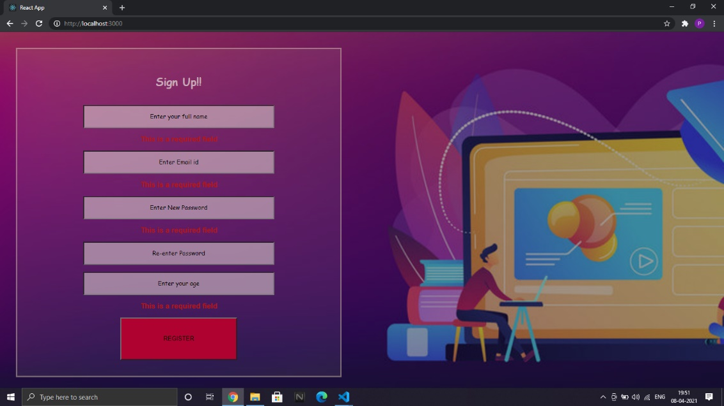It is necessary to make sure that the users’ personal data is kept confidential. So in order to access this website, the users must have registered with our website providing all the necessary information such as name, email id, age etc. The users must set a password of at least six characters while registering.

Figure 1: Register form to sign up

After registering the user can log in with the valid user id and password set by them.

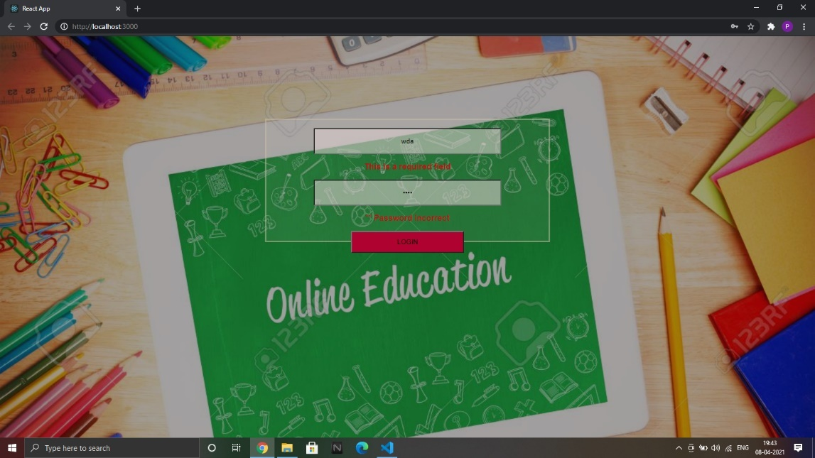

Figure 2: Login page for user

### DATA PRE-PROCESSING

The data sets are taken from Google quickdraw for doodle recognition, Kaggle datasets for digit and alphabet recognition.

They are manually divided into three categories as easy, medium, and hard With 30 categories each.

We randomly shuffle the data and take 70% for training and the rest for testing.

The images are pre processed into 28 x 28 pixel matrices and converted into Gray scale images.as we don’t need colour for feature extraction in our project.

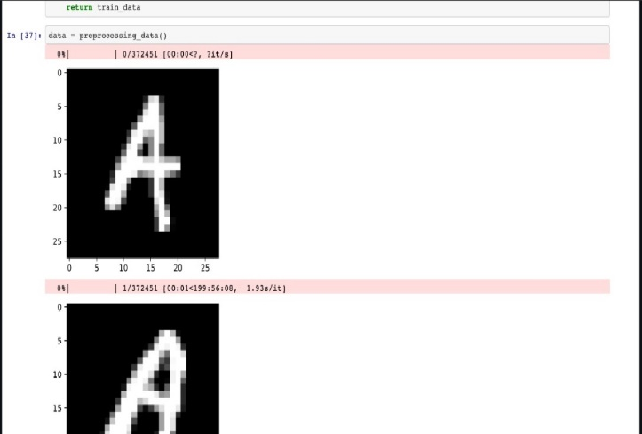

Figure 3:Data for Alphabets

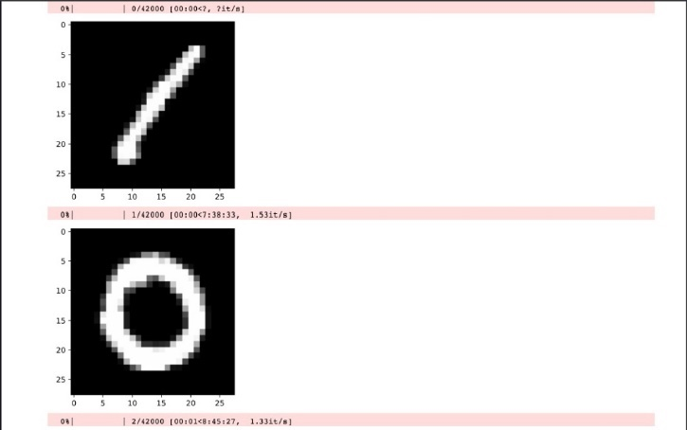

Figure 4:Data for Digits

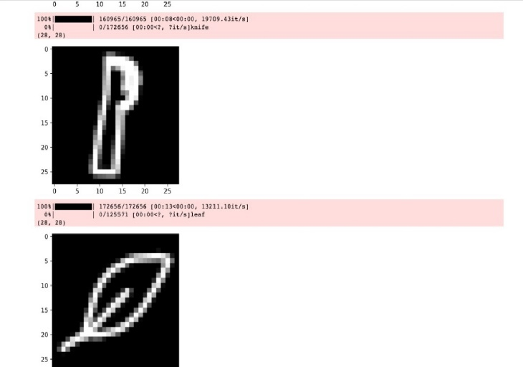

Figure 5:Data for doodle

## REFERENCES

1. Anchit Shrivastava, Isha Jaggi, Shefali Gupta, Deepali Gupta “Handwritten digit recognition using machine learning: A review”

<https://ieeexplore.ieee.org/abstract/document/8976601/authors#authors>.

1. Tsung-Han Tsai, Po-Ting Chi, Kuo-Hsing Cheng “The sketch classifier technique with deep learning models realised in an embedded system”

<https://ieeexplore.ieee.org/document/8724656/authors#authors>.

1. Olisah Kingsley S and Mohamed Ismail Z “web-based E-learning for system for pre-school kids

<https://www.researchgate.net/publication/319360301_Web_Based_E-learning_System_for_Pre-school_Kids>

1. Rahul Chauhan, Kamal Kumar Ghanshala, R.C Joshi “convolutional neural network (CNN) for image detection and recognition”

<https://ieeexplore.ieee.org/document/8703316>

1. Kristine Guo, James WoMa, Eric Xu “Quick, Draw! Doodle Recognition” <http://cs229.stanford.edu/proj2018/report/98.pdf>