AI

ASSIGNMENT-2

Yash Patel
Team : 75
201301134
CSE, IIIT-H
PART-A

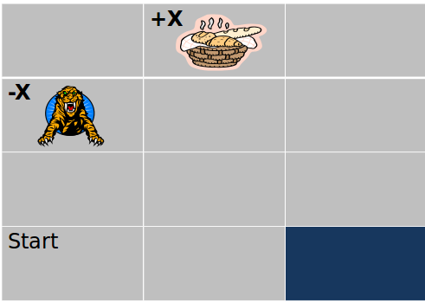

Problem Details :

1). X = 75 (team numebr = 75)
2). Gamma = 1
3). Delta = 3.5
4). Actions = {'move_north', 'move_south', 'move_east', 'move_west'}
5). P(intended_action) = 0.8 ; P(perpendicular_action) = 0.1(each).
6).R(s,a) = -3.5 for non-termainal states.
6). No action is performed at terminal states.

Problem Statement :
Part A : Perform the Value Iteration algorithm manually on the above MDP to calculate the reward achieved for the given start state. The cell (0,1) is the positive sink whereas cell (1,0) is the negative sink. The dark colored cell is blocked(assume it is a wall). All the four corner sides of the matrix are also considered to be walls. Replace X with your respective reward value. The parameters gamma and delta are as mentioned above.

Team number = 75;

ITERATION: 0.000000
48.750000 75.000000 56.250000
-75.000000 48.750000 -3.750000
-3.750000 -3.750000 -3.750000
-3.750000 -3.750000 0.000000

ITERATION: 1.000000
53.625000 75.000000 61.500000
-75.000000 48.375000 45.750000
-7.500000 34.500000 -7.500000
-7.500000 -7.500000 0.000000

ITERATION: 2.000000
54.112499 75.000000 66.974998
-75.000000 53.325001 54.862499
15.600000 33.450001 35.549999
-11.250000 22.350000 0.000000

ITERATION: 3.000000
54.161251 75.000000 68.433746
-75.000000 54.236252 60.648750
14.385000 44.025002 47.040001
14.565001 24.120001 0.000000

ITERATION: 4.000000
54.166126 75.000000 69.158249
-75.000000 56.671501 62.485497
25.426502 45.781502 53.875500
18.441000 35.338501 0.000000

ITERATION: 5.000000
54.166611 75.000000 69.414375
-75.000000 58.316547 63.492302
27.219301 49.517403 56.204098
28.907551 38.253151 0.000000

ITERATION: 6.000000
54.166660 75.000000 69.540665
-75.000000 59.495583 63.962387
31.254677 51.245579 57.615990
32.465206 42.579994 0.000000

ITERATION: 7.000000
54.166664 75.000000 69.600304
-75.000000 60.044468 64.228333
32.992985 52.733532 58.306068
36.685982 44.750984 0.000000

ITERATION: 8.000000
54.166668 75.000000 69.632866
-75.000000 60.406021 64.357521
34.605423 53.415482 58.736626
39.018684 46.580521 0.000000

ITERATION: 9.000000
54.166668 75.000000 69.649040
-75.000000 60.577568 64.432648
36.267036 53.937954 58.951229
40.876827 47.542305 0.000000

ITERATION: 10.000000
54.166668 75.000000 69.658173
-75.000000 60.689911 64.470253
37.971962 54.233879 59.085037
41.998230 48.242275 0.000000

ITERATION: 11.000000
54.166668 75.000000 69.662842
-75.000000 60.749588 64.492554
39.069168 54.507629 59.158092
42.840839 48.661156 0.000000

ITERATION: 12.000000
54.166668 75.000000 69.665543
-75.000000 60.794807 64.504486
39.880352 54.672398 59.210617
43.369926 49.006302 0.000000

ITERATION: 13.000000
54.166668 75.000000 69.667000
-75.000000 60.820831 64.512360
40.401215 54.794945 59.241890
43.780067 49.225540 0.000000

ITERATION: 14.000000
54.166668 75.000000 69.667938
-75.000000 60.839386 64.516922
40.793671 54.870975 59.263573
44.048561 49.386517 0.000000

Policy according to MDP (MAPPED TO GRID):
RIGHT TERMINAL LEFT
TERMINAL RIGHT UP
RIGHT UP UP
LEFT UP NONE

Path from start:
LEFT->UP->UP->RIGHT->UP->LEFT

PART-B

Part B : Modelling the above problem using LP show below.
Q1: Model the parameters r, A and α
Q2: Use the excel LP solver to compute the x values and the expected reward for this
MDP
Q3: Please verify that the expected reward obtained is equivalent to the one obtained
using the VI algorithm. The VI value and LP value can differ at max by Delta*1.2.

Answer : The expected reward from LP is 38.68715929 which is quite close to Value Iteration which is 39.018684(after 8th iteration).

Other parameters are mentioned in excel.

