**STOCK PRICE PREDICTION USING MACHINE LEARNING**

***A Mini Project Report***

***Submitted in Partial Fulfillment for the Award of***

BACHELOR OF TECHNOLOGY

IN

COMPUTER SCIENCE & ENGINEERING (DS & AI)

By

YASH (2015200)

6th Semester 2021-22



Guided by:

Mr. Prabhdeep Singh

(Resource Person)

**DEPARTMENT OF COMPUTER SCIENCE AND ENGINEERING**

# GRAPHIC ERA DEEMED TO BE UNVERSITY, DEHRADUN

# Acknowledgement

I would like to express my sincere gratitude to Mr. Prabhdeep Singh of the department of Computer Science, whose role as project guide was invaluable for the project. I am extremely thankful for the keen interest he took in advising me. I convey my gratitude to all the teachers for providing us the technical skill that will always remain as my asset.

Last but not the least, I wish to thank my parents for financing my studies in this college as well as for constantly encouraging me to learn new things.

Place: Dehradun Name: Yash

**Table of Contents**

1. **INTRODUCTION……………………………………………………….**
   1. **Purpose……………………………………………………….**
   2. **Abstract…………………………………………**
   3. **System Overview…………………………………………….**
   4. **Problem Statement……………………………………………**
2. **REQUIREMENTS SPECIFICATIONS…………………………………**
   1. **Hardware Requirements……………………………………....**
   2. **Software Requirements……………………………………….**
   3. **Technique used……………………………………………….**
3. **DATA PREPROCESSING AND RESULT ANALYSIS……………………………………………………………...**
4. **CONCLUSION……………………………………………………….**

**INTRODUCTION**

* 1. **Purpose**

The Purpose of this document is to give a detailed description of Stock-Price-Prediction Project. It will illustrate the purpose and complete declaration for the development of system. This document is primarily intended to anyone who wants to get an overview of how this project works, its outcomes and possible usages in future.

* 1. **Abstract**

Stock market prediction is a major exertion in the field of finance and establishing businesses. Stock market is totally uncertain as the prices of stocks keep fluctuating on a daily basis because of numerous factors. So we need very higher degree of accuracy in order to predict the price of stock market. The solution to predict the stock price is Machine learning. ML algorithms have been used to devise new techniques to build prediction models that can forecast the prices of stock and tell about the market trend with good accuracy.

* 1. **System Overview**

This project has been made independently as a part of the college curriculum and submitted as the mini project for 6th semester. The project is made on the topic “**Stock Price Prediction Using Machine Learning**” in “Python”. The input to our system will be historical data from Yahoo Finance.

* 1. **Problem Statement**

Investors are familiar with the saying, “buy low, sell high” but this does not provide enough context to make proper investment decisions. Before an investor invests in any stock, he needs to be aware how the stock market behaves. Investing in a good stock but at a bad time can have disastrous results, while investment in a mediocre stock at the right time can bear profits. Financial investors of today are facing this problem of trading as they do not properly understand as to which stocks to buy or which stocks to sell in order to get optimum profits. Predicting long term value of the stock is relatively easy than predicting on day-to-day basis as the stocks fluctuate rapidly every hour based on world events.

**REQUIREMENT SPECIFICATIONS**

**2.1 Hardware Requirements**

* Memory: 1GB
* Storage: 1GB
* CPU Cores: 0.5

**2.2 Software Requirements**

* Language used: Python
* Jupyter Notebook
* Dependencies:
  + PyPlot
  + Pandas
  + Matplotlib
  + Sklearn
  + Tensorflow
  + Keras

**2.3 Technique used**

**1. RNN**s (Recurrent neural networks) are robust and powerful type of neural network and are considered one of the most professional algorithms because they are the only ones with internal memory. The algorithm performs very well for sequential data such as time series, speech, text, financial data, audio, video, weather, and more. RNNs are able to form a much deeper understanding of a sequence and its context compared to other algorithms.

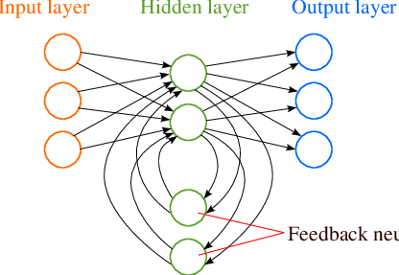

**Recurrent Neural Network**

**2. Long short-term memory** networks are an extension of recurrent neural networks, which basically extend the memory. Therefore it is well suited to learn from important experiences that have very long time lags in between.

LSTMs enable RNNs to remember inputs over a long period of time. This is because LSTMs contain information in a memory, much like the memory of a computer. The LSTM can read, write and delete information from its memory.

In an LSTM you have three gates: input, forget and output gate. These gates determine whether or not to let new input in (input gate), delete the information because it isn’t important (forget gate), or let it impact the output at the current timestep (output gate).

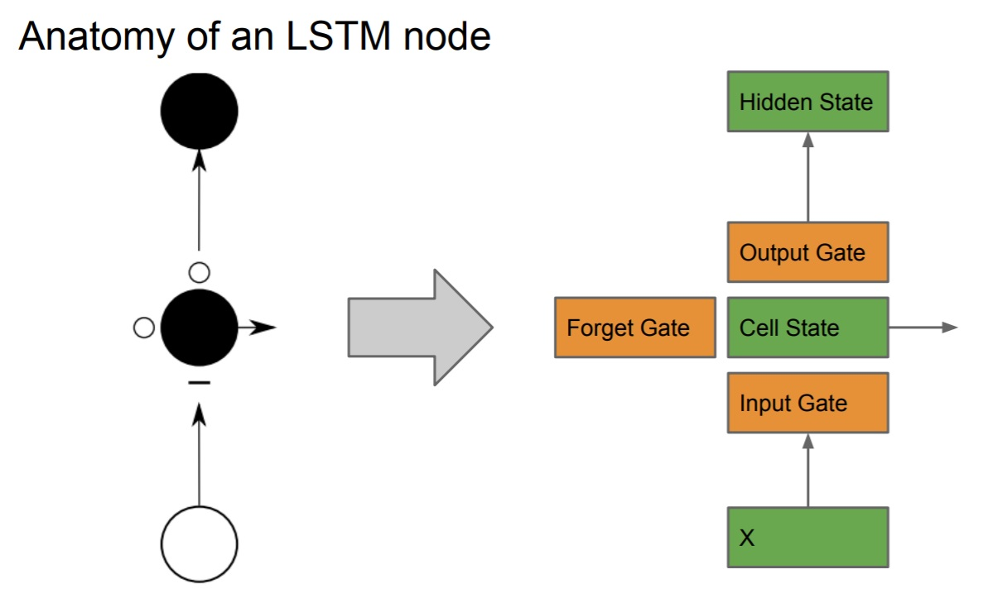

**DATA-PREPROCESSING**

### **DATA NORMALIZATION**

The neural network must load data taking large amounts of different data. Doing so can create major gradient updates that will prevent the network from changing. Doing reading easy on the network, data should have the following features:

* Take small values- Typically most values should be in range 0-1.
* Be homogeneous- That is, all features should take values at roughly the same range.

The goal is to change the values of numeric columns in the data set to a common scale, without distorting differences in the ranges of values.

**Min-MaxScaling**, where the data inputs are mapped on a number from 0 to 1

x’ = x- min(X)/max(X)-min(X)

**RESULT ANALYSIS**

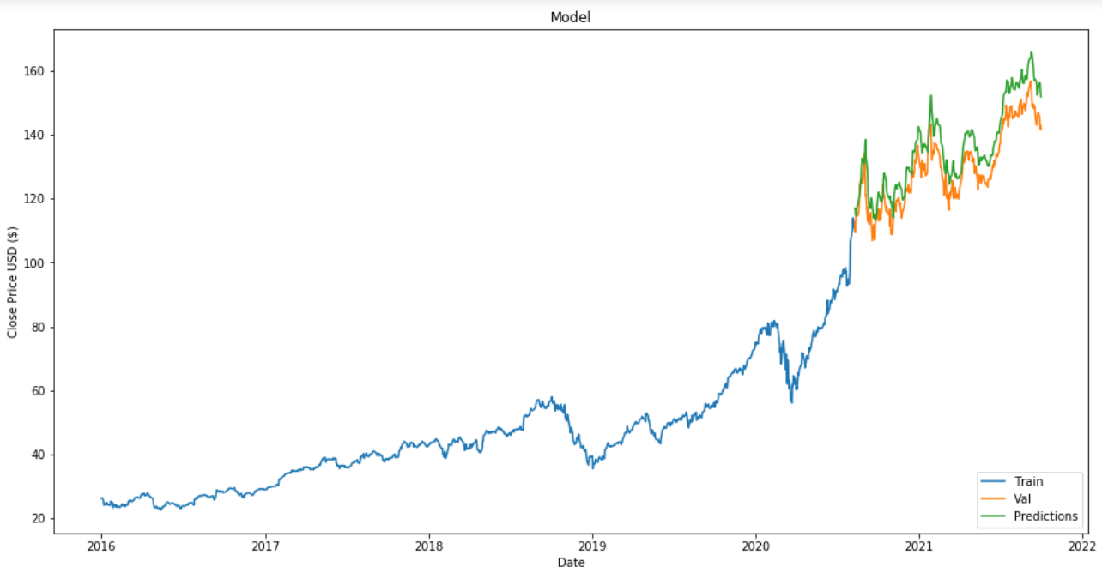

**CONCLUSION**

This project made me get more deep understanding of RNN and LSTM, a very good project that will be helpful to those who are involved in stock market. RNNs and LSTM are excellent technologies and have great architectures that can be used to analyze and predict time-series information.

These models can also be used for other predictions as well as for speech recognition, voice to text conversion, data analysis etc.