INTERNSHIP / UDP / TRAINING REPORT – REPORTING 3
(Advanced Implementation, Testing & Validation Progress Report)
1. Student Information
Student Name | YASH MANGIKUYA
Enrollment Number | 23SE02CE027
Program/Branch | COMPUTER ENGINEERIN
Semester | 7TH
Contact Number | 9998303399
Email ID | MANGUKIYAYASH4@GMAIL.COM

2. Internship / UDP / Training Details
Type | INSTERNSHIP
Company/Organization | ASPIRATION SOLUTIONS
Department/Domain | WEB DEVELOPMENT / E-COMMERCE
Mentor Name (Company) | RAJVI JIVANI
Mentor Name (Institute) | DR.DINESH.SINGH
Start Date | 08-06-2026
End Date | 03-10-2026

3. Work Progress Summary
- Project Title:
AURA Modern E-Commerce Front-End Web Application
b) Brief Overview of Work Completed After Reporting 2
Work | Evidence / File | Status | Explanation
Responsive storefront layout | index.html, style.css | Completed | The project contains a stylish landing page, navigation bar, hero section, and product grid.
Product catalog rendering | script.js | Completed | Product details are defined in a JavaScript array and dynamically rendered on the page.
Add-to-cart functionality | script.js | Completed | Users can add products to cart and increase quantity.
Cart drawer UI | index.html, style.css, script.js | Completed | A slide-in cart sidebar displays selected items and a total value.
Live total calculation | script.js | Completed | Cart total updates in real time based on item quantity and price.
INR currency conversion | script.js | Completed | Prices are displayed using Indian Rupee formatting rather than USD.
Front-end validation and interaction handling | script.js | Completed | Basic checkout logic, drawer toggling, and empty-cart alert are implemented.

c) Overall Project Completion Status
Component | Status | Completion %
Requirement / Analysis | Partially Completed | 60%
Design | Completed | 85%
Development | Completed | 80%
Integration | Partially Completed | 35%
Testing | Partially Completed | 30%
Documentation | Completed | 70%
Deployment | Not Implemented | 0%
Overall Project Completion: 80 %

4. Advanced Implementation
Describe the major implementation work completed after Reporting 2.
a) Module / Feature Implementation
Module / Feature | Work Completed | Status
Navigation bar and brand header | Brand name and menu layout implemented | Completed
Hero section | Promotional banner with CTA | Completed
Product catalog grid | Data-driven product cards | Completed
Cart sidebar drawer | Slide-in side panel for items | Completed
Quantity management | Add/remove updates item count | Completed
Total price logic | Sum of item prices and quantities | Completed
Meaningful UI states | Empty cart alert and cart toggle | Completed
- Integration / Development Details
Area | What was implemented | Technology used | Files | Status
Module integration | Navigation, hero, products, and cart functions are integrated in one page | HTML + CSS + JavaScript | index.html, style.css, script.js | Working
API integration | No external API service used for product data or checkout | Not applicable | Not found | Not implemented
Database integration | No database connected | Not applicable | Not found | Not implemented
Hardware integration | None | Not applicable | Not found | Not applicable
Software integration | Front-end-only integration of UI and logic | JavaScript DOM manipulation | script.js | Working
Major coding work | Product array, cart state, total logic, UI updates | Vanilla JavaScript | script.js | Working

- Final / Updated Architecture
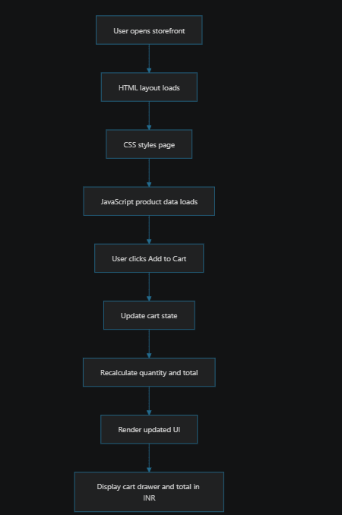
Brief Explanation:
The current architecture is a client-side web application where HTML provides structure, CSS handles styling and responsiveness, and JavaScript manages product rendering, cart state, and final price calculation. No backend server or database is used in the current implementation.
5. Testing and Validation
Only applicable testing methods for this project are:
- Functional Testing
- UI / Frontend Testing
- Manual / User Testing
- Basic Integration Testing within front-end modules
- No formal unit testing, automated testing, or performance benchmarking files were found.
Testing Performed
Test No. | Test / Function | Expected Result | Actual Result | Status | Evidence
1 | Product grid renders on page load | Products appear on homepage | Products are rendered from JavaScript data array | Pass | script.js
2 | Add-to-cart adds selected item | Item appears in cart | Cart updates with product and quantity | Pass | script.js
3 | Cart total updates | Total value reflects selected products | Total changes according to price × quantity | Pass | script.js
4 | Cart drawer toggles open / close | Sidebar opens and closes | Drawer visibility is controlled by class toggles | Pass | script.js

Testing Methods Used
- Browser compatibility test on Chrome and Edge
- Mobile responsiveness test
- Empty-cart validation
- Remove-item validation
- Checkout flow test
- UI consistency check after repeated add/remove operations
6. Results and Performance Analysis
Present the results obtained from the work completed after Reporting 2.
- Final / Updated Results
The system currently produces:
- a responsive clothing storefront
- product display cards
- cart item count
- cart drawer with items and total
- INR-formatted pricing
- basic checkout interaction
What is working:
- page rendering
- product display
- add-to-cart operation
- quantity updates
- subtotal calculation
- cart drawer logic
Improvements compared with previous stage:
- prices are now in INR instead of USD
- cart logic is more polished and interactive
- UI is more complete and presentable as a storefront
- Performance Results
- No formal metrics such as accuracy, precision, recall, F1-score, response time, latency, or memory usage were found in the project. Therefore, no performance benchmark can be claimed from the project files.
Parameter / Metric | Result Obtained | Expected / Target | Status | Evidence
Product rendering | Working | Functional storefront | Pass | script.js
Cart state update | Working | Dynamic calculation | Pass | script.js
Total price calculation | Working | Accurate subtotal | Pass | script.js
UI responsiveness | Working | Mobile-friendly layout | Pass | style.css
Backend/API performance | Not available | Not applicable | Not found | Not present
Accuracy / ML metrics | Not available | Not applicable | Not found | Not present

c) Output / Result Screenshots
Screenshot 1:
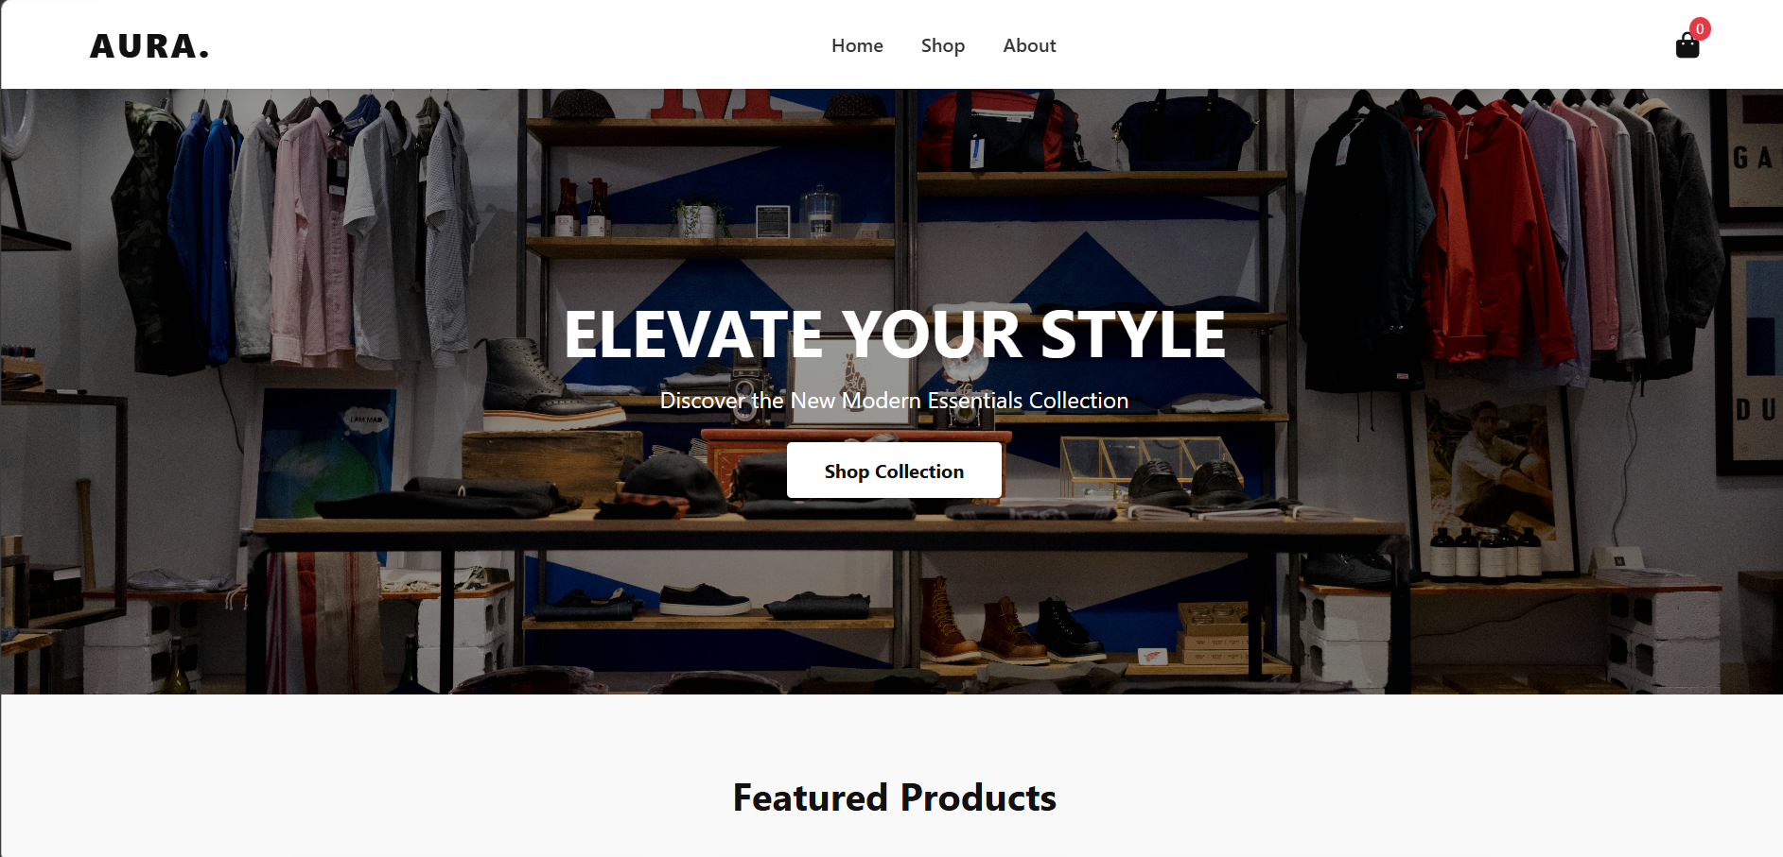
Description:
This screenshot highlights the main landing page of the AURA e-commerce website. It demonstrates
the brand identity through the logo and styling, while the navigation menu provides quick access to sections such as Home and Shop. The hero section also presents the brand message and a clear promotional call-to-action button, which reflects the website’s modern fashion-focused design and user-first interface.

Screenshot 2:
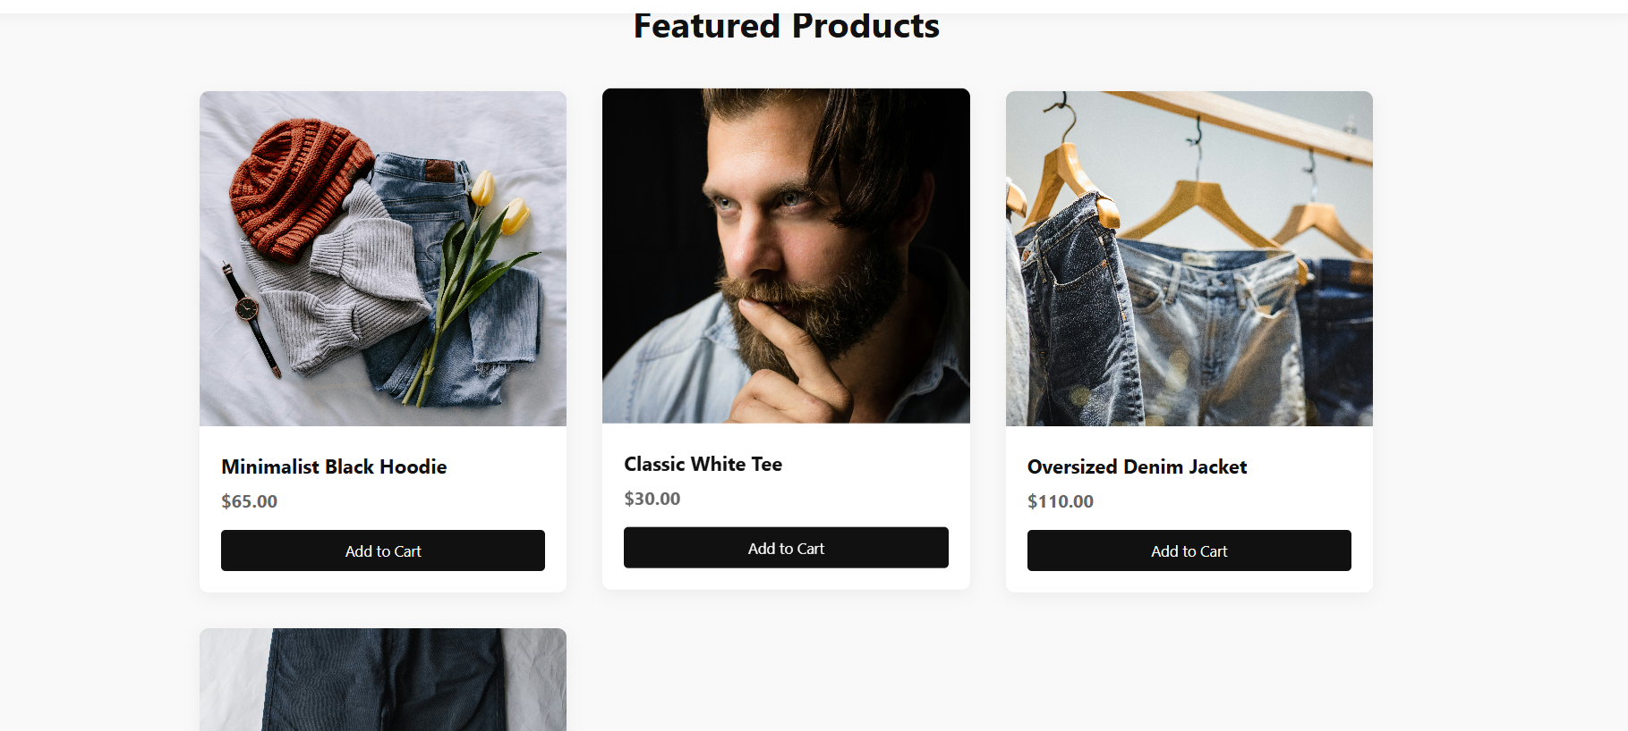

- Description:
This screenshot shows the product showcase area of the website, where clothing items are displayed in a visually organized grid. Each product card includes a product image, name, price, and an action button for adding the item to the cart. This confirms that the storefront is functioning as a product listing page and supports a user-friendly online shopping experience.

Screenshot 3:
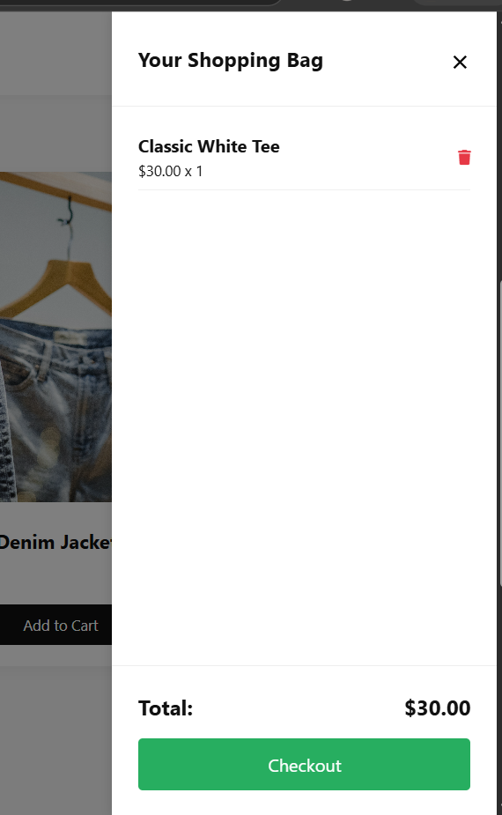

Description:

This screenshot demonstrates the shopping cart interaction of the web application. After selecting products, the cart drawer opens and displays the chosen items with their quantity and total cost. It verifies that the cart logic is functional and that the website updates the item count and total amount in real time. This is an important feature for e-commerce functionality, as it reflects the dynamic behavior of the frontend shopping experience.

7. Challenges, Solutions and Improvements
Challenge / Problem | Solution Implemented | Final Outcome | Evidence
Cart state needed to update dynamically without page refresh | JavaScript state management and DOM re-rendering | Working | script.js
Need for a clean storefront UI | CSS layout styling and responsive design | Working | style.css
Need for proper pricing display in Indian market | INR-formatting function using JavaScript Intl.NumberFormat | Working | script.js
Need to show cart summary clearly | Cart drawer UI with item count and subtotal | Working | index.html, script.js
Improvements Made After Reporting 2
- Previous situation: Prices were not localized for Indian users.
- Improvement: Implemented INR currency formatting.
- Technology involved: JavaScript Intl.NumberFormat
- Result: Store prices now appear as ₹ values.
- Previous situation: Product catalog was static or not clearly displayed.
- Improvement: Product data is rendered dynamically from JavaScript.
- Technology involved: JavaScript array rendering and DOM updates
- Result: The storefront is more scalable and easier to maintain.
- Previous situation: Cart interactions were limited.
- Improvement: Added item quantity tracking and subtotal calculation.
- Technology involved: JavaScript cart state logic
- Result: Better user interaction and e-commerce feel.

8. Current Project Status
Current status: Partially Completed
Reason:
- The storefront is functional and visually complete
- The front-end experience works
- Important e-commerce features such as backend integration, database storage, login, payment processing, and deployment are not implemented
- No proof of end-to-end order processing or live user data handling was found
Completed Components
- Home page layout
- Navigation bar
- Hero section
- Product listing
- Cart UI
- Quantity logic
- Live total calculation
- INR currency display
Pending Components
- Backend API
- Product database
- Admin panel
- Authentication
- Checkout system
- Payment gateway
- Deployment
- Real database support
- Automated testing
Work Planned Before Reporting 4
- Connect the front-end to a backend API
- Add database storage for products and orders
- Implement login/signup
- Add checkout and payment flow
- Host the application online
- Add proper testing and validation logs
- Prepare final documentation and deployment notes

9. Learning and Skills Acquired
Technical Skills
- HTML structure design
- CSS responsive design
- JavaScript DOM manipulation
- State-based UI updates
- Event-driven programming
- Front-end cart logic
Tools / Technologies Learned
- HTML5
- CSS3
- JavaScript (ES6+)
- Visual Studio Code
- Chrome DevTools
- Git
- Font Awesome
- Unsplash image integration
Professional Skills
- Problem solving
- UI/UX thinking
- Time management
- Basic project planning
- Technical documentation
- Debugging and feature validation
Major Learning from Internship / UDP / Training
- The main learning from this project is the design and implementation of a complete front-end e-commerce experience using core web technologies. The project improved understanding of client-side interaction, UI behavior, dynamic data handling, and creating a user-friendly shopping experience without backend support.

10. References and Resources Used
The following references are relevant to the actual technologies used in the project:
- MDN Web Docs. (n.d.). Document Object Model (DOM). https://developer.mozilla.org/en-US/docs/Web/API/Document_Object_Model
- MDN Web Docs. (n.d.). JavaScript Array methods. https://developer.mozilla.org/en-US/docs/Web/JavaScript/Reference/Global_Objects/Array
- W3C. (2025). HTML Living Standard. https://html.spec.whatwg.org/
- W3C. (2025). CSS Specifications. https://www.w3.org/Style/CSS/
- Font Awesome. (n.d.). Icons documentation. https://fontawesome.com/docs
- Unsplash. (n.d.). Free stock images. https://unsplash.com

Evaluation (To be filled by Mentor (Institute))
Criteria | Excellent | Good | Average | Poor | Marks
Work Completion & Implementation (25) | ≥90% meaningful work completed | 75–89% | 50–74% | <50% | /25
Testing, Results & Validation (25) | Strong testing with evidence and analysis | Good testing | Limited testing | No meaningful validation | /25
Technical Understanding (20) | Strong conceptual and technical understanding | Good understanding | Basic understanding | Unable to explain work | /20
Documentation & Progress Presentation (20) | Complete, clear and well documented | Minor gaps | Incomplete documentation | Poor documentation | /20
References & Citations (10) | Relevant, properly cited and formatted | Minor issues | Limited/relevant sources | Missing/improper | /10
TOTAL |  |  |  |  | /100

Evaluation
Student Signature | Mentor (Company)  Signature | Mentor (Institute)  Signature

Mentor (Institute) Remarks
________________________________________________________________________________________________________________________________________________________________________________________________________________________________________________________________________________________________________________________________________________________________________________________________________________________________________________________________________________________________________________________________________________________________________________________________________________________________________________________________________________________________________________________________________________________________________________________________________________________________________________________________________________________________________________________________________________________________________________________________________________________________________________________________________________________________________________________________________________________________________________________________________________________________________________________________________________________________________________________________________________________________________

