

**By Semester 8th of 4th Year**

**M.Sc. (CA & IT)**

Submitted By : - Ashutosh Mer (4026)

Aagam Gopani (4101)

Group Id : - 14

Submitted To : - K.S. SCHOOL OF BUSINESS MANAGEMENT

Project Title : - Online Bakery Shop

Name of Shop : - Krishna Bakery

Date of Submission: - 17th March 2021

**INDEX**

1. **Introduction**
   1. Organization Profile
   2. Project Details
      1. Current system
      2. Proposed system
   3. Scope
   4. Objectives
2. **Requirement gathering**
   1. Stakeholder
   2. Requirement gathering technique used
   3. Consolidated list of requirements
   4. Project Definition
3. **Project Management & Planning**
   1. Feasibility study
      1. Technical
      2. Economic
      3. Operational
   2. H/W S/W Requirement
   3. Project Planning
      1. Work Breakdown structure
      2. Gantt Chart
   4. Project Model
4. **Analysis & Design**
   1. UML Diagram
   2. System Flow Structure
   3. Data Dictionary
   4. User Interface
5. **Summary**
   1. Assumptions
   2. Limitation
   3. Conclusion

5.4 Future Scope

**Chapter: -1**

**(1.1) Organization Profile: -**

Name of Organization: - Krishna Bakery Shop

About Organization: -

**Krishna Bakery Shop,** is a bakery shop situated in Surendranagar. They are leading market seller in bakery items in whole Surendranagar. They are having 4 different outlets in Surendranagar and currently selling many imported items too. This bakery cum patisserie set shop and soon enough it came to be known for mouth-watering delicious baked treats. This bakery serves an assortment pure-vegetarian treats such as cakes, pastries, cookies, snacks, puddings, mousse, cheesecakes and muffins.

**(1.2) Project details: -**

Online Bakery Shop will help the brand to increase the reach to non-delivery rural areas. With increment in digital ecosystem, it is necessary now to adopt online delivery-based system. it's useful for customer to get bakery items delivered at doorstep.

**(1.2.1) Current System: -**

* Shopping is a very integral part of everybody’s life.
* Usually, customers have to go to the store, and buy their desired items by paying with cash, or card.
* It’s an orthodox way of shopping in today’s digital world where the person’s time and money are getting wasted.

**(1.2.2) Proposed System:-**

* Because of the above-mentioned problems in existing system, there is a need of a system that comes up with new features that helps consumer.
* This system would provide customers the feature of doorstep delivery, so they don’t have to stuck in a queue for daily needful items.
* This system will work as an online bakery website where users can buy items with their tip of fingers.
* Just by clicking a button, a user can place orders with pocket friendly deals and added benefits.

**(1.3) Scope: -**

* Online Bakery Shop is used to buy items for consumers who want to save money and the time both.
* This system will help the customer to choose between different food items according to their comfortable time.
* Online Bakery Shop provides buying convenience comparable to orthodox shopping, with less time and the added loyalty rewards.

**(1.4) Objective: -**

* Promoting a service or product online.
* Selling product online.
* Providing customer support.
* Establishing brand awareness.

**Chapter-2**

**(2.1) Stakeholder of System: -**

There are mainly two types of stakeholders in System: -

**1) Admin: -**

Admin will work with full access and updating regularly and also manage control panel according to rights given by authority. Admin can see the orders of users and can take action regarding those orders. Admin will work on database and handle all the essential requests of users by their feedback.

**2) Users: -**

The users of the application are consumers who want to buy bakery items online. Any user of the application can act as:

* User is a any person who can search through products, and place order of any desired items with the help of this proposed system.
* Users can pay via digital wallets.

**(2.2) Requirement gathering technique used: -**

### 1) Questionnaires: -

### Questionnaires are much more informal, and they are good tools to gather requirements from stakeholders in remote locations. In this we create the form of questions and give it to the owner of the organization to complete it. So that we easily get the requirements for the system. The Questionnaires are as follows:

1. What problems are you facing doing it manually?

Ans) Wastage of time by calling or messaging customers for the bakery items and to inform about any update becomes a tedious work.

1. What requirement do you want in the current system?

Ans) we want our system to do all the functionality online, which reduces time and increase efficiency.

1. How you want your system designed/made?

Ans) we want our system to be user friendly and create less redirection pages.

1. How do you share information to the customers without using website?

Ans) Through mobiles and other communication devices

1. How frequently you need to change/update data?

Ans) whenever bakery items sold out, the data has to be updated.

1. How much time will you give for the maintenance break?

Ans) Our website will use by the users at different point of time, so if any bug is fetched, use the midnight if possible.

1. What would be deadline-End date for your website to be completed?

Ans) Try to complete the website before end of the march.

**2.3) Consolidated list of requirements: -**

* In this the owner of the organization is looking for the system which can make daily transportation way easier and better for people who doesn’t own a car and want to travel one place to another.

* The owner of the organization is planning for give us the work to develop the website for their organization.

* Owner of the organization is receiving the payment of the service in the cash or online payment.

* Driver or carpooled who owns a car will communicate to the customers through smart phone.

* There is web-based system for the organization.

* When a car is booked, Customer details will be sent to the admin .After that admin will inform the particular allocated driver.

**(2.4) Project Definition: -**

* The title of our project is “Online Bakery Shop”. An online Bakery shop that allows users to check for various bakery products available at the online store and purchase online.
* The project consists of list of bakery products displayed in various categories. The user may browse through these items as per categories.
* If the user likes a product, he may add it to his shopping cart. Once user wishes to checkout, he must register on the site first.
* He can then login using same id password next time. Now he may pay through a credit card/debit card or cash on delivery.
* Once the user makes a successful transaction, he gets a copy of the shopping receipt on his email id. Here we use user friendly interface to make the entire frontend. The middle tier or code behind model is designed for fast processing.
* SQL serves as a backend to store bakery products lists data. Thus, the online Bakery shopping project brings an entire bakery shop online and makes it easy for both buyer and seller.

**Chapter – 3**

**(3.1) Feasibility** **Study: -**

The feasibility study of a project determines whether it is possible to develop the project as per user **requirements**. It shows the level of satisfaction that the customer and the developer will want from proposed system. We have taken some time in feasibility **study.**

**(3.1.1) Technical Feasibility: -**

Technical Feasibility defines whether system is technical feasible to develop or not. We develop this system in PHP. We are using following tools and technology.

* Front-End – Html5, Css3, JS, jQuery, Bootstrap.
* Technology – PHP, Web technology.
* Tools – Visual Studio Code
* Back-End – Php
* Database – MySQL
* Server – Apache

We have all setup environment and tools available to develop project so our system is Technically Feasible.

**(3.1.2) Economic Feasibility: -**

Economic Feasibility defines that whether development of this project is financial benefit for client and develop or not. As we are developing this website in a PHP and it is an open source so all the required tools and server configuration freely available. So, our system is Economically Feasible.

**(3.2.2) Operational Feasibility: -**

Operational Feasibility defines the whether all the client requirements are satisfied or not. We study our website and gather detail requirements for the website. We also gather requirement from document study and studying similar system and identified requirements.

* Registration
* Login
* Order Management
* User Management

Based on that study we are able to develop all the requirement for the system.

**(3.2) Hardware & Software Requirements: -**

**Software Requirement:**

**Operating System :** Windows, Linux etc.

**Browser :** Which support JavaScript

**Bank-end** : PHP

**Database :** MySQL

**Front-end** : JavaScript, jQuery, HTML, CSS, Bootstrap

**Web Server** : Apache Tomcat 8

**Development Tool** : Visual Studio Code

**Minimum Hardware Requirements:**

**PROCESSOR** : Pentium 4 or higher.

**RAM SIZE** : 1GB.

**HARD DISK DRIVE** : Less Than 1 GB.

**(3.3) Project Planning: -**

**(3.3.1) Work Breakdown Structure: -**

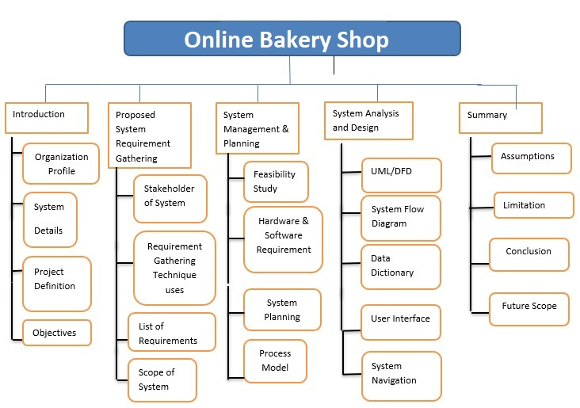

**(3.3.2) Gantt Chart: -**

|  |  |  |  |  |
| --- | --- | --- | --- | --- |
| **Activities** | **Dec’20** | **Jan’20** | **Feb’20** | **Mar’20** |
| **Project Scope** |  |  |  |  |
| **Requirement Gathering** |  |  |  |  |
| **Analysis** |  |  |  |  |
| **Designing** |  |  |  |  |
| **Documentation** |  |  |  |  |

**(3.4) Process Model: -**

* **Reasons to Use Waterfall Model as Process Model: -**
* This model is simple and easy to understand and use.
* Each phase has specific deliverable and a review process.
* In this model phases are processed and completed one at a time.
* Phases do not overlap.
* Waterfall model works well for our project.
* This model is well worked where requirements are well known and well understand.
* Easy to arrange the tasks.

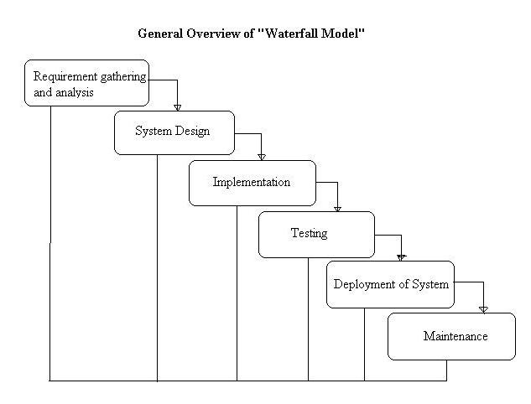

* **Requirement Gathering and analysis: -**

All possible requirements of the system to be developed are captured in this phase and documented in a requirement specification document.

* **System Design: -**

The requirement specifications from first phase are studied in this phase and the system design is prepared. This system design helps in specifying hardware and system requirements and helps in defining the overall system architecture.

* **Implementation: -**

With inputs from the system design, the system is first developed in small programs called units, which are integrated in the next phase. Each unit is developed and tested for its functionality, which is referred to as Unit Testing.

* **Testing: -**

All the units developed in the implementation phase are integrated into a system after testing of each unit. Post integration the entire system is tested for any faults and failures.

* **Deployment of system: -**

Once the functional and non-functional testing is done; the product is deployed in the customer environment or released into the market.

* **Maintenance: -**

There are some issues which come up in the client environment. To fix those issues, patches are released. Also, to enhance the product some better versions are released. Maintenance is done to deliver these changes in the customer environment.

**Chapter: - 4**

**4) Analysis and Design**

**4.1) UML Design: -**

1. **Use Case Diagram**

The Use case diagram is used to define the core elements and processes that make up a system. The key elements are termed as "actors" and the processes are called "use Cases." The Use case diagram shows which actors interact with each use case.

|  |  |
| --- | --- |
| Symbol | Description |
|  | **Use case**  Use cases describe what a system does, not how it  Does it. A use case contains multiple scenarios, each of which describes a  Specific flow of events through the use case. |
|  | **Actor**  An actor is a person, organization, or external system  that plays a role in one or more interactions with the System. |

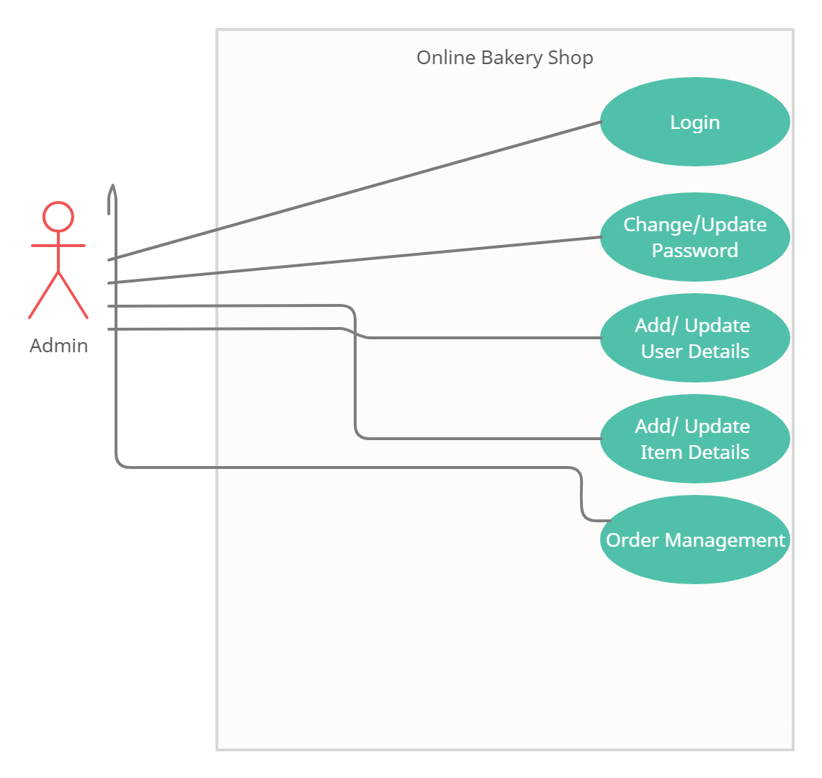

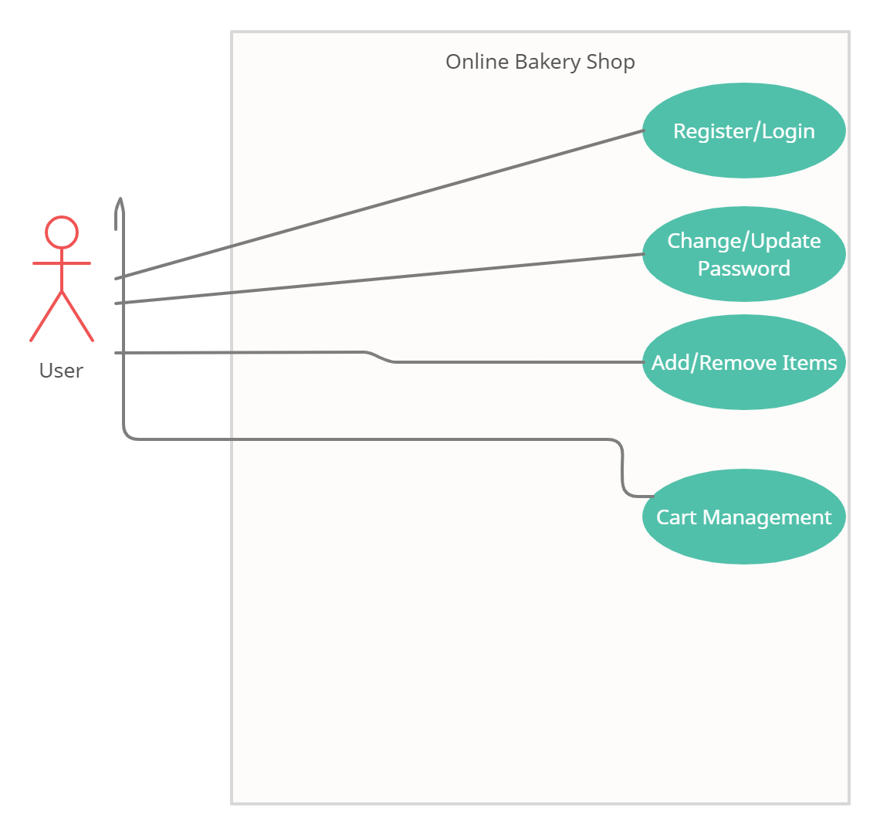

**Activity Diagram: -**

**Admin**

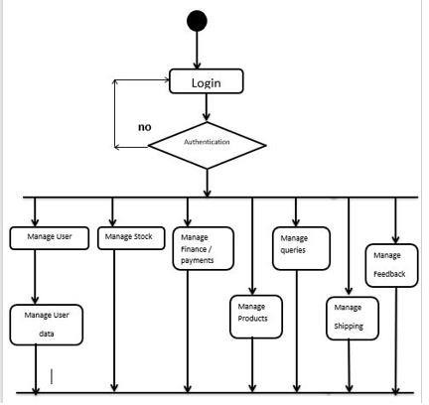

**User**

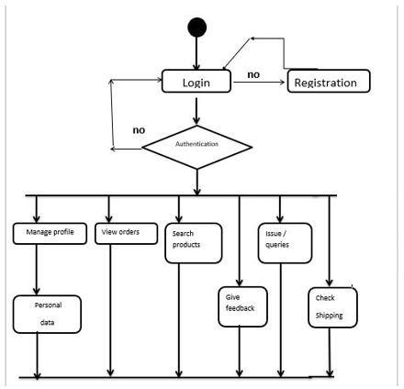

**Class Diagram**

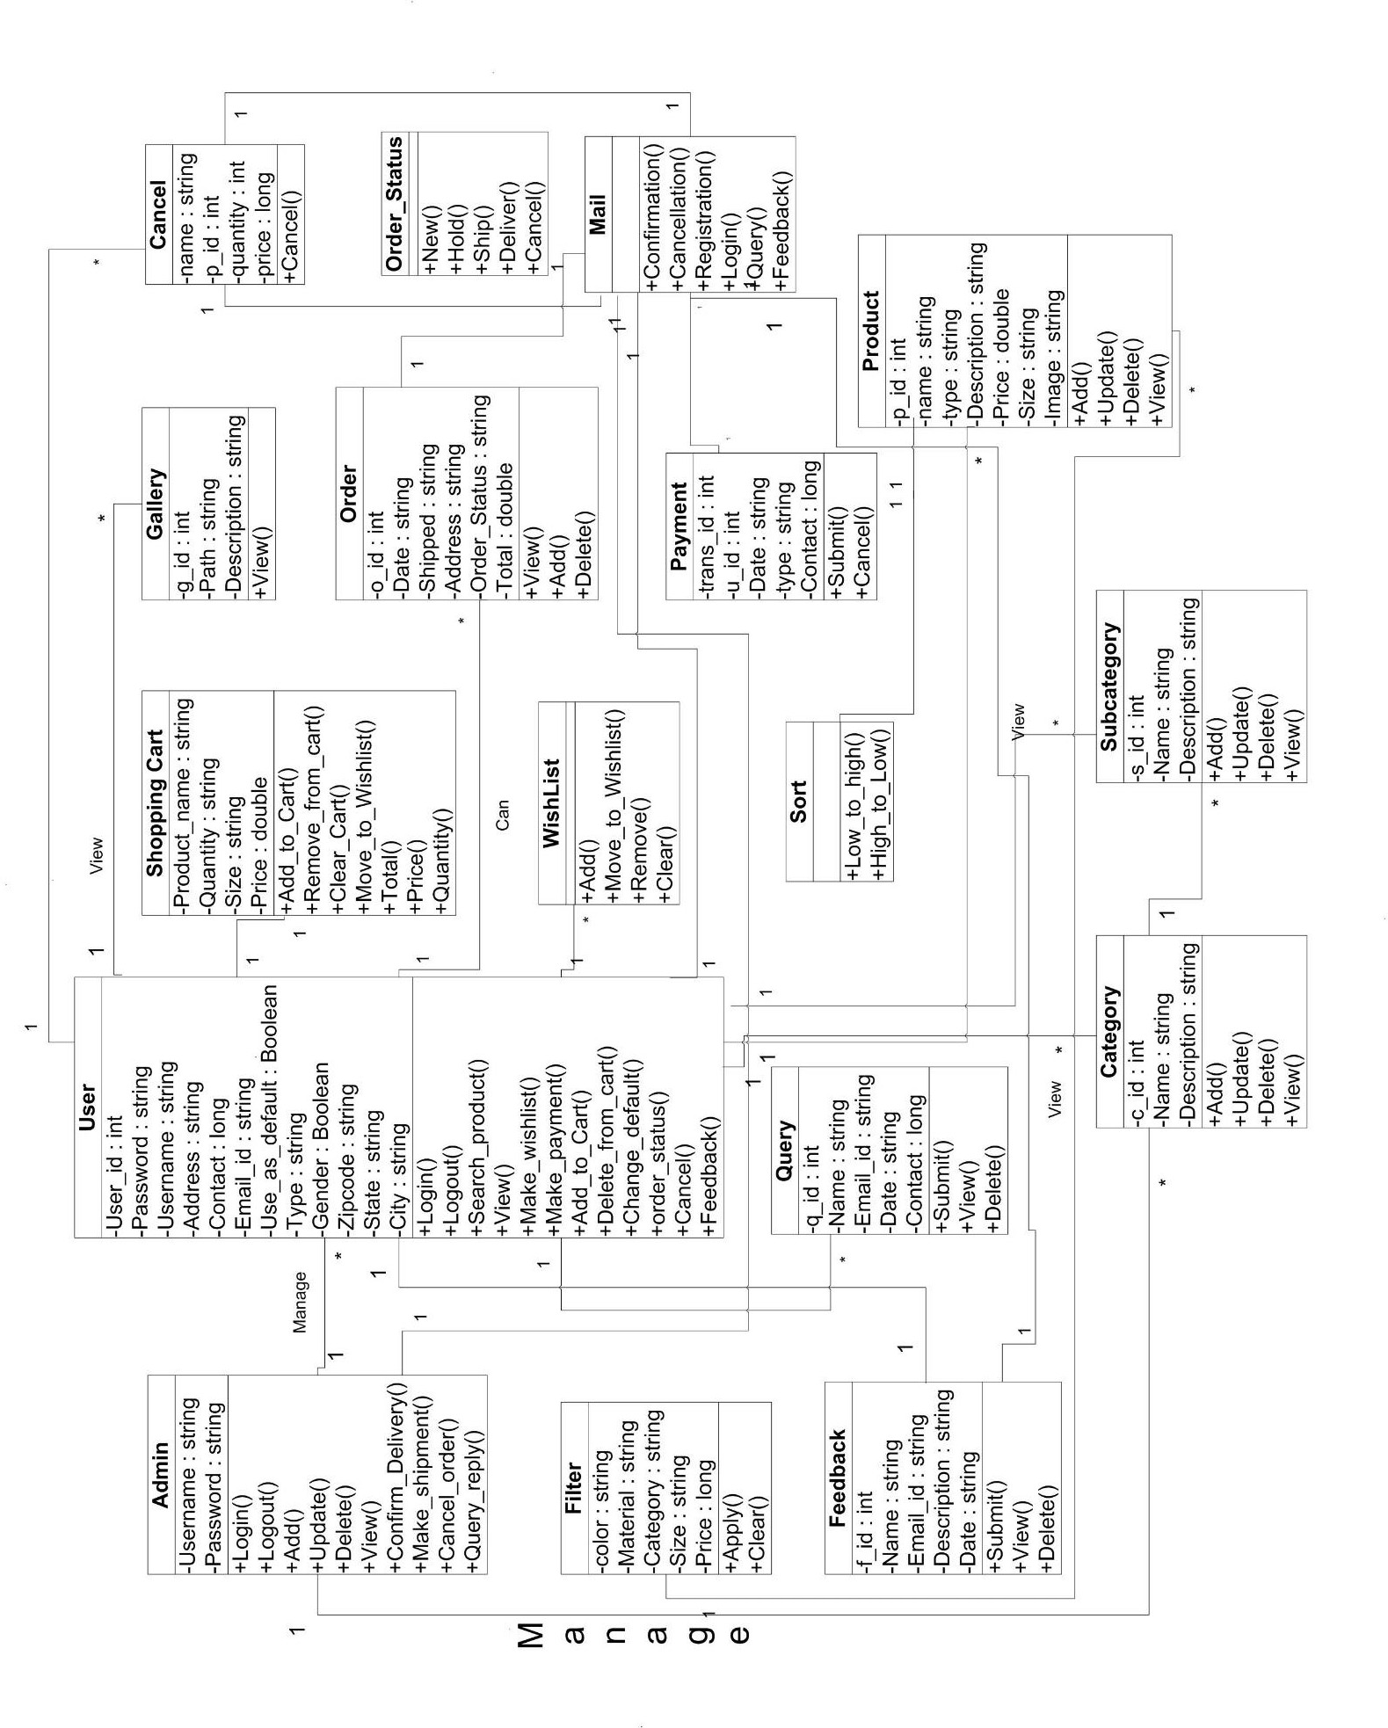

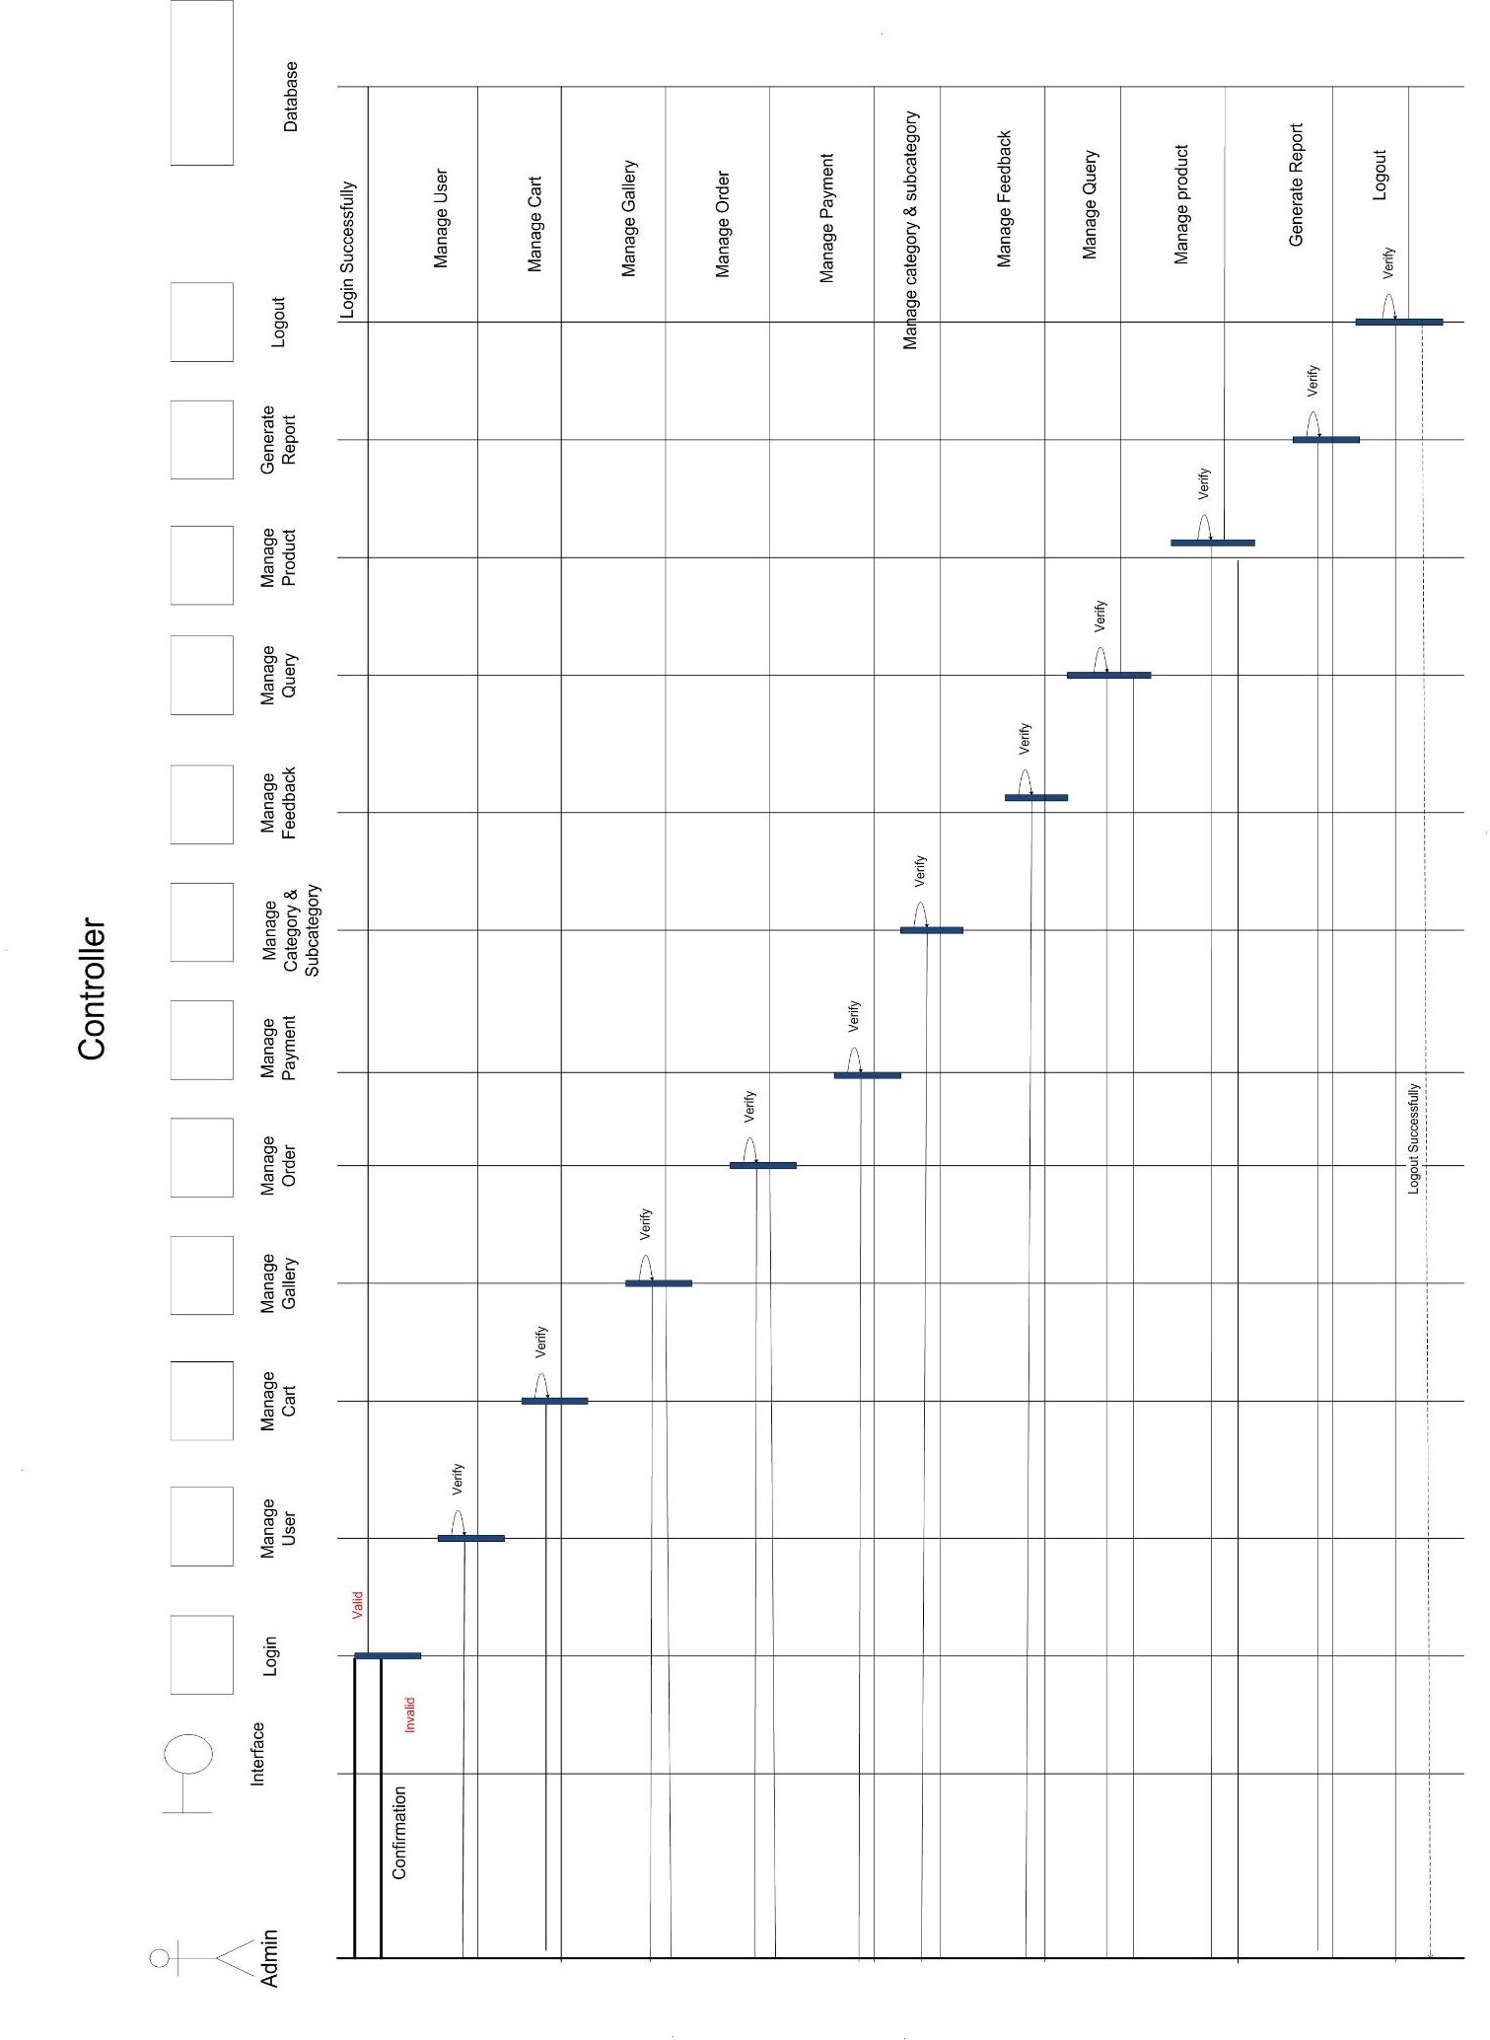**Sequence Diagram**

**Admin**

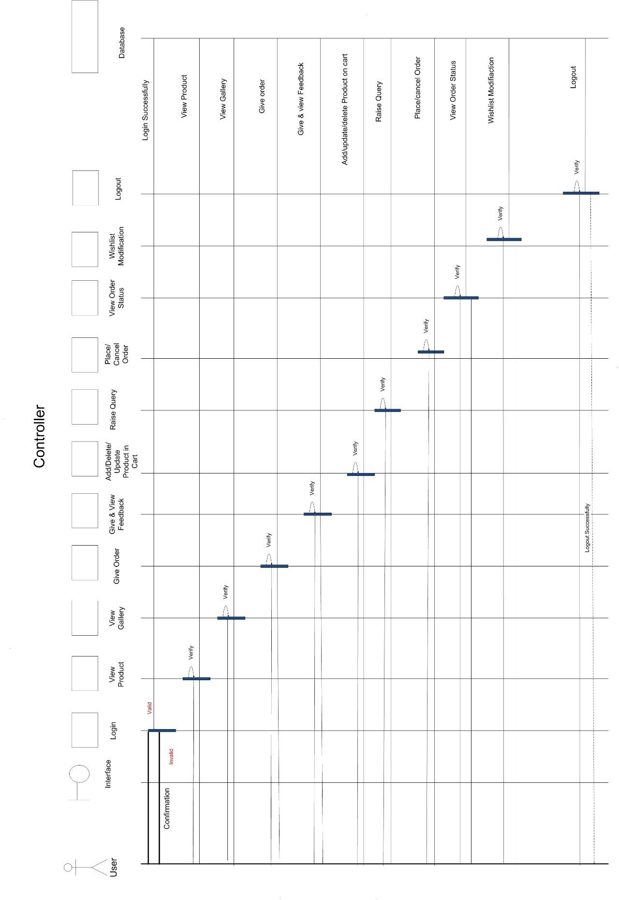

**User**

**System Flow Diagram (Admin & User)**

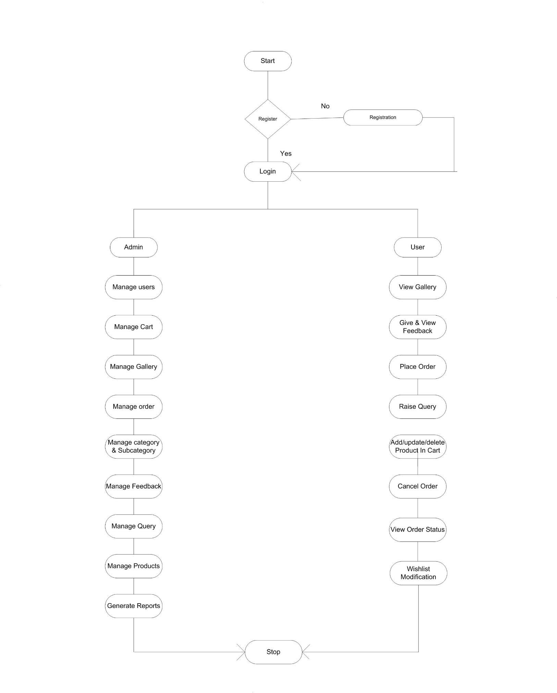

**Data Dictionary**

User:

|  |  |  |  |
| --- | --- | --- | --- |
| Field | Datatype | Constraint | Description |
| User_Id | Integer (20) | Primary key | User id |
| User_name | Varchar (20) | Not Null | Name of user |
| Password | Varchar (20) | Not Null | Password of user |
| Full_name | Varchar (50) | Not Null | Name of user |
| Gender | Boolean | Not Null | Male or Female |
| Type | Varchar (50) | Not Null | Wholesaler or Retailer |
| Address | Varchar (100) | Not Null | Address of user |
| State | Varchar (20) | Not Null | State |
| City | Varchar (20) | Not Null | City |
| ZipCode | Integer (6) | Not Null | Zip Code of area |
| Mobile_No | Integer (10) | Not Null | Mobile number of User |
| Email_Id | Varchar (100) | Not Null | Email id |
| Use_as_default | Boolean | Not Null | For address selection |

Wishlist:

|  |  |  |  |
| --- | --- | --- | --- |
| Field Name | Datatype | Constraint | Description |
| P_id | Integer (10) | Foreign | Product Id |
| P_name | Varchar (100) | Not Null | Product Name |
| Size | Varchar (10) | Not Null | Size of product |
| Price | Long (30) | Not Null | Price of product |

Payment:

|  |  |  |  |
| --- | --- | --- | --- |
| Field Name | Datatype | Constraint | Description |
| Payment_id | Integer (10) | Primary | PAYMENT ID |
| Date | Date | Not Null | Date of payment |
| Type | Varchar (30) | Not Null | Type of payment |
| User_id | Integer (20) | Foreign | User id |
| Contact | Integer (10) | Not Null | Phone Number |

Feedback:

|  |  |  |  |
| --- | --- | --- | --- |
| Field Name | Datatype | Constraint | Description |
| Feedback_id | Integer (5) | Primary | Feedback Id |
| User_id | Integer (20) | Foreign | User Id |
| Date | Date | Not Null | Date of feedback |
| F_description | Varchar (400) | Not Null | Feedback description |
| Email_id | Varchar (100) | Not Null | Email id |

Gallery:

|  |  |  |  |  |
| --- | --- | --- | --- | --- |
| Field Name | Datatype | Constraint | Description |  |
| G_id | Integer (5) | Primary | Gallery Id |  |
| Path | Varchar (70) | Not Null | Path |  |
| G_description | Varchar (400) | Not Null | gallery description |  |

Product:

|  |  |  |  |
| --- | --- | --- | --- |
| Field Name | Datatype | Constraint | Description |
| P_name | Varchar (30) | Not Null | Name of Product |
| P_Id | Integer (10) | Primary | Product Id |
| Type | Varchar (50) | Not Null | Type of product |
| P_description | Varchar (300) | Not Null | Description |
| Price | Long (30) | Not Null | Price of Product |
| Size | Varchar (10) | Not Null | Size of Product |
| Image | Image | Not Null | Image of product |

Category:

|  |  |  |  |
| --- | --- | --- | --- |
| Field Name | Datatype | Constraint | Description |
| C_id | Integer (10) | Primary | Category id |
| Name | Varchar (40) | Not Null | Name of category |
| Description | Varchar (50) | Not Null | Description of category |

Sub-Category:

|  |  |  |  |
| --- | --- | --- | --- |
| Field Name | Datatype | Constraint | Description |
| S_id | Integer (10) | Primary | Sub-Category id |
| Name | Varchar (40) | Not Null | Name of sub-category |
| Description | Varchar (50) | Not Null | Description of sub- category |

Cancel:

|  |  |  |  |
| --- | --- | --- | --- |
| Field Name | Datatype | Constraint | Description |
| P_id | Integer (10) | Foreign | Product id |
| Name | Varchar (40) | Not Null | Name of product |
| Size | Varchar (50) | Not Null | Size of product |
| Price | Long (30) | Not Null | Price of product |

**User Interface**

**User Panel**

**Register**

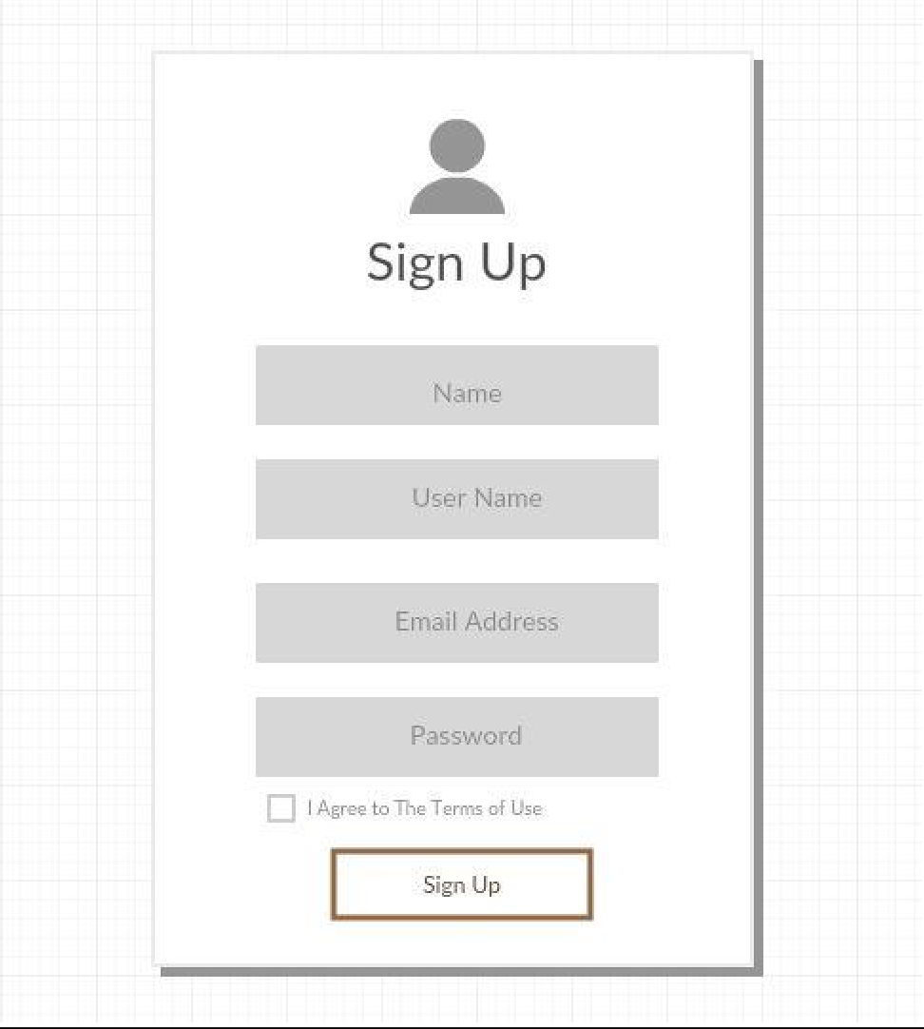

**Login**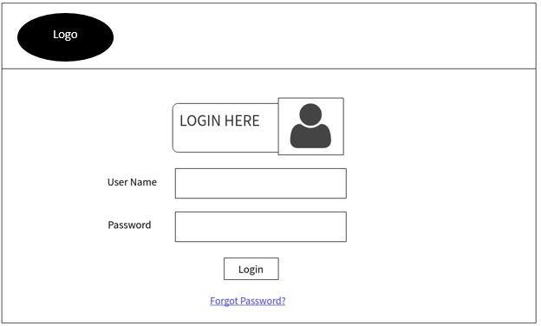

**Homepage**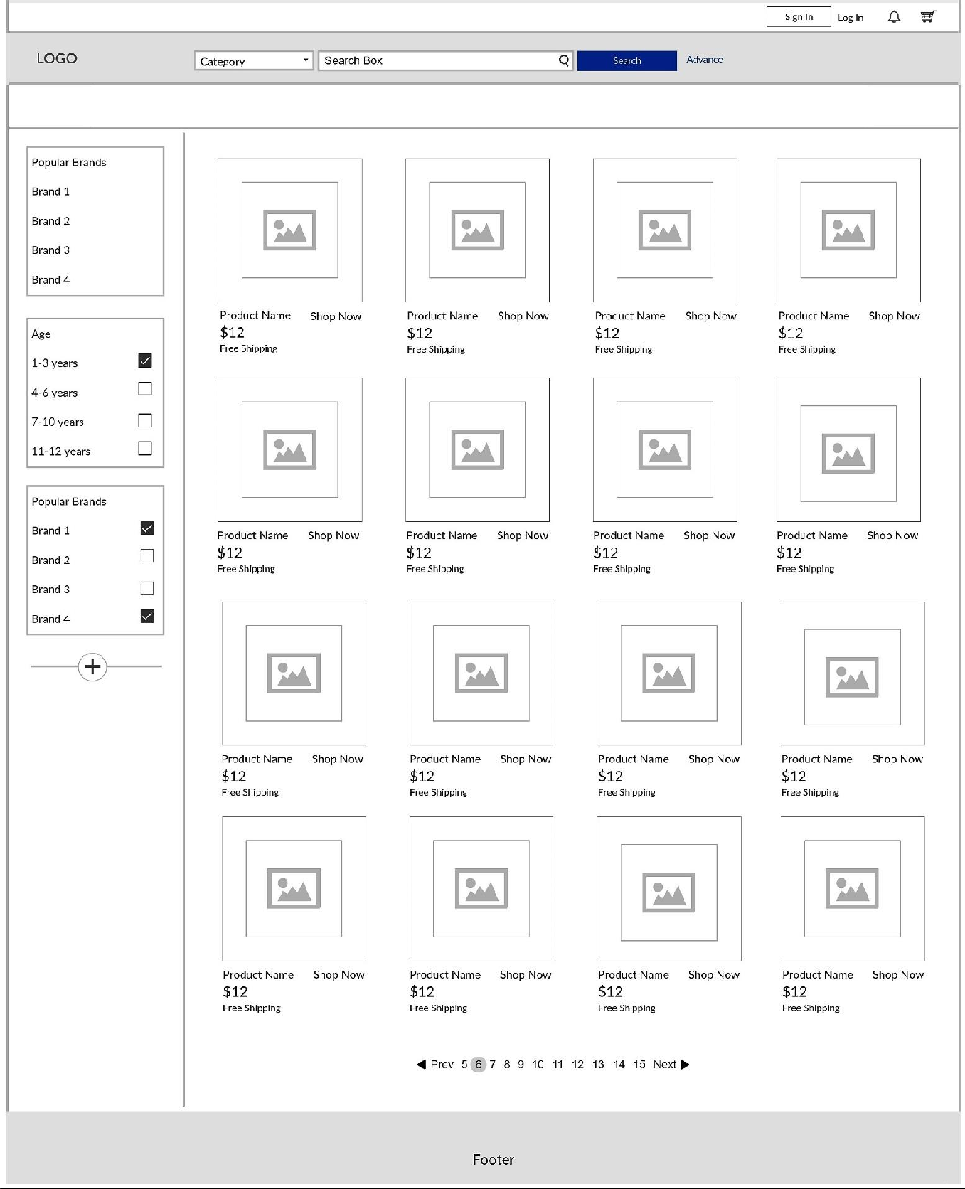

**Feedback**

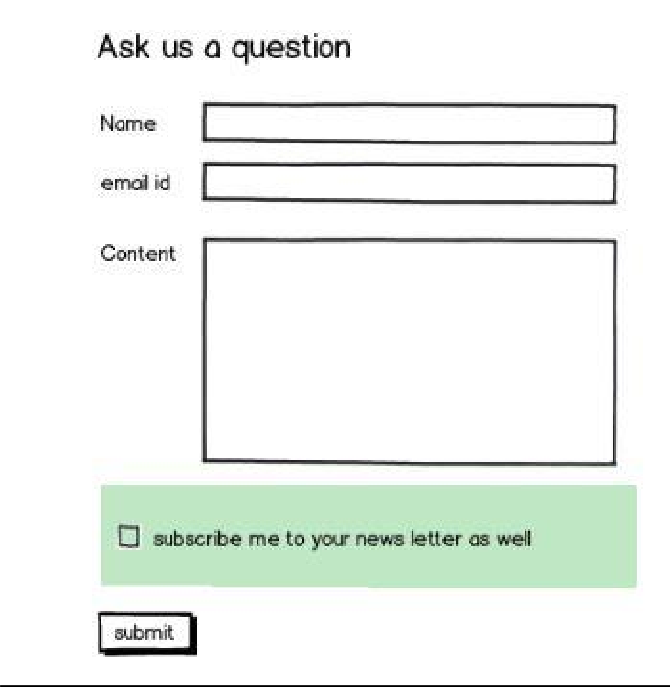

**Admin Panel**

**Dashboard**

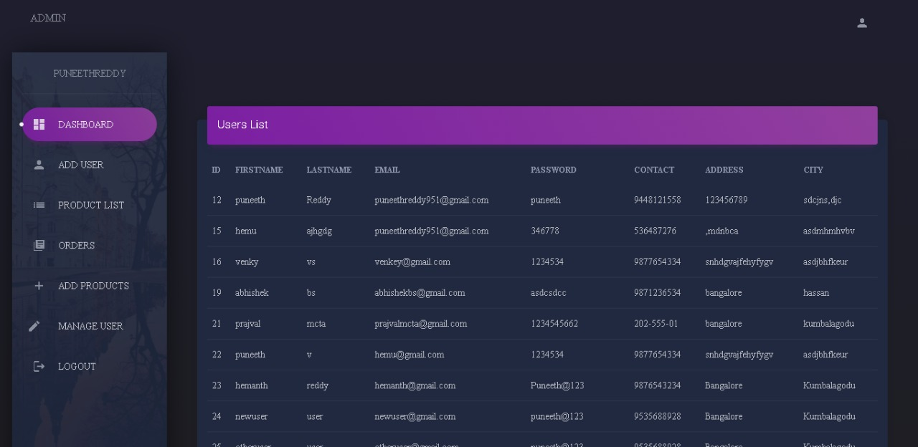

**Add User**

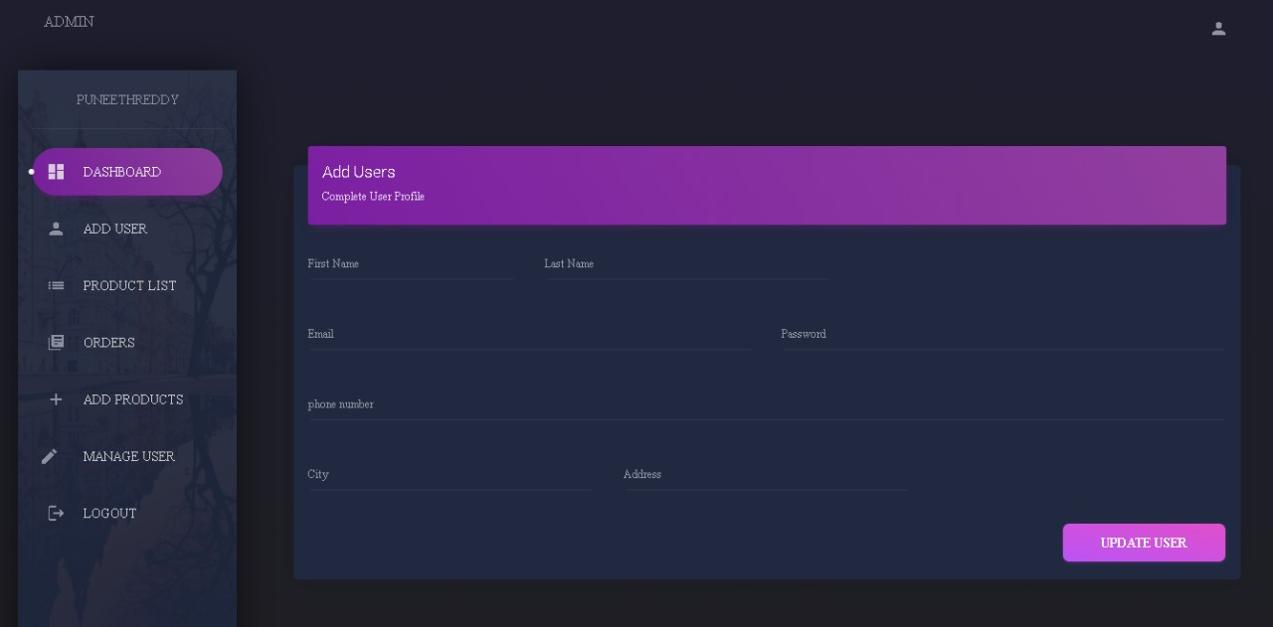

**Add Product**

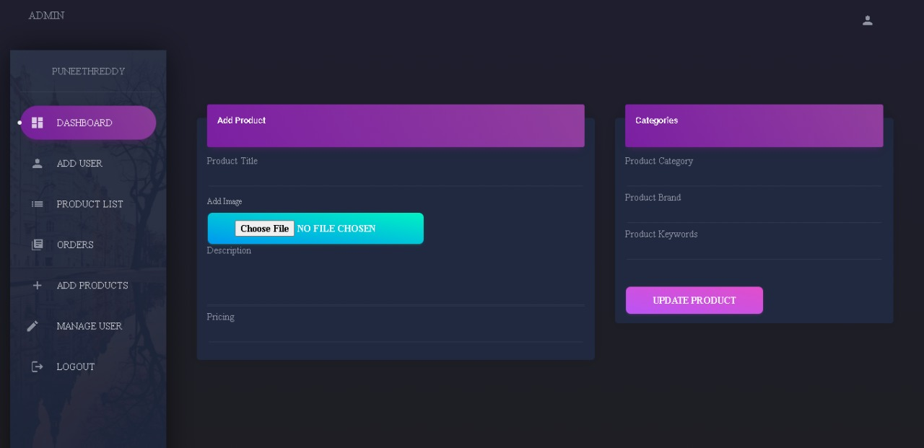

**Manage Order**

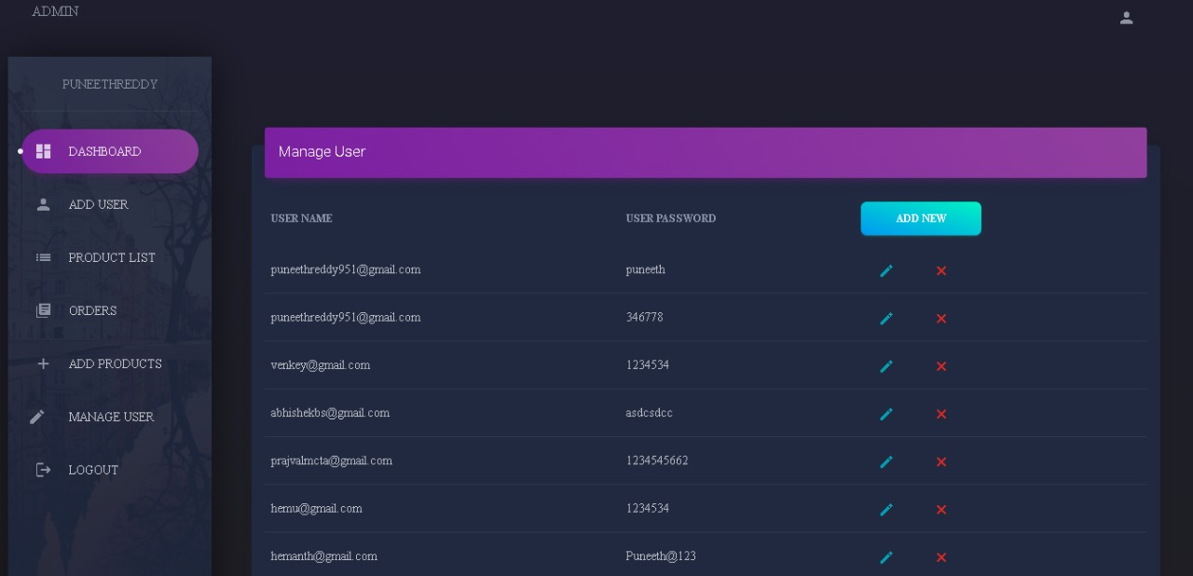

**Manage User**



**Chapter 5**

1. **Assumptions: -**

Shopping has always been a problem in big cities such as Ahmedabad, and Mumbai. One of the solutions to solve this problem is the boon of online shopping. However, it has some limitations and drawbacks but you can’t find a single solution that is completely advantageous to consumer.

What will be your take on the Offline/Orthodox Shopping problem? Can design and technology help make Bakery Shop a more desirable and viable option for consumers?

1. **Limitation: -**

* Now, let’s come to the disadvantages of online bakery shop, or just in the whole concept of online shopping.
* Though internet provides a quick and easy way to purchase a product, some people prefer to use this technology only in a limited way. They regard internet as a means for gathering more information about a product before buying it in a shop. Some people also fear that they might get addicted to online shopping.
* Physical stores allow price negotiations between buyers and the seller. The show room sales attendant representatives provide personal attention to customers and help them in purchasing goods. Online shopping portal do lack of this type of features.
* Customers have to be careful in revealing their personal information. Some of the e-tailers are unreliable. Although, the disadvantages of online shopping will not hinder its growth, Online shopping helped businesses to recover from the recession.

1. **Conclusion: -**

* Online Bakery Shop is very effective means to reduce time wastage and also saves money in some cases. Online stores do not have space constraints and a wide variety of products can be displayed on websites. It helps the analytical buyers to purchase a product after a good search.
* Customers can purchase items from the comfort of their own homes or work place. Shopping is made easier and convenient for the customer through internet. It is also easy to cancel the transactions.

1. **Future Scope: -**

* Online and offline were once two very separate worlds. But with the rise of e-commerce and in particular mobile e-commerce, the distinction between online and offline is blurring rapidly.
* Due to this online shopping era, the gap has subsequently reduced between consumer and manufacturer. The expansion of e-commerce has been developed in rural as well as urban area in reign able cost for consumption, because of that more people are getting linked with e-commerce & the ratio of that is getting increase day by day.

