# Name : Yash Choudhary

# AF code : AF04953367

## STAFF TABLE

### 1) CREATING TABLE

CREATE TABLE staff (  
 staff_id INT PRIMARY KEY,  
 full_name VARCHAR(100) NOT NULL,  
 department VARCHAR(50),  
 salary DOUBLE,  
 join_date DATE  
);

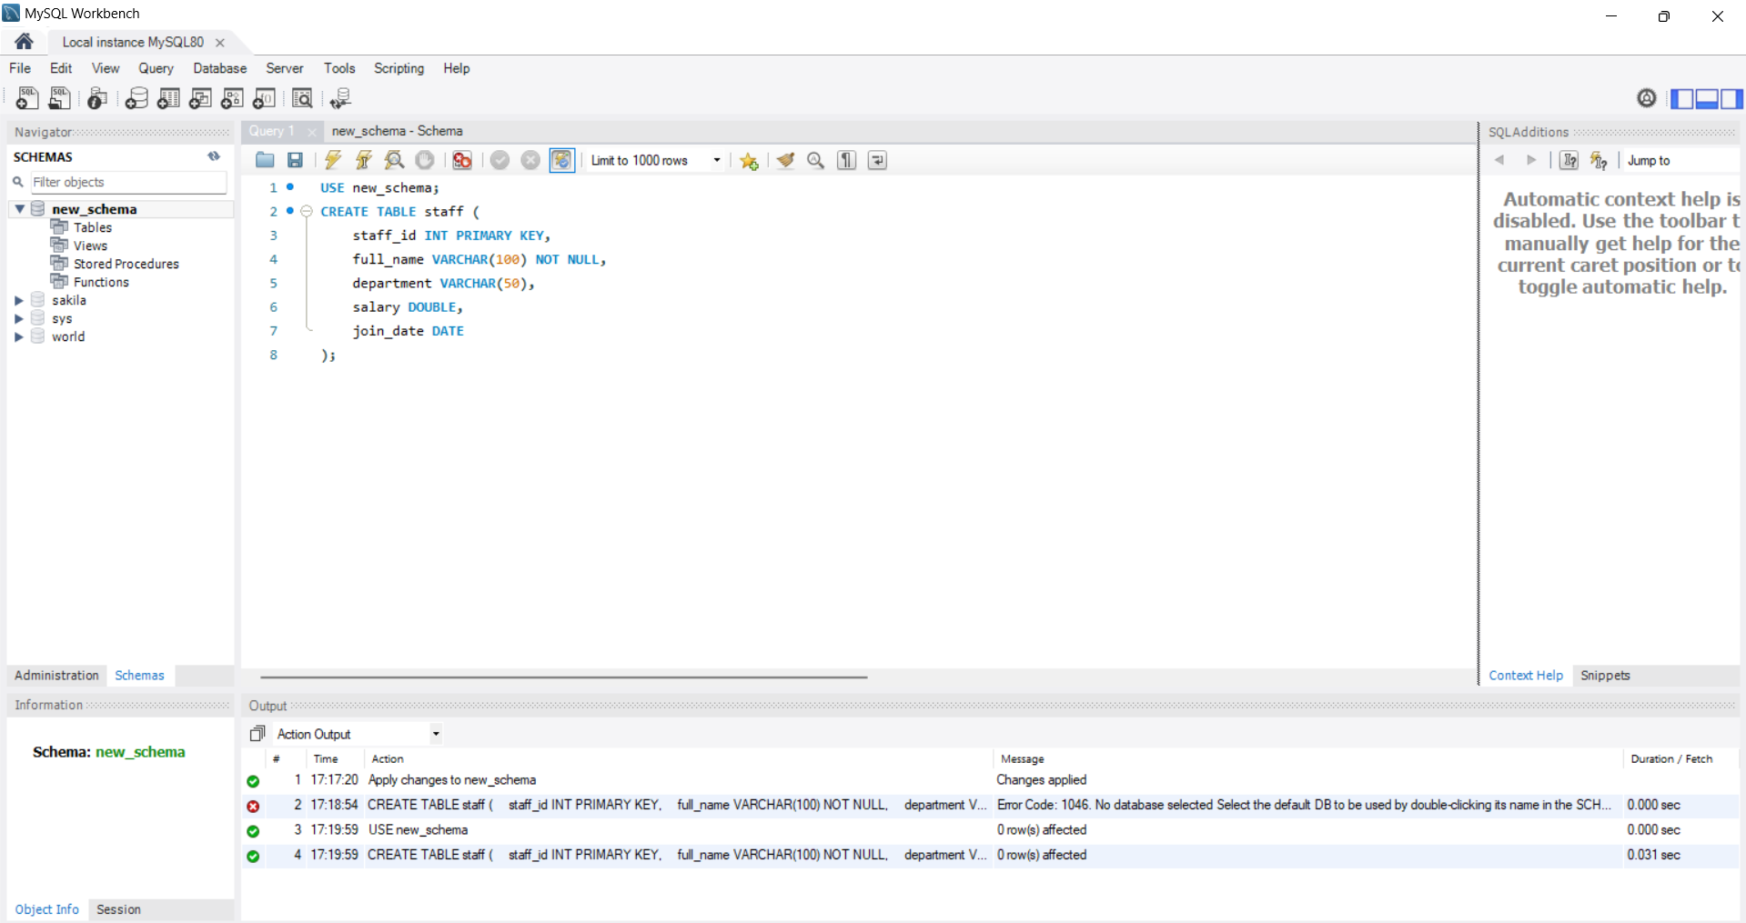

### 2) INSERT QUERY

INSERT INTO staff (staff_id, full_name, department, salary, join_date) VALUES  
(201, 'John Doe', 'HR', 46000, '2021-06-15'),  
(202, 'Jane Thomas', 'IT', 77000, '2020-01-10'),  
(203, 'Alice Johnson', 'Finance', 61000, '2019-08-23'),  
(204, 'Robert Brown', 'IT', 82000, '2022-03-01'),  
(205, 'Eva Daniels', 'Marketing', 57000, '2021-11-05');

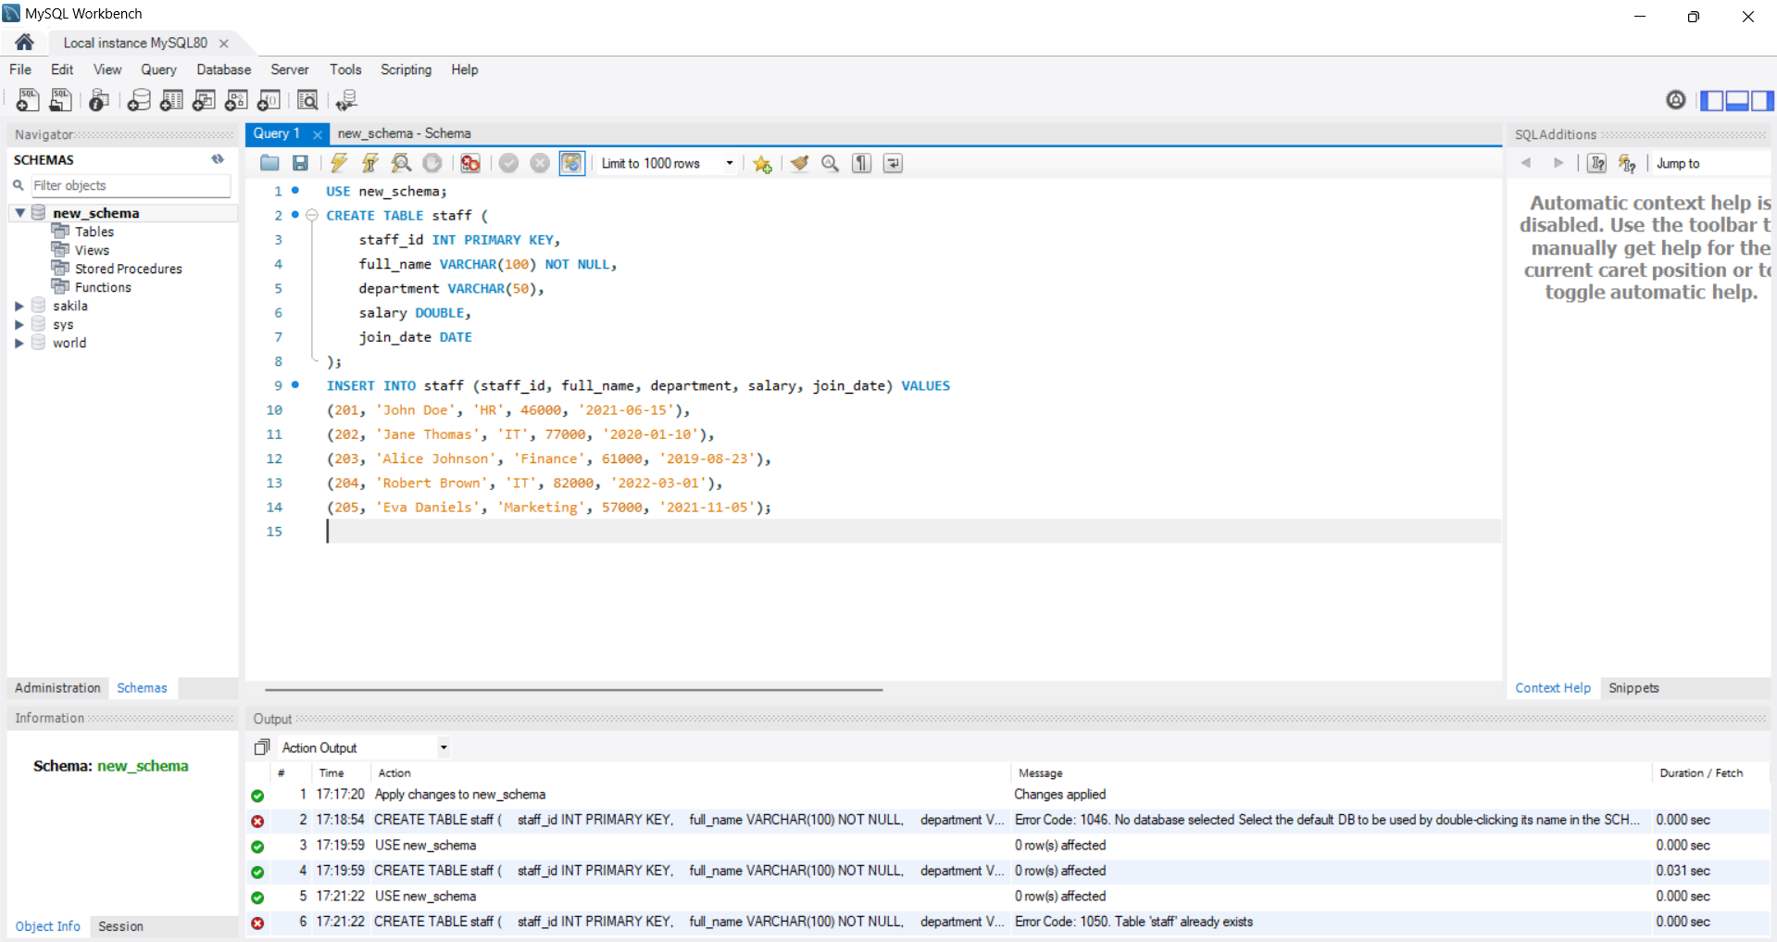

### 3) SELECT QUERY

SELECT * FROM staff;

SELECT full_name, department FROM staff;

SELECT * FROM staff WHERE department = 'IT';

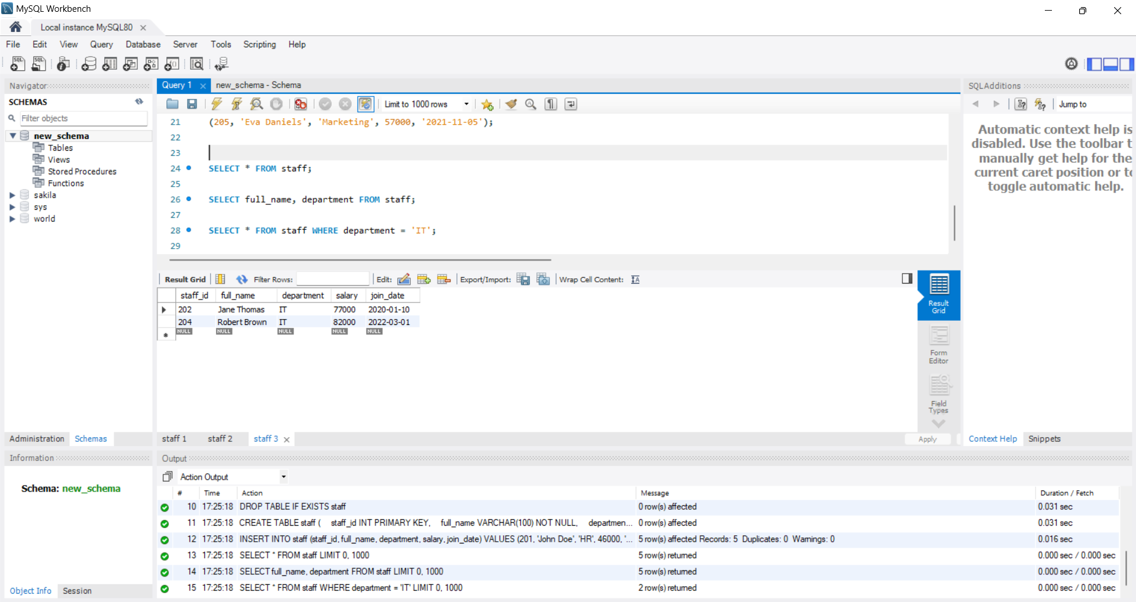

### 4) AND, IN, BETWEEN & LIKE

SELECT * FROM staff WHERE department = 'IT' AND salary > 75000;

SELECT * FROM staff WHERE department IN ('IT', 'Finance');

SELECT * FROM staff WHERE salary BETWEEN 50000 AND 70000;

SELECT * FROM staff WHERE full_name LIKE 'J%'; -- Names starting with J

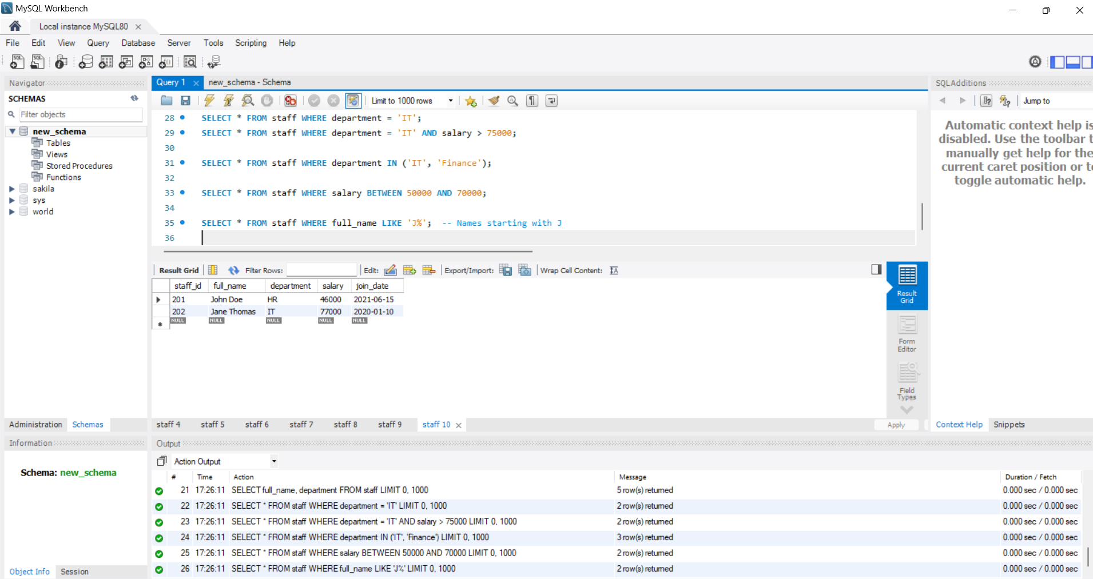

### 5) CLAUSE - ORDER BY, WHERE, HAVING

SELECT * FROM staff ORDER BY salary DESC;

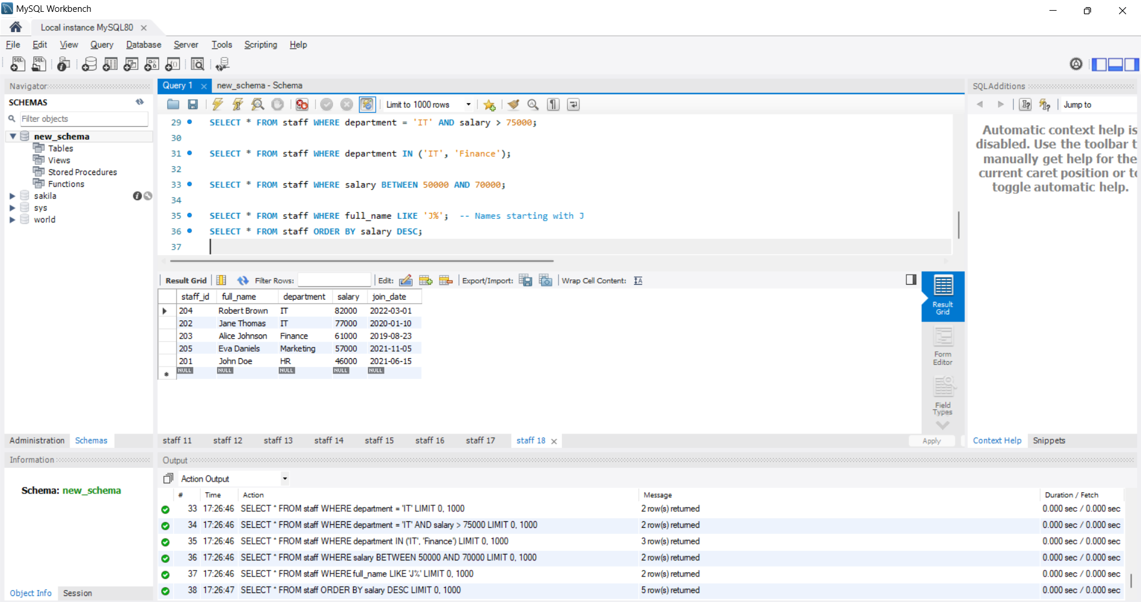

### 6) UPDATE QUERY

UPDATE staff  
SET salary = 84000  
WHERE staff_id = 204;

DELETE FROM staff  
WHERE staff_id = 205;

SELECT department, AVG(salary) AS avg_salary  
FROM staff  
GROUP BY department;

SELECT department, COUNT(*) AS emp_count  
FROM staff  
GROUP BY department  
HAVING COUNT(*) > 1;

