**Student Name:**Yogender Singh  **UID:**24MCA20106

**Branch:**MCA(general) **Section/Group:** 2B

**Semester:**1  **Date of Performance:** 4-11-24

# Subject Name:LINUX ADMINISTRATION LAB Subject Code:24CAP607

**Title of Project-**Daily Planner and Reminder Tool

**Aim/Overview of the practical:**

The aim of this project is to create a **Daily Planner and Reminder Tool** using shell scripting in Linux. This tool helps users plan their daily tasks by allowing them to add, view, and receive timely reminders for scheduled tasks. The tool is designed to improve productivity and organization by making it easy to set up and manage personal tasks with automated reminders. This project utilizes cron for scheduling reminders and notify-send for desktop notifications, making it an efficient and practical tool for Linux users.

The project demonstrates how to automate everyday tasks with scripting, handle user input, manipulate text files, and manage scheduled tasks within a Linux environment.

**Task to be done:**

* **Setup of Task File**: Create a file (daily_tasks.txt) to store tasks and reminders.
* **Task Addition Feature**:

1. Develop a function to allow the user to input a task with a specific time and description.
2. Save the task to daily_tasks.txt in a structured format (time - description).

* **View Tasks**:

1. Implement a feature to display all tasks for the day stored in daily_tasks.txt for easy reference.

* **Set Up Reminders**:

1. Use the cron scheduler to set up reminders for each task.
2. Extract times and descriptions from daily_tasks.txt and create cron jobs that trigger at the scheduled times to send notifications.

* **Create Main Menu**:

1. Design a simple CLI-based menu to allow users to add tasks, view tasks, and set reminders.

**Code for experiment/practical:**

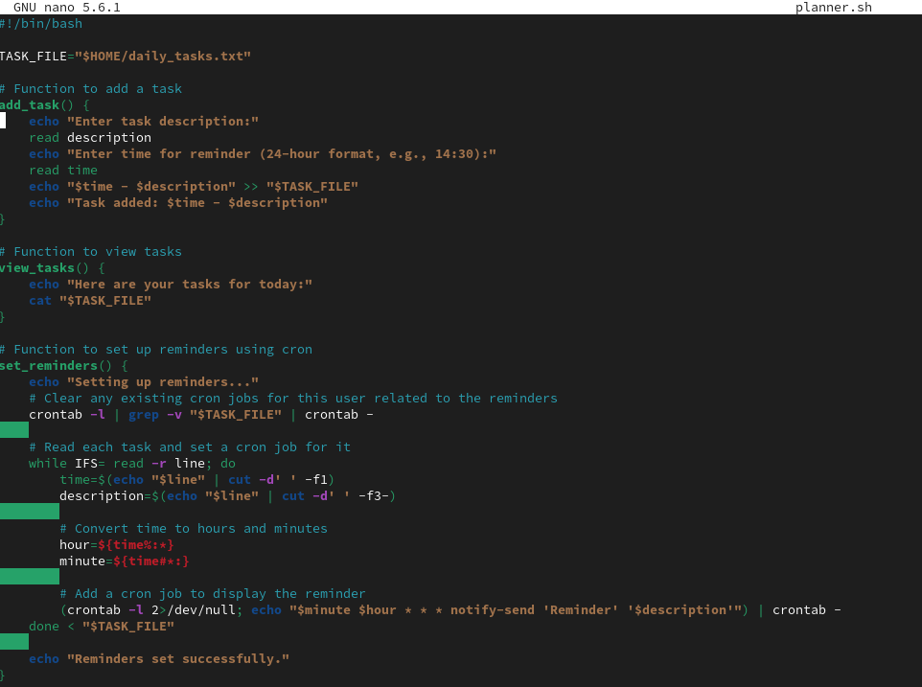

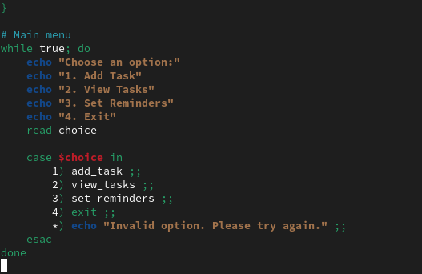

**Result/Output/Writing Summary:**

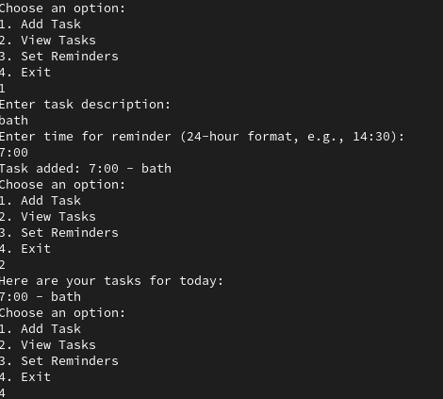

**Learning outcomes (What I have learnt):**

* By completing this project, I have gained experience in:
* **Shell Scripting**: Enhanced skills in writing scripts, handling user input, and managing files in a Linux environment.
* **Text Processing**: Learned to read from and write to files, as well as format and parse text data effectively.
* **Task Automation with** cron: Developed skills in using cron to automate scheduled reminders and notifications.
* **User Interaction**: Designed a user-friendly command-line interface for managing tasks.
* **Desktop Notifications**: Gained experience using notify-send to create non-intrusive reminders on a Linux desktop.
* **Project Structuring**: Improved organizational skills by managing project requirements, implementation, and testing.