**COMP 7500 ADVANCED OPERATING SYSTEM**

**PROJECT-3 AUBatch SCHEDULER**

**BY: YASH MAHAJAN**

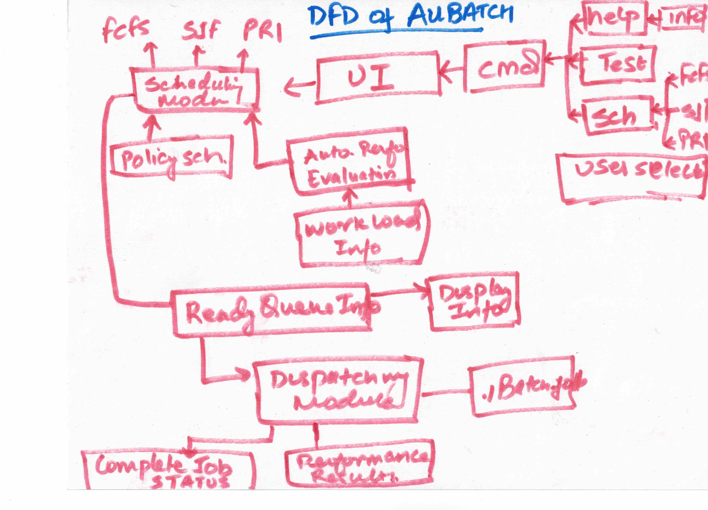**Note: How to run AUBatch? Follow README file.**

1. **Design, Implementation and DFD for AUBatch:**

Above the Data Flow Diagram (DFD) which highlight the structure of the project.

1. **Performance Metric and Workload Conditions**
   1. **MakeFile**

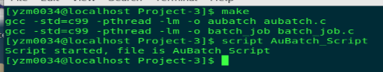

* 1. **Initiation**

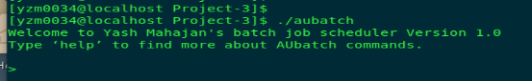

* 1. **First job**

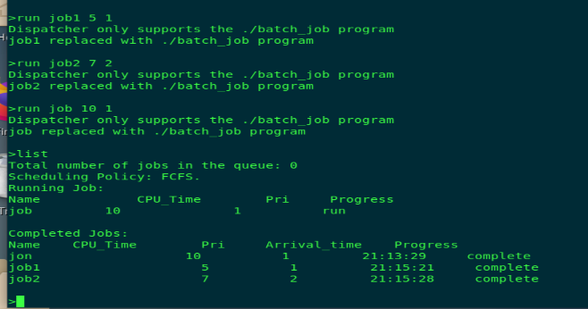

* 1. **FCFS**

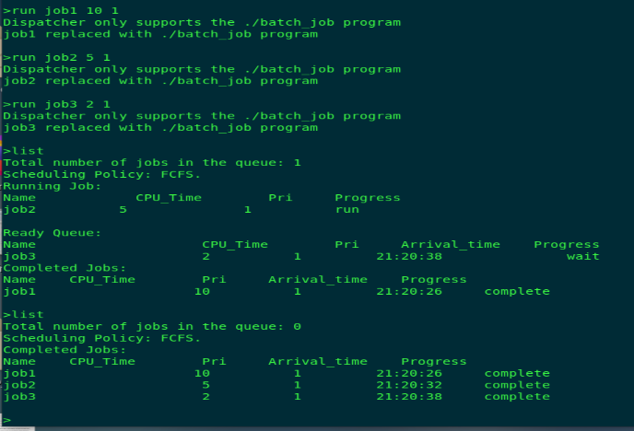

* 1. **SJF**

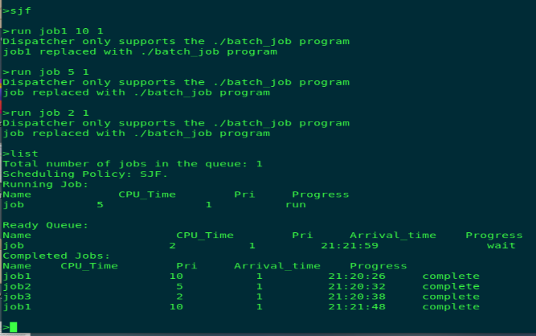

* 1. **PRIORITY**

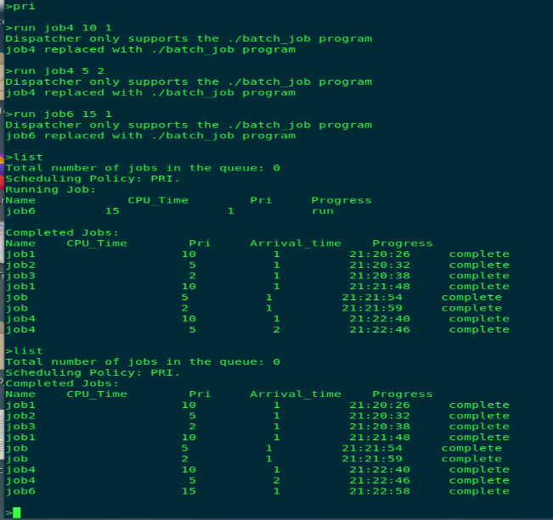

* 1. **Quit**

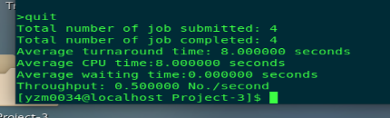

1. **The Performance Evaluation of the three Scheduling algo.** 
   1. **FCFS Test:**

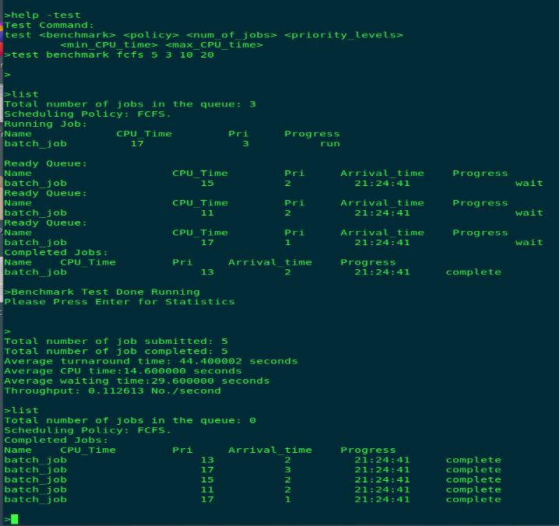

* 1. **SJF Test:**

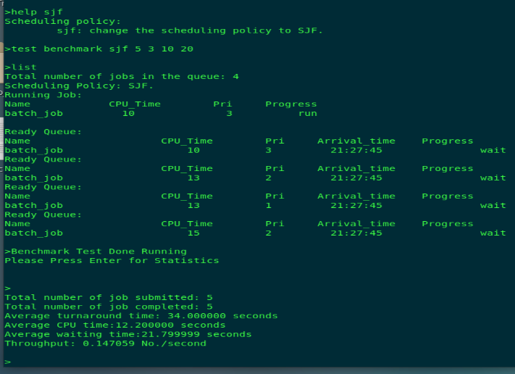

* 1. **PRIORITY Test:**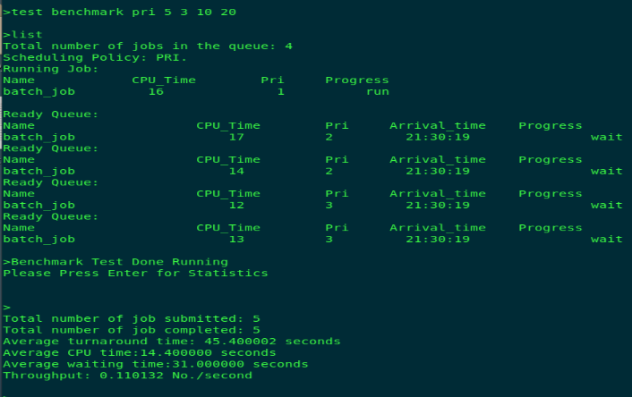

1. **Learned Lesson**
2. How the scheduling algorithms works.
3. How to use Pthreads.
4. How to implement multi-threading.
5. How to use command parser and handle user inputs.
6. How to use evec() function.
7. How to compare different scheduling algorithms and how critical is to select the correct algorithm for a particular task.