**Minimum Domino Rotations For Equal Row**

In a row of dominoes, A[i] and B[i] represent the top and bottom halves of the i-th domino.  (A domino is a tile with two numbers from 1 to 6 - one on each half of the tile.)

We may rotate the i-th domino, so that A[i] and B[i] swap values.

Return the minimum number of rotations so that all the values in A are the same, or all the values in B are the same.

If it cannot be done, return -1.

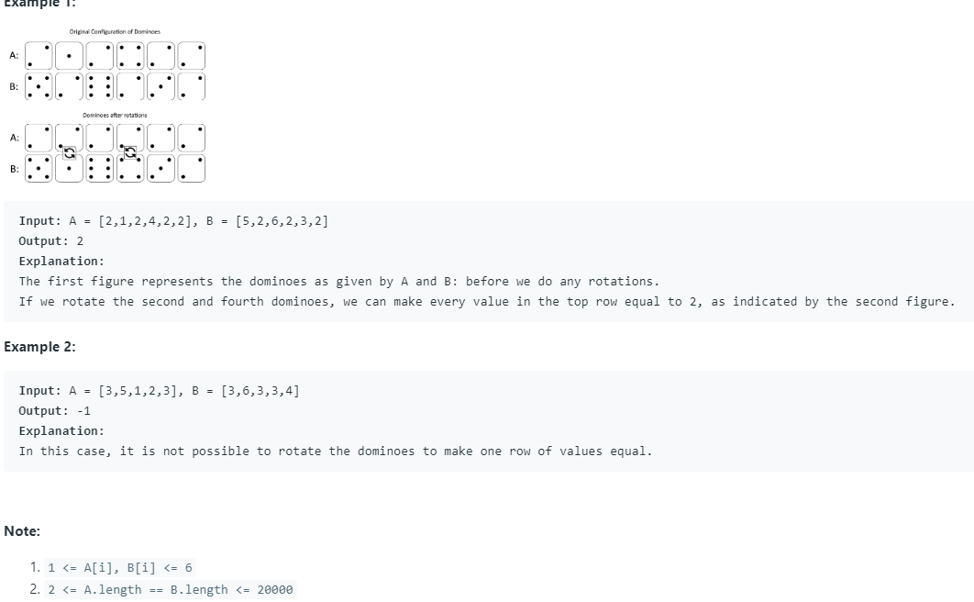

**String Transforms Into Another String**

Given two strings str1 and str2 of the same length, determine whether you can transform str1 into str2 by doing **zero or more** conversions.

In one conversion you can convert **all** occurrences of one character in str1 to **any** other lowercase English character.

Return true if and only if you can transform str1 into str2.

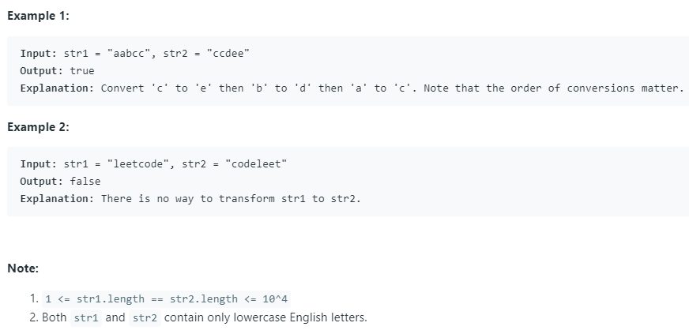

**Expressive Words**

Sometimes people repeat letters to represent extra feeling, such as "hello" -> "heeellooo", "hi" -> "hiiii".  In these strings like "heeellooo", we have groups of adjacent letters that are all the same:  "h", "eee", "ll", "ooo".

For some given string S, a query word is stretchy if it can be made to be equal to S by any number of applications of the following extension operation: choose a group consisting of characters c, and add some number of characters c to the group so that the size of the group is 3 or more.

For example, starting with "hello", we could do an extension on the group "o" to get "hellooo", but we cannot get "helloo" since the group "oo" has size less than 3.  Also, we could do another extension like "ll" -> "lllll" to get "helllllooo".  If S = "helllllooo", then the query word "hello" would be stretchy because of these two extension operations: query = "hello" -> "hellooo" -> "helllllooo" = S.

Given a list of query words, return the number of words that are stretchy.

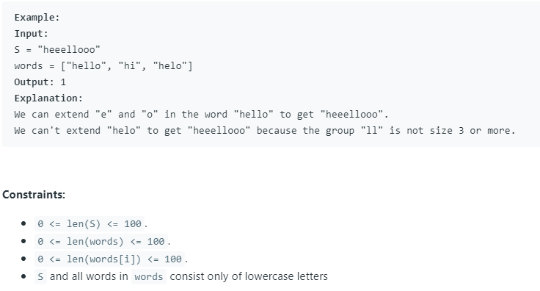

**Confusing Number II**

We can rotate digits by 180 degrees to form new digits. When 0, 1, 6, 8, 9 are rotated 180 degrees, they become 0, 1, 9, 8, 6 respectively. When 2, 3, 4, 5 and 7 are rotated 180 degrees, they become invalid.

A confusing number is a number that when rotated 180 degrees becomes a **different** number with each digit valid.(Note that the rotated number can be greater than the original number.)

Given a positive integer N, return the number of confusing numbers between 1 and N inclusive.

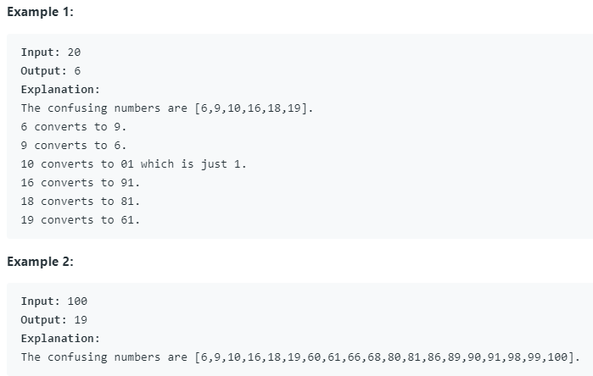

**Campus Bikes**

On a campus represented as a 2D grid, there are N workers and M bikes, with N <= M. Each worker and bike is a 2D coordinate on this grid.

Our goal is to assign a bike to each worker. Among the available bikes and workers, we choose the (worker, bike) pair with the shortest Manhattan distance between each other, and assign the bike to that worker. (If there are multiple (worker, bike) pairs with the same shortest Manhattan distance, we choose the pair with the smallest worker index; if there are multiple ways to do that, we choose the pair with the smallest bike index). We repeat this process until there are no available workers.

The Manhattan distance between two points p1 and p2 is Manhattan(p1, p2) = |p1.x - p2.x| + |p1.y - p2.y|.

Return a vector ans of length N, where ans[i] is the index (0-indexed) of the bike that the i-th worker is assigned to.

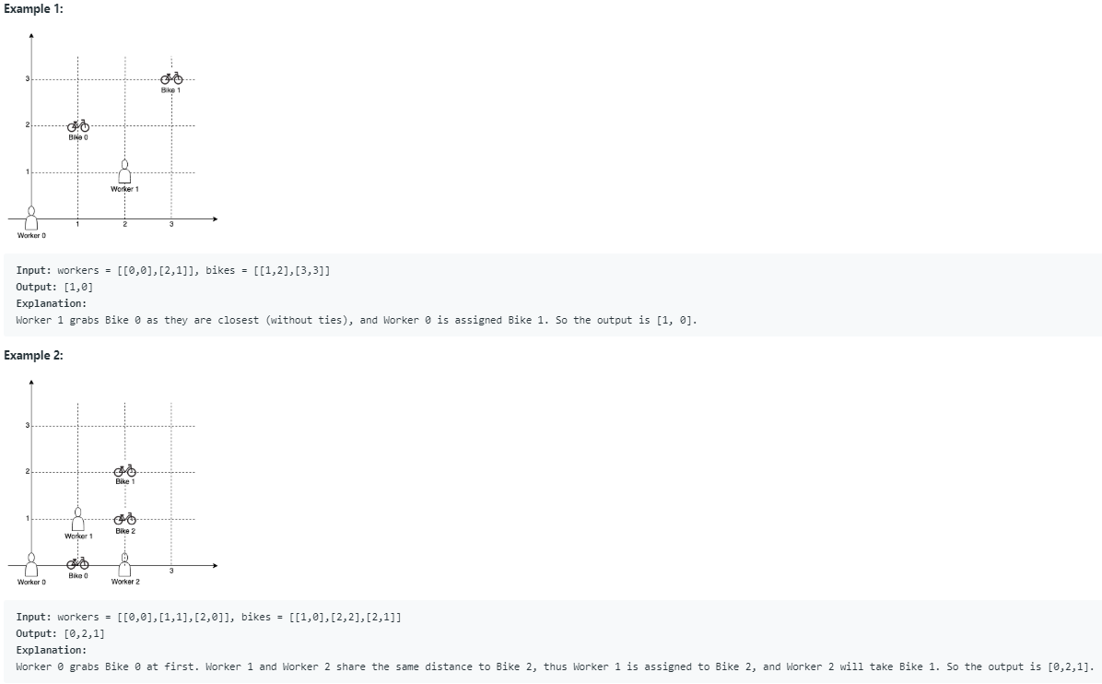

**Minimum Window Subsequence**

Given strings S and T, find the minimum (contiguous) **substring** W of S, so that T is a **subsequence** of W.

If there is no such window in S that covers all characters in T, return the empty string "". If there are multiple such minimum-length windows, return the one with the left-most starting index.

