A Project Based Learning Report on:
INDUSTRIAL SENSOR LINEENCODING SIMULATOR
In partial fulfilment of the requirement for Project Based Learning of
BACHELOR OF TECHNOLOGY
In
COMPUTER ENGINEERING
For
Data Communication

BHARATI VIDYAPEETH (DEEMED TO BE UNIVERSITY) COLLEGE OF ENGINEERING, PUNE-43
DEPARTMENT OF COMPUTER ENGINEERING
2026-27
SUBMITTED TO:
Dr. Rohini Khalkar
SUBMITTED BY: | PRN
Yash Bhalchandra Borse (Roll No. 54) | 2514110237
Tanishka Karande (Roll No. 40) | 2514110222
Anuj Shinde (Roll No. 23) | 2514110204
Kushagra Sharma (Roll No. 26) | 2514110207
Ishaan Soni (Roll No. 32) | 2514110214
BHARATI VIDYAPEETH (DEEMED TO BE UNIVERSITY) COLLEGE OF ENGINEERING, PUNE-43
DEPARTMENT OF COMPUTER ENGINEERING
CERTIFICATE
This is to certify that the Project Based Learning report titled "Industrial Sensor Line Encoding Simulator", submitted by Yash Bhalchandra Borse, Tanishka Karande, Anuj Shinde, Kushagra Sharma, Ishaan Soni to the Bharati Vidyapeeth (Deemed to be University), College of Engineering, Pune-43 for the award of the degree of BACHELOR OF TECHNOLOGY in Computer Engineering is a Bonafide record of the PBL work done by them under my supervision.

Place: Pune
Date:
Dr. Rohini Khalkar

Acknowledgement
To begin with, we would like to thank our Course Coordinator for providing us this golden opportunity. We are very grateful to our Course Coordinator, Dr. Rohini Khalkar ma'am, for her valuable support and guidance.
We are also very grateful to all those who helped us throughout this project. We would like to thank Dr. Rohini Khalkar, our Course Coordinator, and our HOD Dr. S.B. Vanjale sir for their support and guidance in completing our project-based learning on the topic "Industrial Sensor Line Encoding Simulator". It was a great learning experience.
We would like to take this opportunity to express our gratitude to all the group members, Yash, Tanishka, Anuj, Kushagra and Ishaan. The project-based learning would not have been successful without their cooperation and inputs. Last, but not the least, we are thankful to our parents and families who encourage us to study and who gave us the opportunity to spend our time in learning.
Thanks again to all who helped us.

Index
S.NO | TITLE | PAGE NO.
1 | Introduction | 1-2
2 | Objectives | 3
3 | System Requirements | 4
4 | Architecture | 5-7
5 | Implementation | 8-11
6 | Code | 12-14
7 | Output | 15-17
8 | Advantages and Disadvantages | 18-19
9 | Accuracy and Efficiency | 20-22
10 | Challenges | 23
11 | Future Scope and Enhancements | 24
12 | Conclusion | 25
13 | References | 26-27

1. Introduction

1.1 Background
Modern factories depend on a continuous flow of measurements from sensors that monitor temperature, pressure, humidity and vibration. These measurements are converted to digital values and must travel from the sensor on the shop floor to a monitoring system or controller, often over long cables running close to motors, welding equipment and other sources of electrical interference [14], [15], [16]. Before a digital value can travel on a wire, its bits have to be turned into voltage levels. This conversion is called line coding, and the choice of line code affects bandwidth, synchronisation, the presence of a DC component and the resistance of the link to noise [1], [2].
The Industrial Sensor Line Encoding Simulator is a Data Communication Project Based Learning (PBL) project that demonstrates this whole chain on a computer. A sensor reading such as 72 °C is converted into an 8-bit binary number, encoded as a voltage waveform using one of three line codes (Polar NRZ-L, Polar RZ or Bipolar AMI), passed through a simulated noisy channel, sampled and decoded at the receiver, and converted back into a sensor value. The simulator also reports the number of bit errors and the bit error rate (BER) so that the schemes can be compared objectively.

1.2 Problem Statement
Line coding is usually taught through static textbook waveforms. Students see the ideal signal but rarely see what happens to it after noise is added, how a receiver decides between a 0 and a 1, or why one scheme survives a noisy factory cable better than another. The problem addressed by this project is to build an interactive simulator that lets a user enter a sensor value, choose a line code and a noise level, and immediately see the transmitted waveform, the received waveform, the decoded data and the resulting error rate.

1.3 Scope of the Project
The project is delivered in two forms that share the same signal model. The first is a Python console application that uses NumPy for signal generation and Matplotlib for plotting [18], [19]. The second is a browser-based simulator written in React and TypeScript with a dashboard-style interface [20]. Both support the following scope:
- An 8-bit representation of the sensor value (0 to 255) transmitted one bit after another.
- Three line codes: Polar NRZ-L, Polar RZ and Bipolar AMI.
- An additive Gaussian noise channel with selectable noise strength.
- A threshold-based receiver that samples each bit interval, decodes the bit stream and recovers the sensor value.
- Calculation of bit errors and BER, and plots of transmitted and received signals.
The project is a baseband simulation. It does not implement framing, clock recovery, error-correcting codes, modulation or real hardware interfaces; these are listed as future enhancements in Section 10.

2. Objectives
The main aim of the project is to understand and demonstrate how digital sensor data is represented, transmitted and recovered using line coding techniques. The specific objectives are:
- To convert a decimal industrial sensor reading into an 8-bit binary sequence and back again without loss.
- To implement three line coding schemes, namely Polar NRZ-L, Polar RZ and Bipolar AMI, and generate their voltage waveforms.
- To model a noisy industrial channel using additive Gaussian noise at no, low and high noise levels.
- To design a receiver that samples the received waveform inside each bit interval and takes a threshold decision to recover the bits.
- To compute the number of bit errors and the bit error rate for every transmission, so that the effect of noise can be measured.
- To visualise the transmitted and received signals side by side, and to compare all three encodings for the same data.
- To build a web-based simulator supporting temperature, pressure, humidity and vibration sensors with a status indication of normal, warning or critical.
- To relate the behaviour of each line code (DC component, bandwidth, noise tolerance) to its suitability for industrial communication.

3. System Requirements
To run the Python simulator and the web simulator the following requirements are necessary.

3.1 Hardware Requirements
- Processor: Intel Core i3 or higher (Intel i5 or i7 recommended).
- RAM: minimum 4 GB (8 GB recommended).
- Storage: minimum 500 MB of free disk space.
- Display: 1024 × 768 resolution or higher for the plot windows and the web dashboard.

3.2 Software Requirements
- Operating system: Windows 10/11, Linux (Ubuntu 18.04 or later) or macOS.
- Python: Python 3.8 or higher, with the libraries listed in requirements.txt: NumPy (1.24 or later) for signal arrays and Matplotlib (3.7 or later) for plotting.
- Node.js and npm: needed to run the web simulator. The project uses React 19, TypeScript, Vite, Tailwind CSS 4, lucide-react icons and the motion animation library, as listed in package.json.
- Editor: any Python IDE or editor (VS Code, PyCharm, IDLE) and a modern web browser.

3.3 Other Requirements
- An internet connection for the first installation of Python packages and npm dependencies.
- Permission to install packages and to open a graphical window for Matplotlib.
These requirements allow every stage of the project, from sensor input to waveform display, to run smoothly on an ordinary laptop without any special hardware.

4. Architecture
The simulator follows the signal chain of a real digital transmission link and is organised into three stages: a transmitter, a channel, and a receiver with analysis. Each stage is a separate function in the Python version and a separate computed value in the React version, which keeps the code easy to test and explain. Figure 1 gives an overview of the three stages and Figure 2 shows the detailed flow inside each of them. The original bit stream is kept aside during transmission and compared with the decoded bits at the end, which is how the bit error rate is obtained.
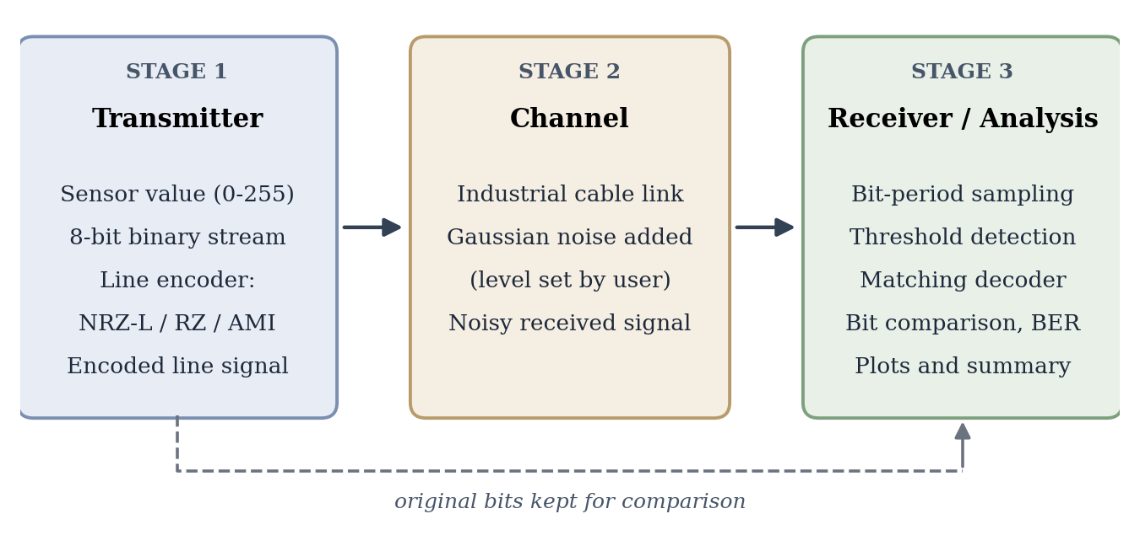
Figure 1: Overview of the three-stage architecture

4.1 Stage 1: Transmitter
The transmitter turns a field measurement into a voltage waveform. The sensor value (for example 72 °C) is converted into a digital number and clamped to the range 0 to 255 so that it fits in 8 bits, giving the bit stream 01001000. In a real installation the signal conditioning and ADC blocks shown in the figure would perform this step; in the simulator it is done by decimal_to_binary(). The user then selects one of the three line codes, and the matching encoder (polar_nrz_encode, polar_rz_encode or bipolar_ami_encode) converts every bit into 100 voltage samples. The result is the encoded line signal, the ideal waveform that leaves the sensor node.
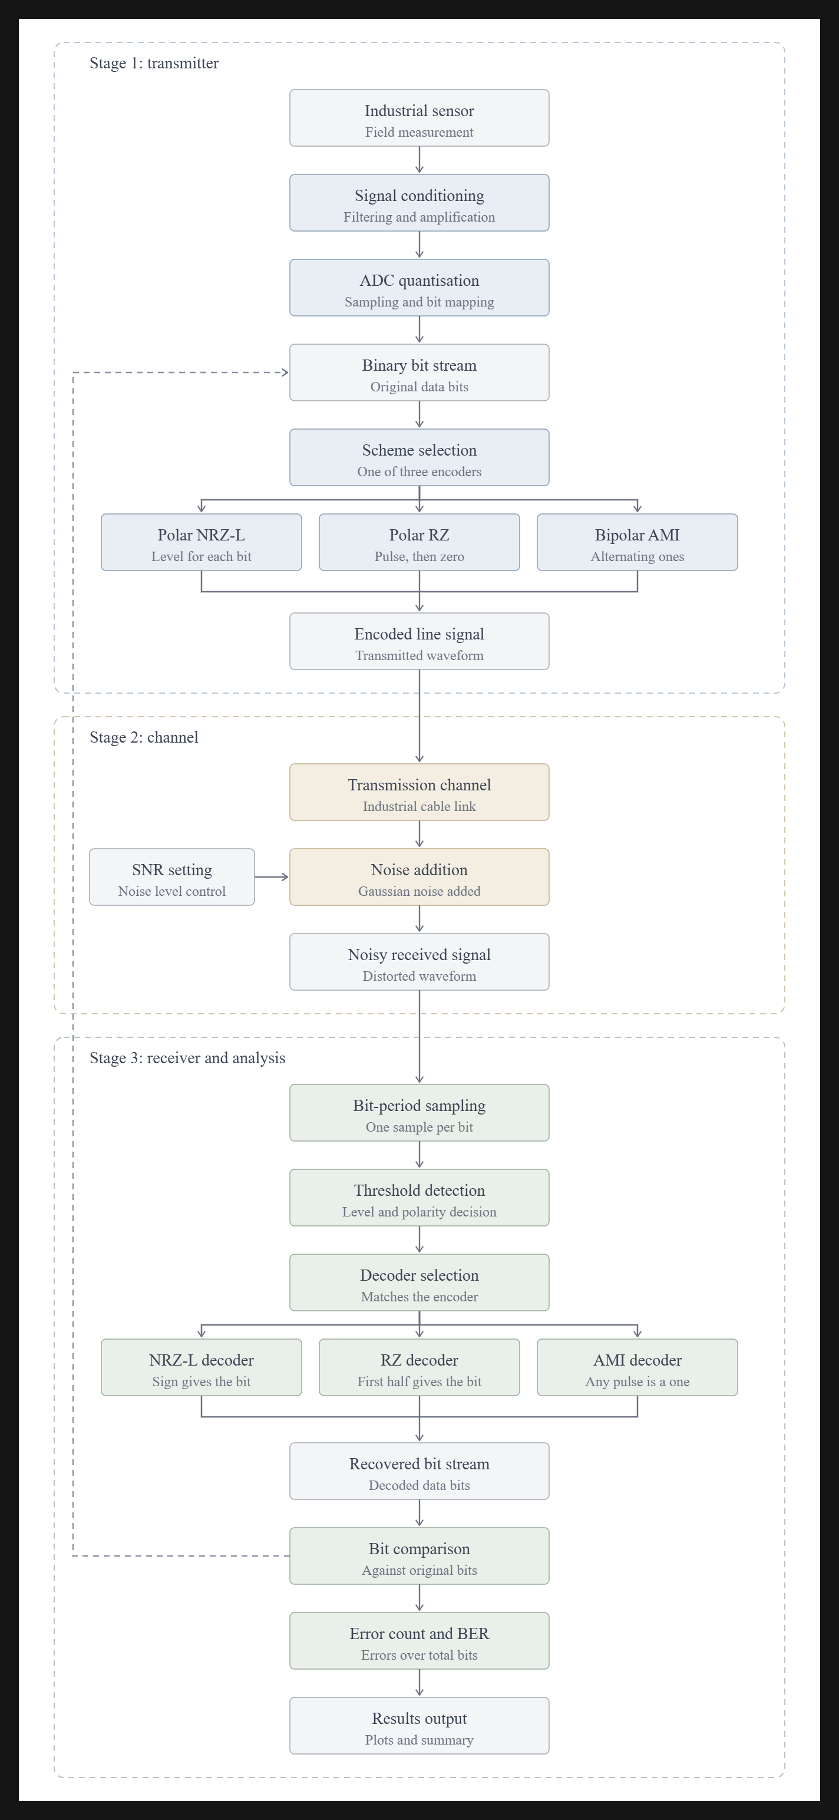
Figure 2(a): Stage 1 – transmitter, from sensor reading to encoded line signal

4.2 Stage 2: Channel
The channel represents the industrial cable between the sensor and the monitoring system. It is modelled as additive Gaussian noise: a random value with standard deviation σ is added to every sample of the transmitted waveform. The noise level setting in the figure controls σ. The console version offers no, low (σ = 0.20 V) and high (σ = 0.65 V) noise, and the web version uses a 0 % to 100 % slider that gives σ = (percent / 100) × 0.75 V.
Figure 2(b): Stage 2 – channel, noise added to the transmitted signal

4.3 Stage 3: Receiver and Analysis
The receiver divides the received signal into bit periods and averages a small window of samples in each period to reduce the effect of noise. A threshold decision then turns each average into a bit, using the decoder that matches the selected encoder: the sign gives the bit for NRZ-L, only the first half of the bit period is examined for RZ, and for AMI a pulse of magnitude at least 0.5 V counts as a 1. The recovered bits are converted back to a decimal sensor value and compared position by position with the original bits. The number of errors and the bit error rate are then calculated and shown, together with the plotted waveforms, as the results output.
Figure 2(c): Stage 3 – receiver and analysis, decoding and bit error rate

5. Implementation

5.1 Sensor Data Acquisition and Binary Conversion
The user enters a sensor reading. The console program asks for a temperature in °C (default 25 °C in the main program), forms a sensor packet label such as [TEMP-01] | [TEMP] | [72°C], and passes the value to decimal_to_binary(). The function clamps the value to the range 0 to 255 and formats it as an 8-bit string; for example 72 becomes 01001000. The inverse function binary_to_decimal() converts the received bit string back to an integer. Invalid text input falls back to the default value instead of crashing the program.
In the web simulator the same conversion is done with toString(2) and padStart(8, "0"). Four sensor types are supported, each with an identifier, unit, default value and normal range, as shown in Table 1. The simulator also classifies the entered value as NORMAL, WARNING or CRITICAL using fixed thresholds.
Table 1: Sensors supported by the web simulator
Sensor | Unit | Default | Normal range | Status thresholds (warning / critical above)
Temperature (TEMP-01) | °C | 72 | 20 - 80 | 80 / 100
Pressure (PRESS-01) | bar | 6 | 2 - 8 | 8 / 10
Humidity (HUM-01) | % | 55 | 30 - 70 | 70 / 85
Vibration (VIB-01) | mm/s | 3 | 0 - 4 | 4 / 7

5.2 Line Encoding Schemes
Every bit is represented by 100 samples in the Python version (40 samples in the web version), so that the waveform appears smooth when plotted. The three schemes implemented are described below and summarised in Table 2 [1], [2], [6].
Polar NRZ-L (Non-Return-to-Zero Level). A binary 1 is sent as +1 V and a binary 0 as -1 V for the whole bit duration. The signal never returns to zero inside a bit. It uses the least bandwidth of the three schemes, but a long run of identical bits gives a constant level with no transitions, which makes clock recovery difficult.
Polar RZ (Return-to-Zero). A binary 1 is sent as +1 V and a binary 0 as -1 V during the first half of the bit, and the signal returns to 0 V in the second half. The guaranteed mid-bit transition helps synchronisation, but the signal needs about twice the bandwidth of NRZ-L and uses three voltage levels.
Bipolar AMI (Alternate Mark Inversion). A binary 0 is sent as 0 V. Binary 1s (marks) are sent alternately as +1 V and -1 V, starting with +1 V. Because the positive and negative pulses cancel, the signal has no DC component, and a violation of the alternation rule can be used to detect errors. Bipolar line codes of this family appear in digital telephony interfaces such as ITU-T G.703 [11].
Table 2: Comparison of the implemented line codes
Encoding | Bit 0 | Bit 1 | Levels | Main feature
Polar NRZ-L | -1 V | +1 V | Two | Bandwidth efficient
Polar RZ | -1 V then 0 V | +1 V then 0 V | Three | Returns to zero every bit
Bipolar AMI | 0 V | +1 V / -1 V alternately | Three | Zero DC component

5.3 Channel Model
The channel is modelled as additive noise: the received signal is the transmitted signal plus a Gaussian random value added to every sample. This is the standard model for thermal and interference noise in communication theory [4], [5]. The Python simulator offers three conditions: no noise, which represents an ideal shielded twisted-pair cable; low noise (σ = 0.20 V), which represents mild industrial electromagnetic interference; and high noise (σ = 0.65 V), which represents heavy interference from motors or welding equipment. The simple main.py version provides a yes/no option with σ = 0.35 V. The web simulator uses a noise slider from 0 % to 100 % and converts it to σ = (percent / 100) × 0.75 V, with 10 % as the default. In the web version Gaussian values are produced with the Box-Muller transform from a seeded sine and cosine sequence, so every press of the simulate button gives a new but repeatable noise pattern.

5.4 Receiver: Sampling and Threshold Decision
For every bit interval the receiver extracts the samples that belong to that bit, averages a small window of them (which reduces the effect of noise), and compares the average with a threshold. The decision rules are:
- Polar NRZ-L: average the samples at 40 % to 60 % of the bit; output 1 if the average is zero or positive, otherwise 0.
- Polar RZ: average the samples at 15 % to 35 % of the bit (inside the active first half); output 1 if the average is zero or positive, otherwise 0.
- Bipolar AMI: average the samples at 40 % to 60 % of the bit; output 1 if the absolute value of the average is at least 0.5 V, otherwise 0. The sign is ignored because marks alternate in polarity.
The decoded 8 bits are joined into a string and converted back to a decimal number, which is the recovered sensor value.

5.5 Bit Error Rate
The function calculate_ber() compares the original and received bit strings position by position, counts the mismatches and divides by the number of transmitted bits: BER = errors / total bits. For 8 transmitted bits, one flipped bit gives a BER of 12.5 %. The result is printed in the summary and shown in the plot title, with a green received waveform when the transmission is successful and an amber one when errors occurred.

5.6 Python Console Application
The repository contains two Python programs. The file main.py is a compact first version that accepts a temperature and an encoding choice, optionally adds noise, decodes the signal, prints the result and shows the transmitted and received waveforms. The file sensor_transmission.py is the extended version. It adds the sensor packet display, the three noise levels, BER calculation, a mode that compares all three encodings in one plot, a step-by-step console explanation, input validation and a loop that lets the user run further tests without restarting the program.

5.7 Web Simulator
The web simulator (src/App.tsx) is a single-page React application styled with Tailwind CSS. The page is divided into numbered cards: sensor input, encoding selection and noise control, the transmitted and received waveforms drawn as oscilloscope-style SVG graphics, the binary data and decoded data, the BER and error count, a comparison table of the three codes, and a section on real-world applications such as temperature, pressure and motor condition monitoring. React hooks (useState and useMemo) recompute the binary data, the transmitted samples, the noisy received samples, the decoded bits and the BER every time the user presses the simulate button. The same sampling and threshold logic as the Python receiver is used, with windows adjusted to 40 samples per bit.

5.8 Project Structure
Table 3: Files in the project repository
File | Purpose
main.py | First, compact Python version of the simulator with optional noise and a two-plot display.
sensor_transmission.py | Extended Python simulator with noise levels, BER, sensor packet and comparison plot.
requirements.txt | Python dependencies: matplotlib and numpy.
src/App.tsx | React and TypeScript implementation of the web simulator.
src/main.tsx, src/index.css, index.html | Entry point, stylesheet and HTML page of the web application.
package.json, vite.config.ts, tsconfig.json | Build, dependency and TypeScript configuration for the web application.

6. Code
This section lists the core signal-processing code of the extended Python simulator (sensor_transmission.py): binary conversion, the three encoders, the noise function, the decoder and the BER calculation. The plotting and menu code is omitted for brevity and is available in the project repository.

6.1 Python: Encoding, Channel, Decoding and BER
# Binary conversion
def decimal_to_binary(value: int, bit_width: int = 8) -> str:
if value < 0 or value > 255:
value = max(0, min(255, value))
return format(value, f'0{bit_width}b')
def binary_to_decimal(bit_string: str) -> int:
try:
return int(bit_string, 2)
except ValueError:
return 0
# Polar NRZ encoding
def polar_nrz_encode(bit_stream: str, samples_per_bit: int = 100):
signal = []
for bit in bit_stream:
voltage = +1.0 if bit == '1' else -1.0
signal.extend([voltage] * samples_per_bit)
return np.array(signal)
# Polar RZ encoding
def polar_rz_encode(bit_stream: str, samples_per_bit: int = 100):
signal = []
half_samples = samples_per_bit // 2
for bit in bit_stream:
first_half_v = +1.0 if bit == '1' else -1.0
signal.extend([first_half_v] * half_samples)
signal.extend([0.0] * (samples_per_bit - half_samples))
return np.array(signal)
# Bipolar AMI encoding
def bipolar_ami_encode(bit_stream: str, samples_per_bit: int = 100):
signal = []
last_mark_polarity = -1.0
for bit in bit_stream:
if bit == '1':
last_mark_polarity = -last_mark_polarity
voltage = last_mark_polarity
else:
voltage = 0.0
signal.extend([voltage] * samples_per_bit)
return np.array(signal)
# Add noise
def add_noise(signal: np.ndarray, noise_level: str = "none"):
if noise_level.lower() == "low":
sigma = 0.20
elif noise_level.lower() == "high":
sigma = 0.65
else:
sigma = 0.0
if sigma == 0.0:
return signal.copy()
noise = np.random.normal(
loc=0.0,
scale=sigma,
size=signal.shape
)
return signal + noise
# Decode received signal
def decode_signal(
noisy_signal: np.ndarray,
scheme: str,
bit_count: int,
samples_per_bit: int = 100
) -> str:
decoded_bits = []
for i in range(bit_count):
bit_start = i * samples_per_bit
bit_end = (i + 1) * samples_per_bit
bit_samples = noisy_signal[bit_start:bit_end]
if scheme == "Polar NRZ-L":
center_sample = np.mean(
bit_samples[
int(0.4 * samples_per_bit):
int(0.6 * samples_per_bit)
]
)
bit = '1' if center_sample >= 0 else '0'
elif scheme == "Polar RZ":
first_half_sample = np.mean(
bit_samples[
int(0.15 * samples_per_bit):
int(0.35 * samples_per_bit)
]
)
bit = '1' if first_half_sample >= 0 else '0'
elif scheme == "Bipolar AMI":
center_sample = np.mean(
bit_samples[
int(0.4 * samples_per_bit):
int(0.6 * samples_per_bit)
]
)
bit = '1' if abs(center_sample) >= 0.50 else '0'
else:
bit = '0'
decoded_bits.append(bit)
return "".join(decoded_bits)
# Bit error rate
def calculate_ber(original_bits: str, received_bits: str):
total_bits = len(original_bits)
if total_bits == 0:
return 0, 0.0
errors = sum(
1 for o, r in zip(original_bits, received_bits)
if o != r
)
ber = errors / total_bits
return errors, ber

6.2 TypeScript: Receiver Logic of the Web Simulator
// 3. Receiver: Sampling, Threshold Decision & Decoding
const { receivedData, errorCount } = useMemo(() => {
const decodedArr: string[] = [];
let errors = 0;
for (let i = 0; i < numBits; i++) {
const start = i * SAMPLES_PER_BIT;
const end = (i + 1) * SAMPLES_PER_BIT;
const bitSlice = rxSamples.slice(start, end);
let detectedBit = '0';
if (activeEncoding === 'Polar NRZ-L') {
// Sample middle of bit (40% to 60%)
const midSlice = bitSlice.slice(16, 24);
const avg = midSlice.reduce((a, b) => a + b, 0) / midSlice.length;
detectedBit = avg >= 0 ? '1' : '0';
} else if (activeEncoding === 'Polar RZ') {
// Sample first half (active pulse period)
const firstHalf = bitSlice.slice(6, 14);
const avg = firstHalf.reduce((a, b) => a + b, 0) / firstHalf.length;
detectedBit = avg >= 0 ? '1' : '0';
} else if (activeEncoding === 'Bipolar AMI') {
// Sample middle: 0 is at 0V, 1 is alternating +1V or -1V
const midSlice = bitSlice.slice(16, 24);
const avg = midSlice.reduce((a, b) => a + b, 0) / midSlice.length;
detectedBit = Math.abs(avg) >= 0.5 ? '1' : '0';
}
if (detectedBit !== binaryData[i]) {
errors++;
}
decodedArr.push(detectedBit);
}
return {
receivedData: decodedArr.join(''),
errorCount: errors,
};
}, [rxSamples, activeEncoding, binaryData, numBits]);

7. Output
The simulator was executed for the sensor value 72 °C, whose 8-bit binary form is 01001000. Figure 3 shows the three encodings of this value side by side. The waveforms follow the rules of Section 4.3: NRZ-L stays at ±1 V for the whole bit, RZ returns to 0 V in the second half of every bit, and AMI is 0 V for the 0 bits while its two 1 bits appear with opposite polarity (+1 V for the first 1 and -1 V for the second).
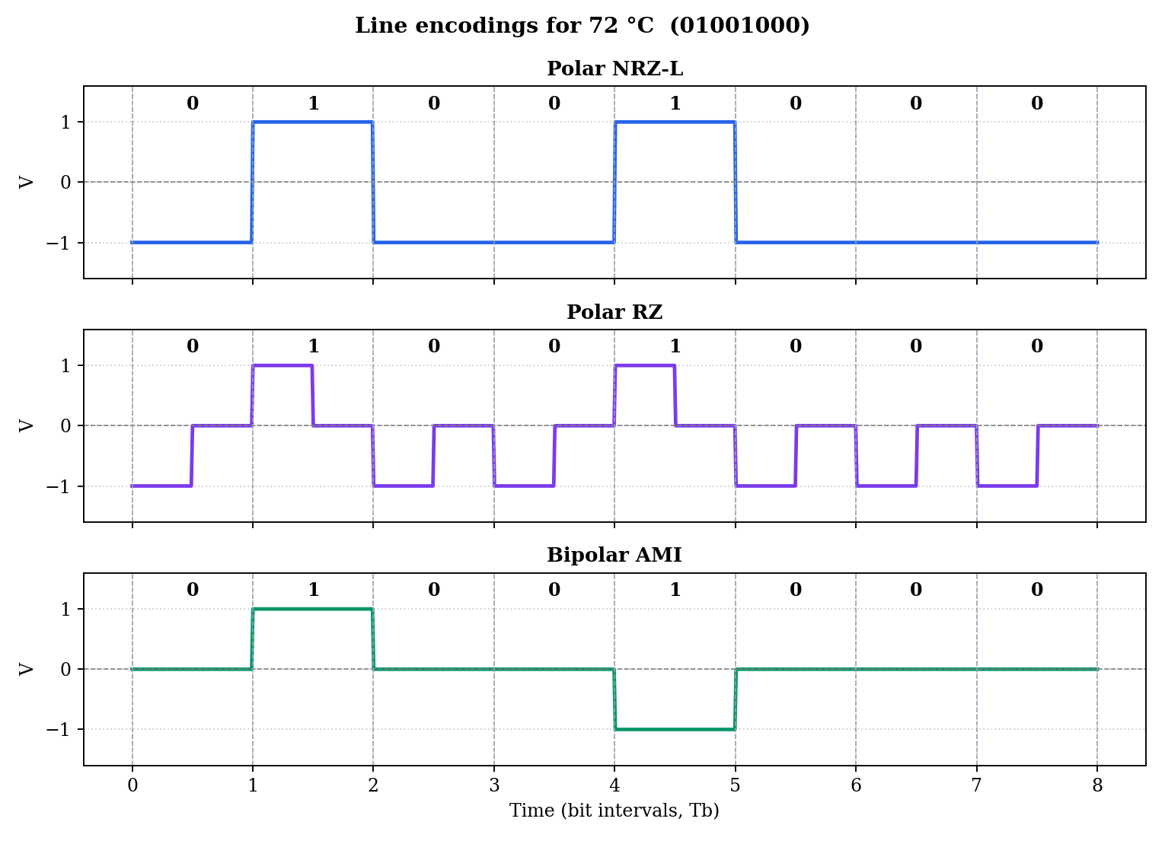
Figure 3: Comparison of Polar NRZ-L, Polar RZ and Bipolar AMI for 72 °C (01001000)
Figure 4 shows Polar NRZ-L over an ideal channel. The received signal is identical to the transmitted one, so all 8 bits are decoded correctly, the recovered value is 72 °C and the BER is 0 %.
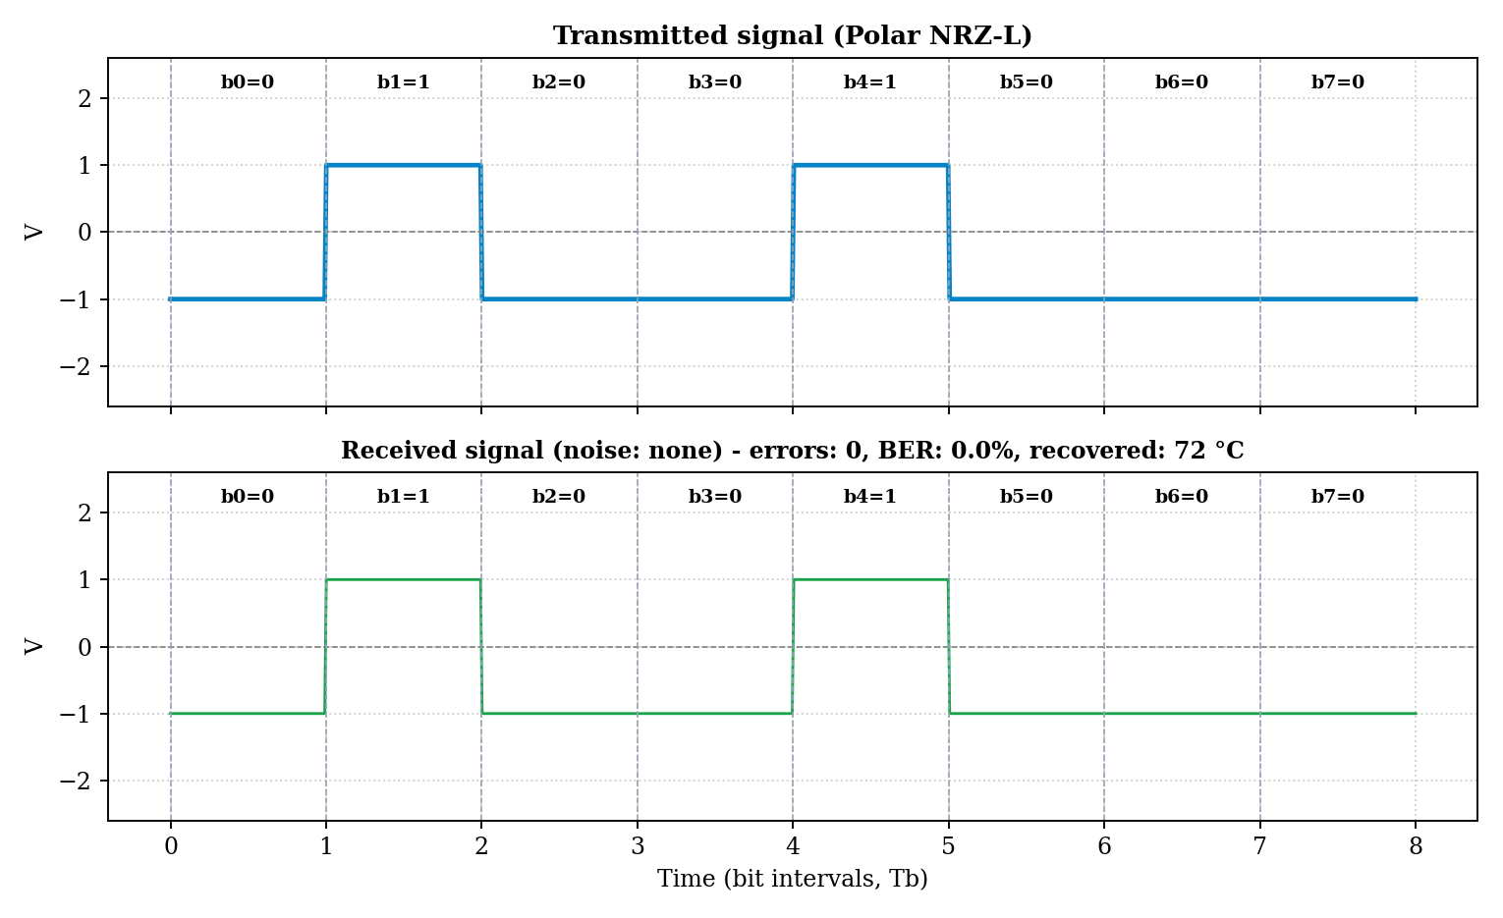
Figure 4: Polar NRZ-L, no channel noise
Figure 5 shows Bipolar AMI with low channel noise (σ = 0.20 V). The received waveform is visibly distorted, but the averaging receiver still decodes 01001000 and recovers 72 °C.
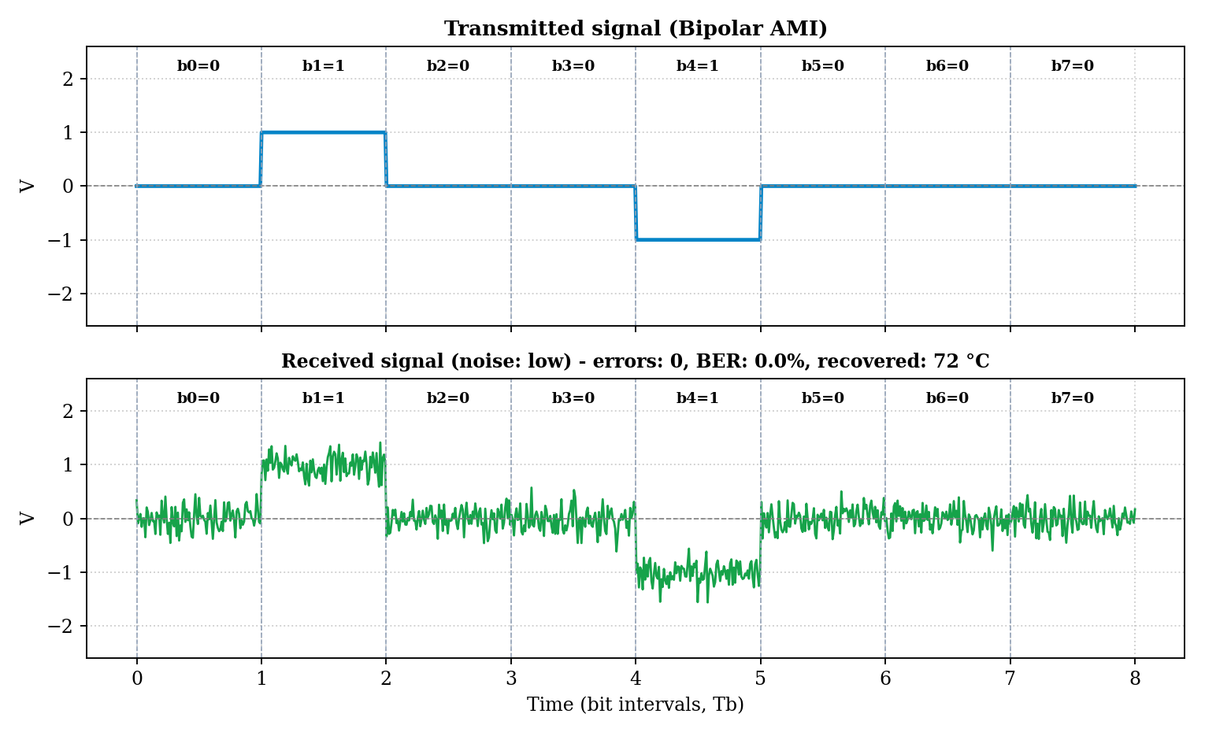
Figure 5: Bipolar AMI, low channel noise
Figure 6 shows Polar RZ with high channel noise (σ = 0.65 V). The noise is large compared with the ±1 V pulses, yet the sampling window inside each first half-bit gives the correct decision for all bits in this run.
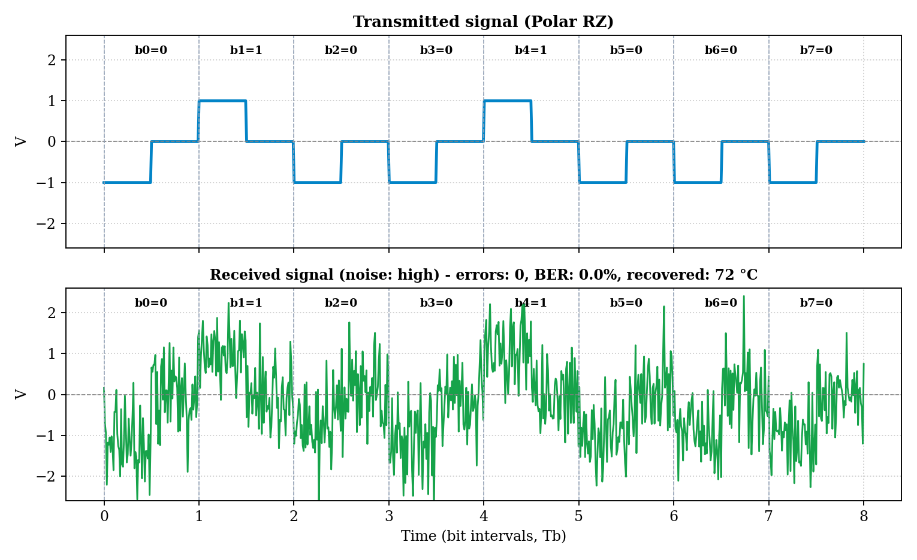
Figure 6: Polar RZ, high channel noise
The console summary printed by the program for such a run has the following form:
Original Sensor Value : 72°C
Transmitted Packet : [TEMP-01] | [TEMP] | [72°C]
Original Binary Stream : 01001000
Received Binary Stream : 01001000
Recovered Packet : [TEMP-01] | [TEMP] | [72°C]
Encoding Technique : Polar RZ
Channel Noise Level : High
Bit Errors Detected : 0 / 8 bits
Bit Error Rate (BER) : 0.00%
Transmission Status : SUCCESSFUL (Data integrity preserved)

8. Advantages and Disadvantages

8.1 Advantages
- Complete signal chain: the project shows every stage from sensor value to recovered value in one tool, which makes the concepts of line coding easy to follow.
- Visual learning: transmitted and received waveforms are plotted together with bit boundaries, so the effect of noise can be seen directly.
- Quantitative comparison: BER and error counts allow the three line codes to be compared with numbers rather than opinion.
- Two interfaces: the Python console version is simple to run and modify; the web version needs no plotting library and gives an interactive dashboard with multiple sensor types.
- Low cost and portable: it runs on any ordinary computer with free software and needs no hardware.
- Easy to extend: every stage is a separate function, so new line codes or noise models can be added with little change.

8.2 Disadvantages
- Simulation only: the project does not use real sensors, cables or line drivers, so effects such as attenuation, reflections and crosstalk are not modelled.
- Simple channel: only additive Gaussian noise is simulated.
- No synchronisation: the receiver knows exactly where every bit starts, so clock recovery is not demonstrated.
- No bipolar violation check: the AMI decoder ignores the sign of the pulses, so it cannot use the alternation rule to detect errors.
- Limited data size: only one 8-bit value (0 to 255) is sent per run, and there is no framing or error-correcting code.

8.3 Advantages and Disadvantages of the Line Codes
Table 4: Strengths and weaknesses of the implemented line codes
Scheme | Advantages | Disadvantages
Polar NRZ-L | Simple; lowest bandwidth; large decision margin (1 V from the threshold). | No transitions in long runs of equal bits; possible DC component; poor synchronisation.
Polar RZ | Transition in every bit helps synchronisation; simple decision rule. | About twice the bandwidth of NRZ-L; three voltage levels; less energy per pulse.
Bipolar AMI | No DC component; error detection through the alternation rule; 0 V for the 0 bit saves power. | Smaller decision margin (0.5 V), so it is the least noise tolerant; long runs of 0 lose synchronisation.

9. Accuracy and Efficiency

9.1 Accuracy
Accuracy was measured with the project's own encoder, noise and decoder functions. For each combination of line code and noise level, 3000 random sensor values between 0 and 255 were transmitted, and the average BER and the percentage of values recovered without any error were computed (Table 5). Because the noise is random, the exact figures change slightly from run to run.
Table 5: Average BER and error-free transmissions (3000 random values per entry)
Encoding | Noise level | Average BER (%) | Error-free values (%)
Polar NRZ-L | No noise | 0 | 100.00
Polar NRZ-L | Low (σ = 0.20 V) | 0 | 100.00
Polar NRZ-L | High (σ = 0.65 V) | 0 | 100.00
Polar NRZ-L | Very high (σ = 1.5 V) | 0.108 | 99.13
Polar NRZ-L | Extreme (σ = 2.0 V) | 1.246 | 90.43
Polar RZ | No noise | 0 | 100.00
Polar RZ | Low (σ = 0.20 V) | 0 | 100.00
Polar RZ | High (σ = 0.65 V) | 0 | 100.00
Polar RZ | Very high (σ = 1.5 V) | 0.129 | 98.97
Polar RZ | Extreme (σ = 2.0 V) | 1.296 | 90.13
Bipolar AMI | No noise | 0 | 100.00
Bipolar AMI | Low (σ = 0.20 V) | 0 | 100.00
Bipolar AMI | High (σ = 0.65 V) | 0.067 | 99.47
Bipolar AMI | Very high (σ = 1.5 V) | 10.121 | 41.67
Bipolar AMI | Extreme (σ = 2.0 V) | 19.842 | 16.47

At the three noise levels built into the program, Polar NRZ-L and Polar RZ made no errors in any of the transmissions, and Bipolar AMI made errors only at high noise, with an average BER of about 0.07 %. This is because the receiver averages 20 samples per decision, which reduces the noise standard deviation by a factor of about √20 ≈ 4.5. For example, a noise σ of 0.65 V becomes roughly 0.145 V after averaging, far smaller than the 1 V decision margin of NRZ-L and RZ.
To see where each scheme starts to fail, an additional experiment was run with larger noise values than the program offers (σ from 0.2 V to 4 V, 1500 random values per point). The result is shown in Table 6 and Figure 7.
Table 6: Average BER (%) against noise standard deviation
Encoding / σ (V) | 0.2 | 0.65 | 1 | 1.5 | 2 | 2.5 | 3 | 4
Polar NRZ-L | 0.00 | 0.00 | 0.00 | 0.18 | 1.10 | 3.71 | 7.03 | 13.19
Polar RZ | 0.00 | 0.00 | 0.00 | 0.10 | 1.30 | 3.66 | 6.33 | 12.98
Bipolar AMI | 0.00 | 0.06 | 2.08 | 10.10 | 19.73 | 27.43 | 33.91 | 40.88

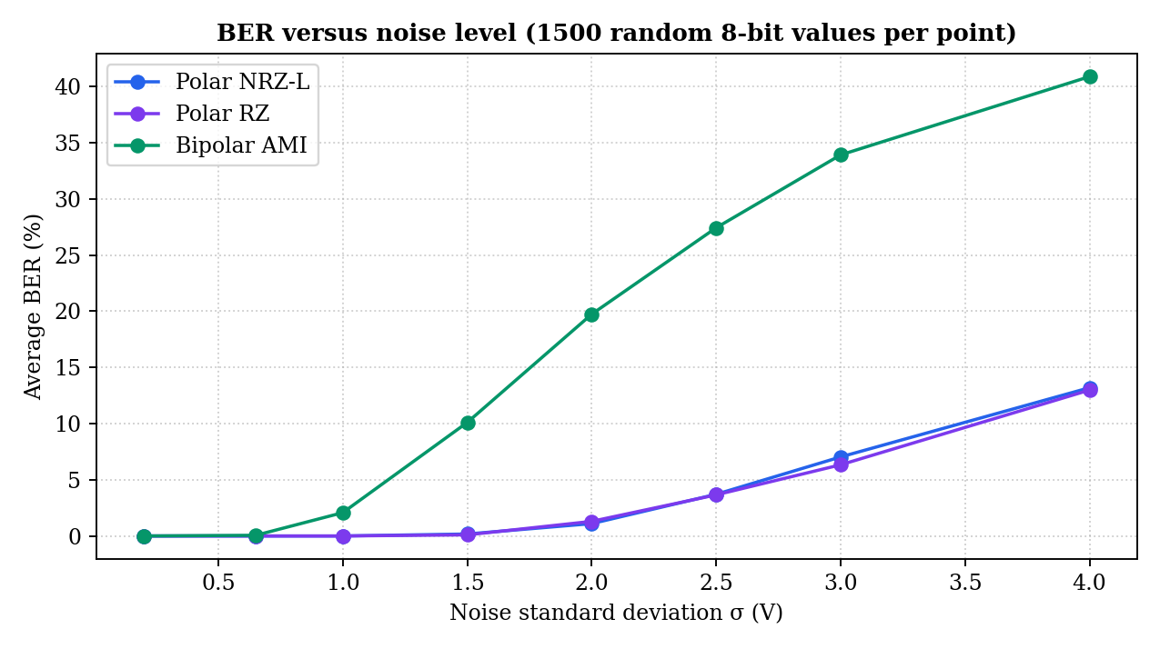
Figure 7: Average BER versus noise standard deviation for the three line codes
Polar NRZ-L and Polar RZ behave almost identically, because both are decided at ±1 V against a 0 V threshold using the same number of samples. Bipolar AMI degrades much earlier: its three levels (-1 V, 0 V, +1 V) are only 0.5 V from the decision threshold, so the same noise pushes more bits across it. This is the price paid for AMI's zero DC component and error-detection property. These results agree with the general theory that more signal levels packed into the same voltage swing reduce noise immunity [4], [9], and with the limit set by noise on the achievable data rate of any channel [17].

9.2 Efficiency
The simulation is computationally light. Every encoder and the decoder run in a single pass over the bit stream, so the work grows linearly with the number of samples (800 samples for one 8-bit value in the Python version), and a complete transmission takes a negligible fraction of a second on an ordinary laptop. Plotting is the slowest step. In terms of channel efficiency, Polar NRZ-L carries one bit per bit interval using the lowest bandwidth, Polar RZ needs about twice the bandwidth for the same bit rate, and Bipolar AMI uses the same bandwidth as NRZ-L-type signalling but is the most sensitive to noise.

10. Challenges
Several practical difficulties were faced while developing the simulator and were solved as follows.
- Choosing sampling windows: sampling a single point of a noisy bit gives many errors. The receiver therefore averages a window of 20 samples placed in the middle of the bit (NRZ-L and AMI) or inside the first half of the bit (RZ), and this made the decoder far more robust.
- Correct AMI polarity: the encoder has to remember the polarity of the last mark. The state variable is initialised so that the first 1 becomes +1 V and every later 1 flips the sign.
- Deciding AMI bits: because marks have both polarities, the decoder uses the absolute value of the sampled average against a 0.5 V threshold instead of the sign.
- Realistic noise levels: noise had to be strong enough to be visible in the plots yet not so strong that every transmission fails. Three named levels were chosen for the console version and a slider for the web version.
- Input validation: sensor values outside 0 to 255 do not fit in 8 bits, and typed input may not be a number. Values are clamped to the 8-bit range and invalid text falls back to a default.
- Repeatable noise in the browser: JavaScript's random generator cannot be seeded, so a seeded sine and cosine sequence with the Box-Muller transform was used to create Gaussian noise that changes with every simulation but can be reproduced.
- Keeping both versions consistent: the Python (100 samples per bit) and web (40 samples per bit) receivers use the same relative windows and thresholds so that their results agree.

11. Future Scope and Enhancements
The simulator can be extended in many directions:
- More line codes: Manchester and Differential Manchester (used in Ethernet [12]), HDB3 and B8ZS, and multilevel schemes such as MLT-3 and 4B/5B block coding.
- Bipolar violation detection: use the alternation rule of AMI at the receiver to flag errors without extra check bits.
- Better channel models: add attenuation, bandwidth limiting, reflections, crosstalk and burst noise to model long industrial cables and RS-485 links [13].
- Error control: add parity bits, CRC or Hamming codes, and framing with start and stop bits, so that a full sensor message can be sent instead of a single byte.
- Synchronisation: add a clock recovery stage to show why transitions in the signal matter.
- Analysis tools: plot BER against signal-to-noise ratio curves, eye diagrams and the power spectrum of each code, with CSV export of results.
- Real hardware: connect a real temperature sensor through a microcontroller and send the encoded signal over a physical link, or use live data from industrial protocols.
- Continuous data: stream many sensor readings in sequence and trigger alarms from the received values.

12. Conclusion
The Industrial Sensor Line Encoding Simulator successfully demonstrates how an industrial sensor reading is converted into bits, encoded as a voltage waveform, sent over a noisy channel and recovered at the receiver. The project implements Polar NRZ-L, Polar RZ and Bipolar AMI in both a Python console application and a React-based web simulator, and reports the bit errors and BER of every transmission.
The experiments show that all three schemes deliver the sensor value without error over an ideal channel and at the low and high noise levels built into the program, thanks to the averaging receiver. When the noise is increased further, Polar NRZ-L and Polar RZ stay reliable for noise up to about σ = 1 V, while Bipolar AMI starts failing much earlier, because its smaller decision margin makes it less tolerant to noise. In return, AMI has no DC component and offers a built-in error-detection rule. The choice of a line code is therefore a trade-off between bandwidth, synchronisation, DC content and noise immunity.
Through this project the team gained practical understanding of digital transmission, line coding, noise modelling, threshold detection and BER analysis, as well as experience in building both a scientific Python program and an interactive web application. The simulator can be used as a teaching aid for the Data Communication course and can be extended with the enhancements listed above.

13. References
[1] B. A. Forouzan, Data Communications and Networking, 5th ed. New York, NY, USA: McGraw-Hill, 2013.
[2] W. Stallings, Data and Computer Communications, 10th ed. Upper Saddle River, NJ, USA: Pearson, 2013.
[3] A. S. Tanenbaum and D. J. Wetherall, Computer Networks, 5th ed. Boston, MA, USA: Pearson, 2011.
[4] J. G. Proakis and M. Salehi, Digital Communications, 5th ed. New York, NY, USA: McGraw-Hill, 2008.
[5] S. Haykin, Communication Systems, 4th ed. New York, NY, USA: Wiley, 2001.
[6] B. P. Lathi and Z. Ding, Modern Digital and Analog Communication Systems, 4th ed. New York, NY, USA: Oxford University Press, 2009.
[7] J. R. Barry, E. A. Lee, and D. G. Messerschmitt, Digital Communication, 3rd ed. New York, NY, USA: Springer, 2004.
[8] L. W. Couch II, Digital and Analog Communication Systems, 8th ed. Upper Saddle River, NJ, USA: Pearson, 2013.
[9] B. Sklar, Digital Communications: Fundamentals and Applications, 2nd ed. Upper Saddle River, NJ, USA: Prentice Hall, 2001.
[10] A. Leon-Garcia and I. Widjaja, Communication Networks: Fundamental Concepts and Key Architectures, 2nd ed. New York, NY, USA: McGraw-Hill, 2004.
[11] ITU-T, Recommendation G.703: Physical/electrical characteristics of hierarchical digital interfaces, International Telecommunication Union, Geneva, Switzerland, 2016.
[12] IEEE Standard for Ethernet, IEEE Std 802.3-2018, IEEE, New York, NY, USA, 2018.
[13] TIA/EIA-485-A: Electrical Characteristics of Generators and Receivers for Use in Balanced Digital Multipoint Systems, Telecommunications Industry Association, 1998.
[14] T. Sauter, "The three generations of field-level networks: Evolution and compatibility issues," IEEE Trans. Ind. Electron., vol. 57, no. 11, pp. 3585-3595, Nov. 2010.
[15] M. Wollschlaeger, T. Sauter, and J. Jasperneite, "The future of industrial communication: Automation networks in the era of the Internet of Things and Industry 4.0," IEEE Ind. Electron. Mag., vol. 11, no. 1, pp. 17-27, Mar. 2017.
[16] J.-P. Thomesse, "Fieldbus technology in industrial automation," Proc. IEEE, vol. 93, no. 6, pp. 1073-1101, Jun. 2005.
[17] C. E. Shannon, "A mathematical theory of communication," Bell Syst. Tech. J., vol. 27, no. 3, pp. 379-423, Jul. 1948.
[18] J. D. Hunter, "Matplotlib: A 2D graphics environment," Comput. Sci. Eng., vol. 9, no. 3, pp. 90-95, May-Jun. 2007.
[19] C. R. Harris et al., "Array programming with NumPy," Nature, vol. 585, pp. 357-362, Sep. 2020.
[20] Meta Open Source, "React: The library for web and native user interfaces." [Online]. Available: https://react.dev

