STUDENT COUNCIL ELECTION SYSTEM
Java Project Documentation

Project Report

Programming Language: Java
Concepts Used: Classes, Objects, Arrays, Methods, Loops and Conditional Statements
Application Type: Console-based Student Election System

1. Project Overview
The Student Council Election System is a console-based Java application designed to conduct and manage elections for four student council posts: President, Vice President, Secretary and Treasurer. The application allows users to select a post, enter the number of voters, record votes for candidates, display election results and identify winners or ties.

2. Objectives
- Provide a simple menu-driven election interface.
- Store candidate names and their vote counts using Java objects.
- Allow multiple voters to cast votes for each post.
- Validate candidate choices before recording a vote.
- Calculate the highest vote count and identify the winner.
- Detect and display ties between candidates.

3. Features
Feature | Description
Candidate Management | Candidates are represented using the Candidate class.
Voting | Voters select a candidate by entering the candidate number.
Vote Counting | Each valid vote increments the selected candidate's vote count.
Result Display | The program displays votes for every candidate.
Winner Detection | The candidate with the highest number of votes is displayed.
Tie Detection | If multiple candidates have the highest vote count, a tie is reported.
Menu System | Users can repeat election operations until they choose Exit.

4. Concepts Used
Concept | Application in Project
Class | Candidate and StudentCouncilElection are classes used to organize the program.
Object | Candidate objects such as Rahul, Priya and Arjun represent individual candidates.
Constructor | Candidate(String name) initializes a candidate's name and vote count.
Methods | addVote(), displayCandidates(), conductVoting() and displayResults() perform specific tasks.
Arrays of Objects | Candidate[] arrays store candidates for each election post.
Encapsulation of Behaviour | Vote-related operations are grouped into methods.

5. Sample Output Screenshots
The following screenshots show representative executions of the program.

5.1 Voting Screen
A voter selects the President option and votes for candidates.
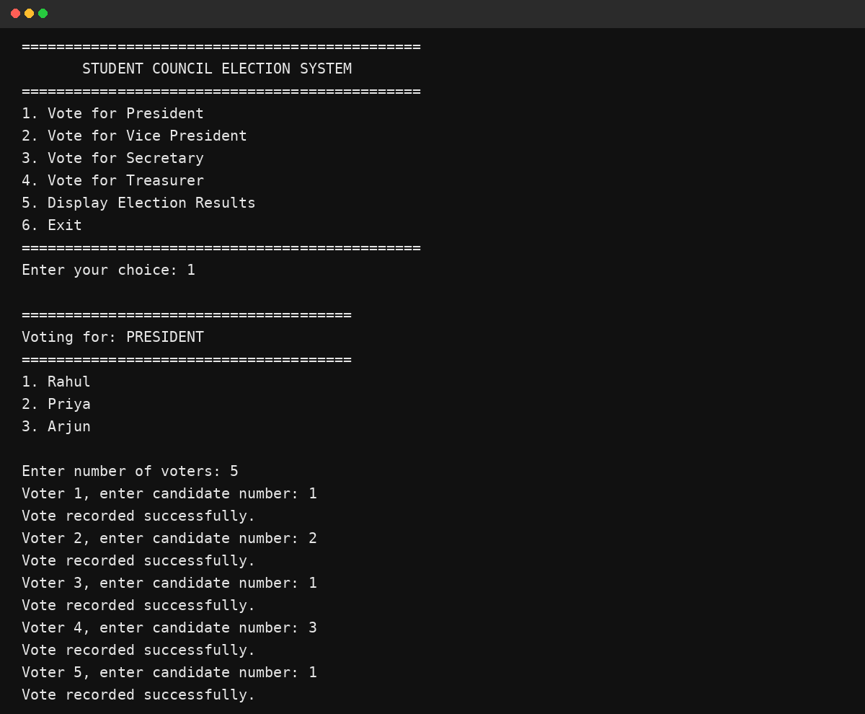

5.2 Election Results
The results screen displays vote totals and the winner for each post.
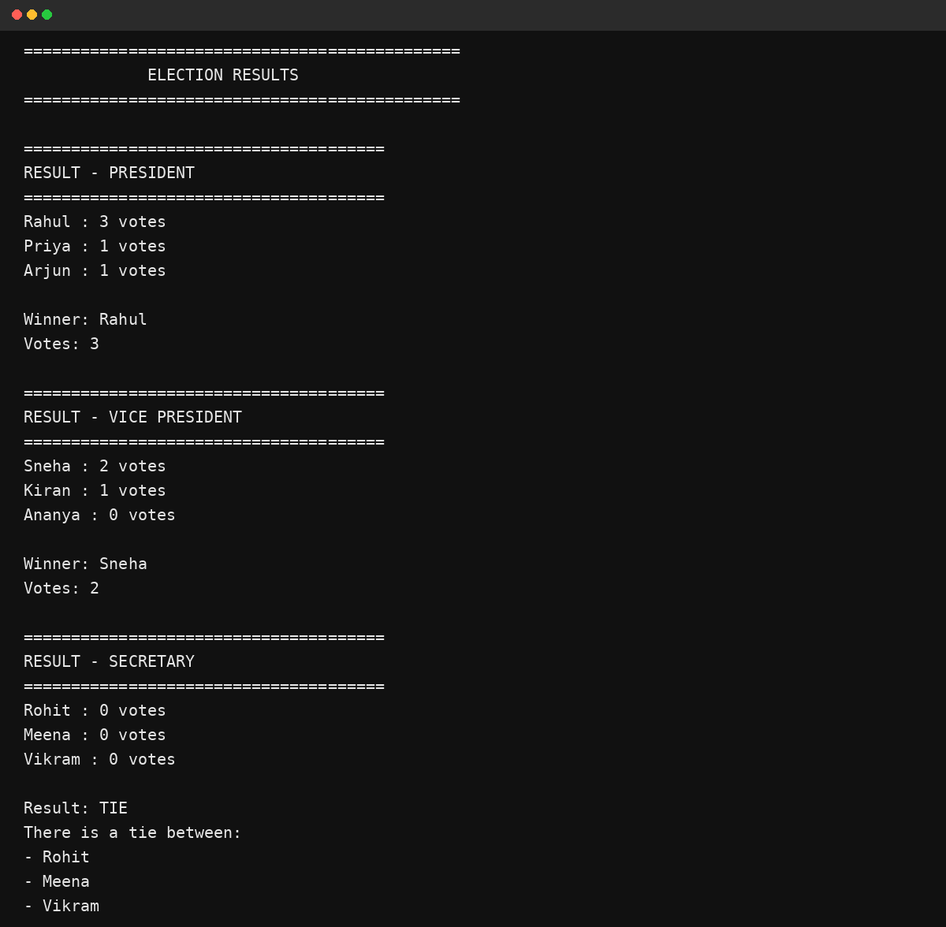

5.3 Tie Result
When two or more candidates have the same highest vote count, the system reports a tie.
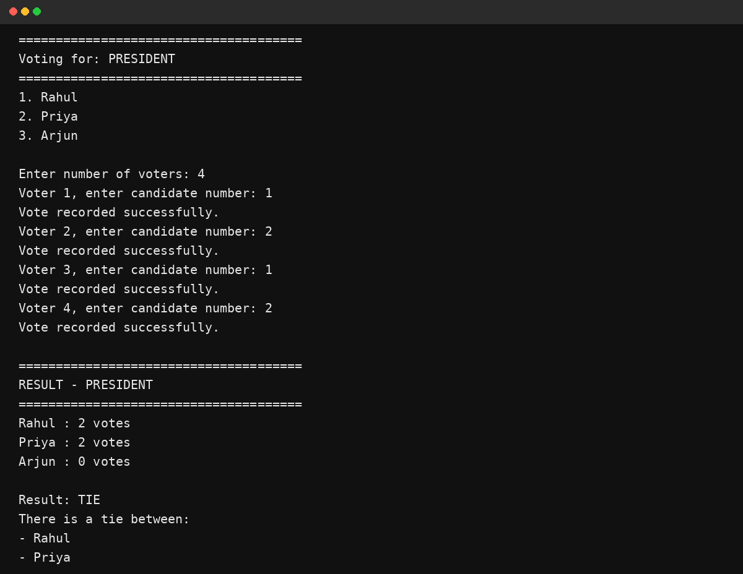

5.4 Vice President Voting and Result
This screenshot shows voting for the Vice President post followed by the corresponding result.
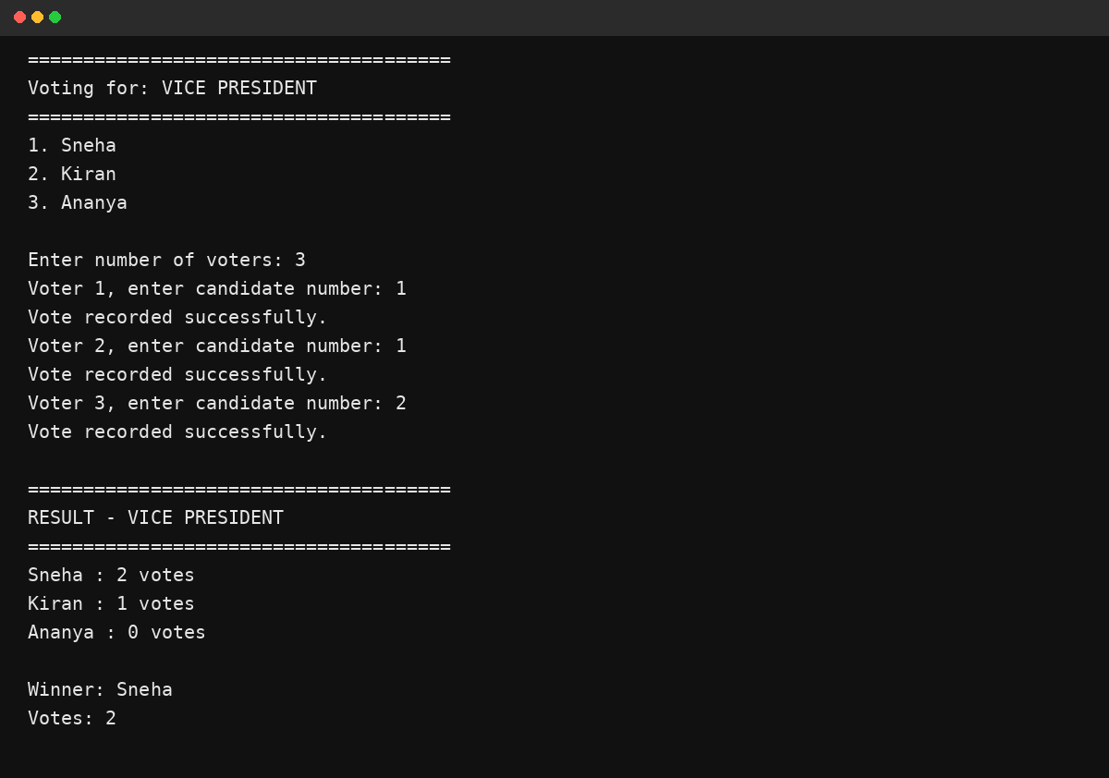

6. Complete Java Program
File name: StudentCouncilElection.java
import java.util.Scanner;

class Candidate {

String name;
int votes;

Candidate(String name) {
this.name = name;
this.votes = 0;
}

void addVote() {
votes++;
}
}

public class StudentCouncilElection {

static Scanner sc = new Scanner(System.in);

// Display candidates
static void displayCandidates(Candidate[] candidates) {
for (int i = 0; i < candidates.length; i++) {
System.out.println((i + 1) + ". " + candidates[i].name);
}
}

// Voting method
static void conductVoting(String post, Candidate[] candidates) {
System.out.println("\n======================================");
System.out.println("Voting for: " + post);
System.out.println("======================================");

displayCandidates(candidates);

System.out.print("\nEnter number of voters: ");
int voters = sc.nextInt();

for (int i = 1; i <= voters; i++) {
System.out.print("Voter " + i + ", enter candidate number: ");
int choice = sc.nextInt();

if (choice >= 1 && choice <= candidates.length) {
candidates[choice - 1].addVote();
System.out.println("Vote recorded successfully.");
} else {
System.out.println("Invalid choice! Vote not counted.");
}
}
}

// Display results
static void displayResults(String post, Candidate[] candidates) {
System.out.println("\n======================================");
System.out.println("RESULT - " + post);
System.out.println("======================================");

int highestVotes = -1;

for (Candidate candidate : candidates) {
System.out.println(
candidate.name + " : " + candidate.votes + " votes");

if (candidate.votes > highestVotes) {
highestVotes = candidate.votes;
}
}

// Find winner
Candidate winner = null;
int winnerCount = 0;

for (Candidate candidate : candidates) {
if (candidate.votes == highestVotes) {
winner = candidate;
winnerCount++;
}
}

if (winnerCount > 1) {
System.out.println("\nResult: TIE");
System.out.println("There is a tie between:");

for (Candidate candidate : candidates) {
if (candidate.votes == highestVotes) {
System.out.println("- " + candidate.name);
}
}
} else {
System.out.println("\nWinner: " + winner.name);
System.out.println("Votes: " + winner.votes);
}
}

// Main method
public static void main(String[] args) {

// President candidates
Candidate[] president = {
new Candidate("Rahul"),
new Candidate("Priya"),
new Candidate("Arjun")
};

// Vice President candidates
Candidate[] vicePresident = {
new Candidate("Sneha"),
new Candidate("Kiran"),
new Candidate("Ananya")
};

// Secretary candidates
Candidate[] secretary = {
new Candidate("Rohit"),
new Candidate("Meena"),
new Candidate("Vikram")
};

// Treasurer candidates
Candidate[] treasurer = {
new Candidate("Amit"),
new Candidate("Pooja"),
new Candidate("Varun")
};

int choice;

do {
System.out.println("\n");
System.out.println("==============================================");
System.out.println(" STUDENT COUNCIL ELECTION SYSTEM");
System.out.println("==============================================");
System.out.println("1. Vote for President");
System.out.println("2. Vote for Vice President");
System.out.println("3. Vote for Secretary");
System.out.println("4. Vote for Treasurer");
System.out.println("5. Display Election Results");
System.out.println("6. Exit");
System.out.println("==============================================");
System.out.print("Enter your choice: ");

choice = sc.nextInt();

switch (choice) {

case 1:
conductVoting("PRESIDENT", president);
break;

case 2:
conductVoting("VICE PRESIDENT", vicePresident);
break;

case 3:
conductVoting("SECRETARY", secretary);
break;

case 4:
conductVoting("TREASURER", treasurer);
break;

case 5:
System.out.println("\n");
System.out.println("==============================================");
System.out.println(" ELECTION RESULTS");
System.out.println("==============================================");

displayResults("PRESIDENT", president);
displayResults("VICE PRESIDENT", vicePresident);
displayResults("SECRETARY", secretary);
displayResults("TREASURER", treasurer);
break;

case 6:
System.out.println("\n==============================================");
System.out.println("Thank you for using the Election System!");
System.out.println("==============================================");
break;

default:
System.out.println(
"Invalid choice! Please try again.");
}

} while (choice != 6);

sc.close();
}
}

7. Algorithm
- Start the program.
- Create candidate objects for President, Vice President, Secretary and Treasurer.
- Display the main election menu.
- Read the user's menu choice.
- If a voting option is selected, display the corresponding candidates.
- Read the number of voters.
- For each voter, read the candidate number and record a valid vote.
- If the results option is selected, calculate the highest vote count for each post.
- Display the winner when there is a single candidate with the highest vote count.
- Display all tied candidates when multiple candidates have the highest vote count.
- Repeat the menu until the user selects Exit.
- Close the Scanner and terminate the program.

8. Conclusion
The Student Council Election System demonstrates how Java can be used to build a simple menu-driven application using object-oriented programming. It combines classes, constructors, arrays of objects, methods, loops and conditional logic to manage voting and election results. The program also handles invalid candidate choices and ties, making the console application suitable as a basic Java project.

