**1.Revised Functionality**

**1.1 Sensors and Actuators**

1. TMP-102 – Is an I2C based temperature sensor which is designed to display the output on an LCD.
2. HC-SR04 – Is a digital sensor which is designed to return status in the project on an LED.
3. GT-521f32- Is an UART based sensor which controls a servo.
4. MQ2 - Is an analog sensor which is pared to run with buzzer.

**1.2 Task features**

1. Each task is spawned for each sensor.
2. There is one logger task which collects all the data from the other threads to send to Beagle Bone.

**1.3 Fault Handling**

1. Disconnecting any sensor lights up a red LED.
2. Alert from any sensor is represented by glowing a green LED.
3. Communication link that breaks between Beagle Bone and TIVA C is represented by a Green LED glowing and 7-segment display lights up with the number ‘8’ on the Beagle Bone side.
4. When Beagle Bone is disconnected completely (reset or unplugging the board) TIVA C continues to display values on the UART terminal.
5. When TIVA C is disconnected completely(reset or unplugging the board) Beagle Bone’s 7 segment displays ‘2’.

**1.4 Fail Safe**

1. When smoke is detected on the smoke sensor, buzzer goes off and door opens (servo rotates).
2. Buzzer continues to ring till smoke goes below threshold.

**1.5 Logging**

Logging on the Beagle bone side includes the following.

1. Logging at boot time.

2. Logging (TIVA_C)thread IDs.

3.Logging sensor value logs.

4. Logging break in communication.

5. Logging alert values on sensor/sensors.

6. Logging when sensor/sensors stop functioning/have faults.

7. Logging time stamps.

**2. Revised Block Diagram**

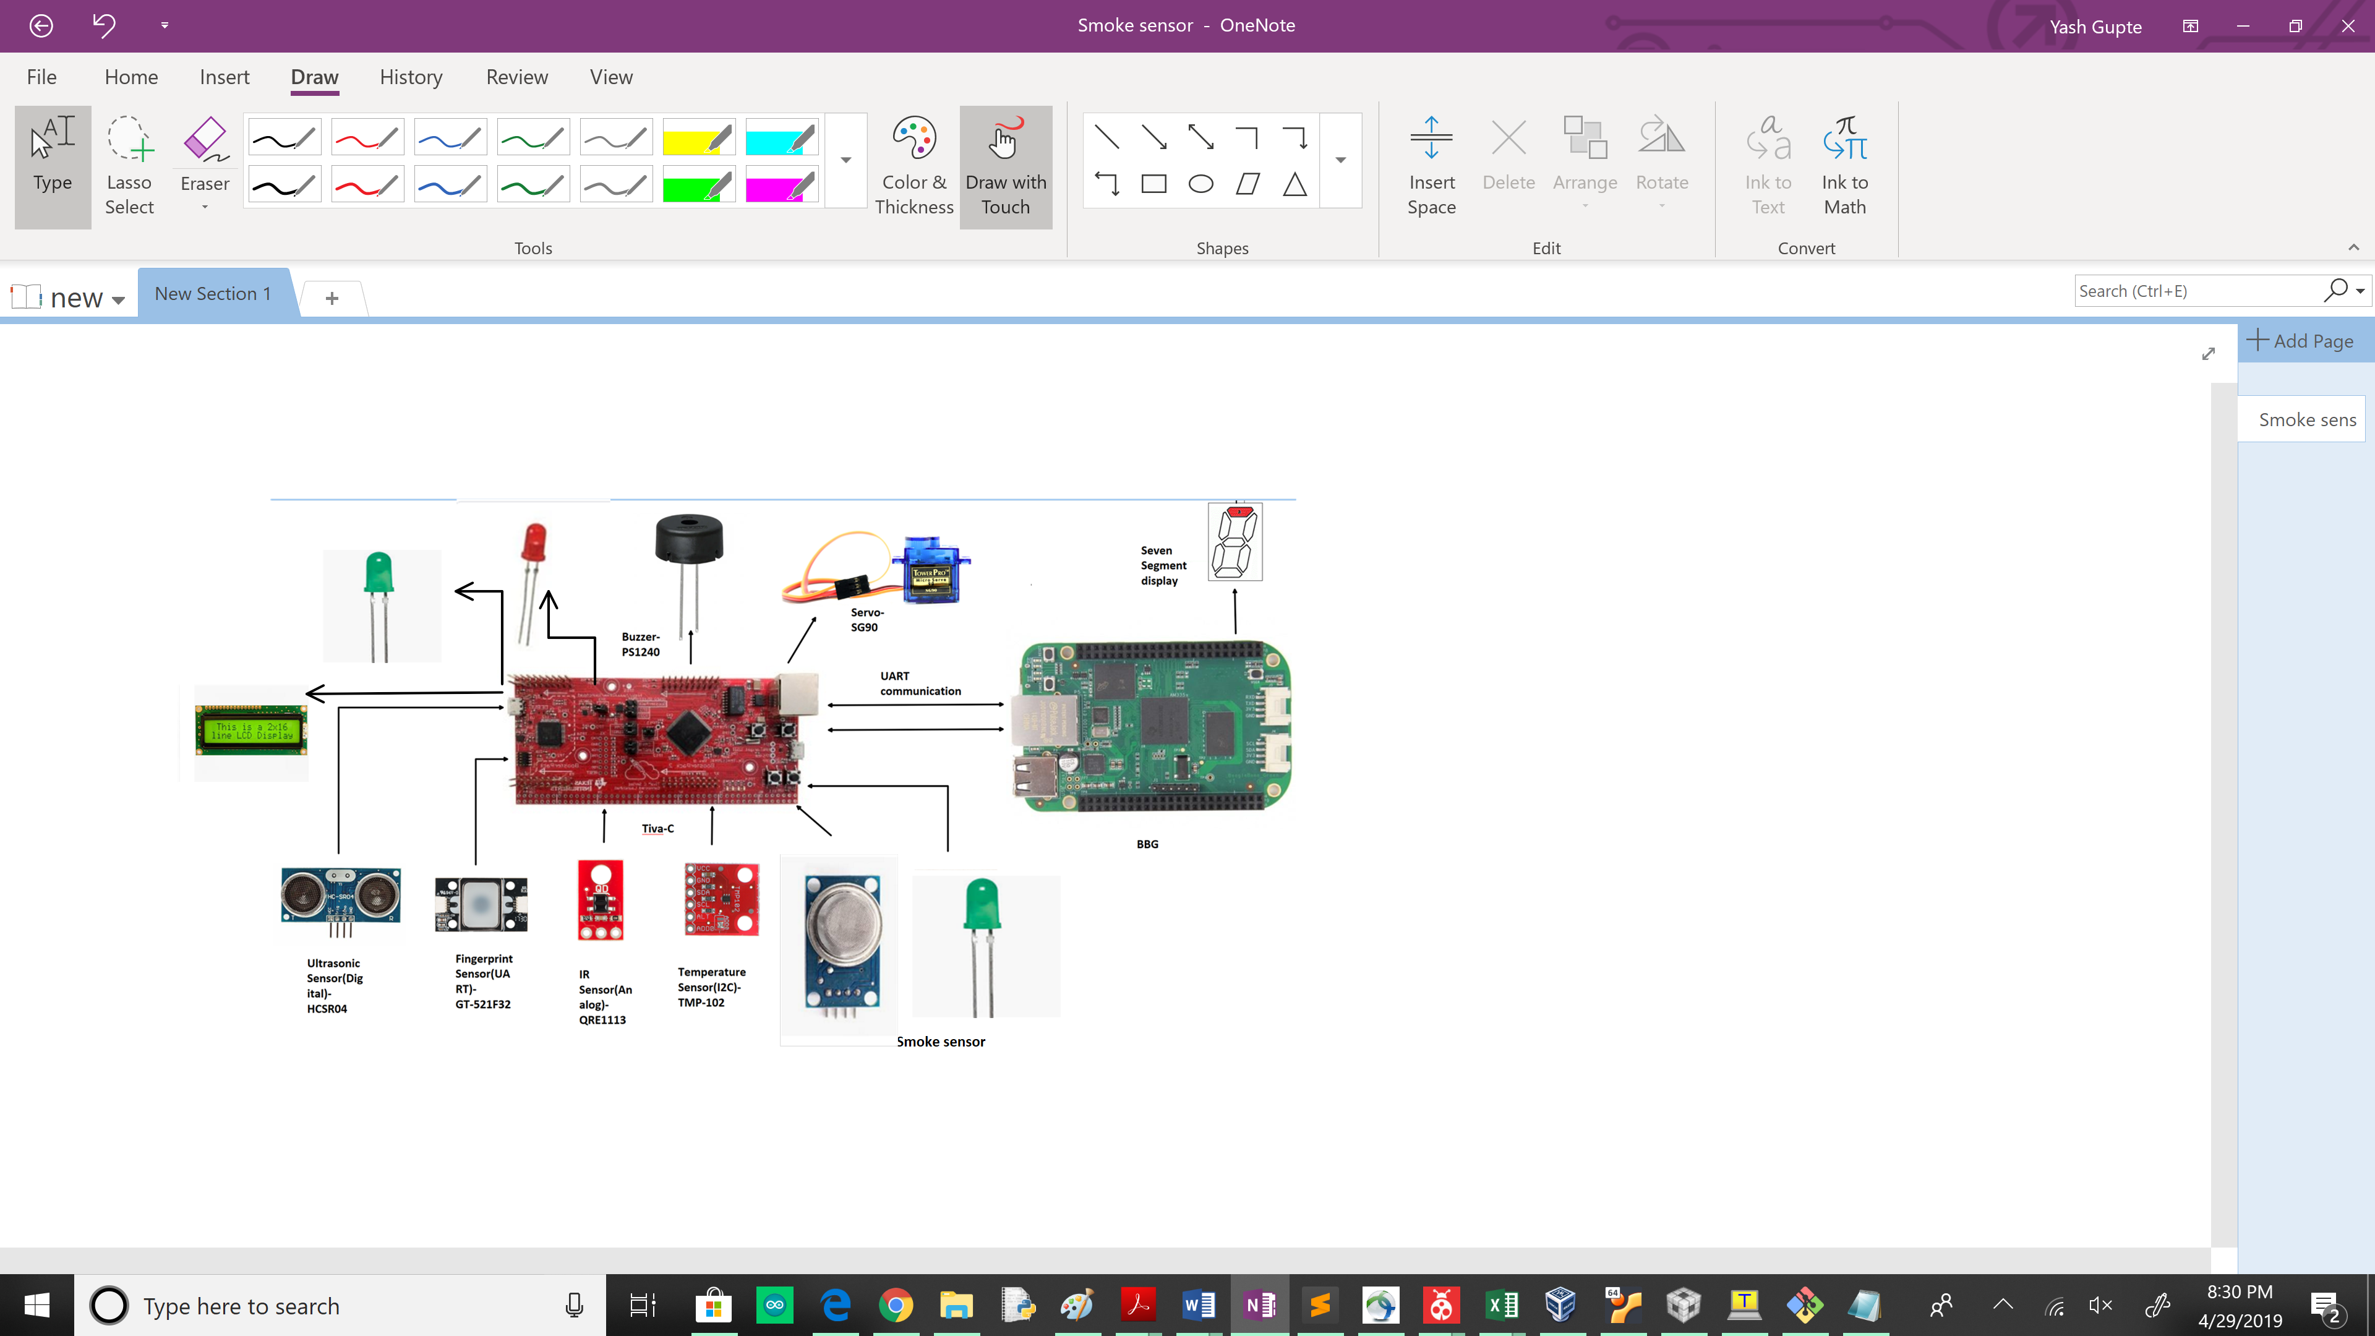

**3. Program Flow**

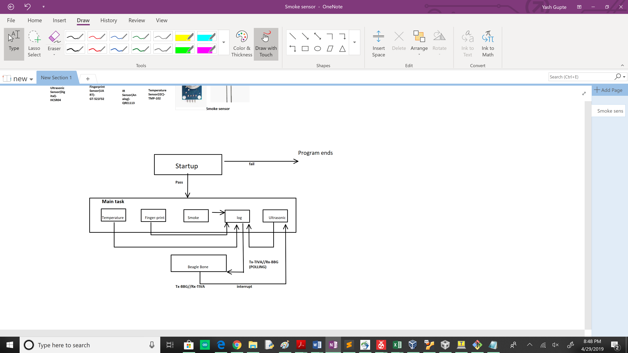

**5. Tests and Results**

Link to test plan**:**

[**https://drive.google.com/file/d/12Sgx5I1wfiK8u7cKQgNSDgkUnxxTGB3S/view?usp=sharing**](https://drive.google.com/file/d/12Sgx5I1wfiK8u7cKQgNSDgkUnxxTGB3S/view?usp=sharing)

**6. Key Learnings**

1. PWM function was a blocking function initially. It required changing the includes, sources and directories of the project folder.
2. Interfacing of buzzer required the use of PWM on a GPIO pin. While PWM was also being used for servo, we had to configure 2 separate PWMs to run the buzzer and servo.
3. PWM based servo consumed around 400mA of current when on. This require us to use a separate power supply.
4. Using a separate UART for integrating Finger Print sensor took a lot of time. Since the sensor does not have ready made APIs, we had to write the functions from scratch plus have mechanisms to integrate them to work coherently to achieve higher functionality. For example, we need 5 different pairs of commands and responses to validate a finger print.
5. Interfacing the Finger-print sensor consumes significant current for the board. This required us to use a separate power supply to power the sensor.
6. Handling communication links breaking between TIVA C and Beagle Bone was cumbersome. This required writing code on both TIVA C and Beagle Bone to ensure proper timers to check sanctity of the communication process.