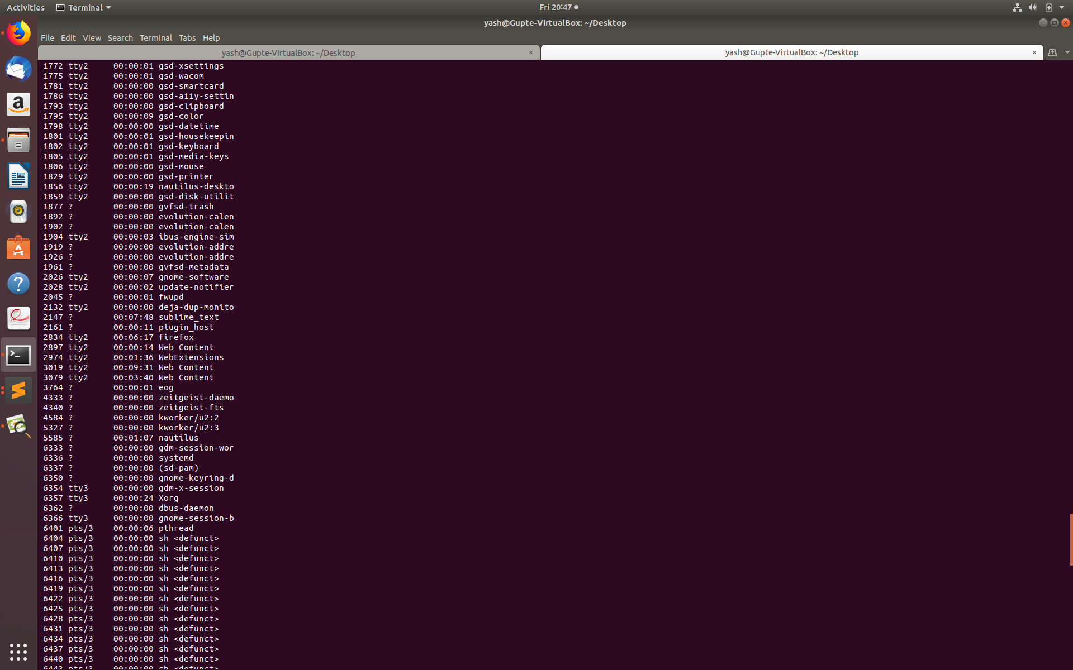

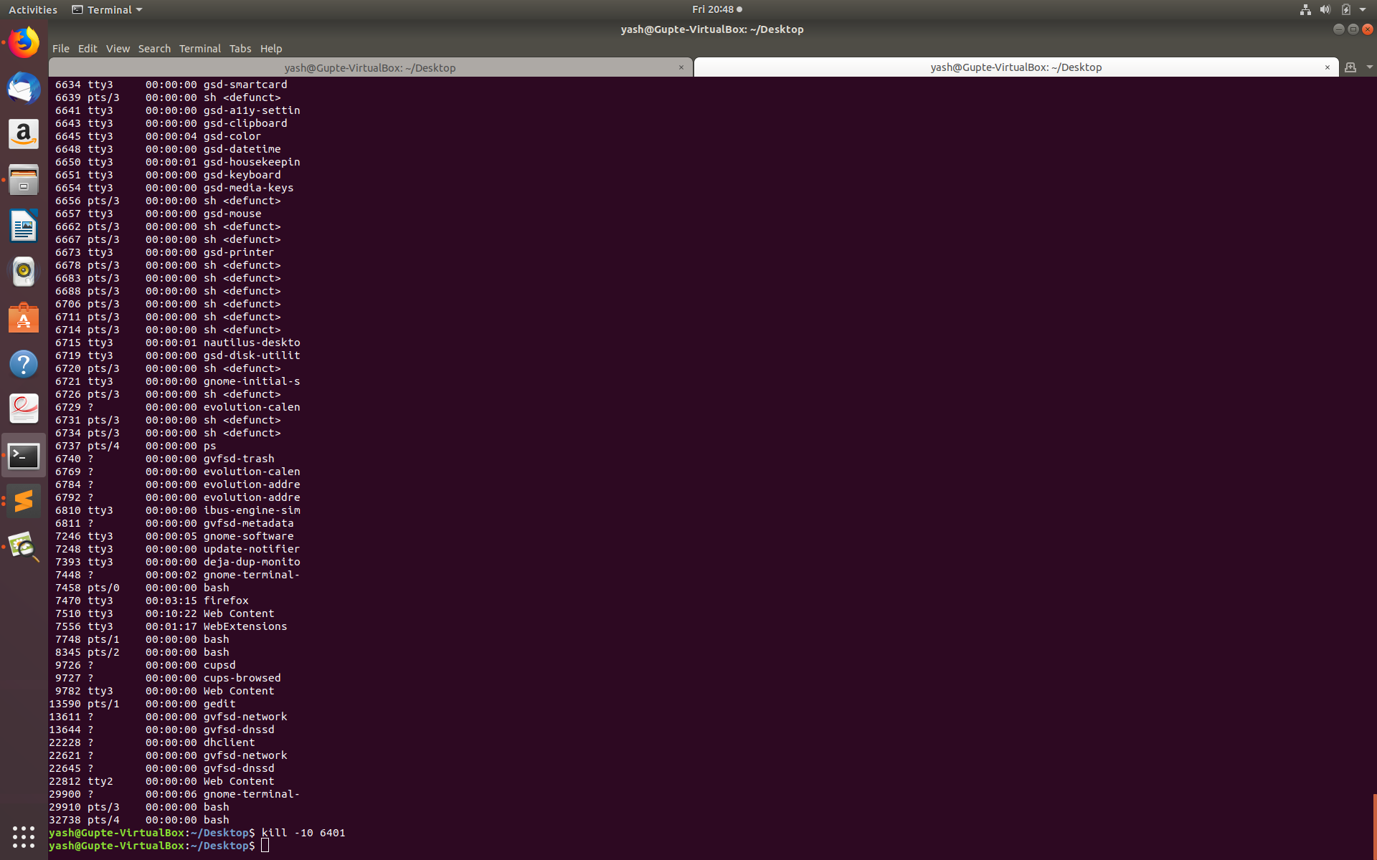

Description:

1. Thread One: The program calculates occurances of alphabets and logs to them to a file. Upper and lower case characters are considered the same in this execution.
2. Thread Two: Thread 2 runs in a loop waiting for the kill command. In the meanwhile it logs the CPU usage. Kill command is issued by finindg the PID of the process. Then issuing a command via- kill -10 PID