**OYESTER-ASSIGNMENT-YASHSHAH**

**1) TABLE-1**

CREATE TABLE table1 (column1 varchar(255), column2 varchar(255), column3 varchar(255))

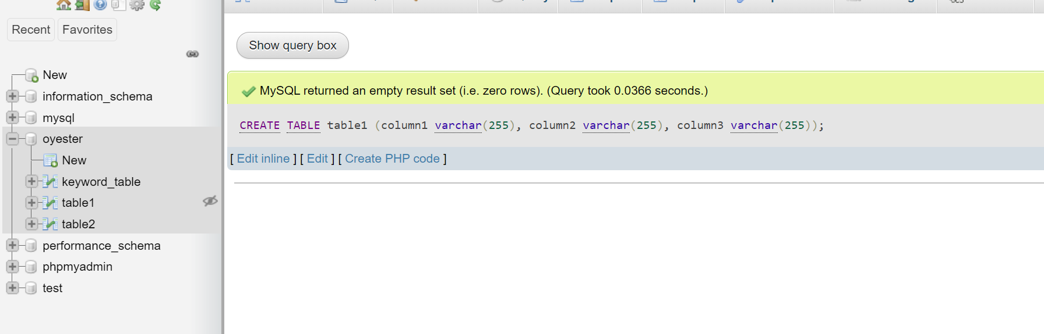

INSERT INTO table1 (column1, column2, column3) VALUES ("value_table1_11",

"value_table1_12", "value_table1_13");

INSERT INTO table1 (column1, column2, column3) VALUES ("value_table1_21",

"value_table1_22", "value_table1_23");

INSERT INTO table1 (column1, column2, column3) VALUES ("value_table1_31",

"value_table1_32", "value_table1_33");

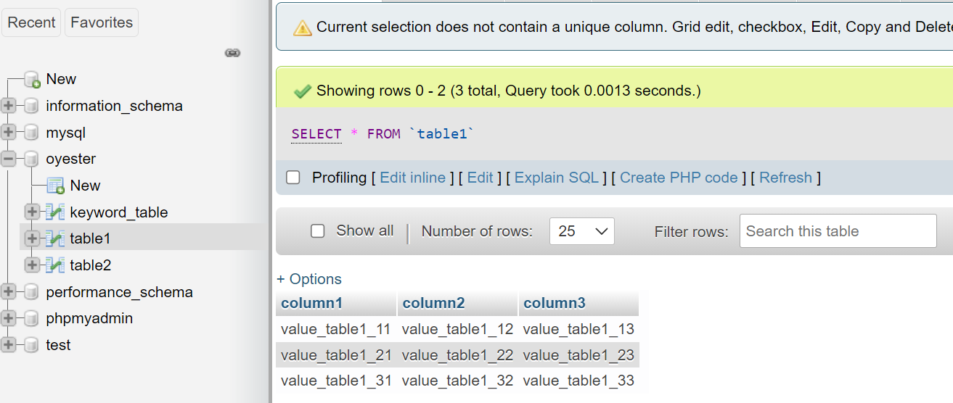

**2)TABLE-2**

CREATE TABLE table2 (column1 varchar(225), column2 varchar(225), column3 varchar(225));

INSERT INTO table2 (column1, column2, column3) VALUES ("value_table2_11",

"value_table2_12", "value_table2_13");

INSERT INTO table2 (column1, column2, column3) VALUES ("value_table2_21",

"value_table2_22", "value_table2_23");

INSERT INTO table2 (column1, column2, column3) VALUES ("value_table2_31",

"value_table2_32", "value_table2_33");

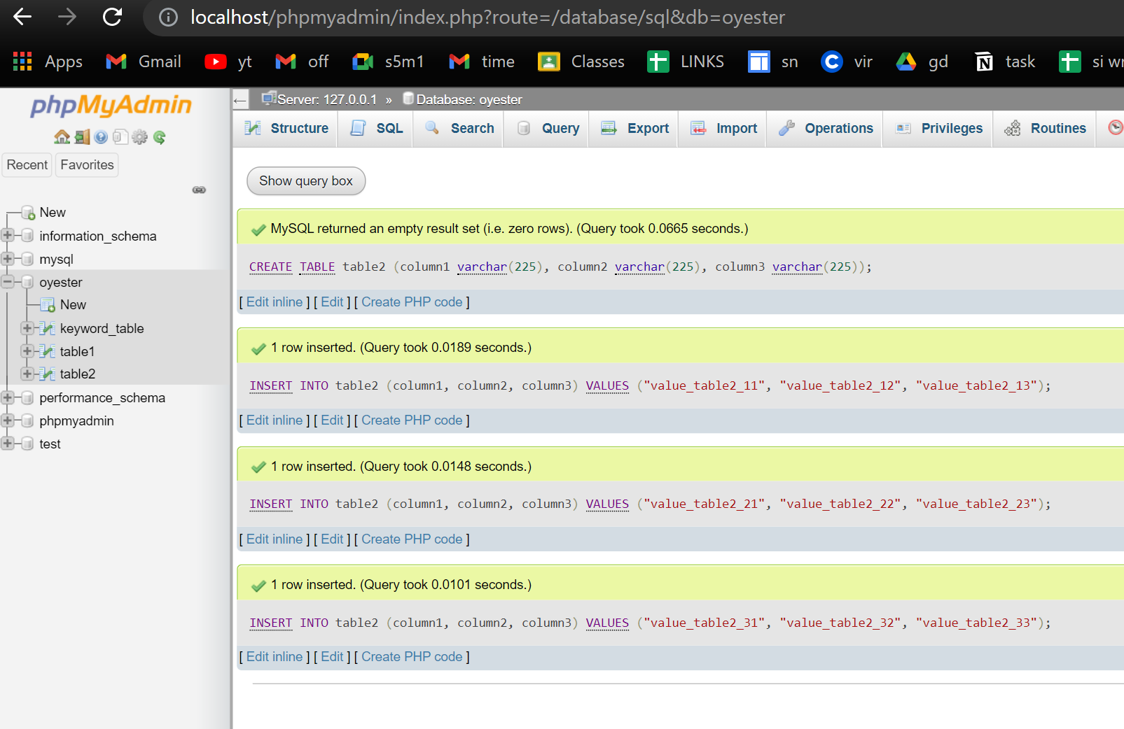

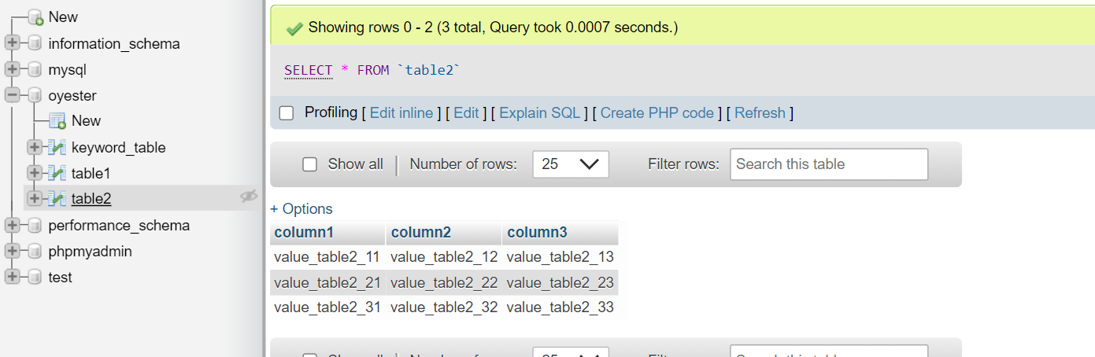

**3) keyword_table**

create table keyword_table(keyword varchar(255),table1 varchar(255),columns_names varchar(255))

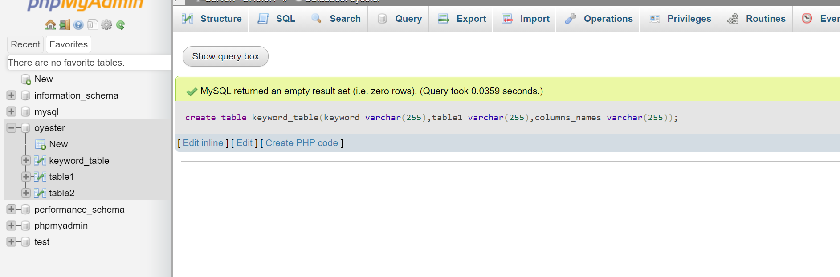

INSERT INTO keyword_table(keyword, table1, columns_names) VALUES ("asd", "table2","[column2, column3]");

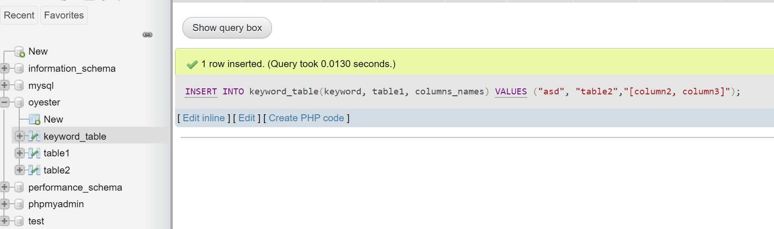

iNSERT INTO keyword_table (keyword, table1, columns_names) VALUES ("xyz", "table1","[column1, column2]");

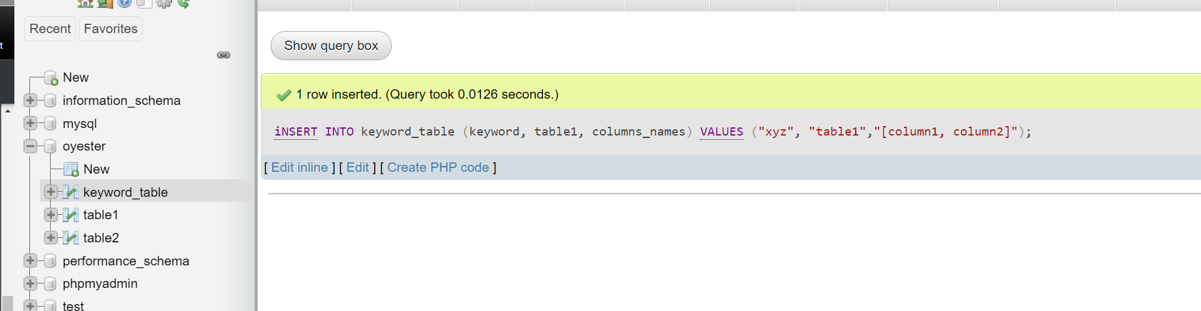

Db.php

<?php

$con = new mysqli("localhost","root","","oyester");

if ($con->connect_error)

{

  die("Connection failed: " . $con->connect_error);

}

?>

disptablename.php

<?php

include "db.php";

include "data.html";

if(isset($_GET['submit']))

{

    $keyword = $_GET['keyword'];

    $url_components = parse_url($keyword);

   parse_str($url_components['query'], $params);

    $key=$params['source'];

    echo $key;

*//  echo $keyword;*

*//  $sql = "select table1 from keyword_table where keyword='$keyword'";*

      if (mysqli_connect_errno())

      {

      echo "Failed to connect to MySQL: " . mysqli_connect_error();

      }

      $result = mysqli_query($con,"select table1 from keyword_table where keyword='$key'");

      echo "<table border='1'>

      <tr>

      <th>Firstname</th>

      </tr>";

      while($row = mysqli_fetch_array($result))

      {

      echo "<tr>";

      echo "<td>" . $row['table1'] . "</td>";

*// echo "<td>" . $row['LastName'] . "</td>";*

      echo "</tr>";

      $tablename=$row['table1'];

      echo $tablename;

      }

      echo "</table>";

}

?>

Index.php

<?php

include "db.php";

include "data.html";

if(isset($_GET['submit']))

{

    $keyword = $_GET['keyword'];

    $url_components = parse_url($keyword);

   parse_str($url_components['query'], $params);

    $key=$params['source'];

*//  echo $key;*

*//  echo $keyword;*

*//  $sql = "select table1 from keyword_table where keyword='$keyword'";*

      if (mysqli_connect_errno())

      {

      echo "Failed to connect to MySQL: " . mysqli_connect_error();

      }

      $result = mysqli_query($con,"select table1 from keyword_table where keyword='$key'");

      echo "<table border='1'>

      <tr>

      <th><b>Table Name</b></th>

      </tr>";

      while($row = mysqli_fetch_array($result))

      {

      echo "<tr>";

      echo "<td>" . $row['table1'] . "</td>";

*// echo "<td>" . $row['LastName'] . "</td>";*

      echo "</tr>";

      $tablename=$row['table1'];

      echo $tablename;

      }

      echo "</table>";

*// $tablename=$row['table1'];*

*// echo "table name " ."$tablename";*

      $result2 = mysqli_query($con,"select * from $tablename");

      echo "<table border='1'>

      <tr>

      <th>column1</th>

      <th>column2</th>

      </tr>";

      while($row = mysqli_fetch_array($result2))

      {

      echo "<tr>";

      echo "<td>" . $row['column1'] . "</td>";

      echo "<td>" . $row['column2'] . "</td>";

*// echo "<td>" . $row['column3'] . "</td>";*

      echo "</tr>";

      }

      echo "</table>";

      mysqli_close($con);

   }

?>

OUTPUT

1)

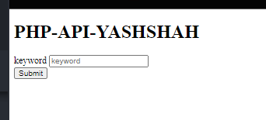

**2)ENTERING KEYWORD-XYXZ**

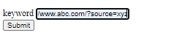

**3)IT WILL DISPLAY TABLE NAME**

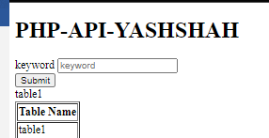

**4)NOW WE HAVE TO DISPLAY DATA OF TABLE1**

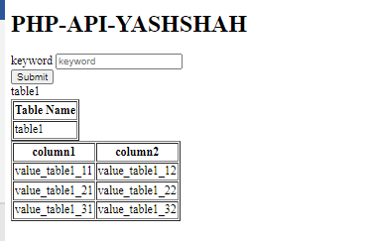

**5)trying second output**

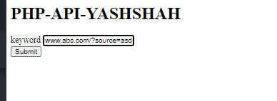

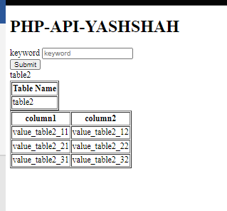

NOTE-I HAVE WORKED REALLY HARD ON THIS ASSIGNMENT PLEASE CONSIDER IT