Yash Acharya (ya754277)

Introduction to Data Science

Assignment 1

1/24/2022

Problem:1

The given task teaches how to calculate the basic values like min, max and mean values of the given data. It makes operations easier to perform in excel rather than calculating it with hands.

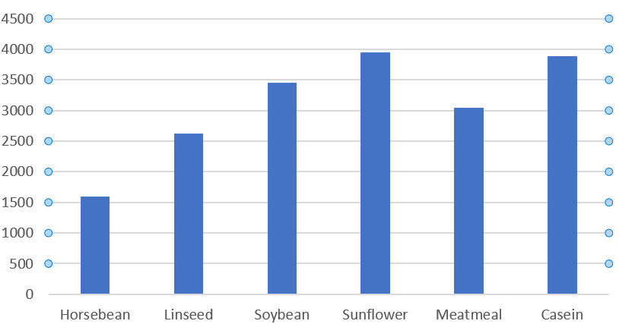

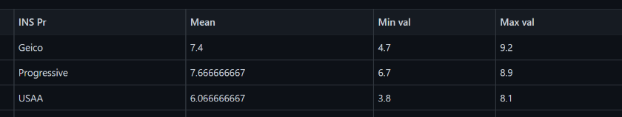

The Sunflower feed appears the most beneficial to the poultry business. Compared to other feeds sunflower has the highest number of sum of weights. This data is useful during the analysis and selection of which feed is the most beneficial.

Problem:2

In the given task we have to find out the best insurance rates provided by insurance providers.

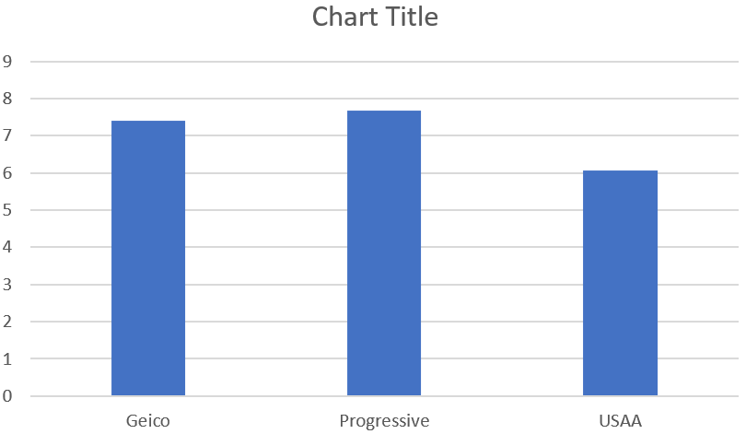

It appears that the Progressive insurance provider gives the best rates to their users.

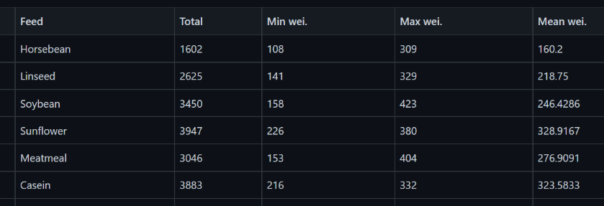

Summary: This analyzing helps us understand how to manage the small data and how to calculate and find out the most profitable outcome.