Game Design Document

Fill up the Following document

1. Write the title of your project.

Nuclear conclusions

1. What is the goal of the game?

The goal of the game is to spread awareness regarding the influences of the nuclear power mismanagement and in this game the player will have the goal to correct what has happened as a result to the nuclear explosion happened.

1. Write a brief story of your game?

This game would be a depiction of the Chernobyl nuclear explosion. In this game there would be a nuclear explosion through which most parts of the country would be affected. This nuclear explosion would release the radioactive waste that would cause a special reaction with the people and make them zombie alike. But somehow a person escapes through this and now it is his responsibility to correct what has happened as a result. Now he has contacted to his doc and that doc has created a chemical through which this can be corrected but to complete that chemical he needs the radioactive wastes that has got into the garbage on the land. Now that person has to carry all the radioactive waste to the place where doc has set up the chemical. He has to go through the obstacles that are the zombies that would try to kill that man as he is not like them. That man will be having a car in which he would be travelling and that car would be having a gun on its top to help the mam to save himself from the zombies.

1. Which are the playing characters of this game?

* Playing characters are the ones which respond to the user based on the input from the user
* Cars, monkeys, dinos, wizards etc, are the playing characters in the game.

|  |  |  |
| --- | --- | --- |
| Number | Character Name | What can this character do? |
| 1 | Benz (MAIN PLAYER) | This character has the ability to shoot , drive the car and he has the bravery needed to save the world |
| 2 |  |  |
| 3 |  |  |
| 4 |  |  |
| 5 |  |  |
| 6 |  |  |
| 7 |  |  |
| 8 |  |  |

1. Which are the Non Playing Characters of this game?

* Non Playing characters are the ones which don't have an action or a behaviour when the user interacts with the game.
* Hurdles, stones, bananas, coins, etc are non playing characters in the game.

|  |  |  |
| --- | --- | --- |
| Number | Character Name | What can this character do? |
| 1 | Zombie | They are stopping the main character from accomplishing the task. |
| 2 | Car with shooter gun | It has the ability to drive at high speed and shoot at the zombies |
| 3 | Garbage | Contains the radioactive particles |
| 4 | Tank | It contains the chemical for antidote |
| 5 |  |  |
| 6 |  |  |
| 7 |  |  |
| 8 |  |  |

Draw your imagination of this game. What does this game look like?

* Draw the game either on your computer or on paper,
* Add images of scenes of the game to show each of the playing and non-playing characters at least once.

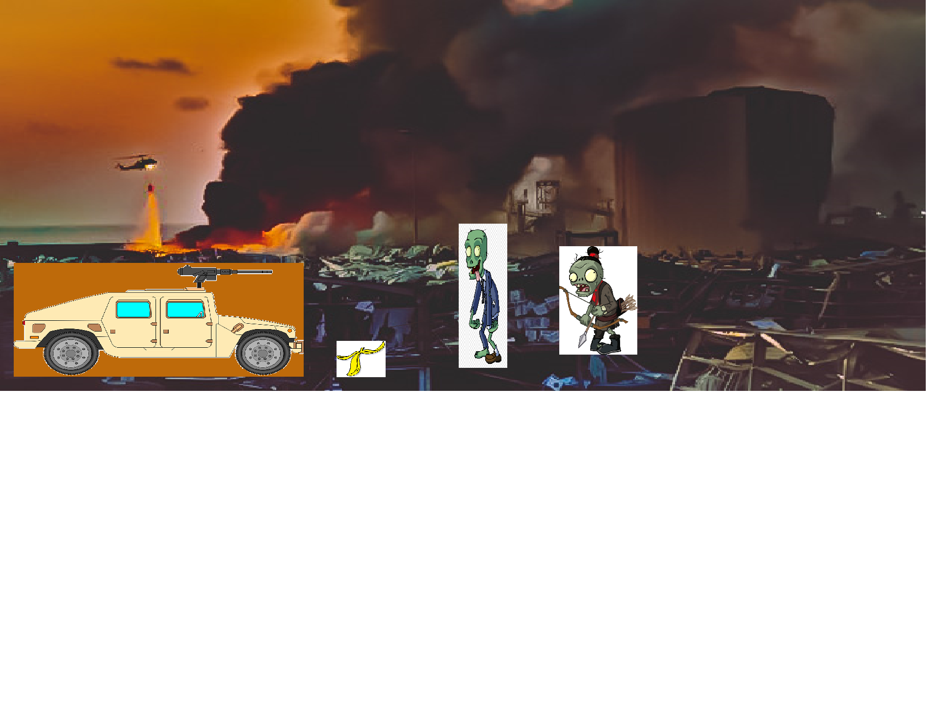

How do you plan to make your game engaging?

Ans. I can make the game more engaging by adding attractive pictures to the screen. I would add the sounds that would give proper feedback after each action making the game more engaging. There would also be a balance between the difficulty level so that the player does not get bored while playing. He would be having only three lives to save himself so that the played remains engaged in saving his lives and continue the game.