**DISCREPANCY OBSERVED WHILE FILING ANNUAL RETURN**

Following error is displayed while filing the annual return in respect of Kumbazari Manganese ore mine (Mine_code 40APR01017) of Shri Suresh Agarwal, Adilabad.

1. The PMCP Table is uploaded successfully.
2. There is problem in uploading UAV Survey (KML/KMZ file).
3. The kmz file depicting the data as indicated in PMCP table (as indicated at 1 above) is loaded in the system as indicated in following screen shot.

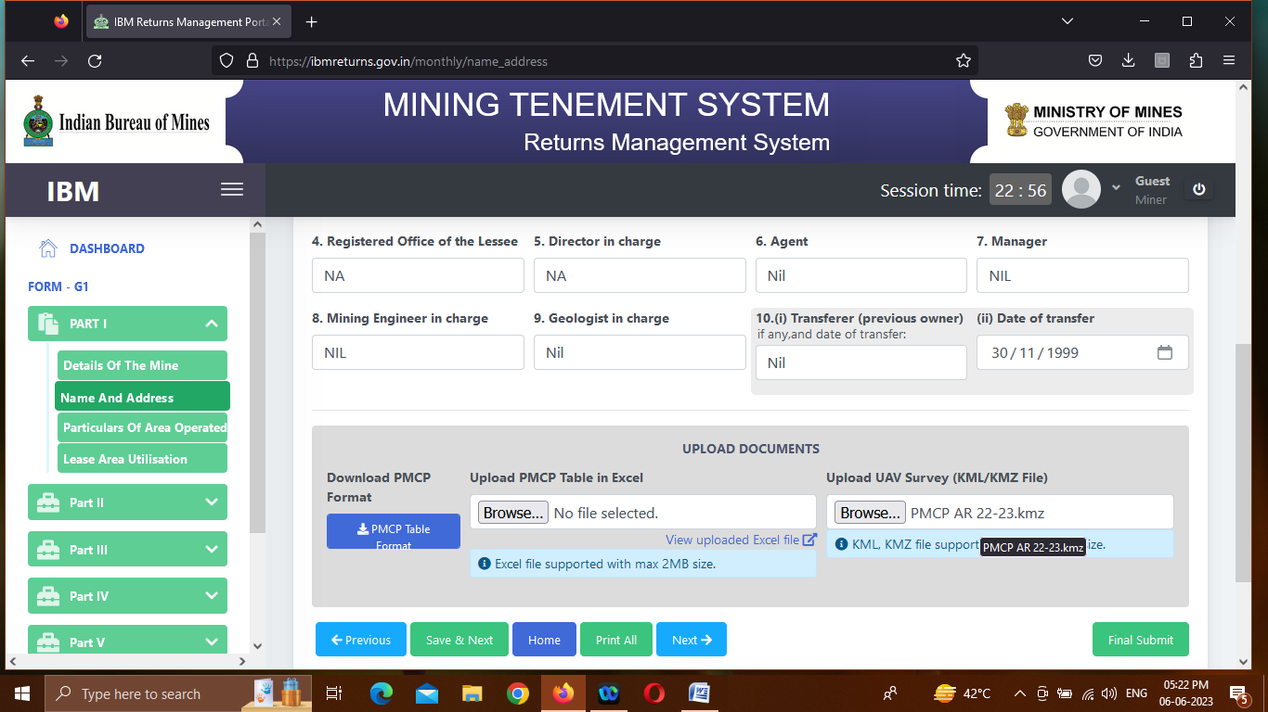

1. However, the same file cannot be uploaded
2. After pressing the BUTTON ‘SAVE & NEXT’, the message ***‘Invalid file type. Only PDF, JPG, Excel, KMZ types are accepted.’ Is displayed.***
3. The screen shot is reproduced below.



1. Finally the following message is displayed.

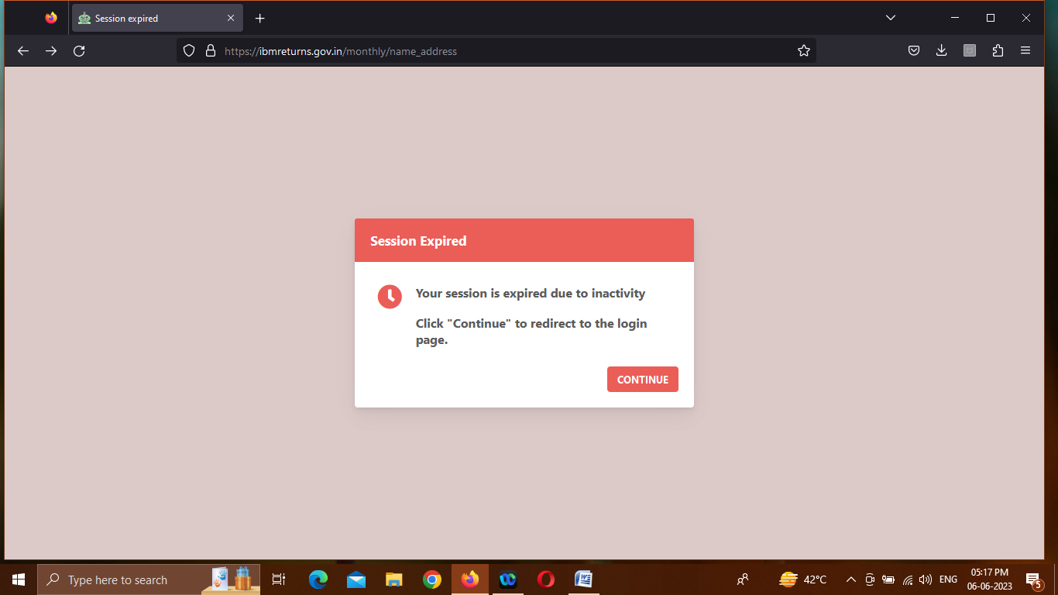

The KMZ file is attached herewith.

Thanks and Regards.

V. K. Misar