BLUESTOCK MUTUAL FUND ANALYTICS CAPSTONE PROJECT

Comprehensive Mutual Fund Data Analysis, Risk Analytics & Dashboard Development

Prepared By
Yash Chowdhary

Project Type:
Individual Capstone Project

Institute:
Kalinga Institute of Industrial Technology (KIIT)

Submission Date:
June 2026
CONTENT
- Executive Summary

- Problem Statement & Objectives

- Data Sources

- ETL Pipeline Design

- Exploratory Data Analysis (EDA)

- Performance Analytics

- Dashboard Development

- Advanced Analytics & Risk Metrics

- Key Findings

- Limitations

- Recommendations

- Conclusion
Executive Summary

This project focuses on analysing mutual fund performance, investor behaviour, portfolio allocation, and industry trends using data analytics and business intelligence techniques. The objective of this capstone project was to design an end-to-end mutual fund analytics system capable of data ingestion, cleaning, exploratory analysis, performance measurement, risk analysis, and interactive dashboard development.

The project uses multiple datasets including mutual fund master data, NAV history, SIP inflows, investor transactions, benchmark indices, and portfolio holdings. An ETL pipeline was developed to clean and process raw datasets, followed by storage in a structured SQLite database for efficient querying and analysis.

Advanced financial metrics such as Sharpe Ratio, Alpha, Beta, Value at Risk (VaR), Conditional Value at Risk (CVaR), and rolling performance measures were computed to evaluate scheme performance and associated risks. Investor cohort analysis, SIP continuity analysis, and sector concentration analysis were also performed to derive actionable investment insights.

An interactive Power BI dashboard was created to visualize industry performance, fund performance, investor analytics, and SIP market trends using dynamic slicers and drill-through functionality. The project successfully demonstrates the practical application of data analytics, financial modelling, and business intelligence in the mutual fund domain.

Problem Statement & Objectives

The mutual fund industry in India has experienced significant growth in terms of assets under management, investor participation, and scheme diversity. However, analysing large-scale mutual fund data to understand fund performance, investor behaviour, portfolio allocation, and risk characteristics remains a complex challenge. Investors often struggle to compare schemes effectively, evaluate risks, and make informed investment decisions due to fragmented and unstructured financial data.
The primary problem addressed in this project is the lack of an integrated analytical system that combines fund performance evaluation, investor analytics, risk measurement, and interactive visualization into a single platform. This project aims to solve this challenge through an end-to-end mutual fund analytics framework.

Objectives of the Project
• Develop an ETL pipeline to ingest, clean, and process raw mutual fund datasets.
• Build a structured SQLite database for efficient storage and querying of mutual fund data.
• Perform exploratory data analysis (EDA) to identify trends, patterns, and industry insights.
• Compute financial performance metrics including Sharpe Ratio, Alpha, Beta, and benchmark comparisons.
• Perform advanced risk analytics using Value at Risk (VaR), Conditional Value at Risk (CVaR), and rolling Sharpe ratios.
• Analyse investor behaviour through cohort analysis and SIP continuity analysis.
• Build an interactive Power BI dashboard to visualize fund performance and investor insights.
• Generate actionable investment insights and recommendations using data-driven approaches.

Data Sources

This project uses multiple mutual fund datasets collected from structured CSV files to perform fund performance analysis, investor analytics, and risk measurement. The datasets were cleaned, processed, and integrated into a unified analytical system.

Datasets Used
1. Fund Master Data
Contains details about mutual fund schemes including fund house, category, assets under management (AUM), expense ratio, benchmark index, and scheme information.
2. NAV History Data
Contains historical Net Asset Value (NAV) data for multiple mutual fund schemes used for return calculations, rolling performance analysis, and risk analytics.
3. AUM by Fund House Data
Provides information regarding total Assets Under Management (AUM) across different mutual fund companies to analyse market leadership and fund house dominance.
4. Monthly SIP Inflows Data
Contains monthly SIP contribution data used to analyse investment trends and systematic investment behaviour.
5. Category Inflows Data
Includes fund category-wise inflow and outflow information to study investor preferences across equity, debt, hybrid, and other mutual fund categories.
6. Industry Folio Count Data
Contains investor folio information to understand market participation and category popularity.
7. Scheme Performance Data
Includes key fund performance indicators such as returns, Sharpe ratio, Alpha, Beta, Sortino ratio, risk grade, and volatility measures.
8. Investor Transaction Data
Contains investor-level transaction records such as transaction type, amount invested, investor demographics, payment mode, and KYC status.
9. Portfolio Holdings Data
Contains stock-level portfolio allocation of mutual fund schemes including sector exposure and holding weights.
10. Benchmark Indices Data
Contains benchmark index performance data used to compare mutual fund returns with market indices.

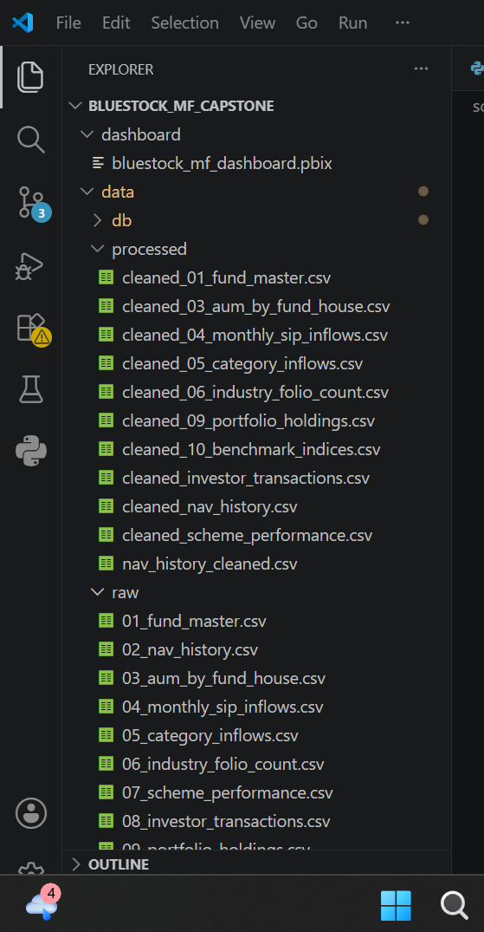

Figure 1: Project Folder Structure

ETL Pipeline Design

The Extract, Transform, Load (ETL) pipeline was designed and implemented to automate the complete lifecycle of mutual fund data processing. Since the project involved multiple heterogeneous datasets containing scheme information, investor transactions, NAV history, SIP inflows, benchmark indices, and portfolio holdings, an efficient ETL framework was required to ensure consistency, reliability, and analytical readiness of the data. The ETL process plays a critical role in transforming raw and unstructured datasets into a clean, standardized, and structured format suitable for exploratory analysis, financial performance measurement, advanced analytics, and dashboard development. The pipeline was developed using Python and automated through reusable scripts to reduce manual effort and improve scalability.

4.1 Extract Phase
The extraction phase involved collecting mutual fund datasets from multiple CSV sources and storing them inside the data/raw/ directory. These datasets served as the foundational input for the analytical system.
The extracted datasets included:
• Fund Master Data
• Historical NAV Data
• AUM by Fund House Data
• Monthly SIP Inflows Data
• Category-wise Fund Inflows
• Industry Folio Count Data
• Scheme Performance Metrics
• Investor Transaction Data
• Portfolio Holdings Data
• Benchmark Indices Data
During extraction, the datasets were imported into Python using the Pandas library. Appropriate file handling mechanisms were implemented to ensure successful loading of datasets without data corruption or formatting issues.

4.2 Transform Phase
The transformation phase was the most critical stage of the ETL pipeline. Since raw financial datasets often contain missing values, inconsistent formatting, duplicate records, and datatype mismatches, extensive preprocessing was performed to ensure high data quality.
The following transformation steps were applied:

Data Cleaning
• Missing value treatment and null value handling
• Removal of duplicate records
• Correction of inconsistent naming conventions
• Standardization of column names across datasets

Data Type Conversion
• Conversion of date columns using datetime functions
• Numerical column standardization for performance metrics and investment amounts
• Formatting categorical variables for better analytical grouping

Data Validation
• Verification of row counts and missing entries
• Cross-checking scheme identifiers and benchmark mappings
• Validation of financial metrics to prevent abnormal values

Data Standardization
• Uniform formatting across all datasets
• Consistent naming structure for mutual fund schemes and fund houses
• Alignment of columns for integration into analytics workflows
After transformation, cleaned datasets were exported and stored inside the data/processed/ directory to enable reproducible analytics and improve downstream efficiency.

4.3 Load Phase
In the loading phase, transformed datasets were stored inside a centralized SQLite database (bluestock_mf.db). SQLite was selected because of its lightweight architecture, ease of integration with Python, and suitability for local analytical projects.
The loading process was automated using SQLAlchemy and Pandas to create database tables and insert cleaned records into structured schemas. This centralized database storage enabled efficient querying, easier data retrieval, and improved integration with analytical workflows.
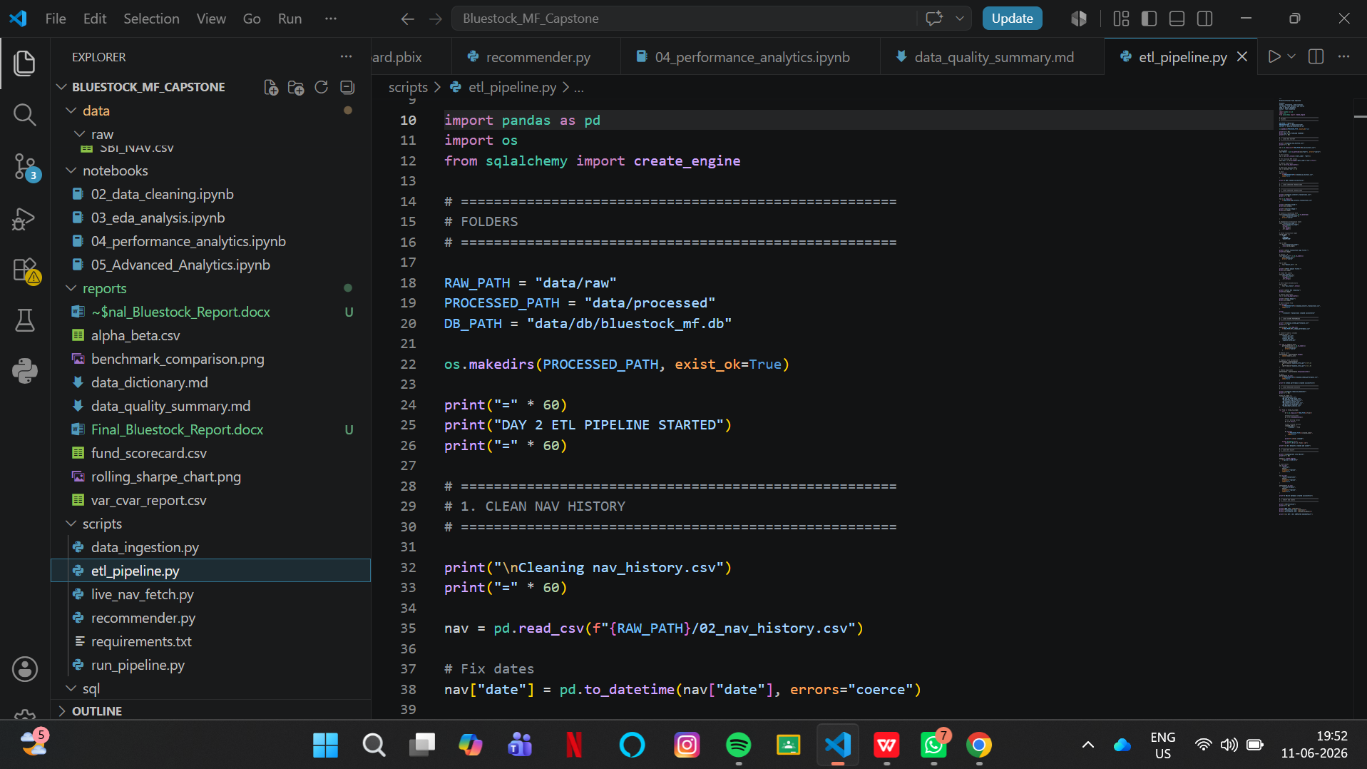

Figure 2: ETL Pipeline Script Implementation

4.4 Technologies Used in ETL Pipeline
The ETL workflow was implemented using the following technologies:
• Python — core scripting and automation
• Pandas — data ingestion, transformation, and preprocessing
• SQLite — structured database storage
• SQLAlchemy — database connection and table management
• CSV Processing — raw dataset handling
• VS Code — development environment for scripting and debugging
Overall, the ETL pipeline successfully transformed raw mutual fund datasets into a structured, analytics-ready environment, enabling efficient exploratory analysis, performance evaluation, risk analytics, and dashboard creation.
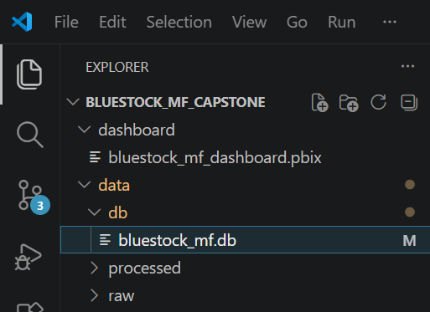


Figure 3: SQLite Database Storage and SQL Schema

Exploratory Data Analysis (EDA)

Exploratory Data Analysis (EDA) was performed to understand mutual fund industry trends, fund performance behaviour, investor participation, and investment patterns. The objective of EDA was to uncover hidden insights, identify trends, validate data quality, and support analytical decision-making.The analysis focused on fund categories, assets under management (AUM), SIP contribution trends, investor participation, benchmark performance, and scheme characteristics. Various statistical summaries and visualizations were used to derive meaningful business insights.

Key Areas Explored

Fund Category Distribution
The distribution of mutual fund schemes across categories was analysed to understand scheme concentration and category dominance within the dataset.

AUM Analysis
Assets Under Management (AUM) analysis was conducted to identify leading fund houses and evaluate market concentration in the mutual fund industry.

SIP Investment Trends
Monthly SIP inflow trends were analysed to understand investor confidence, investment behaviour, and market participation over time.

Investor Behaviour Analysis
Investor demographic and transaction patterns were explored to understand investment preferences, payment modes, city tiers, and behavioural trends.
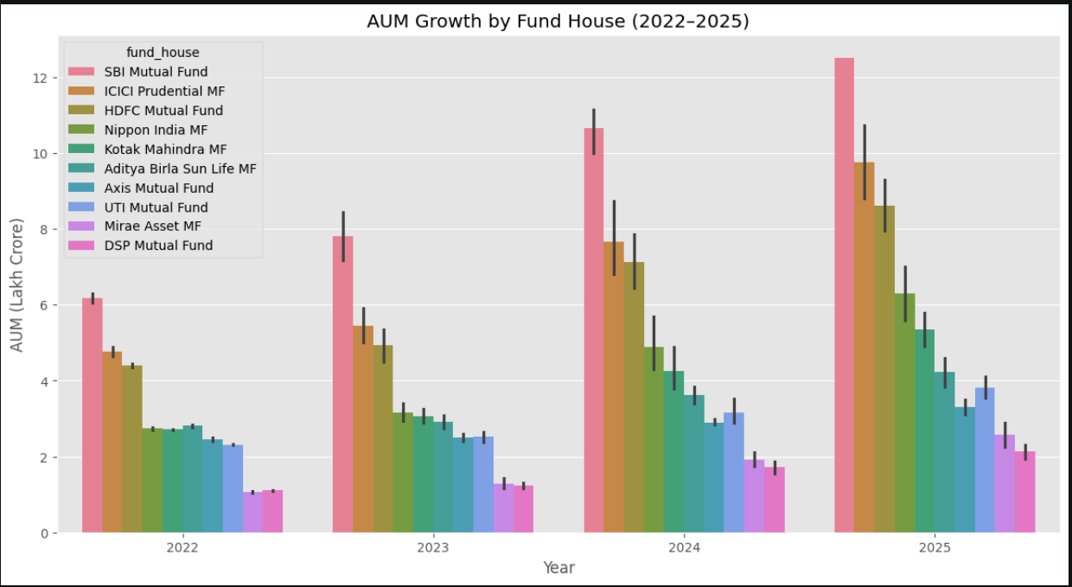
Figure 5: AUM Distribution Across Fund Houses
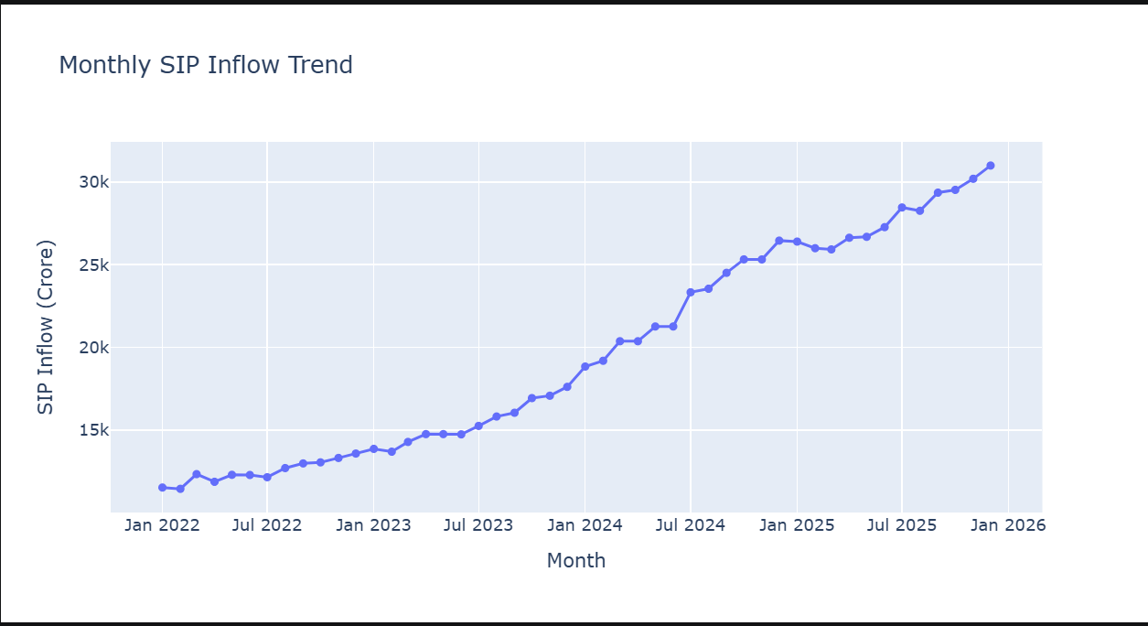
Figure 6: Monthly SIP Inflow Trend
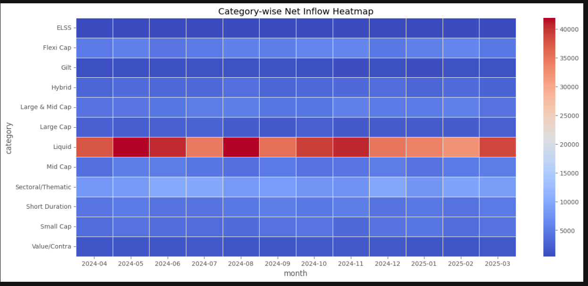
Figure 7: Mutual Fund Category Distribution

Performance Analytics
Performance analytics was conducted to evaluate mutual fund schemes based on risk-adjusted return measures and benchmark-relative performance. Financial performance metrics were calculated to assess fund efficiency, return consistency, market sensitivity, and downside risk.
The analysis focused on comparing fund performance using statistical and financial measures such as Sharpe Ratio, Alpha, Beta, benchmark returns, volatility, and drawdown analysis. These metrics helped identify high-performing schemes and evaluate the relationship between risk and return.

6.1 Sharpe Ratio Analysis
Sharpe Ratio was used to measure risk-adjusted returns of mutual fund schemes. It evaluates how much excess return is generated for every unit of risk undertaken.
Higher Sharpe ratios indicate better risk-adjusted performance, whereas lower values indicate inefficient return generation relative to volatility.
The analysis revealed differences in fund efficiency across categories, highlighting schemes that delivered stronger returns with relatively controlled risk exposure.

6.2 Alpha Analysis
Alpha measures a mutual fund’s ability to outperform its benchmark after adjusting for market risk. Positive Alpha values indicate that a scheme generated returns above benchmark expectations.
The analysis showed that certain schemes consistently demonstrated superior active management performance by outperforming benchmark indices.

6.3 Beta Analysis
Beta analysis was conducted to measure fund sensitivity relative to market movement.
• Beta > 1 indicates higher volatility than the market
• Beta < 1 indicates lower volatility than the market
• Beta = 1 indicates performance aligned with market movement
The results helped classify funds based on market sensitivity and investment risk characteristics.

6.4 Benchmark Comparison
Benchmark comparison was performed to analyse whether mutual fund schemes outperformed market indices over different investment periods.
Fund returns were compared with benchmark returns to evaluate investment efficiency and consistency.

6.5 Risk Metrics
Risk analytics included measures such as standard deviation, volatility, maximum drawdown, Value at Risk (VaR), and Conditional Value at Risk (CVaR). These measures were used to evaluate downside risk and identify schemes exposed to higher market uncertainty. Funds with higher VaR and CVaR values were interpreted as having greater potential downside exposure during adverse market conditions.
Overall, performance analytics enabled comprehensive evaluation of mutual fund schemes and provided a strong foundation for advanced analytics and investment recommendations.
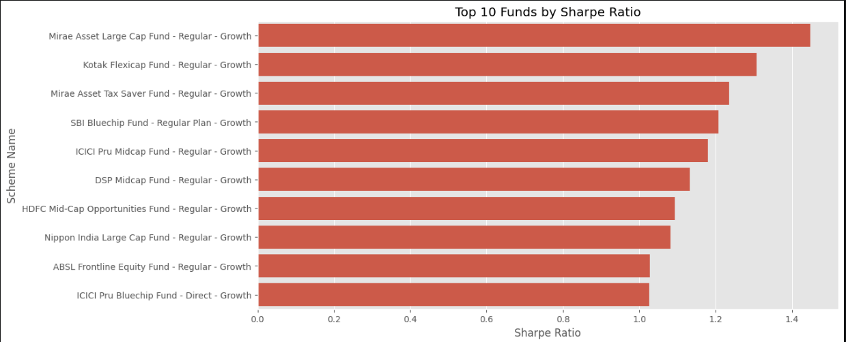
Figure 9: Sharpe Ratio Comparison Across Mutual Fund Schemes
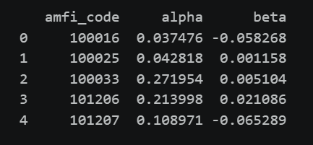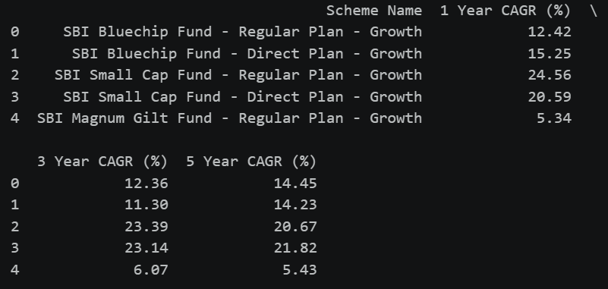
Figure 11: Mutual Fund Benchmark Comparison Figure 12: Mutual Fund Performance Scorecard
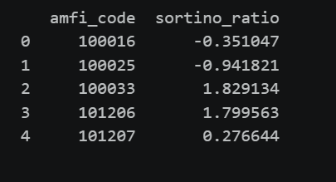
Figure 13: Risk and Volatility Analysis

Dashboard Development
An interactive Power BI dashboard was developed to provide visual insights into mutual fund performance, investor behaviour, risk analytics, and portfolio trends. The dashboard was designed to improve interpretability and enable dynamic exploration of financial information through visual storytelling and interactive filtering.
The primary objective of the dashboard was to transform complex financial and investor datasets into a user-friendly analytical interface capable of supporting investment insights and performance evaluation.
The dashboard was designed using Power BI and integrated processed mutual fund datasets to create an interactive reporting environment.

7.1 Dashboard Objectives
The dashboard was developed with the following objectives:
• Visualize mutual fund performance and benchmark comparison
• Analyse fund category distribution and Assets Under Management (AUM)
• Track SIP inflow patterns and investor participation trends
• Explore investor demographics and transaction behaviour
• Evaluate risk and return metrics across schemes
• Enable dynamic filtering using slicers and interactive visuals

7.2 Dashboard Features
The Power BI dashboard contains multiple interactive components including:
• KPI cards for fund performance indicators
• Category-wise and fund-house level analysis
• Benchmark comparison visualizations
• Interactive slicers for filtering fund categories and schemes
• Risk analytics visualizations
• Investor behaviour and SIP trend analysis
The dashboard improves analytical accessibility by converting raw financial information into meaningful visual insights.

7.3 Dashboard Benefits
The dashboard enables users to quickly identify top-performing funds, compare benchmark performance, understand investment trends, and assess risk-related indicators. The interactive filtering capability allows users to explore data from multiple perspectives without requiring technical expertise.

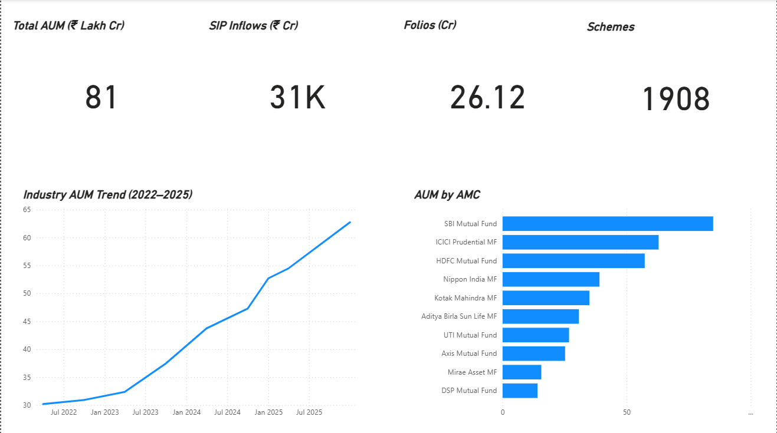
Figure 14: Mutual Fund Overview Dashboard
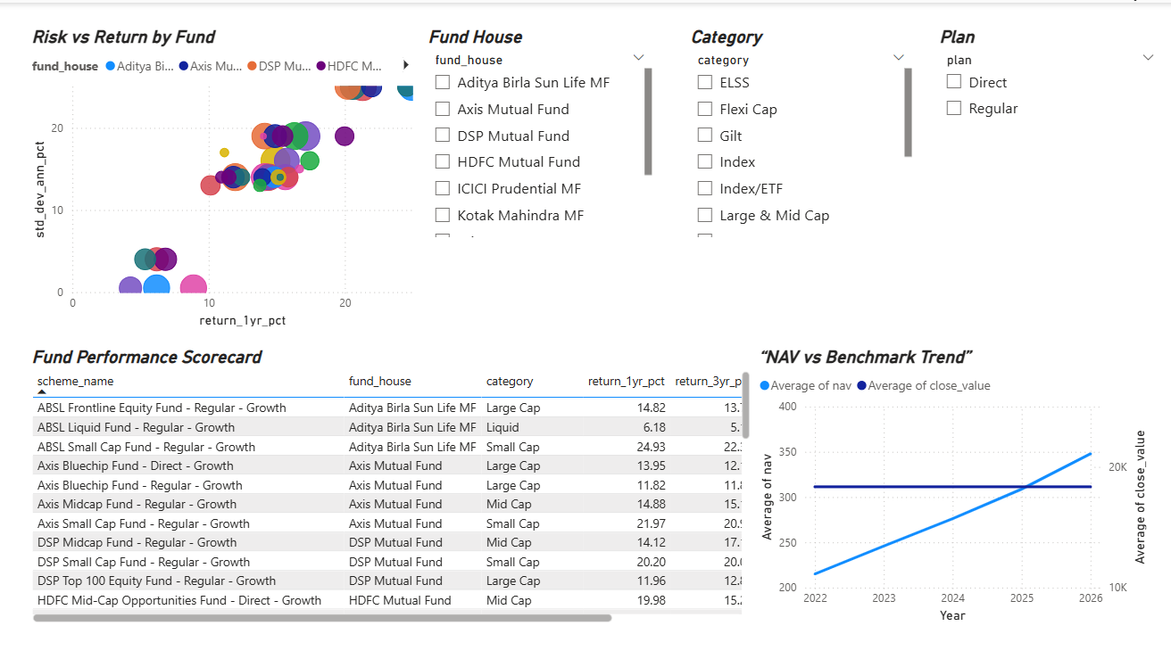
Figure 15: Fund Performance Analytics Dashboard
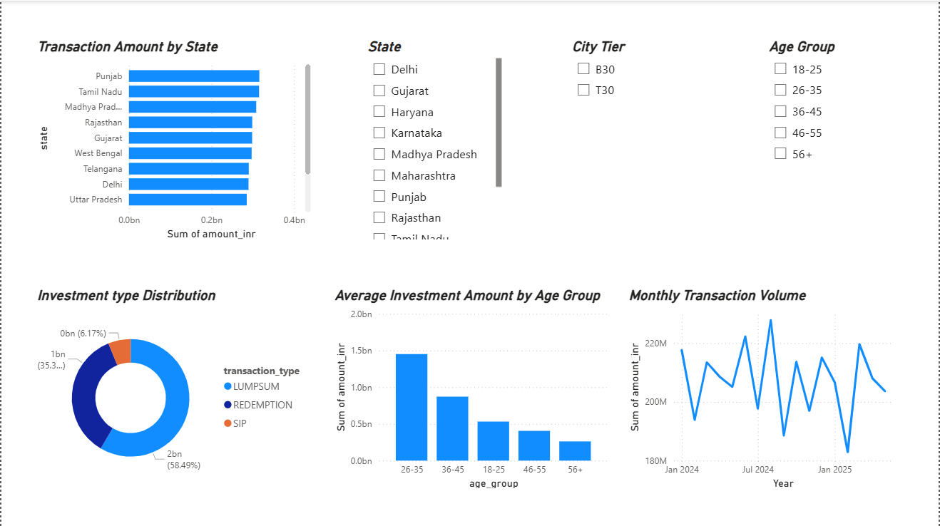
Figure 16: Investor Analytics Dashboard
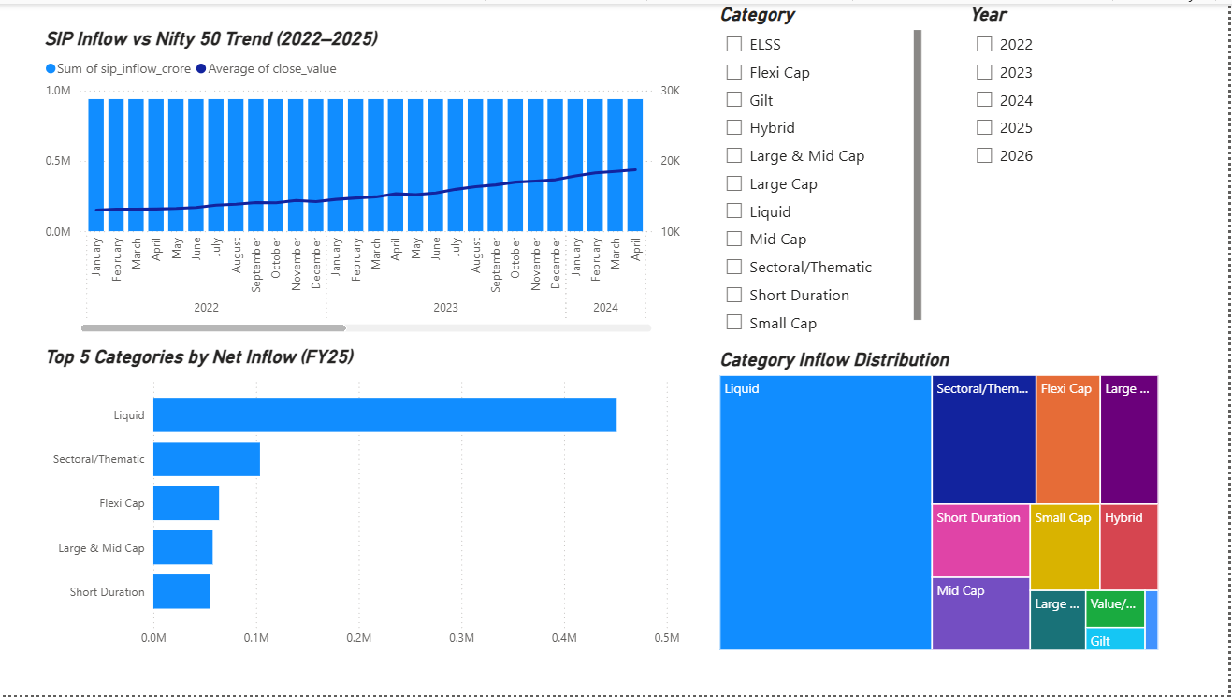
Figure 17 : SIP and Market Trends Dashboard
Limitations
Despite successful implementation of the mutual fund analytics system, certain limitations were identified during the project execution.
• The project relies on static datasets and does not use real-time mutual fund APIs for continuous updates.
• Historical market conditions and macroeconomic factors were not incorporated into performance modelling.
• Limited investor demographic information restricted deeper behavioural segmentation.
• Portfolio optimization and predictive forecasting techniques were outside the current project scope.
• Dashboard analysis is dependent on the quality and completeness of the available datasets.
Although these limitations exist, the project successfully demonstrates a practical framework for mutual fund performance analysis and business intelligence reporting.

Recommendations
Based on the findings of this project, the following recommendations are proposed to improve mutual fund analytics and enhance investment decision-making capabilities:
• Integrate live mutual fund APIs for real-time NAV updates and automated performance tracking.
• Develop predictive analytics models for future fund return forecasting and investment planning.
• Expand investor behaviour analysis using advanced segmentation techniques.
• Incorporate portfolio optimization models to recommend balanced investment allocations based on investor risk appetite.
• Deploy the dashboard through cloud-based platforms such as Power BI Service or Streamlit for wider accessibility.
• Improve risk analytics by integrating macroeconomic indicators and market sentiment data.
These recommendations can further strengthen the analytical framework and improve practical usability for investors and financial analysts.

Conclusion
This capstone project successfully developed a comprehensive mutual fund analytics system aimed at understanding fund performance, investor behaviour, portfolio characteristics, and industry-wide investment trends through the application of data analytics and business intelligence techniques. The project involved the complete lifecycle of data handling, beginning from raw dataset collection and preprocessing to performance evaluation, visualization, and insight generation.
A structured ETL (Extract, Transform, Load) pipeline was designed to clean, standardize, and process multiple mutual fund datasets containing fund information, NAV history, SIP inflows, investor transactions, benchmark indices, and portfolio holdings. The processed datasets were efficiently stored within a SQLite database, enabling structured querying and streamlined analytical workflows.
Exploratory Data Analysis (EDA) played an important role in identifying trends related to Assets Under Management (AUM), SIP investment behaviour, benchmark performance, investor participation, and fund category distributions.
An interactive Power BI dashboard was also developed to provide an intuitive and user-friendly interface for exploring mutual fund trends and investor insights.
Overall, this project demonstrates the practical application of Python, SQL, Power BI, and financial analytics in solving real-world investment analysis problems. It successfully integrates data engineering, business intelligence, financial modelling, and analytics into a unified system capable of supporting better investment understanding and decision-making. The project also establishes a strong foundation for future improvements such as real-time market integration, predictive modelling, portfolio optimization, and intelligent recommendation systems.
THANK YOU

