PGCP (VLSI) · Verilog HDL: from modules to a working UART · case study 2

Assignment — the divider
Report. Answer Q1 to Q6 on paper before you write any Verilog, then copy them here. The names you use in Q1 to Q3 must be the names in your code.
Name | Yash Uchhasare
Roll No. | 260850333035
GitHub username | yash2004malviya-netizen
Repository | https://github.com/yash2004malviya-netizen/26085333035-yashuchhasare-assignment
Hints used (section 10 of the sheet) | none

Q1 Registers before states
What must the circuit remember between clock edges? One row per register, state register included. The inputs may change after the start edge.
register | bits | what it holds | why it must exist
state | 2 | Current state (IDLE, RUN, DONE) | Tracks the FSM phase between clock edges
rem | 8 | Remainder so far; starts at dividend a | Holds running remainder across repeated subtractions
breg | 8 | Divisor b | Input b may change after edge 0; divisor must be held stable
quot | 8 | Quotient count (number of subtractions so far) | Accumulates count of subtractions performed until rem < breg

Q2 Transfers
For each register: what is written into it and when, as register ← expression. Each distinct transfer is one control signal; name it.
state (and condition) | transfer(s) | control signal
IDLE (start == 1) | rem <= a; breg <= b; quot <= 8'd0 | load
RUN (rem_ge_breg == 1) | rem <= rem - breg; quot <= quot + 8'd1 | sub_step
RUN (rem_ge_breg == 0) | none (next_state = DONE) | none
DONE | none (next_state = IDLE) | none

Q3 The status signal
The one bit the controller needs to decide, as an expression of registers.
name | expression | computed from (registers)
rem_ge_breg | rem >= breg | rem, breg

Q4 State diagram
Draw it with the transfers on the arcs. Paste a photo or a drawing below (Insert → Pictures), then classify every output.
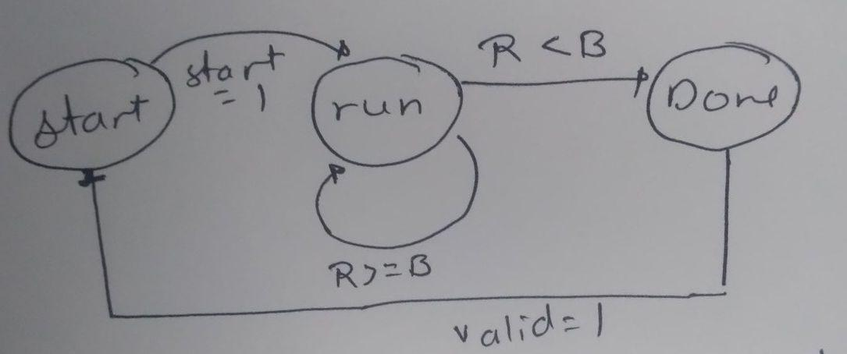

output | Moore or Mealy | why
done | Moore | Decoded strictly from state (state == DONE); independent of current inputs
q | Moore | Driven directly from registered datapath output (quot); changes only on clock edge
r | Moore | Driven directly from registered datapath output (rem); changes only on clock edge

Q5 Per-cycle tables, before any code
Edge 0 is the edge that samples start; the values are what the registers hold after the edge. Rename the register columns to yours and leave unused ones empty; stop at the first row after done and leave the remaining rows empty. A test reads the values the state arrived with; a transfer lands at the edge that leaves it.
7 ÷ 2
edge | state after | rem | breg | quot | - | done | what this edge did
0 | RUN | 7 | 2 | 0 | - | 0 | IDLE saw start: load dividend & divisor
1 | RUN | 5 | 2 | 1 | - | 0 | RUN saw rem>=breg (7>=2): subtract & increment quot
2 | RUN | 3 | 2 | 2 | - | 0 | RUN saw rem>=breg (5>=2): subtract & increment quot
3 | RUN | 1 | 2 | 3 | - | 0 | RUN saw rem>=breg (3>=2): subtract & increment quot
4 | DONE | 1 | 2 | 3 | - | 1 | RUN saw !rem_ge_breg (1<2): go to DONE, write nothing
5 | IDLE | 1 | 2 | 3 | - | 0 | DONE: return to IDLE
6
7

5 ÷ 9
edge | state after | rem | breg | quot | - | done | what this edge did
0 | RUN | 5 | 9 | 0 | - | 0 | IDLE saw start: load dividend & divisor
1 | DONE | 5 | 9 | 0 | - | 1 | RUN saw !rem_ge_breg (5<9): go to DONE, write nothing
2 | IDLE | 5 | 9 | 0 | - | 0 | DONE: return to IDLE
3
4

Q6 The longest case
255 ÷ 1: how many edges from edge 0 to done, and what does that mean for a testbench that gives up after a fixed number of edges?
edges from edge 0 to done | what it means for the testbench
256 edges (q + 1 = 255 + 1 = 256 edges) | The testbench timeout limit must be greater than 256 cycles; if timeout were set lower (e.g. 200 edges), this valid division would prematurely fail as 'done never came'.

Q7 The run
Paste the last line of tb_div_sub.v exactly as printed. Required: 0 mismatches -> PASS; done after q+1 edges on 8 of 8.
tb_div_sub: 8 divisions, 0 mismatches -> PASS; done after q+1 edges on 8 of 8

Q8 Flop count
Predict before you synthesize, from Q1 and the encoding you assume; then paste the Register as Flip Flop line; then reconcile.
Predicted (from Q1), with the state encoding assumed | 26 flip-flops (Datapath: 8 rem + 8 breg + 8 quot = 24; State register: 2 bits for 3 states encoded binary). Note: 27 if one-hot encoded (3 state flops).
Reported (Register as Flip Flop line) | Register as Flip Flop : 27 (FDRE : 27)
Encoding Vivado chose (Synth 8- line) | INFO: [Synth 8-3354] encoded FSM with state register 'state_reg' using encoding 'one-hot' in module 'div_sub' (IDLE: 001, RUN: 010, DONE: 100)
Why they agree or differ (one sentence) | They agree completely: 24 datapath flip-flops plus 3 flip-flops for the state register after Vivado automatically re-encoded the 3-state FSM as one-hot equals exactly 27 flip-flops.

Q9 Two pairs from the testbench
Which decision in your code does each pair exercise, and what would the output have been with the other choice?
pair | decision in your code it tests | output with the other choice
200 ÷ 200 (a = b) | Boundary condition rem >= breg vs rem > breg. Tests equality case where a == b requiring exactly one subtraction. | If rem > breg had been tested instead of >=, the circuit would stop without subtracting, producing q = 0 and r = 200 instead of q = 1 and r = 0.
255 ÷ 1 (b = 1) | Worst-case maximum count and latency: tests full 8-bit dynamic range capacity (q = 255) and long execution without counter overflow or timeout. | If quot register were narrower (e.g., 7-bit), it would overflow to 127; if testbench timeout were under 256 edges, it would abort with timeout FAIL.

Before you push: this file saved as report.docx in your repository folder, the diagram inside it, and the checklist in section 8 of assignment.md read once against your code.

