**IoT Project**

**Control Unit for Irrigation water pumps**

Shreemad Patel (201501045)

Yash Patel (201501046)

Functionalities -

* Android App installed in Farmer’s cell phone from where he can send message to the GSM module. Various Functionalities include storing of Data relevant to Humidity and Temperature before and after the water pump is utilized. Later, on basis of large dataset and applying knowledge of agriculture sciences, various predictions can be made typically for example what kind of crop can be grown at a particular time, how much amount of water will be required in a particular month, etc.
* Arduino Interface is connected with MicroSD card Reader, GSM module and DHT11 Sensor, and Relay circuit which controls flow of water. When the circuit receives message of starting the water sprinkling, initially DHT11 sensor measures the Humidity values.
* Arduino in a way controls the Relay for the flow of water into the farm. After the completion of water sprinkling, the measurements are done again and sent to the farmer for record purpose.

Hardware Used -

* SIM 900A GSM with Antenna.
* MicroSD Card Breakout with Output.
* Digital Humidity Temperature Sensor Module
* 5 V Relay
* DHT 11 Temperature and Pressure Sensor
* Jumper wire.
* Bread Board.
* External Power supply (9V Battery *2) (Optional). and

Circuit design -

* Humidity and Temperature Sensor

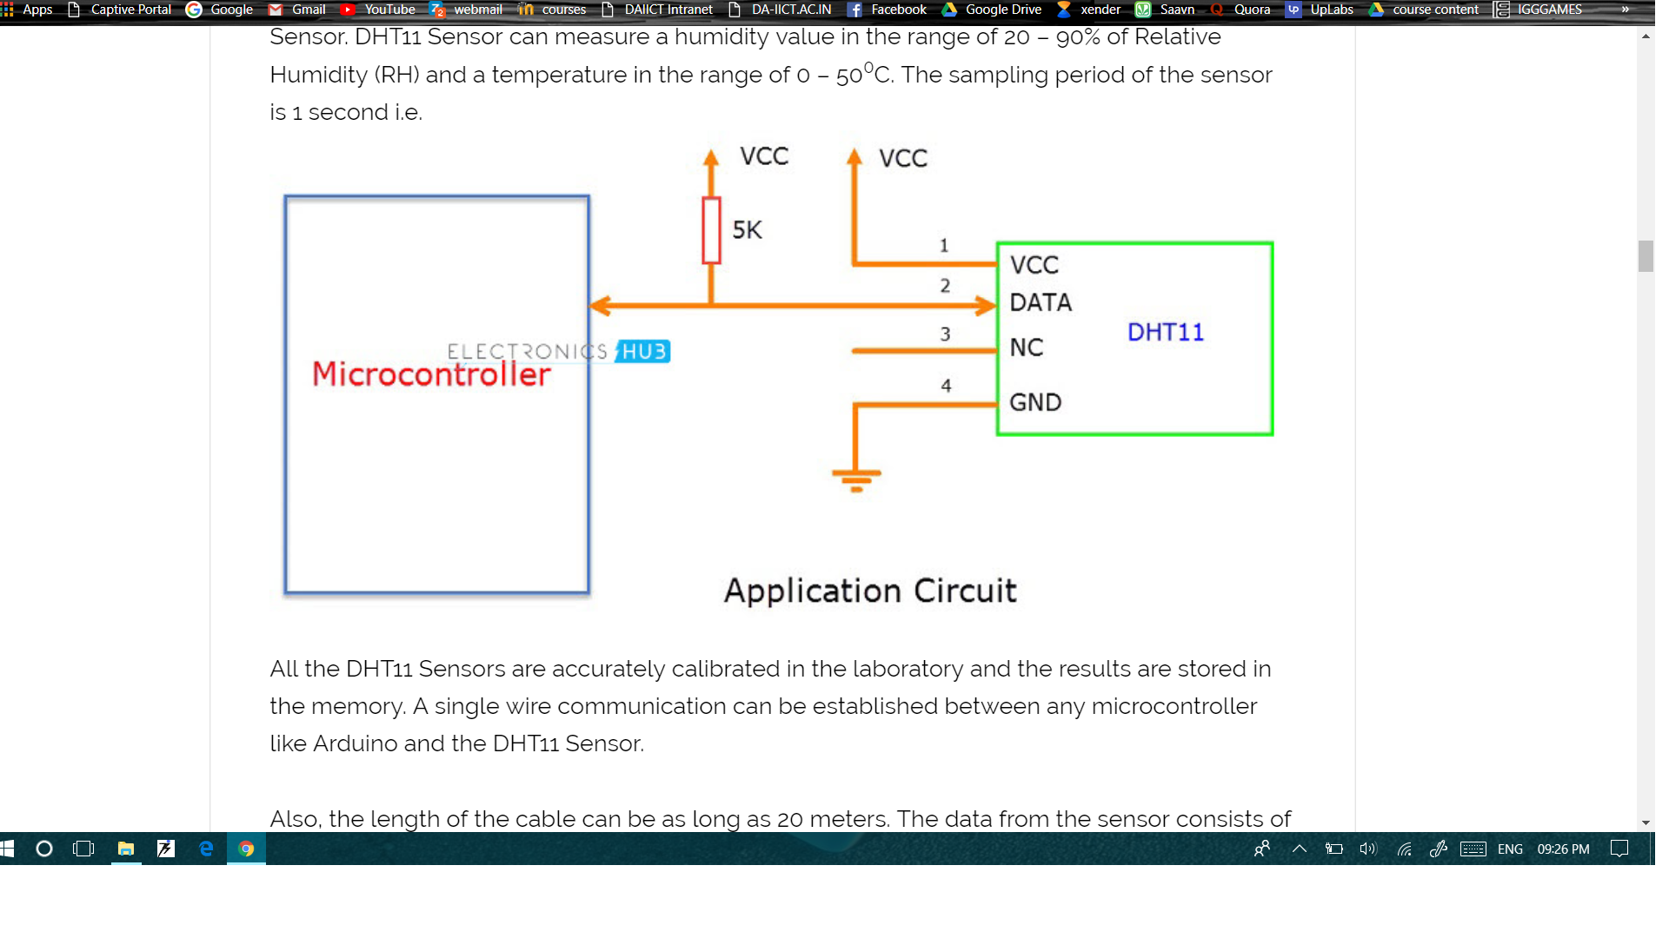

* GSM module Configuration with Arduino -

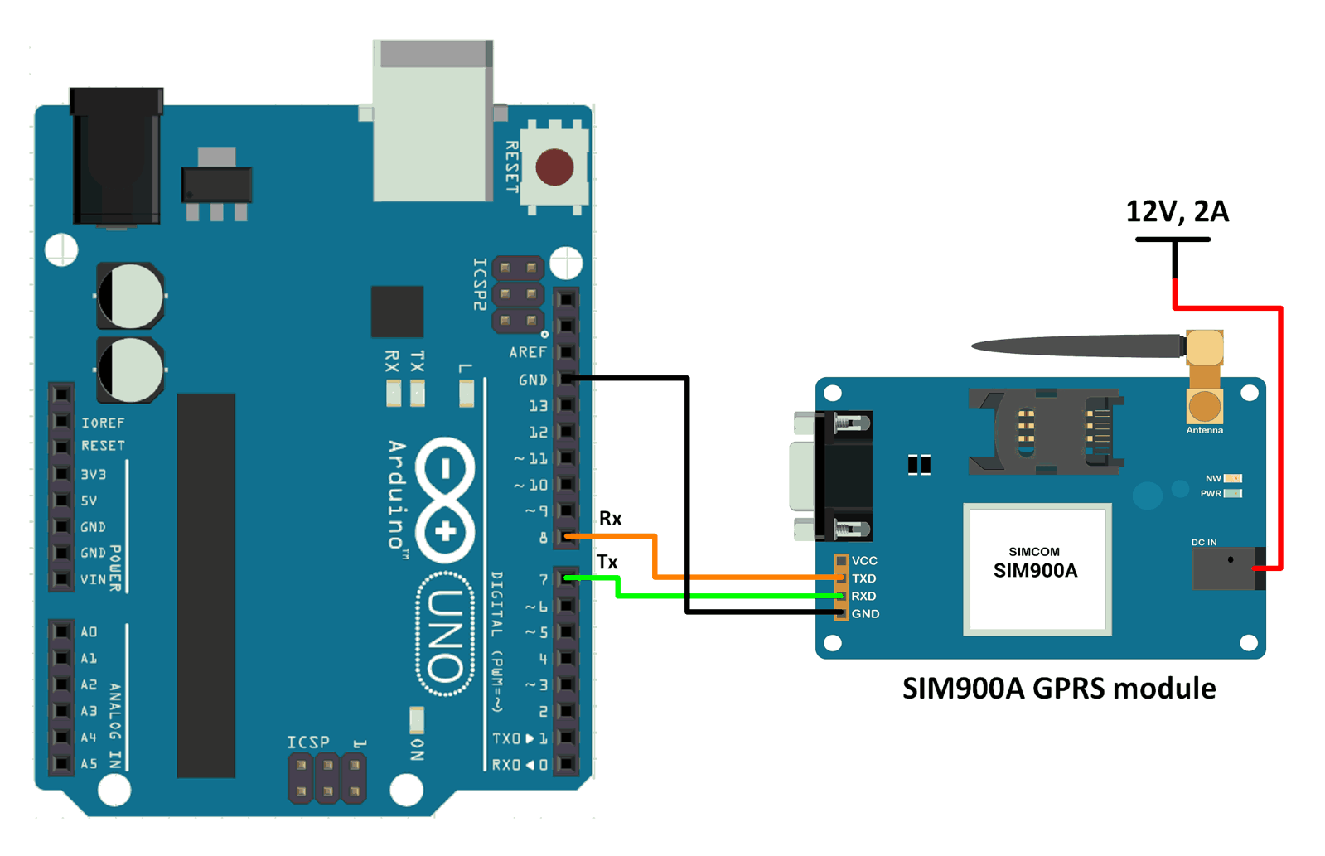

* Water Pump Controlling Relay Circuit -

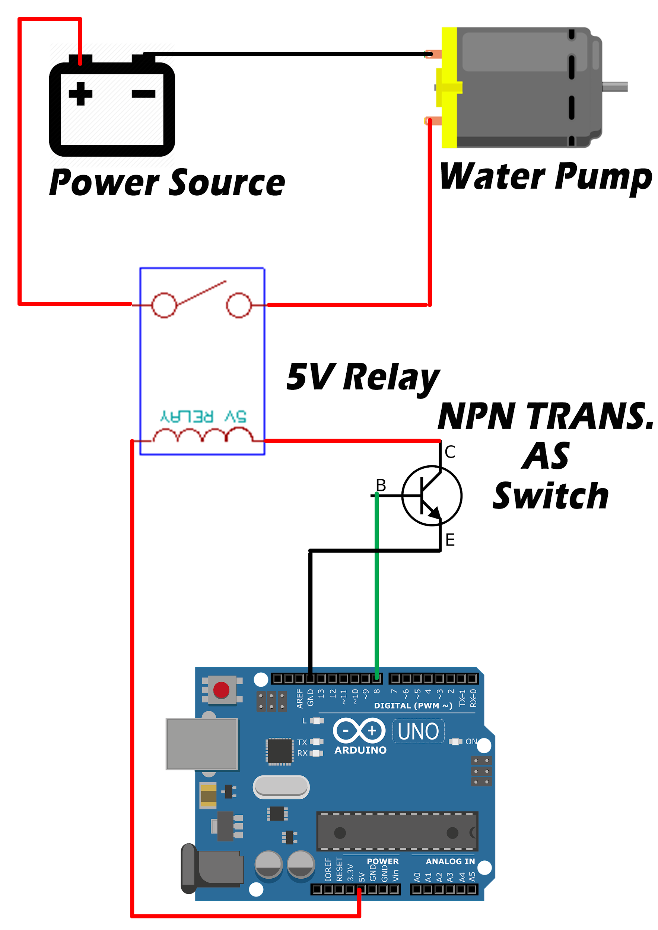

* Memory Card Reader Configuration with Arduino -

