**Just Imagine!**

**(WHEELCHAIR CONTROLLING USING BRAINWAVES)**

Group - 6

201601064 - 201601218

Problem Statement:

* Wheelchair is the most relevant equipment for elderly people and those with walking impairments. We are proposing brain analysis which would help to ease the movement of wheelchairs especially for those who have communication problems without any physical energy.
* A wheelchair will be controlled to different directions left, right, backward, forward and stop. These directions will be identified using EEG signals and machine learning algorithms for classification.

SYSTEM DESIGN:

* EEG (Electroencephalography) signal is collected through electrodes placed on the scalp according to 10-20 International system.
* The signal is then amplified using ECG sensor - SparkFun Single Lead Heart Monitor AD8232.
* Twin-T notch filter has been added after the amplifier to filter the noise present in the surrounding. Op-Amp used here is TL072 low noise JFET - input operational amplifier. It works as band pass filter because of its low power consumption, low noise and its main usage in medical applications. Low pass cut frequency of 40 Hz and high pass cut frequency of 1 Hz is obtained which captures alpha(8-12 Hz) and beta waves(12-40 Hz). These two waves are of main concern to this project for feature extraction.
* Why Filter before ADC?

Filter is needed before ADC because otherwise, depending on the noise levels in the environment, we would result in a signal with amplitudes greater than supported by ADC, therefore we filtered the EEG signal before we convert it into digital from analog.

* The signal must be transformed from analog to digital in order to be processed by the computer. Therefore, Adafruit ADS1115 16 bit ADC 4-channel chip is used. Arduino UNO then captures the data and feeds it to MATLAB via serial communication.
* MATLAB is used to perform the following operations:
  + Recording the EEG signal in real time
  + Pre-processing the signal by removing Artificial noise
  + Converting EEG raw data from Time domain to Frequency domain using FFT.
  + Filtering the useful frequency band (i.e 1-40 Hz) to extract features.
  + Applying SVM on training data and then testing data.
  + Transmitting the output obtained from the above classification method to another Arduino via Bluetooth module - HC-05.
* This Arduino - Arduino Mega - will be used to control the home automation part (e.g lights on/off).

Implementation of filter in software:

* Issues which can come up during filtering in hardware is external noise because of high tolerance of resistors and capacitors. One solution for this is we can use precision resistor or potentiometer.
* Another solution is we can do filtering in matlab before converting signal into digital via ADC.

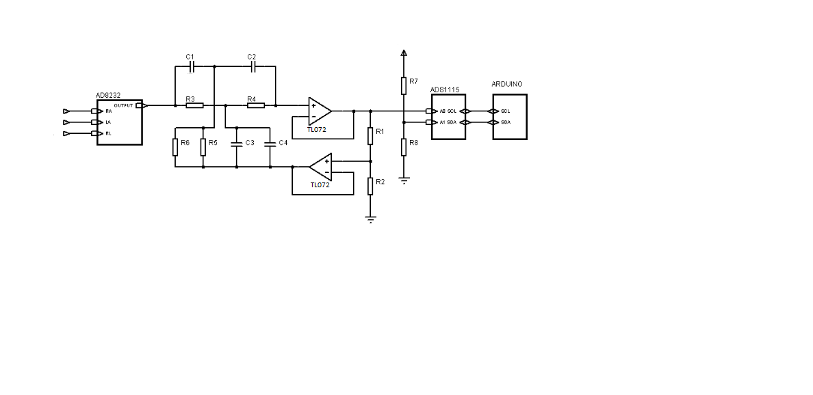

Figure 1 : Signal Acquisition Stage

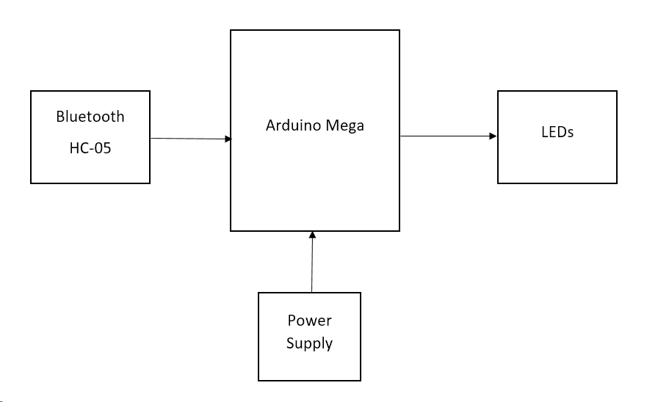

Figure 2 : Block Diagram of Receiver Side(After preprocessing stage)