Box Cricket

L.J. SCHOOL OF COMPUTER APPLICATIONS


Box Cricket

Group No: - IMCA_9_A_Group_9

Under the Guidance of:
Prof. Anurag Sir

Design & Developed By:

1. | Yash Khalas | 21004501210022
2. | Hardik Chauhan | 21004501210004

Box Cricket

Acknowledgement
It is our privilege to express our sincerest regards to our faculty and project guide, Prof.AnuraSir, for their valuable inputs, able guidance, encouragement, wholehearted Cooperation and constructive criticism throughout the duration of our project. We deeply express our sincere thanks to our head of the department Dr. Monica Gahalawat for encouraging and allowing us to present the project on the topic “Box Cricket” at our department premises for the partial fulfillment of the requirements leading to the award of Integrated Master of Computer Application (IMCA) degree. We take this opportunity to thank all our lecturers who have directly or indirectly helped our project. Last but not the least we express our thanks to our friends for their cooperation and support.

Box Cricket

L.J. SCHOOL OF COMPUTER APPLICATIONS
LJ Campus, LJ University Road, Off S.G. Road, Ahmedabad-382210



CERTIFICATE

Enrolment No: 21004501210022 Seat No: W21001222

This is to certify that Mr./Ms. Khalas Yash Dipeshbhai of Integrated Master of Computer Applications, Semester 8 has satisfactorily completed his/ her project titled Examination Management System under the supervision of Prof. Anurag Sir.

Internal Guide Name: Head of Department
Prof. Anurag Sir Dr. Monica Gahalawat Signature:

Date of Submission:
29 November, 2025
Director Prof. Alok Manke

Box Cricket

L.J. SCHOOL OF COMPUTER APPLICATIONS
LJ Campus, LJ University Road, Off S.G. Road, Ahmedabad-382210



CERTIFICATE

Enrolment No: 21004501210004 Seat No: W21001220
This is to certify that Mr./Ms. Chauhan Hardik Ravjibhai of Integrated Master of Computer Applications, Semester 8 has satisfactorily completed his/ her project titled Examination Management System under the supervision of Prof. Anurag Sir.

Internal Guide Name: Head of Department
Prof. Anurag Sir Dr. Monica Gahalawat Signature:

Date of Submission:
29 November , 2025
Director Prof. Alok Manke

Box Cricket

Box Cricket

Table of Contents
- Introduction 7
  - Existing System 7
  - Need for the New System 7
  - Objective of the New System 7
  - Problem Definition 8
  - Core Components 8
  - Project Profile 9
  - Assumptions and Constraints 10
  - Advantages and Limitations of the Proposed System 10
- Requitement Determination & Analysis 11
  - Requirement Determination 11
  - Targeted Users 11
- System Design 12
  - Use Case Diagram 12
  - Class Diagram 13
  - Interaction Diagram 14
  - Activity Diagram 17
  - Data Dictionary 20
- Development 23
  - Coding Standards 23
  - Screenshot 24
- Agile Documentation 34
  - Agile Project Charter 34
  - Agile Road Map 35
  - Agile Project Plan 36
  - Agile User Story 38
5.5. Agile Release Plan 39
5.6 Agile Sprint Backlog 41
5.7. Agile Test Plan 43
5.8 Earned-value and burn charts 44
- Proposed enhancements 45
- Conclusion 45
- Biblography 45

Box Cricket

Introduction
- Box cricket is becoming more popular, especially in crowded cities where space is limited. However, organizing matches is still done through phone calls, social media messages, and manual records, leading to scheduling issues, booking conflicts, and poor management. Without a proper platform, players struggle to find and book courts, while facility owners face difficulties in handling their operations. To solve this, we propose a dedicated box cricket website that simplifies court bookings, schedules, payments, and community engagement. This platform will make the process smooth, efficient, and accessible, connecting players with facilities and creating a vibrant online community for the sport.

Existing System

- Phone/In-person bookings: This is inefficient and prone to errors.
- Social media/Messaging apps: While convenient for communication, they lack structured booking and management features.
- Manual record-keeping: This is time-consuming and susceptible to inaccuracies.
- Limited online presence: Many facilities lack a dedicated website, hindering discoverability.

Need for the New System

    - Slow and inefficient booking.
    - Difficulty managing schedules and payments.
    - Limited visibility for facilities.
    - No platform for players to connect.
    - A dedicated website will solve these issues by making booking and management easier.

Objective of the New System

The new system aims to:

    - Provide an easy-to-use website for booking box cricket facilities.
    - Show details like timings, prices, as well as booking details.
    - Enable online payments as well as Advance Payments.
    - Help facility owners manage their schedules.
    - Create a space for players to connect.
    - Make business management easier for facility owners.
    - Ensure a simple and user-friendly interface.

Box Cricket

Problem Definition

The system will solve issues like:

- Slow and complicated booking.
- Unclear availability and pricing.
- Difficulty in managing payments and schedules.
- Poor communication between players and facility owners.
- No central platform to find and book box cricket facilities.

Core Components

The core components of the website will include:

User Management:
  - Players and facility owners can register and log in.
  - Users can manage their profiles..

Facility Management:

  - Facility owners can list their courts with details like location, timings, prices, amenities, and photos.
  - Manage schedules, availability, and bookings.
  - Handle payments.

Booking System:
  - An online calendar to check real-time availability.
  - Secure online payment options.
  - Booking confirmations as well as Cancel booking.

Search and Filtering:

  - Ability to search for facilities based on location, price, and availability.
  - Filtering of facilities based on user preference.

Admin Panel:
  - Ability to manage users, area ,slot timing, and bookings.
  - Reporting and analytics.

Box Cricket

Project Profile

Project Title : | Box Cricket
Project Developer : | Khalas Yash | (En.No:- 21004501210022)
 | Chauhan Hardik | (En.No:- 21004501210004)
Hardware Require : Intel CORE i7 Processor or Above
RAM 1 GB or Above
Hard Disk 60 GB or Above
Software Require : Platform : Window XP or Above
Front End : HTML, CSS, Bootstrap,
JavaScript

 | Back End :  Framework : | MongoDB  React Js, Express Js, Node Js
 | Other Tools : | MS Word 2007 (Documentation)
 |  | Dia (Diagram)
Project Guide | : | Prof. Anurag Sir
Project Start Date | : | 01 June, 2025
Project End Date | : | 17 November, 2025

Box Cricket

Assumptions and Constraints

Assumptions

    - Users have internet access and a device to use the website.
    - Facility owners are ready to manage their listings online.
    - The payment system will work smoothly and reliably.

Constraints

    - Limited budget and time for development.
    - Need to ensure user data security and privacy.
    - Dependence on third-party services like payment gateways.
    - The website must work well on mobile devices.

Advantages and Limitations of the Proposed System

Advantages

    - Clear and easily accessible information.
    - Better schedule management for facility owners.
    - Smooth communication between players and facility owners.
    - A single platform for all box cricket activities.
    - Secure online payments.
Limitations
    - Requires a stable internet connection.
    - Possible technical problems and security risks.
    - Some users may prefer old booking methods.
    - Facility owners might need training to use the system.

Box Cricket

Requitement Determination & Analysis

Requirement Determination
- ADMIN:

  - Admin can add, edit, and remove users.
  - Admin can manage bookings,canceling, and modifying them.
  - Admin can manage cricket box areas, adding or removing facilities.
  - Admin can update and control booking slot timings.
  - Admin can handle online booking payments and oversee transactions.
  - Admin can monitor system activity and generate reports for performance analysis.
- LOGGED-IN USER:

  - Users must log in to access booking features.
  - Users can book cricket box slots.
  - Users can make secure online payments for bookings.
  - Users can view, modify, or cancel their bookings.
  - Users can check slot timings before booking.

- GUEST-USER:
  - Guest users can explore different cricket box areas available for booking.
  - Guest can check available time slots for different cricket box areas.
  - Guest can view details of existing bookings.
  - Guest can browse images of cricket box areas and facilities.
  - Guest can log in to access additional features.
  - Guest can register to become a logged-in user.
  - Guest can log out of the system after browsing.

Targeted Users
    - Users:

      - Logged Users: Can register, search, book, and manage bookings.
      - Guest Users: View Areawise boxcricket, View areawise slot.

Box Cricket

System Design

Use Case Diagram
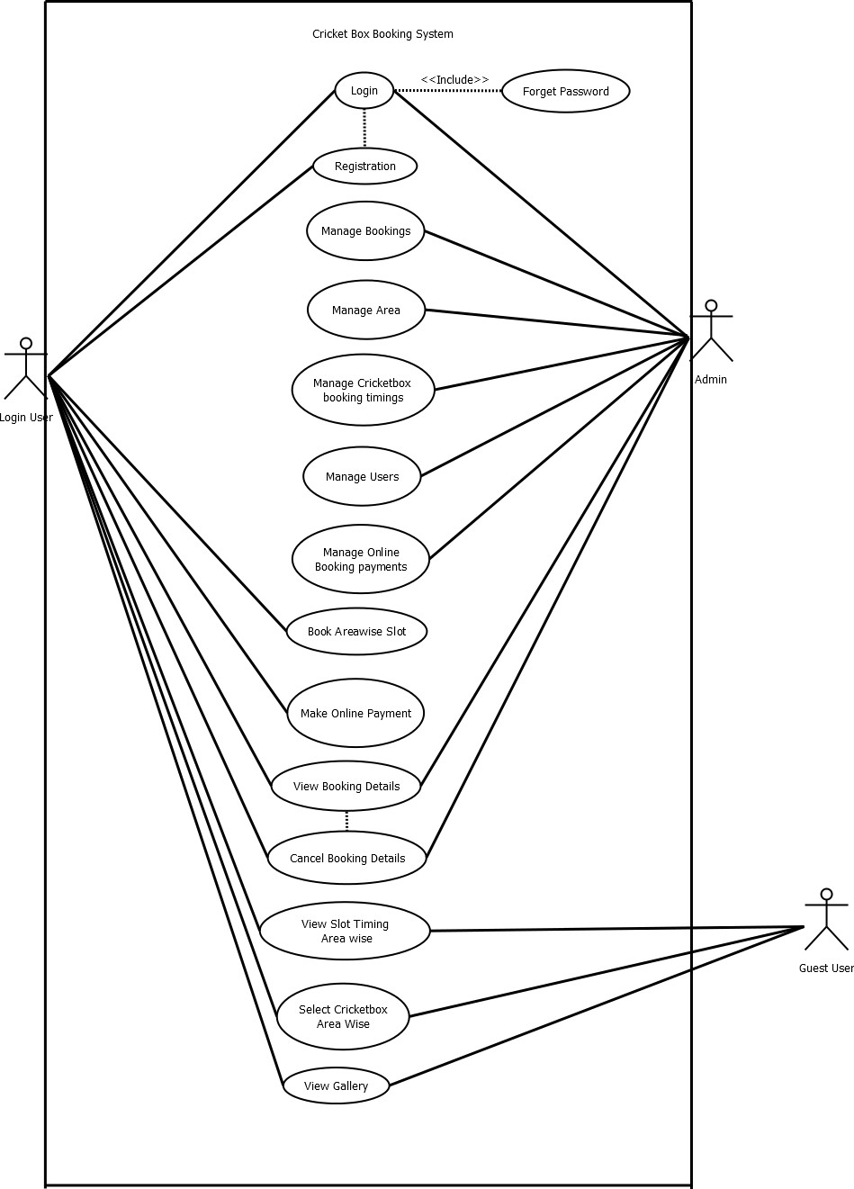

Box Cricket

Class Diagram
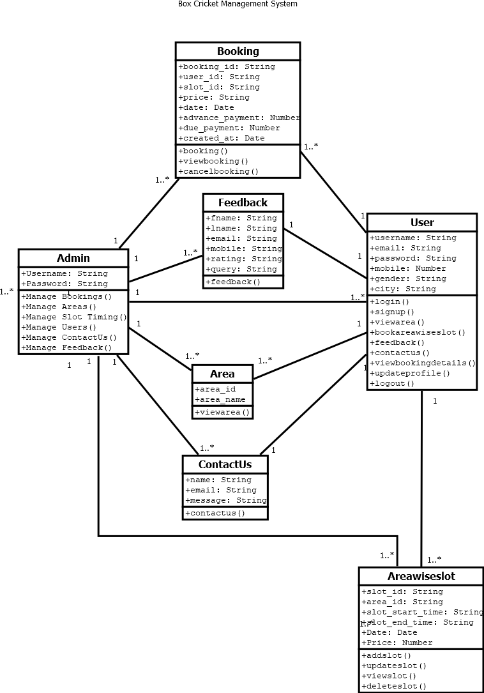

Box Cricket

Interaction Diagram

    - Interaction Diagram For Login:-
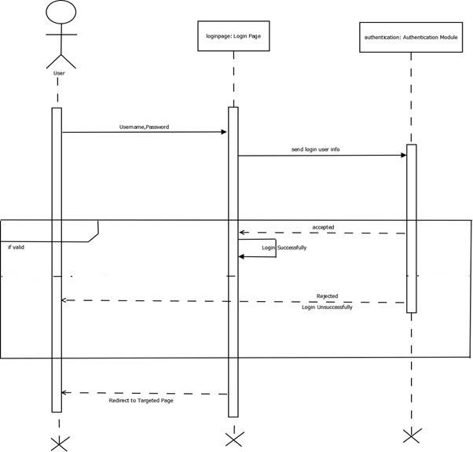

Box Cricket

    - Interaction Diagram For Booking
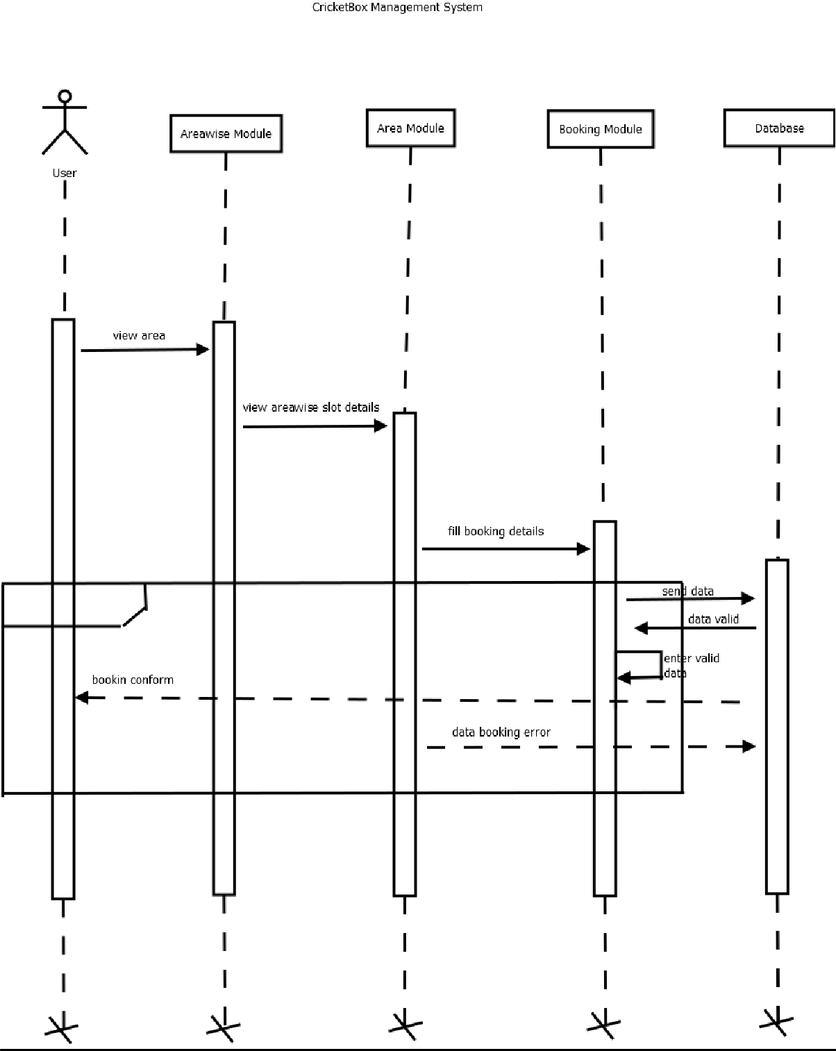

Box Cricket

    - Area wise slot Interaction Diagram
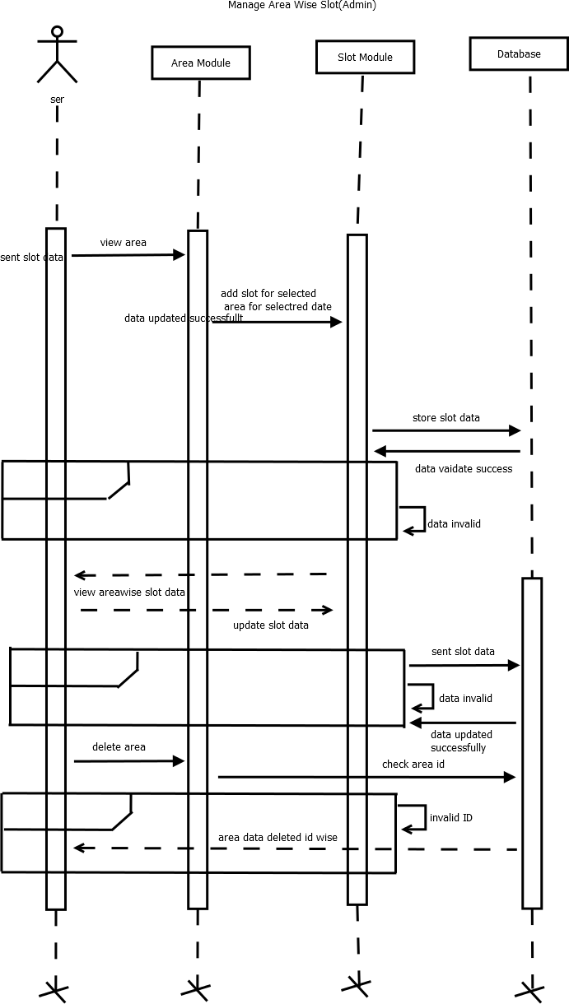

Box Cricket

Activity Diagram

    - Booking Details Activity Diagram
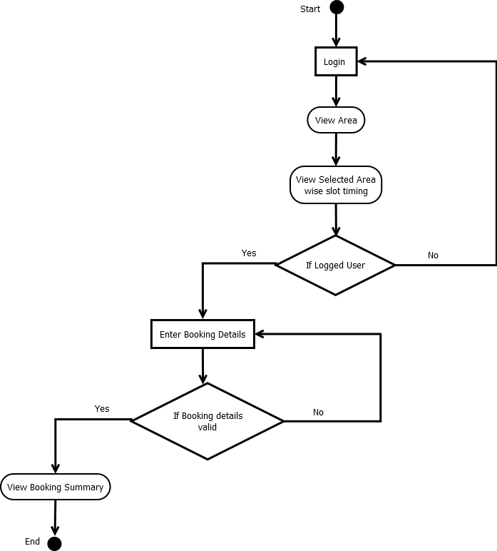

Box Cricket

    - Activity Diagram For Login

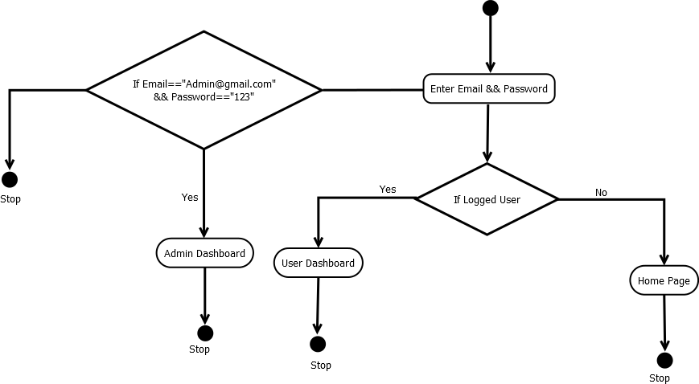

Box Cricket

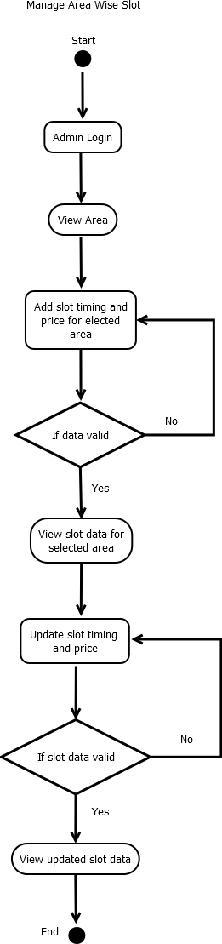
    - Area wise slot activity diagram

    - ​

Box Cricket

Data Dictionary
Table name: RegisterUser
Table description: This table store the information about Register User

Field name | Datatype | Constraints | Description | Sample data
user_id | number | Primary Key | Enter userid | 1
fname | String | Not null | Enter First Name | Mita
lname | String | Not null | Enter Last Name | Kanzariya
email | String | Not null | Enter Email | mitakanzariya79@gmail.com
mobile | String | Not null | Enter Mobile Number | 7016907921
gender | String | Not null | Select Gender | Female
city | String | Not null | Select City | Ahmedabad
password | String | Not null | Enter Password | 12345
cpassword | string | Not null | Enter Confirm Password | 12345

Table name: Area
Table Description: This Table Store The Area Of Cricket Box

Field name | Datatype | Constraints | Description | Sample data
area_id | Number | PK | Enter identification | 1
area_name | String | Not null | Enter Area Name | Bopal

Box Cricket

Table name: Slot
Table Description: This Table Store Slot Of boxcricket

Field name | Datatype | Constraints | Description | Sample data
slot_id | Number | PK | Enter identification | 11
area_id | Number | FK | Enter identification | 1
slot_start_time | String | Not Null | Enter Slot Start Timing | 10:00 am
slot_end_time | String | Not Null | Enter Slot End Timing | 11:00 am
Date | Date | Not Null | Enter Slot Date | 2025-08-21
Price | Number | Not Null | Enter Price | 500

Table name: Booking
Table Description: This Table Store CircketBox Booking Details

Field name | Datatype | Constraints | Description | Sample data
booking_id | Number | PK | Enter identification | 101
user_id | Number | FK | Enter identification | 1
slot_id | Number | FK | Enter identification | 11
Booking_date | Date | Not Null | Enter Date | 2025-08-21
Price | Number | Not Null | Enter Price | 500
advance_payment | Number | Not Null | Enter Advance Payment | 200
due_payment | Number | Not Null | Enter Due Payment | 300
created_at | Date | Not Null | Enter Created Date | 2025-03-21

Box Cricket

Table name: Feedback
Table Description: This Table Store Details Od User Feedback

Field name | Datatype | Constraints | Description | Sample data
fname | String | Not Null | Enter First Name | Mita
lname | String | Not null | Enter Last Name | Kanzariya
email | String | Not null | Enter Email | mitakanzariya79@gmail.com
mobile | String | Not null | Enter Mobile Number | 7016907921
rating | String | Not Null | Enter Rating | Good
feedback | String | Not Null | Enter Feedback | Price is efficience for areawise

Box Cricket

- Development

  - Coding Standards
- Naming Convention

- Use meaningful and descriptive names.
- Use camelCase for variable and function names.
- Use PascalCase for class names and React components.

- Indentation/Spacing

  - Use two spaces for indentation.
  - Maximum line length: 100 characters.
  - No trailing whitespace at the end of lines.
  - Use consistent semicolon usage (; at the end of statements in JavaScript).
  - Use single quotes (' ') instead of double quotes in JavaScript, except for JSON.

- Imports

  - Order of imports (from general to specific):
    - Import from Node.js standard libraries.
    - Import from third-party packages.
    - Import from internal modules.
    - Import local files (with relative paths).
    - Use nodemailer for mail sending.

- Database & Migrations (MongoDB, Express js, Node js)

  - Use Mongoose models for database schema definition.
  - Use indexes where necessary for query performance.
  - Keep database-related logic separate from model.
  - Use JWT token for authenticate route.

- React (Frontend)

  - Use Array function for new component.
  - Keep components small and reusable.
  - Use custom hooks for complex logic.
  - Always handle API errors properly in the UI.

Box Cricket

Screenshot

- Client Site

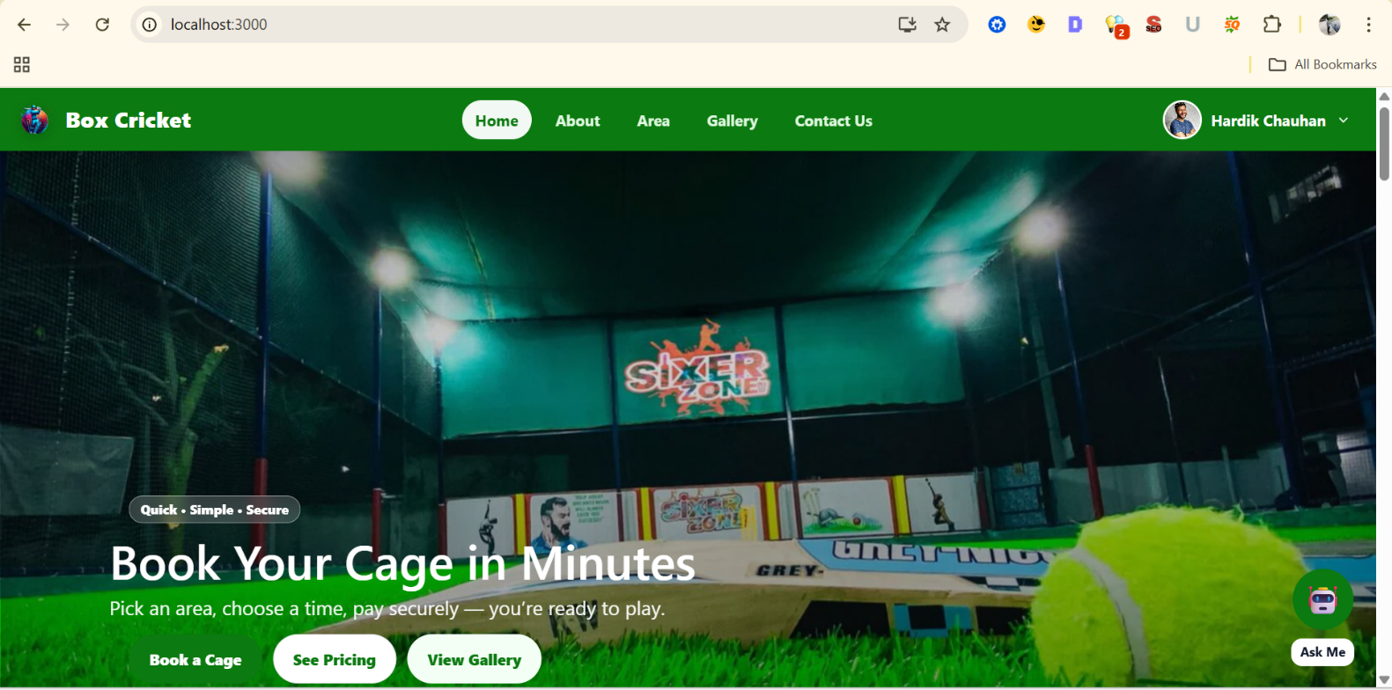

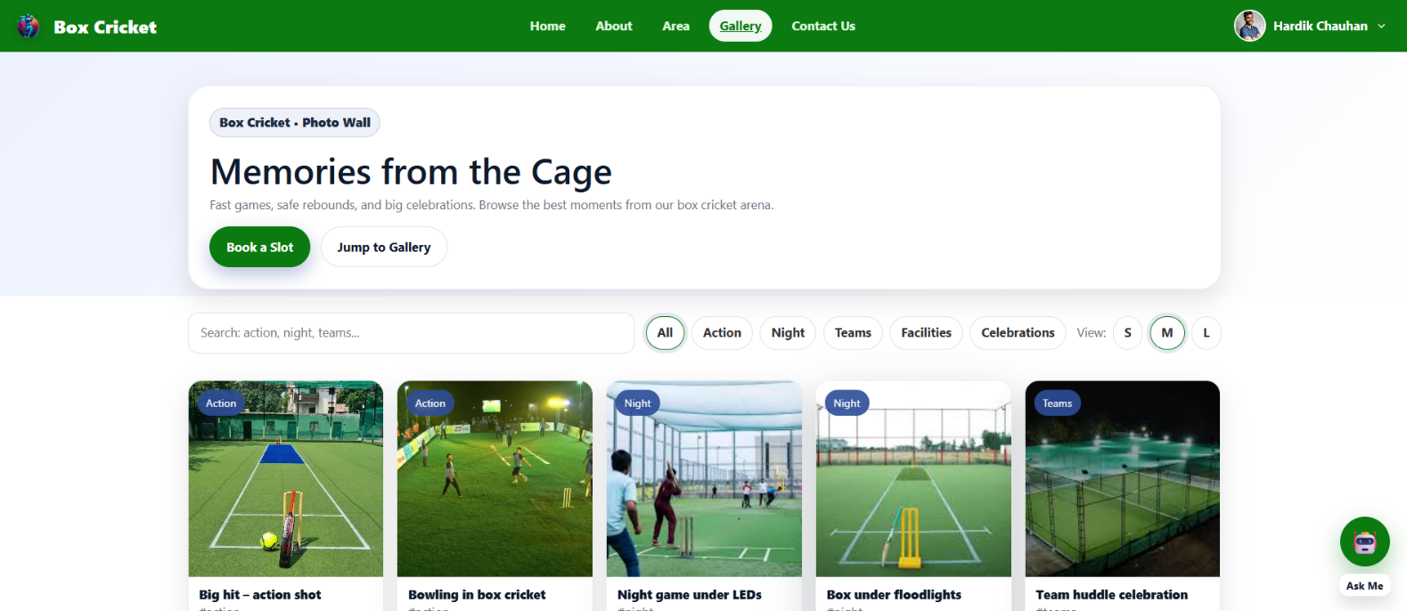
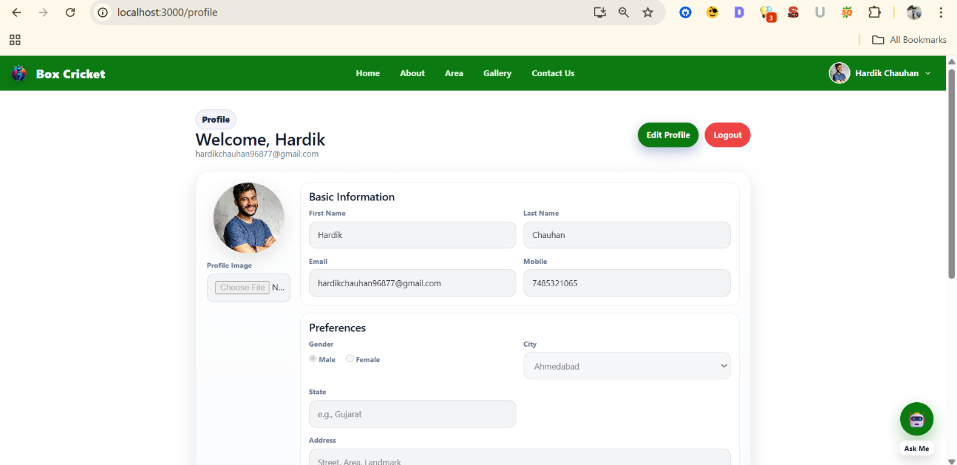

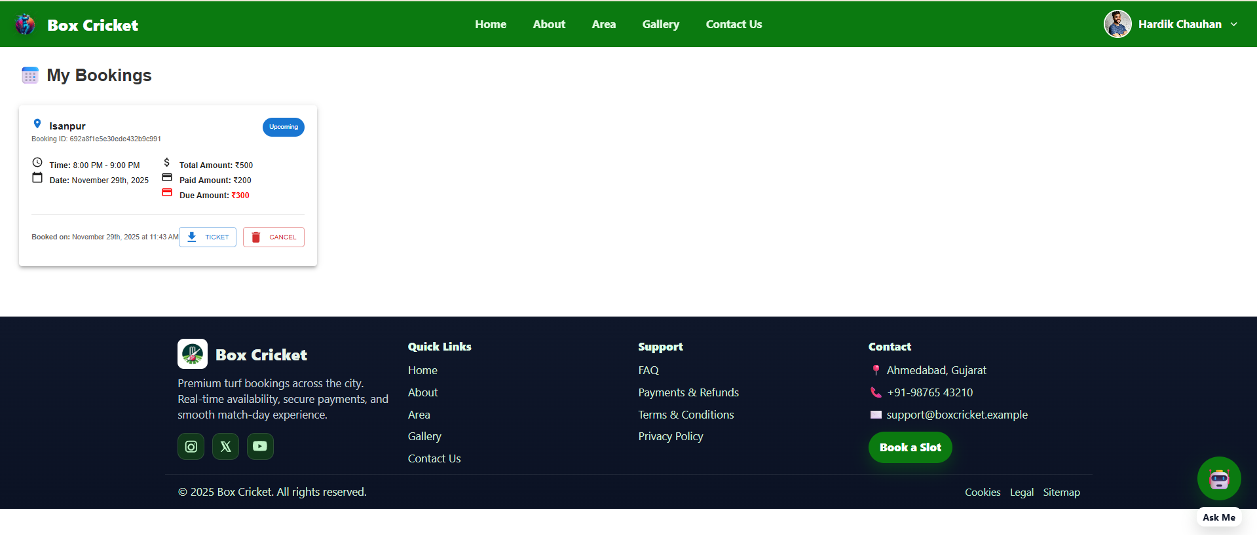

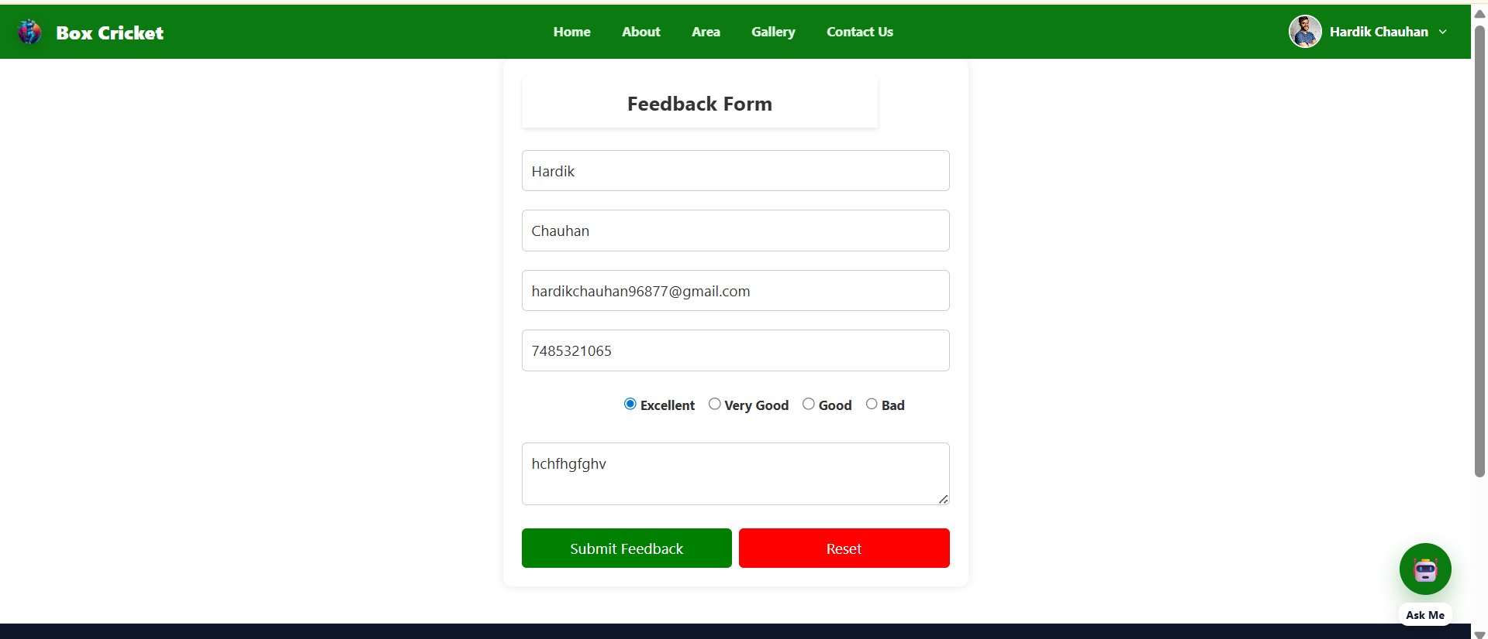

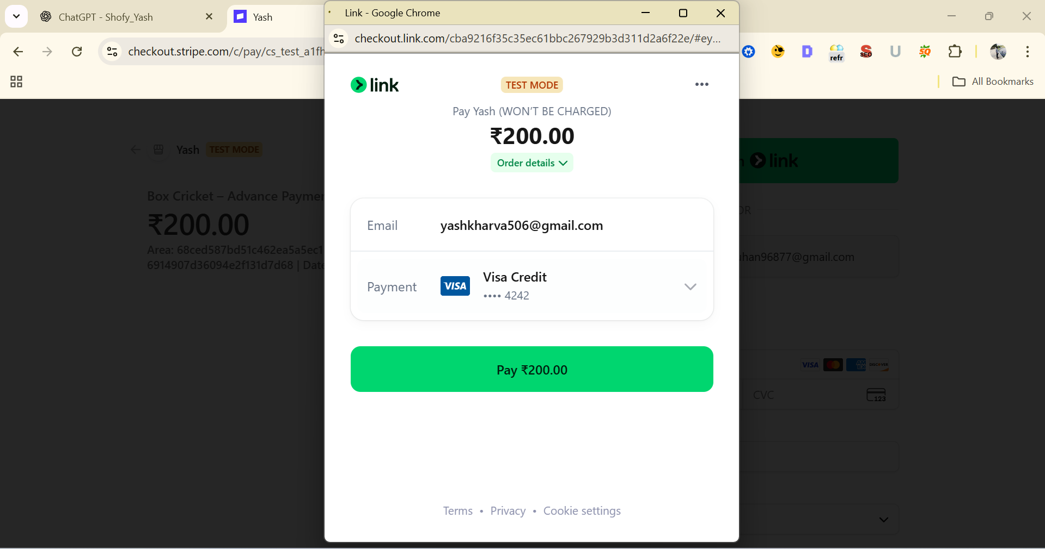

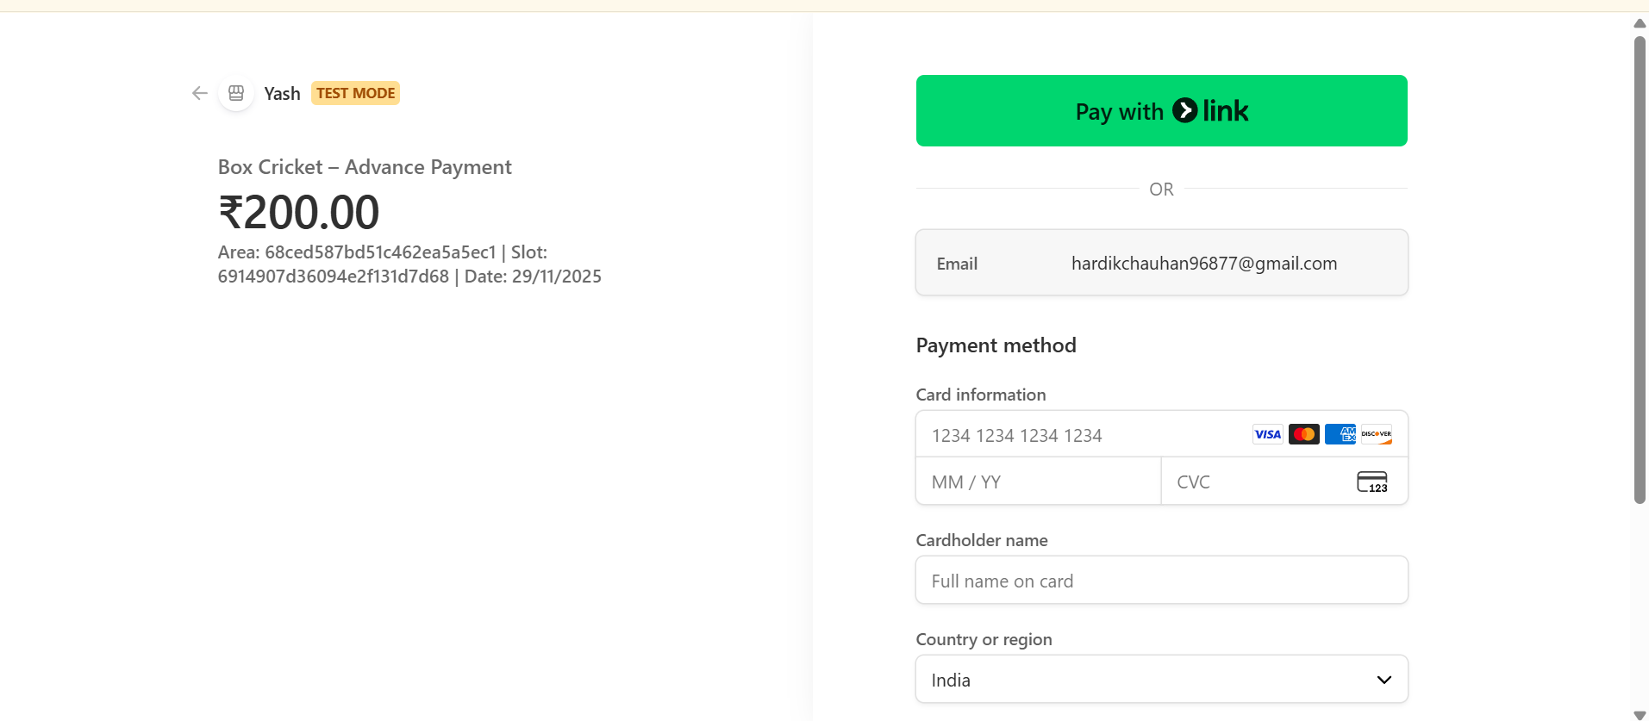

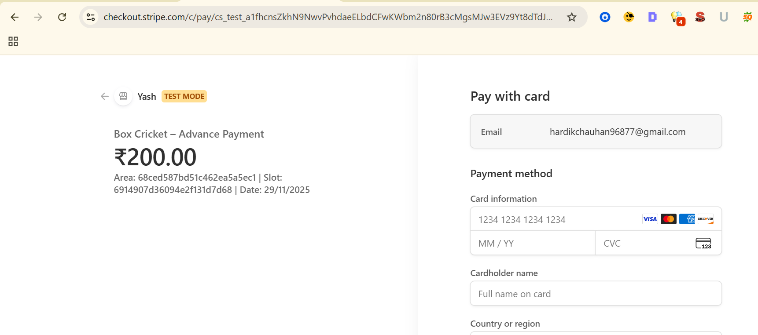

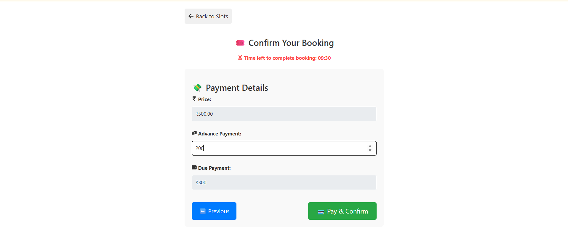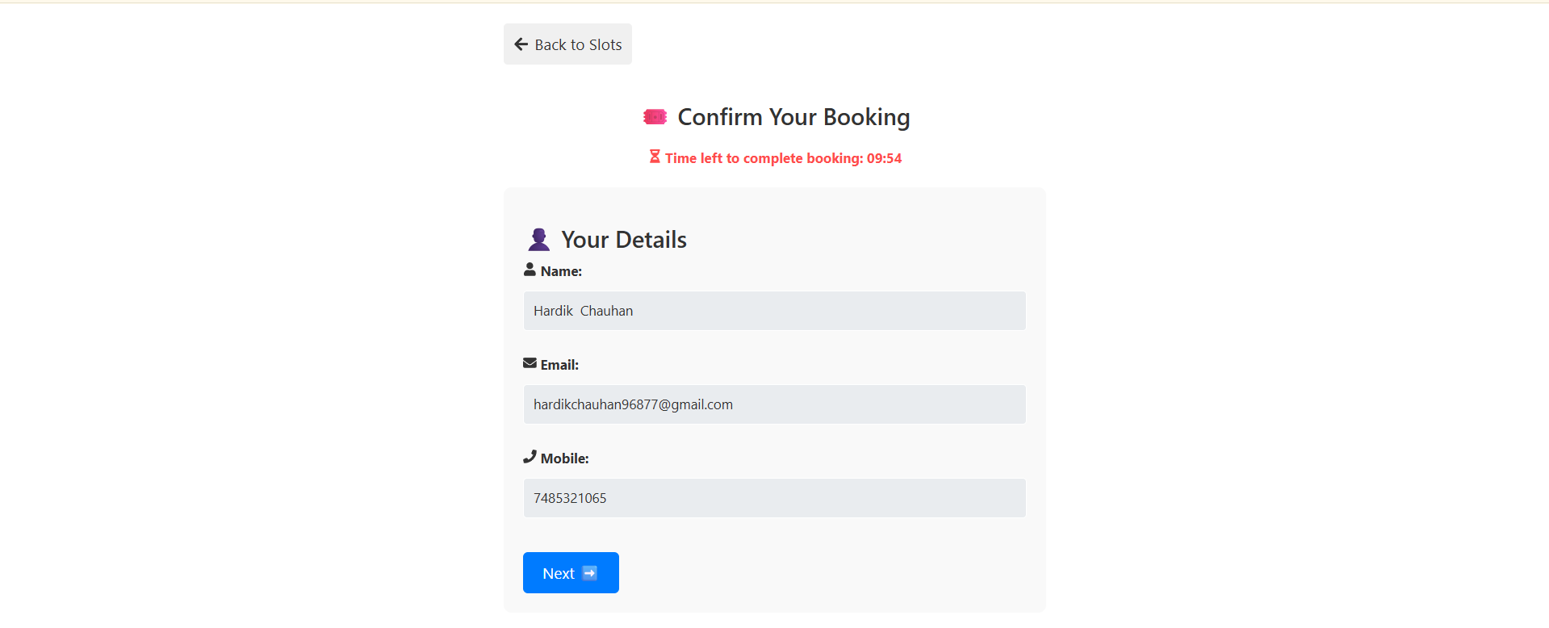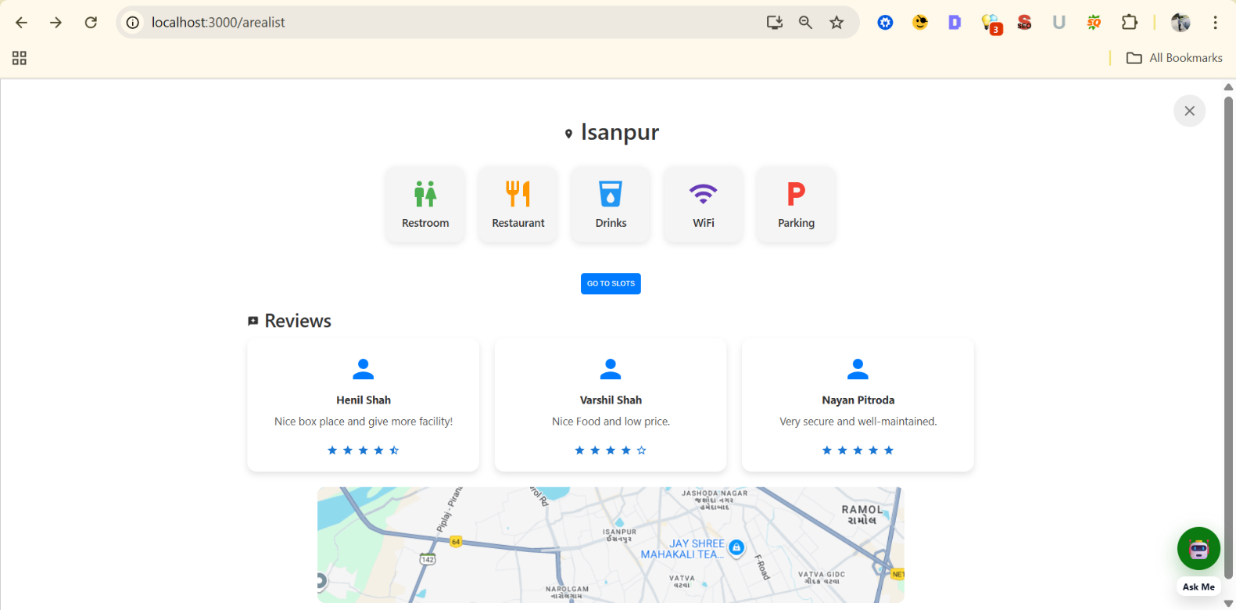

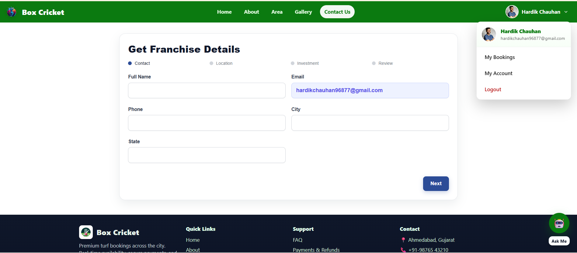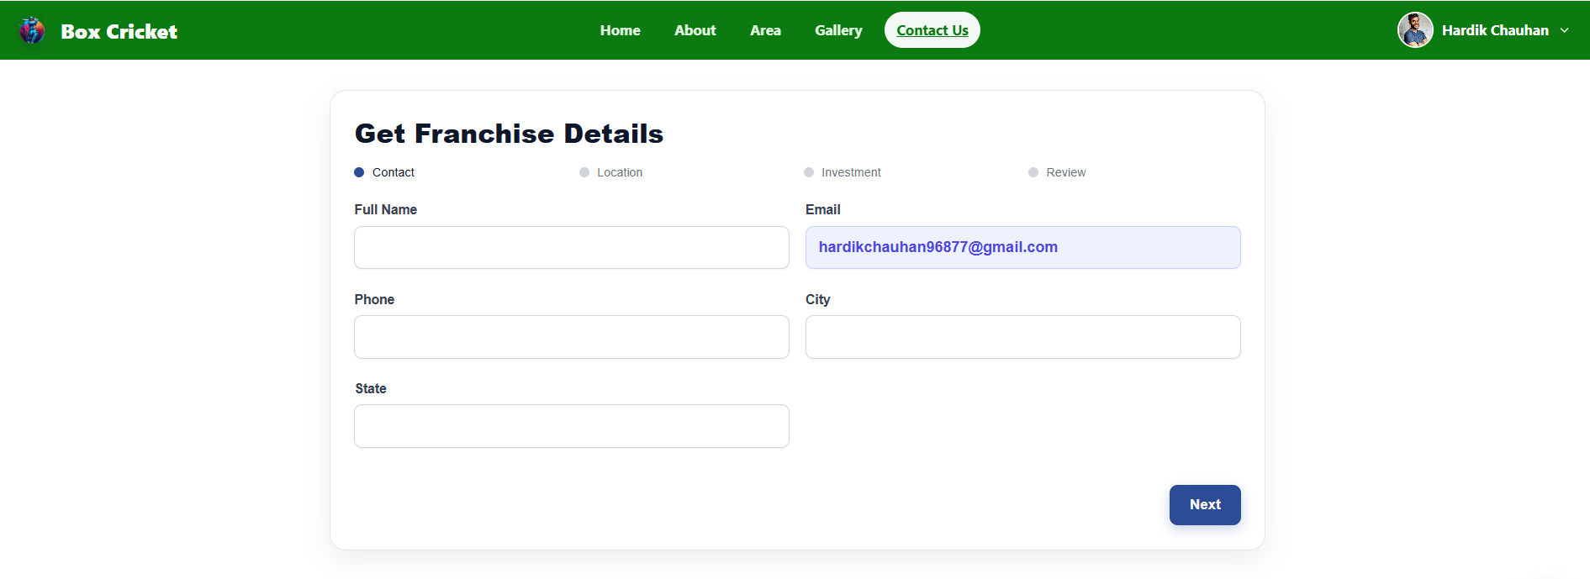

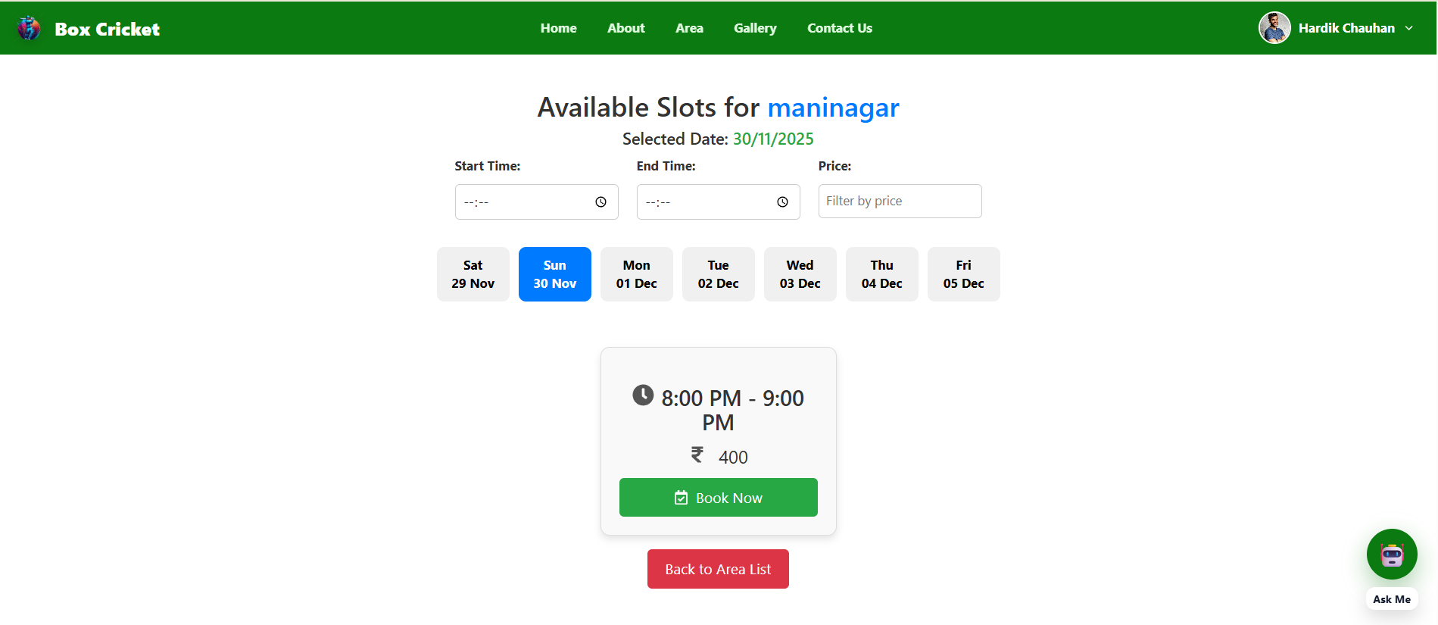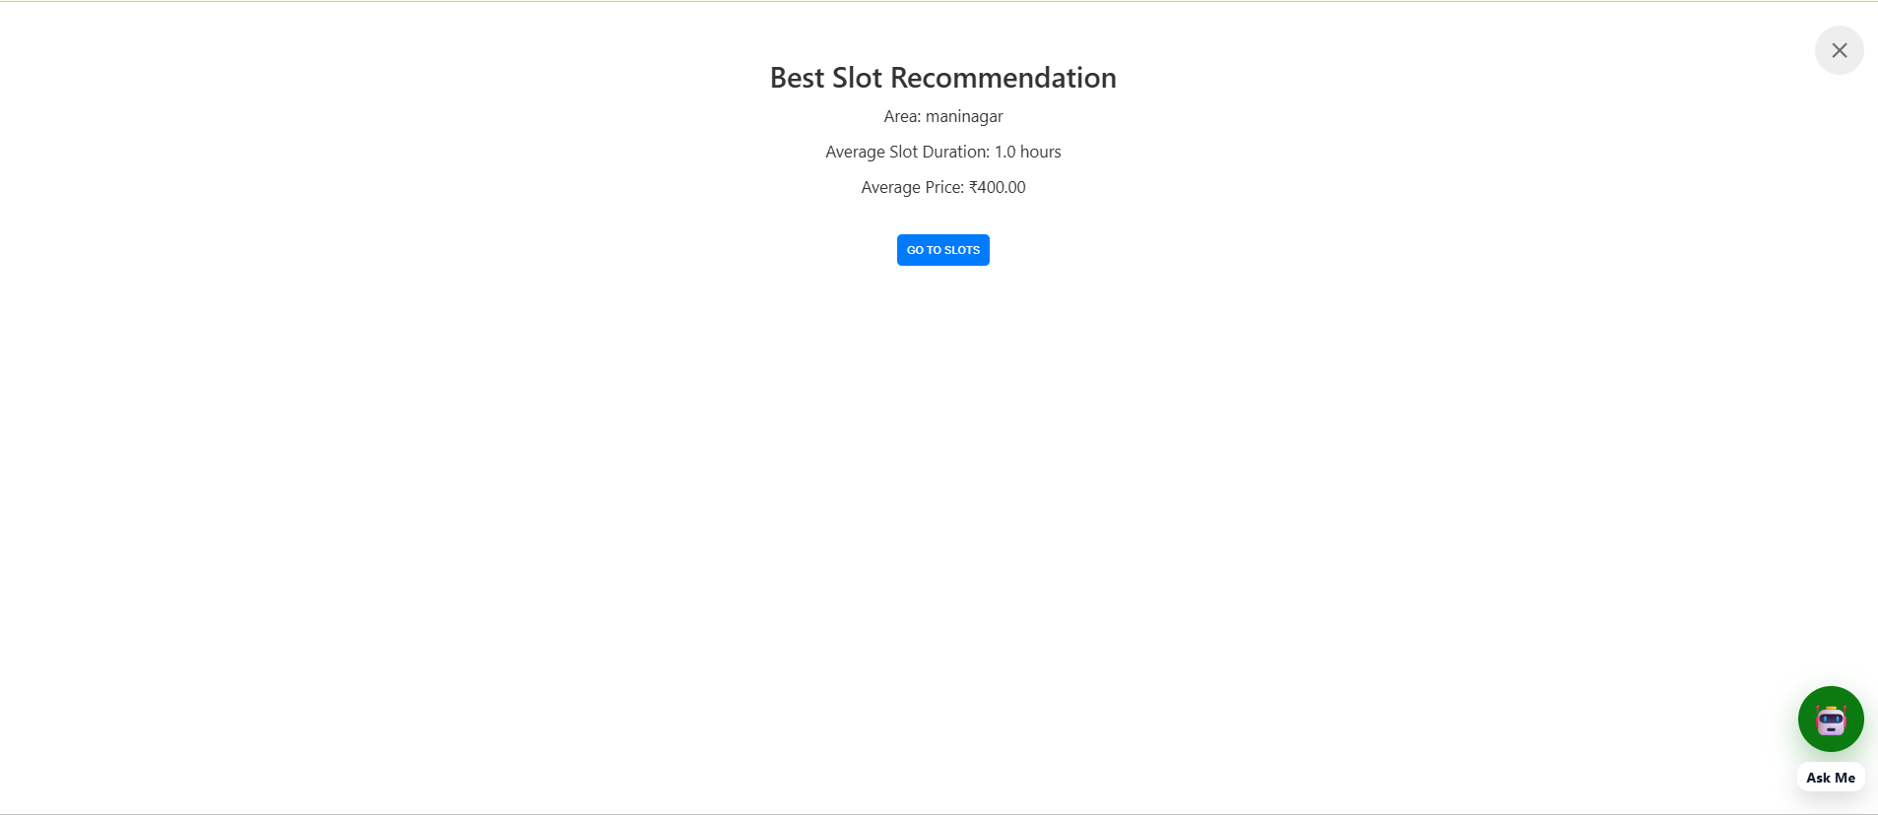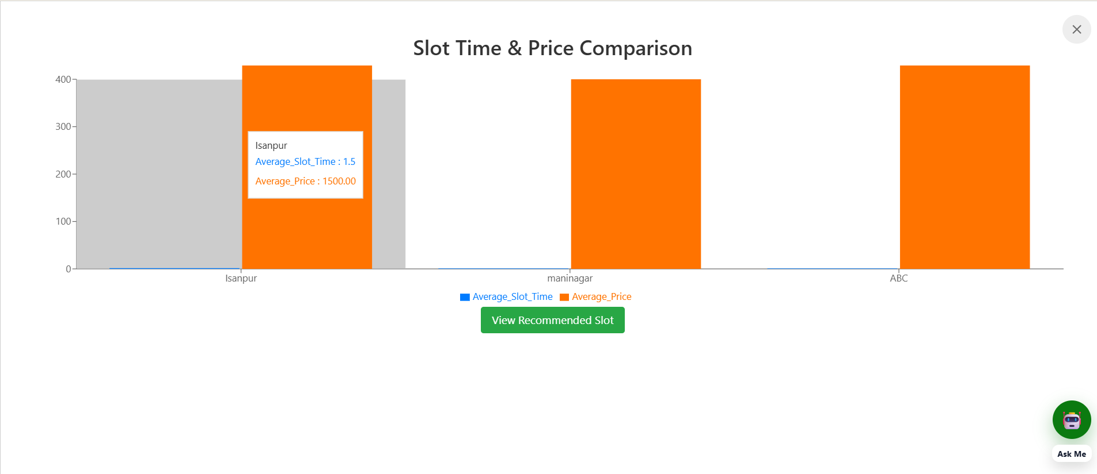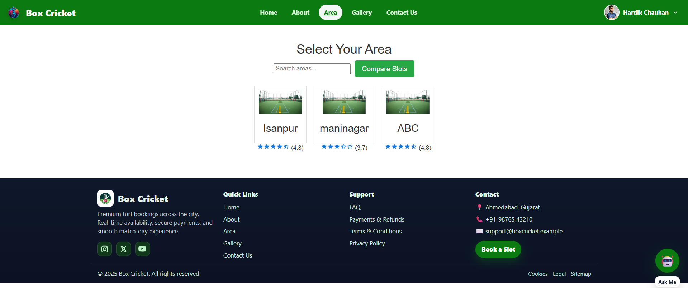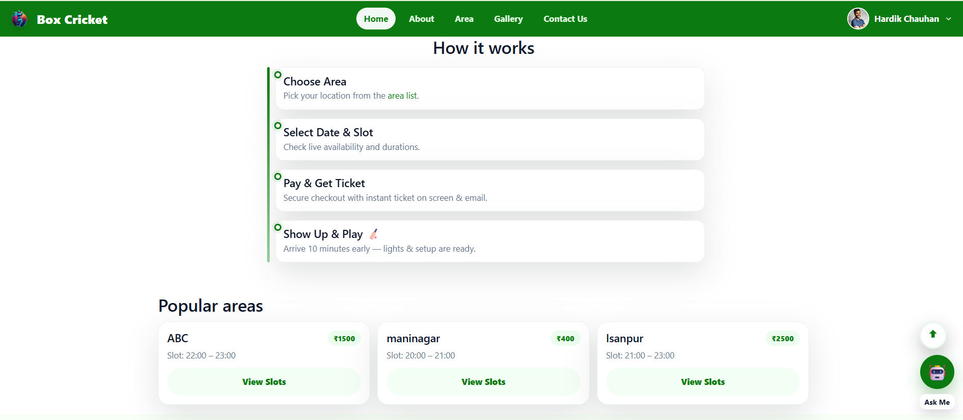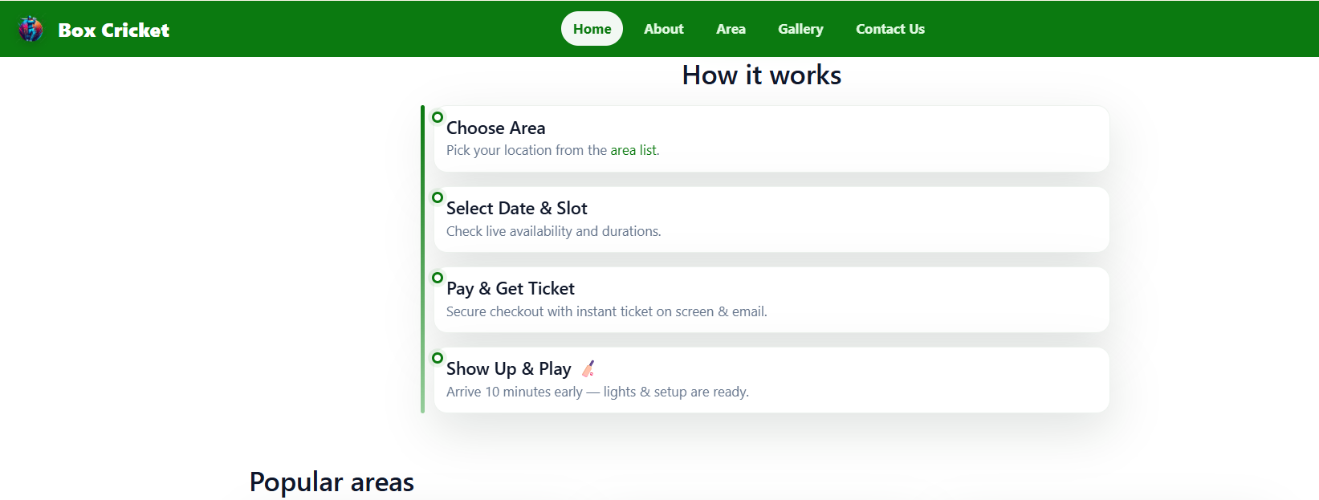

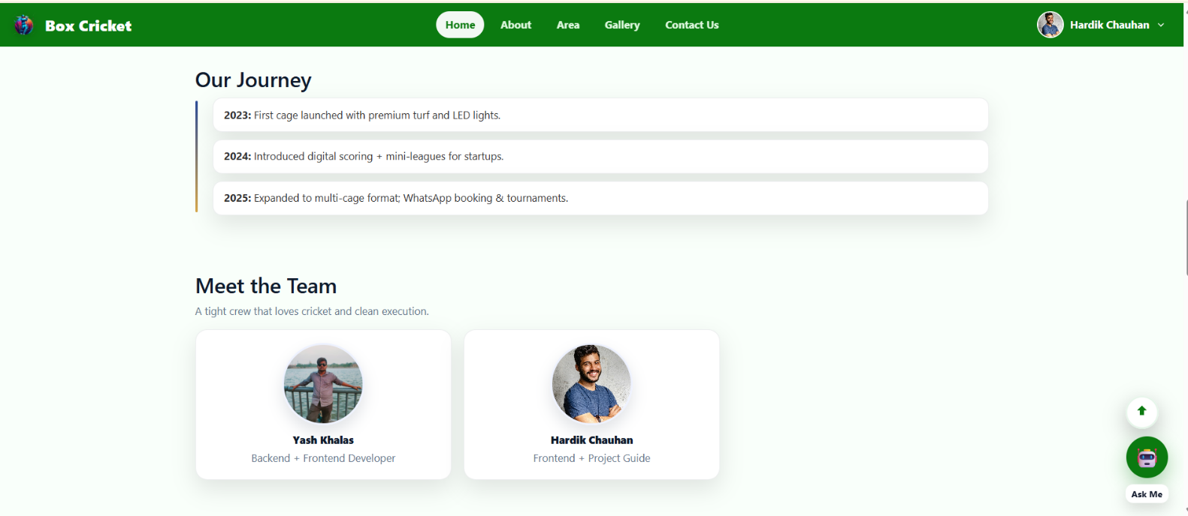

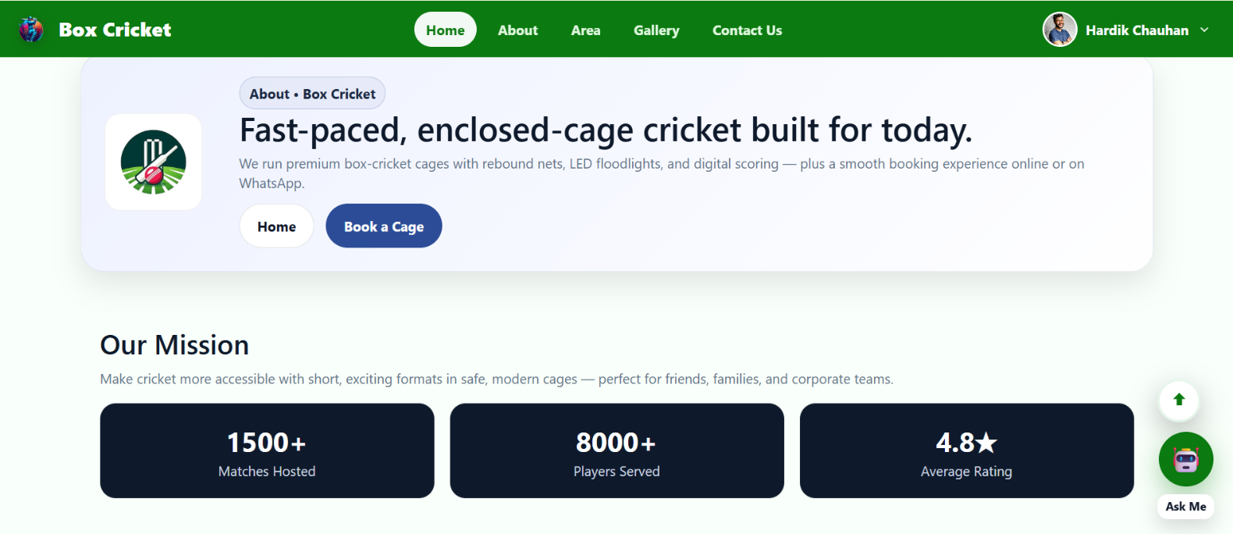

- Admin Site+ Super Admin Site

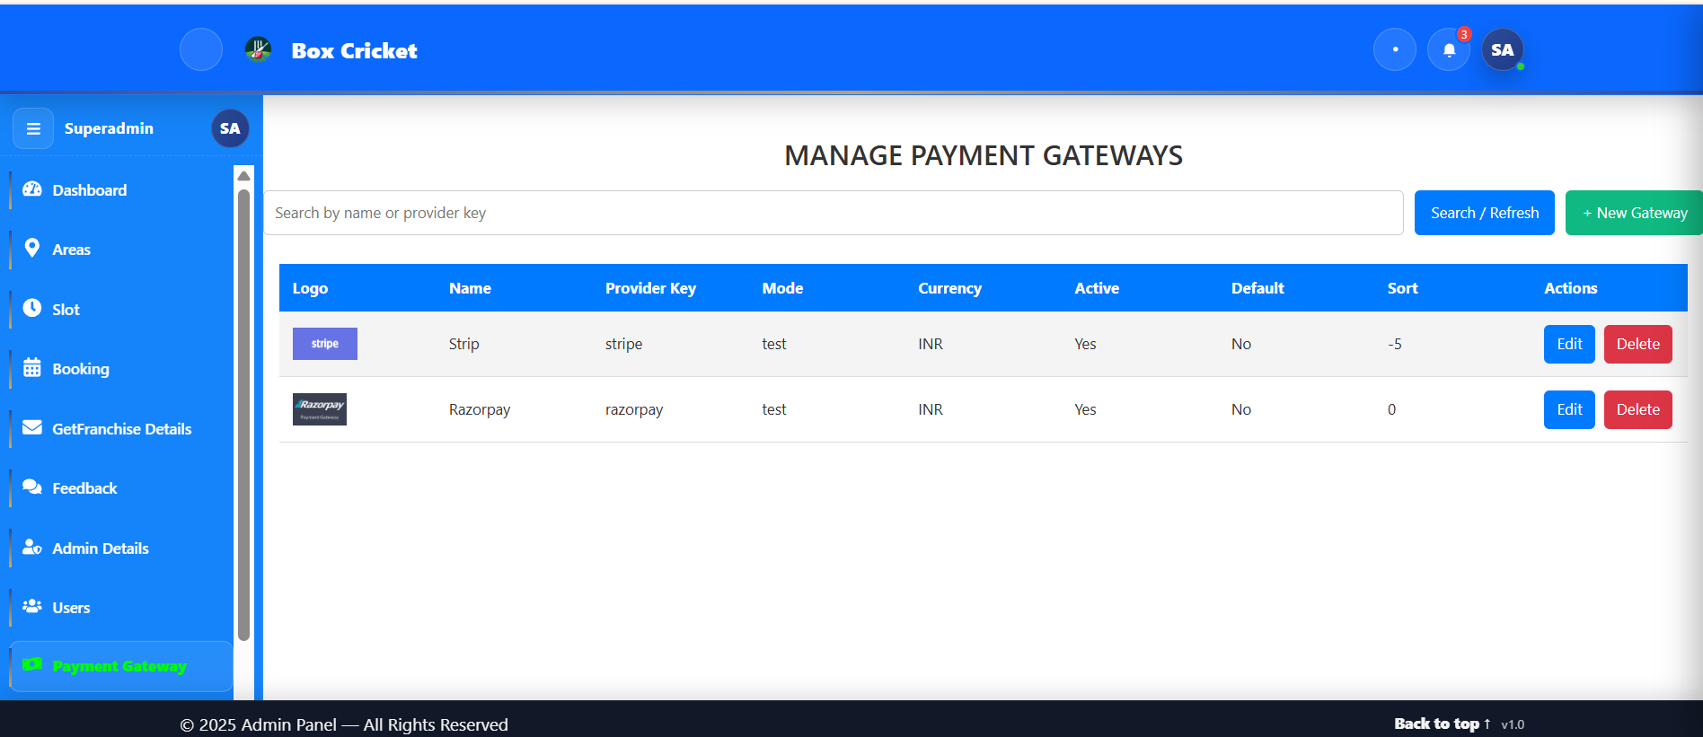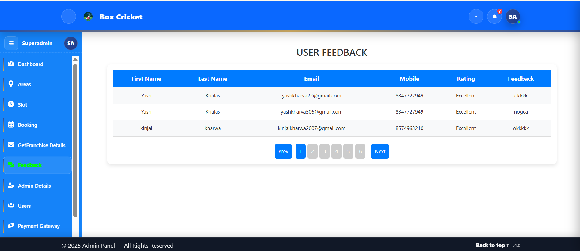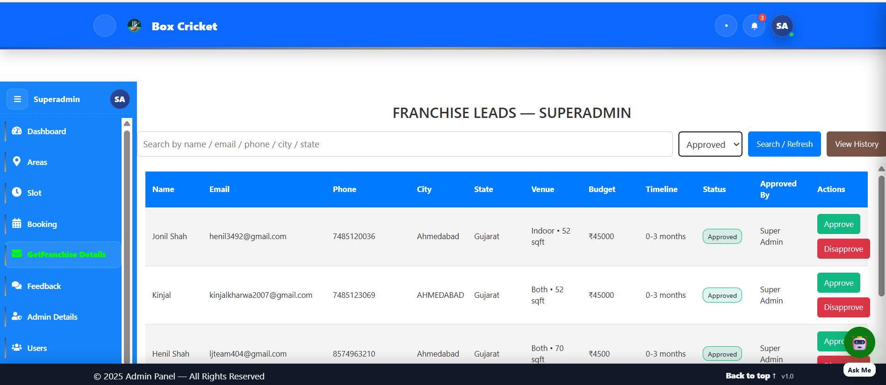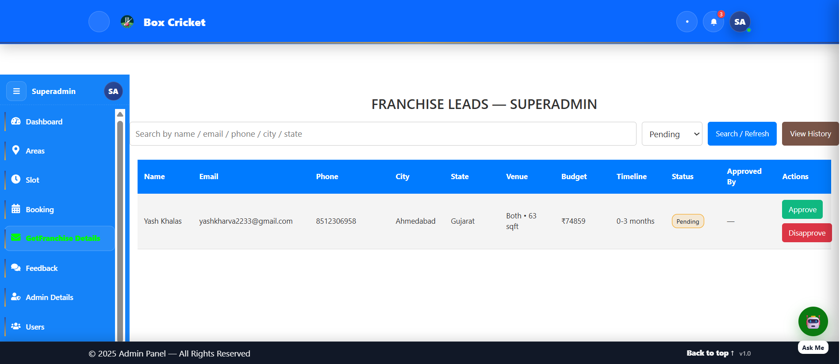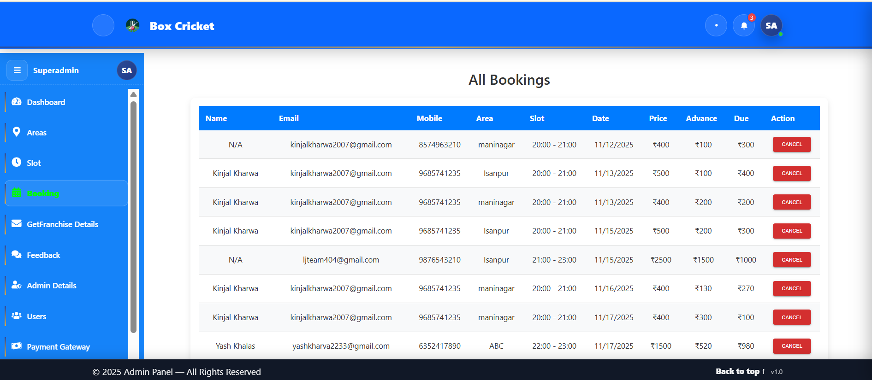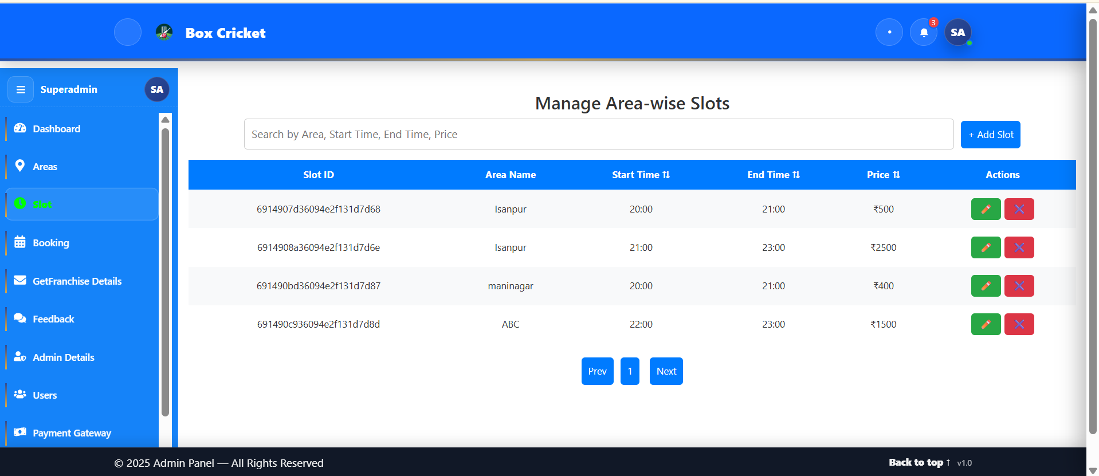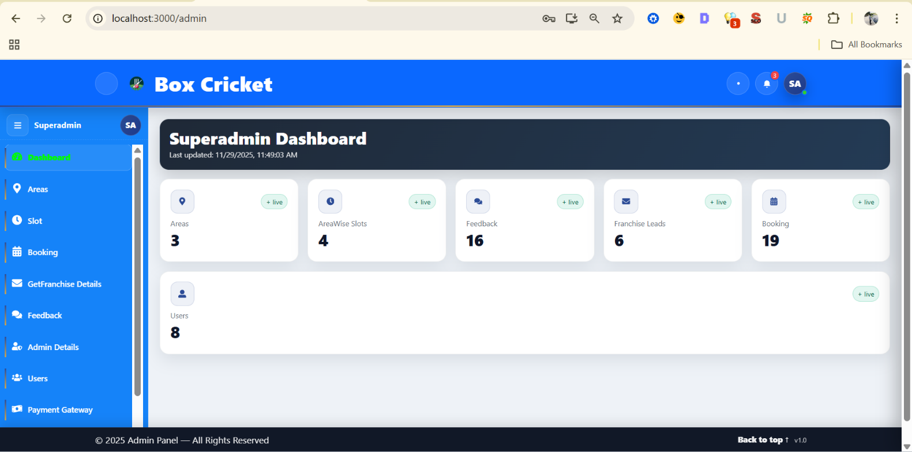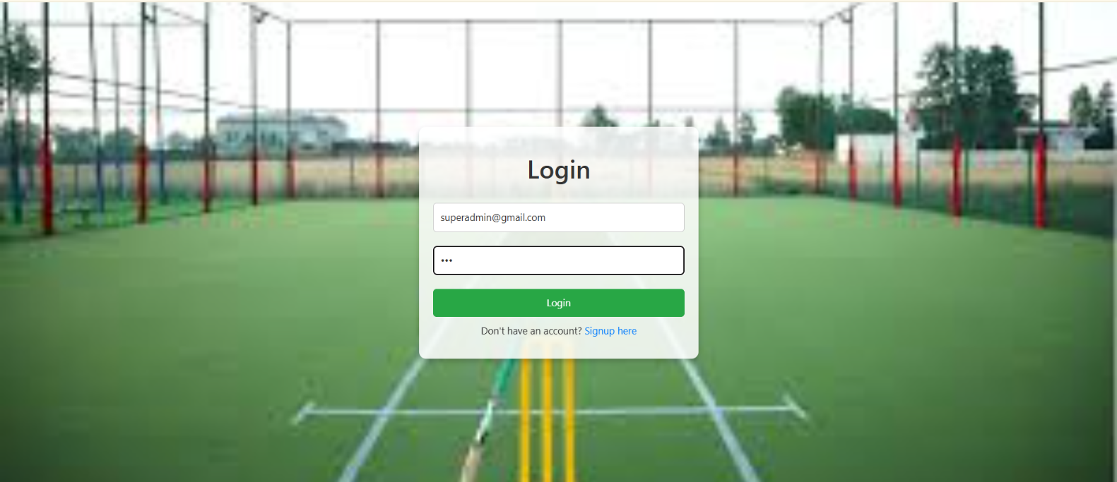

Box Cricket

- Agile Documentation

Agile Project Charter
General Project Information
Project Name | BOX CRICKET
Project Champion | Yash Khalas, Hardik Chauhan
Project Sponsor | LJ University
Project Manager | Prof. Anurag Sir
Stakeholders | L.J Institute of Computer Application
Expected Start Date | 01-06-2025
Expected Completion Date | 28-11-2025

Project Details
Mission | Our mission is to make it easy and safe for people to book cricket boxes online. We want users to have a smooth experience and  trust our system.
Vision | Our vision is to be the best app for booking cricket boxes by keeping things simple, flexible, and always improving to meet the  needs of users and stadium staff.
Scope | Our app will let people book cricket boxes in real-time, show  correct availability, avoid errors, and be easy for everyone to use, including admins and regular users.

Box Cricket

  - Agile Road Map

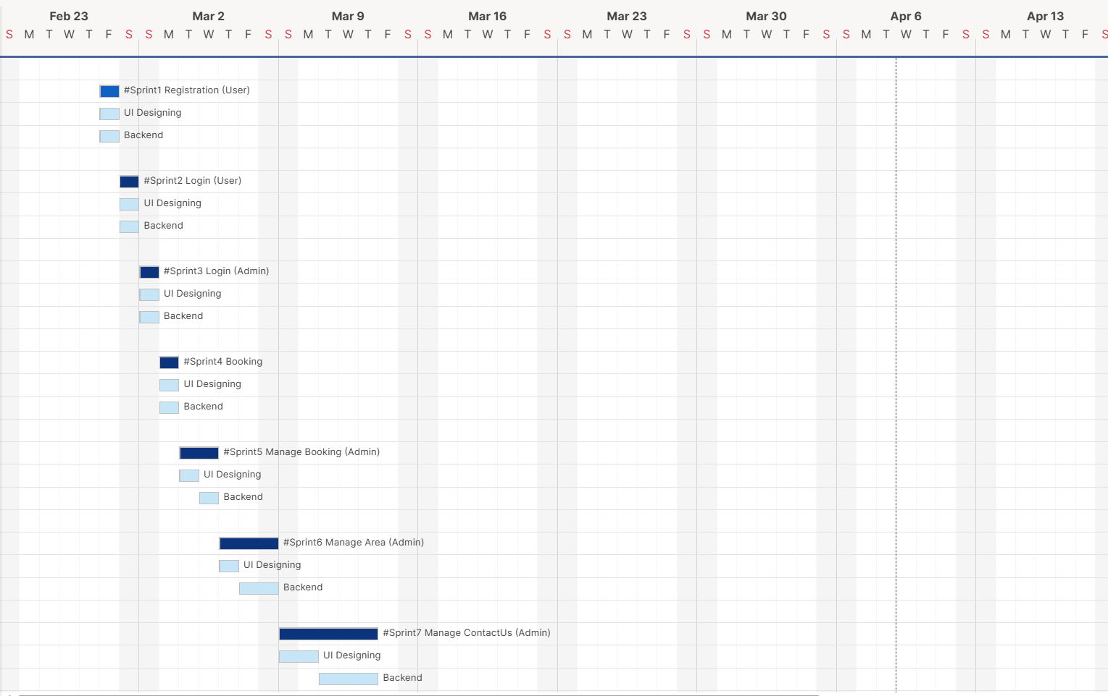

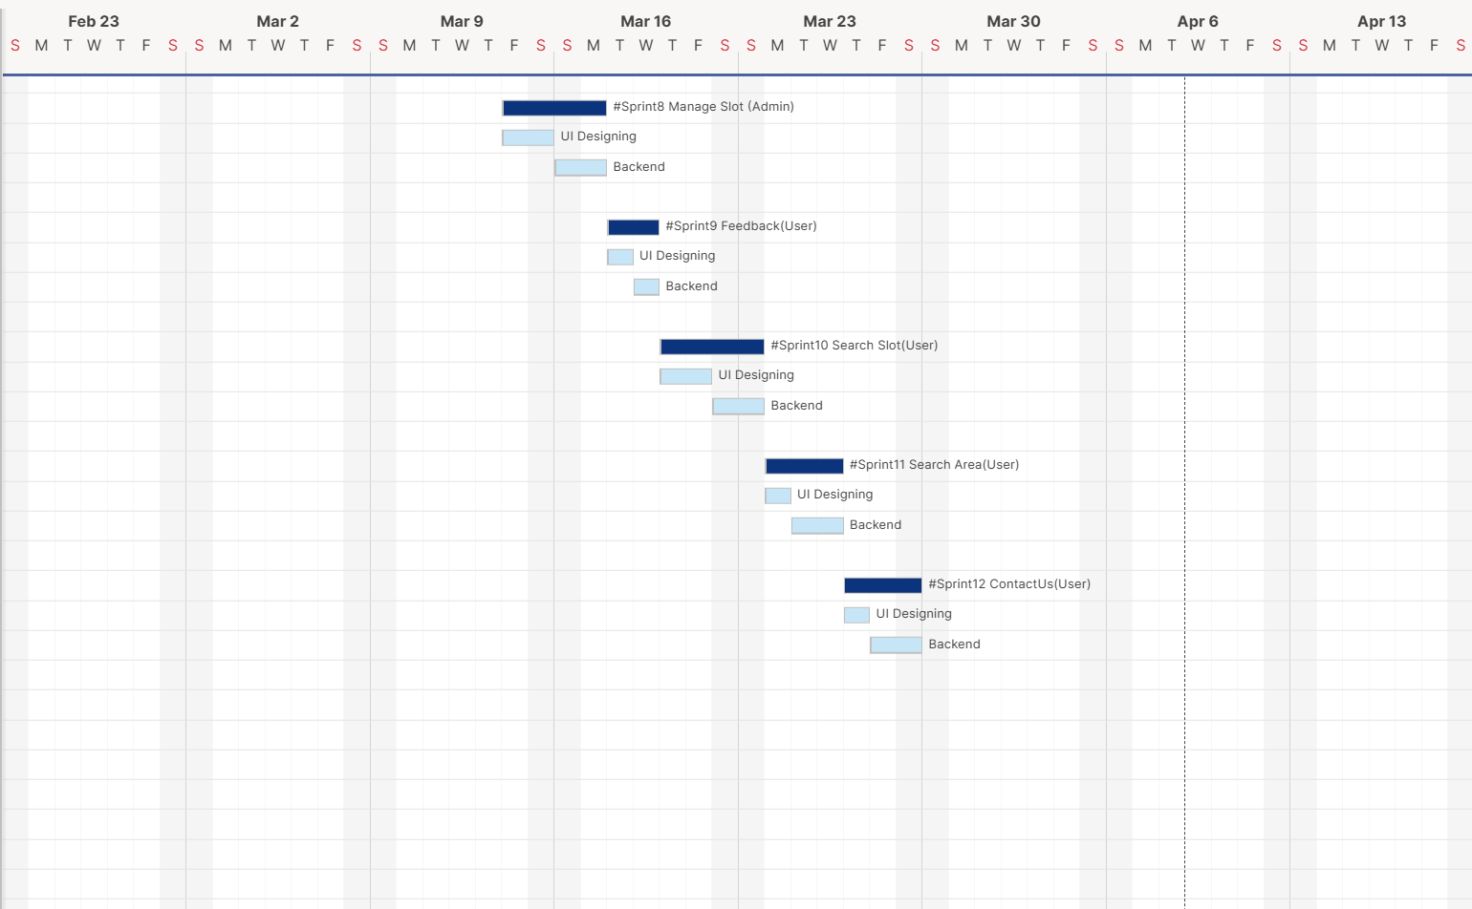

Box Cricket

Agile Project Plan

Task Name | Duration | Start | Finish | Status
#Sprint1 Registration (User) | 1d | 01-06-2025 | 01-06-2025 | Complete
UI | 0.5d | 01-06-2025 | 01-06-2025 | Complete
Backend | 0.5d | 01-06-2025 | 01-06-2025 | Complete
#Sprint2 Login (User) | 1d | 02-06-2025 | 2-06-2025 | Complete
UI | 0.5d | 02-06-2025 | 02-06-2025 | Complete
Backend | 0.5d | 02-06-2025 | 02-06-2025 | Complete
#Sprint3 Login (Admin) | 2d | 03-06-2025 | 04-06-2025 | Complete
UI | 1d | 03-06-2025 | 03-06-2025 | Complete
Backend | 1d | 04-06-2025 | 04-06-2025 | Complete
#Sprint4 Booking | 1d | 05-06-2025 | 05-06-2025 | Complete
UI | 0.5d | 05-06-2025 | 05-06-2025 | Complete
Backend | 0.5d | 05-06-2025 | 05-06-2025 | Complete
#Sprint5 Manage Booking (Admin) | 2d | 06-06-2025 | 07-06-2025 | Complete
UI | 1d | 06-06-2025 | 06-06-2025 | Complete
Backend | 1d | 07-06-2025 | 07-06-2025 | Complete
#Sprint6 Manage Area (Admin) | 3d | 08-06-2025 | 10-06-2025 | Complete
UI | 1d | 08-06-2025 | 08-06-2025 | Complete
Backend | 2d | 09-06-2025 | 10-06-2025 | Complete
#Sprint7 Manage ContactUs (Admin) | 5d | 11-06-2025 | 15-06-2025 | Complete
UI | 2d | 11-06-2025 | 12-06-2025 | Complete
Backend | 3d | 13-06-2025 | 15-06-2025 | Complete
#Sprint8 Manage Slot (Admin) | 4d | 16-06-2025 | 19-06-2025 | Complete

Box Cricket

UI | 2d | 16-06-  2025 | 17-06-2025 | Complete
Backend | 2d | 18-06-2025 | 19-06-2025 | Complete
#Sprint9 Feedback(User) | 2d | 20-06-2025 | 21-06-2025 | Complete
UI | 1d | 20-06-2025 | 20-06-2025 | Complete
Backend | 1d | 21-06-2025 | 21-06-2025 | Complete
#Sprint10 Search Slot(User) | 4d | 22-06-2025 | 25-06-2025 | Complete
UI | 2d | 22-06-2025 | 23-06-2025 | Complete
Backend | 2d | 24-06-2025 | 25-06-2025 | Complete
#Sprint11 Search Area(User) | 3d | 26-06-2025 | 28-06-2025 | Complete
UI | 1d | 26-06-2025 | 26-06-2025 | Complete
Backend | 2d | 27-06-2025 | 28-06-2025 | Complete
#Sprint12 ContactUs(User) | 3d | 29-06-2025 | 1-07-2025 | Complete
UI | 1d | 29-06-2025 | 29-06-2025 | Complete
Backend | 2d | 30-06-2025 | 01-07-2025 | Complete

Box Cricket

Agile User Story

User Story  ID | As (type of user) | I want to perform | So that I can (achieve some  task)
2 | Admin | Login | Access System
3 | Admin | access user data | Manage user
4 | Admin | Access slot data | Manage slot
5 | Admin | Access area data | Manage area
6 | Admin | Access Contact us data | Manage contact us
7 | Admin | Access Feedback data | Manage feedback
8 | Admin | Access Booking data | Manage booking
9 | User | Registration | Login
10 | User | Login | Access Account
11 | User | View my profile | View my profile
12 | User | Edit my profile | Edit my profile
14 | User | Logout | Logout
15 | User | View available slots | View available slots
16 | User | View area list | View area list
14 | User | Book Slot | Book Slot
15 | Guest User | View Home page/About Page | View Pages
16 | Guest User | View Area | View Area
15 | Guest User | View Area wise slot | View Pages
16 | Guest User | View Gallery | View Area

Box Cricket

5.5. Agile Release Plan

Task Name | Duration | Start | Finish | Status
#Sprint1 Registration (User) | 1d | 01-06-2025 | 01-06-2025 | Complete
UI | 0.5d | 01-06-2025 | 01-06-2025 | Complete
Backend | 0.5d | 01-06-2025 | 01-06-2025 | Complete
#Sprint2 Login (User) | 1d | 02-06-2025 | 2-06-2025 | Complete
UI | 0.5d | 02-06-2025 | 02-06-2025 | Complete
Backend | 0.5d | 02-06-2025 | 02-06-2025 | Complete
#Sprint3 Login (Admin) | 2d | 03-06-2025 | 04-06-2025 | Complete
UI | 1d | 03-06-2025 | 03-06-2025 | Complete
Backend | 1d | 04-06-2025 | 04-06-2025 | Complete
#Sprint4 Booking | 1d | 05-06-2025 | 05-06-2025 | Complete
UI | 0.5d | 05-06-2025 | 05-06-2025 | Complete
Backend | 0.5d | 05-06-2025 | 05-06-2025 | Complete
#Sprint5 Manage Booking (Admin) | 2d | 06-06-2025 | 07-06-2025 | Complete
UI | 1d | 06-06-2025 | 06-06-2025 | Complete
Backend | 1d | 07-06-2025 | 07-06-2025 | Complete
#Sprint6 Manage Area (Admin) | 3d | 08-06-2025 | 10-06-2025 | Complete
UI | 1d | 08-06-2025 | 08-06-2025 | Complete
Backend | 2d | 09-06-2025 | 10-06-2025 | Complete
#Sprint7 Manage ContactUs (Admin) | 5d | 11-06-2025 | 15-06-2025 | Complete
UI | 2d | 11-06-2025 | 12-06-2025 | Complete
Backend | 3d | 13-06-2025 | 15-06-2025 | Complete
#Sprint8 Manage Slot (Admin) | 4d | 16-06-2025 | 19-06-2025 | Complete

Box Cricket

UI | 2d | 16-06-  2025 | 17-06-2025 | Complete
Backend | 2d | 18-06-2025 | 19-06-2025 | Complete
#Sprint9 Feedback(User) | 2d | 20-06-2025 | 21-06-2025 | Complete
UI | 1d | 20-06-2025 | 20-06-2025 | Complete
Backend | 1d | 21-06-2025 | 21-06-2025 | Complete
#Sprint10 Search Slot(User) | 4d | 22-06-2025 | 25-06-2025 | Complete
UI | 2d | 22-06-2025 | 23-06-2025 | Complete
Backend | 2d | 24-06-2025 | 25-06-2025 | Complete
#Sprint11 Search Area(User) | 3d | 26-06-2025 | 28-06-2025 | Complete
UI | 1d | 26-06-2025 | 26-06-2025 | Complete
Backend | 2d | 27-06-2025 | 28-06-2025 | Complete
#Sprint12 ContactUs(User) | 3d | 29-06-2025 | 1-07-2025 | Complete
UI | 1d | 29-06-2025 | 29-06-2025 | Complete
Backend | 2d | 30-06-2025 | 01-07-2025 | Complete

Box Cricket

5.6 Agile Sprint Backlog

Task Name | Story | Sprint Ready | Priority | Status | Story Point
Sprint1 Registration (User) | Yes | Yes | High | Complete | 10
UI | Yes | Yes | High | Complete | 7
Backend | Yes | Yes | High | Complete | 6
Sprint2 Login (User) | Yes | Yes | High | Complete | 10
UI | Yes | Yes | High | Complete | 7
Backend | Yes | Yes | High | Complete | 5
Sprint3 Login (Admin) | Yes | Yes | High | Complete | 10
UI | Yes | Yes | High | Complete | 7
Backend | Yes | Yes | High | Complete | 6
Sprint4 Booking | Yes | Yes | High | Complete | 10
UI | Yes | Yes | High | Complete | 7
Backend | Yes | Yes | High | Complete | 6
Sprint5 Manage Booking (Admin) | Yes | Yes | High | Complete | 10
UI | Yes | Yes | High | Complete | 7
Backend | Yes | Yes | High | Complete | 5
Sprint6 Manage Area (Admin) | Yes | Yes | High | Complete | 10
UI | Yes | Yes | High | Complete | 7
Backend | Yes | Yes | High | Complete | 6
Sprint7 Manage ContactUs (Admin) | Yes | Yes | High | Complete | 10
UI | Yes | Yes | High | Complete | 5
Backend | Yes | Yes | Medium | Complete | 5

Box Cricket

#Sprint8 Manage Slot(Admin) | Yes | Yes | High | Complete | 10
UI | Yes | Yes | High | Complete | 7
Backend | Yes | Yes | High | Complete | 6
#Sprint9 Feedback(User) | Yes | Yes | High | Complete | 10
UI | Yes | Yes | High | Complete | 7
Backend | Yes | Yes | High | Complete | 6
#Sprint10 Search Slot(User) | Yes | Yes | High | Complete | 10
UI | Yes | Yes | High | Complete | 5
Backend | Yes | Yes | Medium | Complete | 5
#Sprint11 Search Area(User) | Yes | Yes | High | Complete | 10
UI | Yes | Yes | High | Complete | 6
Backend | Yes | Yes | High | Complete | 7
#Sprint12 ContactUs(User) | Yes | Yes | High | Complete | 10
UI | Yes | Yes | Medium | Complete | 5
Backend | Yes | Yes | High | Complete | 7

Box Cricket

5.7. Agile Test Plan

Project Name |  | Examination System |  |  | Device |  | HP intel core i3  7th gen
Test Case Id |  | 1 |  |  | Test Title |  | Fill Registration Form By User
Module Name |  | Registration Form |  |  | Tested By |  | Hardik Chauhan
Priority |  | High |  |  | Execution Date |  | 01-06-2025
Test | Test Step |  | Action | Expected Result |  | Actual Result |  | Pass
1 | Click on ‘Registration’ |  | Registration of student | User register with their username and password |  | User register with their username and password |  | Yes
2 | Enter Username and Password |  | Valid Identification | Registration Successful |  | Registration Successful |  | Yes

Project Name |  | Examination System |  |  | Device |  | HP intel core i3  7th gen
Test Case Id |  | 2 |  |  | Test Title |  | Fill Login Form By User
Module Name |  | Login Form |  |  | Tested By |  | Yash Khalash
Priority |  | High |  |  | Execution Date |  | 01-07-2025
Test | Test Step |  | Action | Expected Result |  | Actual Result |  | Pass
1 | Click on ‘Login’ |  | Login of student | Login with the help of username and password |  | Login with the help of username and password |  | Yes
2 | Enter correct Username and Password |  | Valid Identification | Login Successful |  | Login Successful |  | Yes

Project Name | Examination System | Device | HP intel core i3

Box Cricket

 |  |  |  |  |  |  | 7th gen
Test Case Id |  | 3 |  |  | Test Title |  | Area Wise Slot
Module Name |  | Area Wise Slot |  |  | Tested By |  | Hardik Chauhan
Priority |  | High |  |  | Execution Date |  | 05-10-2025
Test | Test Step |  | Action | Expected Result |  | Actual Result |  | Pass
1 | Click on ‘Add Slot’ |  | Store Area Wise Slot | Store Area Wise Slot times and date |  | Display Area wise Slot for Selected Area |  | Yes
2 | Enter Slot details |  | Valid Identification | Slot Add  Successful |  | Slot Add Successful |  | Yes

5.8 Earned-value and burn charts

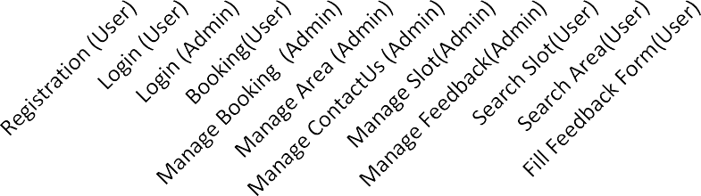
10
9
8
7
6
5
4
3
2
1
0
Actual Day
Planned Day

Box Cricket

Proposed enhancements

  - To improve the Box Cricket system, several enhancements are proposed. These include introducing a mobile application to complement the website, providing real-time notifications for booking updates, integrating advanced analytics for facility performance insights, and offering AI-driven recommendations for optimal slot selection based on user preferences and history. Additional security features, such as two-factor authentication, would enhance data protection, while multilingual support could broaden user accessibility. These enhancements aim to make the platform more robust, secure, and user-friendly, ensuring a superior experience for both players and facility managers.

Conclusion

  - This Box Cricket website offers a user-friendly experience with smooth navigation and clear features. Users can easily explore and interact with the site, making it simple to find what they need. The website delivers reliable performance and ensures a seamless experience, giving users a comfortable and enjoyable way to stay connected with their cricket activities.

Biblography

  - https://www.w3schools.com/REACT/DEFAULT.ASP
  - https://www.spreadsheet.com
  - https://app.diagrams.net/
  - https://app.smartsheet.com/sheets/CC5fqvm8G5Vmc5GGfrvmHHCcqF88rF5H2QjqP W21?view=gantt

