Mongo DB Test

- Find all students from the CS department with marks greater than 80.

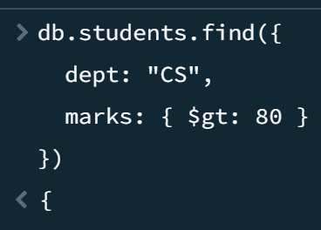

- Find students whose marks are between 60 and 85 (inclusive) using $gte and $lte.

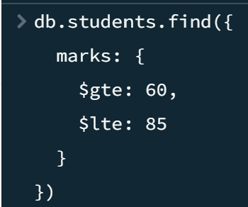

- Find all students who are either from IT or ECE department using $in operator.

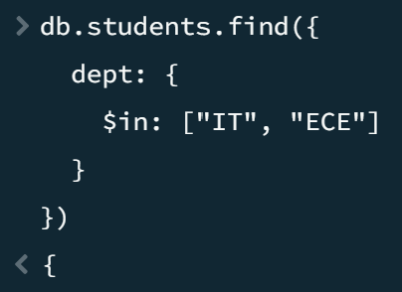

- Find students NOT in the CS department using $nin and project only name and dept.

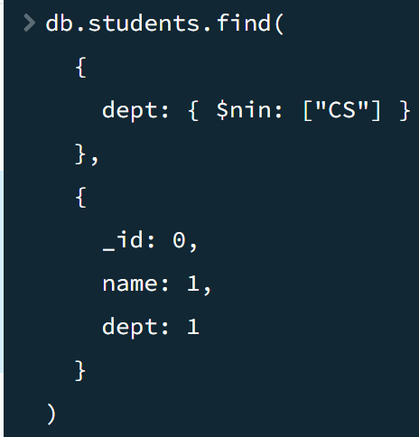

- Find students where the address.city is 'Chennai' using dot notation.

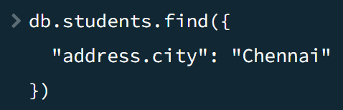

- Find total revenue per category using $group and $sum on a computed field (price × sold).

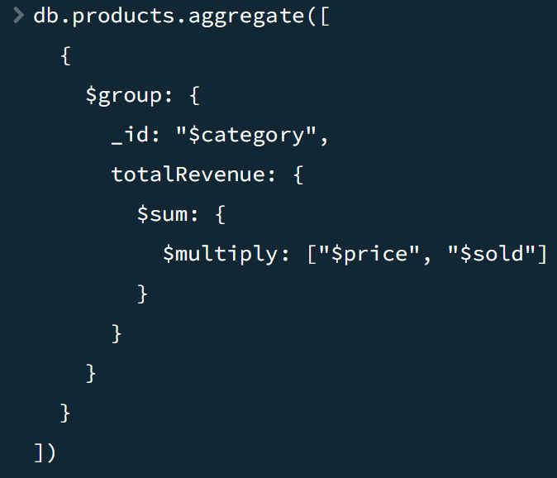

- Use aggregation to find total number of students and average marks per department.

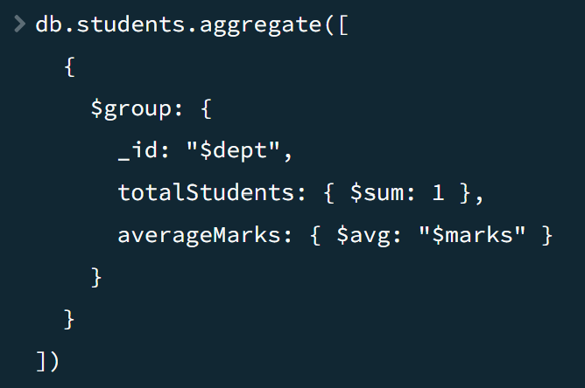

- Remove the 'scholarship' field from all students using $unset.

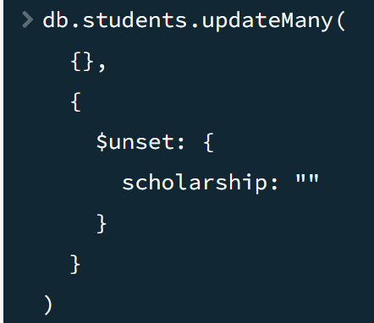

- Add a new field 'scholarship' with value false to all CS students using $set.

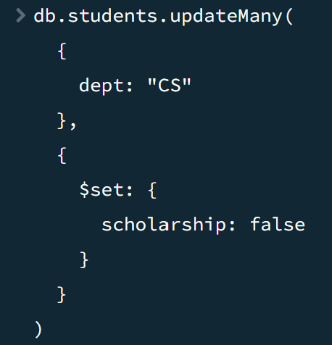

- Increment marks of student with _id:6 by 10 using $inc.

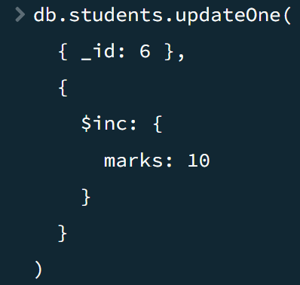

- Find the 3rd and 4th highest scoring students using sort, skip, and limit (pagination).

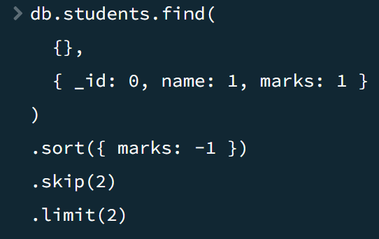

- Find employees whose salary is greater than 50000 and experience greater than 5.

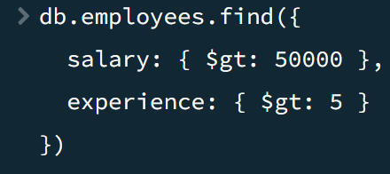

- Find employees whose skills array size is greater than 2.

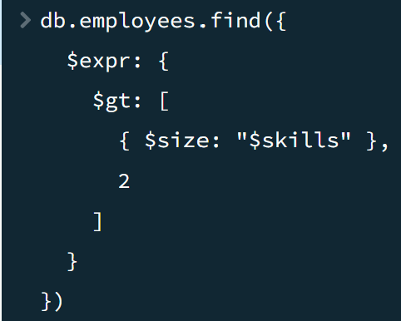
- Find departments whose average salary is greater than 50000.

