1. **INTRODUCATION**

Geo Help an android application. Which will work as an emergency application in all the android supported phone.

**1.1 Purpose**

The purpose of this document is to give a detailed description of the requirements for the “GeoHelp V1” (GPS) software. It will illustrate the purpose and complete declaration for the development of system. It will also explain system constraints, interface and interactions with other external applications. This document is primarily intended to be proposed to a customer for its approval and a reference for developing the first version of the system for the development team.

**1.2 Scope**

The “GeoHelp V1” is a GPS-based mobile application which helps people to find the closest application user based on the user’s current position and fire him the emergency massage that user saved before. The application should be free to download from either a mobile phone application store or similar services.

Users can provide their personal massage information using the function that given in the application. This information will act as it automatically fire to the other user in emergency.

Furthermore, the software needs both Internet and GPS connection to fetch and to fire massage. All system information is maintained in a device internal memory. The software also interacts with the GPS-Navigator software which is required to be an already installed application on the user’s mobile phone. By using the GPS-Navigator, users can view desired user on a map and be navigated to them

* 1. **Objective**

To make the world a safer place using android smart phone technology. Geo help an android application. Which will work as an emergency application in all the android supported phone.

1. **Project Management**

Effective management of a software project depends on thoroughly planning the progress of the project. A well-planned strategy leads to the best and optimal use of the resources available and ensures completion of project on time. Project plan sets out the resources available to the project, the work breakdown and a schedule for carrying out the work. The project needs a lot of research and thus scheduling was a difficult task as there was a need for carrying out a lot of study about various algorithms and techniques and testing them at various stages, thus maintaining the schedule was also difficult.

**2.1 Project Development Approach and Justification**

The life cycle model that has been followed for developing the system is the “Iterative Model”. This model is shown in the figure.

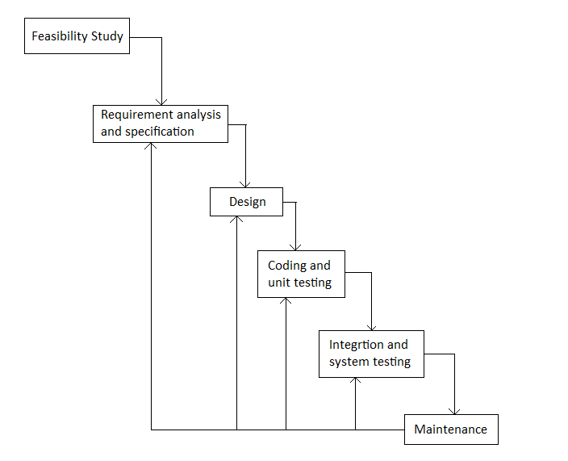

Figure 2.1 Process Model

In this model, Deaf and dumb communicator starts with an initial feasibility study phase. Once it is clear that the system can be implemented with necessary technical and economic support the next phase of requirement gathering and analysis is under taken.

When the system developers are clear with all requirement specifications they go for design. After preparing the design and implementation plan the coding is done and unit testing is performed. All units are integrated together for entire system testing in next phase. At the end the maintenance of the system is to be taken care of.

The main advantage of taking up Scrum Model is of Phase Containment of Errors. That is it provides the system developers the concept of feedback path, so it becomes easy for them to correct the errors committed during a phase, as and when these are detected in a later phase. This model is also advantageous because of its simplicity. The only thing here to be taken into consideration is that later detection of errors in previous phases may make the development costlier.

**JUSTIFICATION**

This model is best suited for this system as the customer mostly has clear idea about the requirements. As well as there are very less possibilities for major changes in requirements. It makes the implementation easier in terms of simplicity. There are no

Risks present in developing the system and step by step development is desirable.

* 1. **Project Effort, Time and Cost Estimation**

**Function Point (FP) Analysis (Theory)**

For a software project, we are interested primarily in estimating the cost and duration of the project. To arrive at these, we need to have a fix on the ‘size’ of the software that is to be developed. Since a major part of the cost of any software project is the effort expended by skilled software developers, accurate estimation of cost and schedule. Figure depicts a simple estimation model relating size, effort, schedule and cost.

* **Size estimate**

The size of the software to be developed is one of the parameters to be estimated. Some size measures of software are lines of code, number of function point, number of objects, number of reports, number of screens etc.

* **Effort estimate**

The estimate for the manpower that is required for the software product. Effort is normally measured in term of person-hours or person-days or person-month or person-years, with conversion factors to convert from one measuring unit to another.

* **Schedule estimate**

Schedule is the duration between the start of the project and the end of the project. Schedule estimate may include high-level intermediate milestones, like end of various phases.

* **Cost estimate**

A major component of costs is the manpower cost in any software project. Apart from that, other costs, such as travel, communication facilities, project specific training, hardware and software for the project team need to be estimated.

Considering the above, a simplistic definition of software project estimate could be “prediction, within a given tolerance, of the size of the software to be developed and the effort, cost and calendar time required to develop the software.”

**COCOMO Model (Theory)**

Boehm postulated that any software development project can be classified into one of the following three categories based on the development complexity:

• Organic

• Semidetached

• Embedded

|  |  |
| --- | --- |
| **Phase** | **Time Duration** |
| Feasibility Study | 1 Week |
| Requirement Gathering and Analysis | 1.5 Week |
| Design | 8 Week |
| Coding | 4Week |
| Testing and Maintenance | 8 Week |
| Documentation | 1 Week |

**2.3 Project Scheduling (Gantt chart/ Tracking Gantt / Network Chart)**

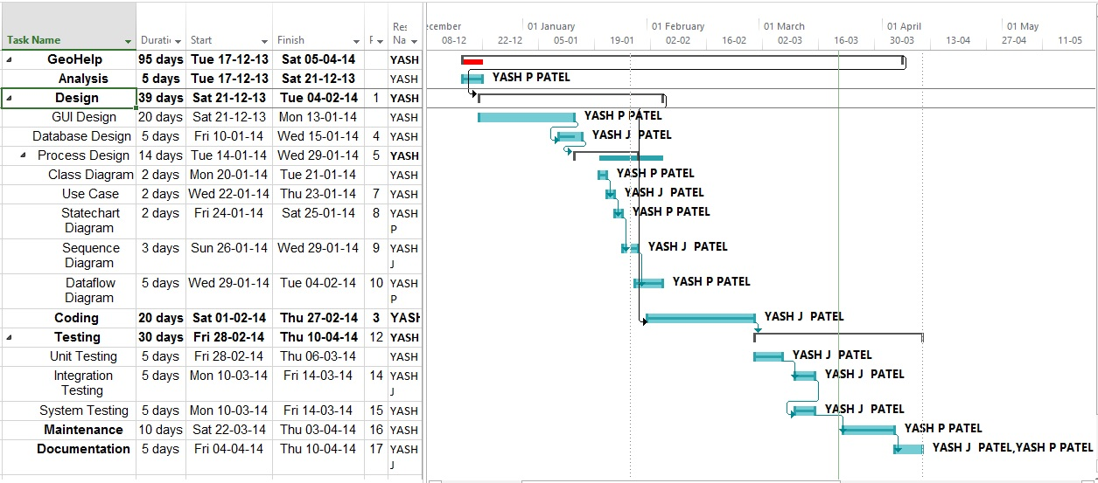

**Gantt chart**

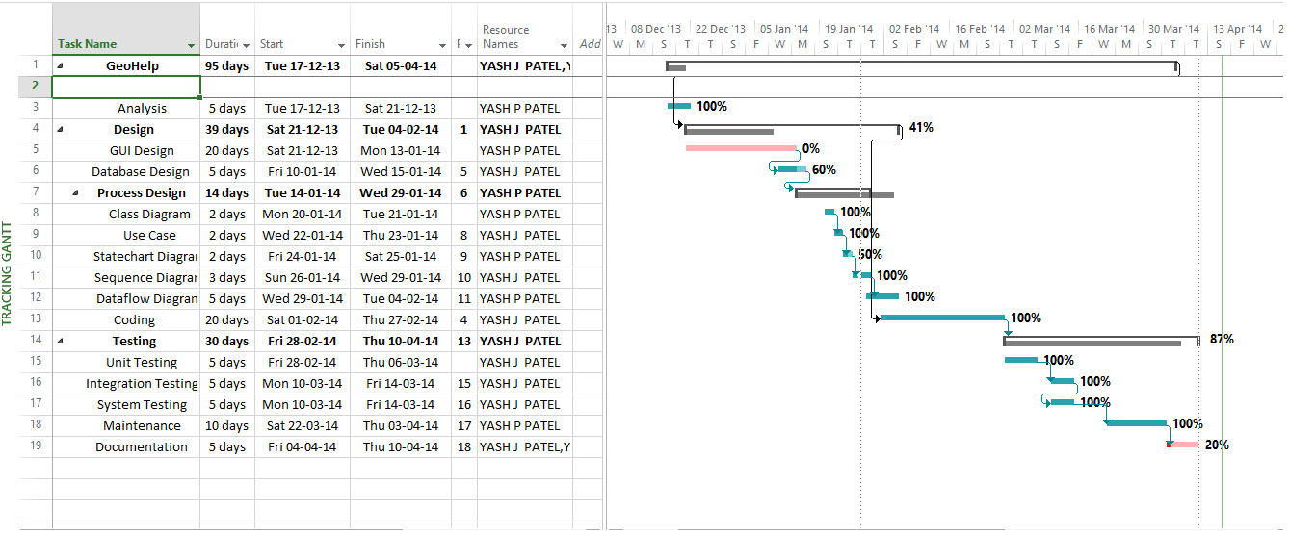

**Tracking Gant Chart**

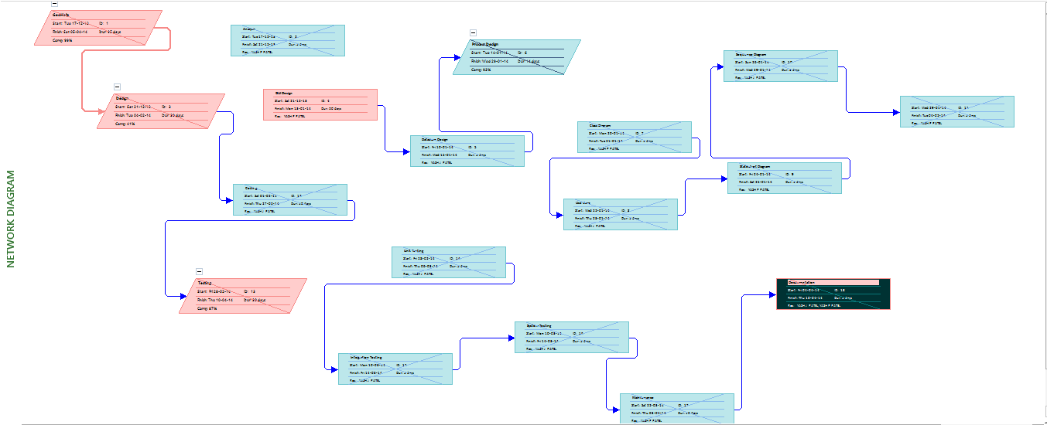

**Network Chart**

1. **System Analysis**

**3.1 Users of System**

They can be any one in the world having an android phone.

User should be fully aware of the functionality of a smart android based phone. He should know how to install and use android applications.

**3.2 Requirements of System**

**3.2.1 Functional Requirement**

When we will install the application after that it will ask two things

1. Emergency message to be send in message body.

2. Four Global mobile numbers (which can be modified later if needed to)

**After this we will have two options**

1. Send message and location using 3 times power button hit if GPS is enabled

2. Send message using 3 times power button hit if GPS is disabled.

**Timer**

We can select the preferred time on which we want to send message automatically. The message will be automatically deported on the saved mobile numbers on that time.

**3.2.2 Nonfunctional Requirement**

* We will have to enable GPS to send location.
* We must have enough balance to send text messages and mobile battery.
* We must should be a valid service provider and we should be in its range

**3.3 Feasibility Study**

**3.3.1 Technical Feasibility**

* We have to map the send message in longitude and latitude which is possible through Google maps
* We have to override the power button which is possible through demon process
* We have to send message which is an in built function in the system
* We have to convert the location in a form of url which is possible through Google api
* Rest of the job is possible in eclipse indigo.

**3.3.2 Economical Feasibility**

As it is a software its cost would be less

* + - The tanning and development in android 5000 per person.
    - Google play store charges $25.

**3.3.3 Operational Feasibility**

* + - We have tested our product on 23 different android phones and its response is good
    - There is quiet a possibility that it may support all android phones worldwide. But we cannot be sure about it
  1. **UML Diagrams**



**Use Case Diagram**





 **Structure Chart Diagram**





**Flow Chart Diagram**

1. **System Design**

**4.1 Data Dictionary**

**Contacts**

|  |  |  |  |  |
| --- | --- | --- | --- | --- |
| Sr.No. | Fields | Data Type | Size | Constraints |
| 1 | mobile no | String | 10 | Not Null |
| 2 | mobile no | String | 10 | Null |
| 3 | mobile no | String | 10 | Null |
| 4 | mobile no | String | 10 | Null |

**Message Box**

|  |  |  |  |  |
| --- | --- | --- | --- | --- |
| Sr.No. | Fields | Data Type | Size | Constraints |
| 1 | message | Varchar | 50 | Not Null |

**4.2 Table Relationship**

* There are two tables and both are separate there is no connection between them
  1. **User Interface Design**
* We have used android as an up design part
* We have kept different button for different purpose

1. **Implementation & Testing**

**5.1 GUI of Form and Reports**

**Splash page (Developer’s page)**

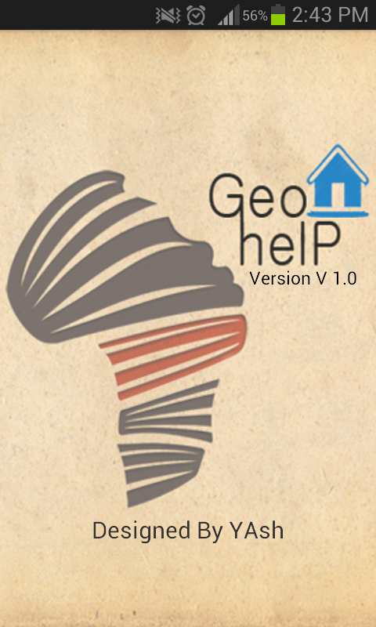

**Main Menu**

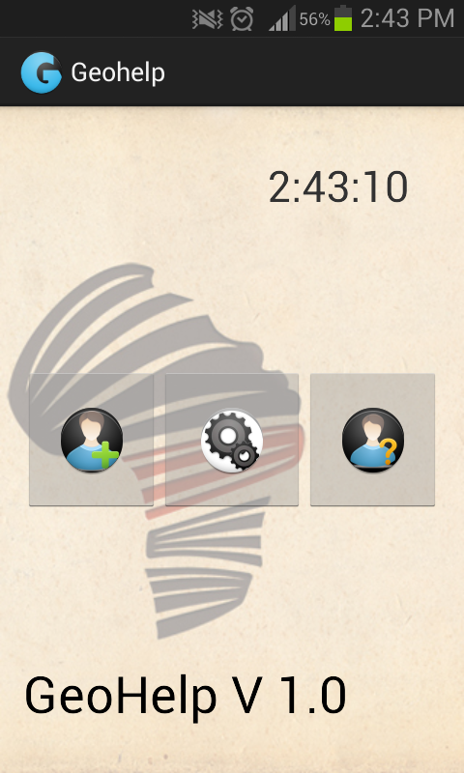

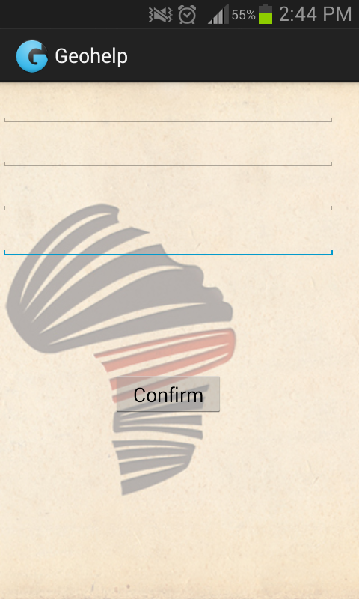**Add Numbers**

**Message body**

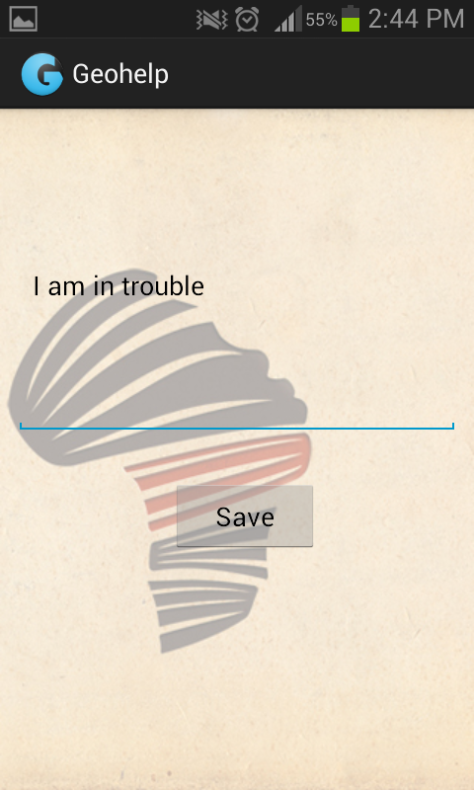

**5.2 Test Cases of System**

**Test Suites No: 1**

Test Suite Detail:

Send message and location

Valid mobile number to stored, GPS on, message written, appropriate balance & network coverage

|  |  |  |  |  |  |
| --- | --- | --- | --- | --- | --- |
| **Test Case ID** | **Function Name** | **Input** | **Expected Output** | **Actual Output** | **Pass/Fail** |
| **1** | Register User’s Number | Mobile No:  9879316527 | Next Connectivity from Register user’s number To Add number | Number Added Successfully. | pass |
| **2** | Add Other Numbers | Number : 9925529737  Number : 9879345251  Number : 9824261763  Number : 9429765524 | Add Other Four Numbers  To The Database.  (Saved Data Successful  To Database) | Other four Numbers were added successfully. | pass |
| **3** | Save message | Mobile no: 9879316527  Message: “I am in danger kindly track my location” | Message Saved on: 9879316527  “I am in danger kindly track my location “ | Message receive on:9879316527  “I am in danger kindly track my location “ | Pass |
| **4** | Send message and location | Mobile no: 9879316527  Message: “I am in danger kindly track my location” | Message receive on:9879316527  “I am in danger kindly track my location  loc:23.0355083+72.5485881 | Message receive on:9825174339  “I am in danger kindly track my location  loc:23.0355083+72.5485881 | pass |
| 3 | Send message and location | Mobile no: 9925529737  Message: “I am in danger kindly track my location” | Message sent | Message sent | pass |

**Test Suites No: 2**

Test Suite Detail:

Send message

Valid mobile number to be stored, message written, appropriate balance & network coverage

|  |  |  |  |  |  |
| --- | --- | --- | --- | --- | --- |
| **Test Case ID** | **Function Name** | **Input** | **Expected Output** | **Actual Output** | **Pass/Fail** |
| 1 | Send message | Mobile no: 9879316527  Message: “I am in danger kindly track my location | Message receive on:9879316527  “I am in danger kindly track my location | Message receive on:9879316527  “I am in danger kindly track my location | Pass |
| 2 | Send message | Mobile no: 9879316527  Message: “I am in danger kindly track my location | Message receive on: 9879316527  “I am in danger kindly track my location | Message receive on: 9879316527  “I am in danger kindly track my location | Pass |
| 3 | Send message | Mobile no:925529737  Message: “I am in danger kindly track my location | Message sent | Message sent | pass |

**Test Suites No: 3**

Test Suite Detail:

Contacts

Valid mobile no to be stored

|  |  |  |  |  |  |
| --- | --- | --- | --- | --- | --- |
| **Test Case ID** | **Function Name** | **Input** | **Expected Output** | **Actual Output** | **Pass/Fail** |
| 1 | contacts | Mobile no:  9925529737  9879345251  9824261763  9429765524 | save Mobile no:  9925529737  9879345251  9824261763  9429765524 | Mobile no:    9925529737  9879345251  9824261763  9429765524 | Pass |

**Test Suites No: 4**

Test Suite Detail:

Message Setting

Valid message to be stored

|  |  |  |  |  |  |
| --- | --- | --- | --- | --- | --- |
| **Test Case ID** | **Function Name** | **Input** | **Expected Output** | **Actual Output** | **Pass/Fail** |
| 1 | Message | “I am in danger kindly try to track my location” | Message saved: “I am in danger kindly try to track my location” | Message saved: “I am in danger kindly try to track my location | Pass |
| 2 | Message | “hi there I need urgent help” | Message saved: hi there I need urgent help” | Message saved: hi there I need urgent help” | Pass |

**6.0 Conclusion, Limitation & Future Enhancement**

**Conclusion:**

* This android application will serve as an security companion in hand. It will be free of cost. It will be usefully to different people in different ways. So more users will download it and use it all over the world.

**Limitation:**

* We should have an android smart phone and the knowledge how to install and use application.
* We should have network coverage of our service provider, appropriate balance and battery to send messages.

**Future Enhancement**

* Platform independent using Jason.
* Freely available to all users.