**SOFTWARE PROJECT MANGEMENT PLAN**

**1. Introduction:**

1.1 Objective:

The objective of this project is to develop GeoHelp V1 which can Track the current/last Updated Location of Users Then find the nearest user’s location and sent him the emergency Short message and his current location. By this Log the user can find out that person who want help from him.

1.2 Major Functions:

In this GeoHelp, major functions available to user are:

1. Track the current Location of user on Geohelp Server
2. Send the emergency message and his current location
3. User can see navigation help from Google maps Service

1.3 Performance Issues:

Here performance issue is that user need to constantly check for User’s last updated location in every 30minutes.when there any user in trouble and if he needed help then he have to click on fire button, the application automatically send the emergency message and his current location in the form of longitude and latitude, so that that user can see navigated map on his android phone.

1.4 Management and Technical Constraints:

Since there are only two team members, so managing the whole project is very difficult on locally on single computer. Also this project needs good database so to ensure updated last updated location of each and every user ‘log when users uses this GeoHelp Android application .

**2. Project Estimates:**

2.1 Historical Data Used:

For developing this GPS based Android application data information of whatsapp and find me application was used. From that application only idea of different function was gather and implemented. Also different methods were executed.

2.2 Estimation Technique Used:

For this project Heuristic Technique i.e. COCOMO was used. Using that project size, project duration, and efforts was calculated.

2.3 Estimation:

Line of code = no. of files * avg. no. of line

=10 * 150

=1700= 1.7(KLOC)

Since project is organic so a1=2.4 and a2=1.05

Efforts= a1 * (KLOC) ^a2

=2.4 * (1.5) ^1.05

=3.67

=4 person month.

**Functional Point Calculation**

|  |  |  |
| --- | --- | --- |
| **Sr.no** | **Factors** | **value** |
| 1 | Data Communication | 4 |
| 2 | Distributed Data Processing | 4 |
| 3 | Performance | 4 |
| 4 | Heavily used Configuration | 2 |
| 5 | Transaction Rate | 3 |
| 6 | End User Efficiency | 3 |
| 7 | Online Update | 4 |
| 8 | Complex logic | 4 |
| 9 | Reusability | 5 |
| 10 | Conversion ease | 5 |
| 11 | Operational ease | 3 |
| 12 | multiple sites | 2 |
| 13 | facilitate change | 4 |
|  | **Total** | **47** |

UFP= (no of ip)*4+ (no of op)*5+ (no of inquiries)*4+ (no of files)*10+ (no of interface)*10

= (5)*4+ (3)*5+ (4)*4+ (10)*10+ (1)*10

=20+15+16+100+10

UFP =161

TCF=0.65+0.01*47

=1.12

FP=UFP*TCF

=161*1.12

=180.32

**FP =180.32**

**3. Scheduling:**

Task Sheet:

|  |  |  |  |  |  |
| --- | --- | --- | --- | --- | --- |
| Task Name | Duration | Start | Finish | Predecessors | Resource Names |
| **GeoHelp** | **95 days** | **Tue 17-12-13** | **Sat 05-04-14** |  | **YASH J PATEL,YASH P PATEL** |
| **Analysis** | **5 days** | **Tue 17-12-13** | **Sat 21-12-13** |  | YASH P PATEL |
| **Design** | **39 days** | **Sat 21-12-13** | **Tue 04-02-14** | 1 | **YASH J PATEL** |
| GUI Design | 20 days | Sat 21-12-13 | Mon 13-01-14 |  | YASH P PATEL |
| Database Design | 5 days | Fri 10-01-14 | Wed 15-01-14 | 4 | YASH J PATEL |
| Process Design | 14 days | Tue 14-01-14 | Wed 29-01-14 | 5 | **YASH P PATEL** |
| Class Diagram | 2 days | Mon 20-01-14 | Tue 21-01-14 |  | YASH P PATEL |
| Use Case | 2 days | Wed 22-01-14 | Thu 23-01-14 | 7 | YASH J PATEL |
| State chart Diagram | 2 days | Fri 24-01-14 | Sat 25-01-14 | 8 | YASH P PATEL |
| Sequence Diagram | 3 days | Sun 26-01-14 | Wed 29-01-14 | 9 | YASH J PATEL |
| Dataflow Diagram | 5 days | Wed 29-01-14 | Tue 04-02-14 | 10 | YASH P PATEL |
| **Coding** | **20 days** | **Sat 01-02-14** | **Thu 27-02-14** | **3** | **YASH J PATEL** |
| **Testing** | **30 days** | **Fri 28-02-14** | **Thu 10-04-14** | 12 | **YASH J PATEL** |
| Unit Testing | 5 days | Fri 28-02-14 | Thu 06-03-14 |  | YASH J PATEL |
| Integration Testing | 5 days | Mon 10-03-14 | Fri 14-03-14 | 14 | YASH J PATEL |
| System Testing | 5 days | Mon 10-03-14 | Fri 14-03-14 | 15 | YASH J PATEL |
| **Maintenance** | 10 days | Sat 22-03-14 | Thu 03-04-14 | 16 | YASH P PATEL |
| **Documentation** | 5 days | Fri 04-04-14 | Thu 10-04-14 | 17 | YASH J PATEL,YASH P PATEL |

Gantt Chart:

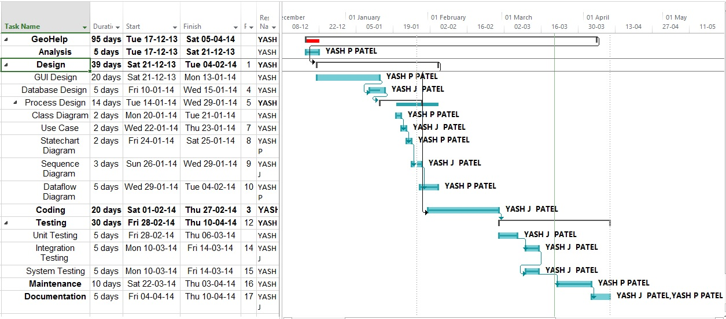

Resource sheet:

|  |  |  |  |  |  |  |  |  |  |  |
| --- | --- | --- | --- | --- | --- | --- | --- | --- | --- | --- |
| Resource Name | Type | Material Label | Initials | Group | Max. Units | Std. Rate | Ovt. Rate | Cost/Use | Accrue At | Base Calendar |
| **YASH J PATEL** | **Work** |  | **Y** |  | **100%** | **$0.00/hr** | **$0.00/hr** | **$0.00** | **Prorated** | **Standard** |
| **YASH P PATEL** | **Work** |  | **Y** |  | **100%** | **$0.00/hr** | **$0.00/hr** | **$0.00** | **Prorated** | **Standard** |

|  |  |
| --- | --- |
| Resource Name | Work |
| **Yash J Patel** | **237hrs** |
| **Analysis** | **0hrs** |
| **Design** | **50hrs** |
| GUI Design | 0hrs |
| Database Design | *25hrs* |
| **Process Design** | **25hrs** |
| Class Diagram | *0hrs* |
| Use Case | *10hrs* |
| State chart Diagram | *0hrs* |
| Sequence Diagram | *15hrs* |
| Dataflow Diagram | *0hrs* |
| **Coding** | ***100hrs*** |
| **Testing** | **75hrs** |
| Unit Testing | 25hrs |
| Integration Testing | *25hrs* |
| System Testing | *25hrs* |
| **Maintenance** | *0hrs* |
| **Documentation** | *12hrs* |
| **Yash P Patel** | **248hrs** |
| **Analysis** | ***25hrs*** |
| **Design** | **160hrs** |
| GUI Design | *100hrs* |
| Database Design | *0hrs* |
| **Process Design** | **60hrs** |
| Class Diagram | *10hrs* |
| Use Case | *0hrs* |
| State chart Diagram | *25hrs* |
| Sequence Diagram | *0hrs* |
| Dataflow Diagram | *25hrs* |
| **Coding** | ***0hrs*** |
| **Testing** | *0hrs* |
| Unit Testing | *0hrs* |
| Integration Testing | *0hrs* |
| System Testing | *0hrs* |
| **Maintenance** | ***50hrs*** |
| **Documentation** | ***13hrs*** |

Resources allocation:

**4. Project Resource:**

4.1 People:

People resources are: a. YASH J PATEL

b. YASH P PATEL

4.2 Hardware and Software:

For implementing this project Android Jelly bean or above version is required and at least 512 MB RAM. Good Internet Speed For better Performance and execution is recommended. Also it will work on all Android platform above Jelly Bean. GPS Navigation Services must be required for this Application.

4.3 Special Resource:

Eclipse and Android Studio and Droid Draw Are required as a special resource for development of project.

**5. Staff Organization:**

5.1 Team Structure:

Our team is made up of two members. So whole project is develop and manage by both the members. Both members were equally present during each phase of development. So analysis, design, implementation, and testing etc. were done by both members. Our team structure is democratic. Both members agree on each other ideas and decision.

5.2 Management Reporting:

Every week we need to submit our report of completion to our faculty. Also appropriate feedback was given by them using which we can make system more efficient.

**6. Miscellaneous Plans:**

6.1 System testing plan:

During project development only several testing were done by both members. Also core modules are under development and are tested several times.

6.2 Validation and Verification:

All module are validated and verified using validation code. In each module both input and output were validated and verified.

6.3 System testing Plan:

System is to be tested after development of the core modules has been developed fully.

6.4 Delivery, Installation and Maintenance Plan:

Since it is Android application so it need to be install. But it can be accessed or used by any authenticated user. User just needs to connect to internet and use this Application.