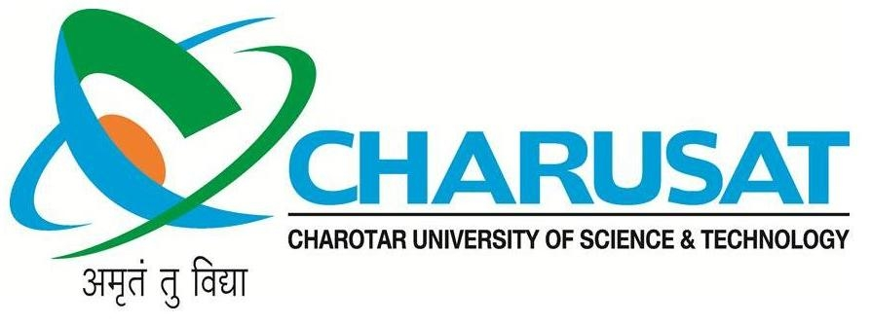

CERTIFICATE

This is to certify that the report entitled “Simple Calculator” is a bonafied work carried out by Yash Patel(11CE091) & Yash Patel(11CE092) under the guidance and supervision of Prof.Paras Kalaria for the subject Software Project-1 (CE309) of 6th Semester of Bachelor of Technology in Computer Engineering at Faculty of Technology & Engineering – CHARUSAT, (C.S.P.I.T.), Gujarat.

To the best of my knowledge and belief, this work embodies the work of candidate himself, has duly been completed, and fulfills the requirement of the ordinance relating to the B.Tech. Degree of the University and is up to the standard in respect of content, presentation and language for being referred to the examiner.

Under the supervision of,

Prof. Paras Kalariya
Assistant Professor
U. & P. U Patel Dept. of Computer Engg.
C.S.P.I.T., Changa, Gujarat.
Dr. (Prof.) Amit Ganatra
Dean,
Faculty of Technology & Engineering,
Head, U. & P. U Patel Department of Computer Engineering
C.S.P.I.T., CHARUSAT- Changa, Gujarat.

Chandubhai S Patel Institute of Technology(C.S.P.I.T.)
Faculty of Technology & Engineering, CHARUSAT
At: Changa, Ta. Petlad, Dist. Anand, PIN: 388 421. Gujarat.

