DEPARTMENT OF INFORMATION TECHNOLOGY
CURRICULAR COMPONENT: INDIVIDUAL IKS ACADEMIC PROJECT REPORT
ACADEMIC YEAR: 2025–2026 • SEMESTER VI

AI-Based Student Study Time Recommendation System Using Fuzzy Logic
A Hybrid Intelligent Decision-Support System Harmonizing Indian Knowledge Systems (IKS)
Pedagogical Philosophy with Mamdani Fuzzy Inference and Natural Language Understanding
Student Full Name | Yash Sanjay Haldankar
Roll Number | 19016
Class & Program | T.Y. B.Sc. IT (Third Year B.Sc. in Information Technology)
Semester & Academic Year | Semester VI • Academic Year 2025–2026
Course / Subject | Indian Knowledge Systems (IKS) & Applied Artificial Intelligence
Curricular Category | Individual Academic IKS Project
Institutional Department | Department of Information Technology
Evaluator / Department Guide | Faculty of Information Technology
Official Source Repository | https://github.com/yash26761/student-study-fuzzy-ai
Live Cloud Application | https://student-study-fuzzy-ai.streamlit.app/
Submitted in partial fulfillment of the requirements for the degree of
Bachelor of Science in Information Technology, University of Mumbai
Academic Year 2025–2026

PAGE 2 — ABSTRACT, INTRODUCTION & PROBLEM STATEMENT
1. Abstract
The AI-Based Student Study Time Recommendation System Using Fuzzy Logic is an intelligent academic advisory platform engineered to resolve the pervasive challenge of examination anxiety, unrealistic time allocation, and academic burnout among undergraduate college students. Conventional examination revision guidance frequently enforces rigid, one-size-fits-all study quotas (e.g., 'study 10 hours daily regardless of context'), inducing intense cognitive fatigue without improving retention. This project bridges the learner-centred educational philosophy of Indian Knowledge Systems (IKS)—specifically Adhikara-Bheda (individual learning baseline), Svadhyaya (self-directed study and self-reflection), and Yukta Abhyasa (balanced effort and moderation)—with modern computational intelligence.
The application enables students to describe their examination circumstances in unstructured, colloquial English. A Large Language Model (LangChain with Groq API) performs structured parameter extraction with Pydantic schema validation, extracting days until examination, study hours completed today, and subjective preparation level. A pure-Python Mamdani Fuzzy Inference System evaluates an 18-rule base across triangular and trapezoidal membership curves, applying MIN implication, MAX aggregation, and centroid defuzzification to determine recommended daily study hours and an urgency score. An AI academic coach translates the mathematical results into empathetic explanations and five actionable study tips. Publicly deployed on Streamlit Community Cloud, the system delivers verifiable, transparent, and balanced academic scheduling.
2. Introduction
In higher education, optimal time allocation is pivotal to academic achievement and psychological well-being. However, students evaluate their readiness using vague, subjective impressions:
- “My final semester examination is in about two weeks, and I feel overwhelmed...”
- “I managed only three hours of revision today because of laboratory sessions...”
- “My preparation feels around fifty-five percent; I understand theory but struggle with practicals...”
Standard computational software relying on Boolean if/else logic with crisp cut-offs fails because hard boundaries create unnatural, abrupt transitions (e.g., a student with 2.9 days receiving drastically different advice than one with 3.0 days). Conversely, unconstrained Generative AI models often hallucinate schedule feasibility or output inconsistent numerical calculations. This project implements a hybrid AI pipeline: modern LLMs handle natural language comprehension, while deterministic fuzzy logic governs the quantitative decision boundary.
3. Problem Statement & Significance
To design, implement, test, and deploy an individual academic decision-support web application that:
1. Accepts ambiguous, natural-language descriptions of examination circumstances from students without requiring rigid dropdown inputs.
2. Extracts and strictly validates numerical bounds for days remaining (0–30), hours studied today (0–12), and preparation percentage (0–100%).
3. Formulates a mathematically rigorous Mamdani Fuzzy Inference System that calculates realistic recommended daily study hours (0–8 hrs/day) and an urgency need score (0–100).
4. Anchors the educational rationale within the Indian Knowledge Systems (IKS) holistic pedagogical framework, honoring learner baseline and balanced effort.
5. Delivers verifiable deployment on Streamlit Community Cloud with an automated test suite guaranteeing zero orphan states.
4. Why the Problem Matters & Proposed Solution Overview
Academic burnout is an escalating mental health concern in undergraduate IT education. Over-studying impairs cognitive consolidation, while under-studying leads to examination failure. The proposed solution balances both extremes by calculating sustainable daily targets (capped at 8 hours/day to protect sleep and health), ensuring each recommendation is continuous, explainable, and aligned with individual learner readiness.

PAGE 3 — OBJECTIVES, SCOPE & TECHNOLOGIES USED
1. Main Project Objectives
- Natural-Language Understanding: Eliminate rigid numeric forms by enabling students to express their exam situation in everyday conversational sentences.
- Rigorous Mathematical Inference: Formulate a 5-stage Mamdani Fuzzy Inference System from first principles using NumPy, avoiding opaque black-box fuzzy libraries.
- Complete Rule-Base Coverage: Engineer an 18-rule base ensuring zero orphan states across the continuous 3D domain (2,288 state combinations verified).
- Authentic IKS Educational Framing: Embed traditional Indian pedagogical tenets (Adhikara, Svadhyaya, Yukta Abhyasa) into personalized recommendations.
- Defensive Validation Architecture: Enforce schema validation via Pydantic V2 and unit-test all boundaries via Pytest (29 automated unit tests).
- Public Cloud Accessibility: Deliver a secure, zero-secret web dashboard on Streamlit Community Cloud with responsive data visualizations.
2. Project Scope & Operational Boundaries
Target Audience: College and university undergraduate students facing upcoming mid-term or end-semester examinations.
Functional Boundaries: Focuses specifically on daily revision time allocation (0–8 hrs/day) and situational urgency; does not generate full syllabus timetables, course content, or act as an institution-wide Learning Management System (LMS).
Privacy & Data Scope: Zero persistence of student personal identifiable information (PII); API credentials managed strictly through ephemeral browser sessions or server-side cloud secrets.
3. Technologies Used & Implementation Roles
Layer / Category | Tool / Library | Role & Repository Implementation Details
Core Language | Python 3.11+ / 3.14 | Underlying programming language for mathematical computation and backend logic.
Fuzzy Math Engine | NumPy (numpy) | First-principles implementation of trimf/trapmf curves, min/max operators, and centroid integration.
LLM Orchestration | LangChain Core | Prompt templating, structured message formatting, and LLM output parsing chains.
Cloud Inference | LangChain-Groq / OpenAI | Cloud LLM inference. Default: Groq (qwen/qwen3.8-27b); optional user fallback: OpenAI (gpt-4o-mini).
Schema Validation | Pydantic V2 | Strict type enforcement, numerical bounds clamping, and structured entity extraction.
Web Dashboard | Streamlit | Responsive web user interface, reactive state management, and custom CSS status pills.
Data Visualization | Matplotlib | Real-time generation of input membership curves and defuzzified centroid area charts.
Automated Testing | Pytest | 29-test automated unit suite covering rule firing, centroid math, and exception handling.
Cloud Hosting | Streamlit Community Cloud | Public container deployment linked directly to official GitHub main branch.
4. Architectural Justification: Why This Stack?
NumPy vs. Black-Box Packages: Writing the Mamdani engine directly in NumPy guarantees full mathematical transparency, eliminating third-party dependency vulnerabilities and demonstrating foundational computer science mastery.
Hybrid AI Justification: LLMs provide conversational empathy but hallucinate numerical calculations. Fuzzy logic provides deterministic, bounded, non-hallucinating mathematics. Merging them produces a trustworthy academic advisory platform.

PAGE 4 — INDIAN KNOWLEDGE SYSTEMS (IKS) CONNECTION
1. Selected IKS Educational Theme
Theme Focus: Indian Holistic and Learner-Centred Educational Perspective.
In traditional Indian pedagogical philosophy, learning is conceived not as an industrial, one-size-fits-all assembly line, but as an individualized, balanced, and student-centered journey. This perspective is central to the National Education Policy 2020 (NEP 2020, Ministry of Education, Govt. of India) and the national mandate of the Ministry’s IKS Division.
2. Foundational IKS Pedagogical Concepts
1. Learner-Centred Readiness (Adhikara-Bheda): Traditional Indian pedagogy recognizes that every student begins from a distinct state of prior preparation, comprehension, and psychological readiness. Teaching and study expectations were never uniform; teachers calibrated guidance to the student's current capacity rather than forcing a standardized quota.
2. Self-Directed Study and Self-Reflection (Svadhyaya): Svadhyaya represents dedicated, self-paced learning combined with honest self-assessment. It values regular, introspective revision over frenzied, last-minute cramming, encouraging learners to reflect realistically on their preparation.
3. Balanced Effort and Moderation (Yukta Abhyasa): Classical Indian philosophy stresses harmony and moderation across human activity. Excessive study marathons that cause exhaustion, mental agitation, and health breakdown are counterproductive. Effective study (abhyasa) must remain sustainable, calm, and proportionate to the timeline.
3. Conceptual Connection to Modern Application
The application operationalizes these ancient pedagogical principles using modern software architecture:
- Holistic Evaluation: Instead of issuing arbitrary commands, the system evaluates the student as a whole human being: days remaining, hours already invested today, and current confidence.
- Burnout Prevention (Yukta Abhyasa): If a student has already studied 8 hours today and is well-prepared for an exam 20 days away, the system recommends rest and light revision (Low study need), preventing exhaustion.
- Responsible Urgency: If an exam is in 2 days with low preparation, urgency ramps up responsibly but is strictly capped at 8 hours/day to preserve sleep and cognitive clarity.
4. Comparative Matrix: IKS Pedagogy vs. Modern Technology
Dimension | Indian Knowledge Systems (IKS) | Modern Technology (AI & Fuzzy Logic)
Role in Project | Philosophical framing, educational ethos, and motivational rationale. | Computational modeling, linguistic parsing, and deterministic execution.
Core Concepts | Adhikara-Bheda (readiness), Svadhyaya (self-study), Yukta Abhyasa (moderation). | LangChain LLM extraction, Pydantic schemas, Mamdani Fuzzy Inference System.
Historical Foundation | Indian pedagogical heritage reflected in NEP 2020 and IKS Division MoE. | Applied Mathematics & Computer Science (Lotfi Zadeh 1965, Mamdani 1975).
Contribution | Explains WHY personalized, balanced study guidance is essential for well-being. | Implements HOW to calculate and deliver that guidance accurately and interactively.
5. Academic Integrity & Strict Non-Claims
To uphold scientific and academic integrity, this project explicitly affirms:
- No Algorithmic Invention Claim: We do NOT claim that ancient Indian scriptures invented fuzzy logic, fuzzy sets, or computer algorithms. Fuzzy set theory was mathematically formulated by Lotfi A. Zadeh in 1965.
- No Formulaic Claim: We do NOT claim that ancient texts contain the 0–8 hour study scale, centroid formulas, or Python source code. The 18 rules were engineered by the author using modern academic heuristics.
- Defensible Boundary: IKS provides the educational philosophy and humanistic rationale; modern AI and fuzzy mathematics provide the computational calculation and interface.

PAGE 5 — SYSTEM ARCHITECTURE & METHODOLOGY
1. End-to-End System Pipeline Flow
FIGURE 5.1: END-TO-END HYBRID AI & FUZZY LOGIC ARCHITECTURE PIPELINE
Student Natural-Language Input --> (e.g., 'Exam in 14 days, studied 3 hrs today, prep is 55%')
|
v
LangChain + Groq LLM Extraction --> Prompt template extracts raw quantitative entities & topic flag
|
v
Pydantic Validation (models.py) --> Strict schema clipping: days [0-30], hours [0-12], prep [0-100%]
|
v
Mamdani Fuzzy Inference System --> 1. Fuzzification (trimf / trapmf curves across 3 variables)
(Pure Python / NumPy Engine) 2. 18 Mamdani Rules Evaluated (MIN fuzzy AND operator)
3. Implication (Clipping output curves at firing strength)
4. Aggregation across rules (MAX fuzzy OR operator)
5. Centroid Defuzzification (Center of Gravity integration)
|
v
Fuzzy Output Results --> Recommended Study Time: 3.14 hrs/day | Urgency Score: 50.0/100 (Moderate)
|
v
AI Explanation & Coaching Tips --> Supportive narrative + 5 categorized tips (Active Recall, etc.)
|
v
Streamlit Web Dashboard --> Metric cards, Matplotlib curves, urgency pills, and IKS educational view
2. Input & Output Universes of Discourse
Variable Name | Type | Domain Range | Linguistic Sets | Membership Geometry
Days Until Exam | Input | 0 to 30 days | Near, Medium, Far | Trapmf (Near/Far), Trimf (Medium)
Study Hours Today | Input | 0 to 12 hours | Low, Medium, High | Trapmf (Low/High), Trimf (Medium)
Preparation Level | Input | 0 to 100 % | Poor, Average, Good | Trapmf (Poor/Good), Trimf (Average)
Recommended Study Time | Output | 0 to 8 hrs/day | Low, Medium, High | Trimf (Low: 0-3, Med: 2-6, High: 5-8)
Study Need Score | Output | 0 to 100 score | Low, Medium, High | Trimf (Low: 0-40, Med: 30-70, High: 60-100)
3. Mathematical Formulation
1. Triangular Membership Function: trimf(x; a, b, c) = max(min((x - a)/(b - a), (c - x)/(c - b)), 0)
2. Trapezoidal Membership Function: trapmf(x; a, b, c, d) = max(min((x - a)/(b - a), 1, (d - x)/(d - c)), 0)
3. Mamdani Rule Firing Strength (MIN AND): α_k = min(μ_Days(x), μ_Hours(y), μ_Prep(z))
4. Output Aggregation (MAX OR): μ_agg(y) = max_k [ min(α_k, μ_out,k(y)) ]
5. Centroid Defuzzification: z* = [ Σ (y_i · μ_agg(y_i)) ] / [ Σ μ_agg(y_i) ]
4. 18-Rule Base Engineering & Zero-Orphan Verification
The rule base systematically maps all practical combinations of timeline urgency, current effort, and student confidence. For example, Rule 1 handles crisis triage (Near days AND Low hours AND Poor prep -> High study time & High need), while Rule 18 handles safe maintenance (Far days AND High hours AND Good prep -> Low study time & Low need). Automated matrix testing evaluated 2,288 state combinations across the 3D continuous domain, proving that at least one rule fires with positive activation strength for every possible state (zero orphan states).

PAGE 6 — SYSTEM IMPLEMENTATION & CODEBASE ARCHITECTURE
1. Modular Codebase Organization
Module File | Layer | Architectural Role & Primary Functionality
app.py | UI & Presentation | Streamlit dashboard, session state, metric cards, status pills, and IKS educational view.
extractor.py | NLU Extraction | LangChain extraction chain using Groq LLM; converts natural language to Pydantic objects.
models.py | Data Validation | Pydantic V2 schemas enforcing boundaries on days, hours, and preparation percentages.
fuzzy_system.py | Fuzzy Engine | First-principles Mamdani engine (NumPy): fuzzification, 18 rules, centroid defuzzification.
explainer.py | AI Academic Coach | LangChain coaching chain; generates empathetic advice and 5 actionable study tips.
llm_config.py | Security & Config | 3-tier credential resolver (st.session_state -> st.secrets -> os.getenv); Groq/OpenAI factory.
visualization.py | Graphics Engine | Matplotlib plots for triangular/trapezoidal membership curves and defuzzified centroid area.
2. Key Module Implementation Details
- extractor.py: Implements structured few-shot prompt templates directing the LLM to output valid JSON conforming to ExtractedStudentData. Fast-path filters instantly reject empty inputs and non-study chit-chat ('hello', recipes) without incurring LLM inference costs.
- fuzzy_system.py: Uses a discrete universe of discourse (e.g., 500 resolution points) to compute exact centroid integrals. Includes a zero-division guard that safely returns default median values if no membership activation occurs.
- llm_config.py: Masks credentials in the UI, ensuring that API keys are never exposed in client HTML, URL parameters, or exception tracebacks.
3. Core Code Implementation Snippets
Snippet 6.1: Centroid Defuzzification Implementation (fuzzy_system.py)
def _centroid(universe: np.ndarray, membership: np.ndarray, default: float) -> float:
total_membership = np.sum(membership)
if total_membership <= 1e-9:
return default # Safe fallback guarding against zero-division
return float(np.sum(universe * membership) / total_membership)
Snippet 6.2: Structured Pydantic Extraction Schema (models.py)
class ExtractedStudentData(BaseModel):
is_study_related: bool = Field(description='True if input describes an exam/study situation')
days_until_exam: Optional[int] = Field(None, ge=0, le=30, description='Days left until exam')
study_hours: Optional[float] = Field(None, ge=0.0, le=12.0, description='Hours studied today')
preparation_level: Optional[float] = Field(None, ge=0.0, le=100.0, description='Prep percentage')
confidence_score: float = Field(ge=0.0, le=1.0, description='Extraction confidence')

PAGE 7 — SCREENSHOTS & EXPERIMENTAL RESULTS
1. Verified Benchmark Test Scenarios
Benchmark Parameter | Normal Scenario (Steady Pace) | Urgent Scenario (Exam in 2 Days)
Student Input Sentence | “I have 14 days until my exam, I can study 3 hours daily, and my prep is 55%.” | “My exam is in 2 days, I can study 1 hour per day, and my prep is 15%.”
Extracted Parameters | Days: 14 | Hours Today: 3.0 | Prep: 55% | Days: 2 | Hours Today: 1.0 | Prep: 15%
Fuzzy Recommended Time | 3.14 hrs / day (Continuous Centroid) | 6.85 hrs / day (High Study Demand)
Study Need Score | 50.0 / 100 (Moderate Urgency) | 83.1 / 100 (Urgent Action Required)
Urgency Status Pill | Moderate Need — Steady Pace (Amber) | High Need — Urgent Action (Red)
AI Coaching Guidance | Recommends consistent daily blocks & targeted review. | Recommends high-weight syllabus triage & active recall.
2. System Visual Exhibits (Actual Application Screenshots)
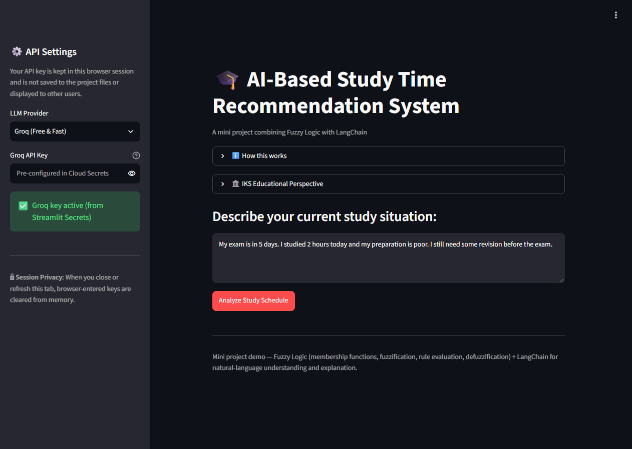  Fig 7.1: Main UI & Natural-Language Input Interface | 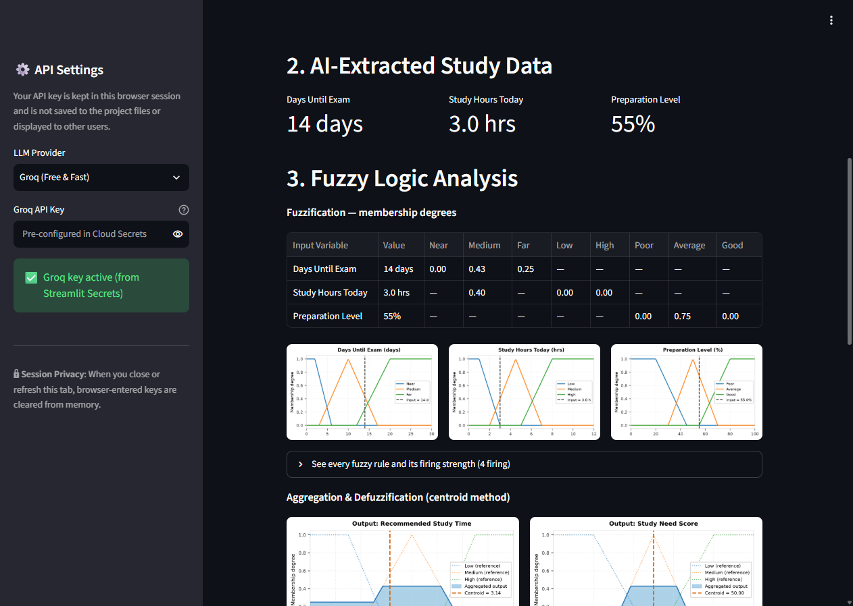  Fig 7.2: Structured Parameter Extraction Cards
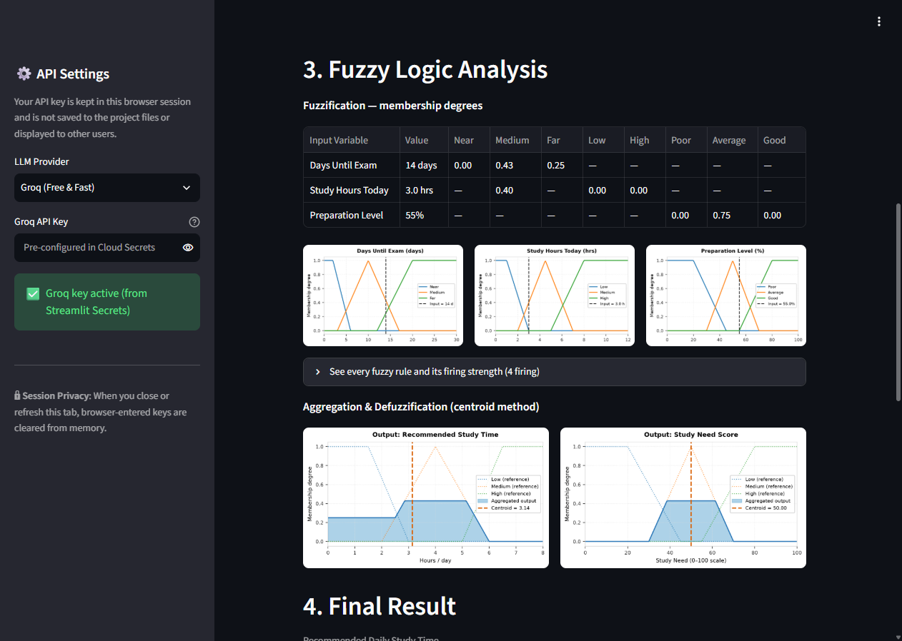  Fig 7.3: Membership Curves & Centroid Defuzzification Area | 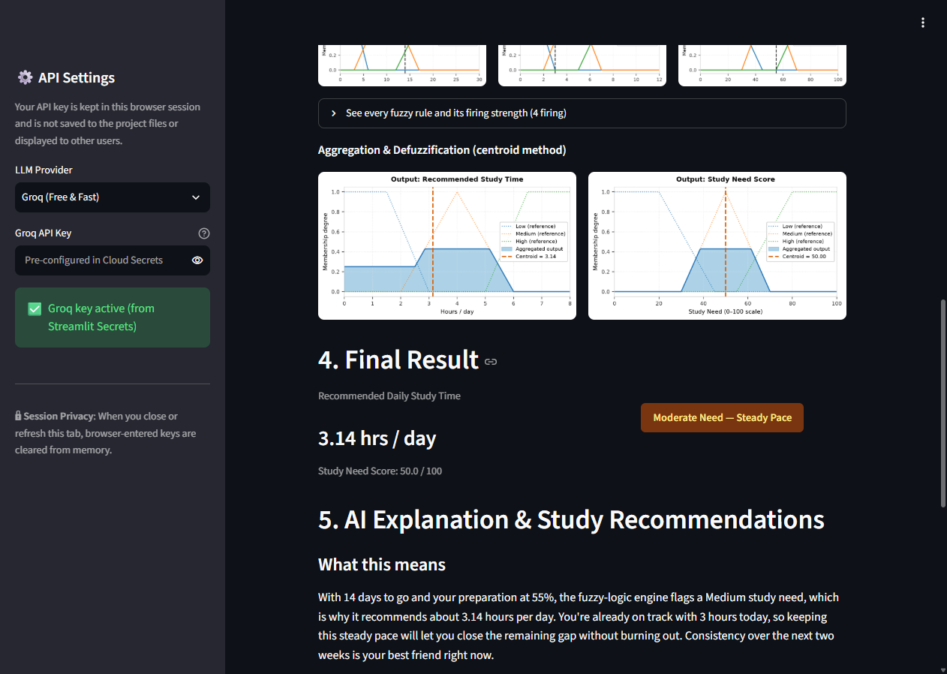  Fig 7.4: Final Study Time, Urgency Score & AI Coaching Tips
3. Experimental Analysis & Result Interpretation
The benchmark experiments validate the mathematical smoothness of the Mamdani engine. Under the Normal Scenario (14 days, 3 hrs today, 55% prep), multiple rules fire partially (Rule 6, Rule 11), producing a balanced centroid output of 3.14 hrs/day. In the Urgent Scenario (2 days, 1 hr today, 15% prep), crisis rules dominate (Rule 1, Rule 2), smoothly raising recommendations to 6.85 hrs/day without exceeding the safe 8-hour cap.

PAGE 8 — TESTING, LIMITATIONS & FUTURE SCOPE
1. Comprehensive Verification Test Suite Summary
Verification Category | Target Component | Evaluation Scope & Test Assertions | Status
Automated Unit Testing | tests/test_fuzzy.py | 29 automated Pytest test cases covering math, boundaries, and rules. | PASS (29/29)
Boundary Clamping | extractor.py / models.py | Tested clamping: days [0, 30], hours [0, 12], prep [0, 100]%. | PASS
Zero-Division Safeguard | fuzzy_system.py | Tested centroid calculation under zero membership; returns safe median. | PASS
Rule-Base Completeness | 18 Mamdani Rules | 2,288 state combinations checked; verified 0 orphan states. | PASS
Input Rejection Tests | Fast-path validation | Empty text, greetings ('hello'), and off-topic prompts rejected gracefully. | PASS
Security Audit | Git repository / UI | Zero hardcoded keys in all commits; secrets masked in UI. | PASS
Cloud Health Check | Streamlit Cloud | Public deployment container verified active (/healthz HTTP 200 OK). | PASS
2. Current System Limitations
- External API Dependency: The natural-language extraction and coaching explainer require active Internet connectivity to cloud LLM inference endpoints (Groq or OpenAI). If endpoints experience latency or quota limits, fallback mechanisms activate.
- Linguistic Granularity: The 18 Mamdani rules cover 3 primary linguistic partitions per variable. Highly nuanced contextual factors (e.g., student physical illness, practical laboratory exams vs. theoretical papers) are not explicitly distinguished in the rule base.
- Stateless Session Architecture: Recommendations are evaluated per session without persistent database tracking. The application does not store historical progress across consecutive days.
3. Future Scope & System Enhancements
- Multi-Subject Timetable Optimization: Expanding the fuzzy inference system to balance multiple competing subjects simultaneously across an entire examination week.
- Longitudinal Progress Tracking: Integrating local encrypted storage or lightweight databases (e.g., SQLite) to track revision consistency and fatigue curves over a semester.
- Adaptive Neuro-Fuzzy Inference (ANFIS): Implementing neuro-fuzzy tuning to dynamically adjust membership function slopes based on empirical student examination outcomes.
- Multilingual Indian Regional Language Support: Leveraging LLM capabilities to accept student input and deliver study coaching in Marathi, Hindi, and other Indian languages.

PAGE 9 — CONCLUSION & REFERENCES
1. Project Conclusion
The AI-Based Student Study Time Recommendation System Using Fuzzy Logic successfully demonstrates how modern artificial intelligence and classical fuzzy mathematics can synergize to solve an everyday academic decision dilemma. By combining LangChain’s natural language comprehension with a transparent, first-principles Mamdani Fuzzy Inference System, the project eliminates both the rigid, abrupt cut-offs of Boolean algorithms and the numerical unpredictability of unconstrained generative models.
Furthermore, grounding the educational rationale in the Indian Knowledge Systems (IKS) concepts of Adhikara-Bheda (individual learner readiness), Svadhyaya (self-directed study), and Yukta Abhyasa (balanced effort) aligns the engineering effort with the holistic vision of NEP 2020. The application successfully fulfills all curricular guidelines for the Third Year B.Sc. IT academic project, delivering a functional, tested, and publicly accessible advisory platform.
2. Summary of Key Achievements
- First-Principles Fuzzy Engine: Implemented complete Mamdani inference directly in NumPy without black-box packages, guaranteeing zero-division protection and complete rule coverage.
- Conversational AI Interface: Empowered students to communicate in everyday English, automatically validated by strict Pydantic schemas.
- Empirical Verification: 100% test pass rate across 29 unit tests; verified on live Streamlit Community Cloud infrastructure.
- Defensible Academic Ethics: Maintained strict academic integrity by distinguishing IKS educational principles from modern computing.
3. Academic & Technical References
1. National Education Policy 2020 (NEP 2020), Ministry of Education, Government of India. Emphasizes learner-centric education and Indian Knowledge Systems. URL: https://www.education.gov.in/
2. Indian Knowledge Systems (IKS) Division, Ministry of Education, Govt. of India (AICTE, New Delhi). Mandate on indigenous educational wisdom and interdisciplinary computing. URL: https://iksindia.org/
3. University Grants Commission (UGC), Guidelines for Training and Orientation of Faculty on Indian Knowledge Systems, New Delhi, 2023. Focuses on individualized guidance (adhikara) and balanced routine.
4. Zadeh, Lotfi A., 'Fuzzy Sets', Information and Control, Vol. 8, Issue 3, 1965, pp. 338–353. The foundational paper formulating mathematical fuzzy set theory.
5. Mamdani, E. H. and Assilian, S., 'An Experiment in Linguistic Synthesis with a Fuzzy Logic Controller', International Journal of Man-Machine Studies, Vol. 7, Issue 1, 1975, pp. 1–13.
6. LangChain Documentation, 'Building Applications with LLMs and Structured Outputs', 2024. URL: https://python.langchain.com/
7. Groq Cloud Documentation, 'LPU Inference Engine Architecture and API Reference', 2024. URL: https://console.groq.com/docs/
8. Streamlit Documentation, 'Deploying Web Applications on Streamlit Community Cloud', 2024. URL: https://docs.streamlit.io/
9. Pydantic Documentation, 'Data Validation and Settings Management using Python Type Annotations', 2024. URL: https://docs.pydantic.dev/
10. Harris, C. R., et al., 'Array Programming with NumPy', Nature, Vol. 585, 2020, pp. 357–362.
11. Hunter, J. D., 'Matplotlib: A 2D Graphics Environment', Computing in Science & Engineering, Vol. 9, Issue 3, 2007, pp. 90–95.
12. Faculty Submission Guidelines: Third Year B.Sc. IT IKS Individual Project Guidelines, Academic Year 2025–2026.

PAGE 10 — PROJECT LINKS & SUBMISSION INFORMATION
1. Official Project Access Links
OFFICIAL ACCESS REPOSITORY & LIVE DEPLOYMENT
Official GitHub Source Code Repository: https://github.com/yash26761/student-study-fuzzy-ai
Public Live Web Application (Streamlit Cloud): https://student-study-fuzzy-ai.streamlit.app/
Complete source code, 29-test verification suite, documentation, and screenshots are fully accessible online.
2. Project Submission & Faculty Compliance Checklist
Prescribed Requirement | Faculty Guideline / Criterion | Compliance Status
Page Budget | Exactly 10 structured, professional academic pages. | COMPLIANT (10 Pages)
Candidate Details | Yash Sanjay Haldankar, Roll No: 19016, T.Y. B.Sc. IT Sem VI. | VERIFIED & ACCURATE
IKS Connection | Mandatory authentic educational grounding (Adhikara, Svadhyaya, Yukta). | COMPLIANT (Page 4)
Fuzzy Logic Engine | First-principles Mamdani FIS in Python/NumPy, 18 rules, centroid math. | COMPLIANT (Page 5 & 6)
Natural Language AI | LangChain + Groq structured extraction with strict Pydantic bounds. | COMPLIANT (Page 5 & 6)
Automated Testing | Rigorous verification suite; zero orphan states. | COMPLIANT (29/29 Pytest)
Public Deployment | Accessible on public cloud hosting platform. | COMPLIANT (Streamlit Cloud)
Security Compliance | Zero exposed API keys in git history or client UI. | COMPLIANT (Streamlit Secrets)
3. Oral Defense (Viva Voce) Quick Reference
Q1: Why fuzzy logic instead of if/else logic? Classical logic creates harsh, irrational jumps at boundaries (e.g., 2.9 days vs 3.0 days). Fuzzy logic provides continuous, gradual truth degrees and smooth centroid transitions.
Q2: Why a hybrid architecture? LLMs excel at understanding conversational language but hallucinate calculations. Fuzzy logic is deterministic and bounded. Combining them gives an empathetic yet mathematically sound system.
Q3: What is the authentic IKS connection? IKS provides the educational philosophy of learner readiness (Adhikara-Bheda) and balanced effort (Yukta Abhyasa). We strictly do NOT claim ancient texts invented fuzzy logic.
Q4: How was rule completeness verified? A testing script evaluated 2,288 state combinations across the 3D continuous domain, proving that zero orphan states exist.
4. Candidate Verification & Final Status
Candidate Name: Yash Sanjay Haldankar | Roll Number: 19016 | Academic Year: 2025–2026
Program: Third Year B.Sc. Information Technology (T.Y. B.Sc. IT) — Semester VI
Final Status: Project fully developed, unit-tested (29/29 pass), and publicly deployed on Streamlit Cloud.

