Objective

The main objective of this assignment is to understand the concepts of MySQL and JDBC Connection. The project is about Order Management System for Restaurants and Cafes. Every time a customer comes in and orders food, the System tracks what he/she ordered and in how much quantity and it automatically generates a total bill. These orders are saved in the database for the use of the manager of the Restaurant. The manager can get interesting and useful information from the orders database which they can use to generate data to increase profits such as getting how many times a dish was sold in the day, or who all entered the café to order something etc.

GUI Screenshot:

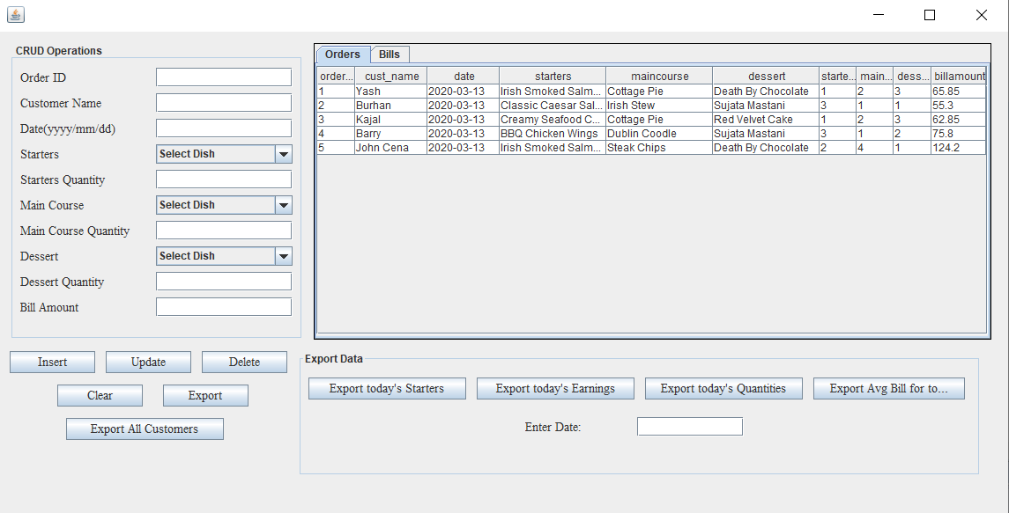

The GUI is divided into three parts:

1. The CRUD Operations

This will take all the fields from the manager and then insert update delete the data.



1. View Panels

This will show the tables Orders and bills on tabs. So all you have to do is click on tabs to view either of the table.



1. Export Data

This will export the data according to the button clicked. All the export buttons are done in the form of stored procedures. So you can export the entire data, export customer names, export starters that customers ate on a date, profits on a date, quantities of starters, mains, desserts on a date, or the average profit.



Extra Features:

The System has used all the basic functionality of MySQL and performed all the CRUDE Operations. But it also uses complex features such as Stored Procedures and Triggers.

Stored Procedures:

Stored Procedures are functions or pre saved SQL queries that are stored in the database and can be used again and again. All you have to do is call the procedure by:

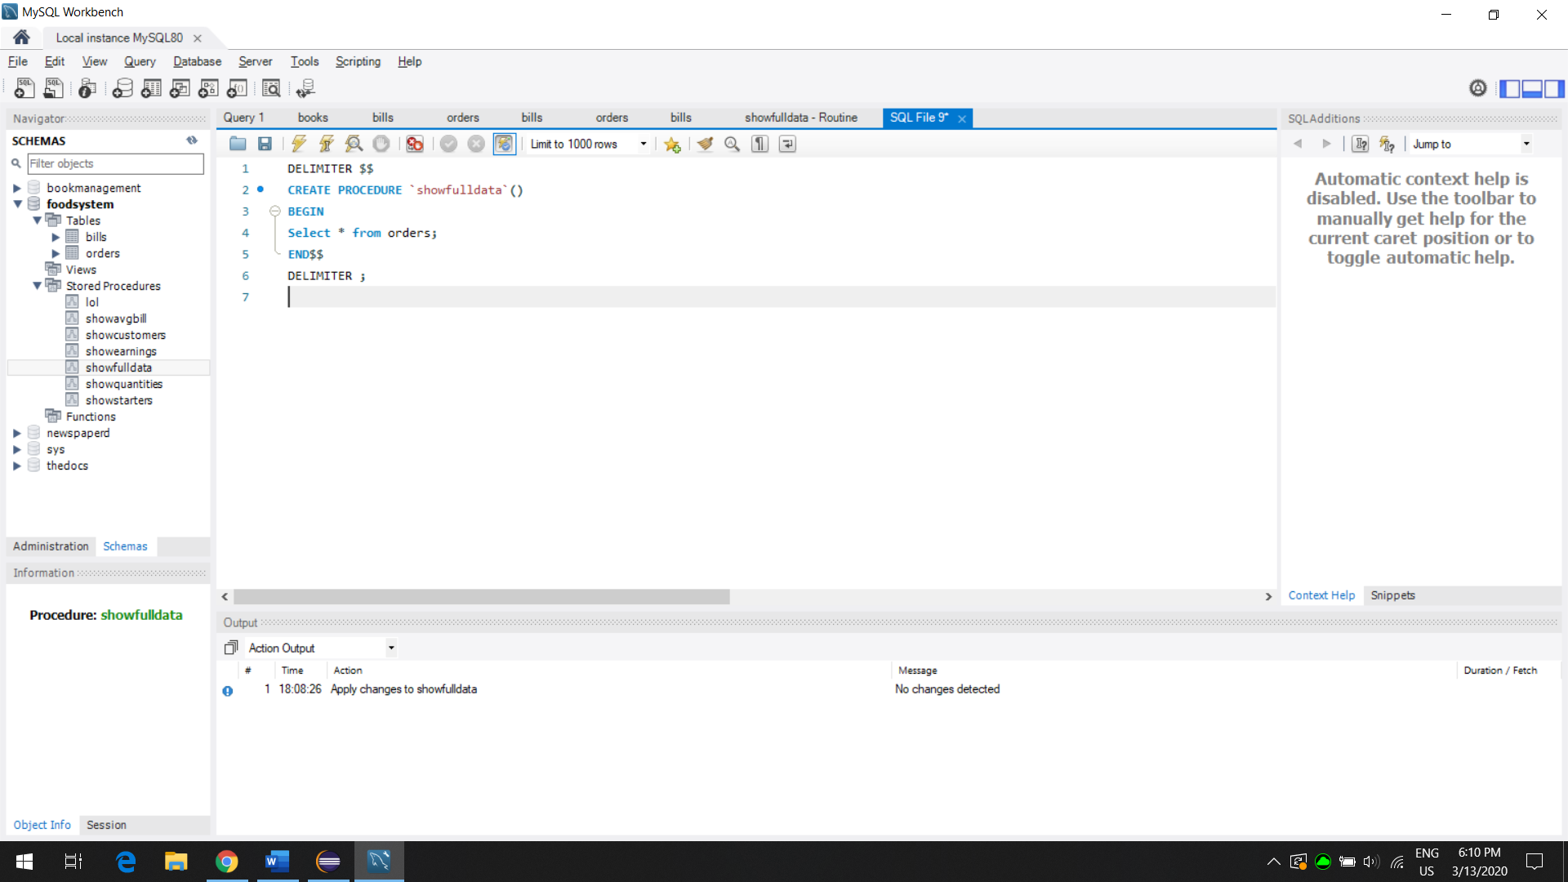Call procedurename();

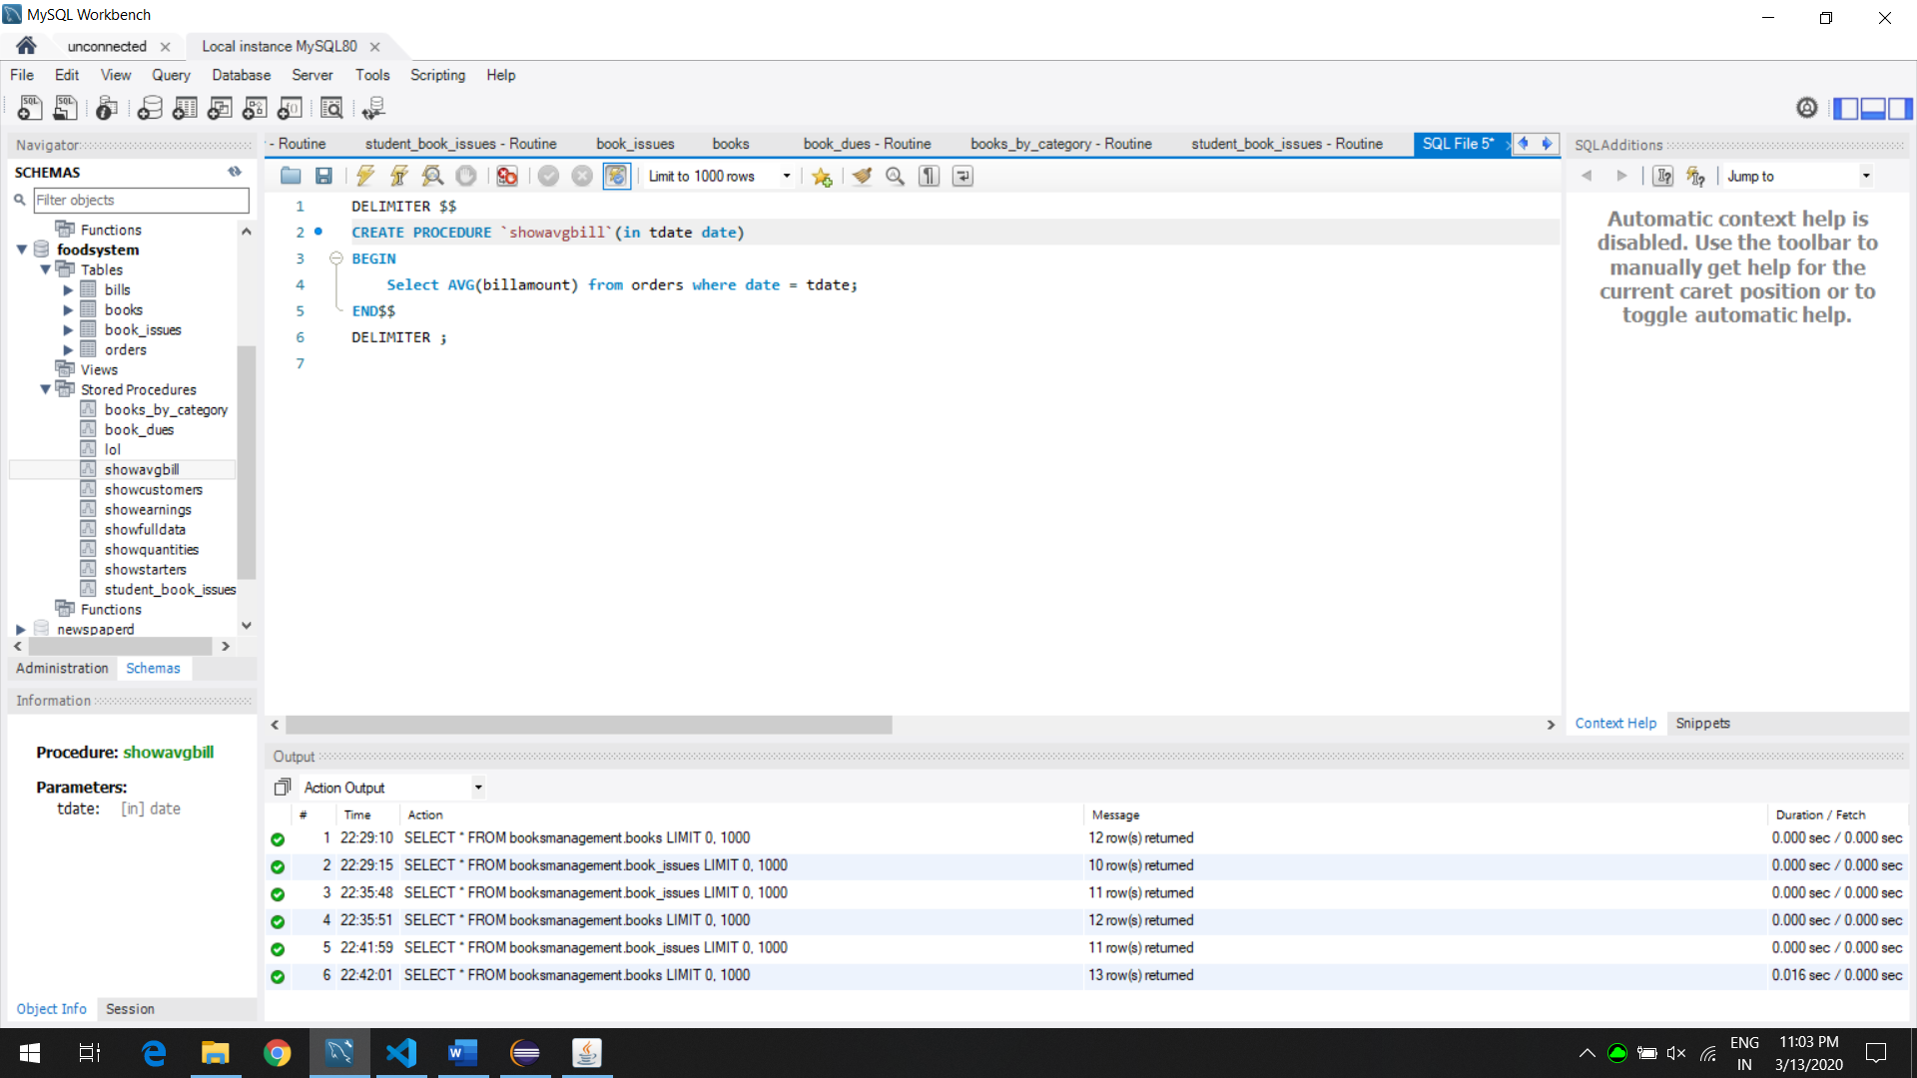

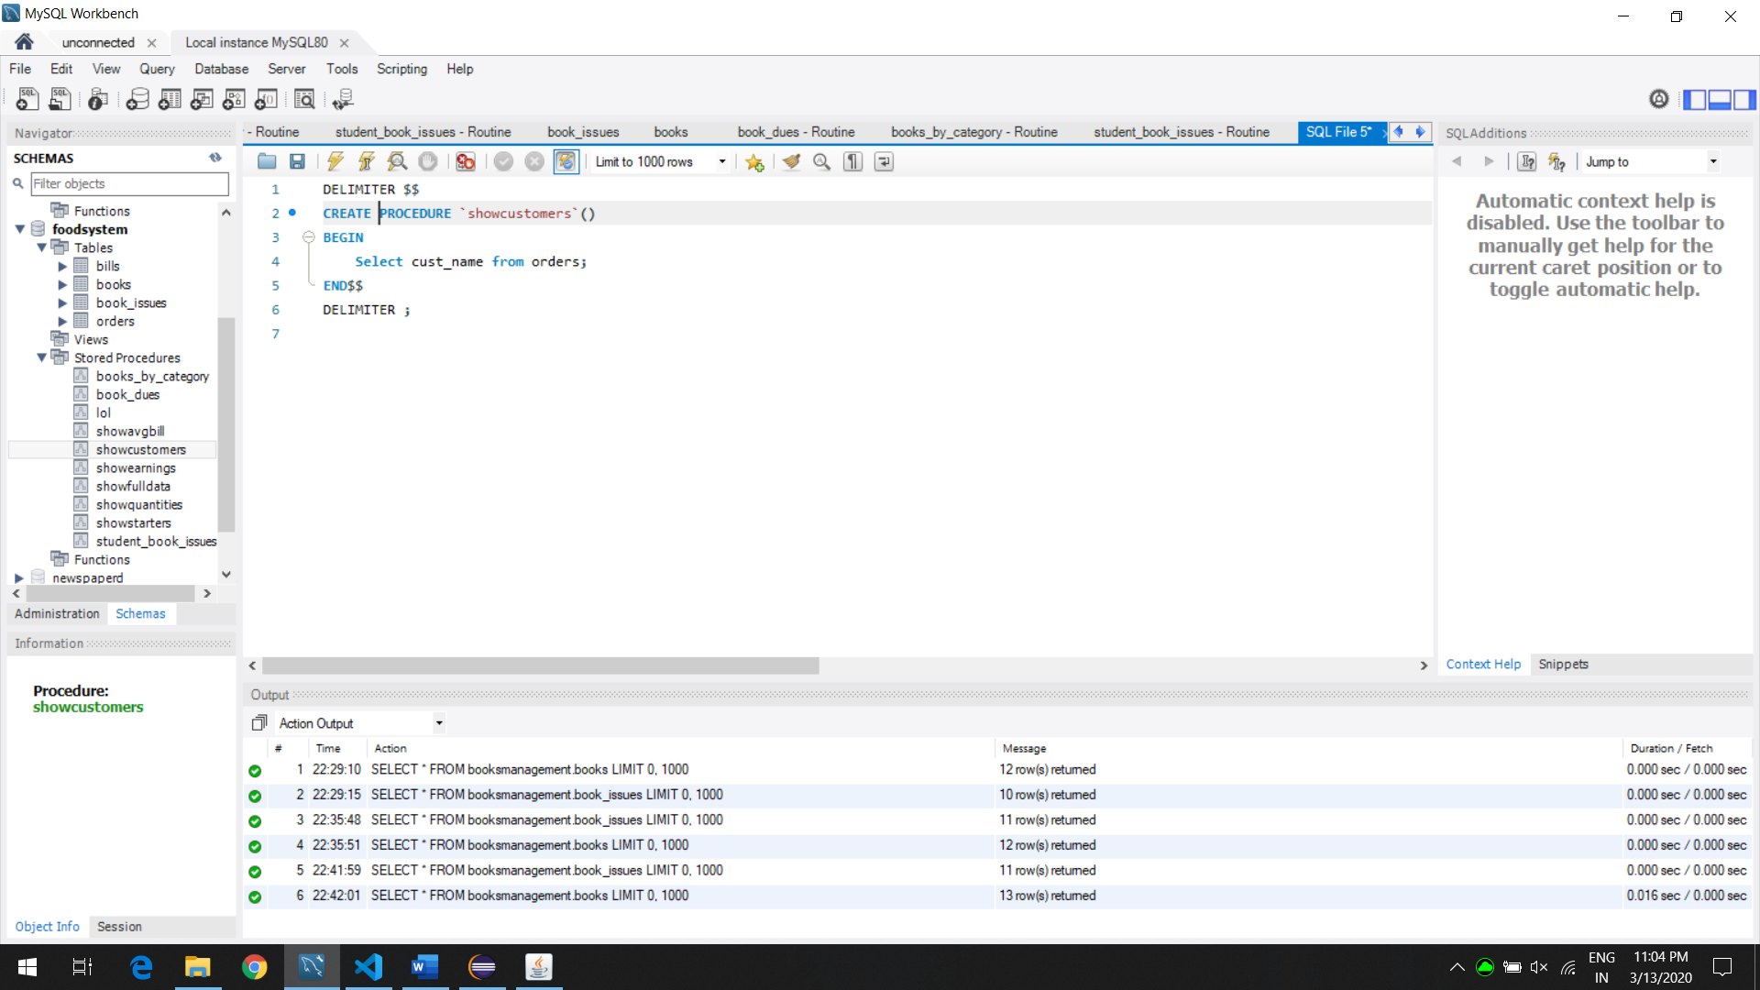

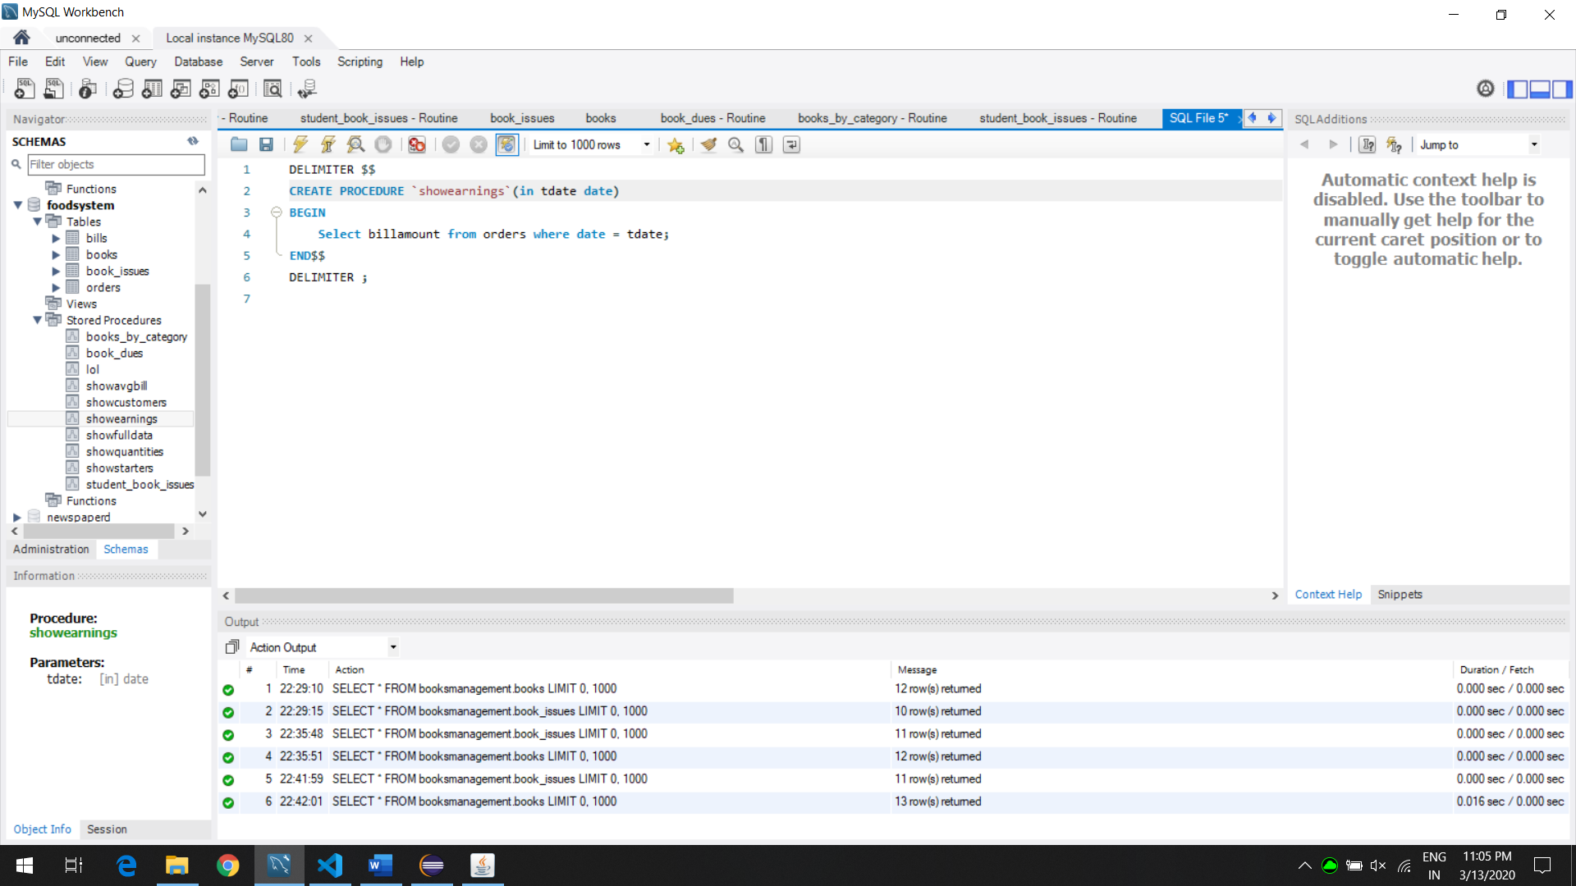

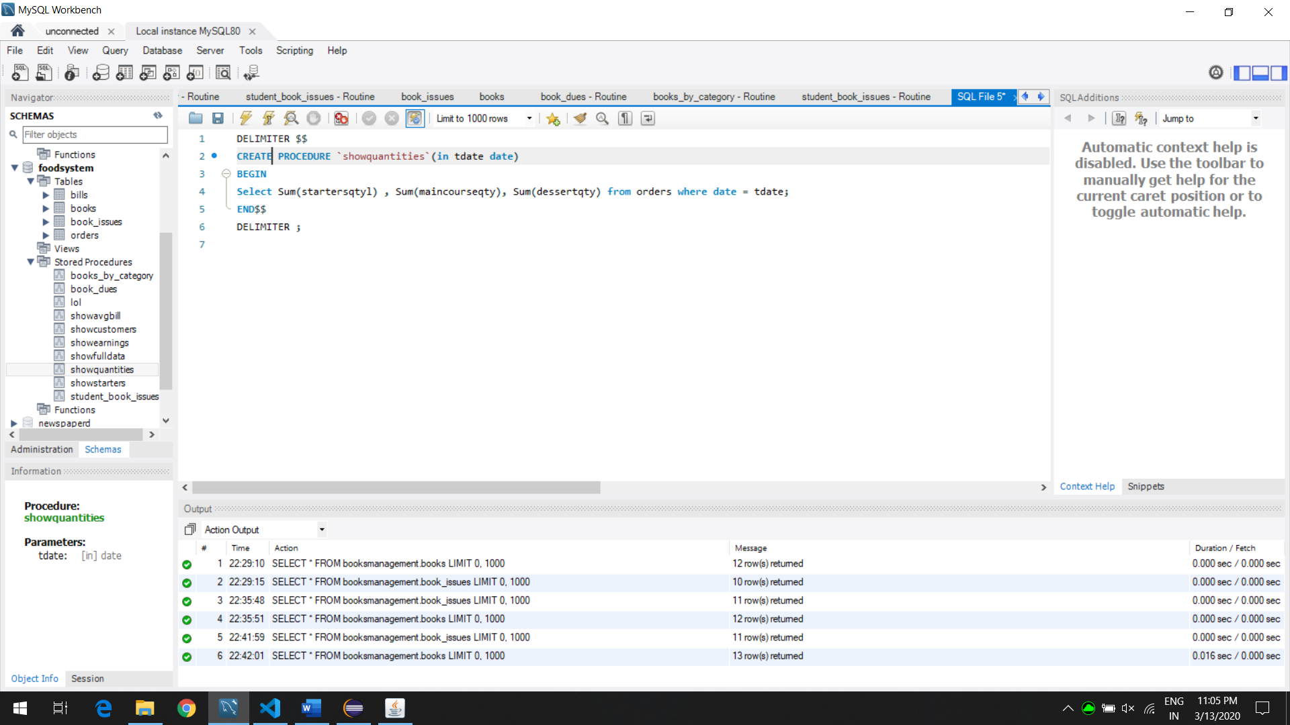

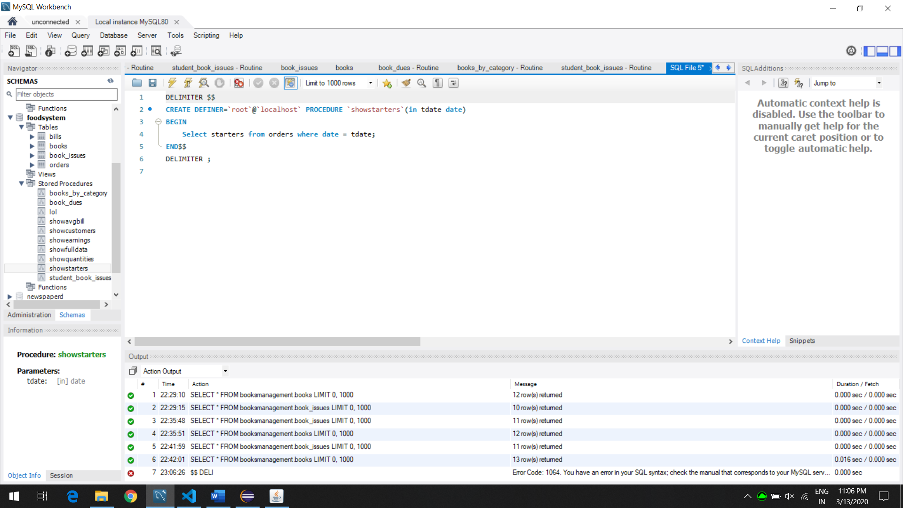

Similarly, A trigger is also been used in this system. In this case, as soon as an order is inserted in the database, there is an event that occurs that takes some data and store it in the Bills table to show which customer spent how much money. A trigger is essentially a stored program that gets executed after an event occurs such as insert, update or delete. A trigger comes in handy to back up data, validate input data.

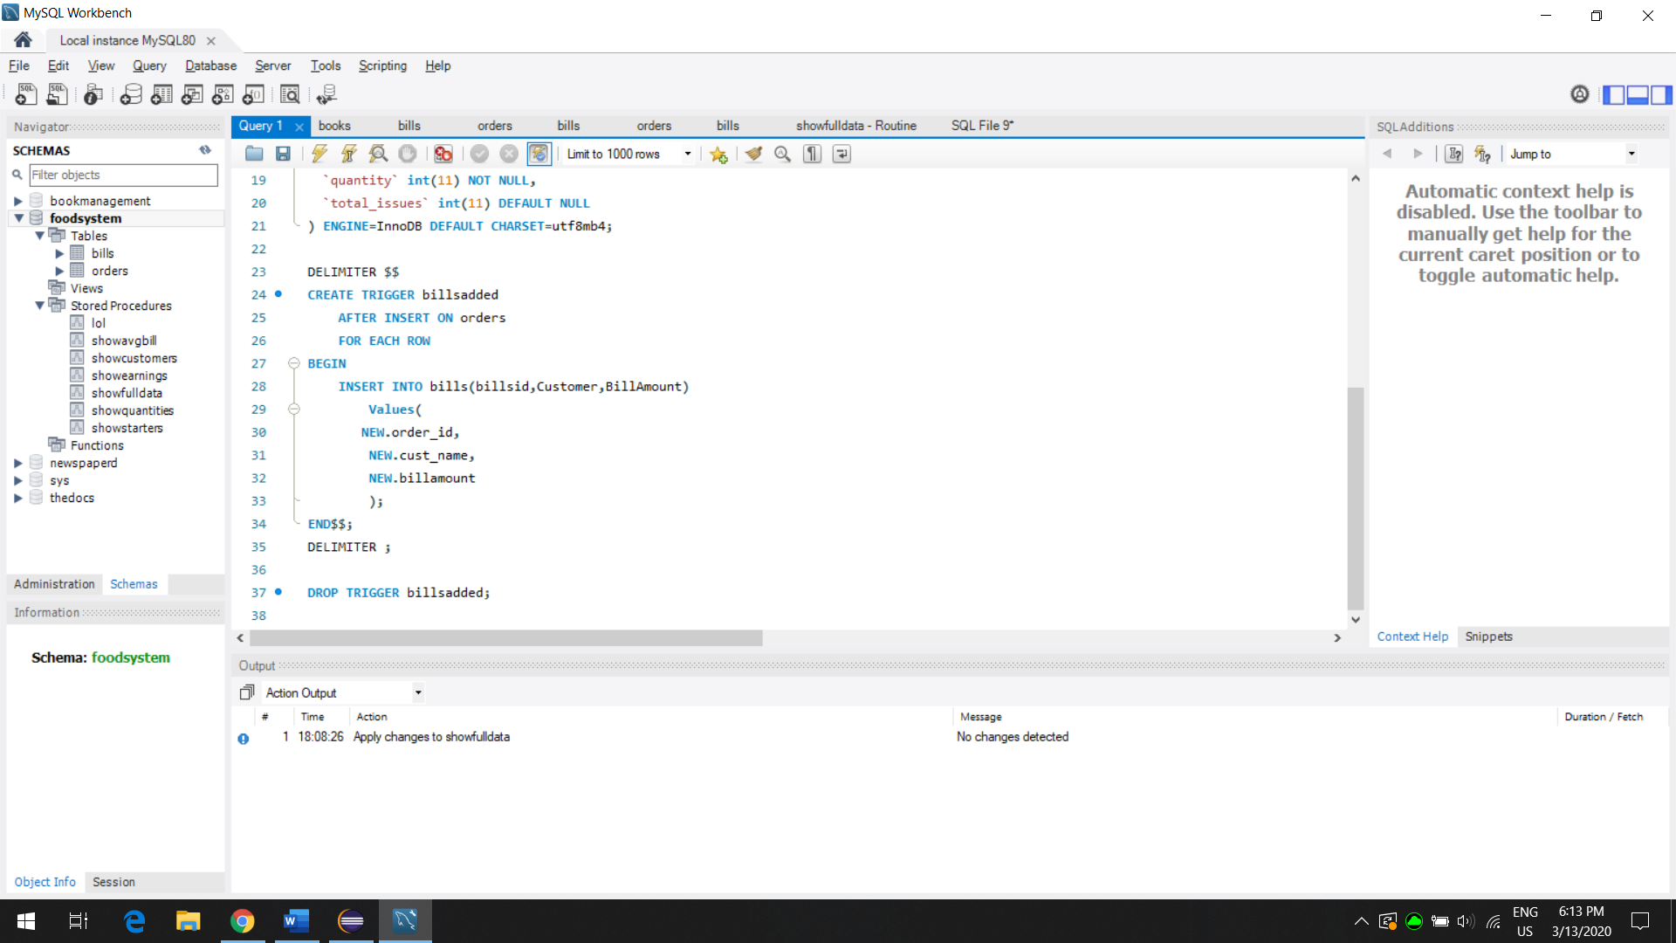

Conclusion:

The Order Management System can be used to track all kinds of orders that took place in a day and comprehend that data to use it and strategize to increase store’s profits. You can get the average spending of a person, who all ordered which starter, main or dessert in how many amounts so that one can focus more on each. This system is fairly simple to use for end users and managers of stores.