CBS - 2

Aim
Implement deep learning methodologies on multimodal dataset.

Theory
Multimodal learning involves processing and integrating information from multiple modalities (e.g., text, images, audio) to perform tasks that require understanding across different data types.
- Multimodal Data: Data that comes from multiple sources or representations:
  - Visual: Images, videos
  - Textual: Captions, descriptions, labels
  - Audio: Speech, sounds
  - Numerical: Metadata, features
- Multimodal Fusion Strategies:
  - Early Fusion: Combine raw features from different modalities at input level
  - Late Fusion: Process each modality separately and combine predictions
  - Hybrid Fusion: Combine at multiple levels of the network
- Architecture Design:
  - Separate branches for each modality (e.g., CNN for images, RNN for text)
  - Feature extraction layers specific to each data type
  - Fusion layer to combine learned representations
  - Shared layers for final prediction
- Applications:
  - Image captioning (vision + language)
  - Visual question answering
  - Video understanding with audio
  - Multimedia recommendation systems
  - Emotion recognition from audio-visual data
Multimodal learning enables richer representations and often achieves better performance than unimodal approaches by leveraging complementary information from different sources.

Code:
import tensorflow as tf
from tensorflow import keras
import numpy as np
# Load MNIST for image data
(x_train_img, y_train), (x_test_img, y_test) = keras.datasets.mnist.load_data()
x_train_img = x_train_img[..., None] / 255.0
x_test_img = x_test_img[..., None] / 255.0
# Create synthetic text modality (one-hot encoded class descriptions)
def create_text_features(labels, noise_level=0.1):
text_features = np.eye(10)[labels]
text_features += np.random.randn(*text_features.shape) * noise_level
return text_features.astype(np.float32)
x_train_text = create_text_features(y_train)
x_test_text = create_text_features(y_test)
# Build multimodal model with two input branches
# Image branch (CNN)
img_input = keras.Input(shape=(28, 28, 1), name='image_input')
img_features = keras.layers.Conv2D(32, 3, activation='relu')(img_input)
img_features = keras.layers.MaxPooling2D(2)(img_features)
img_features = keras.layers.Conv2D(64, 3, activation='relu')(img_features)
img_features = keras.layers.GlobalAveragePooling2D()(img_features)
img_features = keras.layers.Dense(64, activation='relu')(img_features)
# Text branch (Dense)
text_input = keras.Input(shape=(10,), name='text_input')
text_features = keras.layers.Dense(32, activation='relu')(text_input)
text_features = keras.layers.Dense(64, activation='relu')(text_features)
# Fusion layer - concatenate both modalities
merged = keras.layers.concatenate([img_features, text_features])
merged = keras.layers.Dense(128, activation='relu')(merged)
merged = keras.layers.Dropout(0.3)(merged)
output = keras.layers.Dense(10, activation='softmax')(merged)
# Create and compile multimodal model
model = keras.Model(inputs=[img_input, text_input], outputs=output)
model.compile(optimizer='adam', loss='sparse_categorical_crossentropy', metrics=['accuracy'])
print("Multimodal Model Architecture:")
model.summary()
# Train multimodal model
print("\nTraining Multimodal Model:")
model.fit(
[x_train_img, x_train_text], y_train,
epochs=5, batch_size=128, validation_split=0.1, verbose=1)
# Evaluate
loss, acc = model.evaluate([x_test_img, x_test_text], y_test, verbose=0)
print(f"\nMultimodal Test Accuracy: {acc*100:.2f}%")
# Compare with unimodal (image only)
print("\nTraining Image-Only Model for comparison:")
img_only_model = keras.Sequential([
keras.layers.Conv2D(32, 3, activation='relu', input_shape=(28,28,1)),
keras.layers.MaxPooling2D(2),
keras.layers.Conv2D(64, 3, activation='relu'),
keras.layers.GlobalAveragePooling2D(),
keras.layers.Dense(64, activation='relu'),
keras.layers.Dense(10, activation='softmax')])
img_only_model.compile(optimizer='adam', loss='sparse_categorical_crossentropy', metrics=['accuracy'])
img_only_model.fit(x_train_img, y_train, epochs=5, batch_size=128, validation_split=0.1, verbose=0)
_, acc_img = img_only_model.evaluate(x_test_img, y_test, verbose=0)
print(f"\nCOMPARISON:")
print(f"Image-Only Model: {acc_img*100:.2f}%")
print(f"Multimodal Model: {acc*100:.2f}%")
print(f"Improvement: {(acc-acc_img)*100:.2f}%")

Output:
Multimodal Model Architecture:
Model: "functional"
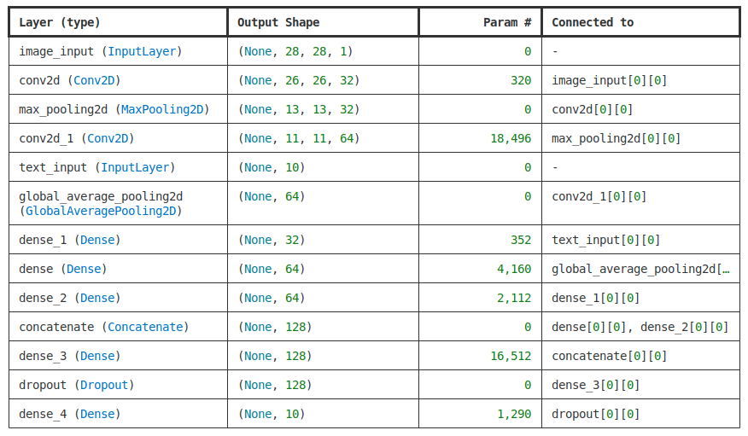
Total params: 43,242 (168.91 KB)
Trainable params: 43,242 (168.91 KB)
Non-trainable params: 0 (0.00 B)
Training Multimodal Model:
Epoch 1/5
422/422 ━━━━━━━━━━━━━━━━━━━━ 3s 5ms/step - accuracy: 0.9710 - loss: 0.2329 - val_accuracy: 1.0000 - val_loss: 5.1156e-04
Epoch 2/5
422/422 ━━━━━━━━━━━━━━━━━━━━ 2s 5ms/step - accuracy: 1.0000 - loss: 9.6791e-04 - val_accuracy: 1.0000 - val_loss: 8.1525e-05
Epoch 3/5
422/422 ━━━━━━━━━━━━━━━━━━━━ 2s 5ms/step - accuracy: 1.0000 - loss: 3.4862e-04 - val_accuracy: 1.0000 - val_loss: 3.2963e-05
Epoch 4/5
422/422 ━━━━━━━━━━━━━━━━━━━━ 2s 5ms/step - accuracy: 1.0000 - loss: 1.6860e-04 - val_accuracy: 1.0000 - val_loss: 1.3007e-05
Epoch 5/5
422/422 ━━━━━━━━━━━━━━━━━━━━ 2s 5ms/step - accuracy: 1.0000 - loss: 1.2648e-04 - val_accuracy: 1.0000 - val_loss: 8.8949e-06
Multimodal Test Accuracy: 100.00%
COMPARISON:
Image-Only Model: 90.37%
Multimodal Model: 100.00%
Improvement: 9.63%

