# **Project : pizza sales analysis using powerBI and SQL**

## A. KPI’s :

1. Total Revenue:

select SUM(total_price) as total_revenue from pizza_sales;

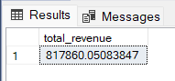

2. Average revenue per order:

select SUM(total_price)/ COUNT(distinct order_id) as avg_order_value from pizza_sales;

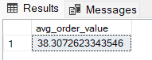

3. Total pizza sold:

select SUM(quantity) as total_pizza_sold from pizza_sales;

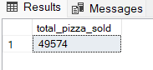

4. Total order:

select count(distinct order_id) as total_order from pizza_sales;

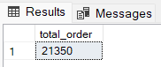

5. Average pizza per order:

select cast(cast(SUM(quantity) as decimal(10,2))/cast(count(distinct order_id) as decimal(10,2)) as decimal(10,2)) as avg__pizza_per_order from pizza_sales;

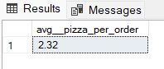

## B. Chart req.:

1. Daily trend for total orders:

select DATENAME(DW, order_date) as order_day, count(distinct order_id) as total_orders from pizza_sales

GROUP BY DATENAME(DW,order_date);

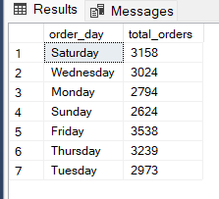

2. Monthly trend for total order:

select DATENAME(MONTH, order_date) as month_name, count(distinct order_id) as total_orders from pizza_sales

GROUP BY DATENAME(MONTH,order_date);

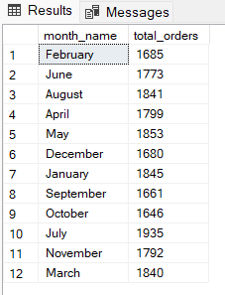

3. Total sale and its percentage by pizza category:

select pizza_category, cast(sum(total_price) as decimal(10,2)) as total_price , cast(SUM(total_price) *100/ (select SUM(total_price) from pizza_sales ) as decimal(10,2)) as pct from pizza_sales

group by pizza_category

order by pct desc;

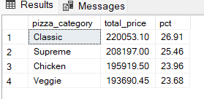

4. Percentage of total sale by pizza size:

select pizza_size, cast(SUM(total_price) *100/ (select SUM(total_price) from pizza_sales ) as decimal(10,2)) as pct from pizza_sales

group by pizza_size

order by pct desc;

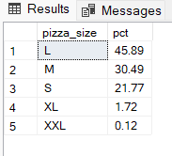

5. Top 5 and bottom 5 best seller and worst seller pizzas by revenue:

select top 5 pizza_name, sum(total_price) as total_revenue from pizza_sales

group by pizza_name

order by total_revenue desc;

select top 5 pizza_name, sum(total_price) as total_revenue from pizza_sales

group by pizza_name

order by total_revenue asc;

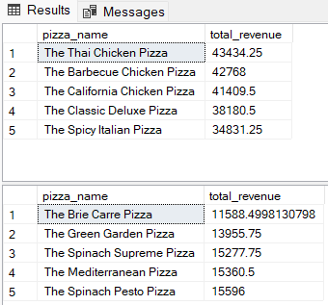

6. Top 5 and bottom 5 best seller and worst seller pizzas by quantity:

select top 5 pizza_name, sum(quantity) as total_quantity from pizza_sales

group by pizza_name

order by total_quantity desc;

select top 5 pizza_name, sum(quantity) as total_quantity from pizza_sales

group by pizza_name

order by total_quantity asc;

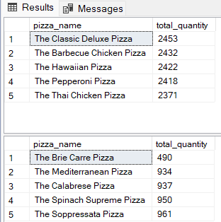

7. Top 5 and bottom 5 best seller and worst seller pizzas by order:

select top 5 pizza_name, count(distinct order_id) as total_order from pizza_sales

group by pizza_name

order by total_order desc;

select top 5 pizza_name, count(distinct order_id) as total_order from pizza_sales

group by pizza_name

order by total_order asc;

