/*NAME-YASH GANDHI SE IT 14*/

/*Problem Statement:

Create a sorted doubly [Linked List](https://moodle.spit.ac.in/mod/resource/view.php?id=7095). Program will have 3 Functions

1- Create()

   user will enter the No's in any order, sorted list will get created as an output.This function expected to have all three cases of insertion into sorted List

2-Reverse()

   This function will simply output the list in reverse order of creation

3- Merge()

    This function will merge 2 created list in sorted manner only. If there are duplicated in 2 lists, it has to be removed at the time of merging

*/

#include<stdio.h>

#include<stdlib.h>

typedef struct NODE //node structure

{

int data;

struct NODE* next;

struct NODE* prev;

}node;

node* add(node* head) //function to insert

{

int data;

node* newnode=(node*)malloc(sizeof(node));

newnode->next=NULL;

newnode->prev=NULL;

printf("\nPlease enter the data\n");

scanf("%d",&newnode->data);

data=newnode->data;

if(head==NULL) //conditions for head and sorting

{

head=newnode;

}

else

{

node *curr=head;

while(curr->next!=NULL)

{

if(data<=(curr->data))

{

break;

}

curr=curr->next;

}

if(data==curr->data)

{

printf("\nData already present enter new data\n");

return head;

}

if(curr==head&&data<head->data)//insert at beginning

{

newnode->next=head;

head->prev=newnode;

head=newnode;

}

else if(data<(curr->data))

{

newnode->prev=curr->prev;

newnode->next=curr;

curr->prev->next=newnode;

curr->prev=newnode;

}

else //insert at end

{

curr->next=newnode;

newnode->prev=curr;

}

}

return head;

}

node* display(node* head) //function to display list

{

printf("\noutput is\n");

node *curr;

curr=head;

while(curr->next!=NULL)

{

printf("%d\n",curr->data);

curr=curr->next;

}

printf("%d\n",curr->data);

return head;

}

node* reverse(node* head,node* head1) //function to reverse and display

{

node *curr=head;

while(curr->next!=NULL)

{

curr=curr->next;

}

node *newnode;

newnode=(node*)malloc(sizeof(node));

head1=newnode;

newnode->data=curr->data;

newnode->prev=NULL;

newnode->next=NULL;

while(curr->prev!=NULL)//loop for storing reverse list

{

newnode=(node*)malloc(sizeof(node));

curr=curr->prev;

newnode->data=curr->data;

node *curr1=head1;

while(curr1->next!=NULL)

{

curr1=curr1->next;

}

newnode->next=NULL;

newnode->prev=curr1;

curr1->next=newnode;

}

node* temp=head1;

printf("\n The reverse list is\n");

while(temp->next!=NULL)

{

printf("%d\n",temp->data);

temp=temp->next;

}

printf("%d\n",temp->data);

return head1;

}

node* create(node* head,int p) //create function usd in merging

{

int data;

node* newnode=(node*)malloc(sizeof(node));

newnode->next=NULL;

newnode->prev=NULL;

data=p;

newnode->data=p;

if(head==NULL)

{

head=newnode;

}

else

{

node *curr=head;

while(curr->next!=NULL)

{

if(data<=(curr->data))//sort condition

{

break;

}

curr=curr->next;

}

if(data==curr->data)

{

return head;

}

if(curr==head&&data<head->data)//at beginning

{

newnode->next=head;

head->prev=newnode;

head=newnode;

}

else if(data<(curr->data))//at middle

{

newnode->prev=curr->prev;

newnode->next=curr;

curr->prev->next=newnode;

curr->prev=newnode;

}

else//at end

{

curr->next=newnode;

newnode->prev=curr;

}

}

return head;

}

node* merge(node* head,node* bead) //merge function

{

node* temp=head;

node* temp1=bead;

while(temp1->next!=NULL)

{

temp=create(temp,temp1->data);

temp1=temp1->next;

}

temp=create(temp,temp1->data);

return temp;

}

void main()

{

int x;

while(x!=1) //option statement

{

node* head=NULL; //initializing pointer

node* head1=NULL;

int d=0;

while(d!=1)

{

head=add(head); //function calls

printf("\nEnter 1 to quite else 0\n");

scanf("%d",&d);

}

printf("\nOutput of list 1\n");

head=display(head);

head1=reverse(head,head1);

node* bead=NULL;

node* bead1=NULL;

int m=0;

while(m!=1)

{

bead=add(bead);

printf("\nEnter 1 to quite else 0\n");

scanf("%d",&m);

}

printf("\nOutput of list 2\n");

bead=display(bead);

bead1=reverse(bead,bead1);

node* mead=NULL;

mead=merge(head,bead);

printf("\n after merging\n");

mead=display(mead);

node* mead1=NULL;

printf("\n After reversing merged list \n");

mead1=reverse(mead,mead1);

printf("\n Enter 0 to do again else 1\n");

scanf("%d",&x);

}

}

/*output

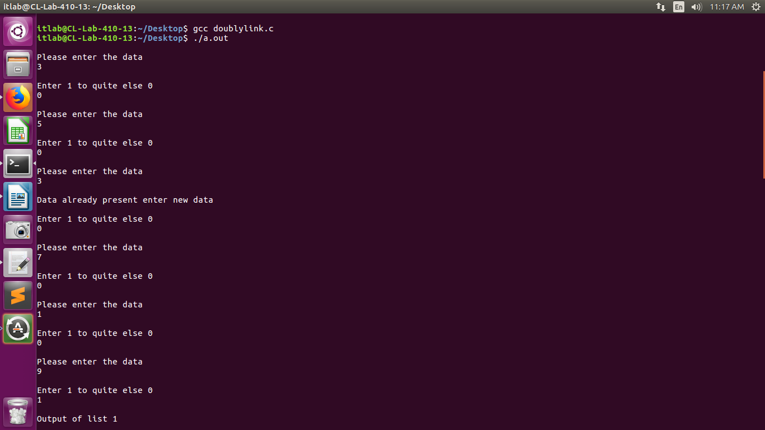

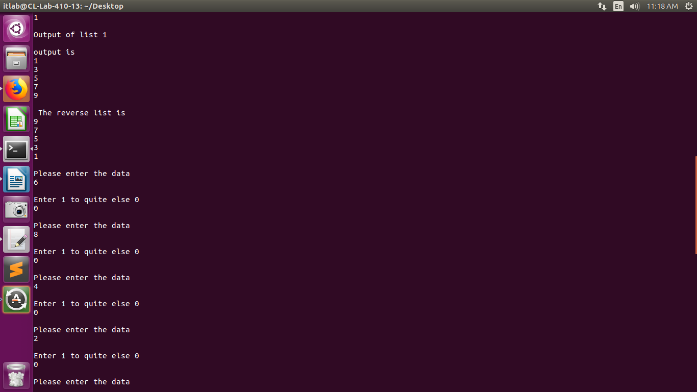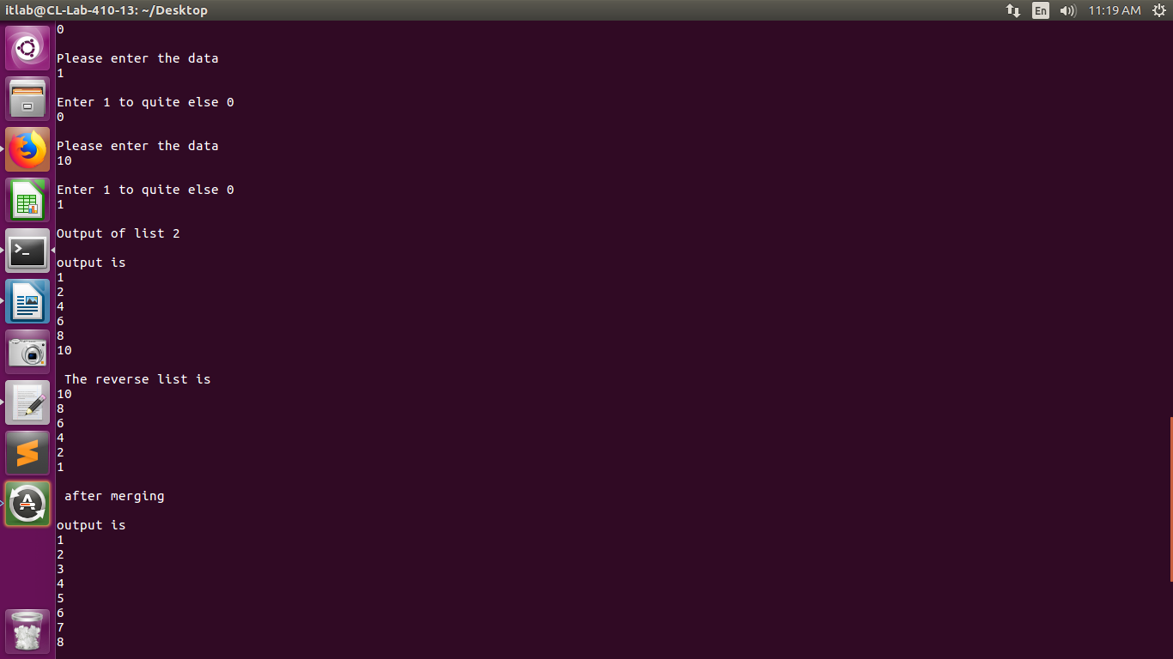

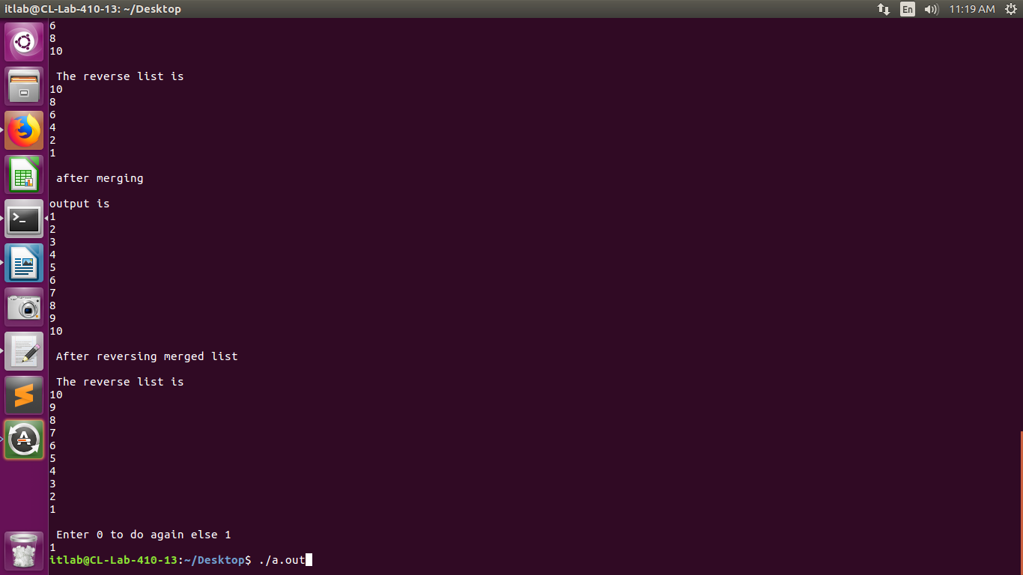

output

itlab@CL-Lab-410-13:~/Desktop$ gcc doublylink.c

itlab@CL-Lab-410-13:~/Desktop$ ./a.out

Please enter the data

3

Enter 1 to quite else 0

0

Please enter the data

5

Enter 1 to quite else 0

0

Please enter the data

3

Data already present enter new data

Enter 1 to quite else 0

0

Please enter the data

7

Enter 1 to quite else 0

0

Please enter the data

1

Enter 1 to quite else 0

0

Please enter the data

9

Enter 1 to quite else 0

1

Output of list 1

output is

1

3

5

7

9

The reverse list is

9

7

5

3

1

Please enter the data

6

Enter 1 to quite else 0

0

Please enter the data

8

Enter 1 to quite else 0

0

Please enter the data

4

Enter 1 to quite else 0

0

Please enter the data

2

Enter 1 to quite else 0

0

Please enter the data

1

Enter 1 to quite else 0

0

Please enter the data

10

Enter 1 to quite else 0

1

Output of list 2

output is

1

2

4

6

8

10

The reverse list is

10

8

6

4

2

1

after merging

output is

1

2

3

4

5

6

7

8

9

10

After reversing merged list

The reverse list is

10

9

8

7

6

5

4

3

2

1

Enter 0 to do again else 1

1

*/