**EXP NO: 8**

**22481A0538:**

**AIM:** Create a user authentication application using JSP where the user submits login name and

password to the server through form. The name and password are verified against the data already

available in the database and if there is a match, a welcome page is returned. Otherwise a failure messageis displayed to the user.

**PROGRAM:**

**<%@page import="java.sql.*"%>**

**<%**

**try{**

**Class.forName("oracle.jdbc.driver.OracleDriver");**

**out.println("Class will loaded");**

**Connection**

**con=DriverManager.getConnection("jdbc:Oracle:thin:@localhost:1521:xe","SYSTEM","cse");**

**out.println("database connected");**

**Statement st=con.createStatement();**

**ResultSet rs=st.executeQuery("CREATE TABLE user2(username varchar(30),password varchar(20))");**

**out.println("Create table successfully");**

**}**

**catch(Exception e)**

**{**

**out.println(e);**

**}**

**%>**

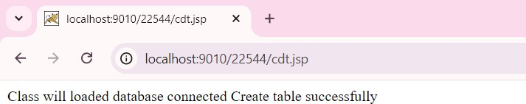

**FORM TO INSERT IN DB:**

**<html>**

**<body>**

**<form action="insert1.jsp">**

**username:<input type="text" name="uname">**

**password:<input type="password" name="password">**

**<input type="submit" value="signup">**

**</form>**

**</body>**

**INSERTING TO DB:**

**<html>**

**<body>**

**<%@page import="java.sql.*" %>**

**<%**

**try**

**{**

**Class.forName("oracle.jdbc.driver.OracleDriver");**

**Connection**

**con=DriverManager.getConnection("jdbc:Oracle:thin:@localhost:1521:xe","SYSTEM","cse");**

**Statement stmt=con.createStatement();**

**String uname=request.getParameter("uname");**

**String pwd=request.getParameter("password");**

**int i=stmt.executeUpdate("INSERT into user2 values('"+uname+"','"+pwd+"')");**

**if(i==1)**

**{**

**out.println("inserted");**

**}**

**}**

**catch(Exception e)**

**{**

**out.println(e);**

**}**

**%>**

**</body>**

**</html>**

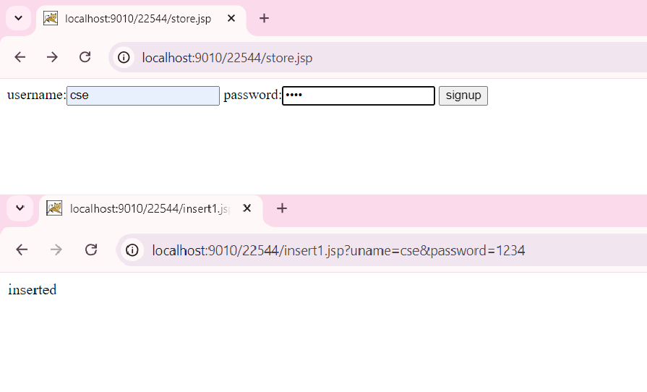

**FORM FOR VERFICATION:**

**<html>**

**<body>**

**<form action="insertlogin.jsp">**

**username:<input type="text" name="uname">**

**password:<input type="password" name="password">**

**<input type="submit" value="login">**

**</form>**

**</body>**

**DB CODE FOR VERFICATION:**

**<html>**

**<body>**

**<%@ page import="java.sql.*" %>**

**<%**

**try**

**{**

**Class.forName("oracle.jdbc.driver.OracleDriver");**

**Connection**

**con=DriverManager.getConnection("jdbc:Oracle:thin:@localhost:1521:xe","SYSTEM","cse");**

**Statement stmt=con.createStatement();**

**String uname=request.getParameter("uname");**

**String pwd=request.getParameter("password");**

**ResultSet rs=stmt.executeQuery("SELECT * from user1S");**

**boolean flag=false;**

**while(rs.next())**

**{**

**String uname1=(String)rs.getString(1);**

**String pwd1=(String)rs.getString(2);**

**if(uname1.equals(uname))**

**{**

**if(pwd1.equals(pwd))**

**{**

**flag=true;**

**session.setAttribute("uname",uname);**

**response.sendRedirect("welcome1.jsp");**

**}**

**}**

**}**

**if(flag==false)**

**{**

**response.sendRedirect("failure.jsp");**

**}**

**}**

**catch(Exception e)**

**{**

**out.println(e);**

**}**

**%>**

**</body>**

**</html>**

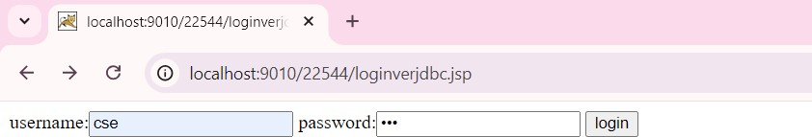

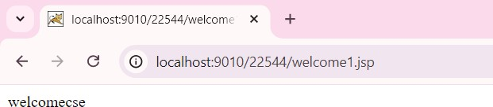

**WELCOME1.JSP:**

**<html>**

**<body>**

**<% String uname=(String)session.getAttribute("uname");**

**out.println("welcome"+uname);**

**%>**

**</body>**

**</html>**



**FAILURE.JSP:**

**<html>**

**<body>**

**<%**

**response.sendRedirect("loginverjdbc.jsp");**

**%>**

**</body>**

**</html>**

