# EXP NO: 11

**AIM:COMPONENTS OF REACT JS**

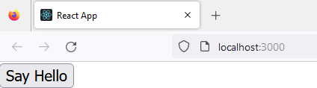

import React from "react";

const App = () => { return (

<button onClick={() => alert("Hello!")}>Say Hello</button>

);

};

export default App;

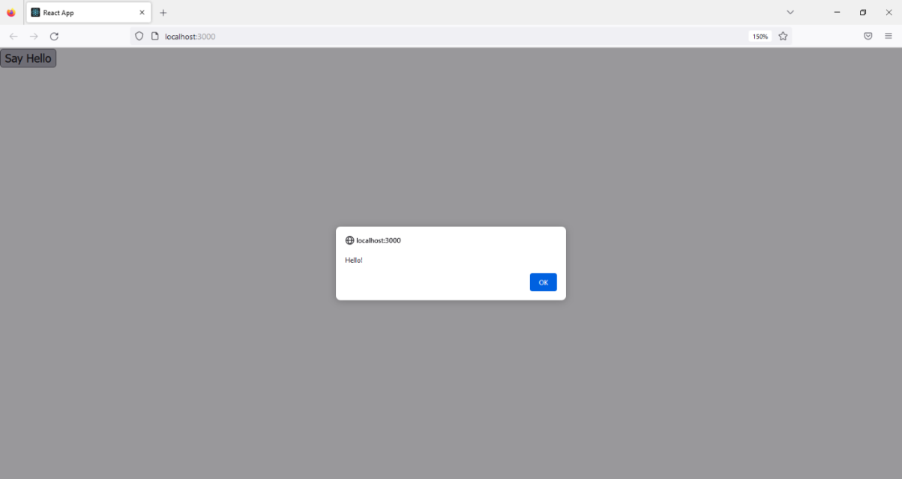

**Custom components and events in React**

import React from "react";

const CustomButton = ({ onPress }) => { return (

<button type="button" onClick={onPress}> Click on me

</button>

);

};

const App = () => {

const handleEvent = () => { alert("I was clicked");

};

return <CustomButton onPress={handleEvent} />;

};

export default App;

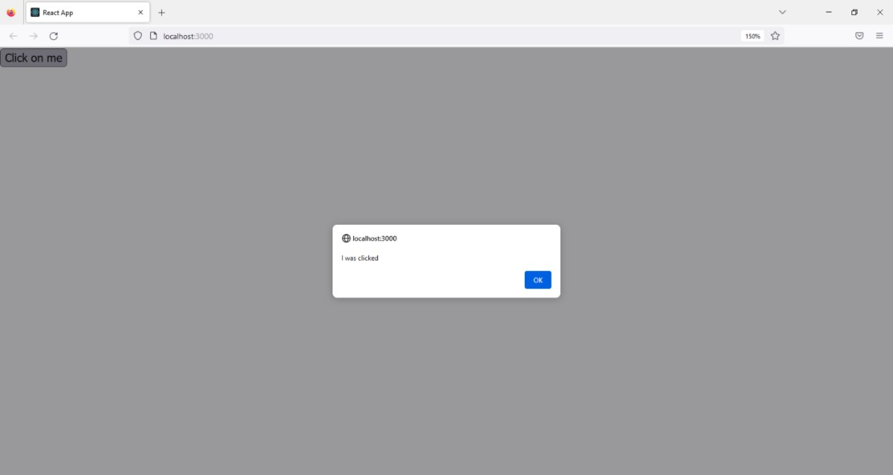

**Update the state inside an onClick event handler**

import React, { useState } from "react";

const App = () => {

const [count, setCount] = useState(0);

return (

<div>

<p>{count}</p>

<button onClick={() => setCount(count + 1)}>Increment</button>

<button onClick={() => setCount(count - 1)}>Decrement</button>

</div>

);

};

export default App;

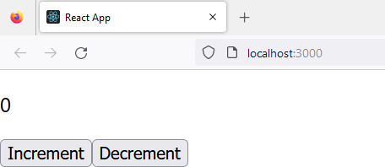

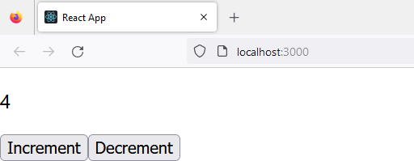

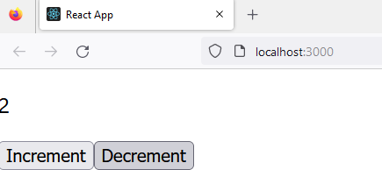

**Call multiple functions in an onClick event handler**

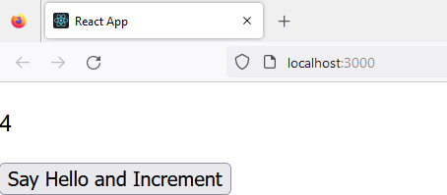

import React, { useState } from "react";

const App = () => {

const [count, setCount] = useState(0); const sayHello = () => {

alert("Hello!");

};

return (

<div>

<p>{count}</p>

<button onClick={() => {

sayHello(); setCount(count + 1);

}}

>

Say Hello and Increment

</button>

</div>

);

};

export default App;

**Pass a parameter to an onClick event handler**

import React from "react";

const App = () => {

const sayHello = (name) => { alert(`Hello, ${name}!`);

};

return (

<button onClick={() => {

sayHello("React JS");

}}

>

Say Hello

</button>

);

};

export default App;