**EXP NO: 1**

**AIM:** Design the following static web pages required for an online book store web site.

1. Home page:- must contains three frames

* Top frame: - should contain logo and college name and links to homepage, login page, registration page and catalogue page.
* Left frame: - at least four links for navigation which will display the catalogue of Respective links.
* Right frame: - the pages to links in the left frame must be loaded here initially it Contains the description of the website

1. Login Page: - should contain Username and Password fields, Submit and reset buttons.
2. Registration Page: - should contain fields for Username, Password, Confirm Password, Gender, Date of Birth, Email Id, Mobile Number and Address.
3. Catalogue Page: - The details should contain the following details of books available in a tabular format: Snap shot of Cover Page, Author Name, Publisher details, Price and Add to Cart button.

1) **HOME PAGE:**

The static home page must contain three **frames**.

Top frame : Logo and the college name and links to Home page, Login page, Registration page, Catalogue page and Cart page (the description of these pages will be given below).

Left frame : At least four links for navigation, which will display the catalogue of respective links.

For e.g.: When you click the link **“CSE”** the catalogue for **CSE** Books should be displayed in the Right frame.

Right frame: The pages to the links in the left frame must be loaded here. Initially this page contains description of the web site.

|  |  |  |  |  |
| --- | --- | --- | --- | --- |
| Logo | Web Site Name | | | |
| Home | Login | Registration | Catalogue | Cart |
| CSE  ECE  EEE  CIVIL | Description of the Web Site | | | |

Fig 1.1

**2) LOGIN PAGE:**

This page looks like below:

|  |  |  |  |  |
| --- | --- | --- | --- | --- |
| Logo | Web Site Name | | | |
| Home | Login | Registration | Catalogue | Cart |
| CSE  ECE  EEE  CIVIL | Login :  Password:  Reset  Submit | | | |

**3) REGISTRATION PAGE**

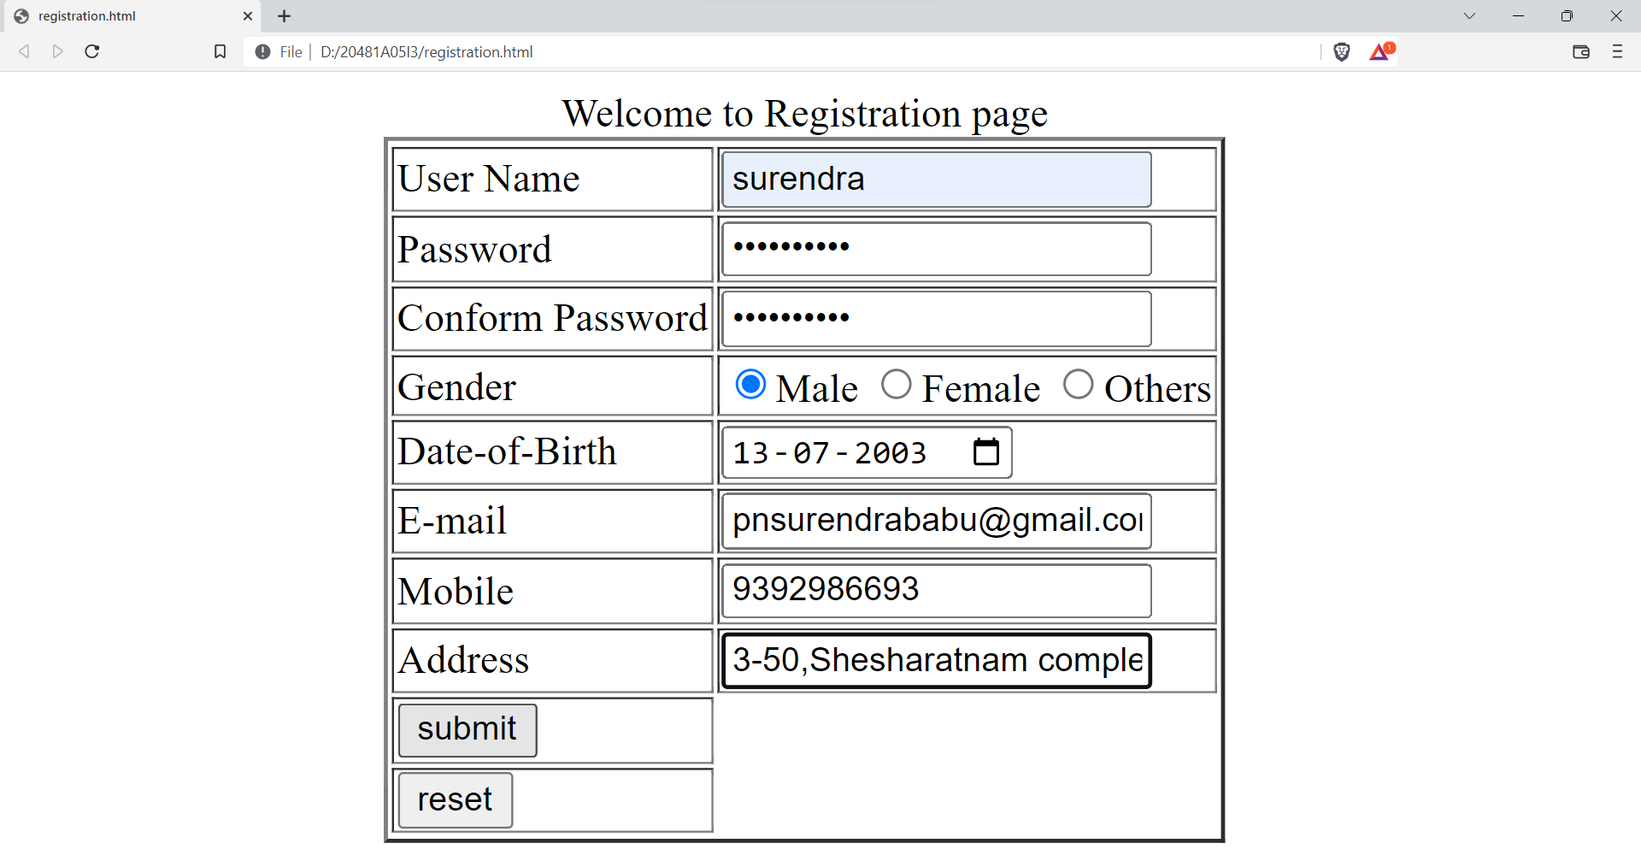

**4 ) CATOLOGUE PAGE:**

The catalogue page should contain the details of all the books available in the web site in a table.

The details should contain the following:

1. Snap shot of Cover Page.
2. Author Name.
3. Publisher.
4. Price.
5. Add to cart button.

|  |  |  |  |  |  |
| --- | --- | --- | --- | --- | --- |
| Logo | Web Site Name | | | | |
| Home | Login | Registration | Catalogue | Cart | |
| CSE  AIDS  AIML  ECE | comp1 | Book : XML Bible  Author : Winston  Publication : Wiely | $ 40.5 | | add |
| ai1 | Book : AI  Author : S.Russel  Publication : Princeton hall | $ 63 | | add |
| comp10 | Book : Java 2  Author : Watson  Publication : BPB publications | $ 35.5 | | add |
| mark5 | Book : HTML in 24 hours  Author : Sam Peter  Publication : Sam publication | $ 50 | | add |

## Source Code

**PROGRAM:**

**<frameset rows="40%,*">**

**<frame name="11" src="top.html" target="13">**

**<frameset cols="30%,*">**

**<frame name="12" src="left.html" target="13">**

**<frame name="13" target="13" >**

**</frameset>**

**</frameset>**

**OUTPUT:**

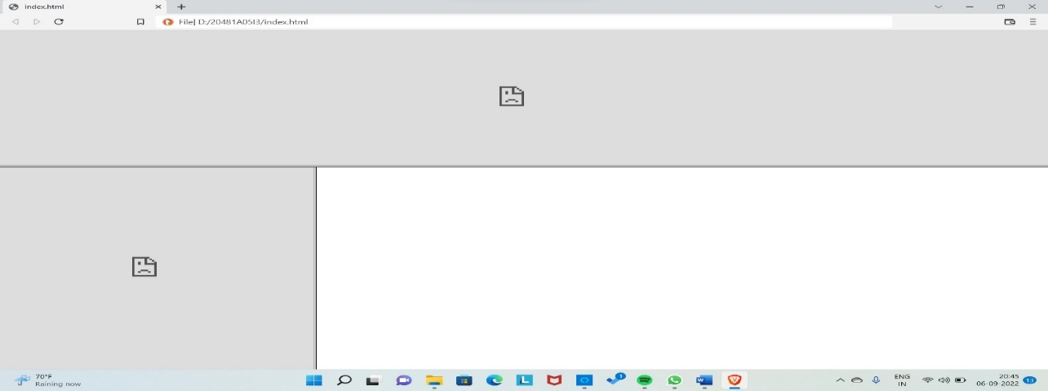

**1.HOME PAGE:** Must contain three frames

**PROGRAM:**

<!DOCTYPE html>

<html>

<body >

<marquee behavior="alternate" text="black"><h1>welcome to home page....</h1></marquee>

<p><i>Online Book store is an online web application where the customer can purchase books online.

Through a web browser the customers can search for a book by its title or author, later can add to

the shopping cart.</i></p>

</body>

</html>

**OUTPUT:**

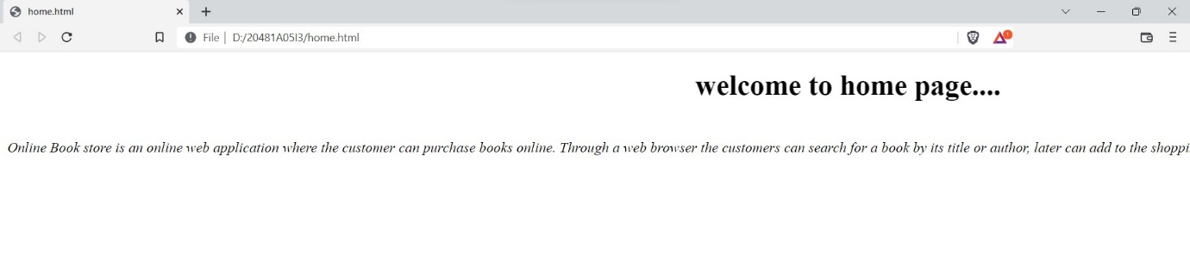

**TOP FRAME:** Shouldcontain logo and college name and links to homepage, login page, registration page and catalogue page.

**PROGRAM:**

**<!DOCTYPE html>**

**<html>**

**<head>**

**<title>top</title>**

**</head>**

**<body background="lib.jpg">**

**<img src="logo.jpg" height="100" weidth="100" align="left">**

**<marquee behavior="alternate" direction="right" bgcolor="white">Gudlavalleru Engineering College </marquee>**

**<table align="center" border="0">**

**<tr>**

**<td colspan="5"><h1 align="center" text="white">Welcome to Libary</h1></th>**

**</tr>**

**<tr bgcolor="white">**

**<td><a href="home.html" target="13">Home</a></td>**

**<td><a href="login.html" target="13">Login</a></td>**

**<td><a href="registration.html" target="13">Registration</a></td>**

**<td><a href="catlouge.html" target="13">Catlouge</a></td>**

**<td><a href="Cart.html" target="13">Cart</a></td>**

**</tr>**

**</table>**

**</body>**

**</html>**

**OUTPUT:**



**LEFT FRAME:**At least four links for navigation which will display the catalogue of respective links

**PROGRAM:**

**<!DOCTYPE html>**

**<html>**

**<body>**

**<a href="cse.html" target="13">CSE</a><br/>**

**<a href="aids.html" target="13">AIDS</a><br/>**

**<a href="aiml.html" target="13">AIML</a><br/>**

**<a href="ece.html" target="13">ECE</a><br/>**

**</body>**

**</html>**

**OUTPUT:**

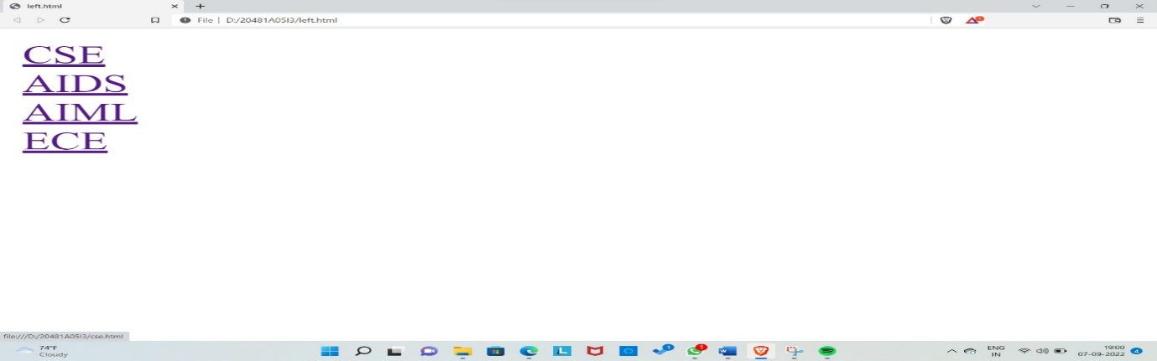

**RIGHT FRAME:** The page to links in the left frame must be loaded here initially it contains the description of the website.

**CATALOGUE PAGE OF CSE PROGRAM:**

**<!DOCTYPE html>**

**<html>**

**<body >**

**<table align="center" border="2" >**

**<caption align="center">welcome to <u>CSE</u> page</caption>**

**<tr>**

**<th>BookName</th>**

**<th>Author</th>**

**<th>Fare</th>**

**<th>Image</th>**

**<th>Add-To-Cart</th>**

**</tr>**

**<tr>**

**<tr>**

**<td>DataStructures</td>**

**<td>Dr.Mohan</td>**

**<td>1999</td>**

**<td><imgsrc="datastructures.jpg" height="100" weidth="100"></td>**

**<td><imgsrc="addtocart.jpg" height="100" weidth="100"></td>**

**</tr>**

**<tr>**

**<td>PythonwithML</td>**

**<td>Dr.Praveen</td>**

**<td>899</td>**

**<td><imgsrc="pythonwithml.jpg" height="100" weidth="100"></td>**

**<td><imgsrc="addtocart.jpg" height="100" weidth="100"></td>**

**</tr>**

**<tr>**

**<td>Java</td>**

**<td>Dr.Surendra</td>**

**<td>1999</td>**

**<td><imgsrc="java.jpg" height="100" weidth="100"></td>**

**<td><imgsrc="addtocart.jpg" height="100" weidth="100"></td>**

**</tr>**

**</table>**

**</body>**

**</html>**

**OUTPUT:**

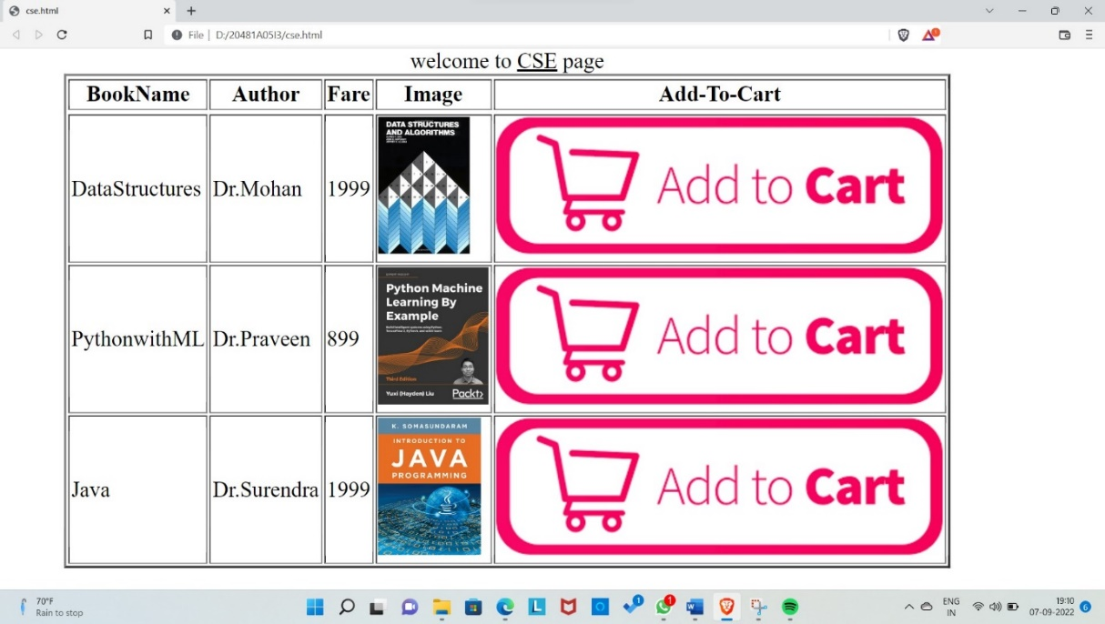

**CATALOGUE PAGE OF AIDS PROGRAM:**

**<!DOCTYPE html>**

**<html>**

**<body >**

**<table align="center" border="2" >**

**<caption align="center">welcome to <u>AIDS</u> page</caption>**

**<tr>**

**<th>BookName</th>**

**<th>Author</th>**

**<th>Fare</th>**

**<th>Image</th>**

**<th>Add-To-Cart</th>**

**</tr>**

**<tr>**

**<td>AI</td>**

**<td>Dr.Subhani</td>**

**<td>999</td>**

**<td><imgsrc="ai.jpg" height="100" weidth="100"></td>**

**<td><imgsrc="addtocart.jpg" height="100" weidth="100"></td>**

**</tr>**

**<tr>**

**<td>DataStructures</td>**

**<td>Dr.Mohan</td>**

**<td>1999</td>**

**<td><imgsrc="datastructures.jpg" height="100" weidth="100"></td>**

**<td><imgsrc="addtocart.jpg" height="100" weidth="100"></td>**

**</tr>**

**<tr>**

**<td>PythonwithML</td>**

**<td>Dr.Praveen</td>**

**<td>899</td>**

**<td><imgsrc="pythonwithml.jpg" height="100" weidth="100"></td>**

**<td><imgsrc="addtocart.jpg" height="100" weidth="100"></td>**

**</tr>**

**<tr>**

**<td>Java</td>**

**<td>Dr.Surendra</td>**

**<td>1999</td>**

**<td><imgsrc="java.jpg" height="100" weidth="100"></td>**

**<td><imgsrc="addtocart.jpg" height="100" weidth="100"></td>**

**</tr>**

**</table>**

**</body>**

**</html>**

**OUTPUT:**

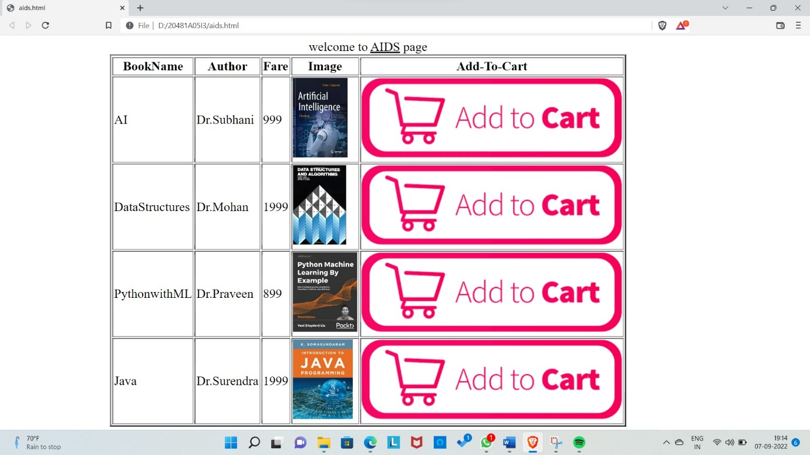

**CATALOGUE PAGE OF AIML PROGRAM:**

**<!DOCTYPE html>**

**<html>**

**<body >**

**<table align="center" border="2" >**

**<caption align="center">welcome to <u>AIML</u> page</caption>**

**<tr>**

**<th>BookName</th>**

**<th>Author</th>**

**<th>Fare</th>**

**<th>Image</th>**

**<th>Add-To-Cart</th>**

**</tr>**

**<tr>**

**<td>AI</td>**

**<td>Dr.Subhani</td>**

**<td>999</td>**

**<td><imgsrc="ai.jpg" height="100" weidth="100"></td>**

**<td><imgsrc="addtocart.jpg" height="100" weidth="100"></td>**

**</tr>**

**<tr>**

**<td>DataStructures</td>**

**<td>Dr.Mohan</td>**

**<td>1999</td>**

**<td><imgsrc="datastructures.jpg" height="100" weidth="100"></td>**

**<td><imgsrc="addtocart.jpg" height="100" weidth="100"></td>**

**</tr>**

**<tr>**

**<td>PythonwithML</td>**

**<td>Dr.Praveen</td>**

**<td>899</td>**

**<td><imgsrc="pythonwithml.jpg" height="100" weidth="100"></td>**

**<td><imgsrc="addtocart.jpg" height="100" weidth="100"></td>**

**</tr>**

**<tr>**

**</table>**

**</body>**

**</html>**

**OUTPUT:**

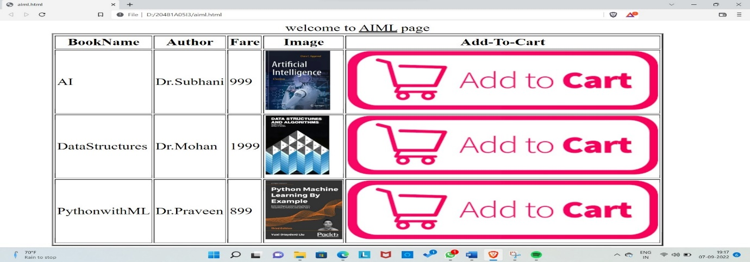

**CATALOGUE PAGE OF ECE PROGRAM:**

**<!DOCTYPE html>**

**<html>**

**<body >**

**<table align="center" border="2" >**

**<caption align="center">welcome to <U>ECE</u> page</caption>**

**<tr>**

**<th>BookName</th>**

**<th>Author</th>**

**<th>Fare</th>**

**<th>Image</th>**

**<th>Add-To-Cart</th>**

**</tr>**

**<tr>**

**<td>AI</td>**

**<td>Dr.Subhani</td>**

**<td>999</td>**

**<td><imgsrc="ai.jpg" height="100" weidth="100"></td>**

**<td><imgsrc="addtocart.jpg" height="100" weidth="100"></td>**

**</tr>**

**<tr>**

**<td>Mechtronics</td>**

**<td>Dr.Mohan</td>**

**<td>1999</td>**

**<td><imgsrc="mech.jpg" height="100" weidth="100"></td>**

**<td><imgsrc="addtocart.jpg" height="100" weidth="100"></td>**

**</tr>**

**<tr>**

**<td>Electrical Engineering</td>**

**<td>Dr.Praveen</td>**

**<td>899</td>**

**<td><imgsrc="electrical.jpg" height="100" weidth="100"></td>**

**<td><imgsrc="addtocart.jpg" height="100" weidth="100"></td>**

**</tr>**

**<tr>**

**<td>Java</td>**

**<td>Dr.Surendtra</td>**

**<td>1999</td>**

**<td><imgsrc="java.jpg" height="100" weidth="100"></td>**

**<td><imgsrc="addtocart.jpg" height="100" weidth="100"></td>**

**</tr>**

**</table>**

**</body>**

**</html>**

**OUTPUT:**

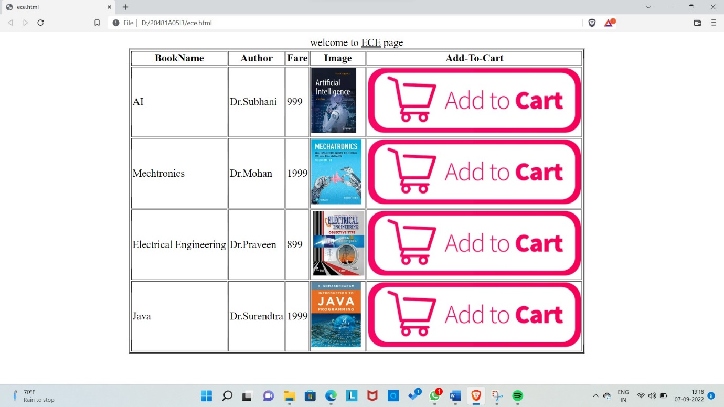

**LOGIN PAGE:**Should contain username and password fields, submit and reset buttons

**PROGRAM:<!DOCTYPE html>**

**<html>**

**<body>**

**<form name="1" method="get">**

**<table align="center" border="2">**

**<caption align="center">Welcome to Login page</caption>**

**<tr>**

**<td>User Name</td>**

**<td><input type="text" name="2" pattern="[a-zA-Z]{4,30}" placeholder="only characters"></td>**

**</tr>**

**<tr>**

**<td>Password</td>**

**<td><input type="password" name="pwd" pattern="[a-zA-Z!@#$%^&*1-9]{12,30}" placeholder="enterpassword" ></td>**

**</tr>**

**<tr>**

**<td><input type="submit" value="submit"></td>**

**</tr>**

**<tr>**

**<td><input type="reset" value="reset"></td>**

**</tr>**

**</table>**

**</body>**

**</html>**

**OUTPUT:**

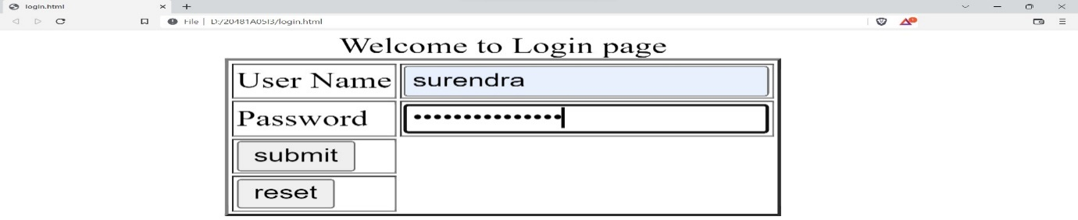

**REGISTRATION PAGE:** Should contain fields for username, password, confirm password, gender, date of birth, email id, mobile number and address

**PROGRAM:**

<!DOCTYPE html>

<html>

<body >

<form name="1" method="get">

<table align="center" border="2">

<caption align="center">Welcome to Registration page</caption>

<tr>

<td>User Name</td>

<td><input type="text" name="2" pattern="[a-zA-Z]{4,30}" placeholder="only characters"></td>

</tr>

<tr>

<td>Password</td>

<td><input type="password" name="pwd" pattern="[a-zA-Z!@#$%^&*1-9]{12,30}" placeholder="enterpassword" ></td>

</tr>

<tr>

<td> Conform Password</td>

<td><input type="password" name="pwd" pattern="[a-zA-Z!@#$%^&*1-9]{12,30}" placeholder="enterpassword" ></td>

</tr>

<tr>

<td>Gender</td>

<td>

<input type="radio" name="gen">Male

<input type="radio" name="gen">Female

<input type="radio" name="gen">Others

</td>

</tr>

<tr>

<td>Date-of-Birth</td>

<td><input type="date"></td>

</tr>

<tr>

<td>E-mail</td>

<td><input type="mail" pattern="[a-zA-Z@.]{5,30}" placeholder="enter mail" ></td>

</tr>

<tr>

<td>Mobile</td>

<td><input type="tel" placeholder="number"></td>

</tr>

<tr>

<td>Address</td>

<td><input type="text area" placeholder="enter address"></td>

</tr>

<tr>

<td><input type="submit" value="submit"></td>

</tr>

<tr>

<td><input type="reset" value="reset"></td>

</tr>

</table>

</body>

</html>

**OUTPUT:**



**CATALOGUE PAGE:**The details should contain the following details of books available in a tabular format: snapshot of cover page, author name, publisher details, price and add to cart button

**PROGRAM:  
<!DOCTYPE html>**

**<html>**

**<body >**

**<table align="center" border="2">**

**<caption align="center">welcome to catlouge page</caption>**

**<tr>**

**<th>BookName</th>**

**<th>Author</th>**

**<th>Fare</th>**

**<th>Image</th>**

**<th>Add-To-Cart</th>**

**</tr>**

**<tr>**

**<tr>**

**<td>DataStructures</td>**

**<td>Dr.Mohan</td>**

**<td>1999</td>**

**<td><img src="datastructures.jpg" height="100" weidth="100"></td>**

**<td><img src="addtocart.jpg" height="100" weidth="100"></td>**

**</tr>**

**<tr>**

**<td>PythonwithML</td>**

**<td>Dr.Praveen</td>**

**<td>899</td>**

**<td><img src="pythonwithml.jpg" height="100" weidth="100"></td>**

**<td><img src="addtocart.jpg" height="100" weidth="100"></td>**

**</tr>**

**<tr>**

**<td>Java</td>**

**<td>Dr.Surendtra</td>**

**<td>1999</td>**

**<td><img src="java.jpg" height="100" weidth="100"></td>**

**<td><img src="addtocart.jpg" height="100" weidth="100"></td>**

**</tr>**

**</table>**

**</body>**

**</html>**

**OUTPUT:**

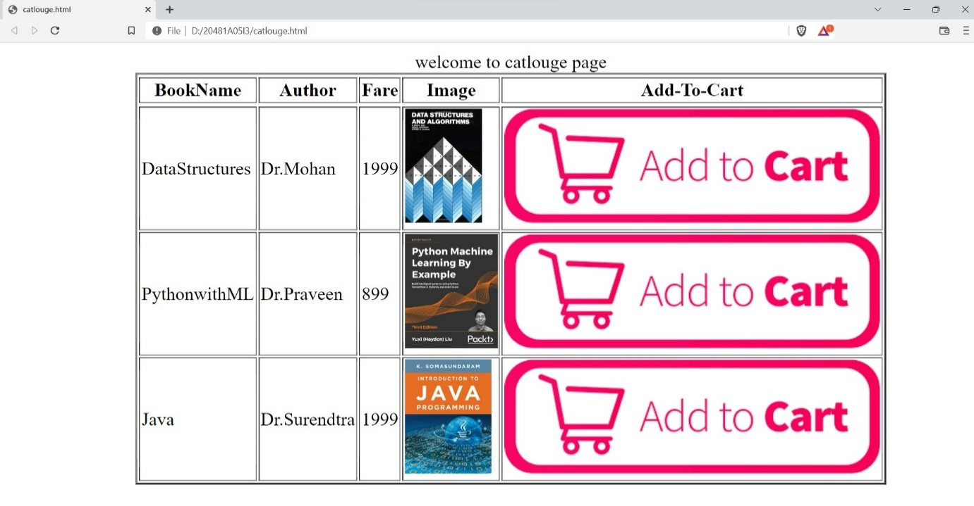

**CART PAGE:**Books selected from catalogue pages of CSE, AI&DS, AI&ML and IT pages should be shown in the cart page as they are added to cart

**PROGRAM:**

**<!DOCTYPE html>**

**<html>**

**<body >**

**<table align="center" border="2" >**

**<caption align="center">Cart details</caption>**

**<tr>**

**<th>BookName</th>**

**<th>Fare</th>**

**<th>Quanity</th>**

**<th>Total</th>**

**</tr>**

**<tr>**

**<td>AI</td>**

**<td>999</td>**

**<td>1</td>**

**<td>999</td>**

**</tr>**

**<tr>**

**<td>DataStructures</td>**

**<td>1999</td>**

**<td>2</td>**

**<td>3998</td>**

**</tr>**

**<tr>**

**<td>PythonwithML</td>**

**<td>899</td>**

**<td>1</td>**

**<td>899</td>**

**</tr>**

**<tr>**

**<td colspan="3">Total Amount</td>**

**<td>5896</td>**

**</table>**

**</body>**

**</html>**

**OUTPUT:**

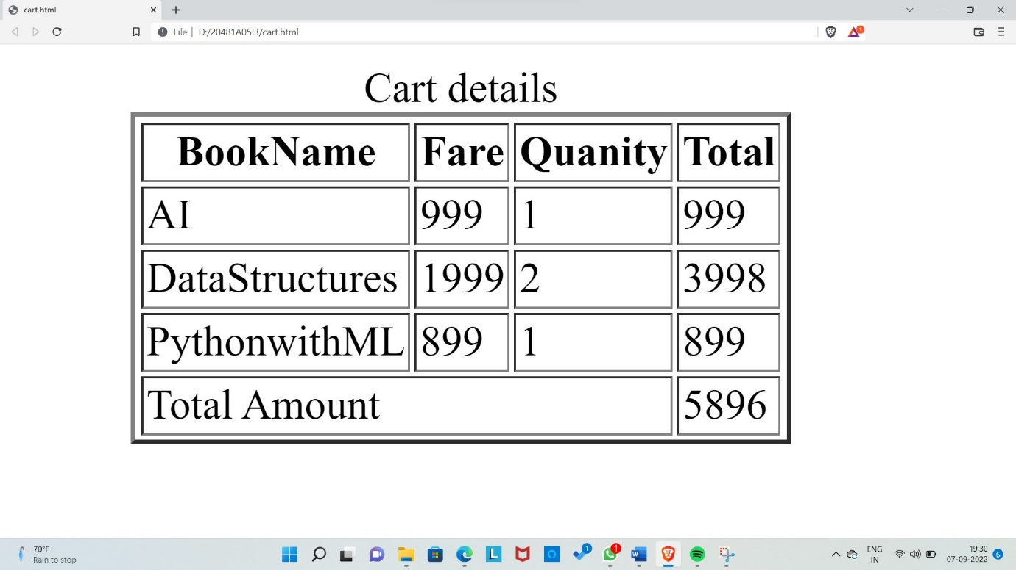

**ONLINE BOOK STORE:**

