|  |
| --- |
| **Automation Of Aerators In Aquaculture**  **A Community Service Project Report**    Submitted to the Faculty of Engineering of  **JAWAHARLAL NEHRU TECHNOLOGICAL UNIVERSITY KAKINADA,**  **KAKINADA**    In partial fulfillment of the requirements for the award of the Degree of    **BACHELOR OF TECHNOLOGY**  In  **COMPUTER SCIENCE AND ENGINEERING**  By    **Chennakesavula Sri Datta (21481A0547)**  **Dasari Leela Lokesh (21481A0555)**  **Abdul Khaleel (21481A0502)**  **Cheeli Enoush (22485A0506)**  **Dara Bharath Sri Vamsi (20481A0540)**        Under the Enviable and Esteemed Guidance of  **Mrs.N.Srivani, M.Tech.**  Assistant Professor, Department of CSE        **DEPARTMENT OF COMPUTER SCIENCE AND ENGINEERING**    **SESHADRI RAO GUDLAVALLERU ENGINEERING COLLEGE**  **(An Autonomous Institute with Permanent Affiliation to JNTUK, Kakinada)**  **SESHADRIRAO KNOWLEDGE VILLAGE**  **GUDLAVALLERU – 521356 ANDHRA PRADESH 2023-24** |

**Program Book**

**for**

**Community Service Project**



**Name of the College: Seshadri Rao Gudlavalleru Engineering College**

**Registration Numbers:**

**21481A0547**

**21481A0555**

**21481A0502**

**22485A0506**

**20481A0540**

**Period of CSP: From:15-5-2023 To: 3-6-2023 (3 weeks)**

**14-8-2023 To: 26-8-2023 (2 weeks)**

**28-8-2023 To: 16-9-2023 (3 weeks)**

**Name&AddressofCommunity/Habitation:**

**Machilipatnam (G), Machilipatnam(m), Krishna(d),521002**

# Community Service Project Report

*Submitted in accordance with the requirement for the degree of*

**BACHELOR OF TECHNOLOGY**

In

**COMPUTER SCIENCE AND ENGINEERING**

Name of the College**:Seshadri Rao Gudlavalleru Engineering College**

Department**:COMPUTER SCIENCE AND ENGINEERING**

Name of the Faculty Guide:Dr.N.Srivani

**Duration of the CSP: From: 15-5-2023 To: 3-6-2023 (3 weeks)**

**14-8-2023 To: 26-8-2023 (2 weeks)**

**28-8-2023 To: 16-9-2023 (3 weeks)**

Names of the Students:

**Chennakesavula Sri Datta**

**Dasari Leela Lokesh**

**Abdul Khaleel**

**Cheeli Enoush**

**Dara Bharath Sri Vamsi**

Programme of Study Year of Study: B.Tech IIIrd Year

Register Numbers: **21481A0547**

**21481A0555**

**21481A0502**

**22485A0506**

**20481A0540**

Date of Submission:

**Student’s Declaration**

We Chennakesavula Sri Datta (Reg.No 21481A0547), Dasari Leela Lokesh (Reg.No 21481A0555), Abdul Khaleel (Reg.No 21481A0502), Cheeli Enoush (Reg.No 22485A0506), Dara Bharath Sri Vamsi (Reg.No 20481A0540), the students of **BACHELOR OF TECHNOLOGY** in COMPUTER SCIENCE AND ENGINEERING Department of Seshadri Rao Gudlavalleru Engineering College do here by declare that we have completed the mandatory community service From: 15-5-2023 To: 16-9-2023 in Aquaculture Community under the Faculty Guideship of Mrs.N.Srivani, M. Tech., AssistantProfessor in the Department of Computer Science And Engineering in Seshadri Rao Gudlavalleru Engineering College, Gudlavalleru.

(Signature and Date)

**Endorsements**

Faculty Guide

Master of Trainer(S):

Head of the Department

Principal

**Certificate from Official of the Community**

This is to certify that, Chennakesavula Sri Datta (Reg. No 21481A0547), Dasari Leela Lokesh (Reg.No 21481A0555), Abdul Khaleel (Reg.No 21481A0502), Cheeli Enoush (Reg.No 22485A0506), Dara Bharath Sri Vamsi (Reg.No 20481A0540),of Seshadri Rao Gudlavalleru Engineering College under went community service in Machilipatnam Aquaculture From:15-52023 To: 16-9-2023.

The overall performance of the Community Service Volunteers during community of their service is found to be Satisfactory.

Authorized Signatory with Date and Seal

## ACKNOWLEDGEMENTS

We express our deep sense of gratitude to my institution, Seshadri Rao Gudlavalleru Engineering College,Gudlavalleru, for providing us the opportunity to carry out this Community Service Project (CSP). It is our privilege to express sincere gratitude to **Mrs. N.Srivani,**  Assistant professor, Department of CSE, Seshadri Rao Gudlavalleru Engineering College, for her valuable guidance and untiring help, which enabled us to successfully complete the work.

We would like to extend our sincere gratitude to **Dr. M.Babu Rao**, Head of the Department, for the valuable assistance provided in the successful completion of the work.

We express our gratitude to our principal, **Dr. B. Karuna Kumar**, for his encouragement and the facilities provided throughout the course of the project.

We are thankful to the officials from soil test centres for providing the necessary information. A special thanks to all faculty and staff members for their motivation and knowledge rendered throughout this program.

We wish to express gratitude to all our friends who have helped us in various stages and provided valuable suggestions throughout the project. Thanks to all the community members who assisted in the successful completion of the project.

We are also grateful to the KalamKari Community and Officials for granting permission to conduct our project in a well-organized manner.

### Chennakesavula Sri Datta (21481A0547) Dasari Leela Lokesh (21481A0555) Abdul Khaleel (21481A0502) Cheeli Enoush (22485A0506) Dara Bharath Sri Vamsi (20481A0540)

**CHAPTER 1: EXECUTIVE SUMMARY**

The community service project is about the aquaculture problems. Aquaculture mainly refers to cultivating aquatic organisms providing suitable environments for various purposes. This paper presents the way of using Internet of Things (IoT) based devices to monitor aquaculture’s basic needs and help provide things needed for the fisheries. Using these devices, various parameters of water will be monitored for a better living environment for organisms. Shrimp density in farms varies, but the farmer is interested in high-density packaging to increase profits.

The primary objective is to monitor the aquaculture system using various sensors to reduce risks. Controlling water quality parameters such as dissolved oxygen (DO) level and Potential of Hydrogen (PH) level in aquaculture to improve quality, productivity which in turn reduce costs and increase profits.

Only dissolved oxygen content, temperature and acidity are being focused. It does not include chemical analysis in the water. Measurement of dissolved oxygen content, temperature and acidity are determined through the use of dissolved oxygen sensor, thermometer and pH sensor.

**Learning Objectives:**

The main objective of the project is to monitoring the aquaculture and correcting device via Android Internet of Things (IoT) application to automate the water monitoring and correction of certain parameters by automation of aerators. IoT is an interconnection of the Internet with various “things” e.g sensors and devices which can improve and enhance their control and sensing capabilities through programming, computing, and analytical implementations.

**Learning Outcomes:**

⮚ Engineering knowledge: Apply the knowledge of mathematics, science, engineering fundamentals and an engineering specialization to the solution of complex engineering problems.

⮚ Problem analysis: Identify, formulate, review research literature, and analyze complex engineering problems reaching substantiated conclusions using first principles of mathematics, natural sciences, and engineering sciences.

⮚ Design/development of solutions: Design solutions for complex engineering problems and design system components or processes that meet the specified needs with appropriate consideration for the public health and safety, and the cultural, societal, and environmental considerations.

⮚ Conduct investigations of complex problems: Use research-based knowledge and research methods including design of experiments, analysis and interpretation of data, and synthesis of the information to provide valid conclusions.

⮚ Modern tool usage: Create, select, and apply appropriate techniques, resources and modern engineering and IT tools including prediction and modeling to complex engineering activities with an understanding of the limitations.

⮚ The engineer and society: Apply reasoning informed by the contextual knowledge to assess societal, health, safety, legal and cultural issues and the consequent responsibilities relevant to the professional engineering practice.

**CHAPTER 2 : OVERVIEW OF THE COMMUNITY**

**The communities are** Machilipatnam:

The village is in Rural of Krishna District in the state of Andhra Pradesh in India.

Machilipatnam had a population of 8,991. The total population constitute, 4062 male

4929 females- a sex ratio of 1073 females per 1000 males.986 children are in the age group of 0-6 years, of which 758 are boys and 742 are girls. The average literacy rate stands at 79.55% with 7,5661 illiterates, x ratio of 1073 females per 1000.

Significantly higher than the district average of 73.7%.

### CHAPTER 3: COMMUNITY SERVICE PART

● **The activities done during the community service project are as follows: -**

We met a farmer in Machilipatnam. He has been working in this field for 10 years

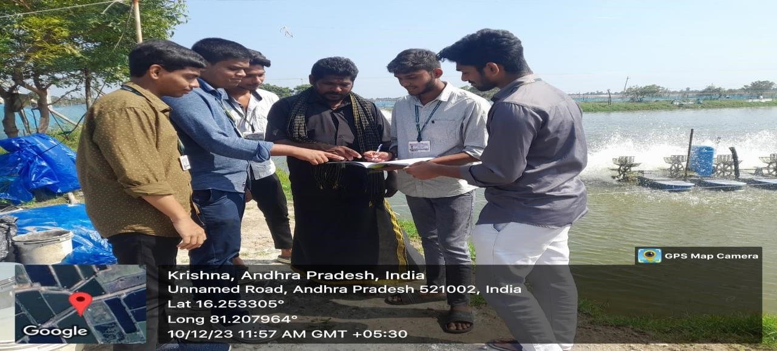

He has been feeding prawns 3 months

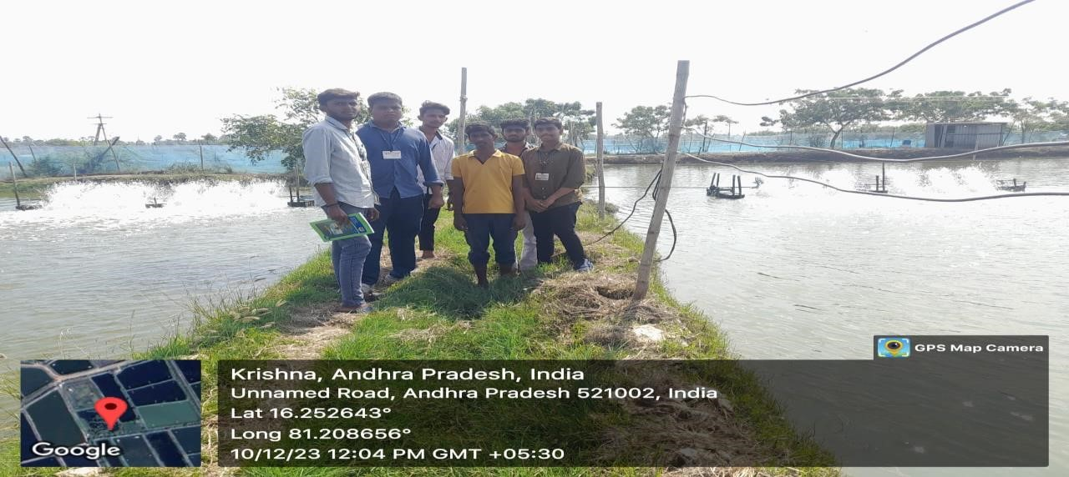

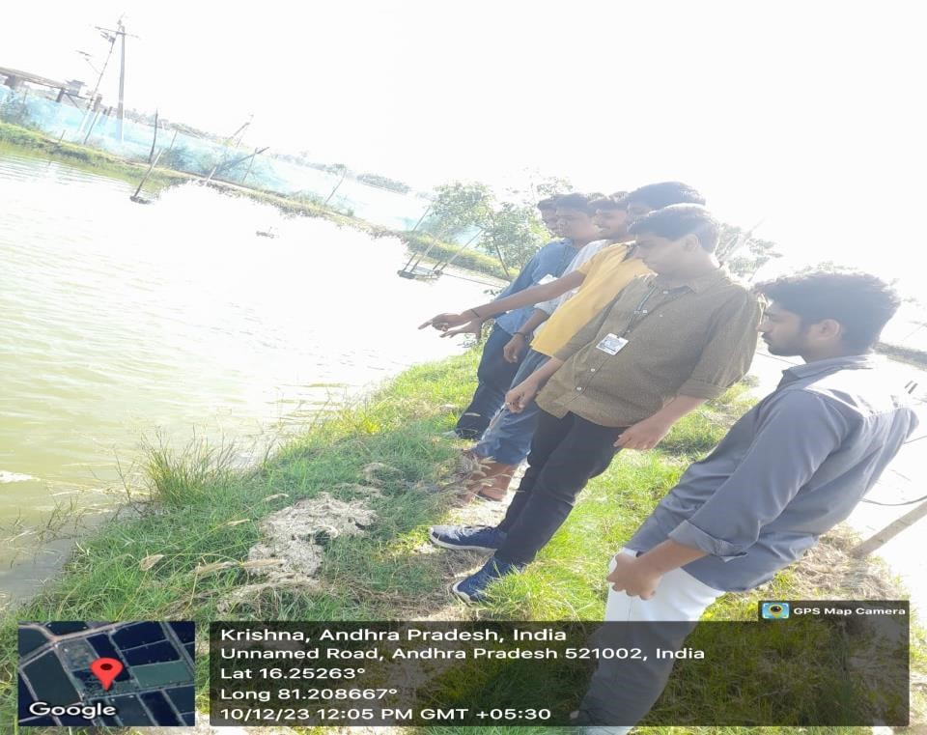

### ACTIVITY LOG FOR THE FIRST WEEK

|  |  |  |  |
| --- | --- | --- | --- |
| **DAY**  **&**  **DATE** | **BRIEF DESCRIPTION OF**  **THE DAILY ACTIVITY** | **LEARNING**  **OUTCOME** | **Person**  **In-charge**  **Signature** |
| **Day–1** |  |  |  |
| **Day-2** |  |  |  |
| **Day–3** |  |  |  |
| **Day–4** |  |  |  |
| **Day–5** |  |  |  |
| **Day–6** |  |  |  |

### WEEK–1(From Dt……………to Dt…………….)

|  |
| --- |
| **Objective of the Activity Done:** |
| **Detailed Report:** |
|  |
|  |
|  |
|  |
|  |
|  |
|  |
|  |
|  |
|  |
|  |
|  |
|  |
|  |
|  |
|  |

**ACTIVITY LOG FOR THE SECOND WEEK**

|  |  |  |  |
| --- | --- | --- | --- |
| **DAY**  **&**  **DATE** | **BRIEF DESCRIPTION OF**  **THE DAILY ACTIVITY** | **LEARNING**  **OUTCOME** | **Person**  **In-charge**  **Signature** |
| **Day–1** |  |  |  |
| **Day-2** |  |  |  |
| **Day–3** |  |  |  |
| **Day–4** |  |  |  |
| **Day–5** |  |  |  |
| **Day–6** |  |  |  |

### WEEK–2(From Dt……………to Dt…………….)

|  |
| --- |
| **Objective of the Activity Done:** |
| **Detailed Report:** |
|  |
|  |
|  |
|  |
|  |
|  |
|  |
|  |
|  |
|  |
|  |
|  |
|  |
|  |
|  |
|  |
|  |

### ACTIVITY LOG FOR THE THIRD WEEK

|  |  |  |  |
| --- | --- | --- | --- |
| **DAY**  **&**  **DATE** | **BRIEF DESCRIPTION OF**  **THE DAILY ACTIVITY** | **LEARNING**  **OUTCOME** | **Person**  **In-charge**  **Signature** |
| **Day–1** |  |  |  |
| **Day-2** |  |  |  |
| **Day–3** |  |  |  |
| **Day–4** |  |  |  |
| **Day–5** |  |  |  |
| **Day–6** |  |  |  |

### WEEK–3(From Dt……..to Dt……….)

|  |
| --- |
| **Objective of the Activity Done:** |
| **Detailed Report:** |
|  |
|  |
|  |
|  |
|  |
|  |
|  |
|  |
|  |
|  |
|  |
|  |
|  |
|  |
|  |
|  |
|  |
|  |

### ACTIVITY LOG FOR THE FOURTH WEEK

|  |  |  |  |
| --- | --- | --- | --- |
| **DAY**  **&**  **DATE** | **BRIEF DESCRIPTION OF**  **THE DAILY ACTIVITY** | **LEARNING**  **OUTCOME** | **Person**  **In-charge Signature** |
| **Day–1** |  |  |  |
| **Day-2** |  |  |  |
| **Day–3** |  |  |  |
| **Day–4** |  |  |  |
| **Day–5** |  |  |  |
| **Day–6** |  |  |  |

### WEEK–4(From Dt………..to Dt…………)

|  |
| --- |
| **Objective of the Activity Done:** |
| **Detailed Report:** |
|  |
|  |
|  |
|  |
|  |
|  |
|  |
|  |
|  |
|  |
|  |
|  |
|  |
|  |
|  |
|  |
|  |
|  |

### ACTIVITY LOG FOR THE FIFTH WEEK

|  |  |  |  |
| --- | --- | --- | --- |
| **DAY**  **&**  **DATE** | **BRIEF DESCRIPTION OF**  **THE DAILY ACTIVITY** | **LEARNING**  **OUTCOME** | **Person**  **In-charge**  **Signature** |
| **Day–1** |  |  |  |
| **Day-2** |  |  |  |
| **Day–3** |  |  |  |
| **Day–4** |  |  |  |
| **Day–5** |  |  |  |
| **Day–6** |  |  |  |

### WEEK–5(From Dt……….to Dt………….)

|  |
| --- |
| **Objective of the Activity Done:** |
| **DetailedReport:** |
|  |
|  |
|  |
|  |
|  |
|  |
|  |
|  |
|  |
|  |
|  |
|  |
|  |
|  |
|  |
|  |
|  |
|  |

### SIXTH WEEK

|  |  |  |  |
| --- | --- | --- | --- |
| **DAY**  **&**  **DATE** | **BRIEF DESCRIPTION OF**  **THE DAILY ACTIVITY** | **LEARNING**  **OUTCOME** | **Person**  **In-charge**  **Signature** |
| **Day–1** |  |  |  |
| **Day-2** |  |  |  |
| **Day–3** |  |  |  |
| **Day–4** |  |  |  |
| **Day–5** |  |  |  |
| **Day–6** |  |  |  |

### WEEK–6(From Dt………….to Dt……………)

|  |
| --- |
| **Objective of the Activity Done:** |
| **Detailed Report:** |
|  |
|  |
|  |
|  |
|  |
|  |
|  |
|  |
|  |
|  |
|  |
|  |
|  |
|  |
|  |
|  |
|  |
|  |

### SEVENTH WEEK

|  |  |  |  |
| --- | --- | --- | --- |
| **DAY**  **&**  **DATE** | **BRIEF DESCRIPTION OF**  **THE DAILY ACTIVITY** | **LEARNING**  **OUTCOME** | **Person**  **In-charge**  **Signature** |
| **Day–1** |  |  |  |
| **Day-2** |  |  |  |
| **Day–3** |  |  |  |
| **Day–4** |  |  |  |
| **Day–5** |  |  |  |
| **Day–6** |  |  |  |

**WEEK– 7(From Dt.............to Dt……………...)**

|  |
| --- |
| **Objective of the Activity Done:** |
| **Detailed Report:** |
|  |
|  |
|  |
|  |
|  |
|  |
|  |
|  |
|  |
|  |
|  |
|  |
|  |
|  |
|  |
|  |

### EIGHT WEEK

|  |  |  |  |
| --- | --- | --- | --- |
| **DAY**  **&**  **DATE** | **BRIEF DESCRIPTION OF**  **THE DAILY ACTIVITY** | **LEARNING**  **OUTCOME** | **Person**  **In-charge**  **Signature** |
| **Day–1** |  |  |  |
| **Day-2** |  |  |  |
| **Day–3** |  |  |  |
| **Day–4** |  |  |  |
| **Day–5** |  |  |  |
| **Day–6** |  |  |  |

**WEEK– 8(From Dt.............to Dt……………...)**

|  |
| --- |
| **Objective of the Activity Done:** |
| **Detailed Report:** |
|  |
|  |
|  |
|  |
|  |
|  |
|  |
|  |
|  |
|  |
|  |
|  |
|  |
|  |
|  |
|  |
|  |

### CHAPTER 5: OUTCOMES DESCRIPTION

**Details of the Socio-Economic Survey of the Village/Habitation. Attach the questionnaire prepared for the survey.**

**What are the major functionalities in Aquaculture?**

Feeding the fishes/prawns, cleaning water and Maintaining aerators..

**1.Why are farmers poor?**

**Ans:** Farmers do not have a huge amount of land for farming. Farmers spend a lot of money to employ labourers. Farmers have cows as an alternative source of income.

1. **What is the importance of aerators in aquaculture?**

**Ans:** Aerators are used for aeration in ponds. Aeration is used to fend off harmful algae blooms. Improve poor water quality caused by traps/lice skirts and help regulate fluctuating water temperatures.

1. **How do you know that pond has enough oxygen in water or not?**

**Ans:** One of the most common signs of stress to look out for is fish/shrimps gasping for air at the surface of the pond water.

1. **What level of dissolved oxygen is suitable for healthy prawns production?**

**Ans:** Dissolved oxygen level at 4 or 5 mg/L or higher is considered as ideal in aquaculture production. In general, values below 2.0 mg/L are associated with restricted growth and high mortality risk.

1. **How does the temperature effects the water quality and its parameters.**

**Ans:** Water temperature can affect fish and shrimp metabolism, feeding rates and the degree of ammonia toxicity.

1. **How many hours a day should you run aerators in pond?**

**Ans:** In general, we run aerators 12 hours per day for the healthy growth.

1. **How long does prawns can live without aerators?**

**Ans:** Maximum of 5hrs without aerators shrimps alive.

1. **How does the change in seasons affects aerator working?**

**Ans** Summer and Winter seasons affects the working of aerators. In summer increase in evaporation rate and in winter water becomes fogg.

1. **Does automation of aerators will helpful for you or not?**

**Ans:** Yes, the automation of aerators will definitely helpful for us

**Report of the mini-project work done in the related subject w.r.t the habitation/village.**

A mini-project work in the related subject w.r.t the habitation/village. (For ex., a student of Botany may do a project on Or Aquaculture or increase prawn production. A student of Zoology may do a project on animal husbandry or poultry or health and hygiene or Blood group analysis or survey on the Hypertension or survey on the prevalence of diabetes, etc. The Report shall be limited to 6 pages.

**INTRODUCTION:**

Aquaculture mainly refers to cultivating aquatic organisms providing suitable environments for various purposes. This paper presents the way of using Internet of Things (IoT) based devices to monitor aquaculture’s basic needs and help provide things needed for the fisheries. Using these devices, various parameters of water will be monitored for a better living environment for organisms. Shrimp density in farms varies, but the farmer is interested in high-density packaging to increase profits. The primary objective is to monitor the aquaculture system using various sensors to reduce risks. Controlling water quality parameters such as dissolved oxygen (DO) level and Potential of Hydrogen (PH) level in aquaculture to improve quality, productivity which in turn reduce costs and increase profits. Water quality is monitored continuously with the help of sensors placed in the pond and aerators are automatically turn ON and OFF based on sensed values. The status of the Aerators will transmit to the aqua farmer mobile viaGSM and able to operate aerators remotely from his location with the help of android-based mobile application

Aqua farmers are relying upon manually operating the aerators to maintain the condition of these parameters of water. But the manual operation is time consuming and also increases the electric charges resulting the running of aerators when the parameters of water quality are in the preferable conditions for the organisms. It will be better if automatic aeration can be done somehow. So modern technology should be brought to aquaculture to overcome this problem.

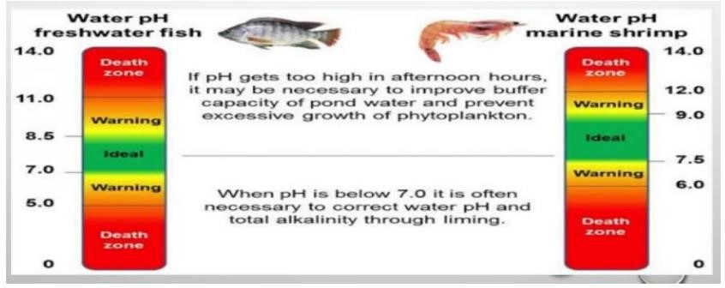

Analog PH Sensor :

It is used to measure PH of water in this work. This PH sensor is specially intended for Arduino andhas built-in convenient connection and features. A BNC connector is required to connect the sensor with Arduino. The range of this sensor is 0-14 PH. It has an accuracy of ±0.1 pH at a standard temperature of 25ºC and operating temperature range is 0-60°C. Just a few sections of the sensor may be inserted into the water. The reliability of this pH sensor can last for a half year when the water is clean and one month for water with high turbidity.

.

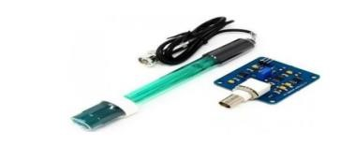

Dissolved Oxygen Sensor:

The probe measures the production of the oxygen in the water, the main use of this sensor is to monitor the respiration of the shrimp in the water. This probe can be fully immersed in marine or salt water as it consists of a polyethylene membrane, in which the oxygen molecules defuse inside in it. Once the oxygen molecules crosses the membrane the values are noted. If no oxygen molecules are present, then the probe will give an output-0.

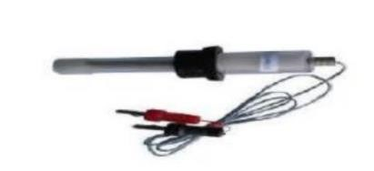

Node MCU:

Node MCU is an open source IOT platform which has inbuilt Wi-Fi platform init. It mainly refers to the firmware which uses scripting language. The main features are the Wi-Fi access point & microcontroller. In Arduino IDE, the code will be written & dumbed into the node MCU. The Node mcu is used as the communication coordinator to the two analog sensor and hencefor communication of sensors. The sensors data gets displayed in the dashboard & also gets stored. The sensors connected to the boards, once the WIFI gets connected to the node mcu the values are shown in an IOT platform “Ubidots”. In the ubidots events are created for higher & lower values to be emailed or a text message and even a voice call regarding the sensor’s values, the timestamp & the solution. Every 5 seconds the measurement is taken, as the request of each sensor is sent, the information is redirected to the application connected to the computer

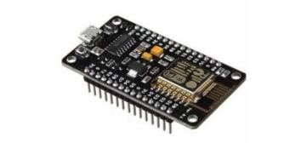

**Irrigation problems:**

.

There are no automatic oxygen checking devices.

* If weeds grow in aquatic culture, then they harm the aquatic life. As we dealt with the fish ecosystem these weeds kill fishes. It also leads to depletion of oxygen. Where these weeds at night time will not release the oxygen.
* Paddle cost is too high.
* Oxygen levels will not be constant in every season it gets changed in every season.
* And we can not know how much time it takes to grow a fish in a healthy way.
* Overflow of water in the pond.
* Loss occurs annually due to several reasons.
* Quality of water cannot be maintained for the fish growth.
* Low pH can cause damage to the gills, skin and eyes.
* Higher H+ concentrations will also increase the permeability of the gills, leading to leakage of Na+ and Cl− which creates osmotic problems.

### CHAPTER 6: RECOMMENDATIONS AND CONCLUSIONS OF THE MINIPROJECT

The main purpose of this study is to develop and a design a system that monitors the pH level and temperature with dissolve oxygen control in aquatic system. The probes of the sensors in pH and D.O. were immersed inside the pond to monitor their values. Using experimental methods in testing the functionality of the different sensors, results show that the system was able to successfully monitor these factors. Information coming from the system such as the pH and dissolve oxygen readings were then displayed to an android mobile phone the Bluetooth serial module stored and displayed to the system software. To control the levels of dissolve oxygen the aerators are connected to the ardunio board. As a result, aqua farmers benefit from a system that works efficiently based on sensor readings and reduces maintenance costs as well as electricity bills. This will help farmers to visit ponds less frequently by using a mobile phone to monitor the conditions of the pond.

CONCLUSION :

We conclude that temperature, pH and oxygen levels can be monitored remotely and in real time via a server with WIFI module. When the oxygen level is below the specified value, the aerator automatically turns on and will turn off when the oxygen level is above the specified value by using the sensors

### Student Self-Evaluation for the Community Service Project

Student Name: Chennakesavula Sri Datta

Registration No:21481A0547

Period of CSP:From: 15-5-2023 To:16-9-2023

Date of Evaluation: 26-12-2023

Name of the Person in-charge: N.Srivani

Address with mobilenumber: Gudlavalleru,8143924885.

**Please rate your performance in the following areas:**

**Rating Scale: 1 is lowest and 5 is highest rank**

### 1) Oral communication 1 2 3 4 5

|  |  |  |  |  |  |  |  |  |  |
| --- | --- | --- | --- | --- | --- | --- | --- | --- | --- |
| **2) Written communication** |  | **1** |  | **2** |  | **3** |  | **4** | **5** |
| **3) Pro activeness** |  | **1** |  | **2** |  | **3** |  | **4** | **5** |
| **4) Interactionability with community** |  | **1** |  | **2** |  | **3** |  | **4** | **5** |
| **5) Positive Attitude** |  | **1** |  | **2** |  | **3** |  | **4** | **5** |
| **6)Self-confidence** |  | **1** |  | **2** |  | **3** |  | **4** | **5** |
| **7) Ability to learn** |  | **1** |  | **2** |  | **3** |  | **4** | **5** |
| **8) Work Plan and organization** |  | **1** |  | **2** |  | **3** |  | **4** | **5** |
| **9) Professionalism** |  | **1** |  | **2** |  | **3** |  | **4** | **5** |
| **10)Creativity** |  | **1** |  | **2** |  | **3** |  | **4** | **5** |
| **11)Quality of work done** |  | **1** |  | **2** |  | **3** |  | **4** | **5** |
| **12)Time Management** |  | **1** |  | **2** |  | **3** |  | **4** | **5** |
| **13)Understanding the Community** |  | **1** |  | **2** |  | **3** |  | **4** | **5** |
| **14)Achievement of Desired Outcomes** |  | **1** |  | **2** |  | **3** |  | **4** | **5** |
| **15)OVERALL PERFORMANCE** |  | **1** |  | **2** |  | **3** |  | **4** | **5** |

### Date: Signature of the Student

Student Name: Dasari Leela Lokesh

Registration No:21481A0555

Period of CSP:From: 15-5-2023 To:16-9-2023

Date of Evaluation: 26-12-2023

Name of the Person in-charge: N.Srivani

Address with mobilenumber: Gudlavalleru,8143924885.

|  |  |  |  |  |  |  |  |  |  |
| --- | --- | --- | --- | --- | --- | --- | --- | --- | --- |
| **Please rate your performance in the following areas:**    **Rating Scale: 1 is lowest and 5 is highest rank** | |  |  |  |  |  |  |  |  |
|  |  |
| **1) Oral communication** |  | **1** |  | **2** |  | **3** |  | **4** | **5** |
| **2) Written communication** |  | **1** |  | **2** |  | **3** |  | **4** | **5** |
| **3) Pro activeness** |  | **1** |  | **2** |  | **3** |  | **4** | **5** |
| **4) Interactionability with community** |  | **1** |  | **2** |  | **3** |  | **4** | **5** |
| **5) Positive Attitude** |  | **1** |  | **2** |  | **3** |  | **4** | **5** |
| **6)Self-confidence** |  | **1** |  | **2** |  | **3** |  | **4** | **5** |
| **7) Ability to learn** |  | **1** |  | **2** |  | **3** |  | **4** | **5** |
| **8) Work Plan and organization** |  | **1** |  | **2** |  | **3** |  | **4** | **5** |
| **9) Professionalism** |  | **1** |  | **2** |  | **3** |  | **4** | **5** |
| **10)Creativity** |  | **1** |  | **2** |  | **3** |  | **4** | **5** |
| **11)Quality of work done** |  | **1** |  | **2** |  | **3** |  | **4** | **5** |
| **12)Time Management** |  | **1** |  | **2** |  | **3** |  | **4** | **5** |
| **13)Understanding the Community** |  | **1** |  | **2** |  | **3** |  | **4** | **5** |
| **14)Achievement of Desired Outcomes** |  | **1** |  | **2** |  | **3** |  | **4** | **5** |
| **15)OVERALL PERFORMANCE** |  | **1** |  | **2** |  | **3** |  | **4** | **5** |

Student Name: Abdul Khaleel

Registration No:21481A0502

Period of CSP:From: 15-5-2023 To:16-9-2023

Date of Evaluation: 26-12-2023

Name of the Person in-charge: N.Srivani

Address with mobilenumber: Gudlavalleru,8143924885.

**Please rate your performance in the following areas:**

**Rating Scale: 1 is lowest and 5 is highest rank**

### 1) Oral communication 1 2 3 4 5

|  |  |  |  |  |  |  |  |  |  |
| --- | --- | --- | --- | --- | --- | --- | --- | --- | --- |
| **2) Written communication** |  | **1** |  | **2** |  | **3** |  | **4** | **5** |
| **3) Pro activeness** |  | **1** |  | **2** |  | **3** |  | **4** | **5** |
| **4) Interaction ability with community** |  | **1** |  | **2** |  | **3** |  | **4** | **5** |
| **5) Positive Attitude** |  | **1** |  | **2** |  | **3** |  | **4** | **5** |
| **6)Self-confidence** |  | **1** |  | **2** |  | **3** |  | **4** | **5** |
| **7) Ability to learn** |  | **1** |  | **2** |  | **3** |  | **4** | **5** |
| **8) Work Plan and organization** |  | **1** |  | **2** |  | **3** |  | **4** | **5** |
| **9) Professionalism** |  | **1** |  | **2** |  | **3** |  | **4** | **5** |
| **10)Creativity** |  | **1** |  | **2** |  | **3** |  | **4** | **5** |
| **11)Quality of work done** |  | **1** |  | **2** |  | **3** |  | **4** | **5** |
| **12)Time Management** |  | **1** |  | **2** |  | **3** |  | **4** | **5** |
| **13)Understanding the Community** |  | **1** |  | **2** |  | **3** |  | **4** | **5** |
| **14)Achievement of Desired Outcomes** |  | **1** |  | **2** |  | **3** |  | **4** | **5** |
| **15)OVERALL PERFORMANCE** |  | **1** |  | **2** |  | **3** |  | **4** | **5** |

Student Name: Cheeli Enoush

Registration No:22485A0506

Period of CSP:From: 15-5-2023 To:16-9-2023

Date of Evaluation: 26-12-2023

Name of the Person in-charge: N.Srivani

Address with mobilenumber: Gudlavalleru,8143924885.

**Please rate your performance in the following areas:**

**Rating Scale: 1 is lowest and 5 is highest rank**

### 1) Oral communication 1 2 3 4 5

|  |  |  |  |  |  |  |  |  |  |
| --- | --- | --- | --- | --- | --- | --- | --- | --- | --- |
| **2) Written communication** |  | **1** |  | **2** |  | **3** |  | **4** | **5** |
| **3) Pro activeness** |  | **1** |  | **2** |  | **3** |  | **4** | **5** |
| **4) Interactionability with community** |  | **1** |  | **2** |  | **3** |  | **4** | **5** |
| **5) Positive Attitude** |  | **1** |  | **2** |  | **3** |  | **4** | **5** |
| **6)Self-confidence** |  | **1** |  | **2** |  | **3** |  | **4** | **5** |
| **7) Ability to learn** |  | **1** |  | **2** |  | **3** |  | **4** | **5** |
| **8) Work Plan and organization** |  | **1** |  | **2** |  | **3** |  | **4** | **5** |
| **9) Professionalism** |  | **1** |  | **2** |  | **3** |  | **4** | **5** |
| **10)Creativity** |  | **1** |  | **2** |  | **3** |  | **4** | **5** |
| **11)Quality of work done** |  | **1** |  | **2** |  | **3** |  | **4** | **5** |
| **12)Time Management** |  | **1** |  | **2** |  | **3** |  | **4** | **5** |
| **13)Understanding the Community** |  | **1** |  | **2** |  | **3** |  | **4** | **5** |
| **14)Achievement of Desired Outcomes** |  | **1** |  | **2** |  | **3** |  | **4** | **5** |
| **15)OVERALL PERFORMANCE** |  | **1** |  | **2** |  | **3** |  | **4** | **5** |

### Student Self-Evaluation for the Community Service Project

Student Name: Dara Bharath Sri Vamsi

Registration No:20481A0540

Period of CSP:From: 15-5-2023 To:16-9-2023

Date of Evaluation: 26-12-2023

Name of the Person in-charge: N.Srivani

Address with mobilenumber: Gudlavalleru,8143924885.

**Please rate your performance in the following areas:**

**Rating Scale: 1 is lowest and 5 is highest rank**

### 1) Oral communication 1 2 3 4 5

|  |  |  |  |  |  |  |  |  |  |
| --- | --- | --- | --- | --- | --- | --- | --- | --- | --- |
| **2) Written communication** |  | **1** |  | **2** |  | **3** |  | **4** | **5** |
| **3) Pro activeness** |  | **1** |  | **2** |  | **3** |  | **4** | **5** |
| **4) Interactionability with community** |  | **1** |  | **2** |  | **3** |  | **4** | **5** |
| **5) Positive Attitude** |  | **1** |  | **2** |  | **3** |  | **4** | **5** |
| **6)Self-confidence** |  | **1** |  | **2** |  | **3** |  | **4** | **5** |
| **7) Ability to learn** |  | **1** |  | **2** |  | **3** |  | **4** | **5** |
| **8) Work Plan and organization** |  | **1** |  | **2** |  | **3** |  | **4** | **5** |
| **9) Professionalism** |  | **1** |  | **2** |  | **3** |  | **4** | **5** |
| **10)Creativity** |  | **1** |  | **2** |  | **3** |  | **4** | **5** |
| **11)Quality of work done** |  | **1** |  | **2** |  | **3** |  | **4** | **5** |
| **12)Time Management** |  | **1** |  | **2** |  | **3** |  | **4** | **5** |
| **13)Understanding the Community** |  | **1** |  | **2** |  | **3** |  | **4** | **5** |
| **14)Achievement of Desired Outcomes** |  | **1** |  | **2** |  | **3** |  | **4** | **5** |
| **15)OVERALL PERFORMANCE** |  | **1** |  | **2** |  | **3** |  | **4** | **5** |

**Date: Signature of the Student**

### Evaluation by the Person in-charge in the Community/Habitation

Student Name: Chennakesavula Sri Datta

Registration No:21481A0547

Period of CSP:From: 15-5-2023 To:16-9-2023

Date of Evaluation: 26-12-2023

Name of the Person in-charge: N.Srivani

Address with mobilenumber: Gudlavalleru,8143924885.

**Please rate the student’s performance in the following areas:**

**Please note that your evaluation shall be done independent of the Student’s selfevaluation Rating Scale: 1 is lowest and 5 is highest rank**

### 1) Oral communication 1 2 3 4 5

|  |  |  |  |  |  |  |  |  |
| --- | --- | --- | --- | --- | --- | --- | --- | --- |
| **2) Written communication** |  | **1** | **2** |  | **3** |  | **4** | **5** |
| **3) Pro activeness** |  | **1** | **2** |  | **3** |  | **4** | **5** |
| **4) Interactionability with community** |  | **1** | **2** |  | **3** |  | **4** | **5** |
| **5) Positive Attitude** |  | **1** | **2** |  | **3** |  | **4** | **5** |
| **6)Self-confidence** |  | **1** | **2** |  | **3** |  | **4** | **5** |
| **7) Ability to learn** |  | **1** | **2** |  | **3** |  | **4** | **5** |
| **8) Work Plan and organization** |  | **1** | **2** |  | **3** |  | **4** | **5** |
| **9) Professionalism** |  | **1** | **2** |  | **3** |  | **4** | **5** |
| **10)Creativity** |  | **1** | **2** |  | **3** |  | **4** | **5** |
| **11)Quality ofwork done** |  | **1** | **2** |  | **3** |  | **4** | **5** |
| **12)Time Management** |  | **1** | **2** |  | **3** |  | **4** | **5** |
| **13)Understanding the Community** |  | **1** | **2** |  | **3** |  | **4** | **5** |
| **14)Achievement of Desired Outcomes** |  | **1** | **2** |  | **3** |  | **4** | **5** |
| **15)OVERALL PERFORMANCE** |  | **1** | **2** |  | **3** |  | **4** | **5** |

### Evaluation by the Person in-charge in the Community/Habitation

Student Name: Dasari Leela Lokesh

Registration No:21481A0555

Period of CSP:From: 15-5-2023 To:16-9-2023

Date of Evaluation: 26-12-2023

Name of the Person in-charge: N.Srivani

Address with mobilenumber: Gudlavalleru,8143924885.

**Please rate the student’s performance in the following areas:**

### Please note that your evaluation shall be done independent of the Student’s selfevaluation Rating Scale: 1 is lowest and 5is highest rank

|  |  |  |  |  |  |  |  |  |
| --- | --- | --- | --- | --- | --- | --- | --- | --- |
| **1) Oral communication** |  | **1** | **2** |  | **3** |  | **4** | **5** |
| **2) Written communication** |  | **1** | **2** |  | **3** |  | **4** | **5** |
| **3) Pro activeness** |  | **1** | **2** |  | **3** |  | **4** | **5** |
| **4) Interactionability with community** |  | **1** | **2** |  | **3** |  | **4** | **5** |
| **5) Positive Attitude** |  | **1** | **2** |  | **3** |  | **4** | **5** |
| **6)Self-confidence** |  | **1** | **2** |  | **3** |  | **4** | **5** |
| **7) Ability to learn** |  | **1** | **2** |  | **3** |  | **4** | **5** |
| **8) Work Plan and organization** |  | **1** | **2** |  | **3** |  | **4** | **5** |
| **9) Professionalism** |  | **1** | **2** |  | **3** |  | **4** | **5** |
| **10)Creativity** |  | **1** | **2** |  | **3** |  | **4** | **5** |
| **11)Quality of work done** |  | **1** | **2** |  | **3** |  | **4** | **5** |
| **12)Time Management** |  | **1** | **2** |  | **3** |  | **4** | **5** |
| **13)Understanding the Community** |  | **1** | **2** |  | **3** |  | **4** | **5** |
| **14)Achievement of Desired Outcomes** |  | **1** | **2** |  | **3** |  | **4** | **5** |
| **15)OVERALL PERFORMANCE** |  | **1** | **2** |  | **3** |  | **4** | **5** |

### Evaluation by the Person in-charge in the Community/Habitation

Student Name: Abdul Khaleel

Registration No:21481A0502

Period of CSP:From: 15-5-2023 To:16-9-2023

Date of Evaluation: 26-12-2023

Name of the Person in-charge: N.Srivani

Address with mobilenumber: Gudlavalleru,8143924885.

**Please rate the student’s performance in the following areas:**

**Please note that your evaluation shall be done independent of the Student’s selfevaluation Rating Scale: 1 is lowest and 5 is highest rank**

### 1) Oral communication 1 2 3 4 5

|  |  |  |  |  |  |  |  |  |
| --- | --- | --- | --- | --- | --- | --- | --- | --- |
| **2) Written communication** |  | **1** | **2** |  | **3** |  | **4** | **5** |
| **3) Pro activeness** |  | **1** | **2** |  | **3** |  | **4** | **5** |
| **4) Interactionability with community** |  | **1** | **2** |  | **3** |  | **4** | **5** |
| **5) Positive Attitude** |  | **1** | **2** |  | **3** |  | **4** | **5** |
| **6)Self-confidence** |  | **1** | **2** |  | **3** |  | **4** | **5** |
| **7) Ability to learn** |  | **1** | **2** |  | **3** |  | **4** | **5** |
| **8) Work Plan and organization** |  | **1** | **2** |  | **3** |  | **4** | **5** |
| **9) Professionalism** |  | **1** | **2** |  | **3** |  | **4** | **5** |
| **10)Creativity** |  | **1** | **2** |  | **3** |  | **4** | **5** |
| **11)Quality ofwork done** |  | **1** | **2** |  | **3** |  | **4** | **5** |
| **12)Time Management** |  | **1** | **2** |  | **3** |  | **4** | **5** |
| **13)Understanding the Community** |  | **1** | **2** |  | **3** |  | **4** | **5** |
| **14)Achievement of Desired Outcomes** |  | **1** | **2** |  | **3** |  | **4** | **5** |
| **15)OVERALL PERFORMANCE** |  | **1** | **2** |  | **3** |  | **4** | **5** |

### Evaluation by the Person in-charge in the Community/Habitation

Student Name: Cheeli Enoush

Registration No:22485A0506

Period of CSP:From: 15-5-2023 To:16-9-2023

Date of Evaluation: 26-12-2023

Name of the Person in-charge: N.Srivani

Address with mobilenumber: Gudlavalleru,8143924885.

**Please rate the student’s performance in the following areas:**

**Please note that your evaluation shall be done independent of the Student’s selfevaluation Rating Scale: 1 is lowest and 5 is highest rank**

### 1) Oral communication 1 2 3 4 5

|  |  |  |  |  |  |  |  |  |
| --- | --- | --- | --- | --- | --- | --- | --- | --- |
| **2) Written communication** |  | **1** | **2** |  | **3** |  | **4** | **5** |
| **3) Pro activeness** |  | **1** | **2** |  | **3** |  | **4** | **5** |
| **4) Interactionability with community** |  | **1** | **2** |  | **3** |  | **4** | **5** |
| **5) Positive Attitude** |  | **1** | **2** |  | **3** |  | **4** | **5** |
| **6)Self-confidence** |  | **1** | **2** |  | **3** |  | **4** | **5** |
| **7) Ability to learn** |  | **1** | **2** |  | **3** |  | **4** | **5** |
| **8) Work Plan and organization** |  | **1** | **2** |  | **3** |  | **4** | **5** |
| **9) Professionalism** |  | **1** | **2** |  | **3** |  | **4** | **5** |
| **10)Creativity** |  | **1** | **2** |  | **3** |  | **4** | **5** |
| **11)Quality ofwork done** |  | **1** | **2** |  | **3** |  | **4** | **5** |
| **12)Time Management** |  | **1** | **2** |  | **3** |  | **4** | **5** |
| **13)Understanding the Community** |  | **1** | **2** |  | **3** |  | **4** | **5** |
| **14)Achievement of Desired Outcomes** |  | **1** | **2** |  | **3** |  | **4** | **5** |
| **15)OVERALL PERFORMANCE** |  | **1** | **2** |  | **3** |  | **4** | **5** |

### Evaluation by the Person in-charge in the Community/Habitation

Student Name: Dara Bharath Sri Vamsi

Registration No:20481A0540

Period of CSP:From: 15-5-2023 To:16-9-2023

Date of Evaluation: 26-12-2023

Name of the Person in-charge: N.Srivani

Address with mobilenumber: Gudlavalleru,8143924885.

**Please rate the student’s performance in the following areas:**

**Please note that your evaluation shall be done independent of the Student’s selfevaluation Rating Scale: 1 is lowest and 5 is highest rank**

### 1) Oral communication 1 2 3 4 5

|  |  |  |  |  |  |  |  |  |
| --- | --- | --- | --- | --- | --- | --- | --- | --- |
| **2) Written communication** |  | **1** | **2** |  | **3** |  | **4** | **5** |
| **3) Pro activeness** |  | **1** | **2** |  | **3** |  | **4** | **5** |
| **4) Interactionability with community** |  | **1** | **2** |  | **3** |  | **4** | **5** |
| **5) Positive Attitude** |  | **1** | **2** |  | **3** |  | **4** | **5** |
| **6)Self-confidence** |  | **1** | **2** |  | **3** |  | **4** | **5** |
| **7) Ability to learn** |  | **1** | **2** |  | **3** |  | **4** | **5** |
| **8) Work Plan and organization** |  | **1** | **2** |  | **3** |  | **4** | **5** |
| **9) Professionalism** |  | **1** | **2** |  | **3** |  | **4** | **5** |
| **10)Creativity** |  | **1** | **2** |  | **3** |  | **4** | **5** |
| **11)Quality ofwork done** |  | **1** | **2** |  | **3** |  | **4** | **5** |
| **12)Time Management** |  | **1** | **2** |  | **3** |  | **4** | **5** |
| **13)Understanding the Community** |  | **1** | **2** |  | **3** |  | **4** | **5** |
| **14)Achievement of Desired Outcomes** |  | **1** | **2** |  | **3** |  | **4** | **5** |
| **15)OVERALL PERFORMANCE** |  | **1** | **2** |  | **3** |  | **4** | **5** |

**Date: Signature of the Supervisor**

### PHOTOS AND VIDEO LINKS

blob:https://web.whatsapp.com/4ae5a988-21f2-41f3-9662-c8564aab9979

blob:https://web.whatsapp.com/1cfb09db-929c-4fda-95b6-9fb882716625

blob:https://web.whatsapp.com/67bba9a5-2241-4d75-87dd-6b249afc0df6