EXP NO: 7

22481A0504:

AIM:

Install a database and design a Web application using JSP:

1. To connect to the database using JDBC.
2. Create new tables.
3. Insert the details of the users who register through the registration page of the online book store web site in to the database. iv. Retrieve and display data related to books stored in the tables to the user.

PROGRAM:

<%@page import="java.sql.\*"%>

<%

try{

Class.forName("oracle.jdbc.driver.OracleDriver"); out.println("Class will loaded");

Connection

con=DriverManager.getConnection("jdbc:Oracle:thin:@localhost:1521:xe","SYSTEM","cse"); out.println("database connected");

Statement st=con.createStatement();

ResultSet rs=st.executeQuery("CREATE TABLE bookstore2(title varchar(30),author varchar(20),publisher varchar2(20),price varchar2(20))"); out.println("Create table successfully");

}

catch(Exception e)

{

out.println(e);

}

%>

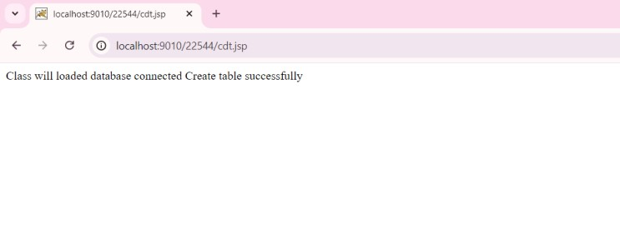

<html>

<body bgcolor="cyan">

<h2 align="center">Book-Details</h2>

<center>

<form name="f1" action="insert.jsp">

<table border="1">

<tr>

<td><label>Book-Title</label></td>

<td><input type="text" name="bt"></td>

</tr>

<tr>

<td><label>Author-Name</label></td>

<td><input type="text" name="an"></td>

</tr>

<tr>

<td><label>Publisher-Details</label></td>

<td><input type="text" name="pd"></td>

</tr>

<tr>

<td><label>Price</label></td>

<td><input type="text" name="price"></td>

</tr>

<tr>

<td><input type="submit" value="Store"></td>

<td><input type="reset" value="Clear"></td>

</tr>

</table>

</form>

</center>

</body>

</html>

<%@ page language="java" contentType="text/html" pageEncoding="UTF-8"%> <%@ page import="java.sql.\*" %>

<%

String title = request.getParameter("bt");

String author = request.getParameter("an");

String publisher = request.getParameter("pd");

String price = request.getParameter("price");

Connection conn = null;

PreparedStatement pstmt = null;

try {

Class.forName("oracle.jdbc.driver.OracleDriver"); conn = DriverManager.getConnection("jdbc:oracle:thin:@localhost:1521:xe", "SYSTEM", "cse");

String sql = "INSERT INTO bookstore (title, author, publication, price) VALUES (?, ?, ?, ?)"; pstmt = conn.prepareStatement(sql); pstmt.setString(1, title); pstmt.setString(2, author); pstmt.setString(3, publisher); pstmt.setString(4, price);

int i = pstmt.executeUpdate();

out.println("Data successfully inserted!");

} catch (Exception e) { out.println("An error occurred: " + e.getMessage());

e.printStackTrace(); } finally { if (pstmt != null) try { pstmt.close(); } catch (SQLException e) { e.printStackTrace(); } if (conn != null) try { conn.close(); } catch (SQLException e) { e.printStackTrace(); }

}

%>

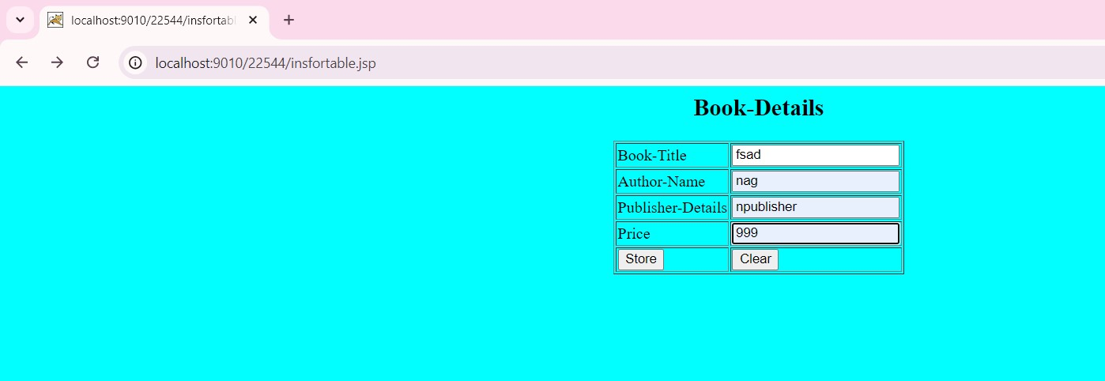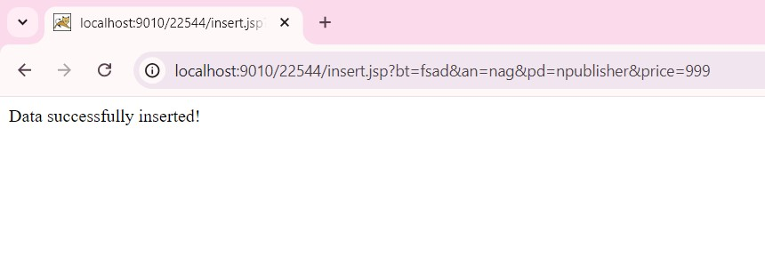

<%@page import="java.sql.\*" %>

<%

try

{

Class.forName("oracle.jdbc.driver.OracleDriver"); out.println("Registered the JDBC driver");

Connection conn = DriverManager.getConnection("jdbc:oracle:thin:@localhost:1521:xe",

"system","cse"); out.println("<br>Connection Established"); Statement stmt = conn.createStatement(); out.println("<br>Statement created");

ResultSet rset = stmt.executeQuery ("SELECT \* FROM bookstore");

out.println("<table border=1 align=center

font=red><tr><td>Title</td><td>Author</td><td>Publisher</td><td>Price</td></tr>");

while(rset.next())

{

out.println("<tr><td>"+rset.getString(1)+"</td><td>"+rset.getString(2)+"</td><td>"+rset.getString

(3)+"</td><td>"+rset.getString(4)+"</td></tr>");

}

out.println("</table>");

}

catch (Exception e)

{

out.println(e);

e.printStackTrace();

}

%>

