EXP NO: 9 22481a0540

AIM: Design a Web application using PHP: i. To connect to the MySQL database. ii. Create new tables. iii. Insert the details of the users who register through the registration page of the online book store web site in to the database. iv. Retrieve and display data related to books stored in the tables to the user

ConnectingtoLocalhost: Conn.php:

<?php

$servername="localhost";

$username="root";

$password="";

$conn=mysqli_connect($servername,$username,$password);

if(!$conn)

{

die("connectionfailed:".mysqli_connect_error());

}

echo("ConnectedSuccessfully");

?>

Output: 

Database.php:

<?php

$servername="localhost";

$username="root";

$password="";

$conn=mysqli_connect($servername,$username,$password);if(

!$conn)

{

die("connectionfailed:".mysqli_connect_error());

}

$sql="CREATEDATABASE20481a0540";

if(mysqli_query($conn,$sql))

{

echo"DatabasecreatedSuccessfully";

}

else

{

echo"ErrorcreatingDatabase";

output



Table.php

<?php

$servername="localhost";

$username="root";

$password="";

$dbname="20481a0540";

$conn=mysqli_connect($servername,$username,$password,$dbname);if(!$conn)

{

die("connectionfailed:".mysqli_connect_error());

}

$sql="CREATE TABLE student(sno varchar(20), sname varchar(20),addr

varchar(20))";if(mysqli_query($conn,$sql))

{

echo"TablecreatedSuccessfully";

}

else

{

echo"Error creating

Table";mysqli_error($conn);

}

mysqli_close($conn);

?>

Output:



Boockstore.php

<html>

<bodybgcolor="cyan">

<h2align="center">Book-Details</h2>

<center>

<formname="f1"action="bookstoreinsert.php"method="post">

<tableborder="1">

<tr>

<td><label>Book-Title</label></td>

<td><inputtype="text"name="bt"></td>

</tr>

<tr>

<td><label>Author-Name</label></td>

<td><inputtype="text"name="an"></td>

</tr>

<tr>

<td><label>Publisher-Details</label></td>

<td><inputtype="text"name="pd"></td>

</tr>

<tr>

<td><label>Price</label></td>

<td><inputtype="text"name="price"></td>

</tr><tr>

<td><inputtype="submit"value="Store"></td>

<td><inputtype="reset"value="Clear"></td>

</tr>

</table>

</form>

</center>

</body>

</html>output:

bookstoreinsert.php:

<?php

/* Attempt MySQL server connection. Assuming you are running

MySQLserver withdefaultsetting(user'root'withnopassword)*/

$link=mysqli_connect("localhost","root","","bookstore");

// Check

connectionif($link==

= false){

die("ERROR:Couldnotconnect.".mysqli_connect_error());

}

//Escapeuserinputsforsecurity

$title =$_POST['bt'];

$author=$_POST['an'];

$pub=$_POST['pd'];

$price=$_POST['price'];

//Attemptinsertqueryexecution

$sql = "INSERT INTO book VALUES ('$title', '$author',

'$pub','$price')";if(mysqli_query($link,$sql)){

echo"Recordsaddedsuccessfully.";

}else{

echo"ERROR:Couldnotabletoexecute$sql.".mysqli_error($link);

}

// Close

connectionmysqli_cl

ose($link);

?>output:

Bookstoredisplay.php:

<?php

$servername="localhost";

$username="root";

$password="";

$dbname="bookstore";

$conn=mysqli_connect($servername,$username,$password,$dbname);

if(!$conn)

{

die("connectionfailed:".mysqli_connect_error());

}

echo"<h1align=center><fontcolor=red>Book-Store-Details</font></h1>";

$res=mysqli_query($conn,"select* frombook"); echo" Title AuthorPublication Price ";while($temp=mysqli_fet ch_array($res)) { echo "".$temp['title']."".$temp['author']."".$temp['public ation']."".$temp['price'].""; } echo"

"; ; mysqli_close($conn); ?>

Output: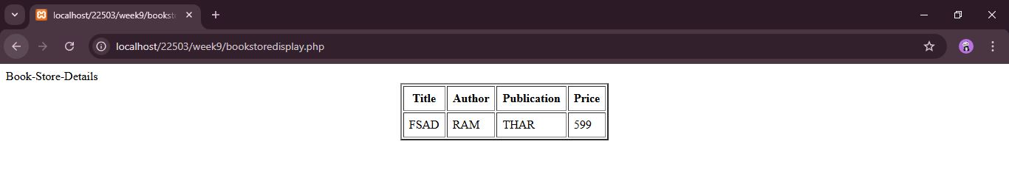

22481a0540

EXPERIMENT- 10

AIM:

Create a user authentication application using PHP where the user submits login name and password to the server through

form. The name and password are verified against the data already available in the database.

i. On successful authentication, display welcome message to the user and create a new session. Otherwise display a

failure message to the user.

User1.php :

<html>

<body bgcolor="Lightblue">

<h1 align="center"><font color="red">Login-Form</font></h1>

<table align="center" border="1">

<form action="loginverification2.php" method="post">

<tr>

<td><label>User Name</td>

<td><input type="text" name="t">

</tr>

<tr>

<td><label>Password</td>

<td><input type="password" name="p">

</tr>

<tr>

<td ><input type="submit" value="Login"></td>

<td><input type="reset" value="Clear"</td>

</tr>

</form>

</table> </body>

</html>

OUTPUT: 

Welcome.php :

<html>

<title>welcome message

</title>

<body bgcolor="white">

<center>

<hr><b>

<h2>congrats...

<font color="red"></font>

you are in home page of this

site

</h2></b>

</center>

<hr>

</body>

</html>

OUTPUT: 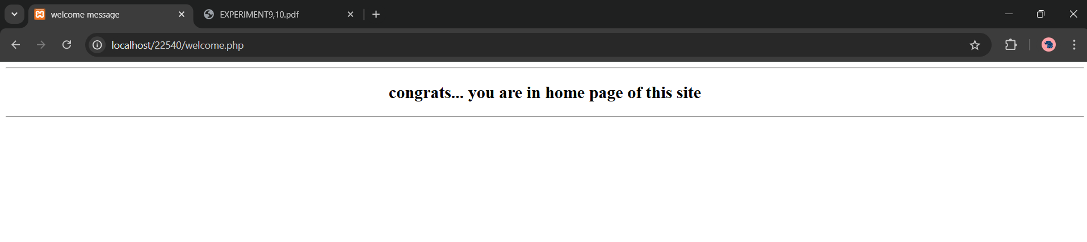

Failure.php :

<html>

<head> </head>

<body align=”center” bgcolor="pink">

<h2><b><hr> Invalid username or password please verify that </b></h2>

<hr><a href="login.php"><b>Try Again</b></a>

</body> </html>

Output: 