Example 1

The following JSP program calculates factorial values for an integer number, while the input is taken from an HTML form.

input.html

<html>  
<body>  
<form action="Factorial.jsp">  
Enter a value for n: <input type="text" name="val">  
<input type="submit" value="Submit">  
</form>  
</body>  
</html>

Factorial.jsp

<html>  
<body>  
<%!  
 long n, result;­­­­­  
 String str;  
  
 long fact(long n) {  
 if(n==0)   
 return 1;   
 else  
 return n\*fact(n-1);  
 }  
%>  
<%   
 str = request.getParameter("val");   
 n = Long.parseLong(str);   
 result = fact(n);  
%>  
<b>Factorial value: </b> <%= result %>  
</body>  
</html>

Output:

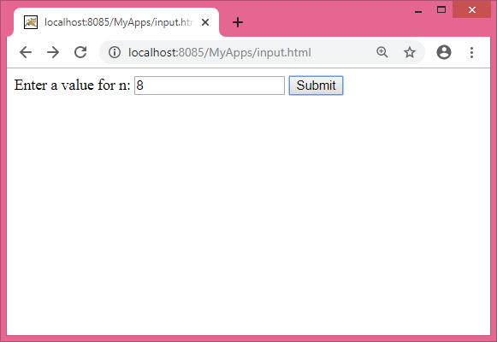

After clicking the “Submit” button we get the following response:

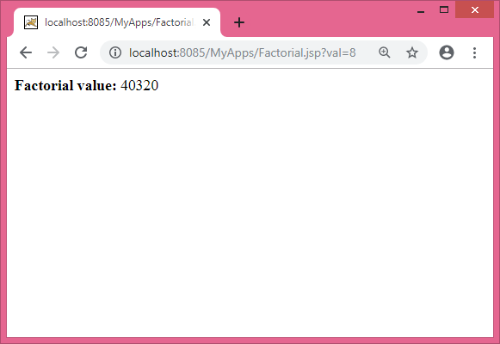

Example 2

The following JSP program shows the Fibonacci series up to a particular term, while the input is taken from an HTML form.

input.html

<html>  
<body>  
<form action="Fibonacci.jsp">  
 Enter a value for n: <input type="text" name="val">  
 <input type="submit" value="Submit">  
</form>  
</body>  
</html>

Fibonacci.jsp

<html>  
<body>  
<%!  
 int n;  
 String str;  
  
 int fibo(int n) {  
 if(n<2)  
 return n;  
 else  
 return fibo(n-1) + fibo(n-2);  
 }  
%>  
<b>Fibonacci series: </b><br>  
<%   
 str = request.getParameter("val");  
 n = Integer.parseInt(str);  
  
 for(int i=0; i<=n; i++) {  
 out.print(fibo(i) + " ");  
 }  
%>  
</body>  
</html>

Output:

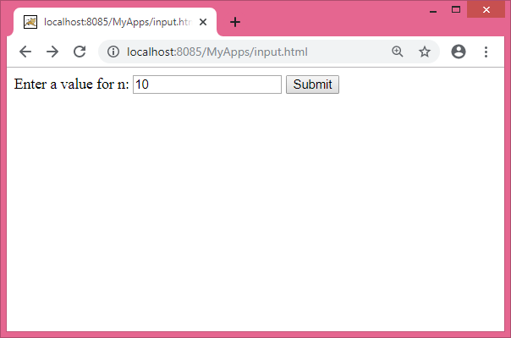

After clicking the “Submit” button we get the following response:

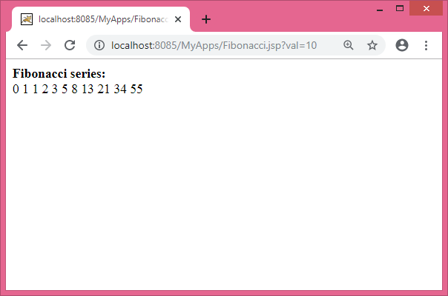

Example 3

The following JSP program shows the System date and time.

Date.jsp

<html>  
<body>  
<%-- JSP comments --%>  
<%@page import="java.util.Date"%>  
<%!  
 Date date;   
%>  
<%   
 date = new Date();  
%>  
<b>System date and time: </b> <%= date %>  
</body>  
</html>

Output:

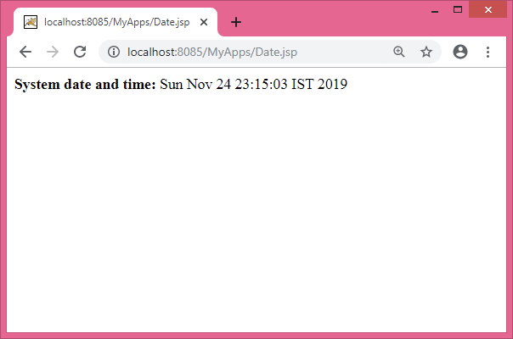

Example 4

The following JSP program calculates Powers of 2 for integers in the range 0-10.

PowersOf2.jsp

<html>  
<head>  
 <title>Powers of 2</title>  
</head>  
<body>  
<center>  
<table border="2" align="center">  
 <th>Exponent</th>  
 <th>2^Exponent</th>  
 <% for (int i=0; i<=10; i++) { //start for loop %>  
 <tr>  
 <td><%= i%></td>  
 <td><%= Math.pow(2, i) %></td>  
 </tr>  
 <% } //end for loop %>  
</table>  
</center>  
</body>  
</html>

Output:

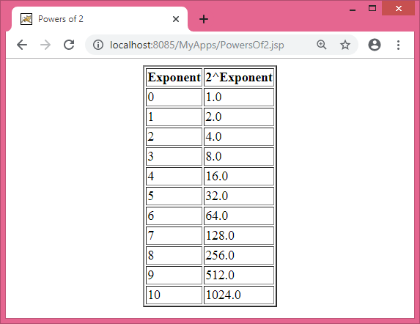

Example 5

The following JSP program shows a Sample Order Form.

OrderForm.jsp

<HTML>  
<HEAD>  
 <TITLE>A Catalog Order Form</TITLE>  
</HEAD>  
<BODY>  
<H1 ALIGN="center">A Sample Order Form</H1>  
<%!   
 String item[] = {"DVD", "CD", "Diskette"};  
 double price[] = {19.99, 12.99, 1.99};  
 int quantity[] = {2, 9, 24};  
%>  
<TABLE ALIGN="center" BGCOLOR="lightgray" BORDER="1" WIDTH="75%">  
<TR><TD>Item</TD>  
<TD>Price</TD>  
<TD>Quantity</TD>  
<TD>Total Price</TD>  
</TR>  
<% for (int i=0; i<3; i++) { %>   
 <TR><TD><%= item[i] %></TD>  
 <TD><%= price[i] %></TD>  
 <TD><%= quantity[i] %></TD>  
 <TD><%= price[i] \* quantity[i] %></TD>  
 </TR>  
<% } //end for loop %>  
</TABLE>  
</BODY>  
</HTML>

Output:

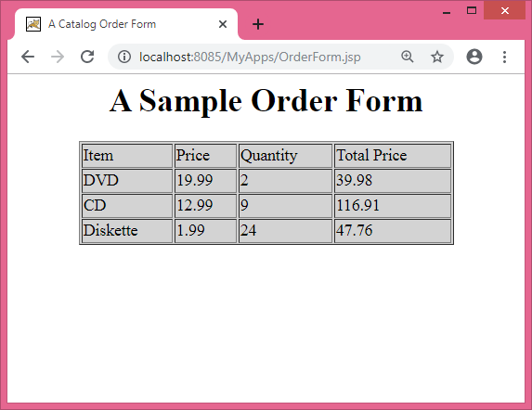

Example 6

The following JSP program shows a Sine Table using java.lang.Math class.

OrderForm.jsp

<html>  
<head>  
 <title>Powers of 2</title>  
</head>  
<body>  
<center>  
<%!   
 int degrees[] = {0, 15, 30, 45, 60, 75, 90};  
 double number;  
 String result;  
%>  
<table border="2" align="center">  
<th>Degree</th><th>Sine Value</th>  
<%   
 for (int i=0; i<degrees.length; i++) { //start for loop   
 number = Math.sin(Math.toRadians(degrees[i]));  
 result = String.format("%.2f", number);  
%>  
 <tr>  
 <td><%= degrees[i] %></td>  
 <td><%= result %></td>  
 </tr>  
<% } //end for loop %>  
</table>  
</center>  
</body>  
</html>

Output:

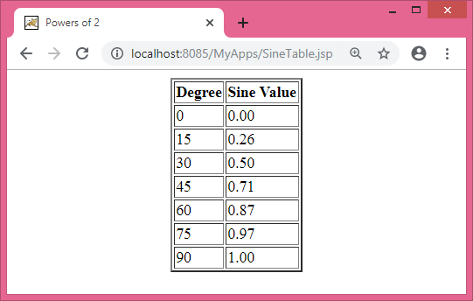

Example 7

The following JSP program shows the use of JSP forward action tag.

ForwardAction.jsp

<html>  
<head>  
 <title>JSP Page</title>  
</head>  
<body>  
<% if (Math.random() > 0.5) { %>  
 <jsp:forward page="PowersOf2.jsp" />  
<% } else { %>  
 <jsp:forward page="SineTable.jsp" />  
<% } %>  
</body>  
</html>

Output:

Depending on the value returned by the Math.random(), the web browser either displays the contents of “PowersOf2.jsp” or displays the contents of “SineTable.jsp“.

Example 8

The following JSP program shows the use of JSP include action tag.

IncludeAction.jsp

<html>  
<head>  
<title>JSP Page</title>  
</head>  
<body>  
<font color="red">Include the First File:</font>  
<br><br>  
<jsp:include page="Date.jsp"/>  
<br><br><br>  
<font color="blue">Include the Second File:</font>  
<br>  
<jsp:include page="OrderForm.jsp"/>  
</body>  
</html>

Output:

