**Experiment - 4**

**AIM**: i. Write a JavaScript to validate the fields of the login page.

ii. Write a JavaScript to validate the fields of the Registration page

**Login**

<!DOCTYPE html>

<html lang="en">

<head>

    <meta charset="UTF-8">

    <meta name="viewport" content="width=device-width, initial-scale=1.0">

    <title>Login Form</title>

    <style>

        body {

            background: linear-gradient( to right, rgb(255, 0, 0), rgb(140, 238, 11));

            font-family: Arial, sans-serif;

            background-color: #f2f2f2;

            display: flex;

            justify-content: center;

            align-items: center;

            height: 100vh;

            margin: 0;

        }

        .login-container {

            background-color: white;

            padding: 20px;

            border-radius: 5px;

            box-shadow: 0 0 10px rgba(0, 0, 0, 0.1);

            width: 300px;

        }

        .login-container h2 {

            margin: 0 0 20px;

        }

        .login-container label {

            display: block;

            margin: 10px 0 5px;

        }

        .login-container input[type="text"],

        .login-container input[type="password"] {

            width: calc(100% - 22px);

            padding: 10px;

            margin-bottom: 10px;

            border: 1px solid #ccc;

            border-radius: 3px;

        }

        .login-container button {

            width: calc(50% - 10px);

            padding: 10px;

            border: none;

            border-radius: 3px;

            cursor: pointer;

        }

        .login-container .submit-btn {

            border-radius: 20px;

            background-color: #4CAF50;

            color: white;

        }

        .login-container .reset-btn {

            border-radius: 20px;

            background-color: #f44336;

            color: white;

        }

        .button-group {

            margin-top: 20px;

            display: flex;

            justify-content: space-between;

        }

    </style>

</head>

<body>

    <div class="login-container">

        <h2>Login</h2>

        <form action="/" method="post">

            <label for="username">Username:</label>

            <input type="text" id="username" name="username" >

            <label for="password">Password:</label>

            <input type="password" id="password" name="password" required>

            <div class="button-group">

                <button type="submit" onclick="sub(event)" class="submit-btn">Submit</button>

                <button type="reset" onreset="ff()" class="reset-btn">Reset</button>

            </div>

        </form>

    </div>

    <script>

function sub(event)

{

    event.preventDefault();

    var name = document.getElementById("username").value ;

    var pwd = document.getElementById("password").value ;

    if (name == "")

    {

              alert("The username cannot be Empty!!");

    }

    if (pwd == "" )

    {

        alert("Should enter password");

    }

    else if(pwd.length <= 6){

        alert("password must be minimum 6 char");

        return;

    }

window.location.href = "content.html";

}

    </script></body></html>

**Output:**

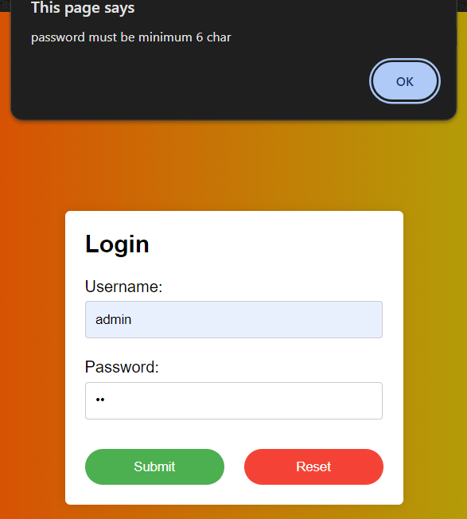

**Register**

<html>

<head>

<title>Registration Form</title>

<style>

body {

font-family: Arial, sans-serif;

display: flex;

justify-content: center;

align-items: center;

height: 100vh;

margin: 0;

background-color: #f4f4f4;

}

form {

max-width: 400px;

width: 100%;

background: #fff;

padding: 20px;

border-radius: 8px;

box-shadow: 0 0 10px rgba(0, 0, 0, 0.1);

}

label {

display: block;

margin-bottom: 5px;

font-weight: bold;

}

input[type="text"],

input[type="email"],

input[type="password"],

input[type="date"],

input[type="tel"],

textarea {

width: 100%;

padding: 10px;

margin-bottom: 15px;

box-sizing: border-box;

border: 1px solid #ddd;

border-radius: 4px;

}

input[type="radio"] {

margin-right: 5px;

}

button {

background-color: #007bff;

color: #fff;

border: none;

padding: 10px;

border-radius: 4px;

cursor: pointer;

width: 100%;

font-size: 16px;

}

button:hover {

background-color: #0056b3;

}

</style>

</head>

<body>

<form id="registrationForm">

<h2>Registration Form</h2

<label for="username">Username:</label>

<input type="text" id="username" name="username">

<label for="email">Email:</label>

<input type="email" id="email" name="email">

<label for="password">Password:</label>

<input type="password" id="password" name="password">

<label for="date">Date of Birth:</label>

<input type="date" id="date" required>

<label for="phone">Phone No:</label>

<input type="tel" id="phone" pattern="[0-9]{10}">

<label for="address">Address:</label>

<textarea id="address" rows="4"></textarea>

<label>Gender:</label>

<label><input type="radio" name="gender" value="male" required> Male</label>

<label><input type="radio" name="gender" value="female"> Female</label>

<button type="submit">Register</button>

</form>

<script>

document.getElementById('registrationForm').addEventListener('submit', function(event) {

event.preventDefault();

const username = document.getElementById('username').value.trim();

const email = document.getElementById('email').value.trim();

const password = document.getElementById('password').value.trim();

const phone = document.getElementById('phone').value.trim();

let valid = true;

let errorMessage = '';

if (username === '') {

errorMessage = 'Username is required.\n';

valid = false;

}

if (email === '') {

errorMessage += 'Email is required.\n';

valid = false;

} else if (!/\S+@\S+\.\S+/.test(email)) {

errorMessage += 'Email is invalid.\n';

valid = false;

}

if (password === '') {

errorMessage += 'Password is required.\n';

valid = false;

} else if (password.length < 6) {

errorMessage += 'Password must be at least 6 characters long.\n';

valid = false;

}

if (phone === '') {

errorMessage += 'Phone number is required.\n';

valid = false;

} else if (phone.length !== 10 || !/^\d{10}$/.test(phone)) {

errorMessage += 'Phone number must be exactly 10 digits.\n';

valid = false;

}

if (!valid) {

alert(errorMessage);

} else {

alert('Registration successful!');

}

});

</script>

</body>

</html>

**Output :**

