**Experiment Title.**

**Student Name: Yash Gupta UID: 20BCS5009**

**Branch: CSE Section/Group: 704-A**

**Semester: 4th Date of Performance:**

**Subject Name: Microprocessor Subject Code: 20CPS-253**

**1. Aim/Overview of the practical:**

# Addition of two 8bit numbers, sum 8 bit.

**2. Apparatus/Simulator used (For applied/experimental sciences/materials based labs):**

# Jubian 8085 Simulator

**3. Algorithm/Flowchart (For programming based labs):**

## 1. Load H-L pair with address 1000H.

## 2.Lower-order of 1000H.

## 3.Higher-order of 1000H.

## 4. Move the 1st operand from memory to reg. A.

## 5. Increment H-L pair.

## 6, Move the 2nd operand from memory to reg. B.

## 7. Initialize reg. C with 00H.

## 8. Immediate value 00H.

## 9. Add B with A.

## 10. Jump to address 000DH if there is no carry.

## 11. Lower-order of 000DH.

## 12. Higher-order of 000DH.

## 13. Increment reg. C.

## 14. Increment H-L pair.

## 15. Move the result from reg. A to memory.

## 16. Increment H-L pair.

## 17. Move carry from reg. C to memory.

## 18. Halt.

**4. Code:**

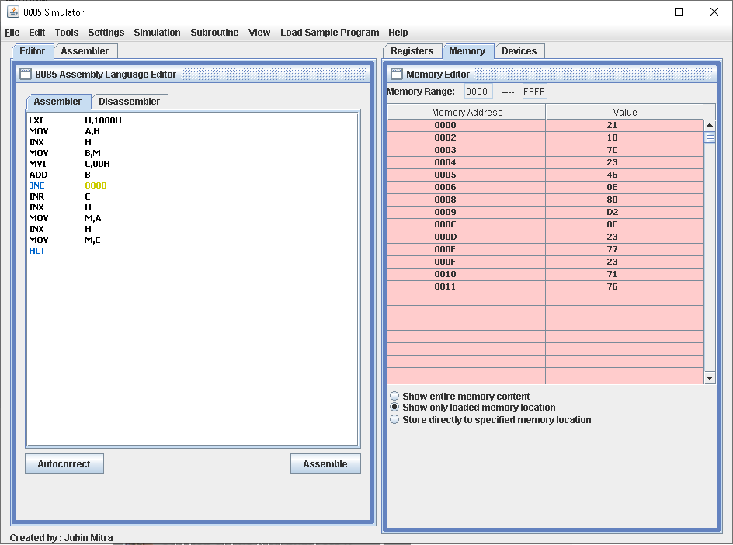

LXI H,1000H

MOV A,H

INX H

MOV B,M

MVI C,00H

ADD B

JNC 0000

INR C

INX H

MOV M,A

INX H

MOV M,C

HLT

**5. Output:**



**Evaluation Grid (To be created as per the SOP and Assessment guidelines by the faculty):**

|  |  |  |  |
| --- | --- | --- | --- |
| Sr. No. | Parameters | Marks Obtained | Maximum Marks |
| 1. |  |  |  |
| 2. |  |  |  |
| 3. |  |  |  |
|  |  |  |  |