**Experiment 1.2**

**Student Name: Yash Gupta UID: 20BCS5009**

**Branch: Computer Science Engineering Section/Group: 704-A**

**Semester: 4th Date of Performance:**

**Subject Name: Microprocessor Subject Code: 20CSP-253**

**1. Aim/Overview of the practical:**

Addition of two 16bit numbers, sum 16 bit.

**2. Apparatus/Simulator used (For applied/experimental sciences/materials based labs):**

Jubin 8085 Simulator

**4. Algorithm/Flowchart (For programming based labs):**

1. Load H-L pair with data from 3000 H
2. Exchange H-L pair with D-E pair
3. Load H-L pair with data from 3002 H
4. Move 0 to C
5. Add D-E pair with H-L pair
6. Jump to location 200E H if no carry
7. Increment C
8. Store the result at location 3004 H
9. Move carry from C to A
10. Store the carry at location 3006 H
11. Halt

**5. Code:**

1. LHLD 3000H
2. XCHG
3. LHLD 3002H
4. MVI C,00
5. DAD D
6. JNC down
7. INR C
8. MOV A,C
9. STA 3006H
10. down: SHLD 3004H
11. HLT

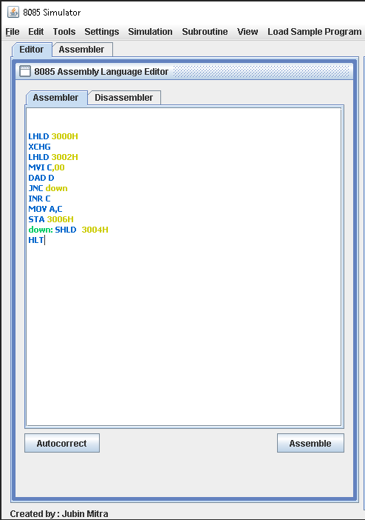

**6. Output:**

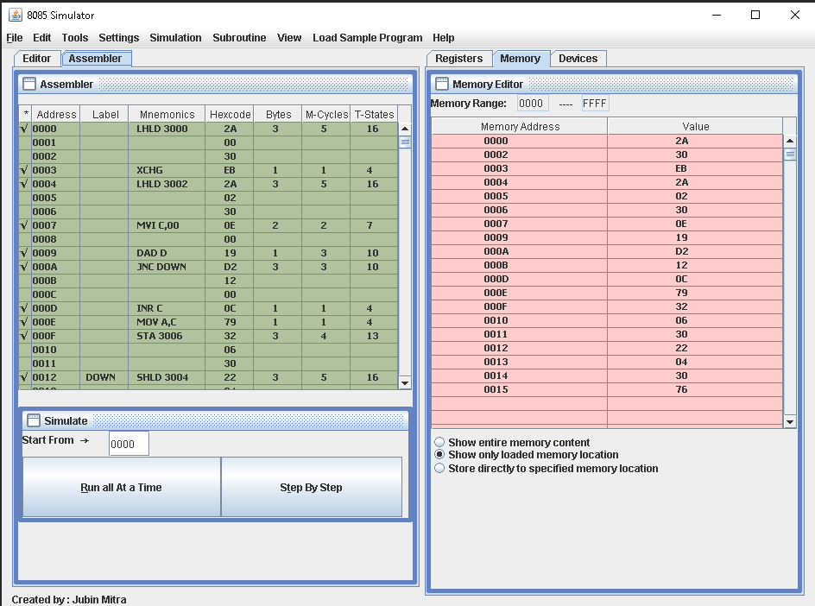

**Evaluation Grid (To be created as per the SOP and Assessment guidelines by the faculty):**

|  |  |  |  |
| --- | --- | --- | --- |
| Sr. No. | Parameters | Marks Obtained | Maximum Marks |
| 1. |  |  |  |
| 2. |  |  |  |
| 3. |  |  |  |
|  |  |  |  |