**Experiment 1.3**

**Student Name: Yash Gupta UID: 20BCS5009**

**Branch: CSE Section/Group: 704-A**

**Semester: 4th Date of Performance: 22/02/22**

**Subject Name: Microprocessor Subject Code: 20CSP-253**

**1. Aim**

## **To do Subtraction of two 8’bit and 16’bit hexadecimal numbers 8085.**

**2. Apparatus/Simulator used (For applied/experimental sciences/materials based labs):**

## **Jubin 8085 simulator**

**3. Algorithm/Flowchart (For programming based labs):**

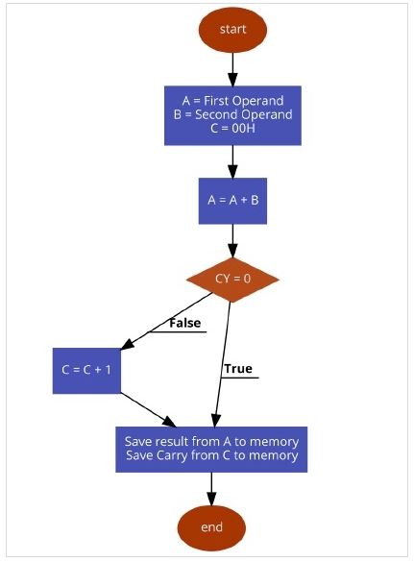

**4.Code:**

## **8’bit subtraction :-**

#BEGIN 0000H

MVI C,00H

LDA 2000H

MOV B,A

LDA 2001H

SUB B

JNC down

INR C

down: STA 2003H

MOV A,C

STA 2005H

HLT

#ORG 2000H

#DB 02,08

## 16’bit subtraction :-

**# BEGIN 0000**

**LHLD 9000**

**XCHG**

**LHLD 9002**

**MVI C,00**

**MOV A,E**

**SUB L**

**STA 9004**

**MOV A,D**

**SBB H**

**STA 9005**

**JNC MOVE**

**INR C**

**MOVE: MOV A,C**

**STA 9006**

**HLT**

**#ORG 9000**

**#DB 45,A6,23,A6**

**5.Output:**

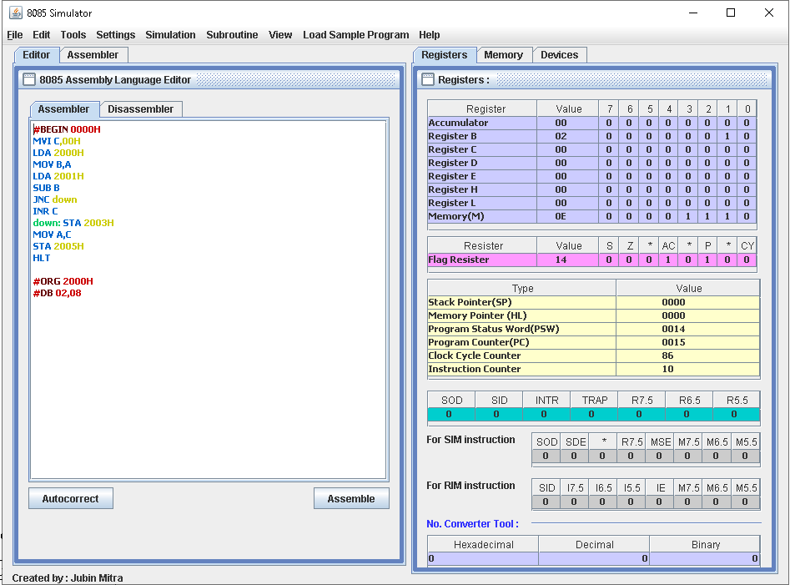

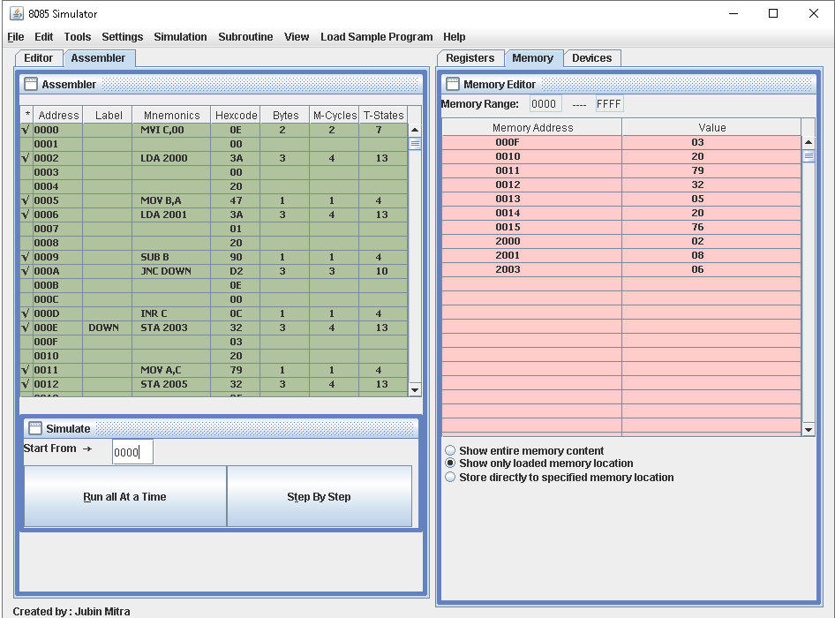

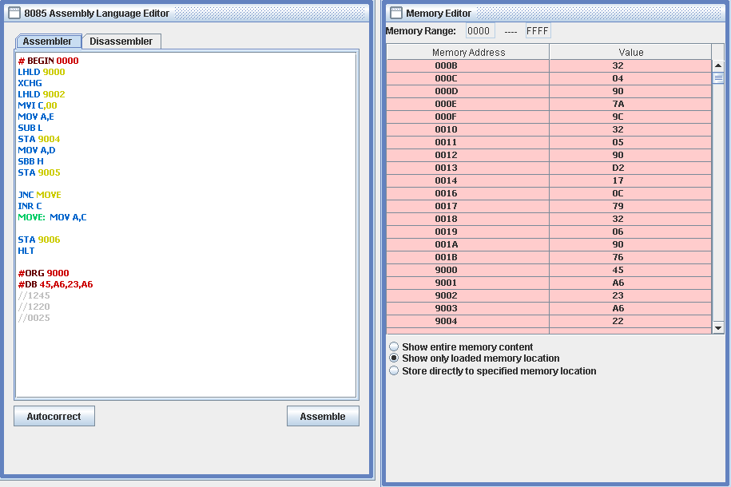

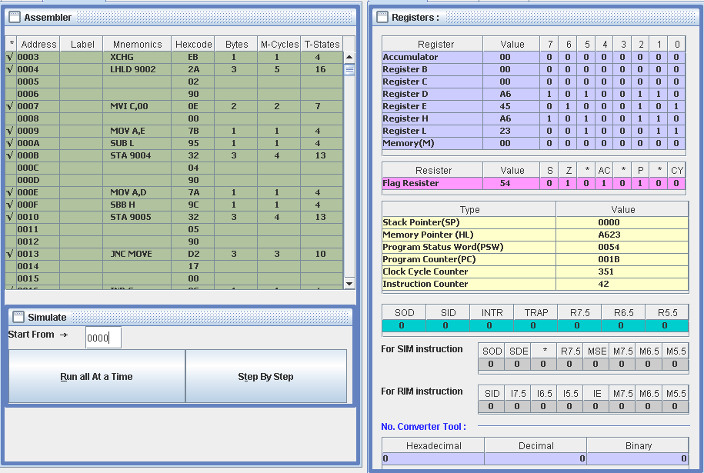

**Evaluation Grid (To be created as per the SOP and Assessment guidelines by the faculty):**

|  |  |  |  |
| --- | --- | --- | --- |
| Sr. No. | Parameters | Marks Obtained | Maximum Marks |
| 1. |  |  |  |
| 2. |  |  |  |
| 3. |  |  |  |
|  |  |  |  |