**Experiment 2.1**

**Student Name: Yash Gupta UID: 20BCS5009**

**Branch: Computer Science Engineering Section: 709-A**

**Semester: 4th Date of Performance: 17/3/2022**

**Subject Name: Microprocessor Subject Code: 20CSP-253**

**Aim:-**

1. **1's complement of 8 bit number**

**Code:-**

**#BEGIN 0000**

**LDA 2000**

**CMA**

**STA 2001**

**HLT**

**#ORG 2000**

**#DB 67**

**Output :-**

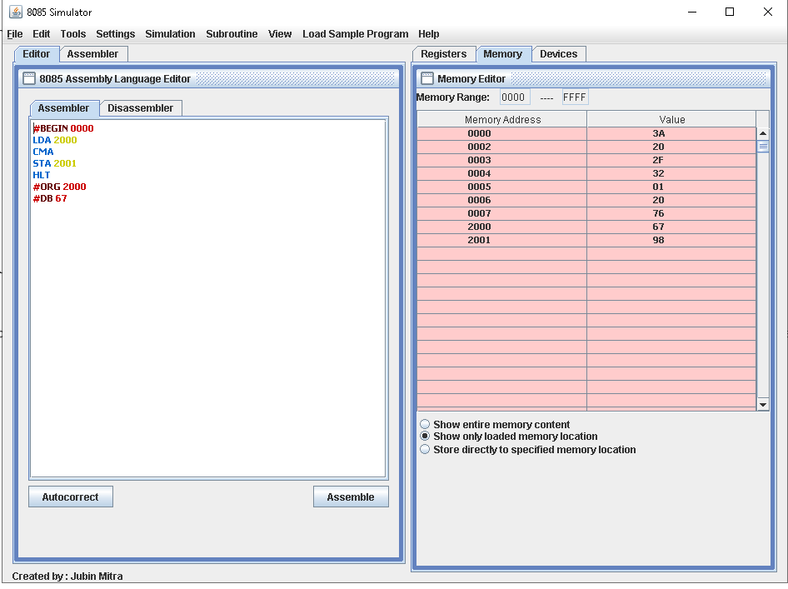

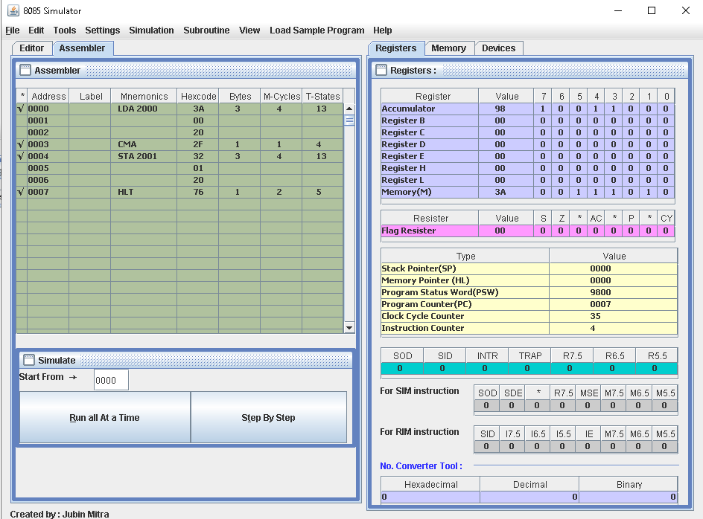

1. **1's complement of 16 bit number**

**Code:-**

**#BEGIN 0000**

**LHLD 2000**

**MOV A,L**

**CMA**

**MOV L,A**

**MOV A,H**

**CMA**

**MOV H,A**

**SHLD 2002**

**HLT**

**#ORG 2000**

**#DB 67,7A**

**Output:-**

